PROGECT MANAGEMENT PLAN.

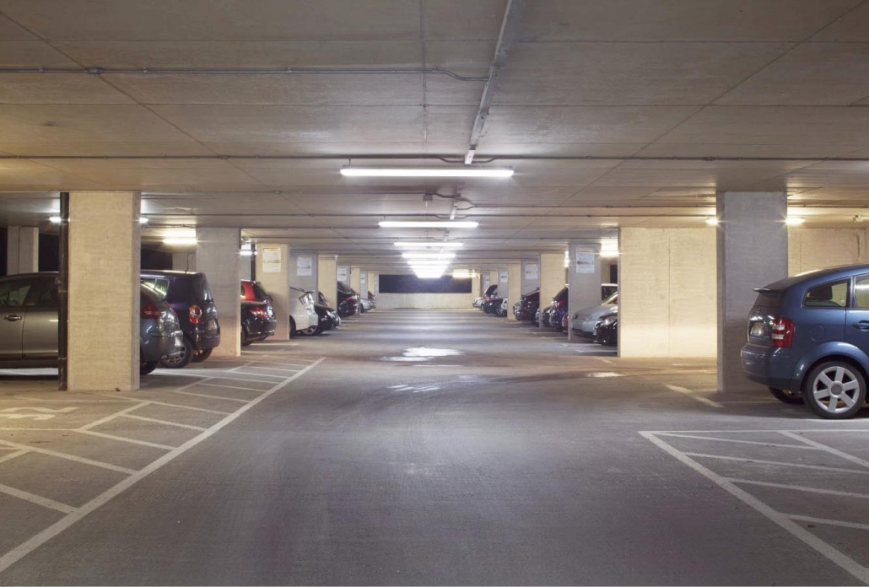

PROJECT NAME; carpark lighting install
PREPARED BY; Justin Thomsen
DATE; 23/07/2020

Document Management

Distribution List

Name | Position | Signature | Date
JUSTIN THOMSEN |  |  | 25/06/2020

Version Control

Revision # | Change Description | Approval Date | Author
1 | INITIAL RELEASE | 25/06/2020 | J.T

Project Registration
Project Name | Carpark lighting install
Project # | 20C00001
Creation Date | 25/06/2020
Sponsor/Client
Project Manager

Authorisation

Recommendation
The recommendation is

Approval
Approved Postponed Cancelled Review

Sign off
The project plan only becomes valid once signed off by the following members of the project team.
Name | Position | Signature | Date
Justin Thomsen | Project supervisor |  | 29/09/20
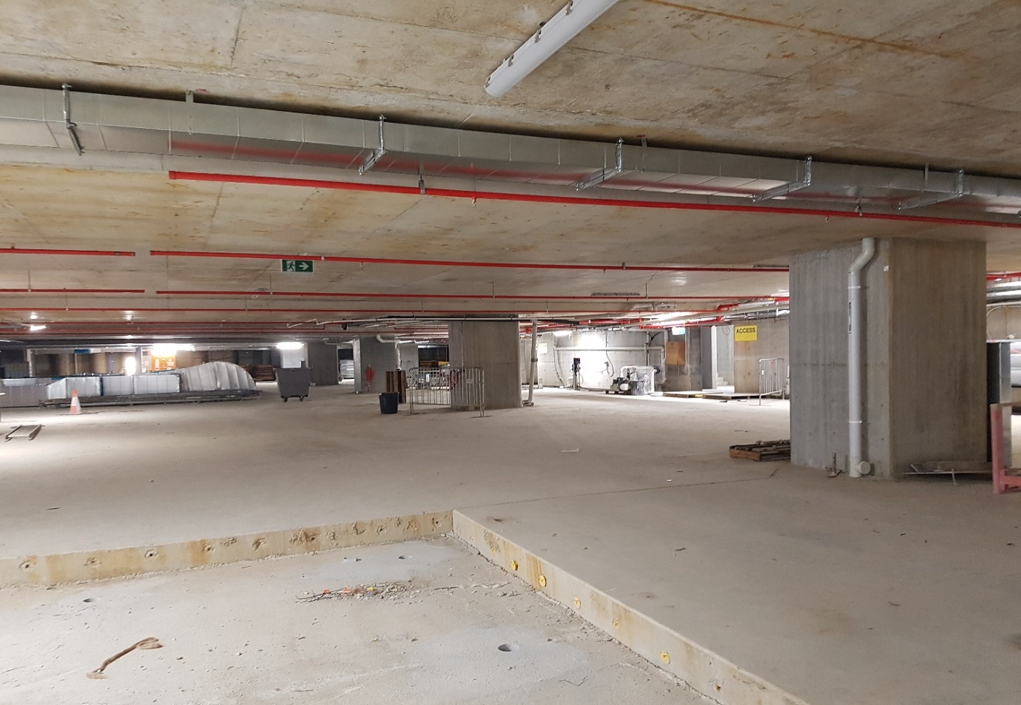

Formal Acceptance and Closure.
Project Name: basement carpark light installs
Prepared by: Justin Thomsen
Date: 23 July 2020
Name of Client or Sponsor:
Statement of Formal Acceptance:
The undersigned formally accept as complete the above-identified project, and do hereby state that this project, project phase, or major deliverable meets or exceeds agreed-upon performance standards for scope, quality, schedule, and cost, and state that we have seen documentation that all relevant legal and regulatory requirements have been met or exceeded.

Additional Remarks:

Accepted by (name of client, sponsor, or other official) | Date
Accepted by (name of client, sponsor, or other official) | Date
Accepted by (name of client, sponsor, or other official) | Date
Signed form distributed to:
Stakeholder name | Date
Stakeholder name | Date
Stakeholder name | Date

Project Charter

Project Name: Install of lights to basement carpark
Prepared by: Justin Thomsen

Date: 23 July 2020
Initiation: | This project will comprise of an installation of an integrated lighting management system to the basement carpark
Synopsis: | The Builder has engaged our project team to provide an eco-friendly, computer managed lighting system to the basement carpark.
Purpose/Business Need: | The purpose of this project is to provide an integrated lighting control system into the basement carpark. This system will be an environmentally friendly project with state of the art fittings being installed.
Product Description and Deliverables: | Deliverables are documented in section 2.2
Project Exclusions: | Exclusions are documented in section 2.3
Project Management: | Justin Thomsen- Project Manager  See responsibility matrix in appendix for complete project team
Assumptions, Constraints, Risks: | Assumptions are document in the assumption log in appendix 1  Risk register and risk mitigation forms are found in appendix 1
Resources: | All resources will be sourced from local contractors and manufacturing
Stakeholders: | Stakeholders are listed the stakeholder analysis found in appendix 1
Approach: | This project will be managed in conjunction with the construction program and GANTT chart.
Communication and Reporting: | All communications will be as specified on the Communication Requirements Analysis Worksheet
Acceptance: | Acceptance off this document requires client signatures from client on the formal acceptance and closure form and also authorisation form.
Change Management: | All changes to this project will be documented in the change register upon acceptance by the client of a change request form, see appendix
Approval | Project Manager: Justin Thomsen

Contents Page

Project Information

1. Integration Management

1.1 Methodology

1.2 Change control

1.3. Performance Reporting

1.4. Audit

1.5. Project closure

2. Scope Management

2.1. scope statement

2.2. Inclusions

2.3. Exclusions

2.4. Handover

3. Time Management

3.1. Schedule

3.2. Milestones

4. Cost Management

4.1. Budget

4.2. Estimating methodology

4.3. Confidence level

4.4. Continue

4.5. Source of Funds

4.6. Cash Flow

5. Quality Management
5.1 Overview of Quality Requirements
5.2 Council Regulations
5.3. Building Regulations
5.4. Operation of Equipment
5.5. Quality Control
6. Human Resource Management
6.1. Stakeholders
6.2. Resource Capability
6.3 Employee development and training procedure
7. Communications Management
7.1. Organisational Structure
7.2. Issue resolution procedure

8. Procurement and Contracts Management
Subcontractor Selection and Management

9. Risk Management

9.1. Constraints

9.2. Assumptions

9.3. Potential Issues

9.4. Risk

Authorisation

Recommendation

Approval

1. INTERGRATION MANAGEMENT
1.1 METHODOLGY
Methodology can be defined as a system of practices, techniques, procedures, and rules used by those who work in a discipline.

1.2 CHANGE CONTROL
A change request is a formal proposal to modify any document, deliverable, or baseline. An approved change request will replace the associated document, deliverable, or baseline and may result in an update to other parts of the project management plan. When issues are found while project work is being performed, change requests are submitted, which may modify project policies or procedures, project scope, project cost or budget, project
schedule, or project quality. Other change requests cover the needed preventive or corrective actions to forestall negative impact later in the project. Requests for a change can be direct or indirect, externally or internally initiated, and can be optional or legally/contractually mandated, and may include:
• Corrective action—An intentional activity that realigns the performance of the project work with the project management plan;
• Preventive action—An intentional activity that ensures the future performance of the project work is aligned with the project management plan;
• Defect repair—An intentional activity to modify a nonconforming product or product component; and/or
• Updates—Changes to formally controlled project documents, plans, etc., to reflect modified or additional ideas or content.
A change log is used to document changes that occur during a project. These changes and their impact to the project in terms of time, cost, and risk, are communicated to the appropriate stakeholders. Rejected change requests are also captured in the change log.

1.3 AUDITING

All work completed on this project will be audited by the project team on a regular basis. All auditing templets are attached to the appendices at the rear of this project plan. See the quality plan for detailed information regarding the individual audits undertaken.

1.4 PERFORMANCE REPORTING

Performance reports will be complied by the project manager. Performance reports will be completed after a change request has been signed. All reports will use the templet attached in the appendices. Once a report has been accepted the project plan will be updated to reflect any changes. All changes will be reviewed in a lessons learned format at the completion of the project. Upon completing all phases of this project a final report is to be completed and signed off by the sponsor.

1.5 PROJECT CLOSURE
Once all phases of the project are completed the project closure will commence as follows
- Payment of remaining invoices
All outstanding invoices are to be closed out with all accounts with subcontractors and manufactures to be settled
- Project closure meeting documentation
Project completion documentation attached to the appendices will be completed.
- Final project meeting
Here all relevant will be provided with the projects completed documentation which includes;
- Project completion report
- Final version of the project plan
- Formal acceptance and closure
- As constructed drawings reflecting all changes to the project.
The meeting commences with confirmation of the accuracy of the report and updated project plan. All documents are to be reviewed and signed off by the committee using the attached formal acceptance and closure templet in appendices.

2. SCOPE MANAGEMENT

2.1 SCOPE STATEMENT
On completion of the base building construction there will be commencing fit out to the project. As indicated on attached for construction drawings, this project will comprise of a fully automated, green star lighting system. The project will be managed across 3 phases comprising of rough in, fit out and commissioning / hand over.
The project team will be responsible for monitoring on site progress with constant reference to project phase deadlines. Through weekly site meetings progress will be documented and forwarded to all stakeholders. Project team leaders will correspond with stakeholders directly via email and onsite inspections as required. As described in this project plan, all stakeholders are listed and their communication preferences are indicated.
Any delay to the project program will be noted and communicated directly to stakeholders. All project requirements will be met and captured with Quality plans and auditing tools with no impact on project time frames.
The driving force behind the project will be the completion of the install on time and within budget. Completing this with a high level of quality will hopefully lead to the fit out of further levels and the construction of strong relationship between client and builder. By employing local wholesalers and manufacturing there will also be a motivating factor to drive productivity to reach time line goals while reducing costs.

2.2 INCLUSIONS
Any unique and verifiable product, result, or capability to perform a service that is required to be produced to complete a process, phase, or project. The deliverable products on this project are pictured below.

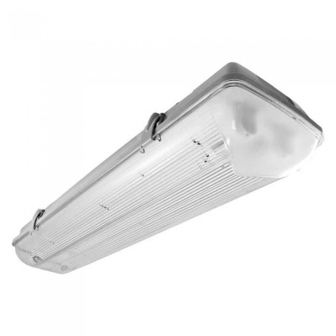This light is a 22w cool white (3600 k) prismatic diffused, vandal proof fitting. It will be the only light installed in the carpark area with an equivalent emergency fitting installed as required. All lights are controlled with a back to base “Dali” system that are monitored for failure at the buildings head end computer. There are 100 standard fittings and 33 emergency fittings. All fittings will be supplied by local wholesalers who have confirmed stock.
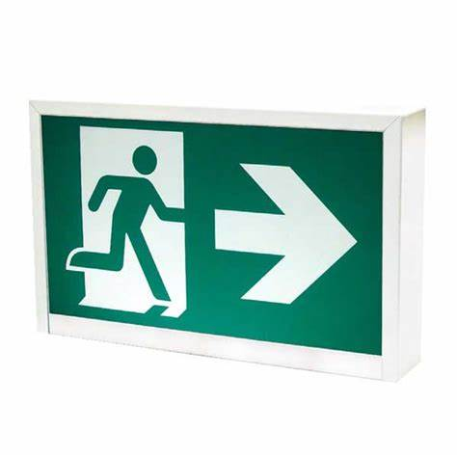This will be the installed exit sign. It will be installed as per constructed drawings and as per all Australian standards. The exits will be spaced at intervals of no greater than 24m and subject to council auditing at the handover of the project. All fittings will be supplied by local wholesalers who have confirmed stock.

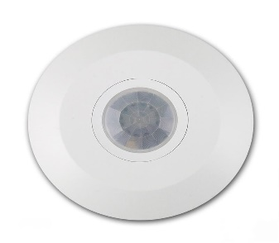Lighting control sensor. These sensors will come in 360°,180° and 60° models, all having the same appearance. Again, these will be installed as per issued drawings. An audit will be undertaken at the completion of the project. Any item blocking the field of view will be required to be moved at others expense. All fittings will be supplied by local wholesalers who have confirmed stock.

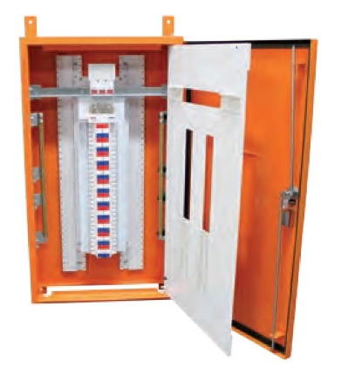This will be the switchboard used to house the lighting control gear and circuit protection. It is located in the central core of this floor, as indicated on for construction drawings. The size of this board has been calculated to cover the required load and spare 25% capacity for future. Any addition to this project will require a reduction to this spare capacity.
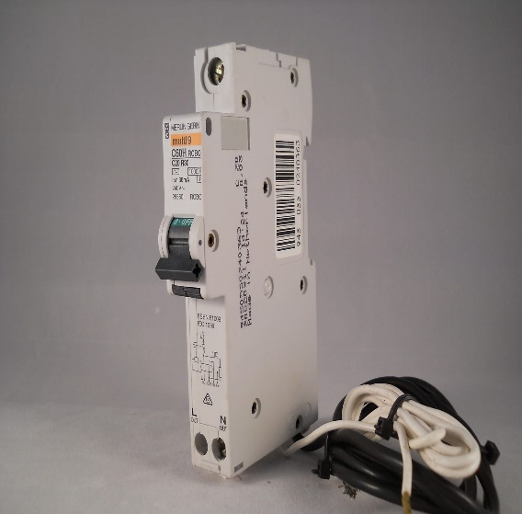
These are the control gear supplied with the switch board. There will be 20amp RCBO supplied for the lighting circuits and 2 Dali controllers supplied to control this output. Any change to the design will require additional labour and material costs.
The labour and management are capped at what has been approved on the attached plan. Any additions will be formally submitted to the client for approval in the way of change request form. These will be time managed to correspond with the project’s program. All costs will be attached to change request where approval from the client will be required to move forward with the alterations.
2.3 EXCLUSIONS
All fittings will be installed as per drawings. There is no allowance made for any additional fittings in this project. Any addition to this project will involve redesign to the customised lighting control package.
All calculations on lighting output and associated cable sizing have been taken from the appropriate standard. Additions will require the redesign and construction to the affected area at the client’s expense.
Reticulation to all fittings will be concealed to our best efforts. There will be no allowance for surface reticulation where fittings have been added after this plan has been approved. There is no allowance for reticulation where damaged has been done by others during the install of the conduit framework in the concrete slab. Prof of all installed pipework will be catalogued in the form of photos of the completed install prior to concrete and quality assurance sheets.
Council inspections / audits will be at the client’s expense. Any reworks due to these inspections will need to be submitted for redesign where costing will be negotiated.
There is no allowance for management when required to supervise the works related to additions. This will form a cost and will be submitted to the client for approval prior to any additional work commencing. All labour related expenses related to additions are shown in the labour breakdown in appendix.


2.4 HANDOVER
At this point, processes will be finalized across all activities of the Project Management Process Groups to formally complete the project. When closing the project, the project manager will review all prior information from the previous phase closures to
ensure that all project work is completed and that the project has met its objectives.
This includes all planned activities necessary for administrative closure of the project, including step by- step methodologies that address:
• Actions and activities necessary to satisfy completion or exit criteria for the phase or project;
• Actions and activities necessary to transfer the project’s products, services, or results to the next phase or to production and/or operations; and
• Activities needed to collect project or phase records, audit project success or failure, gather lessons learned and archive project information for future use by the organization.
As part of the handover, procurement documentation including any seller-developed technical documentation and other work performance information, such as deliverables, seller performance reports and warranties, financial documents including invoices and payment records, and the results of contract-related inspections, will be submitted to the client for archiving.

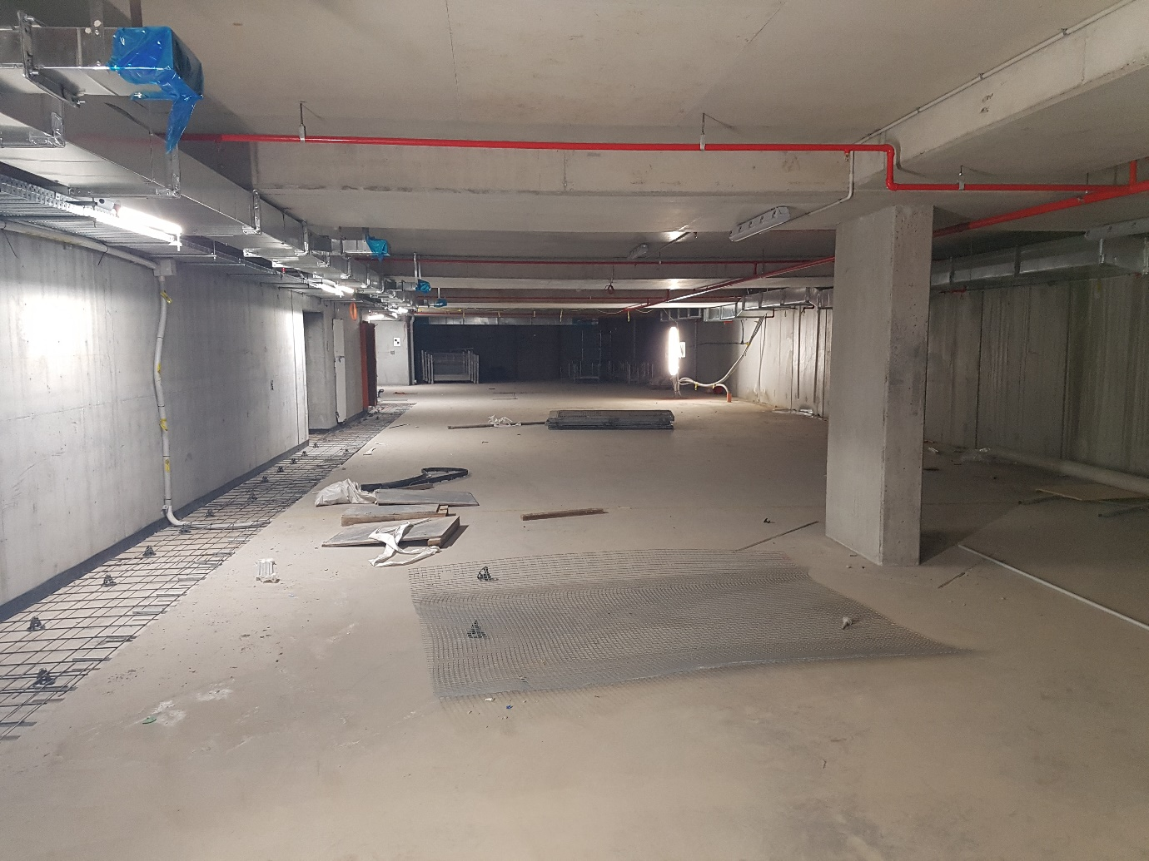

3. TIME MANAGEMENT
3.1 SCHEDULE
This projects Schedule will work in conjunction with the documentation attached in the appendix. A brief outline of the work phases is described below.
1.) WBS
2.) GANNT CHART
3.) PERT CHART

PHASE 1. – CABLE ROUGH IN
This phase will consist of the installation of cabling into the pathways that have been precast into the concrete. This phase will commence works on the project for the team. It will be reliant on the builder completing phases prior to our commencement. As per the dates associated on the PERT chart, this process will commence on 27th July with an aim to complete on the 10th August, a working duration of 10 days.

PHASE 2. – PRODUCT FIT OFF
Commencement of this phase will be relying on the completion of the prior rough in stage. During this process fittings will be installed. As per dates on the pert Chart, this phase will commence on 10th August and continue for 3 weeks completing on the 5th of September.

PHASE 3. - TESTING / COMMISSIONG AND CLOSING
The project will be completed in this phase with a final completion date of 19th September.

3.2 MILESTONES
Key mile stones of the project will be associated with the completion of each of the phases. It will be at each completed phase that check sheets will be submitted to the client as an indication of the work that has been undertaken to this time.

4. COST MANAGEMENT

4.1. BUDGET
The following table is a breakdown of the project phases.
PHASE | LABOUR | PROCUREMENT | PURCHASE | TOTAL
 | $25800 | $6000 |  | $31800
 | $2800 | $4000 |  | $6800
 | $21600 | $12000 |  | $33600
 | $3600 |  |  | $3600
 | $36800 |  |  | $36800
TOTAL |  |  |  | $112600

4.2. ESTIMATING METHODOLOGY
Project management software will be used to aid estimating of this project. Bottom-up estimating involving estimating the time taken to complete individual activities or work packages, then summarising the individual estimates to get a total of the project time.

4.3. CONFIDENCE LEVEL
This project has a high union influence. With the economy as it is at the present, the union have become a very powerful figure head in the construction industry. It is this influence that directly affects this project and the confidence level. This project team does not see any need to make an allowance for additional time in this plan. At this present time the team and the union have a strong working relationship and consider this not to have any detrimental effect to the project.
As the last enterprise agreement was prior to the commencement of this plan all wage increases have to been budgeted into the project and consequently allowed for. All procurement prices have been locked into the project and will stay as this for 12 months from the commencement of the project.
The current pandemic is the project teams only concern. At the moment, with all procurement prices locked in, confidence level is high.

4.4. CONTINGENCY
There will be a fixed payment of $150000. The project budget as per this plan is $112600. There will be a fund of $37400 leaving an additional %33 to cover for any project additions.

4.5. SOURCE OF FUNDS
This plan states that the funds of $150,000 + GST will be made available for the work completed in this project. Funds will be paid as per the below table and as per the completion of the said stages.
• Payment 1: 50% initial payment at the commencement of phase 1.
• Payment 2: 20% progress payment upon completion of all phase 1 deliverables and delivery of project progress report.
• Payment 3: 20% progress payment upon completion of all phase 2 deliverables and delivery of project progress report.
• Payment 4: 10% final payment upon completion of all phase 3 deliverables and delivery of the project final report.

EXPECTED PAYMENT DATE | PAYMENT | PROPORTION | AMOUNT (PRE GST) | AMOUNT (GST INC)
 | PAYMENT 1 | 50% | $75000 | $82000
 | PAYMENT 2 | 20% | $30000 | $33000
 | PAYMENT 3 | 20% | $30000 | $33000
 | PAYMENT 4 | 10% | $15000 | $16500
 | TOTAL | 100% | $150000 | $165000

4.6. CASH FLOW
Cash flow methodology is measured as follows-
Labour – All employees’ wages are set to take into account any overtime or penalty rates. They are calculated by estimating the duration of a given task / phase be that in days. The days are then multiplied by the 8 hour working day and again by the hourly rate.
Procurement – Is measured by the use of contractual quotations from wholesalers. Payments will be made upon the completion of the given stage.

5. QUALITY MANAGEMENT PLAN
5.1 Overview of Quality Requirements
There are a number of sources of quality requirements for this project. These include;
- Australian standards ASNZ 3000 electrical wiring rules
- Australian standards ASNZ 3008-1 cable selection
- Australian standards ASNZ 3008-2 cable selection
- Australian standards ASNZ 3012 construction and demolition sites
- Australian standards ASNZ 2293.3 emergency evacuation lighting for buildings
- Building code of Australia
- Work place health and safety act
- Work place health and safety regulation
- Code of practice
- project specification

5.2 Electrical regulator Regulations
- Electrical regulation 2006
- Electrical safety Act

5.3. Building Regulations
This project will be audited under the guidance of the building code of Australia.
5.4. Operation of Equipment
All equipment used onsite in the testing of electrical circuitry will conform to ASNZ 3760 electrical inspection and testing. All tests performed will be under the guidelines of ASNZ 3017Electrical installations. This standard provides persons who carry out the verification of electrical installations with some methods of checking that the installations complies with the safety requirements for the prevention of fire or persons from sustaining an electric shock.
5.5. Quality Assurance
All processes will be audited at the completion of works for the phase. The auditing will be undertaken with by the onsite completion of an ITC (inspect and test checklist). The ITC will be completed for the phases of;
- Lighting rough in
- Lighting control
- Light install
- sensor installs
- switchboard termination
- fire rating
- These ITC’s will accumulate to form the project ITP (inspect and test Procedures).

5.6. Quality Control
This company is a leading Australian company that supplies electrical, mechanical, security and audio-visual services to industry. It specialises in the design, project management, installation and maintenance of electrical, communications, air conditioning, ventilation, security and audio-visual technology and property and industrial maintenance.
We are dedicated to the delivery and installation of products and services to our customer as agreed by contract: at a quality that meets or exceeds our customer's expectation, to budget, in an efficient and timely manner, and fit for purpose.
The objective is to supply products and services that meet customer needs and have the desired safety, environment and quality fundamentals in accordance with specifications, statutory obligations and other requirements.
We will achieve these by:
- Demonstrating a shared commitment to quality at all levels of the company;
- Establishing and reviewing quality objectives which will enhance our achievements,
- Reviewing performance and continually improving the effectiveness of the business management system, and
- Undertaking assurance activities which substantiate the conformance of our products and services.
In implementing our quality management systems, we aim to enhance customer satisfaction by•
- Identifying the processes needed for the quality management system and their application throughout the organisation,
- Determining the sequence and interaction of these processes,
- Determining criteria and methods needed to ensure that both the operation and control of these processes are effective,
- Planning and ensuring the availability of resources and information necessary to support the operation and monitoring of these processes,
- Monitoring, measure and analyse these processes, and
- Implementing actions necessary to achieve planned results and continual improvement of these processes and outcomes.
This company is committed to ensuring that our management and all workers are appropriately trained and committed to delivering a quality service to our customers
The management system and this policy will be continually reviewed for improvement and continual suitability.



6. HUMAN RESOURCE MANAGEMENT
6.1 STAKEHOLDERS
The stakeholder requirements are covered in the stakeholder analysis template in Appendix
6.2 RESOURCE CAPABILITY
The company has emphasised the high level of priority that has been attributed to this project by the management team. All labour will be acquired in accordance with the project program and resourced from the labour pool that the company already has employed.
6.3 EMPLOYEE DEVELOPMENT AND TRAINING POLICY
Development of knowledge, skills and attitudes enhances the performance of employees in their current tasks and prepares them for any emerging roles. It will also enhance the Company’s performance through improved organisational efficiency and effectiveness,
Extending this knowledge and skills is one of the key commitments.
The need for staff development and training is identified through consultation between the employee and the supervisor, as well as through the Staff Performance Review.
The Company will at the discretion of management, provide assistance to complete courses leading to formal educational qualifications where:
- The proposed course is relevant to the company’s business requirements;
- The proposed course is relevant to the employee’s career development, and
- The employee has consistently demonstrated satisfactory, or above, job performance.
This company is committed to the promotion of equitable access to training, and may at the discretion of the company, be undertaken during working hours either on or off the job,
We shall meet the cost of the course fees for programs approved providing the training is relevant to the employee's current position or career development at this company.
The Company will ordinarily approve paid leave needed to attend examinations, however does not provide paid leave to study for exams, attend courses or seminars.
The Development and Training Application Form must be completed and all approvals must be obtained prior to enrolment in any course for which Company assistance is sought. The application must be submitted at least three months prior to commencement of course and will not consider any subsidy requests from employees who have enrolled prior to seeking company approval.
TRAINING DURING PROBATION
During an employee's probationary period there may be specific job training provided to the employee at a cost to the Company. Should the employee terminate their employment with the Company during the probationary period then the Company has the right to seek reimbursement of the cost of the training from the employee.
Reimbursement for training monies received will be deducted from an employee's termination payment if they resign within the periods as detailed on the application form.

7.COMMUNICATIONS MANAGEMENT
7.1 ORGANISATIONAL STRUCTURE

7.2 ISSUE RESOLUTION PROCEDURE
1.0 PURPOSE AND SCOPE
This company is committed to ensure it maintains a safe and harmonious workplace and to have any issues raised dealt with as quickly and as amicable as possible. The purpose of this procedure is to set out the process to resolve any health and safety issues arising in the workplace and applies to all workplaces under company management.
2.0 PROCEDURE
When a health and safety issue is raised it shall in the first instance be directed to the immediate supervisor for resolution. Where the matter has been discussed by the two parties and the issue remains unresolved, the issue will be further referred to the General Manager of the Division responsible for the issue, adopting the following process for resolution:
i. The Divisional General Manager or either party to the issue may commence the process by
informing each other party:
a) that there is an issue to be resolved,
b) the nature and scope of the issue.
ii. The issue may also be reported to the designated workforce HSE Representative and / or HSE Coordinator / Manager.
iii. As soon as practical all concerned parties are informed of the issue, all parties must meet or communicate with each other to attempt to resolve the issue.
iv. The parties must have regard to all relevant matters, including the following:
a) the degree and immediacy of risk to workers or other persons affected by the issue,
b) the number and location of workers and other persons affected by the issue,
c) the measures (both temporary and permanent) that must be implemented to resolve the
issue,
d) who will be responsible for implementing the resolution measures.
v. A party may, in resolving the issue, be assisted or represented by a person nominated by the
party (e.g. a colleague, committee member, HSR representative, a representative body).
vi. If after reasonable efforts an agreement cannot be reached on a solution to the issue, either or both parties are entitled to obtain outside advice / assistance as detailed:
A party to the issue may ask the regulator to appoint an inspector to attend the workplace to assist in resolving the issue.
a) A request to the regulator under this section does not prevent:
- a worker from exercising the right to cease work, or
- a health and safety representative from issuing a provisional improvement notice
or a direction to cease work.
b) On attending a workplace under this section, an inspector may exercise any of the
inspector’s compliance powers under the legislation in relation to the workplace.
vii. If the issue is resolved, details of the issue and its resolution must be set out in a written
agreement if any party to the issue requests this.
Note. Under the Act, parties to an issue include not only a person conducting a business or
undertaking, a worker and a health and safety representative, but also representatives of these persons).
viii. If a written agreement is prepared all parties to the issue must be satisfied that the agreement reflects the resolution of the issue.
ix. A copy of the written agreement must be given to:
a) all parties to the issue, and
b) if requested, to the health and safety committee for the workplace.
x. To avoid doubt, nothing in this procedure prevents a worker from bringing a work health and safety issue to the attention of the worker’s health and safety representative.
In implementing solutions to HSE issues, agreement is reached between management and the HSE Representatives / Committee on the actions to be taken, the timing and who is responsible for implementation. Details of this agreement are to be brought to the attention of all personnel affected by the issue. This can occur by discussion at tool box meetings, a notice on the notice board or any other means of communication adopted by the company. Details of the issue and the agreed solution are also to be reported to the HSE Committee where present. The HSE Committee has the task of monitoring progress and reviewing any difficulties that may arise.

8. PROCUREMENT AND CONTRACTS MANAGEMENT

1.0 PURPOSE AND SCOPE
The purpose of this procedure is to ensure that the procurement of any Materials, Plant items (hire) or Subcontractors are processed and managed in such a way that is fit for purpose, value for money and available when required.

2.0 DEFINITIONS
COINS: ‘Construction Industry Solutions’ is the Financial Accounting and Job Costing System.

3.0 PROCUREMENT PROCESS AND AUTHORISATION LEVELS
All Procurement is to be carried out in accordance with these procedures, Delegation of Authority Procedure and the Procurement Process Flowchart.
Each Division has specific staff sign-off Authorisation Levels and these are detailed within the Delegation of Authority Procedure.
The Flowchart and Delegation of Authority Procedure are available on the company Management System and are listed in Section 5.0 Related Documents.

3.1 New Suppliers / Subcontractors
COINS has an extensive database containing Suppliers and Subcontractors that are currently being used. Should the need arise to have new accounts set up or transferring an existing account from one company to another then this is handled by Accounts Payable via EFTSURE.
Each division will have EFTSURE administrators set up internally who will log onto https://portal.eftsure.com.au and send invitations to the supplier / subcontractor to provide the necessary details to complete On-boarding process.
Once details are received then the Accounts Payable team shall finalise the process and make the supplier / subcontractor available in Coins

All Suppliers and Subcontractors must comply with the National Code of Practice for the Construction Industry and agree to the Standard Terms and Conditions relevant to each State.

3.2 Purchasing using COINS
When procuring from a Supplier or Subcontractor, it is the responsibility of the Project Manager or Coordinator to initiate all purchase orders within COINS. All correspondence to the Procurement Department shall be submitted via email.
The Purchase Order is to include the name of the Supplier or Subcontractor, the delivery address, details of what is being ordered (Scope of Work) and the price.
The order must not refer to the Supplier or Subcontractor’s quotation or their Terms & Conditions in any of the Purchase Order documentation.

As applicable, the originator will upload the MBA with the appropriate sign off in accordance with the Delegation of Authority Procedure, Subcontract Agreement / or Supply Agreement and any other applicable documentation into COINS and request the Procurement Department to process the order.
The Procurement Department shall assess the validity of the documentation before committing the order. The purchase order shall then be emailed to the Supplier / Subcontractor directly or to the creator of the purchase order to issue to the Supplier/Subcontractor together with any appropriate documentation.
Purchase Order Numbers must not be issued to Suppliers or Subcontractors before the Purchase Order has been reviewed, approved and committed in COINS.
Standard Terms and Conditions shall be sent to Suppliers when a purchase order is raised.

3.3 Major Bid Analysis (MBA) and Supplier Price Comparison
Purchase orders over the value of $10,000 require a Major Bid Analysis and Supplier Price Comparison Form to be completed and uploaded into COINS. These forms must be used for all Major purchases of Materials or Subcontractors. In conjunction with the three quotations obtained for either Material or Subcontractors, the form assists the user in maintaining budget and contractual obligations. These forms must be signed off in accordance with the Delegation of Authority Procedure.

3.4 Subcontractors
It is the Project Manager’s responsibility to engage Subcontractors in accordance with the Subcontractor Selection and Management Procedure An evaluation of the Subcontractor shall be conducted and then the Procurement process shall be carried out in accordance with the Procurement Process Flowchart and these Procurement Procedures.

Whenever Subcontractors are to be engaged on projects, this company will engage them under a Purchase Order and Subcontract Agreement:
The Subcontract Agreement Forms are listed in Section 5.0, Related Documents.

During the Procurement Process, as a minimum, the following documents shall be obtained before commencement on site:
- List of workers;
- Safe Work Method Statement (SWMS) (and a Site Health and Safety Plan if requested by the Project Manager);
- Certificates of Currency for both Workers Compensation and Public Liability Insurances;
- ABCC Letter confirming compliance to the National Code of Practice for the Construction Industry.
- Schedule of Rates for any variation of works.
- Signed Subcontract Agreement
Note: It is company Policy not to engage Sole Traders unless prior approval has been obtained from a Company Director.

3.5 Material Procurement (Service, Onsite Personnel and Coordinators)
When purchasing Materials from a Supplier, Service and Onsite personnel shall complete a Material Requisition Form and have either the Procurement Department, their Coordinator or their Manager process it by:
- Phoning the Procurement Department; or
- Emailing the Material Requisition to Procurement
- Having their Coordinator raise the Purchase Order in COINS in accordance with Clause 3.2
Phone Order requests are capped at $1,000.
Order requests in excess of this value are to be emailed to either Procurement, the relevant Coordinator or Manager to be raised in COINS along with any relevant documents in accordance with Clause 3.2 above.

Material Requisition books are available from the Procurement Department and from the Management System on SharePoint, Material Requisition Form (PRF-003).

A purchase order number along with the contract number shall be issued once the Material Requisition has been processed by the Procurement Department.
The Purchaser shall then forward the Purchase Order number to the Supplier for Phone Orders.
The Procurement Department will issue the Purchase Order to the Supplier for email requested or Orders initiated by a Coordinator or Manager in COINS unless requested otherwise.

3.6 Purchasing Out of Hours, on Weekends or when COINS is not available

If Materials or Services are required either out of hours, on weekends or whenever COINS is not available, the following information shall be provided to the Supplier; and issued to the Procurement Department by email or phone call the next business day.
- Material Requisition number;
- Contract number & name;
- Initials of the person requiring the Order; and
- Order value
The Purchase Order will be issued by the Procurement Department on the next business day.

3.7 Submain Control Sheet
Submain Control Sheet shall be used for tracking changes to Major Cable Orders. Monitoring and updating shall be completed by the Project Manager or Coordinator from Site & uploaded directly into COINS.
The Procurement Department must be informed of any/all changes to the order, to update job costing.

3.8 Project Control Worksheet
Project Control Worksheet (PRF-008) shall be used for tracking changes to Major Orders, mainly lighting but can be used as an ancillary tool for changes to Orders. Monitoring and updating shall be completed by the Project Manager or Coordinator from Site. The Procurement Department shall be informed of any changes to the Order so the job costing is updated.

3.9 Labour Hire
When placing a requisition for a Labour Hire company, the following documents must be obtained before commencement on site:
- List of workers;
- Certificates of Currency for both Workers Compensation and Public Liability Insurances;
- ABCC Letter confirming compliance to the National Code of Practice for the Construction Industry.
- Schedule of Rates for any variation of works.

3.10 Hazardous Chemicals
Safety Data Sheets (SDS) are required for all Materials purchased that contain any form of hazardous chemicals or Materials. The purchaser must ensure that the Supplier provides the SDS with the purchased Materials. The Materials shall be listed in the Hazardous Chemicals Registering site before being used by the Purchaser.

3.11 Capital Expenditure
Prior to placing Material Requisitions for Capital Expenditure, the Request for Capital Expenditure Form must be completed and authorised in accordance with the Delegation of Authority Procedure and emailed to the Procurement Department for Processing.
All items of Plant & Equipment must have an Asset number allocated from the Plant & Equipment register for that Division which must also be painted / engraved onto the equipment prior to being put into use
Where Capital Expenditure orders are being delivered to site please ensure full delivery address and site contacts details are included for reference on the order.
3.12 Development & Training
Prior to placing Material Requisitions for Development and Training the Development and Training Application Form must be completed and authorised in accordance with the Delegation of Authority Procedure and emailed to the Procurement Department for Processing.

3.13 Purchasing Company Uniforms, PPE and Stationery
Company uniforms are to be supplied and replaced in accordance with the EBA and the Uniform Policy using the Uniform Requisition forms and submitted to the Procurement Department for processing. The forms are listed in Section 5.0 Related Documents.
Personal Protective Equipment (PPE) shall be provided in accordance with the EBA and the PPE policy Request for Personal Protective Equipment Form (PPE) shall be submitted to the Procurement Department for processing.
For Company Stationery the Material Requisitions Form shall be submitted to the Procurement Department for processing.

3.14 Order Amendment
For Order Amendments, Order Amendment Form and must be completed by the Project Manager / Coordinator and uploaded directly into COINS for processing in accordance with clause 3.0.
For Order Amendments (amended value only) these have the same staff sign-off Authorisation levels as per Clause 3.2.
The Procurement Department will review and process the Order and send it back to the Project Manager or Coordinator to issue to the Supplier/Subcontractor.

3.15 Request for Credit - Goods Return Authority
When required to return goods to the Supplier for credit, the Goods Return Authority form shall be completed and approved by the Supplier. Prior to completing this form, the Supplier shall be contacted and advised of the goods being returned. Some Suppliers require a Goods Return Authority Form (GRA) to be completed before any goods will be accepted back for return.

3.16 Letter of Intent
Letters of Intent can be used for Major Orders where official Contracts have not been finalised or executed. Letters of Intent are subject to the finalisation and execution of the contract.

4.0 CONTROL OF COMPANY ASSESTS (Vehicle, Plant and Equipment) 4.1 Purchasing Vehicles, Plant and Equipment
For the Procurement of Company Vehicles or Plant and Equipment consideration should be given to safety, suitability and the Safe Use, Inspection and Maintenance of Plant and Equipment Procedure shall be complied with.
Requests for new vehicles should be directed to Procurement along with any specific fit out or accessory requirements to obtain pricing.
Once 3 quotations have been obtained by Procurement these shall be forwarded to the requestor and the requestor will then submit a Request for Capital Expenditure - Motor Vehicle have it approved by the Divisional Manager and Divisional Director.
Once approved at the Divisional level then email the signed off form to Procurement for final approval by the Group Managing Director and CEO prior to processing.
All accessories or fit outs not included by the Dealership shall require a separate Request for Capital Expenditure – Motor Vehicle form and be approved in accordance with the above process.
The Fleet Management Company will assist in obtaining quotations and coordinating deliveries, fit outs and sign writing on all company vehicles.

The Procurement of all Company Assets will be done in accordance with Clause 3.11 Capital Expenditure as above.

4.2 Company Vehicle Management
The Company Vehicles Management Procedure shall be followed when company vehicles require repairs or maintenance.
Vehicle Condition Reports for all company vehicles are to be filled out at the end of each month and forwarded directly to the designated Fleet Co-Ordinator of your business for reporting.
For Vehicle Maintenance and Servicing the driver can use any of our existing approved service Suppliers shown in the Fleet Management company’s manual or alternatively any manufacturers approved dealership and follow the procedure below:
Step1: Book the vehicle in at your preferred approved service centre at a time convenient.
Step2: Identify the vehicle to the service centre as a Fleet Managed vehicle for authorisation and payment.
Step3: Collect your vehicle and do not make any payments.
For any assistance call the Fleet Management company on the number provided in their manual.

4.3 Repairs and Maintenance of Plant and Equipment
For Plant & Equipment requiring repair the Project Manager or Site Supervisor will complete the Plant & Equipment Form and issue it to the Procurement Department. A detailed description of the repairs must be identified in the “Repairs Required” column. The Project Manager or Site Supervisor will return the equipment to the office with the form for repairs. The Procurement Department will then arrange for the repairs to be made.
5.0 RELATED DOCUMENTS

For all related documents refer to Management System on SharePoint

- GOVERNANCE

Subcontractor Selection and Management

1.0 PURPOSE AND SCOPE
The purpose of this document is to ensure that all work undertaken by Subcontractors complies with relevant statutory requirements and conforms to the requirements of the company HSEQ management system.
This document applies to all the company personnel having responsibility for placing orders for Subcontractors, whether under direct or indirect company supervision.

2.0 DEFINITIONS
Subcontractors: For this document, a Subcontractor is defined as an organisation, which shall perform work under the terms of a formal subcontract with the company.
Service Providers: A Service Provider is a person who either solely or as part of an organisation, is employed by the company to carry out specified and agreed duties.
Terms and conditions may be by purchase order, a written Subcontract or a verbal request. Examples of a Service Provider are:
- Provider of labour (i.e. tradesman, labour, etc.)
- Provider of mobile equipment maintenance services;
- Provider of plant and equipment;
- Small scale subcontractors who may not have adequate HSEQ Systems in place and who demonstrate they can manage HSEQ in small scale projects on customer sites, under the guidance of the principal contractor.

3.0 RESPONSIBILITIES Company Management
Ensure the requirements of this document are met, including the provision of resources and delegation of responsibilities.

Managers, Team Leaders, Project Managers, Engineers and Supervisors
Ensure Subcontractors and support services are selected under company selection requirements. Monitor the effectiveness of Subcontractors.
Subcontractors
Subcontractors have the responsibility for carrying out the work per the contract.

4.0 SUBCONTRACTOR SELECTION
It is a mandatory requirement for each subcontract awarded by the company that subcontractors are evaluated and meets the minimum company HSEQ requirements and that they work under a documented HSEQ Management Plan.

Subcontractor Standards and Requirements
The principles of HSEQ management for subcontracts apply regardless of the size of the subcontract; these include but are not limited to:
- Conscious effort to avoid hazardous situations by detailed planning and risk assessment;
- Development of job-specific Work Health and Safety, Environment and Quality Management Plan;
- Development of a job-specific Safe Work Method Statements;
- Plans and preparations for emergency conditions;
- Periodic checks (audit) on actual performance by company Site Management;
- Follow-up on health and safety performance at close-out of the subcontract;
- Quick and firm response in the case of sub-standard safety performance and commitment.
Subcontractors
Subcontractors are subject to all of the provisions set down in this procedure.

Service Providers
Where a Service Provider is unable to provide an HSEQ Management System that aligns to the company’s HSEQ Management System, they shall work under, and comply with the company or the principal contractor site-specific HSE Management Plan and system.
A written statement of intent to comply with the company and customer HSEQ requirements shall be requested from the Service Provider/Subcontractor. In this event, an assessment shall be conducted to ensure that the customer and/or company systems adequately address the hazards associated with the. Services Provider’s duties.
On the initial visit to the site, the Service Provider shall be suitably inducted in the site requirements relevant to the work activities by the responsible company personnel. The subcontractor shall ensure that these requirements are observed and acted upon by their employees at all times.

4.1 Selection
Subcontractor selection is based on commitment and past satisfactory safety performance. When selecting a Subcontractor or Service Provider for work on-site, the company shall ensure that the Health and Safety Standards observed by the potential subcontractors are following the standards the company expects to receive.
When invited to tender for a specific project or work scope, the potential subcontractor shall be required to demonstrate commendable experience for prior safety performance and as a safe working organisation for the past 3 years. Particular attention shall be paid to:
- The process by which subcontractors manage the HSE function;
- The subcontractors’, managers’, supervisors’ and employees’ attitude to Work Health and Safety and environmental protection;
- The competency and experience of the subcontractors and employees;
- The subcontractors’ organisation for Work Health and Safety, their knowledge of safe work practices and compliance with statutory requirements;
- Supply of adequate past project samples of SWMS and HSEQ Site-specific Plans; • Reviewing subcontractor HSE records concerning:
Personal safety i.e. fatalities, injury records and workers’ compensation claims record and experience;
  - Operational safety i.e. records of fires, explosions, dangerous goods, incidents, nuisance claims, prosecutions and similar; and
  - Environmental Protection.

4.2 Pre-Qualification Questionnaire
The pre-qualification questionnaire is a mandatory requirement for all contracts awarded by the company except for the conditions stated for Service Providers. The Pre-Qualification Questionnaire form HSF-036 is to be sent with the enquiry documents to all proposed tenderers, the response submitted via the Lucidity platform. Upon receipt of the tender documents, the person assigned to evaluate the tender shall review the responses and assign an appropriate assessment. If required, clarification should be sought from the Subcontractor or company HSEQ Manager.
After an evaluation (in conjunction with the HESQ Manager), the questionnaire/assessment is to be approved or rejected and signed off by the Project Manager (in Lucidity). Subcontractors that meet the acceptance criteria will be considered an “Approved Subcontractors” and may be engaged by the Company on any project.
Subcontractors who do not meet the criteria will be notified. Subcontractors who may not meet the criteria but demonstrate they can manage small scale projects may be accepted subcontractors, provided they commit in writing to comply with the company HSEQ System and site-specific plans.

4.3 Terms and Conditions
- A copy of the General Conditions of Contract is to be attached to the enquiry documents;
- The Subcontractor shall develop and submit an HSEQ Management Plan and SWMS specific to the scope of work (that aligns with the safety requirements of the company’s Site HSEQ Management Plan);
- The Subcontractor shall be held responsible to comply with the plan and adherence to the requirements of relevant Work Health and Safety Statutory requirements, applicable Codes of Practice and Australian Standards;
- A Service Provider shall be required to submit a statement of intent for compliance with company and customer site safety requirements;
- Further matters to be addressed in the Subcontract that impact on Work Health and Safety are: o The right of the company to inspect subcontractor provisions for work health and safety; o The right of the company to stop the work, if and when agreed, that health and safety measures are violated by the subcontractor;
  - Provision of medical First Aid facilities to a standard acceptable to the company and their customers where applicable;
  - Arrangements for appropriate training of subcontractors’ personnel by the subcontractor or the company;
  - Ensure that subcontractor employees have the various necessary skills competency and qualifications to carry out the tasks required of them;
  - Ensure that visitors to the site shall, subject to the site protocol and requirement, attend a site-specific safety induction.

5.0 SUBCONTRACTOR MANAGEMENT
Once awarded a contract, subcontractors must promptly submit a site-specific HSEQ Management Plan and appropriate SWMS and keep records of implementation of that plan including HSEQ inspections, audit records, minutes of toolbox talks meetings and non-conformance reports, etc. The Subcontractor HSEQ Management Plan Assessment checklist should be used to determine the validity of the plan, and include a recommendation for an amendment to comply with the company requirements. Should it be determined that the subcontractors will work under the company management Plan, a written commitment from the subcontractor’s senior management shall be obtained. the company site management shall then monitor the subcontractor to ensure compliance is met (recorded via Lucidity forms).

5.1 Inductions
On the commencement of work or upon transfer to a new area, subcontractors’ employees shall undertake all relevant induction and sign the induction form to indicate that they understand the company requirements. They shall also provide evidence of licences and certificates of qualifications and competency. Subcontractors shall ensure they provide or arrange training of their employees per their legal obligations and the company requirements.

5.2 Supervision
Subcontractors shall supervise their work activities and the company will monitor the works of subcontractors on-site to the extent that is necessary to ensure the subcontractor meets obligations under the contract.

5.3 Consultation
The subcontractor must facilitate and participate in WHS consultation by:
- Regular subcontractor HSEQ meetings;
- Attendance of prestart meetings and toolbox meetings; • Training and induction of subcontractor personnel.

5.4 Safe Work Method Statements
Subcontractors shall submit all appropriate SWMS promptly for review. The company and/or the Principal Contractor will review for adequacy. When found inadequate the subcontractor shall amend and resubmit. Subcontractors shall implement all approved SWMS.

5.5 Hazardous Substances Register
The subcontractor must keep up to date a register and Material Safety Data Sheet (MSDS) of all hazardous substances they use on the worksite.

5.6 Performance Monitoring
This company’s management representatives and subcontractors each have a role in monitoring and evaluating safety performance. The HSEQ Management Plan documents the requirements for verifying compliance with all safety requirements. Verification shall include:
- Audits;
- Monitoring and inspection of the workplace; • Subcontractor review meetings.
Health, Safety and Environmental audits for the subcontract shall be scheduled within the HSEQ Management Plan and carried out following the HSEQ Management Systems Audit Checklist.
The frequency of audits shall be conducted dependent on work scope requirements, and the size and duration of the subcontract.
When it is found by the company during the assessment process that the Subcontractors’ HSEQ Management System is less than adequate, an audit shall be scheduled as soon as practicable after the commencement of work to enable identification of any deficiencies. An action plan to correct identified gaps shall be established and implemented immediately.
Monitoring and inspection of the workplace is integral to the auditing process and confirmation of compliance to certain elements of the HSEQ Management Plan. The inspection process shall be carried out under the requirements contained in the HSEQ Management Plan.
HSEQ review meetings between the company and subcontractor management will be scheduled regularly (minimum once per month). The agenda for these meetings is to discuss the safety performance of the subcontractor. As a minimum, the result of audits inspections and intended corrective actions are to be scheduled for discussion.

5.7 Monthly HSE performance report
It is a requirement that all subcontractors collate safety statistical data whilst working for the company.
This data shall include but not limited to:
- Number of lost time injuries;
- Number of days lost during the month; Number of medical treatment injuries; The number of first aid injuries. The number of hours worked.
At the end of each month, all subcontractors are required to complete the statistical report and forward it to the nominated company site representative by the required date using HSE Monthly Reporting Form HSF-005.

6.0 POST WORK EVALUATION
After a job or at the expiration of a subcontract an evaluation of the subcontractors’ HSEQ performance shall be conducted using Subcontractor Post work Safety Performance Evaluation HSF-038. If practicable the evaluations should be conducted with subcontractor representatives and may include a meeting to review, discuss and evaluate the performance.
Post work evaluations will be used for future pre-qualifying and selection of the subcontractor.
Any serious incidents that may have occurred during the subcontract will be reviewed so that risk reduction strategies can be implemented before the commencement of future work.
The “Approved Subcontractor Status” will be notified to purchasing periodically. Either the submission of an acceptable updated pre-qualification questionnaire or a satisfactory Health, Safety Environment post work performance evaluation completed within the past year will be used as the basis for remaining as
“Approved Subcontractor”.
Terms and conditions

The vendor, supplier or subcontractor is hereinafter referred to as the Supplier.

- These Conditions prevail over any other Terms & Conditions of sale sought to be imposed by the Supplier and this Order shall be governed by the laws of the State in which the Order has been placed.
- The Supplier must quote the Purchase Order Number on all Invoices. Failure to do so will result in payments being delayed or withheld.
- Where the company Subcontract Agreement has been entered into between the company and the Supplier, the Terms and Conditions of that Agreement are binding and shall be read in conjunction with the conditions set out below.
- Certified drawings shall be supplied to the company within fourteen (14) days of receipt of this order where required.
- Four (4) copies of pertinent technical information required for the company to complete the manuals shall be supplied within four (4) weeks of receipt of this Order. No payment will be made until such information has been received in full.
- The company may be liable for liquidated damages and other costs for non-compliance by the supplier in respect to this Order. Should the Supplier prevent the company from complying with the program requirements of the Contract, the company may in turn hold the Supplier responsible for any costs incurred. Upon it becoming apparent that the Supplier will be delayed in completing the work contained in this Order the Supplier shall immediately advise the company in writing as to the cause of the delay. The Supplier may be liable for damages and / or liquidated damages if the delivery date is not achieved due to the Supplier’s default.
- The Supplier warrants that the goods or services covered by this Order will conform to all Statutory Requirements, Legislation, Acts and Regulations, Australian Standards, the requirements of this Order and will be merchantable and free from any defects in design, material or workmanship for a period of twelve (12) months and shall promptly correct at no cost to the company any such defects as may develop within this period. The foregoing Warranty shall inure to the benefit of and be enforceable by the company or its customers. The warranty shall be deemed to commence from the date of practical completion applicable to the company.
- The Supplier warrants that it has clear title to the Goods, free of any security interests, liens, charges and encumbrances.
- The parties agree that the Contract does not constitute a security agreement and the Supplier will not register a security interest in the Goods unless expressly agreed by the company, in writing.
- The Supplier agrees to protect and hold the company and its customers harmless from all costs, expenses or damages arising from alleged or actual infringement of patents, and from liability from accidental damage, loss or injury sustained by any persons by reasons of anything the Supplier or Supplier’s employees do whilst completing the work contained in the Order.
- No work shall be performed by the Supplier, which is beyond the scope of this Order unless written authority has been given by the company.
- The order shall not be assigned or sub-let either fully or part without the reasonable permission of the company, in writing.
- The Supplier shall work in accordance with the company program. However, it is the responsibility of the Supplier to maintain its own job program.
- The Supplier shall deliver the goods strictly in accordance with the shipping instructions and date required as indicated in this Order. Goods must be accompanied by a delivery docket stating the order number and item shown on the front hereof. Where applicable Safety Data Sheets (SDS) must be provided on all dangerous / hazardous goods supplied.
- Transport arrangements and responsibility for goods in transit to the nominated delivery point including costs are the responsibility of the Supplier. Immediately upon shipment the Supplier is to notify the company advising complete shipping and routing information.
- The Supplier shall hold goods (as required) in store up to a maximum of four (4) weeks after any previously agreed date to meet the delivery requirements for the Project.
- Insurance of materials and equipment supplied and work performed by the Supplier is the responsibility of the Supplier.
- The subject of the Order shall remain the property of the Supplier until actually received by the company at the location stated in this purchase order or paid in full by the company.
- Hoisting and off-loading are the responsibility of the Supplier whenever the Supplier is required under the scope of this Order to install or erect plant, materials, or equipment supplied by the Supplier.
- If the goods are not delivered by the required date the company may cancel the Order in respect of such undelivered goods without incurring charges in relation to such cancellations. The company will not unreasonably withhold payments for goods, which can be incorporated into the works.
- Invoices and progress claims must be received by the company on or from the 25th day of each month. Progress payments and the period for payment will be 25 business days from the end of month in which approved progress claim and invoice was received or as further agreed. Unless otherwise agreed invoicing and progress claims can only be made for goods received on to site prior to that day.
- No claim for Rise and Fall shall be accepted unless Rise and Fall is shown in this Order. Where Rise and Fall is accepted it shall be in accordance with the formula shown on this Order and supported by the relevant calculations.
- The Supplier assumes complete responsibility for all necessary cover under Worker’s Compensation Insurance and any other insurance deemed necessary under law, to the extent that the company is indemnified against any and all claims, which may arise consequent upon completing the work contained in this order.
- It is the responsibility of the Supplier to ensure that all Agreements applicable to the site labour & site are complied with. Any failure to comply with this clause will render the Supplier liable to the company for any and all costs and expenses incurred by the company brought about by the Supplier’s default.
- Where this Order requires work to be carried out on a site the Supplier shall affect Public and Products Liability Insurance with a limit of indemnity of not less than $20 million for any one occurrence (and with respect to products liability also in the aggregate), and evidence of currency of the policy shall be issued to the company.
In addition, the Supplier must affect or cause to be affected insurance against all insurable risks for loss, damage or destruction to the Goods for their full reinstatement or replacement value, including cover while the Goods are in transit.
If the Supplier is carrying out Services on the company site, then it must affect or cause to be affected comprehensive motor vehicle insurance (which includes third party vehicle insurance with a limit of liability of not less than $10 million).
The Supplier must affect any other insurance reasonably required by the company from time to time, including contract works insurance and professional indemnity insurance.
The provisions of this clause are not to be read so as to reduce the Supplier’s Liability under any other provisions of the Contract.
- Any Special Conditions noted on this Order are an integral part of the Order and these Special Conditions shall be read and construed in accordance with the Standard Terms and Conditions.
- GST is payable on this Order. It is deemed to be included in the cost and it is the Supplier’s responsibility to comply with the relevant legislation. All Invoices against this Order must display the Supplier’s ABN where applicable and show the GST value separately.
- Where a Subcontract Agreement has been entered into and those Terms and Conditions conflict with these Standard Terms and Conditions the Subcontract Agreement Terms and Conditions shall take precedence.
- If the Supplier;
  - Informs the company or Creditors generally that it is insolvent or unable to pay its debts as they fall due or if the company on reasonable grounds suspects that the Supplier is insolvent or unable to pay its debts as they fall due;
  - Commits an Act of Bankruptcy;
  - Enters into a composition or arrangement with its Creditors or calls a meeting of Creditors with a view to entering into a composition or arrangement;
  - Has a Mortgagee seek to exercise a right of possession, management or control over the whole or part of the Supplier’s property;
  - Has execution levied against it by Creditors, Debenture Holders or Trustees under a floating change or the PPSR legislation;
  - Takes or has taken or instituted against it or action or proceedings whether voluntary or compulsory which has the object of or which may result in the winding up of the Supplier (except for purposes of reconstruction);
  - Has a winding up order against it or (except for the purposes of reconstruction) passes a resolution for winding up;
  - Is a party to the appointment of or has an Official Manager, Receiver, Receiver and Manager, Provisional Liquidator, Liquidator Controller, Administrator or similar appointee appointed to the whole or part of it property or undertaking;
  - Provides a statement to the company which is incorrect or misleading in any respect or provides any statement or declaration or makes any representation to
the company as to any matter connected with the Supplier’s financial status or solvency which is incorrect or misleading in any respect; or

  - Repudiates the Contract;
The company at any time & without prejudice to any other rights or remedies, by written notice to the Supplier may terminate the Supplier’s employment
- Work Health and Safety (HSEQ):
  - The Supplier must comply with the following HSEQ requirements in the performance of this agreement:
All law relating to work health and safety (HSEQ) including The Work Health and Safety Act and any Regulations made under this Act applicable to the State in which the work is being carried out.
  - Any Codes and Practices, approved and issued pursuant to the above Act and / or Regulations made under the Act;
  - Where an order is placed requiring work to be undertaken on a construction site, the following are required before any work commences:
      - The Supplier’s employees or agents must provide the company evidence of having received the relevant Construction Industry Induction Training, including certificate number where applicable.
      - The Suppliers employees or agents must attend Site Specific Induction Training when first arriving at the site, to be provided by the Principal Contractor.
      - The Supplier must provide a copy of their Worker’s Compensation Insurance Certificate of Currency where applicable.
      - The Supplier must provide the company with a copy of their ‘site specific’ Safe Work Method Statements (SWMS) and Risk Assessment of the work to be carried out, five (5) working days prior to commencement of work.
      - The Supplier must maintain and keep up to date Safe Work Method Statement’s for the place of work & must provide the company with any changes made to the Safe Work Method Statements.
Exception to the above HSEQ compliance to construction work is where deliveries are made to site where the occupant of the delivery vehicle does not exit the vehicle whilst on site.
- When visiting any of the company sites the Supplier will ensure that its employees, subcontractors and agents abide by and co-operate with all health, safety and operational requirements of the company. The Supplier will ensure that its employees, subcontractors and agents will advise the company of any known hazards in relation to the Goods and / or Services prior to or at the time of delivery of the Goods or Services.
- Without limiting (above clause), the Supplier will ensure its employees, subcontractors and agents comply with requirements specified in the company drug and alcohol policies and procedures. The Supplier will ensure that its employees, subcontractors and agents agree to submit to random drug and alcohol testing when undertaken by the company at its sites from time to time.
- In the event that the company discovers an unsafe practice or a breach of this clause, then in addition to any other rights under these Terms, the company may immediately suspend the work associated with the unsafe practice or breach. The suspension will not be lifted until the work area is made safe, the unsafe practice removed or the breach rectified. All direct costs under this clause will be borne by the Supplier.
- If the Supplier does not rectify the breach or unsafe practice as described in (33.) above, then the company has the right to term innate the Contract immediately.
- The Building Code 2016 (the Code):
  - Where works are being carried out for the Commonwealth of Australia or any related entities or as nominated by the company, the Supplier must comply with the Building Code 2016 (the Code) and the Supporting Guidelines. Copies of the Code and the Supporting Guidelines are available at https://www.abcc.gov.au/building-code/building-code-2016.
  - For the avoidance of doubt, unless otherwise nominated, all the company Projects will be carried out in accordance with the Building Code 2016 and the Supporting Guidelines.
  - The Supplier is required to supply goods, or carry out the Works in compliance with the Code and the Supporting Guidelines, referred to in Cl 35.1 above.
  - Prior to commencing the works, or the supply of the goods, the Supplier is required to provide to the company evidence that it’s Industrial Agreements comply with the Code and the Supporting Guidelines.
  - Compliance with the Code or the Supporting Guidelines shall not relieve the Supplier from responsibility to perform the works or supply the goods, or from liability for any defect in the works, or the goods, arising from compliance with the Code or the Supporting Guidelines.
  - Where a change in this Agreement is proposed and that change would affect compliance with the Code or the Supporting Guidelines, the Supplier shall submit a report to the company specifying the extent to which the company compliance with the Code or the Supporting Guidelines will be affected.
  - The Supplier shall maintain adequate records of compliance with the Code and Supporting Guidelines by: a. the Supplier
      - it’s Secondary Suppliers / Subcontractors and
      - it’s Related Entities. “Related Entity has the same meaning as given to that term in the Code for the Tendering and Performance of Building Work 2016 issued pursuant to s34(1) of the Building and Construction Industry (Improving Productivity) Act 2016”.
  - Where applicable, the Supplier shall, and will require that its Suppliers / Subcontractors, and any related entities, provide the Commonwealth, or any person authorised by the Commonwealth, including a person occupying a position in the Australian Building and Construction Commission (ABCC) , with full access to construction sites or premises covered by the Code and Supporting Guidelines to: i) Inspect any work, material, machinery, appliance, article or facility,
ii) Inspect and copy any record relevant to the Project and the Works the subject of this Agreement, iii) Interview any person,
iv) Request a party to this Agreement to produce a specified document within a specified period, being not less than 14 days in person, by fax, post, or email as is necessary to allow validation of its process in complying with the Code and the Supporting Guidelines.
  - The Supplier shall not appoint a secondary Supplier, Consultant or Subcontractor in relation to the Project where the appointment would breach a sanction imposed by the ABCC and the Australian Building and Construction Commissioner (the ABC Commissioner).
‘The ABC Commissioner’ has the same meaning as is given to that term in the Building and Construction Industry (Improving Productivity) Act 2016’.
  - The Supplier shall ensure that all secondary Agreements impose obligations on secondary Suppliers/Subcontractors equivalent to obligations under this Cl
- Where required by any Head Contractor or Principal, the Supplier shall permit an authorized official of the company together with a representative of the Head
Contractor or Principal, full access to construction sites or other relevant places to;
      - Inspect work, material, machinery, appliance, article, or facility,
      - Inspect and copy any record relevant to the Project and Works the subject of this contract, c) Interview any person,
d) Request a party to this Agreement to produce a specified document within a specified period, being not less than fourteen (14) days in person, by fax, post, or email, as is necessary to allow validation of its progress in complying with the Code and the Supporting Guidelines.
- The parties will attempt in good faith to settle any dispute by mediation. However, if any question, difference or dispute rising out of, or in relation to the supply of the Goods and / or Services cannot be resolved by mediation it will be settled by the arbitration of a single arbitrator appointed by the Supplier and the company and in the event of their failing to agree, an arbitrator will be appointed by the President at the time being of the Institute of Arbitrators & Mediators in the State in which the dispute has arisen.
- Asbestos and Asbestos Containing Material (ACM):
The use of asbestos in Australia, including the importation, manufacture, supply, transport, storage, removal, use, re-use, installation and handling of asbestos and asbestos containing material (ACM), is prohibited.
the company may require an appropriately authorised officer of the Supplier to certify in writing that:
    - All materials, goods, products, equipment and plant (including any of these that were imported into Australia) used in or incorporated into the works are entirely (meaning 100%) asbestos and ACM free;
    - None of the exemptions to the prohibition on the importation of asbestos & ACM under the Customs (Prohibited Imports) Regulation 1956 (Cth) applied to any materials, goods, products, equipment & plant that were imported into Australia & used in or incorporated into the works, and
    - The Supplier has otherwise complied with all Statutory Requirements in respect of asbestos and ACM in delivering the works.
    - Where any imported materials, goods, products, equipment and plant have been used in or incorporated into the works, in addition to the certification required above, the Supplier must also supply evidence of: a) Sample reports; and
b) Testing report information in the form of an analysis certificate from an Australian NATA accredited laboratory or international equivalent laboratory (listed on the NATA website).
e) The Supplier hereby indemnifies and shall keep indemnified the company against any losses, damages, costs, liabilities or claims incurred by the company, arising from or in connection with the Supplier’s breach of this clause 38.

End of Terms

RISK MANAGEMENT PROCEDURE

1.0 OVERVIEW AND SCOPE OF RISK MANAGEMENT
The company has established a risk management approach to ensure its success in being a corporation, as well as in the projects it is assigned to deliver. This Procedure outlines the risk management strategy to be adopted and is consistent with the Australian Standard for Risk Management (AS/NZS ISO31000:2009).
The role of this risk management procedure is to provide management and workers with guidance on how to apply consistent and comprehensive risk management throughout the organisation. It provides information on how to identify, analyse, evaluate and treat risks.
This procedure hence provides information on how the company will identify business risks, at both corporate level or project, health and safety hazards and environmental aspects. It then provides guidelines in determining the level of risk associated with identified risks and hazards, assessing those risks and establishing appropriate control measures throughout its business to manage those businesses, health, safety and environmental risks.
It is important that we manage risks in order that the negative impact of risks upon achievement of our objectives is minimised and our ability to realise potential opportunities is maximised, by explicitly addressing uncertainty. This procedure applies to all areas and workplaces within and controlled by Fredon, including subcontractors, customers and visitors.
1.1 Overview
Risk is the chance of something happening that will have an impact on objectives. It is important that we manage risks in order that the negative impact of risks upon achievement of our objectives is minimised and our ability to realise potential opportunities is maximised.
A formalised structured risk management approach ensures critical objective scrutiny that will provide the opportunity to identify as many of the relevant risks associated with a project and/or organisation. Once identified, risks can then be assessed to determine the best ways to detect, eliminate, prevent, mitigate, and/or protect against such risks.
Such a rigorous risk management strategy should significantly decrease the chances of potential problems affecting an organisation, its projects and stakeholders; as potential risks have not only been identified, and where possible reduced, but appropriate controls determined and put in place to manage these risks.
1.2 Definitions
Risk Management: is the culture, processes and structures that are directed towards realising potential opportunities whilst managing adverse effects (AS/NZS ISO31000:2009).
Hazard: A source or situation (physical, biological, chemical, psychological, environmental) with a potential for harm in terms of injury or illness, damage to property, damage to the environment, or a combination of the above.
Hazard Identification: The process of recognising that a hazard exists and defining its characteristics.
Risk Assessment: The overall process of estimating the level of risk of a particular activity or process and deciding what actions will be taken.
Risk: The combination of the likelihood of occurrence and consequence of a specified hazardous event. It is the chance of something happening that will have an impact on objectives (AS/NZS ISO31000:2009).
Likelihood: Probability of occurrence.
Consequence: The maximum credible outcome of an event or situation being injury or ill health, damage to property or the environment.
Risk Control: Measures that eliminate or reduce as far as practicable the risk associated with identified hazards using the ‘hierarchy of controls’ where elimination of the hazard shall be the first to be considered.
Hierarchy of Controls: A list of control, in priority order, which should be used to eliminate HSEQ hazards or minimise exposure to the HSEQ risk. The application of the Hierarchy of Controls considers, as the first priority whether a hazard can be eliminated. Where this is not practicable, the second priority is to consider substitution. If a substitution is not practicable, the third priority is to use engineering controls. Lower order controls are then considered: administrative procedures and, lastly the use of personal protective clothing or equipment. A combination of all levels of the controls should be considered to minimise the risk to as low as reasonably practicable (ALARP).
Incident: An unplanned event resulting in or having the potential to result in injury, ill health, damage to property or environment, or any other loss

Near Miss: An incident which could have caused personal injury, property or environmental damage but did not.
Environmental Aspect: The element of an organisation’s activities or products or services that can interact with the environment. Examples are - Emissions to air, releases to water, releases to land, use of raw materials and natural resources, use of energy, the energy emitted (noise, heat, radiation, vibration), waste and by-products etc.
Environmental Impact: Any change to the environment, whether adverse or beneficial, wholly or partially resulting from the organisation’s environmental aspects.
Significant Environmental Aspect: A Significant Environmental Aspect has or can have a Significant Environmental Impact. Those environmental aspects rated with a risk of “extreme”, or irrespective of an assessed risk, where there is a licence, contractual or operating condition assigned to the environmental aspect.
Risk Register: A list of hazards belonging to a particular site or location.
Fredon Safe: A Task Risk Assessment process to determine whether adequate controls are in place and if not, it implements adequate and effective controls. (In other organisations also known as a Take 5).
Supervisor: A supervisor is a person in control and has responsibility for a project, job or task. This person, depending on the activity, could be the project manager, site manager, site supervisor, foreman, leading hand, technician, engineer, tradesperson e.g., electrician, or other persons responsible for a task.
Also, see Quality Assurance Glossary.
2.0 RISK MANAGEMENT FRAMEWORK
2.1 Risk Management Objectives and Key Processes
Risk management is a responsibility for all, with specific risk responsibilities being allocated to different groups and levels within the organisation. Risk management is not a stand-alone discipline but requires integration with existing business processes.
The objectives of a risk management framework are to:
• Provide a systematic approach to the early identification and management of risks;
• Provide consistent risk assessment criteria;
• Make available accurate and concise risk information that informs decision making;
• Adopt risk treatment strategies that are cost-effective and efficient in reducing risk to an acceptable level; and
• Monitor and review risk levels to ensure that risk exposure remains within an acceptable level

The Australian / New Zealand Standard for Risk Management (AS/NZS ISO31000:2018) provides a generic guide for managing risk. The standard specifies the main elements of the risk management process as being:
• Communicate and consult; where stakeholders are informed as appropriate on the activity at each stage of the risk management process.
• Establishing the context; which involves formulating the external, internal and risk management context in which the activity will take place.
• Risk identification; where the aim is to identify and classify a list of the events that might impact on the success of the activity.
• Risk analysis; which estimates the likelihood that things may go wrong and the potential consequences, and generates a risk score for each risk identified.
2.2 Roles and Responsibilities
An organisation’s ability to conduct effective risk management is dependent upon having an appropriate risk governance structure and well-defined roles and responsibilities.
It is important for everyone to be aware of his or her individual and collective risk management responsibilities. In order for risks to be effectively managed, it is essential to have people behaving in a way that is consistent with the organisation’s approved approach. This indicates that risk management is not merely about having a well-defined process but also about effecting the behavioural change
necessary for risk management to be embedded in all organisational activities.

• Risk evaluation; which determines the risks that should be accorded the highest priority for risk treatment. The types of risk treatment are also considered, and recommendations made where effective risk reduction can be achieved.
• Treat Risk; Using the criteria for acceptable and unacceptable risk, consider the risk treatment alternative, and generate a plan of action when the risk threshold exceeds acceptable levels, and
• Monitoring and review; which ensures that the project risk management process is not static, but continues through the life of the project and/or provides a mechanism for continuous improvement for an organisation. Set out below is Fredon’s risk management governance structure. This structure illustrates that risk management is not the sole responsibility of one individual but rather occurs and is supported at all organisational levels.
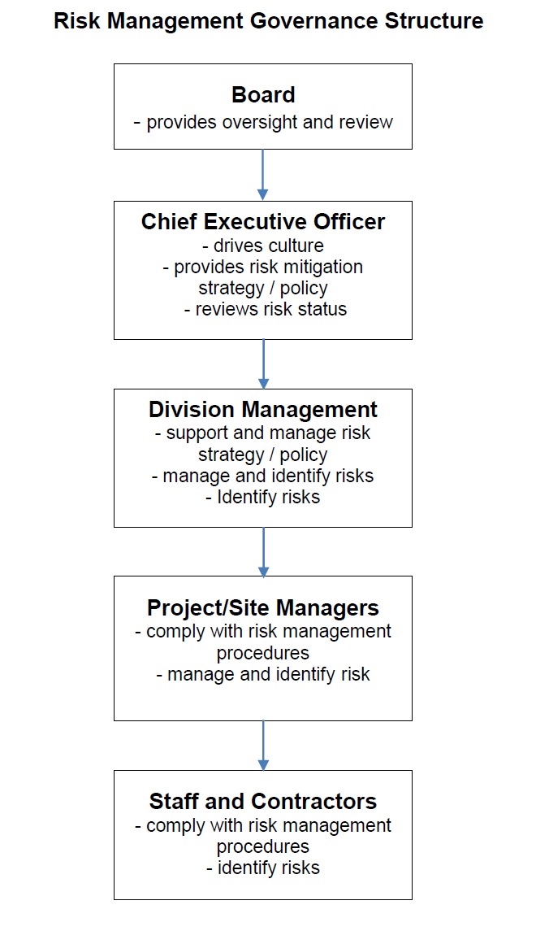
5.0 RISK MONITORING, REVIEW AND REPORTING
Risk control measures shall be monitored and reviewed when the following occurs:
On a periodic basis to ensure they are working correctly.
Activity/tasks reviewed, after any change to workplace layout, equipment, etc.
Following a reported injury or illness has taken place relevant to that activity or process.

Once reviewed, the risk assessment participants and/or employee/contractor(s) may recommend further changes to controls where appropriate.
5.1 Regular Auditing of Risks
Auditing and reporting on progress in the management of risk is a key component in providing assurance on the efficacy of the Fredon Risk Management system. Auditing of risk requires recognition that there are two classes of risk that needs detailed attention, and each needs a different type of attention:
• Extreme / High risks need an investigation to determine why the risk is extreme/high (i.e. of elevated consequences and elevated frequency) and actions available to reduce the risks.
• Risks comprising an elevated consequence (i.e.: Catastrophic or Critical) combined with a low likelihood (i.e., Improbable, Incredible) also need managerial action, to ensure that the likelihood is indeed as low as believed, to ensure the risk is not extreme.

The Responsible Manager for each domain in the Hierarchy of Risk is accountable for performing ongoing reviews that monitor and ensure:
There is sufficient breadth of risks identified for the domain of concern.
Risks are clearly described and continue to be relevant.
Likelihood and severity of consequence ratings remain valid.
Risk controls are still effective and reliable (particularly for high-consequence low-likelihood risks).
Tasks identified to further reduce risks are sufficient for the level of risk and are being performed to time.
The ALARP principle can still be demonstrated.
Confirm that any sub-domains of the domain for which they are the Responsible Manager have an assigned sub-domain Responsible Manager (if not, then they are to formally assign a Responsible Manager).
Extreme and High Risks within any sub-domains of the domain for which they are the Responsible Manager are being formally considered with the sub-domains Responsible Manager.

It is important to provide this evidence of the review from a due diligence perspective, even if it is to only note that no change to the risk has been performed

5.2 Board
The role of the Board is to set the strategic direction of the Corporation, establish performance targets set out in the Statement of Corporate Intent and to monitor the progress in achieving targets. One of the primary objectives of the CEO is to assist the Board in discharging their responsibilities relating to risk management.
5.3 Corporate Risk Workshops
Corporate risk workshops are held annually (typically June) or as required by the CEO. These workshops are attended by the Fredon Executive Team with the aim to:
Review the active list of corporate risks relating to the business of Fredon.
Provide an opportunity to collectively identify any other new risks.
Where applicable, confirm responsibility to a member of the Executive Team as the Risk Owner to identify the required risk treatment plan including the identification of tasks for review with the CEO.

The Corporate Risk Workshop is summarised in a standalone document which captures all the key aspects.
5.4 Quarterly Corporate and CEO Risk Reviews
Quarterly Corporate risk reviews are to be held between the CEO and Divisional managing directors. Unless otherwise required by the CEO, such reviews are to be limited to risks with a rating of Extreme or High and will include the CEO Key Risks. Outcome and date of the review are to be recorded.
5.5 Monthly Administrative (Admin) Reviews
The Administrative Review is a business level review, not an operational review of the project health. It should focus on project status and major issues. Admin Reviews should highlight significant issues and risks, and give management time to initiate corrective action. The review should summarize the project status and major issues. Typical elements include:
Roll-up of monthly project reviews (highlights).
o Overall project health check: safety, quality, finance, workshare.
o Project concerns, issues and risks.
o Action and improvement plans.
Business development opportunities.
Escalation and leveraging of company network.

5.6 Milestone and/or Monthly Project Risk Reviews
Project reviews are critical to project success and risk mitigation. They provide the project team access to seasoned and experienced managers who bring an objective and balanced view to the project team. Fredon requires project reviews for projects as determined (according to the size and complexity), operations and/or maintenance sites on a monthly basis. The level of detail and participants included should again be appropriate for the size and complexity of the project. The expectations of the monthly project reviews are to:
• Ensure customers’ needs are met.
• Ensure Project issues are in control.
• Improve project execution.
• Manage project performance.
• Take ownership and drive outcomes.
• Reduce project write-offs.
• The Utilization of best practices.
• Compliance with company procedures.

5.7 Verifying Effectiveness of Risk Management Process
As part of the quarterly corporate risk review, the CEO and Compliance Manager will undertake a review of the appropriateness, effectiveness, and continuous improvement of the Fredon Risk Management process. The Fredon Board, CEO or HSEQ National Manager may also initiate separate internal and/or external audits of the risk management system as appropriate.
5.8 Risk Management Compliance Records
The Risk Management compliance records will be limited to that held in a Database System. This may include a reference to various risk reports (Project Risk Register, Safety Hazard Logs, Safety Assessment Reports, Project Risk Reports, etc.), review records, and the outcomes of monitoring and audit activities. The Responsible Managers, Risk Owners, Control Owners and Task Owners maintain the information in a Database to enable risk reports and review records; the Fredon National HSEQ Manager is the Custodian of the Database and maintains monitoring and audit records

RISK MATRIX
Once a risk has been identified it must be assessed as to how dangerous it is using the Risk Matrix below. One must ask: how seriously could the business, someone or the environment be affected and how likely is it to occur? Assessing the risk is a process of the following steps:
1. Identifying the most credible consequence – consider the potential seriousness of the outcome. It may range from extreme (e.g. death or permanent disability) to minor (first-aid treatment).
2. Determining the likelihood – estimate the likelihood of the hazard causing the consequence identified. The likelihood may be assessed as almost certain (could happen any time) through to rare (could happen but probably will never).
3. Assessing the risk – using the matrix identifies the risk ranking. This could range from Extreme (25A) to a Low (1R) ranking becoming acceptable. The outcome of this analysis will be a measure of risk for the hazard and will be used to determine the priority assigned to its elimination or control action to eliminate the risk.
4. Risk Control - Appropriate risk control measures shall be determined and implemented to eliminate or minimise each identified risk. All risks shall be eliminated or reduced As Low As is Reasonably Practicable (ALARP) using the Hierarchy of Controls technique below.

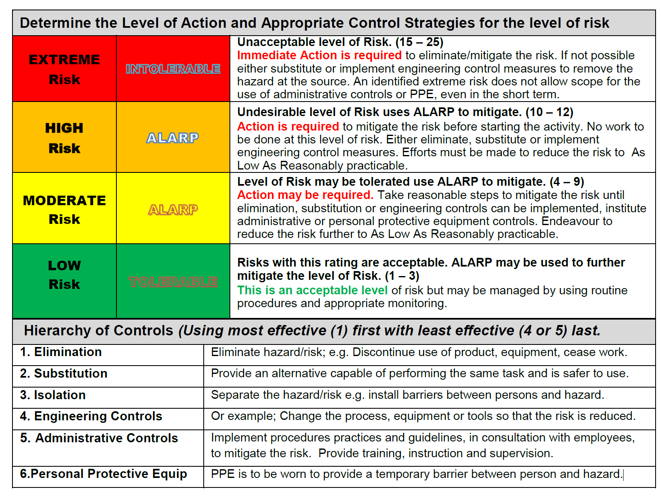

Audit procedure

1.0 PURPOSE AND SCOPE
The purpose of this procedure is to ensure the management system is effectively implemented and is suitable for the business with respect to the customer and regulatory obligations, and that it supports the risk management process and business improvement needs. It describes the planning, executing and reporting of the internal auditing process as well as the monitoring of any actions required. This procedure applies to all Fredon activities including those carried out by Fredon subcontractors.

2.0 DEFINITIONS
HSEQ Health, Safety, Environment and Quality.
Auditee is the organisation, division or location being audited, where organisation relates to a group of people. The people who interact with the auditor are therefore referred to as auditees.
Auditor is a person with competence to conduct an audit.
Internal Audit is where an organisation is performing an audit upon its own systems, procedures, etc., often referred to as a first party audit.
Second-party Audit A second-party audit is when a company performs an audit of a supplier to ensure that they are meeting the Fredon System requirements.
External Audits are conducted by external independent organisations. Such organisations provide certification or registration of conformity with defined requirements (e.g. ISO 9001, AS/NZS 4801, ISO 14001), often referred to as a third-party audit.
Business Management System (BMS) encompassing all business processes including but not limited to the key processes of Health and Safety, Quality and Environment across all facilities and project sites throughout Australia. The Business Management System has been developed in accordance with requirements of the national and international standards. Internal audits on the Business Management system (Functional Audits) will be conducted at a minimum annually.

3.0 PROCEDURE
HSEQ Internal Audits are to assess the ongoing suitability of the Business Management System (BMS) and to ensure compliance with specified requirements such as:
- Customer requirements, e.g. contract, orders, specifications;
- Plans, e.g. strategic, project;
- Legislation and Regulations (e.g. Work Health and Safety, Environmental);
- Quality Management System - Requirements ISO 9001;
- Occupational Health and Safety Management System AS/NZS 4801;
- Environmental management system – Requirements with guidance for use ISO 14001; and
- Risk Management
- Project Management (Design, Procurement, Finance, Scheduling etc)

3.1 Internal Audit Planning
The internal audit strategy is established by the HSEQ National Manager in consultation with operational, customer service and functional managers.
Audits of locations (construction sites and service locations) will be conducted on an as needs basis as determined by the HSEQ Manager / Coordinator or as requested by the National HSEQ Manager, and shall be recorded on a schedule.
The HSEQ Managers / Coordinators are required to develop and manage their schedule based on strategic objectives, risk assessment outputs, analysis of previous audit history and regulatory obligations.
Auditee’s (i.e. Projects, Business Units, Branches etc. personnel) shall be provided with reasonable notice, to confirm audit date, time and location, and be required to ensure that personnel, documents and records are made available. Auditors shall have full access to all of Fredon’s Project records, with strict accountability for confidentiality and safeguarding of records and information. Employees as required shall assist the HSEQ Auditor.

3.2 Audit Scheduling
Audit scheduling will be developed using a risk-based methodology with input from Senior Management to identify and prioritise audit tasks based on a risk assessment. HSEQ Managers /Coordinators are notified of new projects through the online job setup form or appropriate job registers.

The HSEQ Manager / Coordinator will select projects to audit based on assessed level of risk using the Risk Matrix (refer section 4.1), and significance in terms of organisational impact.

3.3 Selection Criteria
The auditor will have full access to all project folders to review project documentation prior to the face to face audit taking place.

The following Audit Tools may be used:

- HSEQ Internal Audit Tool – Project Management - MIF-005
- HSEQ Internal Audit Tool – Site Work - MIF-006
- Functional checklist – See Functional Procedures (Human Resources, Information Technology etc)

Internal audits are undertaken by the HSEQ Coordinator or Manager in accordance with internal audit schedule.
Internal Auditors shall be trained and have no direct responsibility for process or area being audited. Internal audits shall be carried out using an appropriate Internal Audit Tool or as approved by the National HSEQ Manager.

4.0 RISK MANAGEMENT
Through the tender phase to project close out, risks are assessed and mitigated through various risk tools that assists the business with identifying and assessing risks.

When selecting projects to audit, the auditor will look at the risk profile of the project to assess whether or not the project is deemed a high risk or low risk project.

4.1 Risk Matrix
Utilising the Risk Matrix in consultation with the Business Line Manager (or independently if the information is available), for each of the Project Risk Factors allocate a value between one and four and calculate a total Risk Rating for the project.

Project Health Check Risk Matrix
An example of how to apply the risk matrix (See Risk Matrix below):
Greenwich Project
- - Budget $200k = Medium Risk (2)
- - PM Experience = New PM = High Risk (4)
- - Principle Contractor = Fredon is Principal Contractor with 2 subcontractors = Medium/high Risk (3)
- - H&S risk = Site contains asbestos = Medium/high Risk (3)
- - Environmental = Environment (and community) risks (e.g. impacts to flora/fauna/heritage, air, water, land) = Medium/high Risk (3)

i.e. Total Risk Rating = Medium (2 + 4 + 3 + 3 + 3 = 15) 1. Risk Rating:
    - Low - value between 5 & 10
    - Medium – value between 11 & 15
    - High - value between 16 & 20
- Prioritise Project Audits based on Risk Rating.
- Any project having one or more project risk factors scoring a 4 (High Risk) should be considered for an audit even if the calculated Risk Rating is Low or Medium.

Table 1 Auditing risk matrix
Project Risk Factor | 1 (Low Risk) | 2 (Low-Medium  Risk) | 3(Medium-High Risk) | 4 (High Risk)
1-Budget | <$100K | $100K - $500K | $500K - $2M | >$2M
2-PM experience | >10 years project management. | 5-10 years project management. | 1-5 years project management. | First project as PM.
3–Principal  Contractor | Fredon are not  Principal  Contractors | Fredon are Principal Contractors / No subcontractors | Fredon are Principal  Contractors/ with 1 or  2 Subcontractors | Fredon are Principal  Contractors / More than  2 Subcontractors
4-H&S risk | No Site Work | Fredon carrying out site visits and or minimal field work as part of the scope. | Site work with multiple activities also any project involvement with asbestos or Safety in Design element | High risk activities are normally detailed in legislation or have a high fatality rate in industry.
5-  Environmental | Work with no  environmental impact | Site work/Minimal Environmental impact | Environment (and community) risks (e.g. impacts to flora/fauna/heritage, air, water, land) | Fredon is conducting work in environmentally sensitive areas/ Fredon is required to apply for and obtain  environmental permits
Note: Other risk factors should be considered in addition to those listed in the above table where relevant on a project specific basis.
- 20% of all projects with a low risk rating are to be audited
- 50% of all projects with a medium risk rating are to be audited
- 100% of all projects with a high-risk rating are to be audited

5.0 REPORTING
An Audit Report shall be produced for all audits, and will provide a summary and an accurate record of the audit.
A typical report shall include the following:

- References to audit scope;
- Risk rating
- Summary of positive and negative findings.
- Deficiency statements – improvement opportunity, non-conformance etc.;
- Corrective action guidance; and
- Recommendation for improvement.
Findings from audits shall be classified in the Audit Report with the following criteria:

- A Green score is an indication the Auditor believes that the audit meets requirements and will only be issuing the auditee with an Opportunity For Improvement (OFI) if necessary. An (OFI) is an observation of a practice which could be improved to give any health, safety, environmental, quality or financial benefit;
- An Amber score will indicate a Area of Concern (AC) – a AC Identifies a practice that may not fully satisfy the intent of the Fredon Management System and if not addressed may result in a non-conformance;
- A Red score will indicate a Non-Conformance (NC) – A NC Identifies an event or practice that does not conform to the Fredon Management System or Legislative requirements. A Corrective Action request will be raised with a time specified for action.
The audit checklist will be scored with a Green/Amber/Red for each section.
The summary page will contain an overall risk rating for the project, see table below: Table 2 Summary Page risk rating
Risk Rating Legend
 | RED – A ‘real-time’ risk/s which is impacting on Fredon and/or the Customer. Immediate action is required to ensure measures are put in place to mitigate the ongoing risk.
 | AMBER – The review has identified that there is a shortfall/s in the system requirements. However, it is considered that these will not have an immediate impact if action is taken.
 | GREEN – No shortfalls in conformance to system requirements have been identified.  (Opportunities for Improvement may be identified)

Corrective actions identified during the audit process will be captured on either of the following documents and registered on the Corrective Action Register:

- On the Audit Report
- On the Audit Tool itself;
- Action Request Form; or
- Audit Corrective Action Summary MIF-007 (determined by the auditor).

The Auditor must coordinate an independent follow up audit to ensure Corrective Actions or action requests have been implemented and closed out.

The Audit Report shall be distributed by the Auditor to the Project Manager/Customer Manager and all other relevant managers as deemed necessary by the auditor.

6.0 AUDITOR COMPETENCY
Auditors must possess the knowledge, skills and technical proficiency to satisfactorily perform an acceptable and effective audit.
Fredon’s HSEQ Auditors shall be appropriately trained to understand the requirements of ISO AS/NZ 9001:2016 / AS/NZ 4801:2001 / ISO AS/NZ 14001:2016 Management System Standards in relation to the Fredon Audit procedures and be familiar with the process being audited and any associated processes. A register of such auditors shall be accessible to all regions.

The National HSEQ Manager shall maintain a list of qualified, trained and competent auditors and ensure there are sufficient resources to implement the audit schedule. The list shall include their experience, qualifications and certificates.

Internal Auditors training will involve:
- An accredited Internal Audit training course
- On the job training with a competent auditor

Note: Auditors who have not previously conducted audits on their own must work under the supervision of a trained/experienced auditor

7.0 RELATED DOCUMENTS
Non-Conformance Corrective Action Procedure MIP-001
Non-Conformance Corrective Action Register MIF-002
HSEQ Internal Audit Tool – Project Management MIF-005
HSEQ Internal Audit Tool – Site Work MIF-006
Audit Corrective Action Summary MIF-007
Internal Audit Schedule MIF-011
Audit Report Summary MIF-016
8.0 GOVERNANCE

Responsibility
Document Owner | National HSEQ Manager

Revision Control and Change History
Revision No. | Date | Approved by | Amendment
1 | 14/07/2014 | Group Executive Director
2 | 18/08/2015 | Group Executive Director | Update reflects organisational changes
3 | 23/01/2019 | Deputy Chairman | Organisational changes, deletion of Inspection Checklists and the inclusion of a Risk Methodology to selecting projects for auditing.

Appendices
NOTE- TO BE COMPLETED AT COMPLETION OF PLAN

WORK BREAK DOWN STRUCTURE
CARPARK LIGHT INSTALL

ROUGH IN LIGHT WBS 001
WBS

MANAGEMENT WBS 005
FIT OFF
WBS 003
COMMISSIONING WBS 004

DATA ROUGH IN WBS 002

PLANNING WBS 0051
TESTING WBS 0041
LIGHT INSTALL WBS 0031
LIGHTING ROUGH IN WBS 0011

PROJECT ADMIN WBS 0052
ASBUILT DRAWINGS WBS 0042
SENSOR INSTALL WBS 0032
LIGHTING CONTROL ROUGH IN WBS 0012

CLOSING WBS 0055
FIRE RATING WBS 0034
QUAILTY / AUDIT WBS 0054
CONTRACT MANAGEMENT WBS 0053
SWITCHBOARD TERM WBS 0033

WORK BREAK DOWN STRUCTURE
WBS Code | WBS Name | Description
WBS0011 | LIGHTING ROUGH IN | CABLE ROUGH IN
WBS 0012 | LIGHTING CONTROL | CABLE ROUGH IN
WBS0013 | SPARE CODE
WBS 0014 | SPARE CODE
WBS 0015 | SPARE CODE
WBS0021 | SPARE CODE
WBS0022 | SPARE CODE
WBS0023 | SPARE CODE
WBS0024 | SPARE CODE
WBS0025 | SPARE CODE
WBS 0031 | LIGHT INSTALL | ALL CARPARK LIGHTING
WBS 0032 | SENSOR INSTALL | ALL CARPARK SENSORS
WBS 0033 | SWITCHBOARD TERMINATION | COMPLETE SWITCHBOARD
WBS 0034 | FIRE RATING | FIRE RATING BY OTHERS
WBS 0035 | SPARE CODE
WBS0041 | TESTING | ELECTRICAL TESTING
WBS0042 | AS BUILT DRAWINGS | ONSITE DRAWING UPDATE
WBS0043 | SPARE CODE
WBS0044 | SPARE CODE
WBS0045 | SPARE CODE
WBS0051 | PLANNING | MANAGEMENT
WBS0052 | PROJECT ADMIN | MANAGEMENT
WBS0053 | CONTRACT MANAGEMENT | MANAGEMENT
WBS0054 | QUALITY CONTROL | MANAGEMENT
WBS0055 | CLOSING | MANAGEMENT
WBS 0056 | SAFETY | MANAGEMENT

WBS Code | WBS Name | Description
WBS0011 | LIGHTING ROUGH IN | CABLE ROUGH IN
WBS 0012 | LIGHTING CONTROL | CABLE ROUGH IN
WBS0013 | SPARE CODE
WBS 0014 | SPARE CODE
WBS 0015 | SPARE CODE
WBS0021 | SPARE CODE
WBS0022 | SPARE CODE
WBS0023 | SPARE CODE
WBS0024 | SPARE CODE
WBS0025 | SPARE CODE
WBS 0031 | LIGHT INSTALL | ALL CARPARK LIGHTING
WBS 0032 | SENSOR INSTALL | ALL CARPARK SENSORS
WBS 0033 | SWITCHBOARD TERMINATION | COMPLETE SWITCHBOARD
WBS 0034 | FIRE RATING | FIRE RATING BY OTHERS
WBS 0035 | SPARE CODE
WBS0041 | TESTING | ELECTRICAL TESTING
WBS0042 | AS BUILT DRAWINGS | ONSITE DRAWING UPDATE
WBS0043 | SPARE CODE
WBS0044 | SPARE CODE
WBS0045 | SPARE CODE
WBS0051 | PLANNING | MANAGEMENT
WBS0052 | PROJECT ADMIN | MANAGEMENT
WBS0053 | CONTRACT MANAGEMENT | MANAGEMENT
WBS0054 | QUALITY CONTROL | MANAGEMENT
WBS0055 | CLOSING | MANAGEMENT
WBS 0056 | SAFETY | MANAGEMENT

PERT CHART

PROJECT GANNT CHART

HOURS ALLOWED AND WEEKLY LABOUR TRACKING

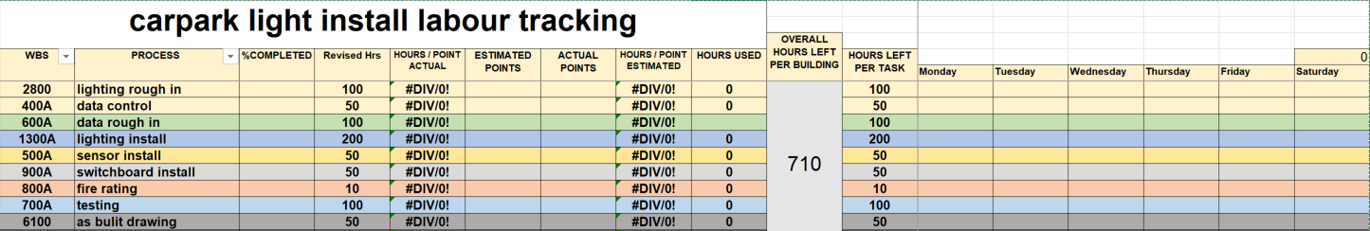
EFFORT AND DURATION OF TASKS

 |  | TASK EFFORT ( HOURS ) |  |  |  | TASK EFFORT (DAYS )
TASK # | TASK DESCRIPTION | TO | TP | TM | TE | TO | TP | TM | TE
 | PHASE #1 - ELECTRICAL ROUGH
 | LIGHTING CABLE ROUGH IN | 160 | 320 | 240 | 220 | 20 | 40 | 30 | 27
 | LIGHTING CONTROL CABLE ROUGH IN | 80 | 100 | 90 | 85 | 10 | 12 | 11 | 10
 | PHASE #2 – DATA ROUGH
 | DATA ROUGH IN | 60 | 80 | 60 | 60 | 7 | 10 | 7 | 7
 | PHASE #3- FIT OFF
 | LIGHT INSTALL | 160 | 320 | 260 | 260 | 20 | 40 | 32 | 32
 | SENSOR INSTALL | 100 | 120 | 100 | 100 | 12 | 15 | 12 | 12
 | SWITCHBOARD TERMINATION | 30 | 60 | 40 | 50 | 3 | 8 | 5 | 7
 | FIRE RATING | 20 | 24 | 15 | 20 | 3 | 3 | 2 | 3
 | PHASE #4 – COMMISSIONING
 | TESTING | 30 | 60 | 40 | 45 | 3 | 8 | 5 | 6
 | AS BUILT DRAWING | 30 | 40 | 30 | 30 | 6 | 5 | 3 | 3
 | PHASE #5 - MANAGEMENT
 | PLANNING | 200 | 300 | 150 | 180 | 25 | 38 | 18 | 22
 | PROJECT ADMIN | 200 | 300 | 150 | 150 | 25 | 38 | 18 | 28
 | CONTRACT MANAGEMENT | 200 | 250 | 150 | 150 | 25 | 32 | 18 | 18
 | QUALITY AUDIT | 100 | 150 | 100 | 100 | 12 | 18 | 12 | 12
 | CLOSING | 100 | 150 | 100 | 100 | 12 | 18 | 12 | 12

NOTES;

TO – THE OPTIMISTIC TIME
TM – THE MOST LIKELY TIME
TP – THE PESIMISTICT TIME
TE – THE EXPECTED TIME

TASK DEPENDENCY WORKSHEET

TASK # | TASK DESCRIPTION | DURATION (DAYS) | PREDECESSORS |  |  |  |  | CONSTRAINTS
TASK # | TASK DESCRIPTION | DURATION (DAYS) | FS | SS | FF | SF | LAG | TYPE | DATE
 | PHASE #1 - ELECTRICAL ROUGH
 | LIGHTING CABLE ROUGH IN | 27 | start | 4
 | LIGHTING CONTROL CABLE ROUGH IN | 10
 | PHASE #2 – DATA ROUGH
 | DATA ROUGH IN | 7 | start | 1
 | PHASE #3- FIT OFF
 | LIGHT INSTALL | 32 |  | 8
 | SENSOR INSTALL | 12 |  | 7
 | SWITCHBOARD TERMINATION | 7 | 7,8 |  |  |  |  | All cabling must be completed prior to commencement
 | FIRE RATING | 3 | 9 |  |  |  |  | All cabling must be completed prior to commencement
 | PHASE #4 - COMMISSIONING
 | TESTING | 6 | 9
 | AS BUILT DRAWING | 3 | 12
 | PHASE #5 - MANAGEMENT
 | PLANNING | 22 |  |  |  |  |  | Must run for entire  duration of this phase
 | PROJECT ADMIN | 28 |  |  |  |  |  | Must run for entire  duration of this phase
 | CONTRACT MANAGEMENT | 18 |  |  |  |  |  | Must run for entire  duration of this phase
 | QUALITY AUDIT | 12 |  |  |  |  |  | Must run for entire  duration of this phase
 | CLOSING | 12

NOTES;
FS = Finish to start – This task commences following the end of the listed tasks.
SS = Start to start – This task starts at the same time as the listed tasks.
FF = Finish to finish – This task finishes at the same time as the listed tasks.
SF – Start to finish – This task finishes at the same time the listed tasks commence.
Lag = number of days between tasks.
As soon as possible – Finish the task as soon as possible based on the constraints of predecessors. This is the most common selection.
As late as possible – Finish this task as late as possible based on the constraints of later activities.
Finish no earlier than – Finish as soon as possible, but no earlier than the specified date.
Finish no later than – Finish as soon as possible, but not later than the specified date.
Must finish on – Task finishes on the specified date.
Must start on – Task commences on the specified date.
Start no earlier than – Task commences on or after the specified date.
Start no later than – Task commences on or before the specified date.
Summary Costing per Phase
 | LABOUR COST |  | PROCUMENT COST | PURCHASE COST | TOTAL COST
PROJECT PHASE DESCRIPTION | LABOUR | COST | PROCUMENT COST | PURCHASE COST | TOTAL COST
PHASE #1 - ELECTRICAL ROUGH
LIGHTING CABLE ROUGH IN | 27 | $10800 | $15,000 |  | $25800
LIGHTING CONTROL CABLE ROUGH IN | 10 | $4000 | $2000 |  | $6000
PHASE #2 – DATA ROUGH
DATA ROUGH IN | 7 | $2800 | $4000 |  | $6800
PHASE #3- FIT OFF
LIGHT INSTALL | 32 | $12800 | $10000 |  | $22800
SENSOR INSTALL | 12 | $4800 | $2000 |  | $6800
SWITCHBOARD TERMINATION | 7 | $2800 |  |  | $2800
FIRE RATING | 3 | $1200 |  |  | $1200
PHASE #4 - COMMISSIONING
TESTING | 6 | $2400 |  |  | $2400
AS BUILT DRAWING | 3 | $1200 |  |  | $1200
PHASE #5 - MANAGEMENT
PLANNING | 22 | $8800 |  |  | $8800
PROJECT ADMIN | 28 | $11200 |  |  | $11200
CONTRACT MANAGEMENT | 18 | $7200 |  |  | $7200
QUALITY AUDIT | 12 | $4800 |  |  | $4800
CLOSING | 12 | $4800 |  |  | $4800

NOTES;
LABOUR RATES ARE CALCULATED AT 1 MAN HOUR EQUALS $50 WORKING AN 8 HOUR DAY.

Detailed Costing per Task
TASK NUMBER | TASK DESCRIPTION | TIME |  |  |  |  | PROCUREMENT |  | PURCHASES |  | TOTAL COST
TASK NUMBER | TASK DESCRIPTION | TE | WHO | # | HOURLEY RATE | LABOUR COST | DESCRIPTION | COST | DESCRIPTION | COST
 | PHASE #1 - ELECTRICAL ROUGH |  | TM
 | LIGHTING CABLE ROUGH IN |  | TM |  | 50/H | $10800 | cable | $15,000 |  |  | $25800
 | LIGHTING CONTROL CABLE ROUGH IN |  | TM |  | 50/H | $4000 | Control cable | $2000 |  |  | $6000
 | PHASE #2 – DATA ROUGH
 | DATA ROUGH IN |  | TM |  | 50/H | $2800 | Data cable | $4000 |  |  | $6800
 | PHASE #3- FIT OFF |  | TM |  | 50/H
 | LIGHT INSTALL |  | TM |  | 50/H | $12800 | fittings | $10000 |  |  | $22800
 | SENSOR INSTALL |  | TM |  | 50/H | $4800 | fittings | $2000 |  |  | $6800
 | SWITCHBOARD TERMINATION |  | TM |  | 50/H | $2800 |  |  |  |  | $2800
 | FIRE RATING |  | SC |  | 40/H | $1200 |  |  |  |  | $1200
 | PHASE #4 - COMMISSIONING
 | TESTING |  | TM/S |  | 50/H 60/H | $2400 |  |  |  |  | $2400
 | AS BUILT DRAWING |  | S |  | 60/H | $1200 |  |  |  |  | $1200
 | PHASE #5 - MANAGEMENT
 | PLANNING |  | PM |  | 75/H | $8800 |  |  |  |  | $8800
 | PROJECT ADMIN |  | PM |  | 75/H | $11200 |  |  |  |  | $11200
 | CONTRACT MANAGEMENT |  | PM |  | 75/H | $7200 |  |  |  |  | $7200
 | QUALITY AUDIT |  | S/PM |  | 60/H 75/H | $4800 |  |  |  |  | $4800
 | CLOSING |  | PM |  | 75/H | $4800 |  |  |  |  | $4800

KEY;
PM=PROJECT MANAGER
S=SUPERVISOR
TM=TRADESMAN
SC=SUBCONTRACTOR

S-CURVE GRAPH

WEEK START | WEEKLY CASHFLOW ( BASLINE ) | WEEKLY CASHFLOW | CUMULAIVE EXPENSES (BASLINE) | CUMULATIVE EXPENSES

27/07

03/08

10/08

17/08

24/08

1/09

08/09

15/09

22/09

29/09

06/10

13/10

20/10

27/10

03/11

10/11

17/11

24/11

PROJECT CASHFLOW

Organisational chart

Responsibility Assignment Matrix

Project Name: Carpark light install
Prepared by: Justin Thomsen
Date: 07/09/2020
PERSON  PHASE | Justin Thomsen (project manager) | Forman | Tradesman #1 | Tradesman #2 | Tradesman #3
Rough in | A,S | A,R | P,I | P | P
Fit off | A,S | A,R | P,I | P | P
commissioning | A,S | A,R | P,I | P | P
closing | A,S | R,S | I | I | I

P = Participant A = Accountable R = Review Required
I = Input Required S = Sign-off Required

Staffing Management Plan
Project Name: Carpark light install
Prepared by: Justin Thomsen
Date: 19/10/20
Project Manager: Justin Thomsen
Staffing Management Plan Number: 001
Project Team Role: Installation of an integrated lighting solution to carpark
Approach to Identifying Human Resource Needs:
- company employees will be utilised on this project with the addition of apprentices from labour hire company.
Approach to Determining Timing Needs for Adding and Removing Project Personnel:
- Will be based on project phase completion. Labour will be assessed prior to any withdrawal from site. Project hours will be measured and compared to productivity prior to labour being removed from site. The same will be applied for the accusation of labour. The workforce will only increase with the growth of work areas.

Human Resource Needs:
Description | Estimated Number | Projected Commencement | Projected Completion
Supervisor / Forman | 2
tradesman | 4

Projected Approach and Schedule for Updating Staffing Management Plan:
Triggering Event | Expected Timing
- Annual leave of management team member | 1 week

Resource Requirements Worksheet

Work Breakdown Structure Element |  | Type of Resource Required: |  | Quantity | Involve Staff Acquisition? (Notes) |  | Involve Procurement? (Notes)
WBS0011 |  | General tradesman + apprentice |  | 2
WBS 0012 |  | General tradesman + apprentice |  | 2
WBS 0031 |  | General tradesman + apprentice |  | 2
WBS 0032 |  | General tradesman |  | 1
WBS 0033 |  | Experienced tradesman |  | 1
WBS 0034 |  | subcontractor |  | 1
WBS0041 |  | Experienced tradesman |  | 1
WBS0042 |  | Forman |  | 1
WBS0051 |  | Project manager |  | 1
WBS0052 |  | Project manager |  | 1
WBS0053 |  | Project manager |  | 1
WBS0054 |  | Project manager |  | 1
WBS0055 |  | Project manager |  | 1
WBS 0056 |  | Safety manager |  | 1

Resource Pool Description
Project Name: carpark lighting upgrade
PROJECT PERIODS (Months)
(Shade in periods of resource availability)
Resource # | Needed Resources | Jul | Aug | Sep | Oct | Nov | Dec |  | Jan | Feb | Mar
1 | Project director
2 | Project manager |  |  |  |  |  | A.L. |  | A. L
3 | Project manager (future)
4 | Procurement manager
5 | Site supervisor
6 | Site supervisor (future)
7 | Site Forman
8 | Site Forman
9 | Tradesman | 1 | 1 | 1 | 2 | 2 | 4 |  | 4 | 2 | 1
Remaining Resource Issues: Apprentices will be Hired and returned as required capped at 2
A.L.- annual leave

Statement of Work
Project Name:
Prepared by:
Date:
Vendor Name:
Description of Deliverables or Procurement Items (in as much detail as needed to accurately define the proposed work):

Required Timeline and Milestone Dates:

Collateral Services Required of Vendor (e.g., performance reporting, post-project operational support, etc.):

Cost Parameters:

Subcontractor Post Work Performance Evaluation
Location: NSW ACT QLD WA VIC NT
Division: Electrical Air Technology Security
Department: Construction CSG Service Infrastructure
Project Name and Location: Job Number:
Subcontractor Name:
This form is to be completed by the Project Manager once the subcontractor has terminated his contract and is off site.
Assessment legend:
A Frequently exceeded HSEQ requirements C Almost met HSEQ requirements
B Satisfied HSEQ requirements D Below HSEQ requirements
Assessment elements |  | A | B | C | D
Were the stated policies and objectives achieved on the project?
Did all personnel actively demonstrate their defined responsibilities?
Did the HSE Coordinator perform the function in accordance with requirements of the HSEQ MP?
Were the competencies of all employees commensurate with the tasks required to be performed?
Were all employees qualified / certified for the appropriate positions?
Were all employees inducted: 1) by the client; 2) by the company; 3) by the Subcontractor?
Were employees suitably train to enable appropriate skills / knowledge to be applied to the task?
Was the Subcontractors safety performance in line with the requirements of:
1) the Subcontractors Health, Safety and Environmental Management Plan
2) the company Health, Safety and Environmental Management Plan
Were necessary actions to correct identified non compliances within an acceptable time frame taken?
Was active involvement demonstrated by the Subcontractor management?
Was t

he attitude and commitment shown by all Subcontractor employees to an acceptable level?
Was the Subcontractor proactive in identifying and correcting safety trends, issues/concerns?
Did the Subcontractor introduce new initiatives to improve safety performance?
Did the Subcontractor self-manage the safety function or was there reliance on The company for support?
Did the Subcontractor take all necessary steps to identify the hazards and associated risks for the work scope activities?
Were SWMS submitted on time, in accordance with legislation and appropriate to the task?
Were SWMS reasonably complied with?
Did the Subcontractor communicate effectively?
1) Internally (pre-starts, SWMS, safety reps – Via Lucidity etc.)
2) to The company (accident/near miss general issues/concerns – Via Lucidity)
Did the condition and maintenance of plant and equipment meet The company and statutory requirements?
Were all environmental requirements set down by The company and relevant statutory provisions met?
Was it recognised by The company that the Subcontractor met all statutory requirements, Australian and accepted industry standards?
STATISTICAL PERFORMANCE FOR THE PROJECT
Man hours Exposure: | First Aid Injuries (FAI):
Lost Time Injuries (LTI): | Lost Time Injury Frequency Rate (LTIFR):
Medical Treatment Injuries MTI): | Total Injury Frequency Rate (TIFR):
REVIEW COMMENTS AND RECOMMENDATIONS
Is the Subcontractor suitable for re engagement for the scope of work performed? Yes No
What improvements are necessary for re engagement:
Additional Comments:
Evaluated by Name: Position: Date:
Signoff/Approval Name: Position: Date:

Employee Assessment Review Form
EMPLOYEE NAME:
REPORTING PERIOD:
DATE:

DETAILS OF ASSESSMENT AS FOLLOWS

1 – Poor. 2 – Needs Improvement. 3 – Good. 4 – Above Average. 5 – Excellent.
PRODUCTION 1 -5 :
SKILLS 1 -5:
QUALITY 1 -5:
CONDUCT 1 -5:
DISCIPLINARY NOTICES 1 -5
1 notice is 3. 2 is 5:
WH&S 1 -5:
SCORING / MARKING TOTALS: | / 30
QUANTITY OF ASSESSMENTS:

EMPLOYEE COMMENTS

EMPLOYEE SIGNATURE:

MANAGERS COMMENTS

TOOL BOX MEETING
Location: NSW ACT QLD WA VIC NT NZ
Division: Electrical Air Technology Security
Department: Construction CSG Service Infrastructure
Project Name & Location: Job Number:
Date: Time:
Presented by: |  | Actions required, by and date
1. Safety Moment
From now onwards a monthly award will be handed out to the employee who is
being enthusiastic, has a positive attitude towards management and client, educating
Apprentices, and for above average work.
2. New Health and Safety issues (any Alerts)
Weather- no work will be undertaken with bad weather.
3. Opening meeting and Status of Items from previous meeting
4. Recent Incidents, Hazards and Near Misses
Site procedures due to bad weather-Site inspection by HSE committee , condition of
Site than assessed and agreement made as to any areas that can be worked in and
Dewater is to occur in other areas where possible. Site work force are to demobilise in
Lunch area until safety committee deems job safe to open.
5. Customer Health and Safety Items
Mates in construction for mental health issues, speaker to be arranged to come to site
To talk to workers about metal health in construction
6. New Health, Safety or Environmental Topic
7. Training requirements
Training offered for all. Courses in management, health and safety, electrical testing
And commissioning
8. Equipment and PPE Issues (in good order, any new requirements etc.)
PPE required at all times. Gloves , glasses and long sleeve shirts, and helmets
9. Environmental Concerns
Areas to be cleaned after every day’s work
10. Other Items
Energy super fund to come to site and speak to workers. To be programed for near
Weeks.
Site BBQ to be held every Friday.
Attendees Name | Signature
The meeting closed at: am/pm
Supervisor Name: Signature:

Procurement Process Flow Chart

The purpose of this Flow Chart is to assist staff in the task of procuring goods and/or services from Suppliers and/or Sub-Contractors. It should be read in conjunction with Purchasing Procedure

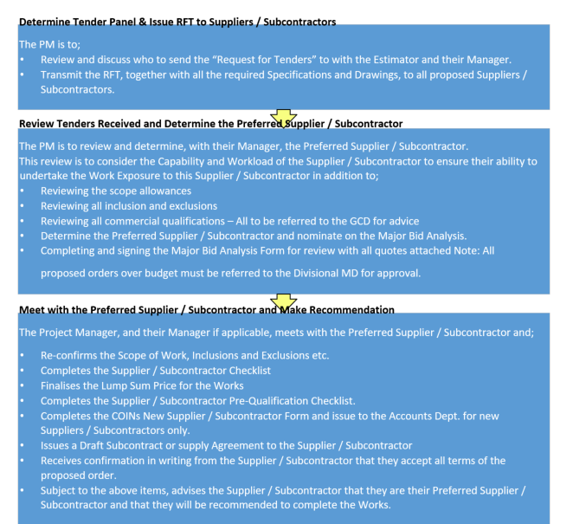
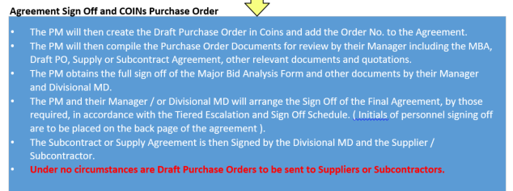
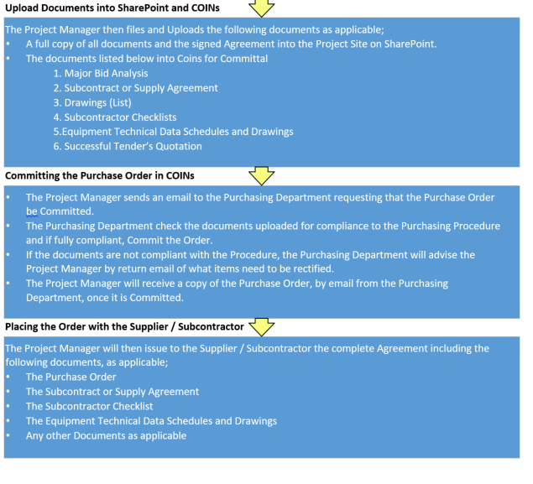

PROCUREMENT SCHEDULE

 | Procurement savings / losses |  |  |  | Procurement phase
STATUS | TENDER PRICE | PO VALUE | SAVINGS OR LOSS $ | WEEKS |  |  | TOTAL LEAD TIME | DATE REQUIRED ON SITE | LATEST DATE REQUIRED TO PLACE ORDER | DATE OF CONFIRMED ORDER | CURRENT ESTIMATED DELIVERY DATE | STATUS OF DELIVERY TO SITE (+ / - DAY) | COMMENTS
 |  |  |  | PROPOSED SUPPLIER | MANUFACTURE TIME PERIOD | CUSTOMS CLEARENCE

Order amendment form
Project name: variation number:
Project address: purchase order:
Project number: date:
SUPPLIER CONTACT DETAILS
Phone: supplier name:
Email: contact person:
Coins line | Original quantity | WBS | Original order description | status | Previous total quantity ordered | Revised total quantity required | Variation quantity | Original unit price | Current unit price | This variation total

Variation register
Trade | Variation description | Reference | Date submitted | Author | Cost submitted | Status | Details of direction |  |  |  | Date work commenced | Date work completed | Client reference | Date claimed | Comments
 |  |  |  |  |  |  | Date of direction | Form of direction | Who gave direction | Who received direction

Procurement Management Planning Checklist
Project Name:
Prepared by: Justin Thomsen
Date: 05/11/2020
Identify types of contracts being used:
Independent estimates required? | Yes | No
If Yes, who will prepare?

By when?

Actions that Project Management Team can take independent of Procurement Department:

Source of standardized procurement documents, if needed:

How will multiple providers be managed?

How will you coordinate Procurement with the following aspects of the project?
Scheduling

Performance Reporting

Human Resources

Other

Project Risk Categorisation Worksheet
Project Name: Install lighting to basement carpark
Prepared by: Justin Thomsen
Date: 07/09/20
NOTE: List all identified project risks within each category. Retain this information for reference throughout the risk management process:
Technical, quality, or performance risks— New lighting control system, Design not keeping up with the construction of the project, new standards change due in the middle of the project, delivery of product to project is time consuming and to be done after normal business hours.
Project-management risks— high level skills shortage at the time, untrained labour being high apprentice to tradesman ratio
Organisational risks—Other company project run concurrently may require labour at middle of project, using new manufacturers and associated problems.
External risks—possible union issue that may close the project leading to disruption in program, poor weather may halt production at the beginning of the project.

RISK REGISTER COVER SHEET

Scope/Location/Project: | Basement carpark
Date of Original Assessment: | 09/09/20
Original Risk Assessment Team: | Justin Thomsen
Last Reviewed By: | Justin Thomsen
Date Last reviewed: | 09/09/20
Comments/notes: | First review
 | Undesirable outcome | How can this happen | Existing controls | probability | Consequence of occurrence | Recommended risk control measures | Residual Risk rating | Person responsible | Action Required
construction risk review
1 | Union issue | Union member disagrees with management decision | Hire union delegate | M | disruption to labour | To have good relation with union members and consult decisions | L | Forman | Monitor all union related movements
2 | New technology | New technology developed for project, computer model | Certified from manufacture | l | Problems commissioning | Have onsite discussion with manufacture with demonstration | L | Project manager | Keep up to date with all new technology
3 | weather | Poor weather during construction | Accelerate program | m | disruption to labour | Increase labour only when project enclosed from weather | L | Project manager | Encourage builder to understand the importance of keeping the project enclosed and completing any external works rapidly
4 | deliveries | Poor management of delivery instructions | Coordination of wholesaler and use of onsite plant | m | Slow movement of product to work face | Coordination meetings. Motivated storeman. Coordinate with other trades | L | Forman | Strict monitoring and review required
5 | Site lift loss of time | Unscheduled Repair to lift | Encourage workforce to have products brought to level by storeman | m | Lost time with worker looking for products | Encourage worker to think of task and plan to have gear delivered to level before required | L | Forman/ tradesman | Understand lift movements, know when repairs/services are occurring as per the daily pre start meeting
6 | Lack of knowledge | Untrained labour | Workforce training | l | Stop works, possible reworks | Standards training | L | Forman
7

Risk Brainstorming Session Worksheet
Project Name: light install to basement carpark
Prepared by: Justin Thomsen
Date: 27/09/20
Session Facilitator: Justin Thomsen
Title/Position: project manager
Participating Group:
- Project team
Location: on site office

Identified Risk | Probability of Occurrence | Potential Impact | Inherent Risk Rating | Controls to be used on risk | Residual Risk Rating | Proposed Actions | Identified by Whom? | Who is responsible?
deliveries | High | high | medium | coordination | medium | Coordinate delivers | PM | PM
Union disruption | Medium | High | Medium | Communication with union members | medium | Weekly scheduled meetings | PM | PM
Technology | Medium | Medium | Medium | Training for new computer model software | Low | Immediate training for all project team | PM | Project team
Weather | Medium | High | Medium | Control workforce when cleaning of wet areas to speed up the return to work | low | Supply workers with cleaning materials | Forman | forman
Standards | Low | High | Low | Ensure workforce are up-to-date with current laws and standards | low | Supply workers with access to standards library and standards training. | Forman | Project manager

Risk Rating Table
Level | Descriptor | Description
E | Extreme | Immediate action required, senior management involvement necessary now.
H | High | Action is required in the short term, strategies to treat the risk must be identified.
M | Moderate | Responses need to be identified and the risks monitored.
L | Low | Monitor by routine procedures.

Likelihood | Consequence
Likelihood | Insignificant  1 | Minor  2 | Moderate  3 | Major  4 | Catastrophic  5
A  (Almost certain) | High | High | Extreme | Extreme | Extreme
B  (Likely) | Moderate | High | High | Extreme | Extreme
C  (Moderate) | Low | Moderate | High | Extreme | Extreme
D  (Unlikely) | Low | Low | Moderate | High | Extreme
E  (Rare) | Low | Low | Moderate | High | High

Hierarchy of Controls
Elimination | Most effective.
Substitution | Use something else or a less hazardous process.
Isolation | Use barriers to shield or isolate the hazard.
Engineering Control | Design and install equipment to counteract the hazard.
Administrative Control | Arrange work to reduce exposure to the hazard and provide training and assessment.
Personal Protective Equipment | Wear PPE while exposed to the hazard – Least effective.

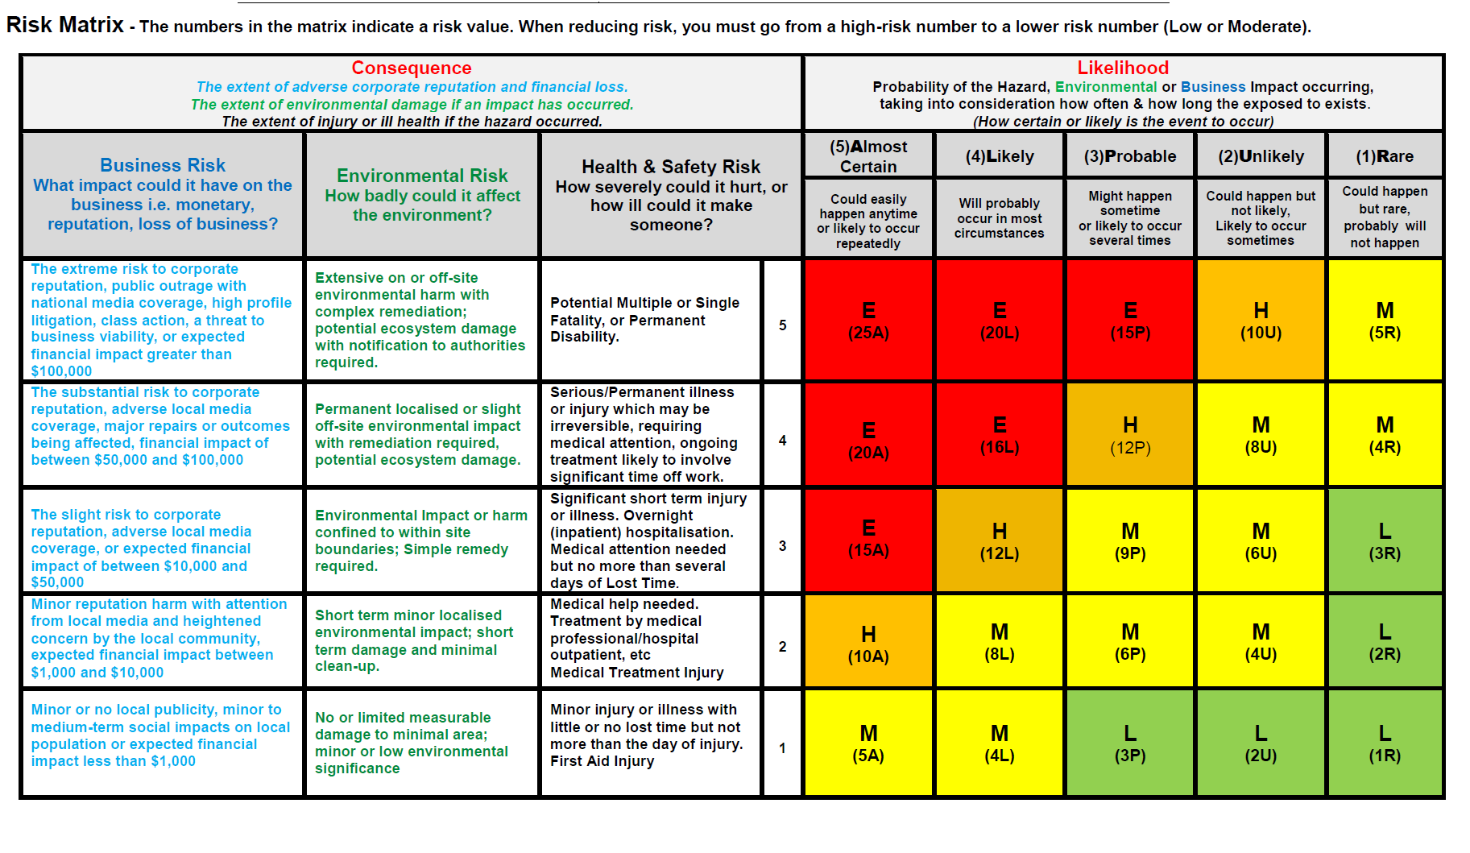

Assumption log
Issue # | Date/time raised | Description | Who raised | Action History | Status open/closed

CHANGE REGISTER
Request No. | Date | Originator | Brief Description | Responsibility | Timeframe | Completed
001 | 01/09/20 | J. Thomsen | 6 Light fittings added | Tradesman #1 | 2 days | Yes; 12/09
002 | 07/09/20 | J. Thomsen | Sensors moved to sense car movements better | Tradesman #3 | 4 days | Yes; 15/09
003 | 15/10/20 | J>Thomsen | Cable tray path moved. Lights to be relocated because of move | Tradesman #1 | 2 days

Stakeholder Analysis
Project Stakeholder | Specific Information Needs | Best Source of Information Needed | Planned Method of Delivery | Timing Considerations
Project manager | Progress on all  tasks. Any issues | Site supervisor and  contractors.  Project  administrator. | Phone calls and emails.  Meetings and email. | All communication to  be immediate as  occurs.  As needed.
Project director | Completion of  stages, any major  issues. All changes | Project manager. | Regular meetings  and e-mails as  needed. | Urgent issues  immediate otherwise at  weekly meetings
Site supervisor | Tasks and quality  standards. | Project manager. | Daily task e-mails  and phone calls as  needed. | All tasks to be  communicated well in  advance to allow for  site planning.
subcontractors | Contract with  specifications.  Specific tasks and  onsite decisions as  needed. | Project manager  Site supervisor | Meeting.  Verbal | Prior to  commencement of  project and when  changes have been  approved.  Tasks and decisions  communicated as  needed.
Wholesaler  (day to day ) | Changes to project and procurement list | Project manager. | Email with attachment  phone | As change requests  are signed off.
Wholesaler  (lighting) | Changes to project and procurement list | Project manager | Email with attachment  phone | As change requests  are signed off.  Procurement schedule to be completed
Manufacture  (switchboards ) | Changes to project and procurement list | Project manager. | Email with attachment | As change requests  are signed off.
builder | Reporting  requirements. | Project manager. | Meetings and emails. | As needed.

Communication Requirements Analysis Worksheet
Project Name: carpark light installs
General Area of Communication Need | Information Needed, and for Whom? | Optimum Information  Format(s) | How is this communication essential to success of project? | Decision to implement  Yes/No
Project Organisation Relationships
Stakeholder Responsibility Relationships
Sponsor Relationships
Logistics of Project Staffing by Location
External: Media
External: Community
External: Government, Regulatory Agencies

Communications Plan Template
Project Name: carpark light installs
Prepared by: Justin Thomsen
Date: 11/10/20
Key Stakeholders (Distribution Schedule) | Stakeholder Issues | Key Messages to Communicate | Communication Methods to be Used  (written, one-on-one, electronic, meetings, etc.) | Description of Specific Communications (content, format, level of detail, etc.) | Timing Issues  (see also Bar Chart, Project Schedule) | Other
Project manager | Items left out of the tender budget | Onsite Productivity to project team | Email, team meetings. | Formal.  Between project team and client | Urgent issues. Weekly team meeting
Client / builder | Labour resourcing | Project timeline | Email, site meetings, phone | Formal  Between project team only | Urgent issues. Weekly team meeting
tradesman | Completing task in given time | safety | Paper drawings, verbal instruction | Verbal  Direction from Forman | daily workforce coordination meeting
Forman | Properly supervising workforce and improving productivity | Safe work practices  Workforce productivity | Email, paper drawings, verbal, team meetings | Verbal and formal  Project team and workforce | Weekly team meeting, daily workforce coordination meeting
Wholesaler  (day to day) | Up-to-date procurement plan, easy to understand | Pricing and  delivery | Email, site meetings, phone | Formal between procurement team and project manager | Weekly review of procurement plan
Wholesaler  (lighting) | Up-to-date procurement plan, easy to understand | Pricing and  delivery | Email, site meetings, phone | Formal between procurement team and project manager | Weekly review of procurement plan
Manufacture  (switchboards) | Up-to-date procurement plan, easy to understand | Pricing and  delivery | Email, site meetings, phone | Formal between procurement team and project manager | Weekly review of procurement plan

Project Change Request
Project Name: carpark light installs
Prepared by: Justin Thomsen
Date: 11/10/20
Changes are being made to the following:
 |  | Project Charter |  |  |  |  | Project Management Approach
 |  | Scope Statement |  |  |  |  | Work Breakdown Structure
 |  | Performance Measurement Baselines |  |  |  |  | Major Milestones and Target Dates
 |  | Key Staff |  |  |  |  | Risk Management Plan
 |  | Scope Management Plan |  |  |  |  | Schedule Management Plan
x |  | Cost Management Plan |  |  |  |  | Quality Management Plan
 |  | Staffing Management Plan |  |  |  |  | Communications Management Plan
 |  | Risk Response Plan |  |  | x |  | Procurement Management Plan
Type of change:
 | Scope |  |  | Time |  | x |  | Cost |  | Quality
 | Communications |  |  | Resources |  |  |  | Risk | x | Procurement
Areas impacted:
 | Scope |  |  | Time |  | x |  | Cost |  | Quality
 | Communications |  |  | Resources |  |  |  | Risk | x | Procurement
Changes to Supporting Detail? (explain):
6 light fitting added ( see change register)
Description of Changes being made:
1. Re-design more fittings added
Risk Issues Prompting Changes: no risk
Corrective Action: lights to be ordered
2.
Risk Issues Prompting Changes:
Corrective Action:

Stakeholders being notified:
Name/Title: project manager | Signature: | Date:
Name/Title: wholesaler | Signature: | Date:

Final project checklist
Project No. :
Project Manager :
Customer:
Date:

Objectives | Document Number | Complete | Comments
- Has Practical Completion date been confirmed? Log Date
- Has all plant and equipment been returned?
- Has all hire equipment been returned?
- Have we returned left over material for a credit?
- Has the project reconciliation form been requested from Accounts receivable to balance the project?
- Has the PC Bank Guarantee return been requested?
- Has the PC Bank Guarantee been received?
- Has the Bank Guarantee Register been updated?
- Have forms been submitted for:
- Emergency Lights
- AS3000
- Fire Rating
- Are all ITC’s and ITP’s uploaded to the job file?
- Are all test results uploaded to the job file?
- Are manuals completed?
- Are soft copies of As Builts & Manuals loaded to the job file?
- Has client training been carried out and signed off by attendees?
- Is the PC defect list closed out?
- Has the final contract figure been signed off?
- Is the final claim in alignment with the sign off submitted?
- Has the DLP Handover form been issued to CSG?
- Have CSG had a project walk through
- Have hard copies of all documents been archived?
General Observations
[Replace this text with information regarding the overall readiness of project initiation. This must be filled-in by the Facilitator.]
Actions
ID | Action Item | Assigned To | Due By
 |  |  | [mm/dd/yyyy]
 |  |  | [mm/dd/yyyy]
 |  |  | [mm/dd/yyyy]

Comments
[Replace this text with comments.]

Project Manager: ______________________________________ Date: ___/___/____

Department Manager: ________________________________ Date: ___/___/____

Lessons Learned Documentation
Project Name: lighting install to basement carpark
Prepared by: Justin Thomsen
Date: 28/09/2020
Lesson Learned Number: 001
Lesson Learned Proposed Name: difficulty installing light fitting with manufactures install techniques
Project Team Role:
Process Group:* |  |  |  | Initiating |  | Planning |  | Executing |  |  |  | Controlling |  |  |  | Closing
Specific Project Management Process Being Used: Audit / quality assurance
Specific Practice, Tool or Technique Being Used:
What was the action undertaken? Review install technique and fixings for light fittings
What was the result? Light taking long time to install due to poor manufacture of fitting
What might have been a more preferred result? More expensive fitting with more fixing options
What might have created the more preferred result? More time spent researching during procurement
What is the specific Lesson Learned?
How could one identify a similar situation in the future? Recognise fitting type
What behaviour is recommended for the future? Replace fitting with another
Where and how can this knowledge be used later in this current project? All lights have been procured, information to be used on next project
Where and how can this knowledge be used in a future project? Procurement
Who should be informed about this Lesson Learned? (check one)
 |  | Executive(s) |  |  |  | Project Manager(s) |  |  |  | Project Team(s) |  |  |  |  |  |  | All Staff
 |  | Other:
How should this Lesson Learned be disseminated? (check all that apply)
 |  | e-mail |  |  |  | Intranet/Web site |  |  |  | Tip Sheet/FAQ |  |  |  |  |  |  |  | Library
 |  | Other:
Have you attached reference(s), example(s) and/or additional material(s)? |  |  |  |  |  |  |  |  |  |  |  |  |  | yes |  |  |  |  |  | no
Name(s) of attachment(s):
1.
2.

Lessons Learned Documentation (2)
Project Name: lighting install to basement carpark
Prepared by: Justin Thomsen
Date: 03/11/20
Lesson Learned Number: 002
Lesson Learned Proposed Name: manage procurement
Project Team Role:
Process Group:* |  |  |  | Initiating |  | Planning |  | Executing |  |  |  | Controlling |  |  |  | Closing
Specific Project Management Process Being Used: procurement management
Specific Practice, Tool or Technique Being Used:
What was the action undertaken? yes
What was the result? Positive. By the use of procurement schedule planning was able to make delivery to site more predictable and reliable.
What might have been a more preferred result? End result will be modelled to use on future projects
What might have created the more preferred result?
What is the specific Lesson Learned? Documentation of procurement in all areas, having suppliers understand what is required and having correct feedback documented correctly
How could one identify a similar situation in the future?
What behaviour is recommended for the future? Instigate this same procedure on future projects
Where and how can this knowledge be used later in this current project? Close out of project
Where and how can this knowledge be used in a future project? Procurement management
Who should be informed about this Lesson Learned? (check one)
 |  | Executive(s) |  |  |  | Project Manager(s) |  |  |  | Project Team(s) |  |  |  |  |  |  | All Staff
 |  | Other: other project teams
How should this Lesson Learned be disseminated? (check all that apply)
 |  | e-mail |  |  |  | Intranet/Web site |  |  |  | Tip Sheet/FAQ |  |  |  |  |  |  |  | Library
 |  | Other:
Have you attached reference(s), example(s) and/or additional material(s)? |  |  |  |  |  |  |  |  |  |  |  |  |  | yes |  |  |  |  |  | no
Name(s) of attachment(s):
1. see procurement documentation in this plan
2.

LESSONS LEARNED
Project Name:
Department:
Scope of Works:
PROJECT MANAGEMENT
Focus Area | Low -------------- High |  |  |  |  | Successes | Shortcomings | Recommended Solutions
Focus Area | 1 | 2 | 3 | 4 | 5 | Successes | Shortcomings | Recommended Solutions
Project Planning
Resource Management
Risk Management
Change Control
Procurement
Budget Management
Quality Control
Project Status Reports
Vendor Selection
LESSONS LEARNED

OVERALL PROJECT SUMMARY
Focus Area | Low -------------- High |  |  |  |  | Successes | Shortcomings | Recommended Solutions
Focus Area | 1 | 2 | 3 | 4 | 5 | Successes | Shortcomings | Recommended Solutions
Customer Satisfaction
Technical Success
Quality Product
Product/Service Acceptance
Project On Time
Project Within Budget
Project Objectives Met
Business Objectives Met

Title: | AMS for Electrical Services | Ref. No: |  | Start Date:
Subcontractor: |  | Area/Building: |  | Work-lot Ref:

ITEM NO | OPERATIONAL ACTIVITIES | VERIFICATION |  |  |  | INSPECTION KEY (sign-off) |  |  |  |  |  |  |  | COMPLETE | N/A | RECORDS & COMMENTS
ITEM NO | OPERATIONAL ACTIVITIES |  |  |  |  | FRE |  | JH |  | CON |  | Other |  | COMPLETE | N/A | RECORDS & COMMENTS
ITEM NO | OPERATIONAL ACTIVITIES | Reference | Acceptance  Criteria | Inspection/ Method | Frequency | Key | By: | Key | By: | Key | By: | Key | By: | COMPLETE | N/A | RECORDS & COMMENTS
1.0 | PRELIMINARY – Mandatory to all activities
1.1 | Review Activity Method Statement (AMS) | JH SQERM Procedures | AMS document authorised prior to commencement of works | Review and conduct workshop to all subcontractor’s involved | Once | HP | ALL | HP | ALL |  |  |  |  | ☐ | ☐
1.2 | Permits  - Hot Works  - Isolation Permits | Permits: | Documents authorised for use | Approval | At the beginning of the Task | R | SF | HP | SF |  |  |  |  | ☐ | ☐
1.3 | Material Submission:  - All cables (CSA, Types, Core)  - All cable support systems (Catenary, Conduit, Cable Trays, Fixings)  - DB’s & Consolidation Points | - Latest IFC Drawings  - AS/NZS 3000  -AS/NZS 3008 | Material certificates of conformity  Material data sheets | Once per source - review and approve prior to use | Once per source | R | SF | R | SPE | R | ENG |  |  | ☐ | ☐ | - Manufacturer’s data sheets and compliance certification submitted to JHG
2.0 | In-slab Services
2.1 | Works applicable to this lot (tick):  ☐ Earthing  ☐ Conduit Installation |  |  |  |  |  |  |  |  |  |  |  |  | ☐ | ☐
2.2 | Earthing & Lightning Protection  - Clamp all Wet area’s  - Denso tape around earthing joints  - Slab exit to be co-ordinated between tilt panel joins  - Test all points for continuity before backfill or pour | -IFC Drawings | - Visually accepted and verified  - AS3000 | Visual Inspection  Testing |  | WP | SF | WP | SPE |  |  |  |  | ☐ | ☐ | Continuity test as part of FRE-PRO-SRV-CD-CHK-00_001
2.3 | Conduit Installation:  - Ensure correct depth of cover  - Check correct bedding material is used  - Route for segregation from other services  - Complete the conduit installation checklist  - Fix conduit to structural steel with appropriate materials.  - Complete trench marker tape installation per electrical service  - Cap conduit end off  - Seal Penetrations | - IFC drawings- IFC Drawings  - AS 2032  - AS 2648  - AS 3000 | - Visually accepted and verified | Visual Inspection | Per service | WP | SF | WP | SPE |  |  |  |  | ☐ | ☐ | Complete checklist for In-Ground Services FRE-PRO-SRV-CHK-00_001
3.0 | Cable Support System
3.1 | Works applicable to this lot (tick):  ☐ Catenary  ☐ Conduits (Power, lights, switches)  ☐ Cable Tray  ☐ Ducting | - IFC Drawings | Identify the service covered within this ITP | Review | Per Building | S | SF | S | SF |  |  |  |  | ☐ | ☐
3.2 | Set-out  - Properly locate supports to grid lines  - Co-ordinate setting-out with the works of other trades | - IFC Drawings | - Measure and set-out as per design | Visual | Per Support | WP | SF | WP | SF |  |  |  |  | ☐ | ☐
3.3 | Cable Supports  - Manufacturer specifications support distances  - Cable tray manufacturer specifications and fixings for bends and rises  - Install catenary wire to manufacturers specifications and tensioned  - Conduits fixed to wall  - Seismic restraints  - Co-ordinate with other Sub Contractors  - Spare Capacity | - IFC drawings  - tray specs  - Cat wire Specs | - Visually accepted and verified | Visual inspection | Per Building | WP | SF | WP | SF | R | ENG |  |  | ☐ | ☐ | Complete  Cable Tray  FRE-PRO-SRV-CD-CHK-00_004  Conduit & Catenary  FRE-PRO-SRV-CD-CHK-00_003
3.4 | Pre-Cast Conduits (Volumetric Cell)  - Secure conduits, bends and boxes to steel  - Seal boxes with foam and tape | - IFC drawings. | - Visually accepted and verified | Visual Inspection | Per Cell Unit | HP | SF | WP | SPE |  |  | HP | SAB  MMM  CIV | ☐ | ☐ | Complete Volumetric Cell Services Checklist FRE-PRO-SRV-CD-CHK-00_002
4.0 | Electrical Installation
4.1 | Works applicable to this lot (tick):  ☐ Power and lighting  ☐ Sub-Mains  ☐ Terminations  ☐ Switchboards | IFC Drawings | Identify the service covered within this ITP | Review | Per Building | S | SF | S | SF |  |  |  |  | ☐ | ☐
4.2 | Rough In  - Correct size/amount of cores  - Clearly Labelled at all cable ends  - Tape all loops and tails  - Twist and tape multi-core cables  - Neatly tied on Cable Tray and Catenary  - BMS Wiring | - IFC Drawings  - JHA  - AS 3000 | - Visually accepted and verified | Visual Inspection | Per Circuit | WP | SF | WP | SPE |  |  |  |  | ☐ | ☐ | Complete FRE-PRO-ELEC-CD-CHK-00_001  Cable Installation  - Cable Hauling FRE-PRO-SRV-CD-CHK-00_005[A]
4.3 | Inspection Points  - Complete Fire rate penetration register and Certify  - Complete Cable Rough-In Installation Checklist | IFC Drawings | - Visually Accepted | Visual inspection | Per service | HP | SF | WP | SPE | WP | ENG |  |  | ☐ | ☐ | Completed FRE-PRO-ELEC-CD-CHK-00_001  - Photos  - Passive Fire Penetration Register FRE-PRO-SRV-CD-REG-00_001  - Engineers Report if available
4.4 | Fit-Off  - Co-ordinate with other sub-contractors  - Terminate Bakelite  - Correct Light type  - Correct Bakelite for admin & Inmate areas  - Vandal proof seal and fixings for in-mate areas.  - Terminate Light Switches & Sensors | IFC Drawings  - AS/NZS 3000  - AS/NZS 3798 | - Measure and set-out as per RCP  - Visually accepted and verified | - Visual Inspection  - Testing | Per Service | WP | SF | WP | SPE | WP |  |  |  | ☐ | ☐ | -Complete FRE-PRO-ELEC-CD-CHK-00_002
4.5 | Emergency Lighting  - Attach Barcode  - Correct vandal/security type  - Correct evacuation position and direction | - IFC Drawings  - AS3000  - AS2293 | -Visually Accepted | - Visual Inspection  - Testing | Per Service | WP | SF | WP | SPE | WP |  |  |  | ☐ | ☐ | Complete Emergency Light Fittings Register -FRE-PRO-ELEC-CD-CHK-00_006
4.6 | UPS  - Lugged and Crimped  - Labelled and Isolated correctly  - Seismic Restrained | IFC Shop Drawings  - AS/NZS 3000  - AS/NZS 3798 | -Visually Accepted | - Visual Inspection  - Testing | Per System | WP | SF | WP | SPE | WP |  |  |  | ☐ | ☐
4.7 | Switchboard  - Stabilise and support Switchboards to wall/floor  - Re-label all circuits and DB schedule  - Metering and control cables to have LV insulation or segregation  - Lugs Crimped and Bolts Tensioned and marked  - PFC Installed  -Building Entry conduits and penetrations sealed  - Seismic Restrained Equipment | - AS/NZS 3000  -Detail design Schematics  - AS3439 | - Visually accepted and verified | - Visual Inspection  - Testing | Per Switchboard | S | SF | S | SF |  |  |  |  | ☐ | ☐ | Complete The company - DB Schedule
5.0 | Lightning and Earthing
 | ☐ Cable Tray  ☐ Communications Rooms  ☐ Lightning Points  ☐ Stud Walls | - AS/NZS 3000 | - Visually accepted and verified | - Visual Inspection |  | S | SF | S | SF |  |  |  |  | ☐ | ☐
 | - Earthing Cable tray  - Crimped & Lugged  - Bolted | - AS/NZS 3000 | - Visually accepted and verified | - Visual Inspection | Per Service | S | SF | S | SF |  |  |  |  | ☐ | ☐
 | - Earthing Communications Rack  - Crimped & Lugged  - Bolted | - AS/NZS 3000 | - Visually accepted and verified | - Visual Inspection | Per Comms Room | S | SF | S | SF |  |  |  |  | ☐ | ☐
 | - Lightning Point  - Crimped & Lugged  - Bolted | -IFC Drawings | - Visually accepted and verified | - Visual Inspection | Per Building | S | SF | S | SF |  |  |  |  | ☐ | ☐
6.0 | Completion
6.1 | Submit Red-line mark-ups | As Built | - Visually accepted and verified | - Visual Inspection | Upon completion | R | SF | R | SF |  |  |  |  | ☐ | ☐

Completed by:  SUBCONTRACTOR – | Name: |  | Received & Verified by: | Name:
Completed by:  SUBCONTRACTOR – | Signature: |  | Received & Verified by: | Signature:
Completed by:  SUBCONTRACTOR – | Date: |  | Received & Verified by: | Date:
FINAL VERIFICATION:
This is to confirm that all above activity checkpoints are acceptably completed and all signed checklist(s) to close this worklot are provided to JH.

Electrical Services Certificate of Testing & Compliance
Job Name |  | Carpark light install
Job Address |  | Brisbane
Area of Works |  | Basement carpark
Description of Works |  | Installation of lights and managed lighting system
Compliance Reference Documentation |  | The installation has been completed in accordance with:  - engineering design and construction issued documentation supply and installation quality management documentation  - Construction issue documentation  - Electrical engineering scope and drawings  - Relevant Australian Standards  - AS/NZS 3000:2018 Australian Wiring Rules  - AS/NZS 3017:2007 Electrical Installation Testing  - AS/NZS 3008.1:2017 Electrical Installations, Selection of Cables  - AS/NZS 3760:2010 In-Service Inspection and Testing  - AS/NZS 2293.1:2018 Emergency Escape Lighting and Exits for Buildings: System Design, Installation and Operation.  - AS/NZS 2293.2:2019 Emergency Escape Lighting and Exits for Buildings: Routine Service and Maintenance.  - AS/NZS 2293.3:2018 Emergency Escape Lighting and Exits for Buildings: Emergency Luminaires and Exit Signs  - Emergency and Exit Lighting Testing Referenced to QDC MP6.1  - AS/NZS: Update to include relevant documentation and standards
As Built Plans |  | Refer to drawing register attached
Date of Completion
I certify that the installation, to the extent it is affected by the electrical work, has been tested to ensure that it is electrically safe and is in accordance with the requirements of the wiring rules and any other standard applying under the Electrical Safety Regulation 2013 to the electrical installation.

Project Manager |  |  | Qualified Technical Person

Electrical Services As Built Documentation and drawing register

Drawing Number | Drawing Title

 |  | Internal Audit Schedule
Location: □ NSW □ ACT □ QLD □ WA □ VIC Division: □ Electrical □ AIR □ Technology □ Security |  |  |  |  |  |  |  |  |  |  | Department: □ Construction
 |  |  |  |  |  |  |  |  |  |  | Key: | x | Planned
 |  |  |  |  |  |  |  |  |  |  |  | √ | Completed
 |  |  |  |  |  |  |  |  |  |  |  |  | High Priority
Last updated: dd/mm/yyyy |  |  |  |  |  |  |  |  |  |  |  | x | Re-scheduled
 |  |  |  |  |  |  |  |  |  |  |  | x | Cancelled
System Internal Audits
HSEQ Management System Element | Audit Frequency | Jan-13 | Feb-13 | Mar-13 | Apr-13 | May-13 | Jun-13 | Jul-13 |  | Aug-13 | Sep-13 | Oct-13 | Nov-13 | Dec-13
01. Policy and HSEQ Management System | 12 mths
02. HSE Planning and Risk Management | 6 mths
03. Administration and Payroll | 3 mths
04. Human Resources, Competency and Training | 3 mths
05. Consultation and Communication | 3 mths
06. Document and Records Management | 3 mths
07. Purchasing | 3 mths
08. Engineering and Design | 3 mths
09. Operational Control (Const & Services) | 2 mths
10. Emergency Management | 6 mths
11. Incident Management | 4 mths
12. Health, Wellbeing, Safety and Environment | 2 mths
13. Performance Monitoring | 9 mths
14. System Audit | 9 mths
15. Corrective Action | 6 mths
16. Management Review | 12 mths

Project Status Report Template
Project Name: carpark light installs
Prepared by: Justin Thomsen
Date: 11/10/20
Status of Project Relative to Project Objectives:
Scope (On scope? If off scope, how serious?): currently running as per scope plan
Schedule (On schedule? Ahead or behind by how much, etc.): currently running as per builders GANNT plan
Cost (On budget? Under or over by how much, etc.): under budget as predicted at this point in the project.
Quality: Quality forms are attached to plan and currently being completed on site
Communications: all communication is being upheld between the builder and, client and subcontractors
HR: no reasons for employment at moment
Risk: risk is low, light fittings onsite at the wholesaler awaiting delivery to site
Procurement: all fittings accounted for and at wholesaler
Integration:
Progress Report: (what is completed, what is in process, key changes made, when and why, etc.)
All fitting additions accounted for and document. Fit out is at %75 and on target to be completed early than programmed

Forecasting: (estimate of future project status and progress)

Forecast to come in on time and under budget
Other issues or comments:

Issue: | Who Will Address:
Union interference | Project manager and union delegate
Project Report Submitted to:
Product Non-Conformance Report
Location: NSW ACT QLD WA VIC NT NZ
Division: Electrical Air Technology Security
Department: Construction CSG Service Infrastructure
Section A Details of product non-conformance (Initiator to complete)
Project Name and Location: Job Number:
Supplier:
Order Number:
Date:
Description of Issue: (Attach copies of related documents if applicable)
Is this issue the cause of a customer complaint? |  |  | Yes No
Is this Variation? |  |  | Yes No |  | Variation No
Was the issue due to
Design/Error Change | Manufacturing Error |  |  | Drawing Error |  |  |  | Transport Damage
Faulty Installation | Faulty Commissioning |  |  | Fault in Procedure |  |  |  | Procedure not followed
Not yet determined | Operational activity |  |  | Audit/Inspection |  |  |  | Other (describe)
Section B Action
Actual or proposed action to be taken in response to issue
Return to supplier |  | Regrate for alternative use |  |  |  | Other
Repair |  | Scrap
Repair/Rectification/Other (Attach additional sheet with sketch or mark-up drawing if necessary)
Initiator: Signature: Date:
Has the issue been rectified? Yes No Accepted by: Date:
Does this repair or action require change to drawings or manual? Yes No
Section C Preventive Action
Is there any action that could be taken to prevent the above product non-conformance reoccurring? Yes No
Suggested action:
Initiator: Signature: Date:

Formal Acceptance and Closure Template
Project Name: carpark light install
Prepared by: Justin Thomsen
Date:11/10/20
Name of Client or Sponsor:
Statement of Formal Acceptance:
The undersigned formally accept as complete the above-identified project, and do hereby state that this project, project phase, or major deliverable meets or exceeds agreed-upon performance standards for scope, quality, schedule, and cost, and state that we have seen documentation that all relevant legal and regulatory requirements have been met or exceeded.

Additional Remarks:

Accepted by (name of client, sponsor, or other official) | Date
Accepted by (name of client, sponsor, or other official) | Date
Accepted by (name of client, sponsor, or other official) | Date
Signed form distributed to:
Stakeholder name | Date
Stakeholder name | Date
Stakeholder name | Date

Quality Audit Template
Project Name: lighting install to basement carpark
Prepared by: Justin Thomsen
Date: 28/09/20
Project Manager: Justin Thomsen
Project Phase: lighting fit off | Overall Project Status:
Audit Date: 28/09/2020 | Audit Number: 001 |  | Audit Leader: Justin Thomsen
Audit Team: tradesman and apprentice
Goal(s) of This Specific Audit: To gauge the percentage of completed works in the fit out phase

Audit of Management of Project:
1. Are correct and in date drawings being worked from |  | Assessment: satisfactory | Comment: All drawings on site match to date drawings on drawing register.
2. Are ITC’s being completed as work is finished |  | Assessment: satisfactory | Comment: ITC are being completed as cables are being completed and fittings are being installed.
3. Are all works installed as per manufactures guidelines |  | Assessment: satisfactory | Comment: all lighting is being installed with correct fixings as per manufactures guidelines
4. are company Safe work method statements being adhered to |  | Assessment: not satisfactory | Comment: work equipment not up to standard. Ladders found in unsatisfactory condition.
5. Are workers working independently and efficiently |  | Assessment: not satisfactory | Comment: noticed excessive talking with not enough work completed
Overall Assessment of Management of Project: All work completed to date has been catalogued on as built drawings with company quality assurance paperwork also completed. Tasks are being managed correctly and information is getting to the workface in an appropriate enough time as to not delay work.
Recommended Action(s)/Lessons Learned Regarding Management of the Project:
1. Safety audit of project required. All tools and plant to be checked for their suitability to the task.
2. Rotate workers, present team are not efficient.
3.
Audit of the Product of the Project:
1.light fittings |  | Assessment: average | Comment: some fittings difficult to install.
2. light sensor |  | Assessment: average | Comment: require additional sensors from original estimates
3. (required product characteristic #3) |  | Assessment: | Comment:
4. (required product characteristic #4) |  | Assessment: | Comment:
n. (required product characteristic #n) |  | Assessment: | Comment:
Overall Assessment about the Product of the Project: More time required to investigate product prior to project commencement. Procurement needs to understand the efficiency loss when a cheaper product is bought and the potential time loss when installing.

Recommended Action(s)/Lessons Learned Regarding the Product of the Project:
1. more research required at procurement stage. Attempt to fit off before purchase.
2.
3.
Additional Audit Comments:
1.
2.
3.
Have you attached additional material(s)? |  |  |  |  |  | yes |  | no
Name(s) of attachment(s):
1.
2.
Audit Report Submitted To: project management team. |  |  |  | Date: 28/09/2020

