Summative Assessment: Section C
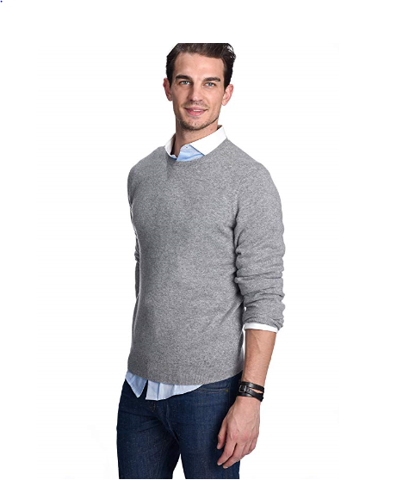
Callous Clothing State Cashmere Men's 100% Pure Cashmere Jumper Long Sleeve Pullover Crew Neck Sweater
- 100% Genuine 2-ply Inner Mongolian Cashmere
- Ribbed Crew Neck, cuffs and hem. Superior softness with easy fit comfort
- 100% Mongolian Cashmere
- Dry clean or Hand wash cold, dry flat.
- ST3612
- Super versatile; Light weight; Relax fit. Classical design. Wearing with shirt shows formal for working, and wearing with jeans shows leisure at home and party.
- Densely knitted with the finest and long staple cashmere which provides best anti-pilling performance
- Model Measurements: height: 6'2"/ waist: 32". Model is wearing size: Large.

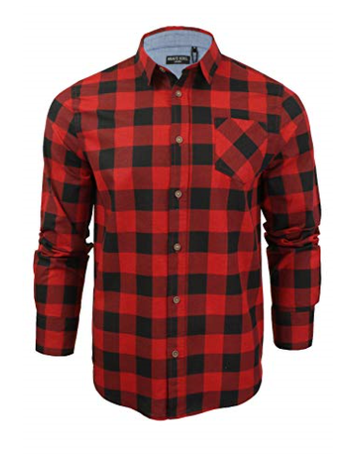

Callous Clothing Brave Soul Men's Tame Casual Shirt
- Heavy brushed checked shirt
- 100% Cotton
- Machine wash - Cold (30° max)
- Fastening: Buttoned
- Collar Style: Classic
- Regular Fit
- Long Sleeve
- MSH-69TAME

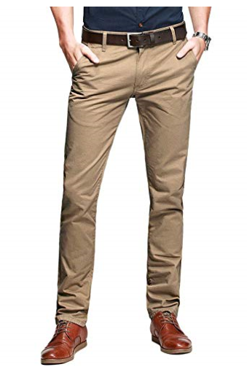
Callous Clothing Mens Casual Slim-Tapered Flat-Front Trousers Khaki
- Breathable chino pants, as they are slim fit trousers, may slight tight when first time wear, please choose one size larger than you usualy wear if prefer more room
- Fleece lined are now available for cold weather, Ideal for casual & formal wear
- 100% Cotton
- Fastening: Zip
- Casual
- Slim
- R8-01-Khaki-33
- 2 front slash pockets, 2 back pockets
- Slim fit style/ Hand/Machine cold wash separately
- Kind Notice: belt not included, shipping time: 1-3days fulfilled by Amazon,5-12 fulfilled by Seller

