BSBWRT301
Write simple documents
Learner Guide



BSBWRT301
Write simple documents

Table of Contents

Table of Contents 2
Unit of Competency 5
Performance Criteria 6
Foundation Skills 7
Assessment Requirements 8
Housekeeping Items 9
Objectives 9
1. Plan document 10
1.1 – Determine audience and purpose for the document 11
Learning Task One 15
Activity 1.1 16
1.2 – Determine the format and structure 17
Format 17
Structure 22
Hyperlink 24
Learning Task Two 25
Activity 1.2 26
1.3 – Establish key points for inclusion 27
Inclusion of Graphics and visuals 27
ClipArt 28
Picture 28
Charts 29
SmartArt 29
Shapes 29
Learning Task Three 30
Activity 1.3 32
1.4 – Identify organisational requirements 33
Organisational requirements 34
Learning Task Four 38
Activity 1.4 39
1.5 – Establish method of communication 40
Learning Task Five 42
Activity 1.5 45
1.6 – Establish means of communication 46
Spread sheets 46
Word processing 46
Database 47
Email and internet programs 47
Learning Task Six 49
Activity 1.6 (1.1 – 1.6) Mini Project 50
2. Draft document 51
2.1 – Develop draft document to communicate key points 52
Learning Task Seven 55
Activity 2.1 56
2.2 – Obtain and include any additional information that may be required 57
Learning Task Eight 58
Activity 2.2 59
3. Review document 60
3.1 – Check draft for suitability of tone for audience, purpose, format and communication style 61
Learning Task Nine 65
Activity 3.1 67
3.2 – Check draft for readability, grammar, spelling, and sentence and paragraph construction 68
3.3 – Check draft for sequencing and structure 68
3.4 – Check draft to ensure it meets organisational requirements 68
3.5 – Ensure draft is proofread, where appropriate, by supervisor or colleague 68
Readability 68
Grammar 68
Spelling 69
Sentence 71
Paragraph Construction 71
Check draft for sequencing and structure 3.3 71
Learning Task Ten 74
Activity 3.2 – 3.5 75
4. Write final document 76
4.1 – Make and proofread necessary changes 77
Learning Task Eleven 78
Activity 4.1 79
4.2 – Ensure document is sent to intended recipient 80
Learning Task Twelve 82
4.3 – File copy of document in accordance with organisational policies and procedures 83
Learning Task Thirteen 85
Activity 4.2 – 4.3 86
Skills and Knowledge Activity 87
Major Activity – An opportunity to revise the unit 88
Appendices 90
Appendix One 90
Appendix Two 92

Unit of Competency

Application

This unit describes the skills and knowledge required to plan, draft and finalise a basic document.

It applies to individuals who apply a broad range of competencies in various work contexts and may exercise some discretion and judgement to produce a range of workplace documentation.

No licensing, legislative, regulatory or certification requirements apply to this unit at the time of publication.

Unit Sector

Communication – Writing

Performance Criteria
Element  Elements describe the essential outcomes. | Performance Criteria  Performance criteria describe the performance needed to demonstrate achievement of the element.
- Plan document | - Determine audience and purpose for the document  - Determine the format and structure  - Establish key points for inclusion  - Identify organisational requirements  - Establish method of communication  - Establish means of communication
- Draft document | - Develop draft document to communicate key points  - Obtain and include any additional information that is required
- Review document | - Check draft for suitability of tone for audience, purpose, format and communication style  - Check draft for readability, grammar, spelling, and sentence and paragraph construction  - Check draft for sequencing and structure  - Check draft to ensure it meets organisational requirements  - Ensure draft is proofread, where appropriate, by supervisor or colleague
- Write final document | - Make and proofread necessary changes  - Ensure document is sent to intended recipient  - File copy of document in accordance with organisational policies and procedures

Foundation Skills
This section describes language, literacy, numeracy and employment skills incorporated in the performance criteria that are required for competent performance.

Skill | Performance  Criteria | Description
Reading | 1.1-1.3, 3.1-3.4, 4.1 | - Recognises and interprets a variety of text to determine and confirm task requirements  - Proofreads documents checking for grammar, spelling, structure, and suitability of style and format for audience
Writing | 2.1, 2.2, 3.1-3.5, 4.1 | - Produces and edits basic documents, according to organisational requirements, for a given audience and purpose
Oral Communication | 2.2, 3.5 | - Uses listening and questioning skills to seek additional information or confirmation of task completion
Navigate the world of work | 1.4, 3.4, 4.3 | - Understands and complies with organisational policies and procedures
Interact with others | 2.2, 3.5 | - Follows accepted communication practices and protocols when seeking information or feedback from others
Get the work done | 1.1-1.6, 2.1, 2.2, 3.4, 3.5, 4.1-4.3 | - Takes responsibility for planning, sequencing and prioritising tasks to achieve required outcomes  - Uses the main features and functions of digital tools to complete work tasks

Assessment Requirements
Performance Evidence

Evidence of the ability to:

- Plan, draft and finalise three different simple documents that accurately convey the required basic information in a format suitable for the intended audience and in accordance with organisational policies and procedures for document production.

Note: If a specific volume or frequency is not stated, then evidence must be provided at least once.

Knowledge Evidence

To complete the unit requirements safely and effectively, the individual must:

- Identify the process for checking basic grammar, spelling and punctuation
- Describe different communication methods
- Describe how audience, purpose and method of communication influence the tone of a document.

Assessment Conditions

Assessment must be conducted in a safe environment where evidence gathered demonstrates consistent performance of typical activities experienced in the communication – writing field of work and include access to:

- Office equipment and resources to assist in document production
- Organisational policies and procedures
- Examples of documents to review.

Assessors must satisfy NVR/AQTF assessor requirements.

Links

Companion volumes available from the IBSA website: http://www.ibsa.org.au/companion_volumes

Housekeeping Items
Your trainer will inform you of the following:
- Where the toilets and fire exits are located, what the emergency procedures are and where the breakout and refreshment areas are.
- Any rules, for example asking that all mobile phones are set to silent and of any security issues they need to be aware of.
- What times the breaks will be held and what the smoking policy is.
- That this is an interactive course and you should ask questions.
- That to get the most out of this workshop, we must all work together, listen to each other, explore new ideas, and make mistakes. After all, that’s how we learn.
- Ground rules for participation:
  - Smile
  - Support and encourage other participants
  - When someone is contributing everyone else is quiet
  - Be patient with others who may not be grasping the ideas
  - Be on time
  - Focus discussion on the topic
  - Speak to the trainer if you have any concerns

Objectives
- Discover how to plan document
- Know how to draft document
- Learn how to review document
- Understand how to write final document
- Gain skills and knowledge required for this unit

1. Plan document

1.1 Determine audience and purpose for the document
1.2 Determine the format and structure
1.3 Establish key points for inclusion
1.4 Identify organisational requirements
1.5 Establish method of communication
1.6 Establish means of communication


1.1 – Determine audience and purpose for the document

When you write a document or even choose the software that you are going to use, it is important that you take the time to consider who your audience is and the purpose of the document. Your organisations procedures will help you to make your choice. Organisational procedures are put in place to make sure that you consider the audience and the purpose of the document that you are writing.
For example when you write a report for your manager, you will provide more information in a report for them to make a decision or to inform them of your findings. However, when you present information for your workgroup, you need to consider their level of language and their ability to understand the information. In this case, you may want to use a program that allows you to present information to the workgroup in a manner that is easier to read.
This means that you need to consider who your audience is. Organisational requirements include what the formatting of the document should take and the other is the amount of information that you are able to supply your audience with. The level of information will vary according to the type of audience you are communicating to and the purpose of the document.
The audience is the person who you are writing to. The audience may include:
- Internal and external customers – An internal customer is someone who works for the organisation. This is your manager, your supervisor and your workgroup. An external customer is anyone who does not work for your organisation. This includes your supplier, any OHS/WHS consultants or specialists who are going to assist you or run an investigation with a hazard or risk in the work place.
This also includes the inspector who may be allocated by your State/Territory Regulator to investigate an accident or incident in your workplace. A customer is someone who enters your workplace. They may not buy anything, but they observe your operations and form opinions about your operations and your product. I

- Recipient/s who receive a copy for information – There will also be times in which you will need to send information to more than one person. For example when you send an email to an external customer (Appendix Number Two),
  - They will be the main recipient, which is to.
  - Anyone who requests a copy of the report or information will be CC which means carbon copy.
  - There is also an option to send the information to someone who does not want others to know that they received the information. This is BCC which means blind carbon copy.

When a recipient asks for a copy of an email, make sure that they are allowed to have that access to the information.
- Primary recipient/s of the communication – The primary recipient is the main person who the communication is to, such as in the example of the email above. When you send information, it is essential that you communicate in the manner that they prefer. The primary recipient is the one that must receive the information.
This means that when you send a communication or communicate information you must consider the purpose of the communication and how they would like or need the information communicated.
The purpose of a communication will determine what information is sent, the type of information sent and how it is formatted. This means that when you put information together to communicate to another party, you need to consider the purpose of the information. The purpose of the information being communicated may include:
- Clarification of issues – A hazard has been identified in the workplace. When a worker completed the accident/incident report, they may not have been clear in the information provided. A team member or someone involved in the reporting or investigation of the event may ask a question to make sure that they clearly understand the report.
Clarification is used to make sure that the information that they have received is correct. Information is important to an organisation because decisions are made on the answers that you provide them with.

- Communication about meetings or events – An organisation will have standard protocols for communicating information. Make sure that you are aware of the preferred method of communicating events and situations. This will be discussed in more detail within this learner guide.
- Information – Make sure that you are clear on the information that you need to communicate. When you know the purchase of the communication, you will be able to plan the way in which it is communicated and how it is communicated.
- Minutes/outcomes of meetings – Minutes to meetings may need to be required. They are a record of decisions:
  - Who did attended and who did not attend a meeting
  - What decisions were made
  - What was discussed during the meeting
  - The decisions made
  - Who has been allocated tasks to perform before a certain time and date; and
  - When the next meeting shall be held
Your organisation will usually have a template for the presentation of information from meetings. This information will usually include your legislative requirements and who can obtain access to the information.
- Request for information, advice or assistance – When you do not have sufficient information, you may be required to follow up and ask for information. For example, when you communicate with your workgroup, you may discuss an issue personally with a team member. Conversely if you have required information from your supervisor, you may email them so that you can have a response in writing and a record of the communication. Emails also allow your supervisor to access the information and give the appropriate attention to your question.

- Statements of fact – At times, you may need information of fact. Information of fact is information that is correct and true such as the law. Statements of fact may be required to confirm that you are following your organisational or legislative requirements as part of your organisations procedures. Statements of fact are events that are covered by law and failure to follow these laws or organisational procedures can lead to fines.
Statements of fact must also be obtained from trade journals, industry specialists and government bodies that can provide you with the facts that you are seeking.
- Straightforward advice – Statements of fact differ from straightforward advice in that straightforward advice is usually based on the opinion of personnel.


Learning Task One
What is the difference between the information you communicate to your internal customer and the information that you provide to your external customer?

Internal customers are people who work for the organisation. This includes managers, supervisors and your work group. With Internal customers you can use more technical language but as with external customers it must be polite and use less technical language.

What will influence the way in which information is communicated? Give an example of a common form of communication in your workplace to explain your answer
Depending on what the message is about and who it is being sent to will decide what form of communication is used. For example texts are for less detailed information such as starting times for a specific day etc. and emails would be used to send more detailed information such as documents, presentations etc.

1.2 – Determine the format and structure


The format and structure of any communication needs to be consistent with organisational procedures. Most organisations obtain and retain this consistency with templates. Templates will not only reflect the house style (design of the template including colour, font, etc), they will even demonstrate how the message should be structured. Consistency in logo, colour and font all contribute to the statement an organisation is making about itself.
A logo to a client or worker identifies the letter as important to read. Junk mail even with its filters and messages on the letter box asking for you no junk mail to be delivered is something we are exposed to everyday at some level.
Format may include:
- Email (Appendix One)
To open electronic mail, you must go to
Start- All Program-Microsoft Office-Microsoft-Office Outlook
Most organisations use Microsoft Office now, however, it is important to read your organisations policies and procedures to make sure that you are using the correct program.
Every email that you send has a several sections. If you are not already familiar with these sections, then you should ask for assistance.
- Forms (Appendix Two)
Forms can be created in Microsoft Word, Excel and Access. If there is no form to suit your needs already developed, you can start by either obtaining a template from your program or downloading a template from the Microsoft template
- Letters (Appendix Two)
A normal part of your day will include being exposed to different types of letters. While the style and format of the letters will vary, the same general rules shall apply.
When you write a letter, it is important to keep your style formal than the way you normally speak. The layout should be clear and have all of the information set out as shown below.
Read the sample of the letter provided above. Notice that it is more formal than the way you would normally speak.
- Memos (Appendix Two)
Memorandums are documents that are internal to an organisation. Memorandums are usually sent to individuals within an organisation. Notice the cc in the first section of the memorandum. It is usually standard practice for individuals listed in this section to initial the memorandum to show that they have read it.

This is an example of a memorandum found in the templates discussed on page 20. When you open the task pane, you should go to memos. Left click once. Move the cursor to elegant memo and this interoffice memorandum will appear. You should follow the same process for each template you use, unless the organisation has a template
- Minutes of meetings (Appendix Two)
Minutes of meetings are an official record of an organisation. It is essential that they are accurate since they may be needed as a record to protect the organisation in the case of legal proceedings and actions against the organisation. For example, in the Work Health and Safety Consultation, Cooperation and Coordination Code of Practice the COP states that there is no legal obligation to maintain records of consolidation meetings. However, it strongly recommends that the organisation workers maintain and document records of meetings that so that the organisation will have proof that it is complying with its legislative requirements.
- Organisational templates or proformas for letters, memos or reports (Appendix Two)
Whenever, you present any information it needs to meet the organisational standards of the organisation. The standardisation of the presentation of written information means that each and every customer, whether internal or external will receive the same quality when they receive information from any member of staff working in the organisation.
Most organisations will use these standards as part of their quality program. It is important to make sure that you follow your organisations standards to ensure that customers do not believe that they are discriminated against. What does this mean? How can they feel like they are discriminated against?
This means that your clients will talk to each other. If a client receives information that is not presented professionally they will ask other clients if they receive the same type of formatted information. If the other client receives a different standard of written information they will contact the organisation to find out why.
Excellent customer service means that each and every customer must receive the same level of service, respect and written information. If the customer feels that they are not receiving the same level of service as other customers, then you will lose that customer.
If you are not sure what standards your organisation has set, you need to find out. Standards may include:
Organisational policies and procedures
Paper | White
 | 9 inches by 11 inches
 | One side only
Title | Centre near the top
 | ALL CAPS
 | Your name centred underneath the title
 | Name of team, supervisor and date
Text | 11 point standard font
 | 1.5 space text body
 | Single space block quotes
 | One space following a period at the end of a sentence
Margins | 1 inch at top, bottom, and sides
Paging | Page numbers in bottom middle
Indentation | Omit page number on title page and first page
 | Indent 5 spaces for each new paragraph
Quotations | Use quotation marks when quoting directly

This is an example of what your workplace policies and procedures may look like in regards to the presentation of written information.
- Specified work standards
Specified work standards are the standards that are set by the organisation. These standards can include the way in which the workers will perform their jobs. For example; after each shift, each worker is expected to check the worksite to ensure that the area is safe for the next shift of worker.
These standards are usually set up to ensure that the workers are working in a safe work environment.
- Legislation
In some instances, such as the presentation of financial and legal information, you may be required by law to present your information in a specific format. Your organisation will usually include these requirements in their policies and procedures.
If you work for an organisation that does not have policies and procedures in regards to the presentation of information, then you should confirm that you are not contravening any laws. Particular attention should be paid to the information presented in Financial and Legal Services. Failure to present information correctly can lead to legal proceedings.
Confidentiality (as per the Privacy Act, 1988) ensures that you do not supply competitors and other workers information to anyone that is not allowed to access it. For example, under the WHS Act, when an Investigator enters the work site and you are assisting them in their investigations, the worker can deny you access to an interview and can ask that their information is not released. This means that you would not be able to attend the interview
- Australian Standards
Most organisations will have quality standards. For instance, ISO9000 a Quality Management System is used to manage the quality of an organisation’s products and services. These standards are used to give the customer confidence in the quality of your products and services.
There are many industries in Australia that are required to follow set standards. These standards can include the
Standards set by work group
Your work group may also set their own standards. If your organisation has not set any standards, then your team may set their own. These work standards will usually reflect the requirements of the team.
If your organisation has set standards or there are legal requirements that you must follow in regards to the presentation of written information, they will take precedence over the work group.
- Tables
Tables are an excellent way in which to present information. To open a table in a word document once a word document is opened:
  - Move mouse and use the pointer on Insert.
  - Left click Insert and move cursor down to Table.
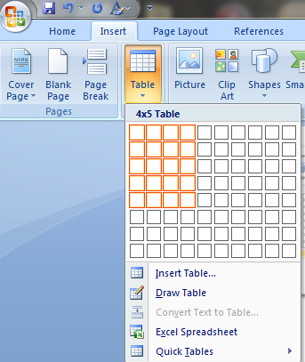
  - Left click cursor and this task pane shall appear.
The table can be designed in two ways:
Firstly click the small downward pointing icon under the table button on your toolbar.
Highlight the box in the drop down pane for the number of columns and rows you require. Notice; that the number of lines and rows match those that are available on the document.
Once you have the correct number of rows and columns, left click your mouse.
The second method is to:
- As before click the small downward pointing icon under the table button on your toolbar.
- Move the cursor down the drop pane and left click the words "Insert Table".
- A new pane shall appear. Enter the amount of columns and rows you require and left click on OK. The table below shall appear.

Structure
The structure is the way in which a written document is formatted. Not all written records have the same structure. For example, the conventions of most letters will vary according to the type of letter and who the recipient is. Refer to Appendix Number Two and look at the formatting of the different letter formats in the templates. Notice that the positioning of the name and address, and the formatting differs.
Structure may include:
- Organisation of the material to suit the format (e.g. Scannability for on-screen use)
When you communicate information using a document, it is important that you design the material so that it can be used across different forms of media and written material so you are not repeating the same information again and again.
For example, you may use graphs to show trends to your workgroup. However, when you send information to managers and others, that same graph can be used to support your recommendations. The only difference between both sets of information may be the amount of information conveyed. Think of the information that you would send to work group members. There has been an increase in falls and slips in a work area recently. The information that would be provided to workers in the consultation process would be the information needed to make a decision.
However, if management need to make an informed decision, you would need to add the workers recommendations and then use the information to support the response. This means that you would use more information such as basing your recommendations on the size of the budget allocated to minimise the risk.
Treatment of attachments and hyperlinks
Both attachments and hyperlinks can be used to provide recipients of information, mainly on email that will assist them in making a decision; communicating a change or for other business purposes. Both attachments and hyperlinks can be found on emails. Hyperlinks can also be found in other document formats.
An attachment is a supplementary document that is added to an email. It may provide further information as evidence, documents from other sources that will enable the recipient to become informed so that they can make a decision.
To enter an attachment on an email,
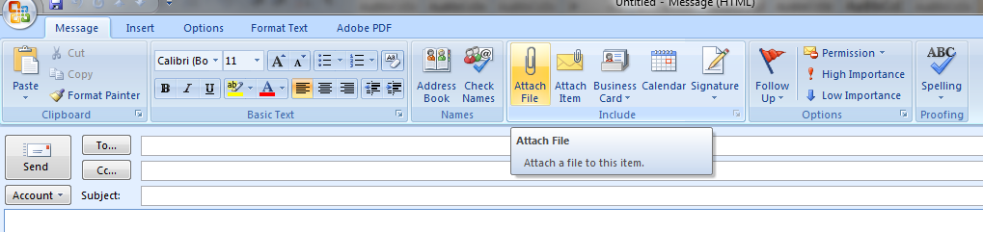
- Open an email
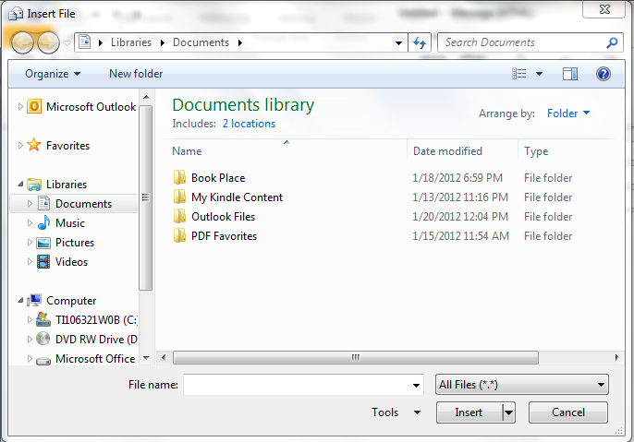
- Left click on attach file and the following task pane will open

Go to the appropriate file and then click insert. The file will attach to the email. Give a few seconds for it to attach before sending.

Hyperlink
A hyperlink is a piece of text or a graphic on an Internet Document that can direct readers to another webpage or section of a document. An example of a hyperlink is found at URL Address: http://www.wisegeek.com/what-is-a-hyperlink.htm Access Date. To open the link, point a cursor at the link and left click it.
Now follow the link and read about how to design one.
Visual signposting of material, including use of headings, lists, keywords and text in boxes
Signposting is a technique used to assist people in following the meaning of what is being said. Headings, lists, keywords and text in boxes demonstrate what the communication is about because they draw attention to what is being said.
Headings allow personnel to see what they are going to be reading about, lists allow personnel to see what topics are going to be discussed and text in boxes are sometimes use to reinforce information that has already been read.
These signposts also assist when personnel are trying to reconfirm information that they read. The signposts allow personnel to find the information and confirm what they have read.


Learning Task Two
What role does format and structure play in reinforcing an organisations reputation?
Format and structure have an important role in relation to an organisations reputation. The way their documents and other media is formatted and structure if poorly formatted this can reflect badly on the organisations staff.

Find a template that is use in your organisation. Use this template to explain how it is used to ensure that personnel read it.

1.3 – Establish key points for inclusion

The keys points for inclusion entail making sure that you are clear on the information that you provide and the structure of that information. In section 1.1, signposting demonstrated that you could ensure that recipient’s attention was drawn toward specific text that allows recipients to have a focus that allows the reader to learn what the writer is talking about.
To provide more structure to information, you should consider the inclusion of say tables to make the information that the recipient receives clearer and easier to read. However you are not constrained to tables. There are other types of inclusion that can be added to the document when you are making key points.

Inclusion of Graphics and visuals
You are working in a work place where many staff has English as a second language. You have responsibility to provide them with not just tables and works, but with graphics and other visuals that will clarify and can be used to reinforce the point that management is trying to convey. Different types of inclusions can be applied through illustrations on the Insert Tab in a work document

To open each icon within the illustrations section of the insert on the Microsoft 2010, you need to open Microsoft Word:
- Move the cursor to Insert
- Left Click and the toolbar will change
- Move the cursor to illustrations; and write click
Before you use any illustration features, make sure that you follow the first three steps above.


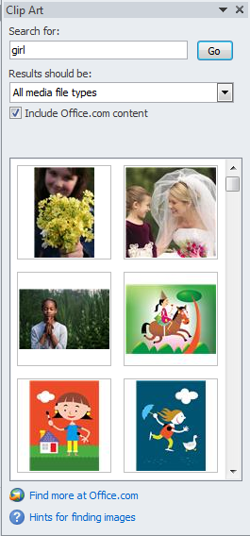
ClipArt
- Click
- The task pane Clip Art will appear on the right side of the screen.
- Enter the Clip Art that you would like in Search for:
- Once you have chosen a Clip Art that you believe will suit your purposes, click on it once and it will open on your document.


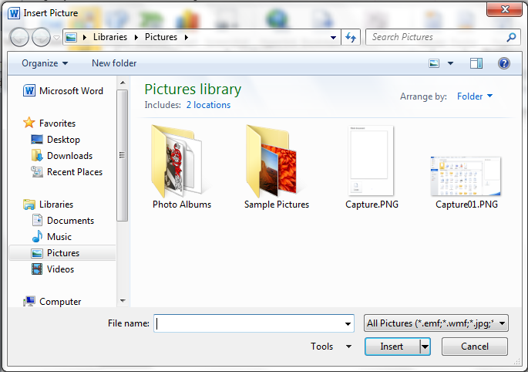

Picture
- Click
- Double Click and Pictures folder opens
- Double left click on appropriate file and it will open
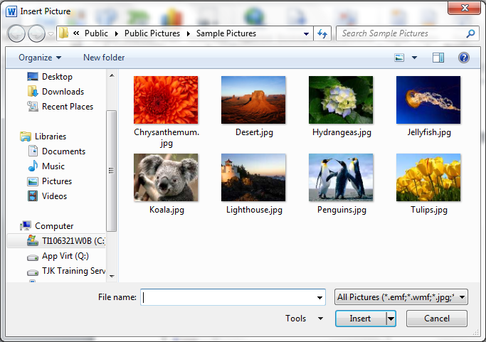
Right click picture and it will appear on the document that you have open


Charts

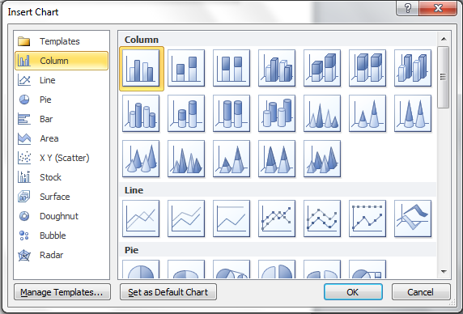
- Click
- The task pane Insert Chart will open on the screen
- Choose a chart and click on it.
- Click ok
- The task pane will open as shown below
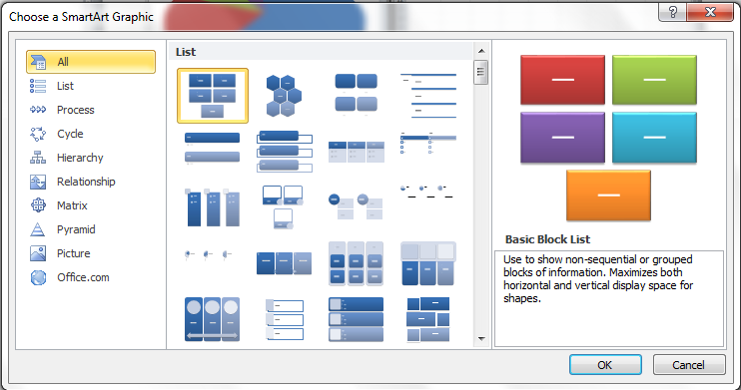
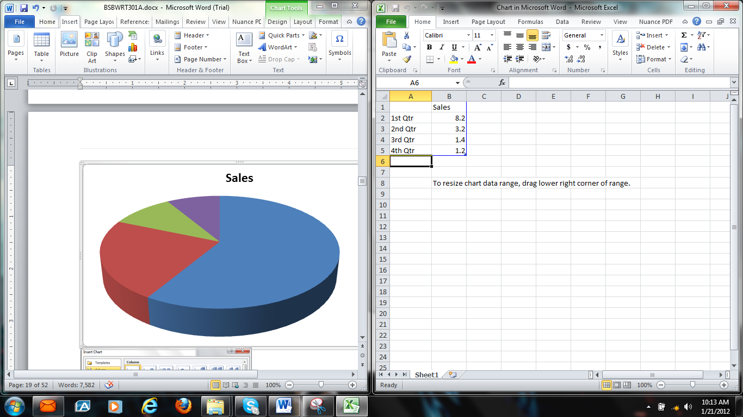


SmartArt
- Click
- The upper task pane, choose a Smart Art Graphic will appear.
- Click on the graphic that you would like to use and the graph art such as the text will appear.

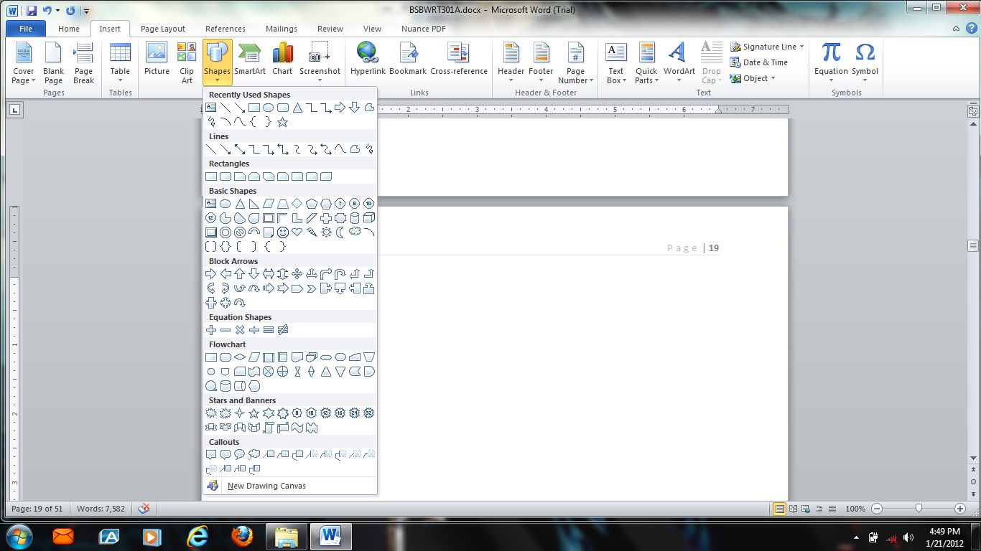

Shapes
- Click
- This task pane will appear on your screen
- Choose the shape that you prefer ; and
- Click on it

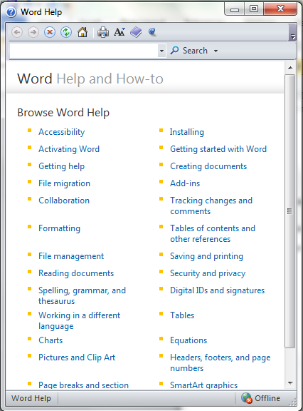
Practice using each of these icons in your documents as part of improving your written communication skills. If you would like to learn more about these formatting processes, refer to on the upper right hand corner of the Word Document.
Use the Search parameter to provide you with information about how the package works. The program can be obtained on and off line.
If you are a learner who learns better with instruction rather than reading make sure that you are connected to the internet and you will be able to download video instruction on how to use the function within the program.

Learning Task Three
You have been allocated the task of ensuring that the following information for your team. Use the inclusions (words, visual and graphics) to design a message appropriate to your team.
Change to Work Health and Safety Legislation
Meeting: Friday 12th
Time: 10.00 am
Location: Meeting Room Five
Review of changes to the law and how it will affect you
As a supervisor use your knowledge of WHS/OHS legislation to highlight the impact of the change.

1.4 – Identify organisational requirements

Every time that you present information to workers or any other stakeholder, you are acting as a representative of you organisation. For this reason when you send information; to both internal and external customers it must be consistent with organisational procedures. How you present the information, such as using the appropriate forms and formatting may also be a requirement under the law.

For example, the information that you present to your team may one day be used as evidence that you provided your team with information as per your legislative requirements. Your failure to comply and use appropriate forms and formats with logo if required may cause the courts to question the legitimacy of the records. These records in many instances must be kept and maintained in a storage facility for 30 years. They may not be able to find you to question you about the information that you gathered and in many instances cannot remember may not remember what happened.
These records are evidence that you have performed your tasks within the requirements of the law. This is what you are doing when you follow procedure. If there is proof that the procedure is up to date, and legislative requirements are not being met, you also protect yourself in that you were following your employer’s instructions. This means that the employer becomes liable for failure to comply with legislative or regulative requirements.

Organisational requirements
may include:
- House style requirements
Enterprise templates or house style conventions are margins, fonts, use of colour as part of document design.

To open the Styles and Formatting
- Make sure that you are on the Home Tab
- Move mouse pointer to and left click on the icon
- A new drop pane will appear.
- Move mouse pointer down to Style Set
- A new task pane will appear.
- This is the pane that should be used to develop a document.
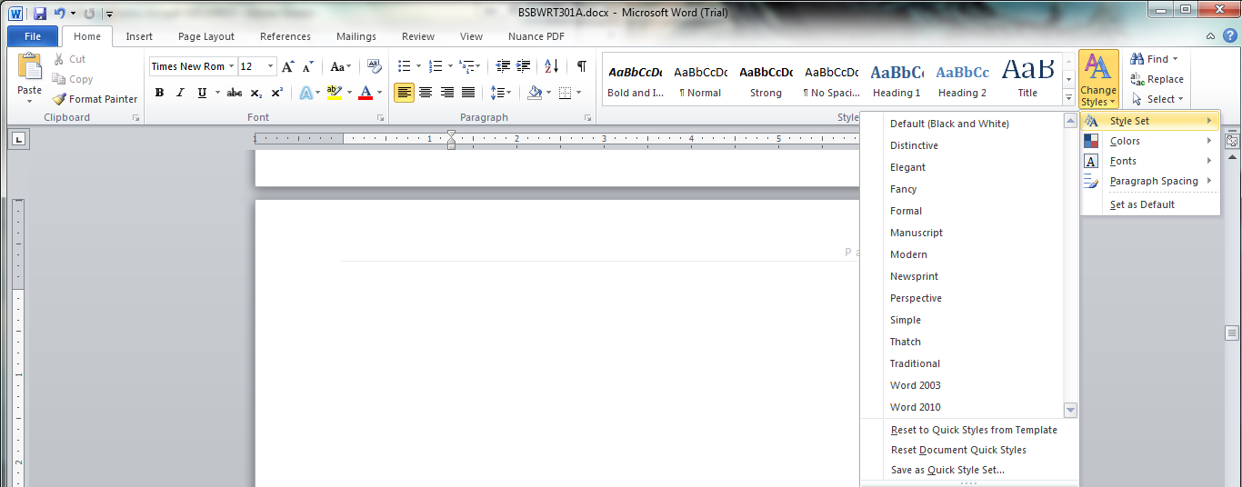
- Many organisations will already have a house style set up in this section
A set of formatting characteristics that is applied to text is called a style. When you apply a style you will apply a whole set of formats in one simple task. For example; if you format the title as 14 pt, Times Roman and center aligned, you can the same results by applying this style.
You can apply paragraph, character, table and list styles. You can apply a style while you are typing and after you have finished typing.
- Identified authorities for signatories for correspondence/communications
Part of your job may include a task such as purchasing orders or completing reports. Your level of authority may allow you to authorize a specific transaction, however in other instances you may be required to obtain authorization to process other transactions.
For example, at one location, the purchasing officer was authorized to purchase parts up to and including $500.00. However, when an order is $501.00 and up, then the purchasing officer had to obtain approval from the supervisor.
If you look at your job description, you will be able to view your level of authority and may provide you with the signatories for the position. If you cannot find the information in the job description, check the procedures manual and you will be able to see who has the level of authority to sign off on the purchase. If the procedure names a person that you know has left the organisation, you can find who has taken over the same position by looking up the organisation’s contact sheet or organisational chart.
- Protocols, both written and unwritten for the organisation's internal and external communications
Communication protocols will include how you should communicate with workgroup members, management or customers. An organisation will have protocols that you must follow to ensure that communication is controlled. Your job description should provide you with the communication protocols that you should follow.
For example, you need to contact a client with question regarding a sale of a product. Your organisation refines raw materials in preparation for further production. Your client has requested unrefined raw materials. The raw materials in their unrefined state are a risk if not handled and stored. You have a legal obligation not to sell the product unless the client can demonstrate that they have the facilities to maintain the raw product safely.

- What should you do? Should you contact the client personally?
One of the reasons why communication protocols are put in place is to ensure that communication channels are controlled. If you contact the client personally you will usually be breaching the relationship between the client and the sales representative.
Communication protocols in this example may require that you discuss the issue with your supervisor before contacting the sales representative. The sales representative already has an established relationship with the client. If you interfere with that relationship, the organisation may lose the client.
The sales representative would also lose credibility. In this case, you would usually need to contact the sales representative to handle the process. You may also be required to consult with the appropriate personnel such as your work health and safety representative or your supervisor to ensure and confirm that the information that you are going to provide the sales representative with. Conversely, you may be authorized only to identify a problem but not authorized to speak to the sales representative. Your procedures may be to escalate the problem to your team leader or supervisor to resolve.
- Requirements for inclusive and non-discriminatory language and for adherence to copyright legislation
Discrimination takes on many forms. Both organisations and their employees have a responsibility to ensure that no discrimination occurs in the workplace. Discrimination should lead to equal opportunities and should protect all staff from customers, staff or management. All groups that are in contact with your staff need to be made aware that discrimination in any form is unacceptable. Australia is a socially diverse country. This means that acceptance should be emphasised irrespective of gender or personal affiliations.
It is against the EOA 2010 to discriminate against a person for the following attributes:
  - Age
  - Breastfeeding
  - Carer status
  - Disability/impairment
  - Employment activity
  - Gender identity
  - Industrial activity
  - Lawful sexual activity
  - Marital status
  - Parental status
  - Physical features
  - Political belief or activity
  - Pregnancy
  - Race (colour, national and/or ethnic origin)
  - Religious belief
  - Sexual orientation
It is important to make sure that care is taken not to use any words that are associated with the above areas. If you do, you may be accused of acting in a nondiscriminatory manner.
There are also discriminatory laws in the new WHS legislation relating to terminating personnel. When communicating with personnel, care should be taken that you are aware of the language that is unacceptable in your workplace. Certain words should be avoided.
Copyright legislation may also constrain the information that you can provide. For instance in the WHS Act, if you are assigned to accompany an investigator when they are on the work site, you can be cut off from interviews as employees have the right to stop you from entering an interview. Privacy and confidentiality will also apply when referring to information. If you were going to use information provided by a worker who has asked to remain anonymous, then by the WHS Act you could provide information but must make sure that the information can be used who the worker is.

Learning Task Four
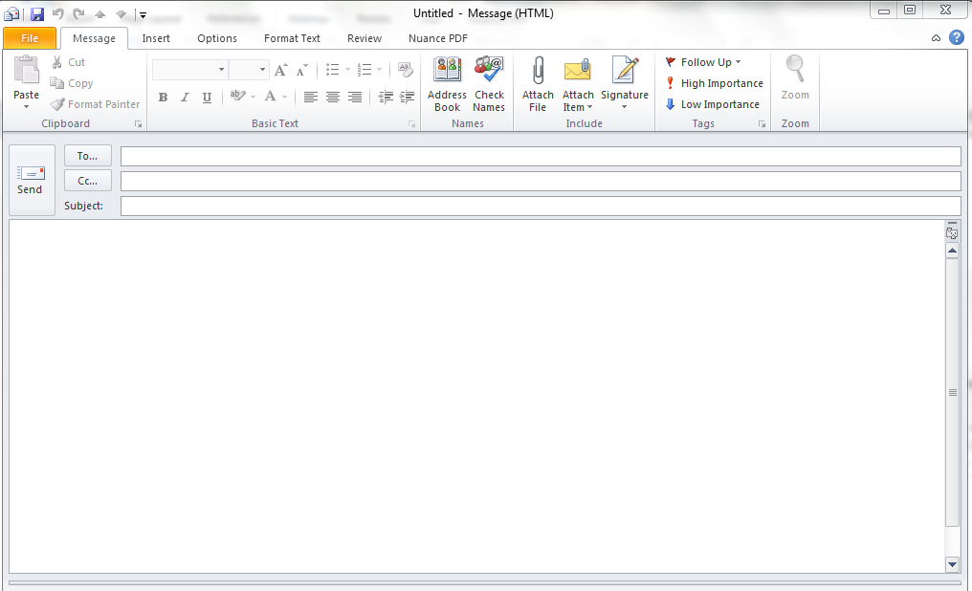
Write an email to a member of your team. Explain the communication protocols in your work area. Make sure that you explain the discriminatory process for your work area.

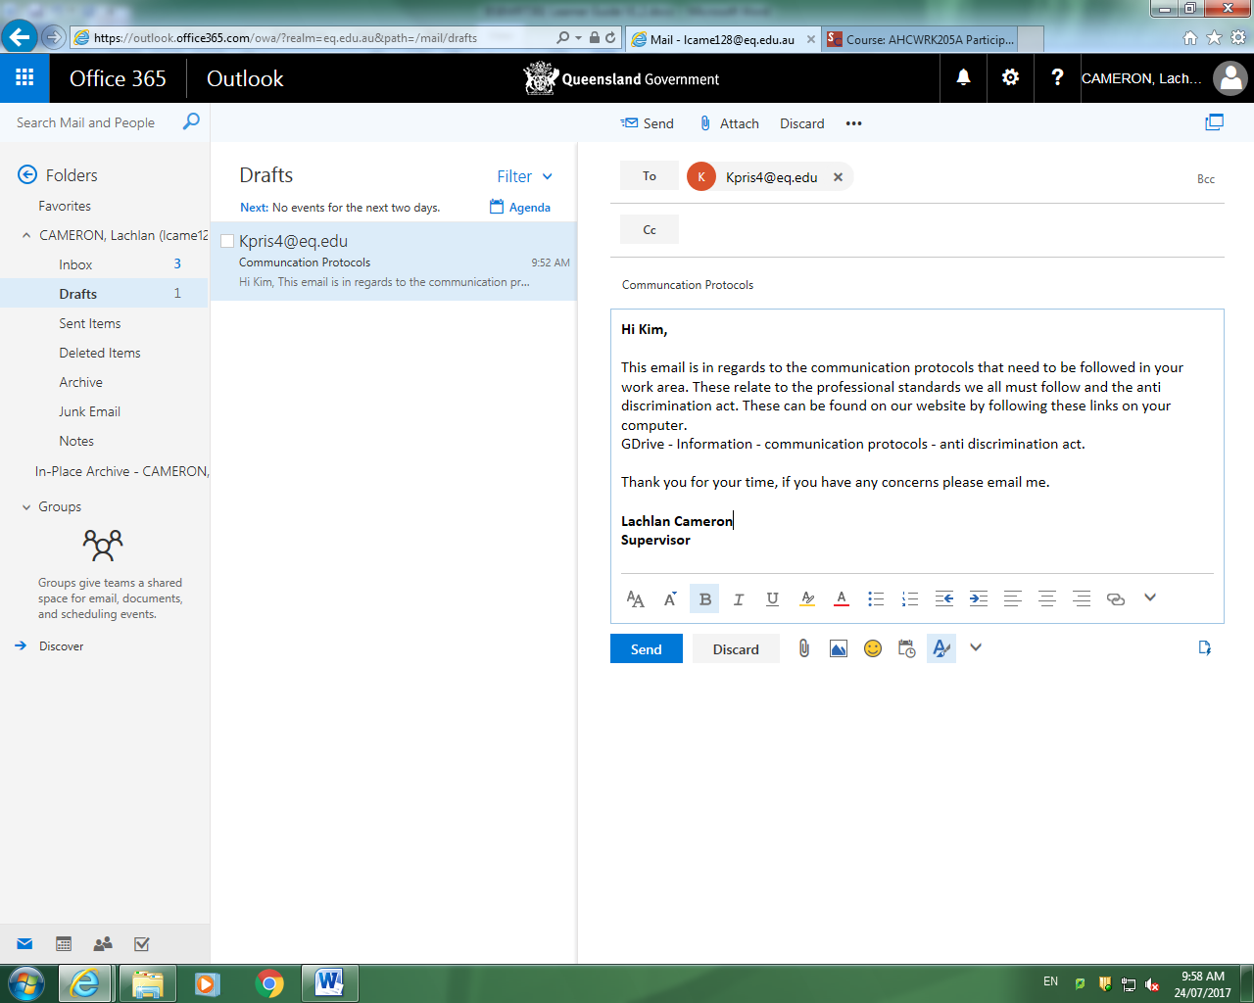

1.5 – Establish method of communication

When you communicate with personnel, it is important to make sure that you use a method of communication that work group members will understand. The aim of information is to provide information. If the method of communication is incorrect you could do more damage than good to say your WHS Consultation process.
Workgroups may see a formal report as a negative. If they are unable to understand it, for example, incorrect and uninformed decisions made will have a negative impact on morale and will impede the WHS consultation process. Workers may also make incorrect decisions. Workers may also see a report as an attempt to patronize them. Education in some cultures is seen in a good light. When a person is unable to obtain an education, they may see that you are trying to patronize them. When a person sees a communication as a personal insult, they will become angry and not work with you to achieve the organisations goals.
When you consider a method of communication, consider:
- The roles of personnel and their level of authority
- The type of personnel that you are communicating with
- The type of information that you are going to provide the recipient with.
Method of communication may include:
- Inclusive communication
An inclusive communication strategy is one in which explicit steps are taken to ensure that all employees feel they are involved in decisions that affect their day-to-day work. The consultation process that forms part of the harmonisation of the new work health and safety legislation is an important part of ensuring that all employees actively participate in WHS in the workplace.
Harmonisation aims to ensure that work health and safety legislation is consistent across all States and Territories across Australia. Correct use of the consultative process requires that information flows freely across all level s of the organisation, taking into consideration any levels of authority and confidentiality and discriminatory laws.
Organizations with a secretive communication environment shut people out, which can stifle involvement and will result in lost ideas and opportunities. Employee involvement is a key factor that affects employee satisfaction and success as demonstrated in a work environment that embraces the use of consultation.
- Use of active or passive voice
Language barriers are a common challenge in international business settings—and a two-way process. What native speakers often do not realize is that frequently it is not the other person's accent but their own way of speaking that creates the greatest barriers to effective communication.
Use the strategies below to ensure you are not putting up your own roadblocks to effective international communication.
- Ask for clarification.
If you are not 100% sure you’ve understood what others say, politely ask for clarification. Avoid assuming you’ve understood what’s been said.
- Frequently check for understanding.
Check both that you’ve understood what’s been said and that others have fully understood you. You can do this by paraphrasing whatever is being said to you.
- Avoid idioms.

Business language is often contextual, and therefore culture specific. Use clear and concise worlds that will not confuse listeners that will take what is said literally.
- Be careful of jargon.
Watch the use of TLAs (Three Letter Abbreviations) and other organizational language that may not be understood by others. If you use them, provide in parentheses a description of what these are so others can learn to use the same language you do.
- Define the basics of business.
In international business contexts terms such as: ‘success’, ‘doneness’, ‘meetings’, ‘punctuality’, etc. may mean different things to different people. Spend time early in your communication defining what these mean to you and others. Invest in building a shared vocabulary.
- Be specific.
Spell out your expectations and deadlines clearly. Instead of, ‘Please get back to me shortly,’ say ‘Please email the completed report by 5 pm Eastern Standard time on Wednesday, February 21.’
- Choose your medium of communication effectively.
Carefully choose your form of communication (phone or video conference, email, instant message, etc.). Be mindful not to ‘overuse’ email. While useful, there are times when the medium is likely to be ineffective. When a message is complex and complicated or there is tension or conflict that needs to be resolved, switch to another medium.
- Provide information via multiple channels.
Follow phone calls with emails that summarize what’s been said. When possible, provide presentations, agendas, etc. in advance so those working in their non-native language can get familiar with materials.
- Be patient.
Cross-cultural communication takes more time. If not at all times, certainly initially you cannot expect your communication to occur with the same speed and ease as when you are communicating with someone from your own culture.
- Use of the appropriate register or style of language
Style of language will vary between formal, standard and informal language that you use. The style that you use should reflect the level of familiarity that you have with the recipient of your communication and the type of communication. For example; you may have a line of communication with a client that is very informal. When you send them a report at the start of the month, the report may be formal, however the level of communication that you provide in the email may be informal where you make more personal dialogue with the client.
When the client sends the emails of the report to the members of his/her team the message is more standard because the email is for a variety of personnel on many levels. When you write a communication to personnel make sure that you consider they type of communication and who the recipient is.
Informal communication usually refers to information that is passed through the use of casual conversation. Formal is usually used in a professional setting.
The differences between formal and informal communication includes:
Formal | Informal
Scheduled in advanced  Arranged with participates  Participants are given a role  Has an agenda  One way communication  Formal language | Unscheduled  Random participants  No set roles  No arranged agenda  Two way communication  Informal language that may use slang.

Learning Task Five
You are required to write an introductory letter to your manager and one to your team leader about a hazard that you have identified in your workplace. Use the next two pages to write one formal and one informal letter.
Once you have finished the letters, reflect on the letters and discuss the differences that you found with three or four people in your class.

25/07/17
Coombabah State High School
Pine Ridge Road
Coombabah QLD

Dear Mr Kenny,
After my usual fortnightly inspection of J8 the following faults were found. These include dangling cords from the roof (unorganised and loose) this could be dangerous if a student was to walk into them or could become an electrical hazard if students pull on them, the book shelf was not attached to the wall the danger of this is if a student was to pull on the bookshelf or stand on it in a unsafe manner the bookshelf would collapse on the student and cause injury and students are obstructing one of the doorways this is a danger due to the fact as they are obstructing on the exits of the room.
I will be contacting the workplace health and safety rep to investigate and find a solution to these faults. We will write a report and forward it to you after the investigation is complete.
Kind regards,
Lachlan Cameron

25/07/17
Hi Jayden,
I have found a few faults in J8 after my inspection. Let’s discuss them 9am Thursday in J8 so I can show you the faults as we discuss them. If you can’t make it please let me know to a better time that would suit.
Regards,
Lachlan Cameron

1.6 – Establish means of communication

Once you have established who you need to communicate to, the way to communicate and how you are going to gain the attention of the personnel, you will need to determine the means of communication. Which software package would you use?
When you communicate, you need to consider the most appropriate package that will meet your needs. Listed below are three packages common to most organisations. By know what software options there are available and what each package will allow you to do, you will be able to choose the package that will afford you the most productivity.
Software packages as a means of communication may include:

Spread sheets
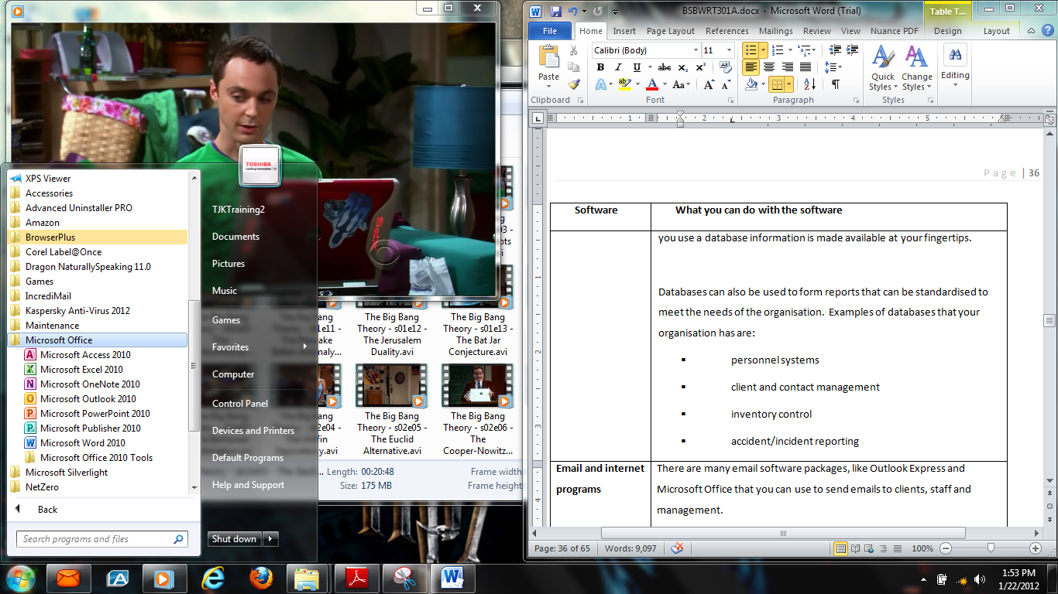

Spread sheets are an excellent way in which to make tables. Using columns and rows, you will be able to form graphs, set out data so it is easy to read and make calculations. Spread sheets are usually used in business to calculate figures for:
- Cost analysis
- Sales
- Budgeting
The spread sheet package can perform any task that requires the use of numbers and calculations.

Word processing

Most word processing programs give the functionality of increasing your productivity. Some of the options that you will find in most word processing programs are:
Dictionary Auto shapes Different fonts
Drawing Different colours Bold
Underline Italics Mail merge
Spell checking Formatting Designing tables
Inserting clip art and images

Database
A database is a collection of data put together to put records together. This information is vital to the smooth running of an organisation. When you use a database information is made available at your fingertips.

Databases can also be used to form reports that can be standardised to meet the needs of the organisation. Examples of databases that your organisation has are:
- personnel systems
- client and contact management
- inventory control
- accident/incident reporting

Email and internet programs
There are many email software packages, like Outlook Express and Microsoft Office that you can use to send emails to clients, staff and management.
There are many email software programs. Examples of components are email software programs include:
- Journals
- Tasks
- Contacts
- Calendars
- Send emails
If you are not familiar with the communication software, hardware and devices, you should take steps to learn how to use it. Most software packages will come with help and written manuals. Hardware will usually have a user’s instructor guide or a user manual. These manuals are designed to teach you how to use the equipment.
If you do not know how to use the hardware, software and/or software packages, you should take the time to learn how to use them correctly. This will increase your productivity and will make your job easier.

When you use any of these devices or packages to communicate with the required parties, you need to make sure that you communicate in the way that the party indicated. For example:
- A manager who is always on the run will not have time to stop and talk to you. The manager will want to thoroughly read a report and then make an appointment to see you if she or he has any questions. In this case, the manager may prefer to receive an email.
- Conversely, a client may prefer to receive a telephone call. The client may prefer the personal touch and they like to talk to you. If you send an email, they may in some instances ignore it.


Learning Task Six
Even though Microsoft Word and other Word Processing packages are one of the most popular software within a package, there are other packages that you can use to communicate to other personnel.
What other software is used within your organisation to communicate? What can your software do? Give an example of a time in which it would be appropriate to use this software package to communicate with personnel in your organisation?
Microsoft Outlook
Microsoft outlook is a personal information manager from Microsoft, available as a part of the Microsoft Office suite. Although often used mainly as an email application, it also includes a calendar, task manager, contact manager, note taking, journal and web browsing.
For example, I would use outlook to send emails to my team regarding staff meeting, Workplace Health and Safety issues and any other information where all staff needs to be notified.

2. Draft document

2.1 Develop draft document to communicate key points
2.2 Obtain and include any additional information that may be required

2.1 – Develop draft document to communicate key points

When a document is designed, it needs to appeal and attract its audience. If you know who the organisations audience is, then you should be able to ensure that the templates obtain and retain the interest of the audience. Documents should be geared towards:

- Simplicity – Make sure that the document is short and straight to the point. Avoid using verbose words that the reader does not understand. They will quickly grow bored with the document and stop reading it.
- Diversity – The tone of a simple document can be changed by the words that you use. For example, instead of writing that “the product is bad,” you could write that “even though the customer’s did not like the product, a surprising interest was found by another target group.” This stimulates the readers and encourages them into reading the rest of the document
- Balance – Documents should be balanced in two ways. They include:
- If you choose a picture on one side of the page, do not leave the area next to it white. The audience will become confused. Write about the picture by writing next to it and explain what the picture is about.
- Words can also be used to balance a document. There will be some documents that you will expect to have verbose words in it. To stop the audience from going to sleep when they read the document, use words that will maintain their attention.
- Relative positioning of headings and graphics – Headings should be clear and simple. They should ensure that the audience knows what you are trying to tell them. The graphics used to convey information should relate clearly with the heading. A graphic that does not relate to the heading can confuse the audience.
- Typography –Typography includes the font that is used for the document. The most common forms of font are Times New Roman or Arial. When a font is chosen it needs to be legible. Small print or capital letters are hard to read. The audience may become bored reading the font in long documents.
- Text flow – Text should flow together. Use headings as a guide to control the document. Disjointed words and sentences that change topic all of the time can confuse the audience. To avoid confusion:
  - Use one topic per paragraph


When you write the document, it is important that you remember:
- Who the audience is
- The purpose of the document
- How would you format the letter?
- What structure would you use?
- How would you use key points?
- What are the organisational requirements that you would need to consider?
- What method of communication would you use?
- What package would you use to communicate the message?
The way in which you structure and design the layout of your text documents should be a reflection of your audience. Make sure that the text is kept short and simple, taking care to ensure that:
- The page layout is consistent through the whole document. For instance, indented paragraphs should be used throughout the whole document
- White space is used to make the document more attractive and easier to read, by giving the reader time to pause and think about what they have read
- Typeface is used to make the document more attractive. For example, changing the colour of text or changing it to bold without making it look too busy.
- Graphics, photographs, clipart and drawings are used to prove a point
- Boxes are used to make points next to graphs and to add colour to the document
- Colour is used to highlight shape or main points.
- Headings are short and succinct telling the reader what is in the section below; and
- Columns are used to make lists of items.
The purpose of drafting a communication, especially when you do not have much experience and are not familiar with the legislation in the communication, care should be taken to ensure that no part of the communication is incorrect. Many supervisors and managers can lose their credibility if they do not adhere to organizational conventions and make sure that the facts in their communications are correct.
In the same way, as a worker you can also place yourself at risk by providing insufficient data where individuals make decisions. Those decisions can be high not only for the organization as a whole not only financially, but also for their credibility and reputation. On a personal level, you could also lose your reputation if you do not ensure that you do a draft and then follow it up by proof reading the document.
Templates and house styles are two ways in which you can obtain assistance in your graphics and art. You may also need assistance in writing the draft. You will always find words that are hard to spell or you are not sure about. A dictionary can assist in spelling and can define a word so you can identify whether the word is appropriate for the subject matter.

There may also be times when you may know a word, but do not think that the word is appropriate. Refer to a thesaurus. A thesaurus will provide you with all of the nouns, adjectives and verbs that you need. The thesaurus will allow you to look up a word and then will list words that are similar to it. If you are unsure about a word, look it up in the dictionary.

Learning Task Seven
Trainer note, if the learners have already completed any of the Learner Guides pertaining to the Consultation process, encourage them to identify the sections of the legislative and regulative requirements or within the codes of practice that they should consider in their communication to reinforce the need for workgroup members to attend the workgroup meeting.
Using your knowledge of your workplace and a potential hazard, write a draft of a letter to staff providing them with information about the hazard and asking them the ways in which they can suggest in improving the procedures for the potential hazard to minimize the risk.
It is important that you give workers sufficient time to reflect on the information that you have provided them with so that they can come up with ideas. In your letter, identify possible times for work group meetings. Remind workers that they must attend or make themselves available to participate in the consultation process as part of their agreement to keep the workplace safe and to maintain the safety of the workers.
Use this space to write a letter. It shall be used to complete the tasks in Section Three of this Learner Guide

Heavy Diesel Repairs

26/07/17

28 Ramley Drive
Burleigh Heads
QLD, 4221

Dear Workshop team,

I have become aware of a safety breach in the workshop where the general public have been wandering around the workshop area. This is a workplace health and safety issue because of the possibility of injury due to the machines and tools used in the workshop area.

I would appreciate all staff to think of any ideas I can use to resolve this problem. I will be scheduling a meeting on the 29th, July at 9.30am to resolve the issue.

This meeting is compulsory for all staff.

Regards,
Lachlan Cameron

2.2 – Obtain and include any additional information that may be required

It is only when you are writing a draft of a communication that you may become aware of information that you may be required to add to the communication or additional information that you believe is relevant to the communication.
When adding information, ensure that it is relevant to the parties that it involves. Members of your workgroup may require that you add information that is not relevant to the purpose of the communication and not relevant to resolving the issue. Whenever you write a communication, it is essential that you maintain the standards set by the organization, legislative and regulative requirements and as the code of practice and privacy laws.
Breaching any of the legislative and regulative requirements can leave you open to fines and in some cases jail term for not following your legislative requirements. Remember it is also essential to follow your duty of care to ensure that your workgroup members confidential information is not accidently passed on in the communication. In fact, remember that unless the employee has given their permission, you are not legally allowed to let anyone recognize them under confidentiality laws.

When you identify a need for information, it is important that you identify
- The source of the information
- Whether you are required to consult with people internal or external to the organization
- Whether you have access to the information
- The relevance of the information
- Whether you are required to obtain permission to provide the recipients with the information required.
If you are still learning to communicate with personnel in writing and you are consulting with a member of staff who may be operating as a mentor, trainer or coach, take the time to review the document with them. Their experience will assist you in ensuring that the quality of your work adheres to organizational standards. If you do not have the advantages of another person who you can consult with, then check your organisations historical records to determine whether the information that you gathered is relevant and to check that the tone of the letter matches the tone that you have used.

Learning Task Eight
For the hazard that you have identified in Learning Task Seven, use the table below to identify two pieces of additional information that you may require for the letter. How will you research the information? Who would you need to consult with in regards to the letter? Why?
What additional information do you require? | How will you research the information? | Who will you consult with? Why?
Workplace Health and Safety laws | Internet and government websites | Business lawyer as they would have up to date knowledge.
Safety signs and written posters | 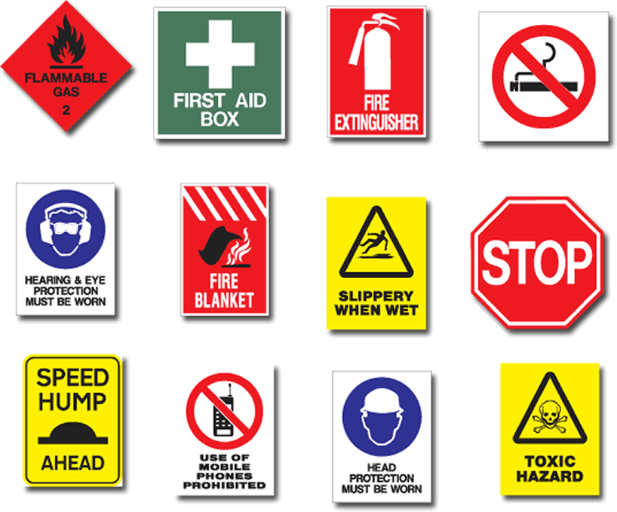 | We will consult with the workplace health and safety officer to ensure the correct signs are put in place.

If you are unable to consult with another member of staff, what do you need to do?
Consult with other similar businesses or relevant websites.

3. Review document

3.1 Check draft for suitability of tone for audience, purpose, format and communication style
3.2 Check draft for readability, grammar, spelling, and sentence and paragraph construction
3.3 Check draft for sequencing and structure
3.4 Check draft to ensure it meets organisational requirements
3.5 Ensure draft is proofread, where appropriate, by supervisor or colleague

3.1 – Check draft for suitability of tone for audience, purpose, format and communication style

Care should be taken when you check the draft of the communication that has been sent. During the planning process, you wrote about:
- The purpose of the communication
- The format of the communication
- The communication style; and
- The tone used for the audience.
During each step of review, it is essential that you confirm that everything that you have written is suitable for the intended recipient.
- The purpose of the communication

When you plan your communication, it is essential that you are clear on the purpose of the communication. Review the purpose. Have you achieved your goal? Is the purpose of the communication clear and concise?
If your communication is unclear, you will need to review your document and the words that you use. It is important to make sure that the purpose is clear. Ask another member of your team to read the communication if you are not sure.
For example, is your request for information, really just a request, but really a demand. Make sure that your wording is passive and that you are not making demands. One wrongly written word can have a negative impact on the way in which the letter is received.
- The format of the communication
Make sure that the format of the communication is correct. For example; if you use an email format to communicate with work group members. What may be an appropriate way of communication for one workgroup member may not be appropriate for another. Workgroup One may have access to internet due to their roles and responsibilities. However, work group two may not have access to the internal internet.
Many of the workgroup may also not have access to the internet and in some cases, workgroup two do not even have email accounts. This means that you should review the format to ensure that all work group members have access to the communication. This means that you should review the format that you are using for a group.
You may also be faced with client preferences. Your organisation may require that only hard copies of contracts to the client via registered post to ensure that their contracts are not stolen through cybercrime. However, your client would prefer the communication to be sent in an email as their procedures require that all emails are backed up on the system.
It is important to not only consider the organisations requirements, but the requirements of the clients’ preferences should also be considered. In the same vein, you should consider the needs of the personnel receiving the communication. Managers and clients will usually prefer to receive reports via email so that they can review the communication at their own leisure, whereas workgroups prefer the communication to be in the required format, but with more inclusions to assist them in understanding the flow of information.
Templates can greatly assist in ensuring that information is communicated in the appropriate format. Organisational policies and procedures will help you to ensure that information is communicated in a manner that is appropriate to the recipient. Be aware however, that you may work in an organisation that does not supply templates.
Historical data can assist you in determining the format used in the past. Consultation with members of your workgroup can inform you about the format that the recipient prefers.
Formatting can also include the dissemination or break down of information. As a culturally diverse society, there is a high level of workers who have English as a second language. The use of tables can help make the information easier to understand. If you are writing an email for personnel make sure that the information within the table flows into the rest of the formatting and is part of the requirements of the communication.

- The communication style;
What style are you?
  - The passive writer develops a pattern of avoiding opinions and feelings, thus protecting their rights and identifying and meeting their needs
  - The aggressive writer express their feelings and opinions and advocate for their needs in a way that violates the rights of others in that they try to dominate people through words.
  - The passive aggressive writer is passive on the surface but is really acting out in anger by undermining the communication.

  - The assertive writer clearly states their opinions and styles and firmly advocates the rights of others without violating them. They value themselves, their time and are respectful of the needs of others.
Anger and the violation of another person’s rights really have no business in business. You need to have the ability to balance between passive and assertive when you are communicating with other parties. For example, if you are assertive with your workgroup, they may follow your lead without presenting you with new ideas. If they respect you, the workgroup will usually follow you. Being passive allows workgroup members to step forward with their opinions.
Conversely, assertiveness is respectful, but allows the writer to express their opinions and make recommendations when they are needed. Passive personnel will not win a point. If you are in a situation where you want to advocate for your work group, you will need to be assertive.
Aggressive and passive aggressive writers will undermine themselves and lose credibility. When you work in a professional environment, it is important to be professional all of the time.

- The tone used for the audience.

The tone of the document will affect how the reader will interpret what is said. When you determined the purpose of your document, you needed to make sure that you express the message that you conveyed you want to reach your audience and obtain some kind of action in response to your message. Make sure that you have considered the reader when you wrote your draft. If this is not the case then you should review the tone of the document.
Business writers need to make sure that they use the same tone for all of their messages. The tone should be confident, courteous and sincere, using emphasis and subordination appropriately. Make sure that the message is non-discriminatory and that you have provided the facts to support any point or argument you are making.
This means that when you write, you should be confident to build your credibility in saying “I know what I am talking about.” To be courteous and sincere, you are building goodwill as the information you write should have words and phrases that will be perceived in the manner intended by the recipient. However, it is important that you are not too polite because it may be seen as condescending.
Have you used the written and visual signposts appropriately? Do you provide supporting evidence to reinforce and support your arguments? Did you use an active or passive voice? This is about the style of communication that you used? Was it appropriate?
Consider the amount of space and the language that you use because both together will suggest how important the idea is.

Learning Task Nine
These are the four different types of writing communication styles. Use your writing skills to write a paragraph for each style. Swap the style with someone in your class and see if they can identify which style you are using.
- The passive writer develops a pattern of avoiding opinions and feelings, thus protecting their rights and identifying and meeting their needs
- The aggressive writer express their feelings and opinions and advocate for their needs in a way that violates the rights of others in that they try to dominate people through words.
- The passive aggressive writer is passive on the surface but is really acting out in anger by undermining the communication.
- The assertive writer clearly states their opinions and styles and firmly advocates the rights of others without violating them. They value themselves, their time and are respectful of the needs of others.
Passive

Hi everyone,

I have just realised that there is a hazard in the workshop. It seems like the general public have walking around the area which is dangerous. We need to find a solution quickly so if you don’t mind could you think of ideas that could fix the problem. We might have a meeting to talk about please let me know what time suits everyone. This meeting will be compulsory to come to.

Thank you,
Lachlan Cameron

Aggressive

To all work colleagues, I have been made aware of a serious safety hazard that requires a solution immediately. The safety breach is in regards to the general public accessing the workshop area and this is a danger due to the dangerous tools and machinery. It is essential that everyone presents a solution at the compulsory meeting today at 9:00am.

Lachlan Cameron

Passive Aggressive

To all work colleagues, I have been made aware of a safety hazard in the workshop area that must be fixed. The safety hazard is in the workshop and this involves the general public’s ability to walk through the workshop this is a danger due to the dangerous tools and machinery. This could cause serious injury and result in penalties for the company. I would like everyone to attend the compulsory meeting and discuss solutions for this issue, today at 9am.

Lachlan Cameron

Assertive

Dear colleagues,

We have an issue in regards to where the general public have been walking in the mechanics area where dangerous tools and machinery could cause injury. I think we could agree that this could result in serious injury and is therefore unacceptable. Everyone is to attend the compulsory meeting to discuss this issue today at 10am.

Lachlan Cameron

3.2 – Check draft for readability, grammar, spelling, and sentence and paragraph construction

3.3 – Check draft for sequencing and structure

3.4 – Check draft to ensure it meets organisational requirements

3.5 – Ensure draft is proofread, where appropriate, by supervisor or colleague

The grammar and spellchecker in most software packages will only catch a few of the mistakes. To catch errors that are more obvious, you will need to visually proofread your document.
Punctuation, sentence structure and the construction of the paragraphs all add to the readability of the draft. Your aim should be to ensure that you obtain and retain the attention of the audience. Poorly structured and designed documents will usually be put aside.
When you use a document to train and educate it must draw the reader in, to want to learn. It is the same for business communication. Managers and clients are provided with large amounts of information. When you are writing a document, remember that the more pleasant the document is to read, the higher the chance that your document will be read first. Personnel are more interested in reading something that appeals to them, than to a document that is hard to understand and unclear.
By reading the draft, you are reviewing the correctness of the data and information in the document and increasing the chances of your document being read first.

Readability
Before proofing a document read it through first and re-check the layout. It is not only important that the document is clear and concise. The document needs to appeal to the recipient, encouraging them to read it. The use of graphics and art, the sequencing and structure of the document should all appeal to the recipient. It is important to make sure that the language is appropriate, that the art and design of the document balances and that the content stimulates the end-user. Managers, clients and their representatives and any other people that you may communicate with usually receive a lot of emails, letters and other forms of communication every day.
In most instances, people will usually choose the documentation that appeal to them first. If your document is clear and concise and appealing to look at and read, then it will most likely be one of the first that will be read. When a document does not appeal to a person, they tend to put off reading the document until it is imperative that they do so.

Grammar
Grammar is the way in which the English language is structured. There are two types of grammar:
- Descriptive grammer; is the way in which we actually talk and write. Descriptive grammar relies on the patterns that underlie our use of words, phrases, clauses and sentences
- Prescriptive grammer is the structure in which specific people feel it should be. Prescriptive grammar relies on what people believe are the correct and incorrect use of language.
To practice your grammar, go to Learn 4 good Website at http://www.learn4good.com/languages/evr_english_grammar.htm Access Date: 15.01.12

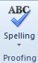
Spelling
When checking your spelling, you can access Spell Check on Microsoft Office. However, it is important to note that the spell checker has a reputation for not being able to deliver as errors can still be found after you have used it.
It is always good to read the document through once to identify irregularities in the spelling, font, text, numbers. Proof reading grammar includes:
- Checking punctuation
- Remove jargon and slang from the document
- Spelling irregularities
- Check the spelling of all names and the names of the business
- Take care to check the numbers carefully. In one instance, an organisation sent an email to its customer underquoting itself by $10 000 when a member of the work group forgot to add an extra zero to the end of the document. If calculations are being used make sure that the addition, subtraction or other math operations appear in text, doublecheck the figures.
The failure to check spelling and grammar can lead to expensive errors if they are not caught on time. Care should always be taken to double check all documents and care should be taken to make sure that the document goes to the correct recipients.
The following table is used by many proof readers to assist in the correction of incorrect spelling and grammar. By learning the corrections and applying them to your workplace, you will easily be able to identify problems and highlight them when you update the errors on either the print out of the document or within the text on the computer.
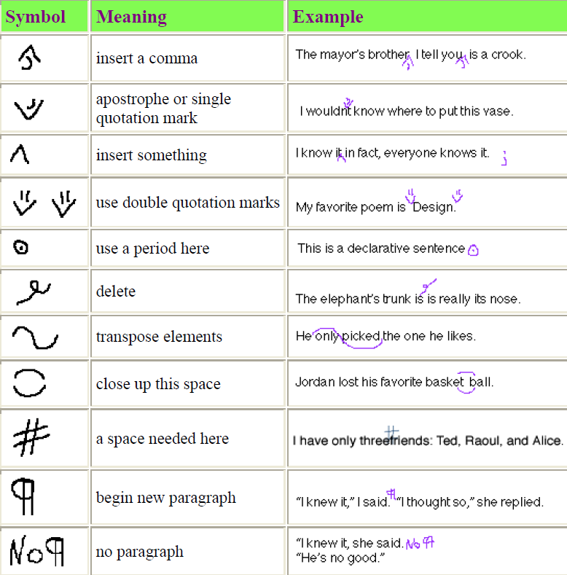
http://teachers.sd43.bc.ca/RMcmahon/Class%20Documents/Webster%27s%20Common%20Proofreading%20Symbols.pdf

Sentence
Sentence structure is very important. When you write a sentence, it is important to ask yourself the following questions:
- Is your sentence clear?
- Is it easy to understand? – did you avoid the use of jargon and acronyms such as WHS (work health and safety)
- Is the text justified, so lines start at the beginning and continue to the end?
Make sure that you place one idea in one sentence. Do not make sentences too long. Long sentences can lead to confusion. Short succinct sentences allow the recipient to reflect and think about the sentence as they require. You not only maintain control over the document, you will also ensure that the recipient will receive the correct message.

Paragraph Construction

In a similar context, you will find that paragraphs should be constrained to the introduction of a new point. Do not make more than one point in a paragraph. This may lead to confusion. Paragraphs should not be more than five sentences long. Break the paragraph into two sections.
For example, if you are making a recommendation, you may use a couple of sentences explaining why you made the recommendation in the manner you have. Then you can use the next paragraph to provide support for your recommendation. This support should be in the form of credible information such as performance being negatively impacted on the workplace because a lot of workers are not happy with the lack of response to the increase in injuries.

Check draft for sequencing and structure 3.3
Sequencing refers to the flow of information throughout the document. Think of the time that you received a document and then spent a couple of hours trying to understand the message being conveyed. The message did not flow together. Instead the writer would make a recommendation but would not support their recommendation until three pages latter.
How frustrated did you get with them? When you write a document, you need to not only consider that structure of the document, you also need to consider if the document is easy to read and that it flows together.
The sequencing and structure will be enhanced when you asking yourself the following questions. They are:
- Are there any inconsistencies in the font type including the headings and captions that you included in the document?
- Also make sure that the artwork and graphics flow together by making sure that you:
- Proof read artwork and captions to make sure that words are spelt correctly with them
- Check that the spacing is consistent
- Ensure sure that text font is consistent across the different headlines
- Check draft to ensure it meets organisational requirements 3.4

While checking the draft, make sure that organisational requirements are met. These requirements may include
- Ensuring that you are not in breach of any discriminatory laws. This means that you must check the wording to ensure that discriminatory words are not used. Your organisation may have specific procedures that outline the words that should not be used.
- Ensuring that no breach in copyright or confidentiality laws is breached. Check to make sure that if you are handling a work health and safety issue that the name of workers are not released and that they are not identifiable based on your document. Breach of this law will ensure a fine if the issue is escalated to a complaint to a work health and safety investigator.
- That the organisations communication protocols are met. Check to make sure that you have considered all protocols such as whether you have breached your level of authority or whether you are including information that should not be in the report. Remember the communication protocols are in place to control the flow of communication. If you are not sure about information that you would like to include in the process, discuss it with your supervisor.
Ensure draft is proofread, where appropriate, by supervisor or colleague 3.5


Proof reading a draft is not a hard thing. However when you are learning a new skill, you will find that you will have difficulty remembering every protocol, constraint and legislative, organizational and regulative requirements that you are required to meet. When deciding on who should read the draft, you should consider:
- Who has the level of authority to read the draft – Confidentiality constraints may mean that only specific staff can read the information in the draft.
- Who has the ability to proof read the draft – Even though a member of staff is your supervisor or manager, this does not necessarily mean that they have the ability to proof read the draft. English may be their second language so they may not be familiar with the way in which you have written the report.
When deciding on a proof reader, take the time to consider their relevance to the document or whether they have the time to proof read it. There are managers who spend their evenings reading their emails because they never find time to read them during the day.
If you have a situation where you have a busy manager, consider your supervisor or team leader. As long as they have the ability, knowledge and skill and level of authority to read the draft, they will be able to proof read the draft for you.

Learning Task Ten
Read the following text and make the appropriate corrections.
Fred saw the accident and and to tried assist Lily when she slipped on the floor. Fred alsos slipped trying to help Lily stand. Lily complete her work after she complete her accident/incident report.
Fred went to hospital and will be absent from work for at least si weeks while he wears a cast on both of the egs that he broke. Another member of staff who witnessed the event believes that Fred set up the accident so he could stay home for a few days.
The investigator is going to speak to other staff to make sure that paul is not lying about the incident.
Fred saw the accident and tried to assist Lily when she slipped on the floor. Fred also slipped trying to help Lily stand. Lily completed her work after she completed her accident/incident report.
Fred went to the hospital and will be absent from work for at least six weeks while he wears a cast on both of the legs that he broke. Another member of staff who witnessed the event believes that Fred set up the accident so he could stay home for a few days.
The investigator is going to speed to other staff to make sure that Paul is not lying about the incident.

You should have found at least nine errors and one legislative breach
If you are not sure about who to consult with in regards to writing, what should you do?
I would see my line manager (supervisor).

Activity 3.2 – 3.5


4. Write final document

4.1 Make and proofread necessary changes
4.2 Ensure document is sent to intended recipient
4.3 File copy of document in accordance with organisational policies and procedures

4.1 – Make and proofread necessary changes

Once you have identified the changes, you need to update them. When updating changes, care should be taken to ensure that you do not miss any. You may want to double check.
Remember it is important to be consistent with your documents so that you meet your organisational requirements. To protect yourself, be systematic:
- Take the time to consciously make the changes – Double check the changes to ensure that they are correct. If your communication utilises a lot of numbers, pay special attention to them. If the communication is a contract and there is one zero too high or too low up could either lose the contract or win the contract based on a low figure.
- Follow up when in doubt – If you are not sure about a change that has taken place which you did not make ask the person who made the change. There may even be times when you make a change and do not understand the changes that you have made.
- Keep your dictionary and thesaurus close – When you ask a person to proof read your work, they may spell words in a different manner. For example, in different English speaking countries, words mean the same thing but are spelt in a different way. (i.e. Australians’ spell organisation with an “s” and Americans’ spell it with a z. Colour in Australia is spelt “lour”, whereas in America it is spelt color).
Most Microsoft programs allow you to change the language to Australian. Other organisations do not

Learning Task Eleven
Re-write the small paragraphs that you corrected in Learning Task Ten here without the spelling mistakes and the breach of the law.
Trainers guide answer:
Fred saw the accident and tried to assist Lily when she slipped on the floor. Fred also slipped trying to help Lily stand. Lily finished her work after she completed her accident/incident report.
Fred went to hospital and will be absent from work for at least six weeks while he wears a cast on both of the legs that he broke. Another member of staff who witnessed the event believes that Fred set up the accident so he could stay home for a few days.
The investigator is going to speak to other staff to make sure that the worker is not lying about the incident.
What was the legislative breach?
Fred was trying to defraud his company by causing a fake incident.

Workers in NSW are covered by OHS (occupational health and safety) laws passed by the NSW Government. (OH&S ACT 2000, OH&S Regulations 2001)

Activity 4.1

4.2 – Ensure document is sent to intended recipient

When you send a document, it is essential that you double check the documents address to make sure that the document is addressed to the correct party. Many organisations, for example will write “if you are not the intended recipient please do not access this email.” This is to protect the data sent.
Confidential and sensitive information is sent to organisations’ on a daily basis. When information is sent to the wrong party, especially when they are in competition with the intended recipient, your organization can be left open to litigation. This means that your organization and you as a representative of the organization can be sued, especially if the organization lost business or suffered a loss due to the negligence of the sender.
Imagine the impact this would have on your employer’s reputation. Your credibility would also be affected. Care should be taken to ensure that you follow organizational procedure when sending a document. It is essential that the document reaches its intended audience. This means that the document must reach its intended recipient.
Intended recipient may include:
- Audience for document – Attention must be paid to making sure that you have the correct recipient/s. If the document needs to go to more than one party, then you must confirm the parties that should receive the information.
Always proof read the names on the envelope or in the email. When a document is processed with CC (carbon copy) and BCC (Blind carbon copy) make sure that you have the correct parties. In many organisations, when a report or other style of document is sent to workgroups and clients on a regular basis, lists of the intended audience are made up.
These lists can then be Ccd or Bccd onto the email. This saves time and effort only if the lists are kept up to date. If the lists are not maintained, there is the chance that new personnel or recipients will be missed and that other personnel may be sent the information even when they no longer require it. This can occur when personnel change positions in the organisation or leave it.

- Signatory of the document – Check to make sure that the person or person/s required who are authorised to sign the document are authorised to do so. There will be times when the required signatory is not available. In these instances, another member or staff will usually sign of on the document.
The signatory will usually proof read the document before signing off on the document.
If you are still new to writing documents, let them know so they will look more closely at the document before signing it.
- Supervisor /or other staff member who may add to or forward document to another recipient – You will not always be required to send the document to the intended recipient. There will be occasions when your supervisor is unable to check the document. In these instances, they will usually advise you that they are going to keep the document before sending it to the recipients on the document.

Other staff may be authorised to add to or forward the document to another recipient. This may be a normal part of business operations or it may be at the request of the recipient.

Learning Task Twelve
List all of the documents that you handle. Do all of the documents have to have a signatory?
In reference to the hypothetical company “Heavy Diesel Mechanics” in learning task seven. The documents a company in that industry would handle include: Invoices (this requires a signature), emails, information sheets, pay slips, work order and part orders (this requires a signature).

What is the importance of making sure that the documentation reaches its intended recipient? What can happen if you do not reach the correct recipient?
Sensitive information involving clients and documents of any financial matter could end up in the wrong hands of someone who could spread the personal/financial information on the documentation that they received by mistake. Also it could slow down workflow and cost the business money and time resending the documentation to the correct recipient.

4.3 – File copy of document in accordance with organisational policies and procedures

When you are saving your file, it is important to make sure that you follow the organisations established policies and procedures so that you:
- Know where the files and folders are
- Back up your files so important data is not lost
- Delete information that is no longer needed
- Copy files from one area to another
- Change the name of files.
When you name and store documents you need to make sure that the:
File names which are easily identifiable in relation to the content
Some organisations have hundreds of files and folders in all of their drives. If you name the file a name that is not easy to remember and identify it may be impossible to find it again. When you name your files, they should be named in relation to the content that you have in them. For example; if you do a mail merge that is regular, you may date the file and place it in a folder that is common to that mail merge.
File/directory names which identify the operator, author, section, date etc
Some organisations have files that will identify who wrote which document. If you put your files in detail view in the file directory, you will be able to obtain some of this information. Some files will automatically be signed to the person, who wrote them.
File names according to organisational procedure
Some organisations will back up their information by numbers so that the files are easily identifiable to them and no one external to the organisation. By doing this they are protecting the information within the files.
Storage in folders / sub-folders
Make sure that you place your files in a place that you can find them. This means that if you are making files for different people you may wish to save these files to the person’s name. This means that you will be able to access the files easily if you need to find them again.

Storage on hard/floppy disk drives, cd rom, tape backup

The most common way of saving a file is onto a hard drive of the computer you are working on. You may also use a CDR or DVDR disk. The way in which you save your file will depend on the organisation you work for.
Your organisation’s policies and procedures will advise you about which drive you should save your files in. Some organisations will have several drives with hundreds of separate folders and files. If you save the file to the wrong drive, it may take you a long time to find it again.
CD ROMs or DVDRs are accessed through C: drive. If you have a very new computer, you will probably find that the computer does not have a floppy disk drive. Instead you will need to save your file on a cd rom. The CD ROM is used for permanent storage or backup files of data. Some organisations use a magnetic file to back up their files. The magnetic tape can be used repeatedly making it a very economical type of storage device.
Organisation policy for backing up files
To protect data from loss or damage many organisations make it regular, and in some cases daily practice for them to back up their work for that day. In many instances, you may find that the organisations make several backups of their files and data. These backups are usually locked away and accessed by authorised personnel only.
It is important to make sure that you use the organisations regular back up procedures to ensure that important information is not lost. To back up a file that you are using simply select file and save as: this means that you should specify the drive.
Filing locations
Some organisations use a file register telling interested parties who wrote the file, the name of the file, the date the file was written and a brief description of what is in the file. This allows the users to review and locate files as they require them.
For example, if you are asked to locate a file or files with particular information you can easily check the file register to find the file/s that you require.
Security / password protection
Documents need to be protected. Confidentiality of files should be maintained. To protect your customers, for instance, a password is allocated to all users to ensure that only authorised personnel can access the file. Your system administrator will usually allocate a user name and password to you. It is important to make sure that you do not forget the password. You should change the password regularly to make sure that no one else can access your files.

Learning Task Thirteen
What is the importance of maintaining files?
It is important to maintain files so they are easily accessible and are up to date if information is required from the files. Such information might include payrolls, maintenance schedules, employee/customer information etc.

Where are your WHS files stored within your organisation?
Your employer should have them filed somewhere within the office or there may be copies online on the companies site or file system.

Activity 4.2 – 4.3

Skills and Knowledge Activity

Nearly there...

Major Activity – An opportunity to revise the unit

At the end of your Learner Workbook, you will find an activity titled ‘Major Activity’. This is an opportunity to revise the entire unit and allows your trainer to check your knowledge and understanding of what you have covered. It should take between and 1-2 hours to complete and your trainer will let you know whether they wish for you to complete it in your own time or during the sessions. Once this is completed, you will have finished this unit and be ready to move onto the next, well done!

Congratulations!
You have now finished the unit 'Write simple documents'.


Appendices

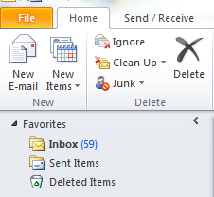
Appendix One

To send email
Open Microsoft Outlook
Once the program is open
- Move the cursor across the screen
- Point the cursor at New E-mail. Left Click and an email page will open

The address to an email is To:
CC: Is carbon copy as recipients are given a copy of the original communication so they know what is happening
BCC: Blind Carbon Copy is for recipients who are given a copy of the e-mail but do not want anyone else to know that they have a copy
Subject: Topic of the E-mail

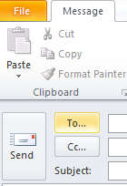
Underneath the topic, you can write your message.
Once you have completed the message, proof read it
Left Click the mouse when you point the cursor on Send

Appendix Two
How to access templates (Word 2010)
Once you have opened a program, the way in which to access a template in Microsoft is consistent across most of the programs.
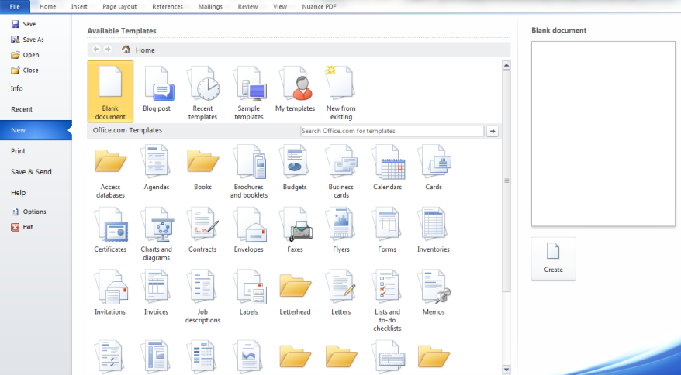
To Open or Find Templates:
- Open Microsoft Word.
- Point your cursor at File, Left click your mouse
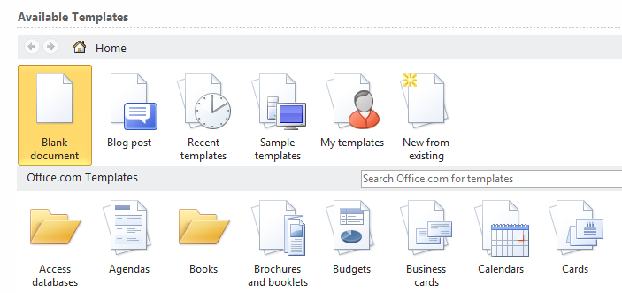
- Move the cursor down the left side of the screen and Left Click on New (This new screen will appear. If you are lucky, your organisation will store all templates in this part of the program. If you are not lucky, ask a member of your workgroup where the organisations templates are stored).
- Move the cursor across the screen until you find the template that you would like to use
- Left click the cursor on the icon that you would like to use.
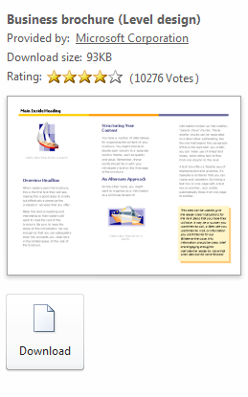
- The icon shall be highlighted. Move your mouse across the screen until you see Create. Check that you have the appropriate document. If it is correct Left Click to open a new document.
- If it is not the correct document, go back and repeat 4 and 5 again.
- Note: There may be times in which the template will not open and it will indicate that you will need to download it . You need a connection to the internet to perform this task.
- Once you click download, the template will be automatically downloaded and open on your screen

