
SISFFIT004 Incorporate anatomy and physiology principles into fitness programming

Copyright © 2018 CSTC Pty Ltd

All rights reserved. No part of the contents of this publication may be reproduced or used in any form or by any means – graphic, electronic, or mechanical including photocopying, digitising, recording, or information storage-and-retrieval systems – without the written permission of CSTC Pty Ltd.
ASSESSMENT FOR SISFFIT004

Student name | Paul van der Merwe
Date of assessment submission | Click here to enter a date.

Trainer/Assessor’s name | Kymberley Sant
Date of assessment marking | Click here to enter a date.
Outcome for units | ☐ Competent  ☐ Not Yet Competent

TASK INSTRUCTIONS

- The assessment for these units of competency consists of the following:
  - Quiz: You are required to complete a series of multiple choice questions to demonstrate your knowledge and skills.
  - Short answer activities: You are required to provide short written responses to a series of activities to demonstrate your knowledge and skills.
  - Case studies: You are required to provide written responses to a series of case study scenarios to demonstrate your knowledge and skills.
  - Practical task: You will be required to put your knowledge and skills into practice, through observed tasks and work experience.
- At times, you will be provided with a specific context to which you must respond, otherwise it is anticipated that you will use a scenario of your choosing to provide context to the task.

QUIZ

QUESTIONS | CORRECT
- What are the planes of body motion?  ☐ Sagittal, Frontal, Reverse  ☐ Sagittarius, Frontal, Transverse  ☒ Transverse, Sagittal, Frontal  ☐ Back, Front, Side | ☐
- What is the term associated with moving towards the midline of the body?  ☐ Superior  ☐ Inferior  ☐ Plantar  ☒ Medial | ☐
- What is the focussed movement in the movement of a shrug?  ☐ Superior and then Inferior  ☐ Anterior and then Medial  ☒ Elevation and Depression  ☐ Protraction and Retraction | ☐
- Which of the following are examples of connective tissue?  ☐ Muscle, Bone, Cartilage, and Skin  ☐ Ligaments, Tendons, Fascia, and Cartilage  ☐ Tendons, Bones, Ligaments, and Muscle  ☒ Muscle, Fascia, Cartilage, and Tendons | ☐
- What are the major muscles required for the flexion and extension of the elbow?  ☐ Quadriceps and Hamstring  ☐ Pectoral and Latissimus Dorsi  ☐ Biceps Femoris and Triceps  ☒ Biceps and Triceps | ☐
- What two (2) sections can the skeleton be divided into?  ☒ Axial and Appendicular  ☐ Axial and Appendages  ☐ Torso and Limbs  ☐ Long bones and Short bones | ☐
- What three (3) sections can joints be classified into?  ☒ Fibrous, Cartilage, Synovial  ☐ Fibre, Cartilaginous, Synovial  ☐ Fibrous, Cartilaginous, Synovial  ☐ Fibro, Hyaline, Symphasis | ☐
- What are fast twitch fibres known as?  ☐ Type I  ☒ Type II  ☐ Type IA and Type IB  ☐ Type III | ☐
- What does the mechanics of breathing involve?  ☐ Breathing in and breathing out  ☐ Inspire and exhale  ☐ Inspiration and expiration  ☒ Respiration and expiration | ☐
- What does ATP stand for?  ☐ Adenosine Two Phosphate  ☒ Adenosine Tri Phosphate  ☐ Adenosine Three Phosphates  ☐ Adrenaline Tri Phosphate | ☐
- True or False: In multicellular organisms, including humans, all cells, tissues, organs, and organ systems of the body work together to maintain the life and health of the organism.  ☒ True  ☐ False | ☐
- What are the four (4) tissue types?  ☐ Isokinetic, Isometric, Concentric, Eccentric  ☒ Connective, Muscle, Nervous, Epithelial  ☐ Superficial, Inferior, Deep, Anterior  ☐ Muscle, Nervous, Connective, Organism | ☐
- Which of the following methods will keep you aware of emerging knowledge of anatomy and physiology relevant to the development of your own professional practice? Select all that apply.  ☒ Reading journal articles  ☒ Newsletters from health professional associations  ☒ Networking within your industry | ☐

- Fill in the blanks for the statements below, selecting the correct option. | ☐
  Statement | Option 1 | Option 2
  The pectoralis major is _____ to the rhomboids. | ☐ Anterior | ☒ Posterior
  The soleus is _____ to the gastrocnemius. | ☒  Deep | ☐ Superficial
  The pectoralis major is _____ to the rhomboids. | ☐  Deep | ☒ Superficial
  The rhomboids are _____ to the trapezius. | ☒ Anterior | ☐ Posterior
  The bicep femoris is _____ to the semimembranosus. | ☒  Lateral | ☐  Medial
  Anterior deltoid is _____ to rectus abdominus. | ☒ Superior | ☐  Inferior
  Rectus abdominus is _____ to the obliques. | ☒  Lateral | ☐  Medial
  The elbow joint is _____ to the shoulder joint. | ☐ Superior | ☒  Inferior
  The wrist joint is _____ to the elbow joint. | ☒  Distal | ☐  Proximal
  The knee joint is _____ to the ankle joint. | ☐  Distal | ☒  Proximal
- Match the terms below with the appropriate movement, placing the corresponding movement letter label next to each term. | ☐
  Letter | Term |  | Movements
  H | Flexion |  | - The movement of a limb sideways direction towards the midline of the body
  D | Extension |  | - Extension at the ankle
  A | Adduction |  | - To allow a joint to perform movement through all possible axes
  K | Abduction |  | - The straightening of a joint. It occurs when the angle at a joint increases and the two opposing surfaces move apart
  J | Pronation |  | - To turn the sole of the foot laterally
  G | Supination |  | - To turn the sole of the foot medially
  B | Dorsiflexion |  | - To turn the palm posterior
  I | Plantarflexion |  | - The bending of a joint. It occurs when the angle of the joint becomes smaller and the two opposing surfaces move together
  C | Circumduction |  | - Flexion at the ankle
  F | Inversion |  | - To turn the palm anterior
  E | Eversion |  | - The movement of a limb in a sideways direction away from the midline of the body
- Identify the type of muscle tension for each listed exercise. | ☐
  Exercise | Isokinetic | Isometric | Isotonic
  Pushing against a wall | ☐ | ☒ | ☐
  Performing a bicep curl | ☒ | ☐ | ☐
  Holding a push up position at the bottom of the movement | ☐ | ☒ | ☐
  Swimming | ☒ | ☐ | ☐
  Holding a shopping bag | ☐ | ☒ | ☐
  Performing a squat | ☐ | ☐ | ☒
  Cycling on a stationary bike | ☒ | ☐ | ☐
- Match the terms below with the appropriate diagram label, placing the corresponding number label next to each term.  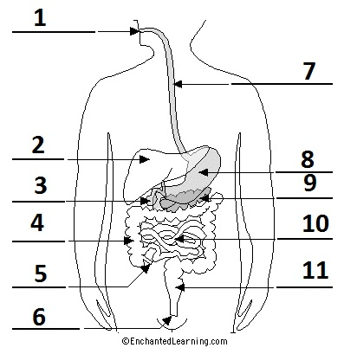 | ☐
  Number | Term
  6 | Anus
  5 | Appendix
  7 | Esophagus
  3 | Gall bladder
  4 | Large intestine
  2 | Liver
  1 | Mouth
  9 | Pancreas
  11 | Rectum
  10 | Small intestine
  8 | Stomach

- What effect does regular cardiovascular exercise have on the following respiratory volumes? Select the correct option. | ☐
  Respiratory volume | Increase in size | Decrease in size
  Vital capacity | ☒ | ☐
  Residual volume | ☒ | ☐
  Total lung capacity | ☒ | ☐

Outcome for Quiz | ☐ Satisfactory  ☐ Not satisfactory
Trainer/Assessor comments

SHORT ANSWER ACTIVITIES

Consider the relevance of the anatomical position.
- Provide a definition of the anatomical position.
- Explain the reason for this body position in relation to health screening.

Definition
The erect position of the body with the face directed forward, the arms at the side, and the palms of the hands facing forward, used as a reference in describing the relation of body parts to one another.
Relation of health screening
Health screening needs to be known by physiotherapists and doctors to be able to tell if when there is something wrong in the body. They should know what the muscles and organs feel like and where they should be

Outcome for Activity 1 | ☐ Satisfactory  ☐ Not satisfactory
Trainer/Assessor comments

Explain the path of an oxygen molecule from the initial phase of inspiration, starting at the nasal cavity.

Path of oxygen molecule
After the air leaves the trachea it enters the lungs. It starts in the bronchi, goes into the bronchioles, and then into the alveoli. Small capillaries that wrap around the alveoli receive oxygen from the lungs. The red blood cells carry that oxygen from the capillaries to hear.t

Outcome for Activity 2 | ☐ Satisfactory  ☐ Not satisfactory
Trainer/Assessor comments

Draw and label a sketch of a long bone.

Labelled sketch
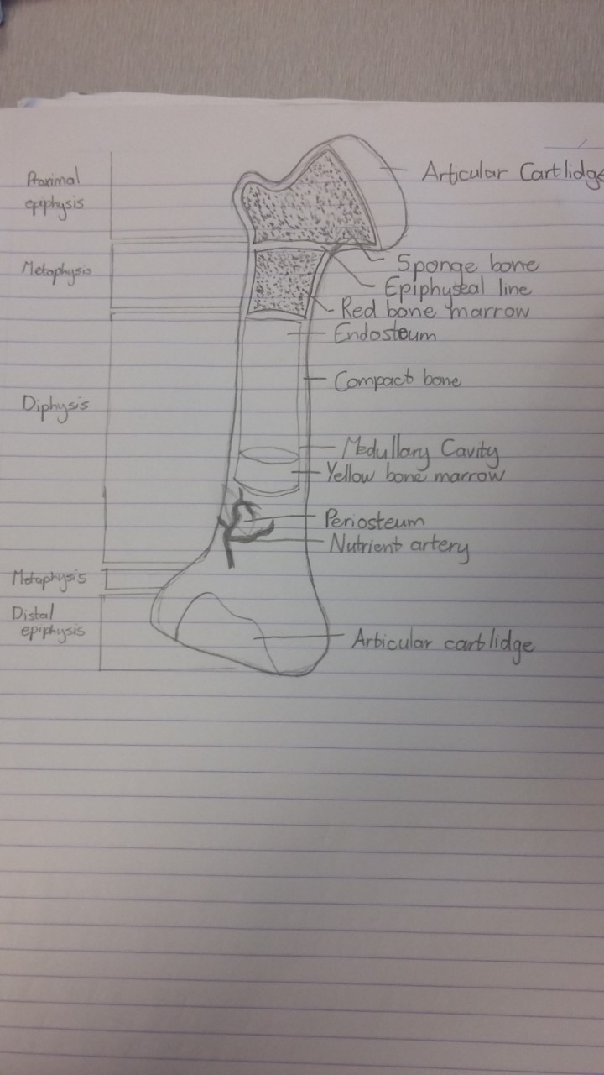

Outcome for Activity 3 | ☐ Satisfactory  ☐ Not satisfactory
Trainer/Assessor comments

Identify three (3) types of muscle. Describe these muscles and explain where they are found in the body.

Muscle 1
Name of muscle | Skeletal Muscle
Description and location | It is a form of striated muscle tissue which is under the 'voluntary' control of the somatic nervous system. Most skeletal muscles are attached to bones by bundles of collagen fibres known as tendons. Because the Skeletal muscle is voluntary, this means that the muscles can be controlled.
Muscle 2
Name of muscle | Cardiac Muscle
Description and location | Cardiac muscle (heart muscle) is an involuntary muscle that is found in the walls and histological foundation of the heart, specifically the myocardium.
Muscle 3
Name of muscle | Smooth Muscle
Description and location | Muscle tissue in which the contractile fibrils are not highly ordered, occurring in the gut and other internal organs and not under voluntary control.

Outcome for Activity 4 | ☐ Satisfactory  ☐ Not satisfactory
Trainer/Assessor comments

Draw and label a sketch of the cardiovascular system.

Labelled sketch
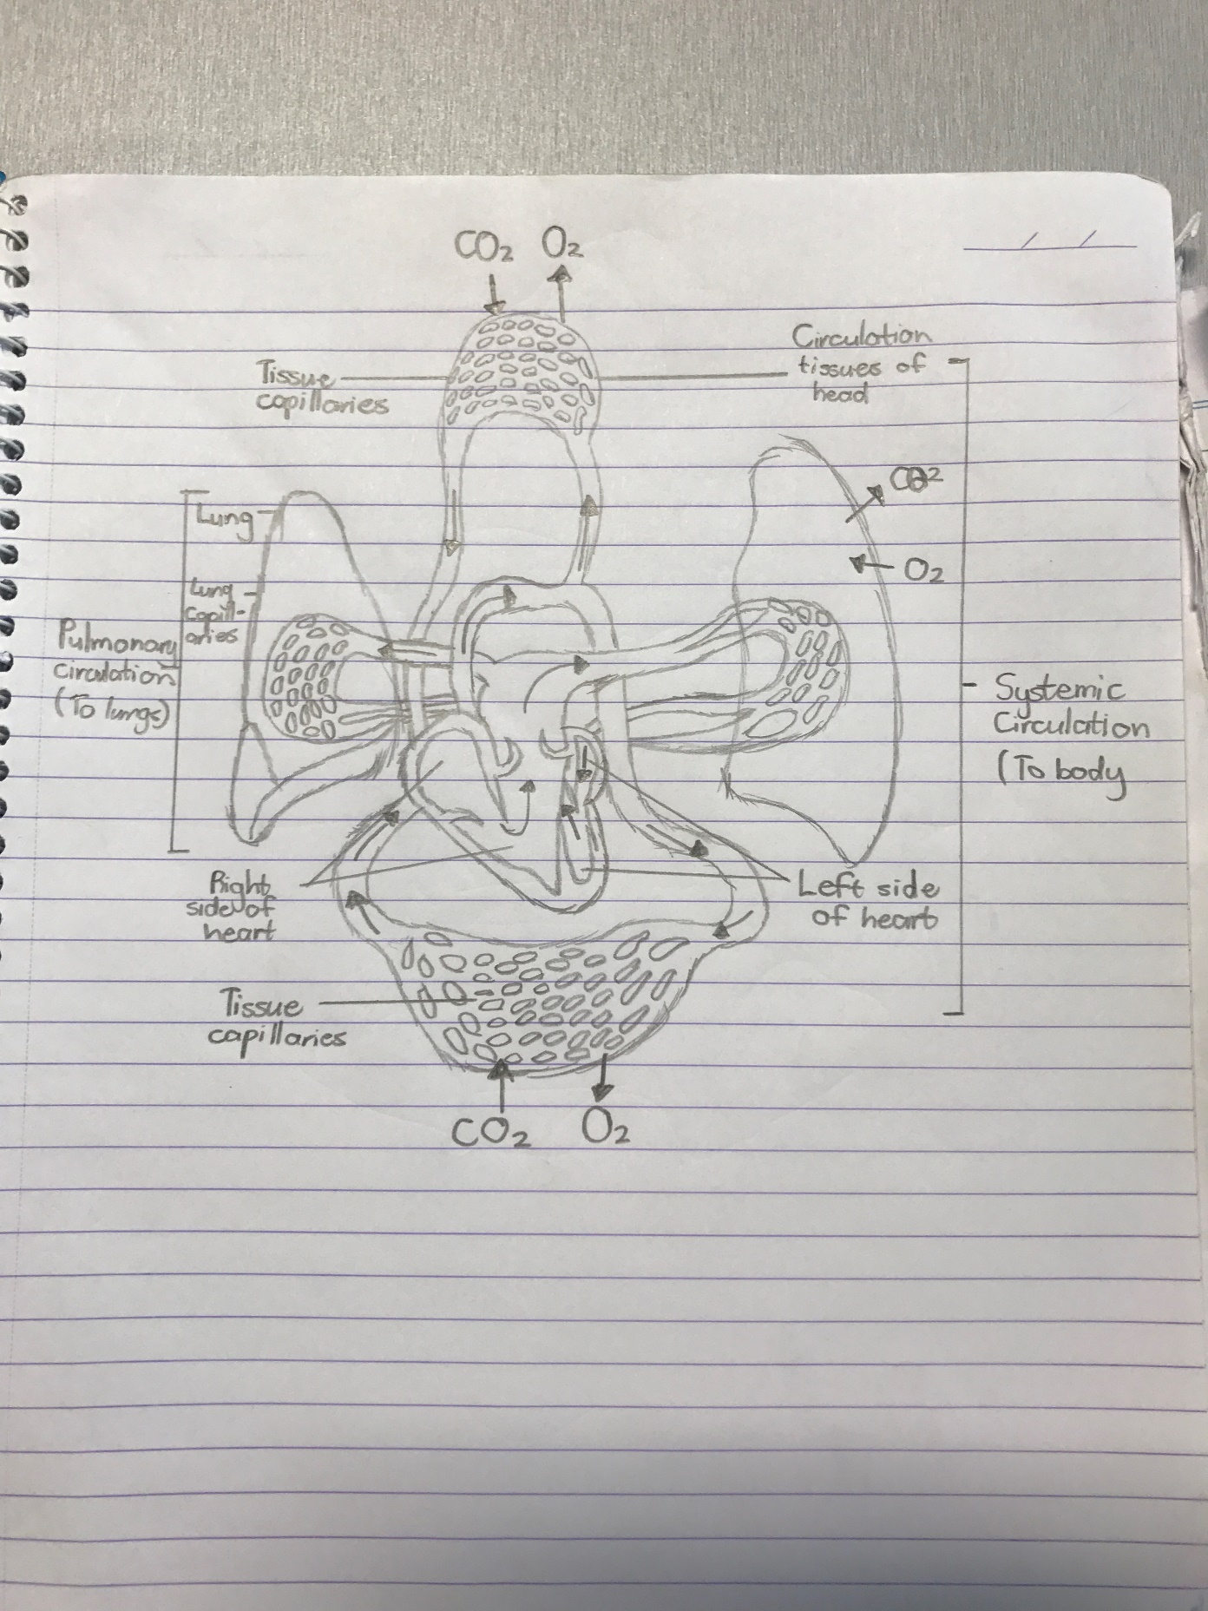

Outcome for Activity 5 | ☐ Satisfactory  ☐ Not satisfactory
Trainer/Assessor comments

Consider the movements in a push up.
- Describe the agonists and antagonists responsible for movement.
- Describe the role synergists play in this movement.
- Describe the role connective tissue plays in this movement.
- Describe the role of a Fixator or Stabilizer during an exercise movement, such as a push up.
- Describe the role of a Prime Mover in muscle movement.

Agonists and antagonists
The agonist, or the prime mover muscle, is the target muscle and usually the reason for selecting a particular exercise. For the push up, the agonist is the pectoralis major, or pecs. Your pecs are essentially your chest muscles. As you lower yourself toward the floor, the pecs lengthen and control the speed of your descent. As you push back up again, they shorten. The lowering and lengthening phase of the exercise is called an eccentric contraction while the lifting and shortening phase is called a concentric contraction.
Muscles are arranged in opposing pairs across joints. For movement to occur, when one muscle within the pair contracts, its opposite must relax. This is called reciprocal inhibition. The muscle which opposes the agonist is called the antagonist. In push ups, there are a number of antagonists, but the main ones are the middle fibres of the trapezius muscle, the posterior deltoids and the rhomboids. These muscles are on the opposite side of the torso in relation to your pecs.

Synergists
Although not the target muscle of the exercise, these muscles are important as they assist the agonist. The main synergists in the push up are the triceps and the anterior deltoids or front shoulder muscles. They assist with elbow extension and shoulder flexion, respectively.
Connective tissue
Tissue that connects, supports, binds, or separates other tissues or organs, typically having relatively few cells embedded in an amorphous matrix, often with collagen or other fibres, and including cartilaginous, fatty, and elastic tissues.
Fixator or Stablizer
Fixators help hold your body in a certain position so the agonists and synergists have a stable base from which to work. Small muscles in your shoulder, called your rotator cuff, keep the head of your humerus firmly located within your shoulder socket while your rectus abdominus, or abs, hold your spine straight. Other fixators of note include your latissimus dorsi muscles on the side of your upper back which aid in shoulder stability and your quadriceps, or thigh muscles which work to keep your legs straight and rigid.
Prime Mover
Agonists are also interchangeably referred to as "prime movers," since they are the muscles considered primarily responsible for generating or controlling a specific movement.

Outcome for Activity 6 | ☐ Satisfactory  ☐ Not satisfactory
Trainer/Assessor comments

Write a description of cross bridging. Include references to the following:
- All or none theory
- Motor units
- CNS
- Structure of a muscle

Description
Cross-bridge cycling between actin and myosin is responsible for muscular contraction. A single cross-bridge cycle consists of four basic stages. First, myosin binds actin, forming the high-energy/attached state. The cross-bridge theory of muscle contraction states how force is produced, and how the filaments actin and myosin are moved relative to each other to produce muscle shortening. A motor unit consists of a motor neuron and the muscle fibres that it innervates. Skeletal muscle fibres are innervated by a-motor neurons.

Outcome for Activity 7 | ☐ Satisfactory  ☐ Not satisfactory
Trainer/Assessor comments

Muscle fibres can be classified as either fast twitch or slow twitch.
  - Describe each twitch type.
  - Provide an example of a specific sport where they are most used.

Description
Fast-twitch muscles fatigue faster but are used in powerful bursts of movements, while slow-twitch muscles help enable long-endurance feats.
Sports where most used
Fast-twitch muscles are engaged more during sports that require short fast bursts like sprinting.
Slow-twitch muscles are required when someone is doing long enduring exercises like jogging long distances.

Outcome for Activity 8 | ☐ Satisfactory  ☐ Not satisfactory
Trainer/Assessor comments

It is important to have a detailed knowledge of the human skeleton as part of fitness programming.
  - Name the labelled parts of the skeleton shown below.
  - Give three (3) examples of bony landmarks from the diagram.

Labelled sketch
Ischium
Metatarsals
Fibula
Patella
Phalanges
Carpal
Illium
Vertebrae
Humorous
Scapula
Phalanges
Tarsals
Tibia
Femur
Metacarpal bones
Ulna
Sacrum
Radius
Ribs
Sternum
Clavicle
Mandible
Cranium
Bony landmarks
Clavicle
Patella
Tuberosity of Tibia

Outcome for Activity 9 | ☐ Satisfactory  ☐ Not satisfactory
Trainer/Assessor comments

Name the labelled muscles shown in the sketches below.

Labelled sketch 1

Sartorius
Pectorals Major
Serratus Anterior
Biceps
Brachioradialis
Vastus Medials
Vastus Laterals
Tibialis Anterior
Stemocleidomastroid
Deltoid
Triceps
Rectus abdominus
Gracilis

Labelled sketch 2

Latissimus Dorsi
Deltoid
Gluteus Medius
Gluteus Maximus
Biceps Femoris
Semitendinosus
Trapezius
Triceps
Gastrocnemius
Peroneus Longus

Outcome for Activity 10 | ☐ Satisfactory  ☐ Not satisfactory
Trainer/Assessor comments

Consider the role of thermoregulation.
- Provide a description of this term.
- Outline the role it plays in exercise.
- Describe what a person can do to ensure their body is prepared to undertake the stresses of exercise in relation to body temperature, as well as accounting for environmental conditions.

Description
Thermoregulation is a process that allows your body to maintain its core internal temperature. All thermoregulation mechanisms are designed to return your body to homeostasis. This is a state of equilibrium. A healthy internal body temperature falls within a narrow window.
Role in exercise
During exercise, several powerful physiological mechanisms of heat loss are activated to prevent an excessive rise in body core temperature. However, a hot and humid environment can significantly add to the challenge that physical exercise imposes on the human thermoregulatory system, as heat exchange between body and environment is substantially impaired under these conditions. This can lead to serious performance decrements and an increased risk of developing heat illness. Fortunately, there are a number of strategies that athletes can use to prevent and/or reduce the dangers that are associated with exercise in the heat.
Preparing the body for exercise
If one was preparing for exercise in the heat, you would not want to overwork yourself in a warm up. Slow warm up with some dynamic stretches will do. If one was preparing themselves for exercise in the cold, you would want the body moving as much as possible to stay warm. A more intense warm up with a light jog will do.

Outcome for Activity 11 | ☐ Satisfactory  ☐ Not satisfactory
Trainer/Assessor comments

Explain the difference between motor and sensory neurons. Be sure to refer to afferent and efferent nerves.

Motor and sensory neurons
Sensory neurons carry signals from the outer parts of your body into the central nervous system. Motor neurons carry signals from the central nervous system to the outer parts of your body. Neurons that receive information from our sensory organs and transmit this input to the central nervous system are called afferent neurons. Neurons that send impulses from the central nervous system to your limbs and organs are called efferent neurons.

Outcome for Activity 12 | ☐ Satisfactory  ☐ Not satisfactory
Trainer/Assessor comments

Why does oxygen demand increase when you are physically active?

Oxygen demand
Depending on the type of exercise, when the body is physically active it uses glycogen and oxygen to replenish ATP and produce energy. Therefore the body needs more energy than if it wasn’t physically active.

Outcome for Activity 13 | ☐ Satisfactory  ☐ Not satisfactory
Trainer/Assessor comments

CASE STUDIES

A 39 year old female client, Janice, has shown indications of scoliosis during her exercise pre-screening. The postural problem is causing problems with her work and has been slowly getting worse since she started playing social tennis three (3) nights a week.

Janice has come to you looking for advice on how to relieve these symptoms and improve her overall strength. She has concerns that lifting weights will make her bulky and put her at risk of further injury.

Respond to the following points:
- Write a 200 word response to Janice allaying her concerns and giving suitable advice. Be sure to consider the following:
- What anatomical positioning would indicate these symptoms
- Why the factors indicated would make her muscles imbalanced
- Where to access further information to help you prior to writing Janice’s program
- Any Allied Health Professionals (AHPs) you would recommend Janice visit prior to commencing her training program with you
- Using the template below, write a program from Janice to commence her training with you. Be mindful of the following points:
- Janice has never been to the gym before and intends to come to you three (3) times a week initially
- Janice’s doctor has recommended that she improve her lower back and abdominal strength, as well as improve the balance of strength in her upper back
- Currently, Janice’s right side is much stronger than her left
- Ensure you provide exercises to prevent the development of pathological postures and provide correction of joint alignment
- Explain how both the Golgi tendon reflex and the Stretch reflex will potentially assist Janice. Include a description of how the reflex arc works and the response it will have.

Advice to Janice
Symptoms of scoliosis range from pain in the back, constantly leaning to one side, muscle spasms, physical deformity or an uneven waist. Anatomical poaitioning that may hint towards this might be a clear visible curve in the spine or even a constant lean to either the left or right side. My advice to Janice would be to not do any weight exercise whatsoever that puts heavy strain on her back as this may put her at further risk of injury. If Janice was to do exercise I would recommend that she does not do any exercise whatsoever that would put excessive strain on her back. Treatment depends on the degree of curve, location, and cause. Minor curves may simply be watched periodically. Treatments may include bracing or surgery. There is a lack of evidence that chiropractic manipulation, dietary supplements or exercises can prevent the condition worsening. However, exercise is still recommended due to its other health benefits. I would also recommend that Janice goes to see her general practitioner to then get referred to a specialist, either a physiotherapist or a paediatrician. In a Golgi tendon reflex, skeletal muscle contraction causes the antagonist muscle to simultaneously lengthen and relax, this will help Janice relieve pain that may limit her from completing any exercise or even completing everyday tasks. The stretch reflex is the contraction of a muscle that occurs in response to its stretch. It is not controlled by higher functioning center i.e. the brain, and is a monosynaptic response that is transmitted to the spinal cord. Our body needs to be able to respond without our cortical input. This will warm up the back and spine and reduce risk of injury.

FIT TO LEARN PROGRAM CARD
Name | Janice
Trainer | Paul van der Merwe
Date | 27/07/17
Goals/Aims | Improve lower back strength.  Improve strength of left side of body.  Improve abdominal strength.  Improve balance of upper back strength.
Contraindications | Client has shown signs of scoliosis, exercises will have to prevent further damage to client’s spine.
Session length | 1 hour 30 min (Exercise done in own time.)
Exercise |  | Sets | Reps | %1RM/Weight |  | Rest
Squat |  | 3 | 8-10 | 70% |  | 60 sec
Bird-dog |  | 22 | 8-10 | 70% |  | 60sec
Hip Bridge |  | 2 | 10-12 | 60% |  | 60sec
Single arm dumbbell presses |  | 2 | 8-10 | 8Kg |  | 60sec
Kneeling cable Anti-rotation  (Left and Right side) |  | 3 | 8-10 | 10kg |  | 60sec
3-point Dumbbell Row |  | 2 | 8-10 | 8Kg |  | 60sec
Kettlebell Suit Case Deadlift  (Left side only) |  | 2 | 8 – 10 | 8 Kg |  | 60sec
Pistol Squat Against wall |  | 2 | 10 - 12 | 70% |  | 60sec
Pilates |  | 2 | 8 - 10 | 60% |  | 60sec
Cardiovascular training method |  | Time/Distance |  |  | Level/Resistance/Intensity
Swimming |  | 30min |  |  | 40 – 50%
Jog on sand or grass |  | 30min |  |  | 40 – 50%
Cool down | Complete static stretches
Stretches | Cross Arm Stretch, Sitting Rotation Stretch, Cat/Cow Stretch, Spine Release.

Outcome for Case Study 1 | ☐ Satisfactory  ☐ Not satisfactory
Trainer/Assessor comments

Steven is a 22 year old athlete who is trying to transition from a junior career as a 100m sprinter into playing state league Australian Rules football. While he is very lean and muscular, he says that he is feeling very tired after the first 10 minutes of each quarter. Also, as a result of moving from a short distance sport to an endurance sport, he is finding the DOMS he is experiencing seem to be lasting longer than the other members of his team.

Steven has always played sport but is wants to better understand how different energy systems and training styles can impact on his health, performance and recovery.

Respond to the following points:
  - Using Steven’s sports and symptoms, describe how understanding muscle types, energy systems and training methods can help to improve sport performance. Include definitions of key terms.
  - What training advice would you give Steven to help make his transition to a new sport easier in the coming months?
  - Explain the role the nervous system plays in Steven’s training.

 | Response
a) | Due to the fact that Steven has transitioned from sprinting 100m in a few seconds to playing a sport that has four quarters with 20 minutes in each quarter, he will also need to change his training almost entirely to be able to perform to the best of his ability at Aussie Rules Football. When Steven was a sprinter he would have focused on training his creatine phosphate system which is dominant for the first 10 – 15 seconds of activity. This system is the only system a 100m sprinter would require and need to focus on. Sprinters also mainly focus on improving their fast twitch muscles, these muscles make your body react faster when starting out of blocks and while running. Due to the fact that Steven has decided to transition to Aussie Rules Football, he will need to adjust his training to focus on not only the creatine phosphate system, but also the lactic acid system. The lactic acid system is dominant for a continuous activity for 15 sec – 2 min.
b) | Training methods that aren’t as intense as sprint training would be the way to go if Steven is looking to get better. Still do a lot of interval training but exercise for longer periods of time but at lower intensity to sprint training.
c) | Stevens’s body would need to adapt to contact as Aussie Rules is a contact sport with a lot of contact to the body and impact on the muscles. This also has a big impact and change on the body’s nervous system, the nerves all over Stevens body would have to adapt to the new types of trainings he will undergo. The different intensities and frequencies will cause his body to be able to take more of a hit and still be able to function as he wants it to. Luckily for an athlete like Steven it would not take long for him to become contact fit once he has changed his training habits to suit his new sport.

Outcome for Case Study 2 | ☐ Satisfactory  ☐ Not satisfactory
Trainer/Assessor comments

PRACTICAL TASK

You are required to have a suitable observer verify your ability to complete the following tasks. These tasks may be simulated or real.

TASKS | VERIFIED
- You are to plan for and provide five (5) clients with instruction on the following body systems – cardiovascular, respiratory, musculoskeletal (with attention to bone strength, muscle endurance, muscle strength), nervous and digestive. Your clients will include beginners, intermediate and advanced participants, and will require instruction for low and high impact. During each client session, you are to complete the following:  - Explain and demonstrate:  - The major movements of the body, while identifying major muscles  - Actions of major joints during exercise  - Relevant information regarding structure and function of skeletal muscle, and process of muscle contraction during exercise  - Muscle actions and functions during different types of contractions  - Complete an evaluation of your work (including associated documentation) identifying improvements for your professional practice | ☐

Outcome for Practical Task | ☐ Satisfactory  ☐ Not satisfactory
Trainer/Assessor comments

