CPCCBC4011B

Practical Assessment Tasks:

Practical Assessment task 1:- Isn’t Class 2 in Volume 1?
Attached is a floor plan of a Class 2 Low rise commercial building you are planning to commence.
Upon review of the soil report you are concerned the ground slab has not been designed correctly.
The soil report states the soil is a class ‘S’, use the NCC Volume 2 attached to determine the stiffened raft slab design required and answer the following questions:

Question/ Item: | Answer/ requirement | Volume & Section of the NCC where you find the answer/ requirement
What does an ‘S’ Class Soil type mean according to NCC Vol 2? | Slightly reactive clay sites with only slight ground movement from moisture changes | Volume 2 Part 3.2
What Australian Standard is referenced in NCC Vol 2 regarding concrete slabs and footings? | AS 2870 | Volume 2 Part 3.2
If the building is be constructed with a masonry veneer, what is the minimum depth required for the stiffened raft slab measured from top of slab to bottom of edge beam? | Table 3.2.5.4b Reinforcement for stiffened raft footings for Class S sites | Volume 2 Part 3.2.5.4b
  Type of con- struction | Depth (D) (mm) | Bottom reinf. | Max. spacing c/l to c/l | Slab fabric where slab length <18 m | Slab fabric where slab length <25 m | Slab fabric where slab length <30 m
  Clad frame | 300 | 3-L8TM | N/A | SL72 | SL82 | SL92
  Articulated masonry veneer | 300 | 3-L8TM | N/A | SL72 | SL82 | SL92
  Masonry veneer | 300 mm | 3-L11TM | N/A | SL72 | SL82 | SL92
  Articulated full masonry | 400 | 3-L11TM | N/A | SL72 | SL82 | SL92
  Full masonry | 450 | 3-L11TM | 5.0 (m) Note 2 | SL82 | SL82 | SL92

Practical Assessment Task 2:

As previously mentioned, the vertical structure of the Class 2 low rise building shown is to be constructed using masonry.
Refer to the NCC Vol 2 provided and complete the following table:

Question/ Item: | Answer/ Requirement: | Volume & Section of the NCC where you find the answer/ requirement:
What is the Australian Standard referenced as the ‘Acceptable Construction Manual’ to be complied with when constructing masonry veneer structures? | - (a) AS 3700.  - (b) AS 4773.1 and AS 4773.2. | Volume 2, Part 3.3.5
If the masonry veneer nominated for the building is a hollow unit (meaning brick with (hollow cored sections), what is the minimum compressive strength that must be achieved? | 10 MPA | Volume 2, Part 3.3.5
What is the required mortar mix required for the masonry veneer if the masonry classification is ‘P’ (Protected)? | General Use- 1:2:9  Concrete Masonry- 1:0:5 | Volume 2, Part 3.3.5.4

Practical Assessment Activity 3:

Upon reviewing the construction drawings and referencing the NCC Vol 2, you find that the wall tie specification nominated in the drawings is not suitable due to the construction project being built in an ‘N3’ wind zone area. The current drawings nominate a ‘light duty veneer tie’.

Use the email template below to draft an email to the structural engineer for the project asking to have the drawing notes revised detailing the correct wall tie specification for a 450mm wall stud spacing in an N3 wind category area.
Your email to the engineer must detail the required wall tie spec, reference the relevant Australian Standard and section of the NCC Vol 2 that must be complied with along with information stating where the wall ties must be located according to the NCC.

To: Rarely Falls Engineering Specialists;
Body of email:
To whom it may concern,
I refer to the construction drawings for 50-52 Mascar Street, Upper Mt Gravatt. I would like to request a revision of these drawing notes due to the “light duty veneer tie” not being an adequate choice for the N3 Wind rating of the site.

As per NCC Vol 2, Part 3.3.5.10 as well as AS/NZ 2699.1, in areas where the design wind speed is more than N2, “Medium duty ties” must be used.
For a 450mm wall, the wall stud spacing and placement of wall ties must reflect the following:
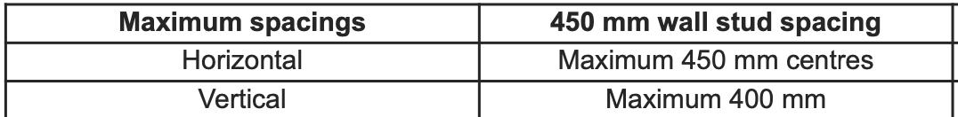

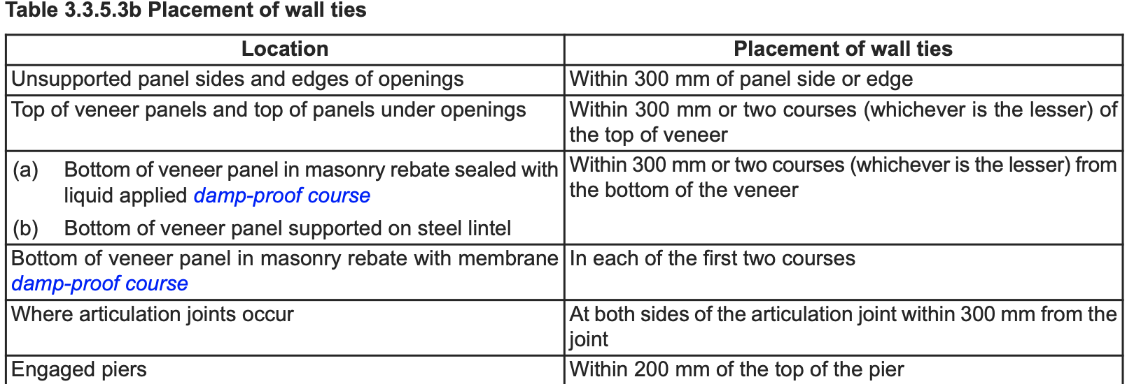

I look forward to receiving the updated drawing notes as soon as practicable.

Thank you

Yours Truly,
Stacey Lui

