BSBPMG517
Manage project risk

PRACTICAL ASSESSMENT INSTRUCTIONS

- The following practical assessment will require the participant to complete work related activities.
- Observations will be conducted of the participant’s work to determine whether they display sufficient practical skills and knowledge.
- Please fill in the details below, providing your name, signature and date of assessment.
  - Your signature acknowledges that the assessor provided clear instructions and the participant understood what was required to complete this assessment.
- The assessor may substitute a Practical Task with another task of equal value.
  - Alternate tasks must be fully documented by the assessor.

Participant name | Daniel Bond
Participant signature | 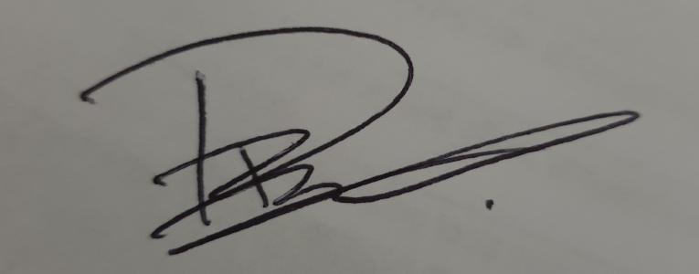

Assessor name
Assessor signature | 

Date | Click here to enter a date.

Number of tasks | Number of tasks completed | Satisfactory?
1 |  | Yes | No

Assessor Comments
BSBPMG517
Manage project risk

Practical Task 1
Description of task:
A suitable observer is to verify the participant’s ability to identify, analyse and refine project costs to produce a budget and use it and the principal mechanism to control project cost.

These tasks may be simulated or real. The participant is to gather evidence of how they have completed each component of the Practical Task, which is to be submitted with this Practical Assessment sheet. The observer is to provide detailed comments on the tasks completed by the participant. The assessor is to verify the observer’s comments in the Assessor Comments section, and provide the Practical Assessment outcome on the front cover of this document.
Resources required:
Workplace risk management documentation (including risk register and risk management plan).
Assessment of task
Name of participant: | Daniel Bond
Name of observer: | Greg Murphy
Role of observer  (Confirm suitability to sign) | Project Manager
Email address of observer | Greg@nardiaplumbing.com.au
Signature of observer: | 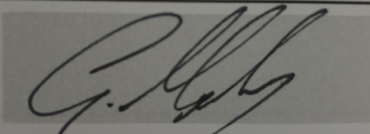
Date: | 13/07/2019
When completing the task, did the participant: |  | Tick if satisfactorily completed.  Provide comments if left unticked.
1 Identify project risks
- Determine project risk objectives, standards and context, with input from stakeholders.
- Identify project risks using valid and reliable risk identification methods.
- Classify project risks within agreed risk categories.
2 Analyse project risks
- Determine risk analysis classification criteria and apply to agreed risk ranking system.
- Use risk analysis processes, within delegated authority, to analyse and qualify risks, threats and opportunities.
- Determine risk priorities in agreement with project client and other stakeholders.
- Document risk analysis outcomes for inclusion in risk register and risk management plan.
3 Establish risk treatments and controls
- Identify and document existing risk controls.
- Consider and determine risk treatment options using agreed consultative methods.
- Record and implement agreed risk treatments.
- Update risk plans and allocate risk responsibilities to project team members.
4 Monitor and control project risks
- Establish regular risk review processes to:
- Maintain currency of risk plans
- Monitor risk environment to identify changed circumstances impacting project risks
- Determine risk responses to changed environment.
- Implement agreed risk responses and modify plans to maintain currency of risk treatments and controls.
5 Assess risk management outcomes
- Review project outcomes to determine effectiveness of risk-management processes and procedures.
- Identify and document risk management issues and recommended improvements for application to future projects.
The participant’s performance was: Satisfactory Not Satisfactory

observer Comments
Great understanding of risk analysis and implementing controls

