Project Plan

Muster Building Extension 2020

Project Manager Christian Turner

Contents

- Project Authorisation
- Accounts Payable
- Project Governance
- Project Scope
- Project Benefits
- Project Outcomes
- Scope Management Plans
- Scope Management Procedures
- Change Management Procedures
- Scope Management faults and recommended improvements
- Work Breakdown Structure
- Schedule
- Schedule Modifications
- Identified scheduling faults
- Improvements for future Projects
- Muster Building Extension Project Gannt Chart
- Muster Building Project Quality Requirements
- Quality Assurance Audit ( ITP attached in Email)
- Budget
- Costings summary
- Cash expenditure flow chart
- Estimating Methodology

Project Authorisation

This project must be approved by BHP representatives from Engineering department and co signed by Mjm owner Matt Murphy or delegate Albert Langford, all information in project plan must be signed off and approved by mine SSE or authorised delegate. All documents once signed must be forwarded to steering committee by Project manager and made available to other relevant stakeholders.

Approval :
Engineering Project Manager or Program Director
……………………..
Matt Murphy
……………………..
SSE or Delegate
……………………..

Accounts payable.

All invoices will be directly forwarded from MJM to BHP program director on the agreed upon dates as follows.

Initial 40% of project total June 1st 2020
30% structure landing completion July 30th 2020
Final installment 30% post hand over.

Project Governance

Project based Governance – All resources managed and controlled by Mjm Project manager Christian Turner and reviewed weekly by Bhp Program Director Dean Grant.
All onsite construction will be co ordinated by Liam Odea and audited for quality by both Project Manger and Program director.

MJM developments Project manager
Christian Turner
MJM Developments Owner or Delegate
Matt Murphy
Albert Langford
MJM Developments Onsite supervisor
Liam Odea

BHP Program Director
Dean Grant

Project Scope

Project boundaries –
Deliverables
MJM agrees to construct four individual buildings off site to be relocated and positioned on a mine site in the Moranbah region. All buildings will adhere to building codes and regulations of Queensland.

The work area and lifting procedure will not interfere with other work groups and regular mine site operation can continue.

Inclusions: For detailed Inclusions see Project Gannt
Site works
Excavations
Footings
Offsite building construction
Lift plan
Lift buildings into position
Fix out internal
Paint

Exclusions:
Landscaping
Electrical
Plumbing
Drainage
Furniture installation
Mine site compliance

Project Benefits

The extension will create 8 more desk spaces for the Operations control of Moranbah based mine, along with the office room the four buildings will accommodate 2 female toilets and 4 males. The remaining space will be reserved for a meeting room.
By providing these extra offices the client BHP is able to decommission pod A saving on infrastructure expenses.
Bhp Engineering department will output $45556556556575 with $5454656556 in reserve incase of variation.

Project outcomes.

From a BHP point of view the most important aspect is completion date and meeting critical path timelines. Mjm agrees to strive to meet these deadlines and document milestone and hold points appropriately. All project phases will be discussed at weekly meeting held on Thursdays at 3pm. Meeting attendees must include at least 2 delegates from each party.

Scope management plan

Deliverables
Phase One- Off site Building Construction
- NDT TESTING
- Painting and steelwork
- Building framing
- Flooring decking and covering
- External wall
- Insulation
- Roofing
- External doors and windows
Phase two – Onsite civil works
- Excavation of footings
- Formwork and steel fixings
- Pour concrete footings
- Measure posts
- Set up area for cranage
Phase three – Buildings lifted to site
- Lift study
- On site notice
- Crane set up and lift
Phase four – Onsite building works
- External cladding at modular joints
- Roof connection and flashings
- Internal wall framing and partitions

Phase five – Handover
Final handover to client is to occur upon completion of phase four. Mjm will handover completed buildings to BHP program director and final invoice will be issued.
The project will be signed off as complete only when:
1. The client is satisfied all deliverables have been completed and delivered to the required quality.
2. Deane Grant from BHP has conducted the final inspection of the constructed buildings and has advised he is happy to sign off on it as per Bhp approval.
3. The client has settled all outstanding contract payments.
4. A completion report has been written, and provided with an updated version of the project plan showing all project activities have been complete.
5. The project plan and other relevant documentation have been examined by both parties to ensure all project due diligence is complete.

Scope management procedures
MJM will conduct construction audits during off site construction and forward these progress audits to BHP delegate weekly.
Onsite audits will be conducted by Christian and Deane prior to the scheduled meeting. The Thursday meeting will give Program director Dean a platform to discuss any scope management variations and convey the changes to Christian (MJM Project manager) so he can update relevant documents.

Change Control Procedures

The BHP Management of Change (MOC) system will be used to manage the change, including all BHP approvals required prior to commencing construction, during construction, building handover and project completion.

1. All suggestions for changes to the project scope, time, cost, quality, human resources, communications, risk, procurement and integration will be sent to the project manager (MJM) who will populate the information into a change request.
2. The details going into the change request will be negotiated between the project manager (MJM) and the program director (BHP).
3. If a SSE approval is needed, the program director (BHP) will commence the application process as needed.
4. The project plan must include all change requests (template provided in Appendix 5), along with an up to date change register.
5. The changes in the project documentation must be clearly colour coded by highlighted text as below. All omitted text must be formatted with strikethrough to show it has been deleted, and must be highlighted with the colour relevant to the version.
a. Change request 1 – Yellow highlighting.
b. Change request 2 – Green highlighting
c. Change request 3 – Blue highlighting
d. Change request 4 – Pink highlighting
6. The change request and all modified documentation is examined at a face to face meeting by Program director BHP (Dean Grant)
Project Manager MJM (Christian Turner)
MJM Owner (Matt Murphy)
MJM Site Supervisor (Liam Odea) and any other stakeholders directly impacted on the change request.
7. The change request is signed off by BHP Program Director Dean Grant
8. The changes are communicated and implemented by the project manager (MJM).

Scope Management faults and recommended improvements.
MJM has been unable to get a clear communication path with material providers.
This has impacted on the critical path and more staffing hours were needed to complete procurement objectives.
It is recommended to not only send plans and quote requests by email but also to get phone clarification by project manager that the vendors have received and are following up on said plans and quotes.

Work Breakdown Structure Muster Building Extension
Construction Phase 1

- Off site Building Construction
- Ndt testing
- Painting
- Framing of building
- Flooring joists and coverings
- External coverings
- Roofing
- Insulation
- External windows and doors
- Misc items

- Civil Works
- Concrete curing
- Measure and fab posts

- Building Landed on site
- Site notice
- Lift study
- Crane set up
- Escort Trucks
- Lift buildings into place
- Fix down

- Site Building works
- External Wall cladding at modular joints
- Roof connection and flashings
- Internal wall frames and partitions
- Electrical contractors

Engineering Phase 2
2.1 Architectural designs and drawings
• Ifc design and drawings

2.2 Civil/ structural
• Building plans
• Structural plans
• Engineering plans
• Building compliance

2.3 Electrical
• Lighting design
• Power layout

Project Management Phase 3
- Planning
- Project Admin and reporting
- HR
- Contract management
- Project auditing
- Financial Management

Schedule
The schedule of this project needs to primarily work around the construction of the muster buildings off site.
A summary of the schedule at each phase of the project appears below.
Phase 1: Off Site Building Construction
The project commences on Monday 15th of June 2020. Expected Finish date 16/09/20.
The Engineering phase will need to be complete prior to the commencement of the construction of the buildings off site. The expected start and completion of this phase will be 2/03/20 to 12/06/20.
Phase 2: Engineering 2/03/0 – 12/06/20
Phase 3: Project Management
This will coincide with the Engineering and construction phases and will continue until the handover on the expected date of 16/09/20.
The project schedule has been broken down by task and has been attached as a WBS ( See above).
Schedule Modifications

All schedule changes and hold points will be discussed at Thursday weekly meeting and signed of by MJM Project Manager and BHP Program Director. The documentation will be amended post meeting by MJM Project manager and forwarded to relevant stakeholders. The Gannt and WBS will be revisited at the following weekly meeting once updated with changes.

Identified scheduling issues
- Weather has impacted the completion of the muster buildings off site which has pushed back all works associated with the completion of project including crane lift and building transport.
- Some of the materials were not supplied on time and created a hold point off site for building crew.

Recommended Improvements for future projects
- If possible, use shed space more effectively and try build each module under cover one at a time.
- Follow up on all emailed orders.

Muster Building Extension Project Gannt Chart Can be found as a Pdf attached on email. Or below as word document.
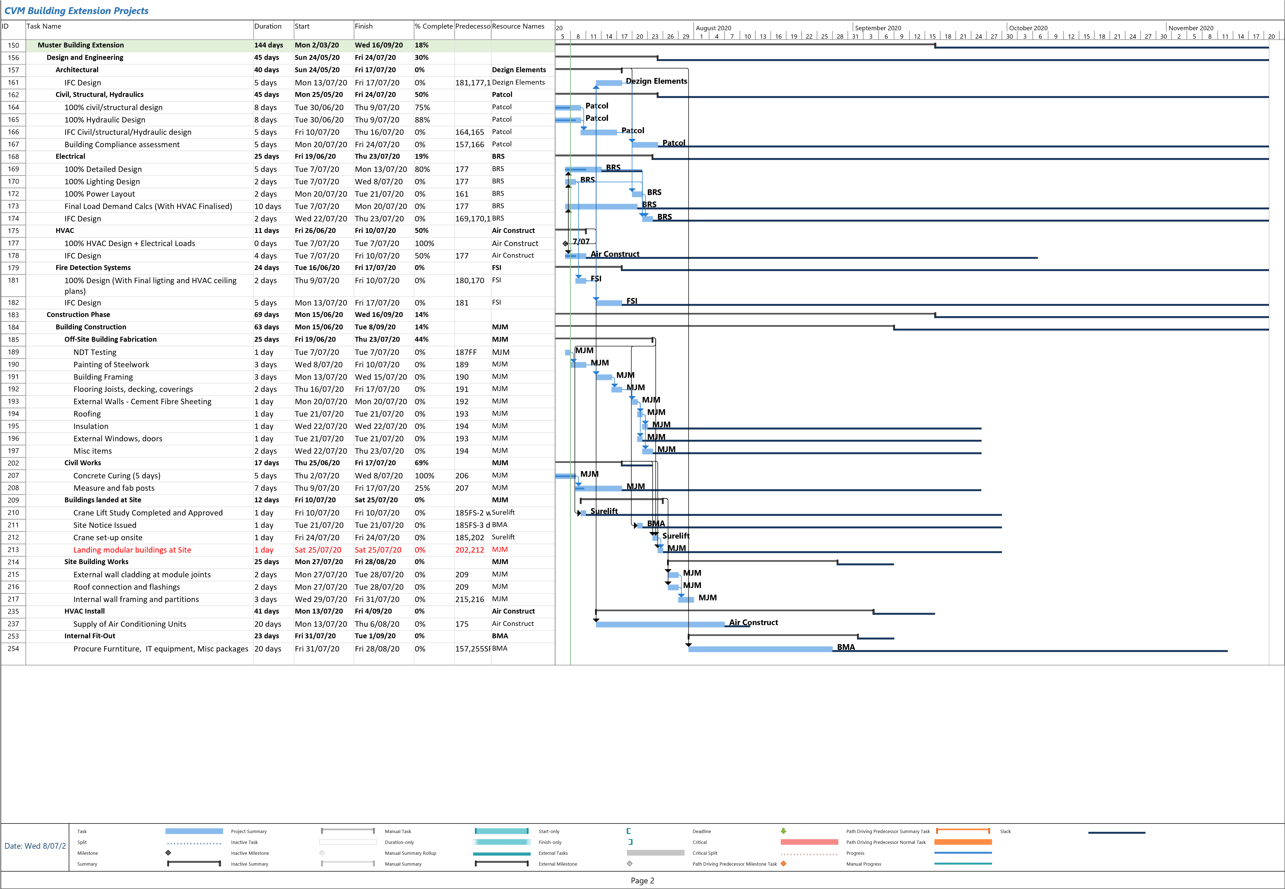
Muster Building Project Quality Requirements.

Construction work shall not commence until the respective Inspection Test Plan (ITP) templates are complete and approved by BHP Program Director or Delegate. ITPs shall include Hold Points and Witness Points and incorporate specification references. All testing and inspection data shall be recorded progressively on the approved quality control check sheets held by MJM Project management team (Christian Project Manager / Liam supervisor).
MJM project team shall ensure that all quality systems, ITP’s, procedures and protocols are in place and are implemented to demonstrate compliance with the requirements of the specifications and drawings and relevant Australian Standards.
Where required as per Scope of Work, AS or BHP standard, testing shall be performed by NATA accredited laboratories.
3rd party inspections shall be performed by the building engineers.

Quality requirements will be conveyed to Mjm supervisors and contractors at each tool box meeting and at every commencement of a phase by Project Manager Christian Turner.

MJM shall include a procedure for the management and control of non-conformances. Any non-conforming components must not be covered up nor be further incorporated into the goods in unless the non-conformance has been rectified.
A notice of any non-conformance must be provided to BHP as soon as reasonably possible, and a clear detailed plan to rectify provided.
MJM will be responsible for maintaining a punch/defects list to manage any defects or additional works required to deliver the project in accordance with the scope and to adhere to all quality requirements.

Quality Assurance Audit

The Project Management team from MJM endeavors to put the three Quality management concepts into play throughout all projects and keep these in mind while conducting quality audits.
- Customer Satisfaction
- Prevention Over Inspection
- Continuous Improvement
Project Name: Muster Building Extension
Prepared By: Christian Turner
Date: 15/07/20
Project Manager:  Christian Turner | Audit Team:  Liam Odea , Albert Langford , Jayke Hanson
Date of audit: 10/08/20 |  | Overall Project status: 45% |  | Audit Number: 4

Please refer to ITP template sent separately.

Manage Project Costs
Budget
MJM has allowed approximately $300,000 for Muster Building Budget, Initial estimates and costings total $236.650 which leaves a reserve of $63,350 for contingency. MJM has a float of $150,000 and will be able to cover expenses until time of first invoice payment 40% of total project on June 1st 2020. This payment will total $120,000. Combining first payment and MJM cash float to a total of $270,000 all estimated costs will be achievable throughout lifecycle of project.
No cash flow discrepancies are expected.
The table below shows a broad view of the total project costs broken into phases.

Phase | Labour | Procurement | Purchase | Total
Engineering | $15,000 | $10,000 | $1000 | $26,000
Construction | $30,000 | $100,000 | $50,000 | $180,000
Building Lift | $5,000 | $5,000 | $500 | $10,500
Project Management | $20,000 | $0 | $150 | $20,150
Total | $70,000 | $115,000 | $51,650 | $236,650

Detailed Summary of Costings

Project Phase | Labour cost
 | Time | Cost | Procurement cost |  | Purchase Cost | Total Cost
Engineering | 150 hrs | $15.000 | $10,000 |  | $1000 | $26,000
Architectural Drawings and design | 20 | $2000 | $1500 |  |  | $3500
Building plans | 20 | $3000 | $1500 |  |  | $4500
Structural Plans | 20 | $2000 | $2000 |  |  | $4000
Engineering Plans | 30 | $2500 | $1000 |  |  | $3500
Building compliance | 10 | $500 | $1500 |  | $1000 | $3000
Electrical plans | 20 | $3000 | $1000 |  |  | $4000
Electrical design | 20 | $1000 | $1500 |  |  | $2500
Electrical Installation / contractor | 10 | $1000 |  |  |  | $1000
Construction | 400 hrs | $30,000 | $100,000 |  | $50,000 | $180,000
NDT Testing | 10 | $750 |  |  |  | $750
Painting | 30 | $2250 | $2000 |  | $5000 | $9250
Framing and Building | 70 | $5250 | $20,000 |  | $5000 | $30250
Flooring Joists and Coverings | 60 | $4500 | $28,000 |  | $5000 | $37500
External Coverings | 35 | $2625 | $25,000 |  | $5000 | $32625
Roofing | 25 | $1875 | $10,000 |  | $5000 | $16875
Insulation | 15 | $1125 | $1000 |  | $5000 | $7125
External Windows and Doors | 50 | $3750 | $9000 |  | $5000 | $17750
MISC Items | 20 | $1500 | $1500 |  | $5000 | $8000
Concrete | 45 | $3375 | $2000 |  | $5000 | $10375
Post FABRICATION | 40 | $3000 | $1500 |  | $5000 | $9500
Building Lift | 100 | $5000 | $5000 |  | $500 | $10500
Site Notice | 5 | $250 |  |  |  | $250
Lift Study | 15 | $750 |  |  |  | $750
Building Transport | 25 | $1250 | $2000 |  |  | $3250
Crane Rental | 12 | $600 | $2000 |  |  | $2600
Building  tie down | 43 | $2150 | $1000 |  | $500 | $3650
Project Management | 134 | $20000 |  |  | $150 | $20250
Planning | 30 | $4500 |  |  | $150 | $4650
Project Admin | 20 | $3000 |  |  |  | $3000
Project Reporting | 15 | $2250 |  |  |  | $2250
HR | 15 | $2250 |  |  |  | $2250
Contract Management | 10 | $1500 |  |  |  | $1500
Project Auditing | 20 | $3000 |  |  |  | $3000
Financial Management | 24 | $3600 |  |  |  | $3600
 |  | $100 over budget
Flow Chart of Project expenditure

Estimating Methodology.
The estimating methodology for this project budget is based on MJM mine site rates and quotes associated with individual projects. The methodology used to calculate the figures are as follows:
Staff costs - MJM and Contracted work force –The hourly rate has been calculated based on the staff member’s hourly wage or salary. This figure is multiplied by 1.3 to cover leave entitlements and staff administration costs.
All procurement and purchase costs are invoiced directly to MJM and falls under project budget. Large quantity materials can be cross referenced by client if deemed necessary.

