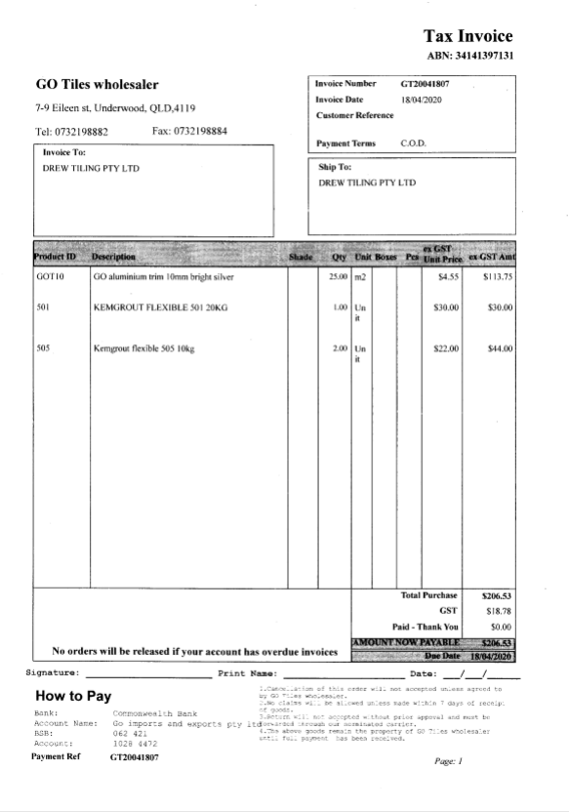

Dear Tiling Team,

I already ordered some trim and grout for Lot 3 Darre St job, and they will be deliver before you start. Tiles and Glue already on site.

Thanks
Guangyu

