BSBWHS431
Develop processes and procedures for controlling hazardous chemicals in the workplace
ASSESSMENT SUMMARY

The assessment activities for BSBWHS431 Develop processes and procedures for controlling hazardous chemicals in the workplace cover all aspects of the unit of competency required. To demonstrate competence in this unit, a participant must undertake all tasks and complete them satisfactorily and consistently. For Apprentices and Trainees, this includes employer completion of the Employer Record Book (ERB).

Participants must read all the information given before starting any assessment task. The assessment tasks are intended to be equitable, fair and flexible. If a participant has any questions or requires alternative arrangements to be made such requests should be directed to their Trainer/Assessor, who should note such arrangements in the ‘Assessor Comments’ on the affected assessment. If a participant feels they are not yet ready to be assessed, they should discuss their options with their Trainer/Assessor.

To satisfactorily complete the assessment, the participant is required to answer all questions correctly and demonstrate their skills to industry standards. If a participant does not answer some questions or perform some tasks, they will be deemed ‘Not Satisfactory’ for the task and ‘Not Yet Competent’ for the unit of competency. The Trainer/Assessor is able to provide the participant with additional information on interpreting the assessment outcomes and provide guidance on the participant’s options. Should a participant still be deemed ‘Not Satisfactory’ they will have the opportunity to undertake a supplementary assessment or appeal the result.

By signing the cover page for each assessment item, the participant acknowledges they understand the assessment instructions and requirements and consent to being assessed. The participant also verifies and assures the RTO that the work submitted is their own work.

Participant Name | Casey Wait

Task | Assessment Results
Workbook | Satisfactory | Not Yet Satisfactory
Quiz | Satisfactory | Not Yet Satisfactory
Practical Assessment | Satisfactory | Not Yet Satisfactory
Outcome for Unit of Competency | Competent | Not Yet Competent

Assessor Name
Assessor Signature | 
Unit Competence Determination Date | Click here to enter a date.

BSBWHS431
Develop processes and procedures for controlling hazardous chemicals in the workplace

WORKBOOK INSTRUCTIONS

- This workbook will occur under standard assessment conditions.
  - An oral assessment may be allowed under certain circumstances, whereby the Participant’s answers will be documented by a party other than the Participant. This must be acknowledged in writing (e.g. FT001 and Assessor Comments)
- Participants must provide enough detail in their responses to demonstrate their knowledge and skills.
- Please fill in the details below, providing your name, signature and date of assessment.
  - Your signature acknowledges that this is your own work.
- Assessors are to complete marking in pen of a different colour to the Participant.
- If a Participant initially answers a question incorrectly but modifies their response, they must follow the instructions below:
  - If a Participant changes their response in writing, they must put their initials next to the written change.
  - If a Participant changes their response verbally, this must be noted on the document by the assessor.

Participant name | Casey Wait
Participant signature | 
Date | 18/04/2024

Assessor name
Assessor signature
Date | Click here to enter a date.

Number of activities | Number of activities answered correctly | Task outcome (Tick)
4 |  | Satisfactory | Not Yet Satisfactory

ASSESSOR Comments
NOTE

At times, you will be provided with a specific business context to which you must respond, otherwise it is anticipated that you will use a workplace of your choosing (your own, or hypothetical) to provide the context to the task.

At all times, the responses in your assessment must reference Australian (Queensland or Federal) documentation, including legislation, regulations, codes of practice, standards and guidance publications.

For the following activities, name a workplace that you wish to examine.

Name of workplace | Hutchinson Builders

Identify the duty holders and their range of duties regarding the control of hazardous chemicals by explaining the legislative requirements for the topics listed below:
- Labelling hazardous chemicals
- Obtaining and giving access to safety data sheets
- Hazardous chemicals register
- Management of risk
- Safety signs
- Spills and damage
- Emergency and safety equipment
- Storage and handling systems
- Health monitoring and records
- Induction, information, training and supervision

Labelling hazardous chemicals
The below must be on a label:
- Name of the product
- The name, Australian address, and business telephone number of either the manufacturer or importer
- Identity and proportion disclosed, in accordance with schedule 8 of the WHS regulations for each chemical ingredient.
- Any hazardous pictograms, hazard statements, signal word and precautionary statements
- Any information about the hazards, first aid, and emergency procedures relevant to the chemical, which are not otherwise included in the above
The expiry date of the chemical, if applicable.

Obtaining and giving access to safety data sheets
The PBCU must give access to all SDS’s for products used to workers.
The WHS Regulation provides for an exemption for having to obtain and give access to an SDS when:
- hazardous chemicals are in transit.
- the PCBU is a retailer, and the hazardous chemical is a consumer product and intended for supply and not intended to be opened on the premises
- the hazardous chemical product is a consumer product used in quantities and a manner which is consistent with household use and incidental to the nature of the work carried out by a worker using the hazardous chemical.

Hazardous chemicals register
The register of an SDS is required under section 346 and should be used as an information tool to make sure everyone is involved in managing hazardous chemicals exposure at the workplace. A register is a list of the hazardous chemical products and the current SDS for each of those products that is readily accessible to a worker and anyone else who is likely to be affected by the hazardous chemical.

Management of risk
A person conducting a business or undertaking must manage risks associated with using, handling, generating, or storing of hazardous chemicals at a workplace. In order to manage risk under the WHS Regulations, a duty holder must: a) identify reasonably foreseeable hazards that could give rise to the risk b) eliminate the risk so far as is reasonably practicable c) if it is not reasonably practicable to eliminate the risk – minimise the risk so far as is reasonably practicable by implementing control measures in accordance with the hierarchy of risk control d) maintain the implemented control measure so that it remains effective e) review, and if necessary revise all risk control measures so as to maintain, so far as is reasonably practicable, a work environment that is without risks to health and safety.

Safety signs
Safety signs are a risk control measure for using, handling, generating, and storing hazardous chemicals.
A safety sign has:
- warnings about hazards
- information about a particular person’s responsibilities with a hazardous chemical.
You must put the sign next to the hazard, and it must be clearly visible to people approaching the hazard.

Spills and damage
As a PCBU you must ensure, so far as is reasonably practicable, that where there is a risk of a spill or leak of a hazardous chemical in a solid or liquid form, provision is made in each part of the workplace where the hazardous chemical is used, handled, stored or generated for a spill containment system that contains within the workplace any spill or leak of the hazardous chemical and any resulting effluent.

Emergency and safety equipment
As a PCBU that uses, handles, generates, or stores hazardous chemicals you must ensure that equipment is always available at the workplace for use in an emergency. The type of emergency equipment required to respond to an emergency, contain and clean up spills and assist workers in conducting emergency procedures safely will vary depending on the type and quantities of hazardous chemicals at the workplace. Equipment must be located so it is readily accessible for all workers if an emergency arises. If safety equipment is needed to respond to an emergency, you must ensure that it is provided, maintained and readily accessible at the workplace. Safety equipment for use with hazardous chemicals should be compatible with the hazardous chemicals they may come in contact with. For example, water fire extinguishers must not be used on oil fires.

Storage and handling systems
Even when not in use, chemicals can still pose a risk. Flammable and oxidising chemicals may cause or contribute to a fire, corrosive chemicals can injure people and damage property and structures they come into contact with and toxic chemicals can poison people who are exposed to them. Compressed gases can also suffocate or poison workers if they leak. Additionally, some chemicals are not compatible with one another. When incompatible chemicals mix they may:
• ignite or explode
• release toxic, flammable or corrosive gases, or
• corrode chemical containers, causing them to leak.

It’s important that you identify which chemicals are incompatible and ensure that hazardous chemicals are stored safely in a way that:
• minimises the chance of any incidents and reactions, and
• reduces the chance that stored chemicals will contribute to or worsen an incident.

Health monitoring and records
Health monitoring of a worker means monitoring the worker to identify changes in their health status because of exposure to certain substances. It involves the collection of data to measure exposure or evaluate the effects of exposure and to determine whether or not the absorbed dose is within safe levels.
You must:
• inform workers and prospective workers about health monitoring requirements
• ensure health monitoring is carried out by or under the supervision of a registered medical practitioner with experience in health monitoring
• consult workers in relation to the selection of the registered medical practitioner
• pay all expenses relating to health monitoring
• provide certain information about a worker to the registered medical practitioner
• take all reasonable steps to obtain a report from the registered medical practitioner as soon as practicable after the monitoring has been carried out
• provide a copy of the report to the worker as soon as practicable after obtaining the report
• provide a copy of the report to the regulator if the report contains test result that indicate the worker may have contracted a disease, injury or illness or recommends remedial measures should be taken as a result of the work that triggered the requirement for health monitoring
• provide the report to all other persons conducting a business or undertaking who have a duty to provide health monitoring for the worker as soon as reasonably practicable after obtaining the report
• keep reports as confidential records for at least 30 years after the record is made (40 years for reports relating to asbestos exposure)
• not disclose the report to anyone without the worker’s written consent unless required under the WHS Regulation..

Induction, information, training and supervision
The WHS Act requires that a PCBU ensure, so far as reasonably practicable, the provision of any information, training, instruction, or supervision that is necessary to protect all persons from risks to their health and safety arising from work carried out as part of the conduct of the business or undertaking. As a PCBU you must ensure that information, training, or instruction provided to a worker is suitable and adequate having regard to:
• the nature of the work carried out by the worker
• the nature of the risks associated with the work at the time the information, training or instruction is provided
• the control measures implemented.

Satisfactory Outcome

Explain the requirements of your organisation regarding the control of hazardous chemicals by identifying the requirements found in the WHSMS (i.e. policies, procedures and processes) for:
- Control of hazardous chemicals (including accessing internal and external sources of WHS information and data)
- Recording outcomes of monitoring and distributing to required personnel

Control of hazardous chemicals
WHS policy
WHS Policy – Hutchinson Builders
Hutchies is committed to conducting its business so that the health, safety and wellbeing of all workers and other parties who may be affected by our activities are not compromised. Identifying, assessing and planning controls to mitigate risks associated with our activities
WHS procedure
SP 01 / Hazardous Substances
Prior to the commencement of work where there are hazardous substances in use, the following information is required to be provided to Hutchies’ site management
Safety Data Sheet (SDS), Hazardous Substances Register, Hazardous Substances Risk Assessment, Hazardous Substances/ Dangerous Goods Training Records, Safe Work Method Statements (SWMS)

WHS process
Work Health and Safety Management Plan
In advance of the use or arrival of hazardous chemicals to the project the substances are to be registered with the site team on HammerTech. Registration requires that a current Safety Data Sheet (SDS) is uploaded with information on the substance along with any additional risk assessments or training documentation. A Hazardous Chemical Register is maintained in HammerTech and can be accessed by all workers (along with the relevant SDS) via site posters located in the site compound and at designated storge locations. Full registers can be downloaded by the site team as required.

Recording outcomes of monitoring and distributing to required personnel
WHS policy
WHS Policy – Hutchinson Builders
Hutchies is committed to conducting its business so that the health, safety and wellbeing of all workers and other parties who may be affected by our activities are not compromised. Consulting with and involve workers on matters of health, safety and wellbeing

WHS procedure
SP 01 / Hazardous Substances
Personnel are trained in the handling, use and proper storage requirements associated with the hazardous substance/ dangerous good as well as in the correct use and maintenance of PPE. Relevant SWMS are associated with the use of hazardous chemicals and these are to be reviewed by personnel before works are started.
WHS process
Work Health and Safety Management Plan
In advance of the use or arrival of hazardous chemicals to the project the substances are to be registered with the site team on HammerTech. Registration requires that a current Safety Data Sheet (SDS) is uploaded with information on the substance along with any additional risk assessments or training documentation. A Hazardous Chemical Register is maintained in HammerTech and can be accessed by all workers (along with the relevant SDS) via site posters located in the site compound and at designated storge locations. Full registers can be downloaded by the site team as required.

Satisfactory Outcome

Identify one (1) hazardous chemical that may be used in your workplace and respond to the following points. Identify the source of your information for each response (e.g. SDS).
- The range of harms caused by the chemical and how they are caused
- Identify exposure standards, environmental requirements, and storage specifications
- Identify one (1) specialist you may seek advice from about emerging issues and potential risks from exposure to the chemical
- Workplace tasks involved with the chemical
- The level of risk for the chemical within your workplace
- Describe a safe system of work (including risk controls) that may be implemented to address the hazardous chemical and risk assessment results
- Consider the hierarchy of control and any legal requirements
- Identify who you would seek feedback from when developing processes and procedures
- How you advise others of safe systems of work
- Identify the individuals and parties who should be notified (i.e. because they are at risk or are required to implement controls)
- Describe the process you would undertake to evaluate the implementation of the safe system of work and identify non-compliances
- Explain how findings should be recorded
- Identify who should be notified of the outcomes of monitoring

Name of chemical
Lead (from lead acid batteries) which causes lead poisoning

The range of harms caused and how they are caused
Amplify 95 (Won’t let me amend name of chemical above)

Hazard Classifications
Flammable Liquids - Category 2
Aspiration Hazard - Category 1 Skin Corrosion/Irritation - Category 2
Germ Cell Mutagenicity - Category 1B
Carcinogenicity - Category 1B
Specific Target Organ Toxicity (Single Exposure) - Category 3 Narcotic Effects Chronic
Hazard to the Aquatic Environment - Category 2

Hazard Statements:
H225 Highly flammable liquid and vapour.
H304 May be fatal if swallowed and enters airways.
H315 Causes skin irritation.
H336 May cause drowsiness or dizziness.
H340 May cause genetic defects .
H350 May cause cancer .
H411 Toxic to aquatic life with long lasting effects.

Classified as Dangerous Goods by the criteria of the "Australian Code for the Transport of Dangerous Goods by Road & Rail" and the "New Zealand NZS5433: Transport of Dangerous Goods on Land"

If poisoning occurs, contact a doctor or Poisons Information Centre (Phone Australia 131 126, New Zealand 0800 764 766).

Handling: Avoid eye contact and skin contact. Avoid inhalation of vapour, mist or aerosols.
Storage: Store in a cool, dry, well-ventilated place and out of direct sunlight. Store away from foodstuffs. Store away from incompatible materials described in Section 10. Store away from sources of heat and/or ignition. Store locked up. Keep container standing upright. Keep containers closed when not in use - check regularly for leaks.

Workplace tasks
Refuelling Plant and Equipment
Determine the level of risk
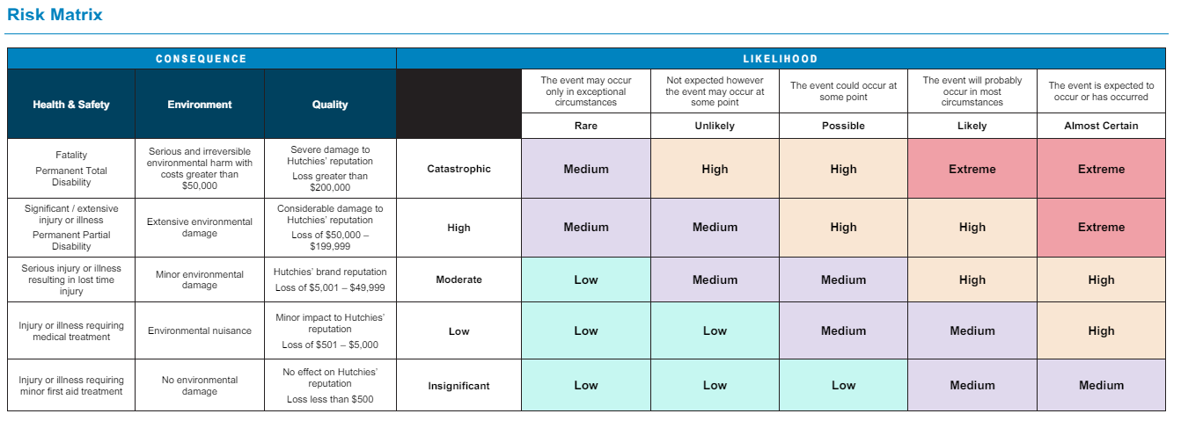
Safe system of work
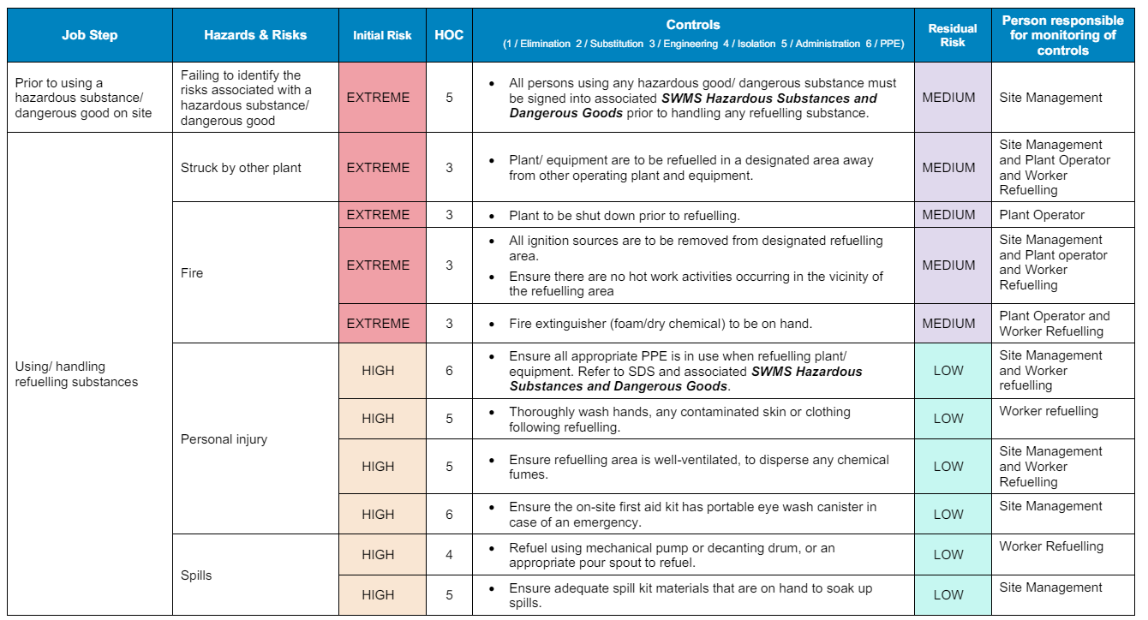
How you advise others about safe systems of work
Reviewing SWMS and SOP’s to workers, creating exclusion zones and making the SDS available to all personnel on site
System review
After ensuring administrative controls are in place and workers are consulted about the hazardous chemical, further inspections/ audits of the work area should be completed. An audit report should outline if the chemical was used/stored incorrectly indicating that the control measures in place need to be reviewed. Toolbox talks should be implemented if any non-conformances arise from workers. All workers should be advised of any non-conformances.

Satisfactory Outcome

For the safe system of work identified in Activity 3, outline what training and development opportunities you may provide to assist in compliance with safe systems of work.

Training and development
I would provide a site toolbox talk to all personnel regarding the hazardous chemical and the correct use/ storage requirements and the potential hazards. I would also include the hazardous chemical into SWMS so workers can review.

Satisfactory Outcome

BSBWHS431
Develop processes and procedures for controlling hazardous chemicals in the workplace

QUIZ INSTRUCTIONS

- This quiz will occur under standard assessment conditions.
  - An oral assessment may be allowed under certain circumstances, whereby the Participant’s answers will be documented by a party other than the Participant. This must be acknowledged in writing (e.g. FT001 and Assessor Comments)
- Participants must provide enough detail in their responses to demonstrate their knowledge and skills.
- Please fill in the details below, providing your name, signature and date of assessment.
  - Your signature acknowledges that this is your own work.
- Assessors are to complete marking in pen of a different colour to the Participant.
- If a Participant initially answers a question incorrectly but modifies their response, they must follow the instructions below:
  - If a Participant changes their response in writing, they must put their initials next to the written change.
  - If a Participant changes their response verbally, this must be noted on the document by the assessor.

Participant name | Casey Wait
Participant signature
Date | 18/04/2024

Assessor name
Assessor signature
Date | Click here to enter a date.

Number of questions | Number of questions answered correctly | Task outcome (Tick)
11 |  | Satisfactory | Not Yet Satisfactory

ASSESSOR Comments
- Which of the following would need to be recorded on a workplace register for hazardous chemicals? Tick all that apply.

Answer | Choice | Possible Answers
 |  | Acids
 |  | Disinfectants
 |  | Glue
 |  | Paint
 |  | Water

- The ‘Managing risks of hazardous chemicals in the workplace – Code of Practice 2013’ describes the types of labels that may be present on chemicals used when working.
Match the following pictograms and their meanings by writing the appropriate letter next to each number in the centre column.

Answer | Meaning |  |  | Pictograms
 | 1 | Warning | 1 - C | A | 
 | 2 | Human health | 2 - D | B | 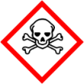
 | 3 | Acute toxicity | 3 - B | C | 
 | 4 | Corrosive | 4 - E | D | 
 | 5 | Flammable | 5 - A | E | 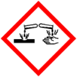

- For chemicals stored indoors, where must safety signs be placed?
Tick the most appropriate response.

Answer | Choice | Possible Answers
 |  | Not publicly, to avoid drawing attention (e.g. in manifest)
 |  | At the entry to the specific room
 |  | At the main entrance to the workplace

- Which two (2) factors are considered when assessing risks?
Tick all that apply.

Answer | Choice | Possible Answers
 |  | Consequence
 |  | Cost of risk control
 |  | Likelihood of occurrence
 |  | Observance of legislation

- True or False (Tick your response): Information about hazards and risks can come from both internal sources (e.g. policies and procedures, workplace monitoring results) and external sources (e.g. specialists on emerging issues, training).

Answer |  | True
 |  | False

- Order the elements of the hierarchy of control, from 1 to 6 (i.e. most effective to least effective).

Answer | Label (1 – 6) | Element
 | 3 | Isolate the hazard
 | 6 | Provide and use Personal Protective Equipment (PPE)
 | 1 | Eliminate the hazard
 | 4 | Control the hazard by engineering means
 | 5 | Control the hazard by administrative means
 | 2 | Substitute the hazard

- True or False (Tick your response): In Queensland, the Agricultural Chemicals Distribution Control Act 1966 may require that you hold a commercial operator’s licence if you intend to use ground equipment to distribute herbicides.

Answer |  | True
 |  | False

- True or False (Tick your response): You can apply for a permit to allow for the legal use of chemicals in certain ways that are contrary to the label instructions or for the limited use of an unregistered chemical product.

Answer |  | True
 |  | False

- Which of the following information can be found in a Safety Data Sheet (SDS)? Tick all that apply.

Answer | Choice | Possible Answers
 |  | Disposal requirements
 |  | Handling and processing requirements
 |  | Transportation and storage limitations
 |  | Safe use of product

- When monitoring chemicals in the workplace, which of the following information and data should be reported? Tick all that apply.

Answer | Choice | Possible Answers
 |  | Interpretation of results (e.g. non compliance)
 |  | The process undertaken
 |  | Information about equipment that was not used
 |  | Effects for workers and the workplace

- True or False (Tick your response): All health monitoring reports must be submitted to the regulator.

Answer |  | True
 |  | False

BSBWHS431
Develop processes and procedures for controlling hazardous chemicals in the workplace

PRACTICAL ASSESSMENT INSTRUCTIONS

- The following practical assessment will require the Participant to complete work related activities.
- The Assessor will conduct observations of the Participant’s work to determine whether they display sufficient practical skills and knowledge.
- Please fill in the details below – providing your name, signature and date of assessment.
  - The Participant’s signature acknowledges that the Assessor provided clear instructions and the Participant understood what was required to complete this assessment.
- The Assessor may substitute a Practical Task with an alternate task of equal value.
  - Alternate tasks must be fully documented by the assessor in the Assessor Comments area.

Participant name | Casey Wait
Participant signature
Date | 13/05/2024

Assessor name
Assessor signature
Date | Click here to enter a date.

Task | Task outcome (Tick)
Task | Satisfactory | Not Yet Satisfactory
Task 1 (Occasion 1)
Task 1 (Occasion 2)

Assessor Comments
BSBWHS431
Develop processes and procedures for controlling hazardous chemicals in the workplace

Practical Task 1 (2X)
Description of task:
The participant is to consult with the PCBU and review a chemical register to identify two (2) hazardous chemicals in the workplace. These may reflect actual workplace circumstances or the provided chemical register. The participant is to draft, develop and communicate processes and procedures for the control of each chemical.

In response to observing non-compliances with the implementation of the processes and procedures, the participant is to develop and deliver a short presentation (e.g. PowerPoint presentation slides with accompanying face-to-face delivery or real-time video, as arranged with your assessor) to address compliance requirements of workers.

The participant is to submit the following evidence with this Practical Assessment sheet. There should be two (2) of each of the following documents submitted (i.e. one for each chemical):
- Processes and procedures for control hazardous chemical
- Email communications with:
  - PCBU – identifying hazardous chemicals, and seeking feedback about processes and procedures
  - Workers – promoting developed processes and procedures
- Presentation materials (e.g. PowerPoint)

The assessor is to provide detailed comments on the tasks completed by the participant. Detail should be recorded in the Assessor’s Comments (e.g. questions asked by assessor during presentation).
Resources required:
Computer, Chemical Register, SDS, Code of Practice.
Assessment of task
Name of participant:
Name of assessor:
Location:
Date:
When completing the task, did the participant: |  | Tick if satisfactorily completed.  Provide comments if left unticked.
 |  | 1st  Occasion | 2nd  Occasion
1 Hazard and risk identification
- Consult with PCBU and chemical register to identify hazardous chemical used in the workplace.
- Identify workplace tasks involving identified hazardous chemical.
- Refer to legislation, codes of practice and SDS to identify requirements for identified hazardous chemical regarding:
- Licences and permits
- Safe use, handling, processing and disposal
- Exposure standards, and associated monitoring
- Transportation and storage (including labelling and signage)
- Determine potential worker exposure to identified hazardous chemical – using specialist advice, as required.
- Assess risks associated with identified hazardous chemical, reflecting on information from workplace environmental monitoring.
2 Develop and monitor processes and procedures
- In line with organisational requirements, develop safe systems of work, policies and procedures addressing:
- Safe work practices
- Risk control measures, as per hierarchy of control
- Incident response
- Seek and integrate PCBU feedback about developed processes and procedures.
- Using email, communicate and promote developed processes and procedures to workers.
- Monitor and review implementation of control processes and procedures, identifying non-compliances.
3 Maintaining WHS legislative compliance
- Develop a presentation for workers which covers:
- Identification of PCBU’s duties regarding identified hazardous chemical
- Non-compliances highlighted from workplace monitoring
- Recommendations for improvements
- Deliver presentation (in person/via live stream video) and listen to your audience to respond appropriately to any questions.
The Participant’s performance was: Satisfactory Not Satisfactory

HAZARDOUS CHEMICAL REGSITER | comments | - Flammable liquid  - Aspiration hazard  - Skin corrosion/irritation | - Poisons Schedule S6  - Flammable  - Corrosive | - Flammable liquid/vapour  - Harmful if swallowed | - Organ toxicity  - Toxic to aquatic life | - Flammable liquid/vapour  - Serious eye irritation | - Highly flammable liquid and vapour
HAZARDOUS CHEMICAL REGSITER | location | Workshop cage | Workshop cage | Workshop cage | Outdoor storage area | Office | Indoor kitchen area
HAZARDOUS CHEMICAL REGSITER | quantitiy | 20L | 500ml | 4L | 1L | 250ml | 500ml
HAZARDOUS CHEMICAL REGSITER | issue date of sds | 11/08/2016 | 27/06/2017 | 10/12/2018 | 08/05/2019 | 15/02/2020 | 26/03/2020
HAZARDOUS CHEMICAL REGSITER | nAME OF CHEMICAL | Mineral Turpentine | Ajax Hydrogen Peroxide 30% 100 VOL | Acetone | Esplanade Herbicide | Sanikleen  (Ethyl alcohol) | Rasmsol Disinfectant Spray

