For this task, I have reviewed the contract terms for completion of work and verified that the terms have been met and issued the relevant certificates for completion of work. (please also refer to WPA Task 13 document)
And the copies of certificates issued upon completion of work will contain the below (also refer to screenshot below for details)
A Certificate of Final Completion will state that the main parties of the construction project and include when construction project began, when the final date was, and what work was completed, along with the final construction cost that was paid. Also, all related construction contract and final inspection documentation were collated in order to issue the completion certificate.

Certificate of Practical completion
The Contractor states that the Works at have reached Practical Completion for Project - 123 ABC RESIDENTIAL STREET, QLD, which commenced on 5/3/23 as:
- upon inspection of the Works, the Owner was satisfied that the Works had reached Practical Completion in accordance with the requirements of the Contract; and
- the Contractor has provided the Owner with all written evidence (including, where the Owner has not engaged the building certifier, copies of all relevant certificates of inspection produced or held by the building certifier) that all relevant inspections and approvals required by the Planning Act 2016 and the Building Act 1975 and any body having the relevant jurisdiction were satisfactorily completed; and
- If the Owner or their representative claims that there are minor defects or minor omissions, the Contractor has compiled with the Owner or their representative, and signed, Defects Documents; and
- the Contractor has handed over the Works (including all keys and other access devices) to the Owner in exchange for payment of the Progress Claim for the Practical Completion Stage.
The Final date of major works was: 5/5/23
The Date of Practical Completion was: 5/5/23

(Signed by the Owner/Owner’s Representative)
SIGNED: Big Boss
ABC RES Company
DATED: 6/5/23

(Signed by the Contractor/Contractor’s Representative)
SIGNED: NAO
Knights CBI
DATED: 6/5/23

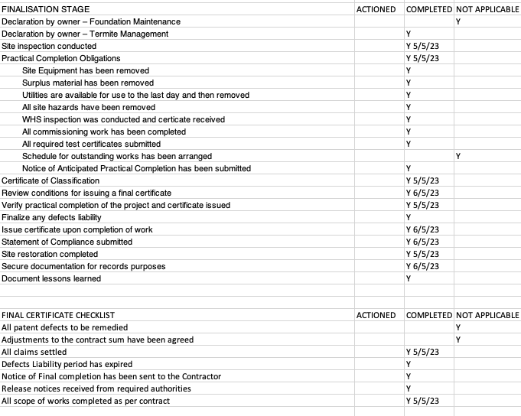

The Final Inspection Certificate follows the below as required:
Who can complete and sign a Form 21? (section 99(2) of the Building Act 1975)
The relevant building certifier must complete and sign the Form 21 for the purpose of stating the work is certified compliant with the building development approval.
The building certifier is required to attach to this form, all relevant inspection documentation that has been relied on by the building certifier to certify the building work complies with the building development approval. Inspection documentation, for inspection of building work, means the following documents given for the building work:
- a compliance certificate
- a notice, given to the builder for the work by or for the building certifier about an inspection of the work
- a certificate about an inspection under this Act
- a final inspection certificate
- a certificate of occupancy
- a certificate relating to the inspection of the building work relied on by the relevant building certifier.
Examples of the above documents are the Form 16 – Inspection certificate, 43 – Aspect certificate (QBCC licensee) and 12 – Aspect Inspection Certificate (appointed competent person).
Visit the Business Queensland website for all approved and administrative building forms published by the department.
When is a Form 21 issued? (section 99 of the Building Act 1975)
If the building certifier is satisfied the final stage of building work complies with the building development approval and the inspection was carried out under industry best practice, that the work complies with the building development approval, they must within the required period give the Form 21 and the inspection documentation to the owner. The required period means the period that ends five business days after:
- accepting all the inspection documentation relied on by the building certifier, or
- all of the building work has been inspected.
Giving inspection documents to the relevant local government (section 149 of the Building Act 1975)
A private certifier must give the relevant local government copies of all inspection documentation within five business days after one of the following happens:
- the giving of the final inspection certificate for the building work or a certificate of occupancy for the relevant building
- the discontinuance of the engagement of the private certifier
- the lapsing of the building development approval; in these circumstances the certifier must also give the local government a copy of
the relevant reminder notice issued under section 95 of the Building Act.
However, if the inspection documentation includes certificates relied on by the certifier, the five business days do not start until after the certifier has accepted all the certificates.
Note: under section 150 of the Building Act the building certifier must keep all inspection documentation for at least seven years.
Competent person (section 10 of the Building Act 1975 and Part 6 of the BR 2021)
A building certifier must assess and decide to appoint an individual as a competent person before they can, as a competent person, give design-specification help. The building certifier is required to keep detailed records about what was considered when appointing a competent person.
A competent person cannot give inspection help to a building certifier until they have been appointed by the building certifier. For further information about assessment of someone as a competent person refer to the Guideline for the assessment of competent persons.
Under section 36 of the Building Regulation 2021, the building certifier must record the details of their decision making to appoint a competent person and keep this record for at least 7 years. A maximum 20 penalty units apply for each offence committed under this provision.
Inspection help (section 34 of the BR 2021)
A building certifier must be satisfied that an individual is competent to give the type of inspection help having regard to the individual’s experience, qualifications and skills and if required by law to hold a licence or registration, that the individual is appropriately registered or licensed.
For further information about conducting inspections for class 2 to 9 buildings, refer to the Guideline for inspection of class 2 to 9 buildings. For further information about conducting inspections for detached class 1a and 10 buildings or structures refer to the Guideline for
inspections of class 1 and 10 buildings and structures.
PRIVACY NOTICE
The Department of Energy and Public Works is collecting personal information as required under the Building Act 1975. This information may be stored by the Department, and will be used for administration, compliance, statistical research and evaluation of building laws. Your personal information will be disclosed to other government agencies, local government authorities and third parties for purposes relating to administering and monitoring compliance with the Building Act 1975. Personal information will otherwise only be disclosed to third parties with your consent or unless authorised or required by law.

