CPCCBC4012B
Read and interpret plans and specifications

THEORY EXAM INSTRUCTIONS

- This exam will occur under standard assessment conditions.
  - An oral examination may be allowed under certain circumstances.
Answers will be documented and FT003 (Oral examination declaration form) must be completed.
- Participants must provide enough detail in their responses to demonstrate their knowledge and skills.
- Please fill in the details below, providing your name, signature and date of assessment.
  - Your signature acknowledges that this is your own work.
- If a participant initially answers a question incorrectly but modifies their response, they must follow the instructions below:
  - If a participant changes their response in writing, they must put their initials next to the written change.
  - If a participant changes their response verbally, this must be noted on the exam paper by the assessor.

Participant name | ERICA TAYLOR
Participant signature | 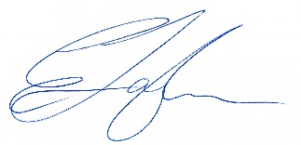

Assessor name
Assessor signature | 

Date | 21/04/2018

Number of questions | Number of questions answered correctly | Satisfactory?
77 |  | Yes | No
Assessor Comments
- What does the term ‘plan’ mean when referencing plans and drawings for construction purposes?

Answer | a plan is a view which shows the layout or arrangement of rooms and other parts of the interior of a house

- Name the people and organisations who will have an interest in plans and drawings for a construction project.

Answer | Local Authorities for approval purposes  Consultants – Hydraulic, Electrical  Engineers – Structural, Civil,  Building Certifier  Builders  Subcontractors – all trades  Client  Bank  Electrical, gas, NBN,supply companies  residents in the surrounding areas  Real Estate Agents

- What will plans show to the interested parties?

Answer | Plans will show what the proposed structure will look like once completed and how it will be constructed. It will show a detailed layout of the rooms including fixtures such as light fittings, joinery, doors, windows, plumbing etc

- What types of plans is it necessary to be familiar with for building and construction projects?

Answer | Working or construction drawings

- All plans and drawings give a compass direction.
Which compass direction is always shown and on which drawings is it likely to be found?

Answer | The compass always shows North to show how the house is orientated and is found on key, site, block and floor plans

- What does a location plan contain?

Answer | A location plan shows the position of the site in relation to the surrounding area

- What does a site or block plan contain?

Answer | The site or block plan shows reference height to other site levels and the buildings orientation to the north point. It also includes the following details:  Outline of site boundaries showing location of proposed building and existing dwellings  Plan page number, client name, project address, scale, reference numbers and dates  Major geological and topographical features (trees and vegetation)  Contours and slopes – 500mm intervals  Depths where they may occur  Distance from the boundaries to the building foot print  Driveways, stormwater drainage, easements and right of carriage  Soil and surface water drains, pipe sizes  Service runs from the house to mains - utility services location (sewer, water, gas, electricity)  New levels on the site in connection with the new house  Paving  Retaining walls

- What features would you expect to look for and find on plans and drawings for a construction project?

Answer | Dimensions, location of services and features, details regarding the build for specific trades to quote, heights and overall size of the building for approval purposes, information for the surveyor.

- What do floor plans identify?

Answer | A floor plan identifies the layout of a home or property from above. Floor plans show the location of walls, windows, doors, and stairs, as well as fixed installations such as bathroom fixtures, kitchen cabinetry, and appliances.

- What are elevation views? What do they provide to the plan reader?

Answer | The elevations show the side view of the building or what it would look like if you stood in front of it. The elevations give an idea as to the size of the windows, doors, balconies and other external features plus the wall finish.

- What is a section?

Answer | Sections show a vertical view through the building – as if the building has been cut in half. These will show internal dimensions such as floor to ceiling heights, distance between flooring and ground levels, construction details, heights and the position of beams etc

- What are detailed drawings?

Answer | Detail drawings provide a detailed description of a specific part of the building. It will be a large scale close up of a certain part which will show in detail, sizes, dimensions and materials of that specific part which would not normally be included on the plans.

- What are specifications?

Answer | Specifications describe the materials and minimum standard of workmanship required for a project. They do not include cost, quantity or drawings and must be read along with contract documents, engineering details, permits and approvals and any other documentation provided.

- What information will you find in a title block to a drawing?

Answer | The title block will contain information that clearly identifies common information to do with the project, as well as information to do with only that particular drawing. Details shown will include:  Project Name  Project Address including Lot & RP or SP Number  Title  Scale  Revision Date  Drawing Number  Revision Number

- What is the significance of the Australian Architectural Standards?

Answer | These Standards define how architectural features are show on drawings so all plans, regardless of who created them, can be easily read by all interested parties.

- What will you find in the Waste Management Plans & Site Management plans?

Answer | The waste management plan will contain information regarding all waste generated on the site a and will include details such as how to minimise the amount of waste generated and therefore sent to landfill, correct disposal of the waste and recycling.  The site management plan shows in detail information regarding the day to day running of the site and includes details of the project such as, times of operation, contact details of all relevant companies and people associated with the project, evacuation procedures, nearest emergency services and medical facilities

- What is a landscape plan?

Answer | A landscape plan provides visual representation of the location of softscape ie plants, trees, grass etc as well hardscape items for example garden beds, paths, bike racks, garden sheds etc.

- What is the purpose of a shadow diagram? Who primarily would seek one?

Answer | The shadow diagram shows where a shadow will be cast across an adjoining property. The local council would seek a shadow diagram during the approval stage to show the impact the building will have on neighbouring properties

- What is a bracing schedule?

Answer | A bracing schedule shows what extent of bracing is required on structure to withstand wind pressure. Requirements are calculated using information to determine wind classification, wind pressure, surface area of the elevation and then the racking force.

- What must we do with plans and drawings in our on-site environments? How often should plans and drawings be viewed on site?

Answer | A1 copies of all plans are kept in the site office for subcontractors to reference at all times. As these are regularly updated, superceeded copies should be removed immediately and replaced with the new version to avoid anything being missed.

- Explain the meaning of the abbreviations in the table below.

Answer | Abbreviation | Meaning
 | ACRYL | ACRYLILC
 | AS | AUSTRALIAN STANDARD
 | ASSD | ASSUMED DATUM
 | B | BASIN
 | BN | BULL NOSE
 | BTH | BATH
 | BWK | BRICKWORK
 | CB | CONCRETE BLOCK
 | CF | CONCRETE FLOOR
 | CG | CLEAR GLASS
 | CJ | CEILING JOIST
 | CORR | CORRUGATED
 | CWT | COLD WATER TANK
 | DG | DOUBLE GLAZING
 | DH | DOUBLE HUNG
 | DPC | DAMP PROOF COURSE
 | DSB | DISTRIBUTION SWITCH BOARD
 | DW | DISHWASHER
 | EJ | EXPANSION JOINT
 | FPBD | FIBROUS PLASTER BOARD
 | FFL | FINISHED FLOOR LEVEL
 | FHR | FIRE HOSE REEL
 | GPO | GENERAL PURPOSE OUTLET
 | HBD | HARDBOARD
 | HTR | HEATER
 | HWD | HARDWOOD

- Why and when would you use presentation drawings?

Answer | Presentation drawings are used to convey basic design concepts from the design team to the client. These are used as part of public hearings or design reviews and are studied to determine the projects impact on the community.

- Service drawings provide information about a variety of different components and equipment. In order to identify individual items, it is usual to give them a reference number on drawings such as services layout drawings and location plans.
What details might we expect to see from service drawings?

Answer | Service drawings will show the location of all pipework in hydraulic drawings such as sewer, water, pits etc underground along with hidden pipes in the walls of the structure. Electrical services shows information regarding the power and lighting and layout of the wiring. They also include the location of lights, light switches GPO’s etc Mechanical services for example will show the location of ducting throughout the structure

- What are working drawings? What do they record?

Answer | Working drawings record or explain the appearance and construction of an existing building or sketch and are used as preliminary plans to clarify onsite details not made clear by other drawings. It is a blue print which is complete with enough plan and section views (including dimensions, details and notes) to enable the depicted items construction without additional information.

- What is an isometric view?

Answer | The term isometric means equal view so in terms of drawings, an isometric view is a two-dimensional representation of a three-dimensional object, aligned to three axes.

- Sketch a concrete block in isometric view.

Answer

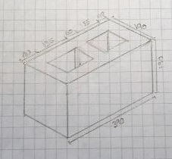

- What is the purpose of perspective projection and representation in drawing of architectural buildings and edifices?

Answer | Perspective projection and representation is the most realistic form of a drawing. It provides the viewer with a 3D view of the object and shows a visual perception of the object.

- What is a topographical survey?

Answer | Topographic Surveys are used to identify and map the contours of the ground and existing features on the surface of the earth or slightly above or below the earth's surface (i.e. trees, buildings, streets, walkways, manholes, utility poles, retaining walls, etc.)

- What is an ecological survey?

Answer | An ecological survey identifies habitats or species that exist in the proposed build site at that point in time. Identifying these early ensure there’s no delay in obtaining the DA and any identified issues can be dealt with.

- What is significant to keep in mind when developing the Schedule of Quantities (also known as a Bill of Quantities)?

Answer | The Bill of Quantities is a document used during the tender process which outlines measured quantities and dimensions of the build. These qtys and dimensions usually differ from actual qty’s so the BOQ should not form part of a lump sum contract to avoid variation claims.

- What should be applied in consideration of stress, load and bearing calculations in the design, the drawings and the building of a structure?

Answer | The requirements of the building code.

- What is a prime cost (PC) item? Give an example.

Answer | A prime cost is an amount included in the contract to purchase specified items such as plumbing fixtures ie taps, toilets, baths etc. A builder can only estimate what the item will cost and if the purchaser chooses something more expensive than the allowed amount, then a variation will be required.

- What is a provisional sum (PS) item? Give an example.

Answer | A provisional sum is an amount included to cover work and materials not detailed in the contract which may arise due to unforeseen circumstances. For example, the builder might start clearing and cutting a site only to discover an inground swimming pool which has been filled in under the surface. The provisional sum should cover the extra costs

- Suggest when you would need to provide ‘additional’ plans.
Give some examples of such plans.

Answer

- How do you identify and record customer variations?

Answer | A Customer Variation occurs when the customer decides after the contract has been signed that they would like to change something to do with the design, build or materials used. The vary must first be put in writing and agreed upon by both parties before the work commenced, This will include any time loss for the vary, extra over costs incurred and terms of the vary. If it’s not practicable to produce a document before the work commences, it must be done within 24 hours of the work commencing and all subsequent documents must be completed within 5 business days of when the vary was agreed to.

- When reading and interpreting (or amending) variations project specifications, what documentation should you also refer to?

Answer | - Plans  - Contract doc  - Engineers details  - Building permits  - Other permits  - Any and all other documents that form the legal documentation for that building

- So you don’t end up in a dispute what strategies can you employ with your customer/client/home owners?

Answer | Remind the home owners that it I their responsibility to put variations in writing to the builder as soon as possible. Any changes to the terms, including cost musts be dated and signed by all parties. Submit EOT’s for any delays incurred.

- Name each of the drawing symbol images shown in the table below.

Answer | Name | Image
 | Double block wall | 
 | Single block wall with non structural wall | 
 | Non Structural Wall | 
 | Fixed Window with flush sill | 
 | Fixed window with projected sill | 
 | Single leaf door opening 90° | 
 | Double leaf door opening 90° | 
 | Cavity Sliding Door | 
 | Standard sliding door | 
 | Single GPO | 

- Draw symbols for the following items.

Answer | Item | Drawing
 | Basin
 | Bidet | 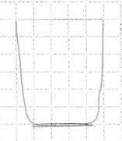
 | Bath | 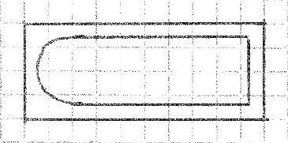
 | Drinking fountain | 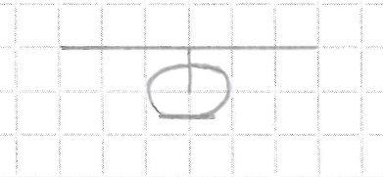
 | Sink: Single bowl | 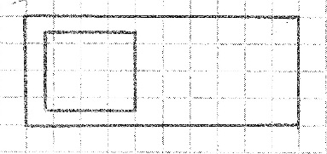
 | Sink: Double bowl | 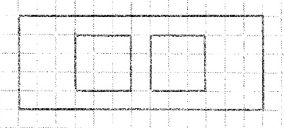
 | Tub: Double | 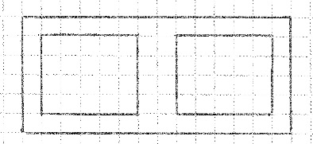
 | Tub: Single | 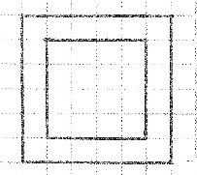
 | Drinking trough | 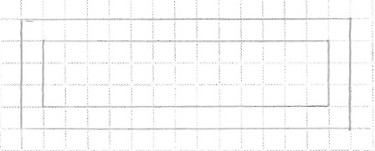
 | Hotplates | 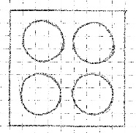
 | Shower | 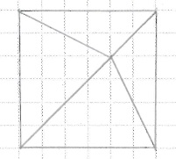
 | Shower bath | 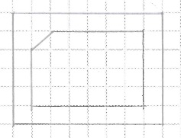
 | Urinal stall | 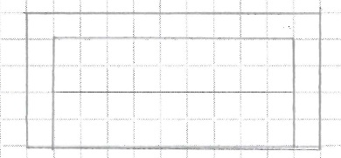
 | Vanity basin
 | Water Closet (Toilet) | 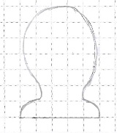

- Draw the following window symbols in elevation.

Answer | Item | Drawing
 | Hinged at side | 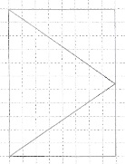
 | Hinged at top | 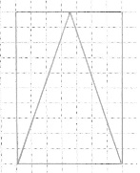
 | Sliding horizontally | 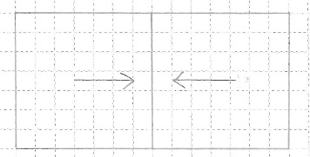
 | Fixed | 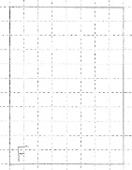

- Draw symbols for the following items.

Answer | Item | Drawing
 | Brickwork | 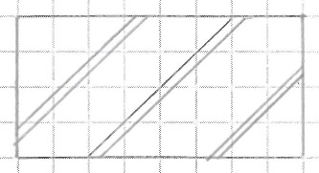
 | Blockwork | 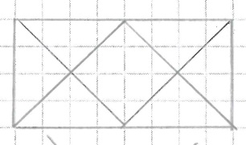
 | Concrete | 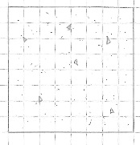
 | Plaster/Render | 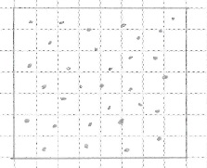

- Provide a description of the residence shown in the plan drawing below.

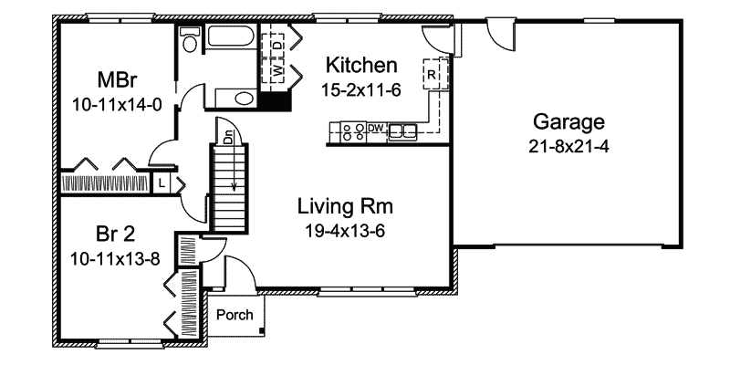

Answer | Single storey 2 bed house with single bathroom, kitchen and living room plus double garage

Refer to the sectional drawing below to respond to Q43. to Q63.


- Give a brief description about the building from the detail available in the sectional drawing.

Answer | 2 Storey timber frame 4 bedroom home with metal roof and covered verandah

- Who is the client?

Answer | Joe Foreman

- Where is this project to be built?

Answer | Lot 16 Glenvalley Road  Richmond

- What are the contact details for the draftsman?

Answer | DJA

- What sheet number is this drawing?

Answer | 5

- What timber is required for loading and non-load bearing walls?

Answer | Load Bearing – Treated Pine 45 x 90  Non-Load Bearing – Treated Pine 35 x 90

- What spacing is recommended for common studs?

Answer | 450mm

- What type of roof truss is to be installed?

Answer | Scissor Truss

- What centres are the trusses positioned at?

Answer | 900

- What size are the veranda posts?

Answer | 90 x 90

- What timber species are the veranda posts to come from?

Answer | Oregon (Douglas Fir)

- What pitch is the roof?

Answer | GF - 15°  L1 - 30°

- What size are the noggings and at what spacing?

Answer | 35 x 70 with a max spacing of 1350

- What size are the ceiling joists?

Answer | 240d X 47w

- What timber is used for roof battens and what spacing?

Answer | Pine @ 900 spacing

- What thickness is the plasterboard sheeting?

Answer | 10mm

- What type of flooring is to be installed?

Answer | 15mm Plywood

- What is the roof cladding material?

Answer | Colorbond corrugated metal roofing

- Where will you find information about the footings?

Answer | Engineers Drawings

- What do the letters DAR refer when timber ordering?

Answer | Dressed All Round – timber which has been planed on all sides and is smooth with rounded edges

- Explain 240 x 63 LVL. What does it refer to on the section?

Answer | 240 x 63 is the size and LVL stands for Laminated Veneer Lumber (LVL) which is a high-strength engineered wood product used primarily for structural appliances

Refer to the drawing overleaf to respond to Q64. to Q75.

- What is the number of the drawing?

Answer | 2

- What is the Job Number?

Answer | OOR-112

- What is the scale of the drawing?

Answer | 1:100

- What does the drawing show?

Answer | Elevations of a single storey dwelling with double garage and tiled roof

- Which view shows the front of the house?

Answer | East Elevation

- How many motor vehicles can be parked in the garage?

Answer | 2

- What are the window and doors made from?

Answer | Aluminium framed windows and sliding doors along with a timber entrance door

- What is the size of the eaves?

Answer | 450

- What are the eaves lined with?

Answer | Hardiflex

- What type of roof structure is the roof built from?

Answer | Timber framed roof trusses

- What is the roof cladding materials made from?

Answer | Concrete roof tiles

- What is the roof pitch?

Answer | 22.5°



- You have spoken with a client on the phone and they are seeking to make amendments to some plans. They wish to add two more bedrooms to extend their home from the current four bedrooms to six bedrooms.
The two new bedrooms are to both have ensuites (including single shower in each, double bowl vanity unit and under cupboard and toilet) with walk in robes, including the extension of the existing hallway with built-ins for the existing Bed 1 and Bed 2. The Family Room is to be extended to the rear wall in line with kitchen rear wall.
The client has faxed through the image below. Re-sketch and redesign the drawing and add the two new bedrooms along with extended hallway, ensuites, walk-in robes and the Family Room extension for consideration by the client.
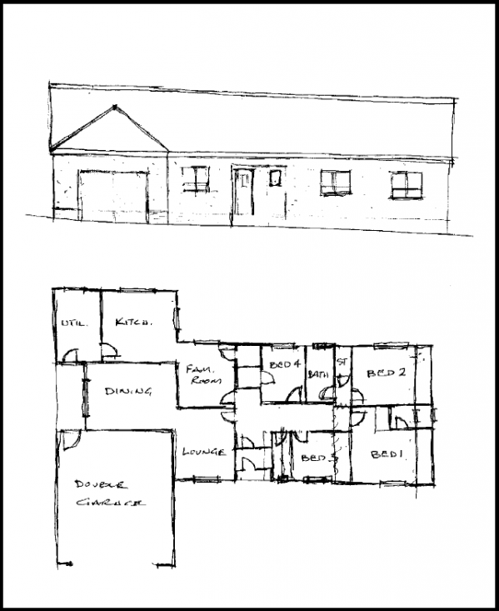
SKETCH
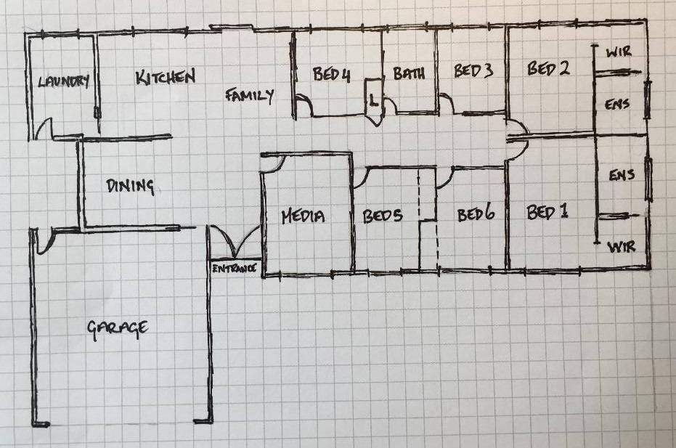

Answer

- Referring to Q76. compose an email to the client, providing an estimate of the additional labour hours/costs and material quantities/costs that have resulted from the their request.

Answer | Dear Mr & Mrs Client,  Please see attached drawing showing revised floor plan which incorporates 2 extra bedrooms plus extending the Family Room. To accommodate these changes, the following amendments have also been made:  - The lounge has been moved to the left side of the front door to allow for an open plan kitchen family dining area.  - The hallway leading to the original family room as been deleted.  - Linen cupboard now located next to the bathroom  - Cavity sliders have replaced standard doors to garage and kitchen/laundry  An estimate of the costs to carry out the variation are as follows:  Should you wish to go ahead with this variation, please be advised an Extension of Time of 20 business days will be required for approvals and documentation.  Please don’t hesitate to give me call to discuss further.
  No. | Item Description | Unit | Qty | Unit Price | Item Cost
  1 | Increase floor area on existing design by extending the family room in line with the kitchen wall plus the addition of add 2 bedrooms which include an ensuite and WIR | m2 | 56 | $ 1,850.00 | $ 103,600.00
  2 | Add built in robes to Bed 1 & 2 (now shown on plans as Bed 5 & Bed 6) | ea | 2 | $ 450.00 | $ 900.00
  3 | PC Items
   | Allowances have been made as follows:
   | Toilets | ea | 2 | $ 300.00 | $ 600.00
   | Shower inc wall mixer | ea | 2 | $ 200.00 | $ 400.00
   | Vanity Basin | ea | 4 | $ 80.00 | $ 320.00
   | Basin Mixer | ea | 4 | $ 60.00 | $ 240.00
   | Tiles - supply & labour | m2 | 15 | $ 65.00 | $ 975.00
   |  |  |  |  | $ 107,035.00

