
AHCLSC307
Implement a retaining wall project

Copyright © 2021 CSTC Pty Ltd

All rights reserved. No part of the contents of this publication may be reproduced or used in any form or by any means – graphic, electronic, or mechanical including photocopying, digitising, recording, or information storage-and-retrieval systems – without the written permission of CSTC Pty Ltd.
ASSESSMENT FOR AHCLSC307

Student name | Lachlan Pomerenke
Date of assessment submission | Click here to enter a date.

Trainer/Assessor’s name
Date of assessment marking | Click here to enter a date.
Outcome for unit | ☐ Competent  ☐ Not Yet Competent

TASK INSTRUCTIONS

- As part of the assessment for this unit of competency, you are required to complete a series of activities.
  - Some of these activities will require you to provide a response within this document, others will require you to gather evidence to demonstrate your knowledge and skills.
- At all times, the responses in your assessment must reference Australian (Queensland or Federal) documentation, including legislation, regulations, codes of practice, standards and guidance publications.

ACTIVITIES

Draw a simple concept plan for a proposed landscape design which includes a retaining wall.

Response
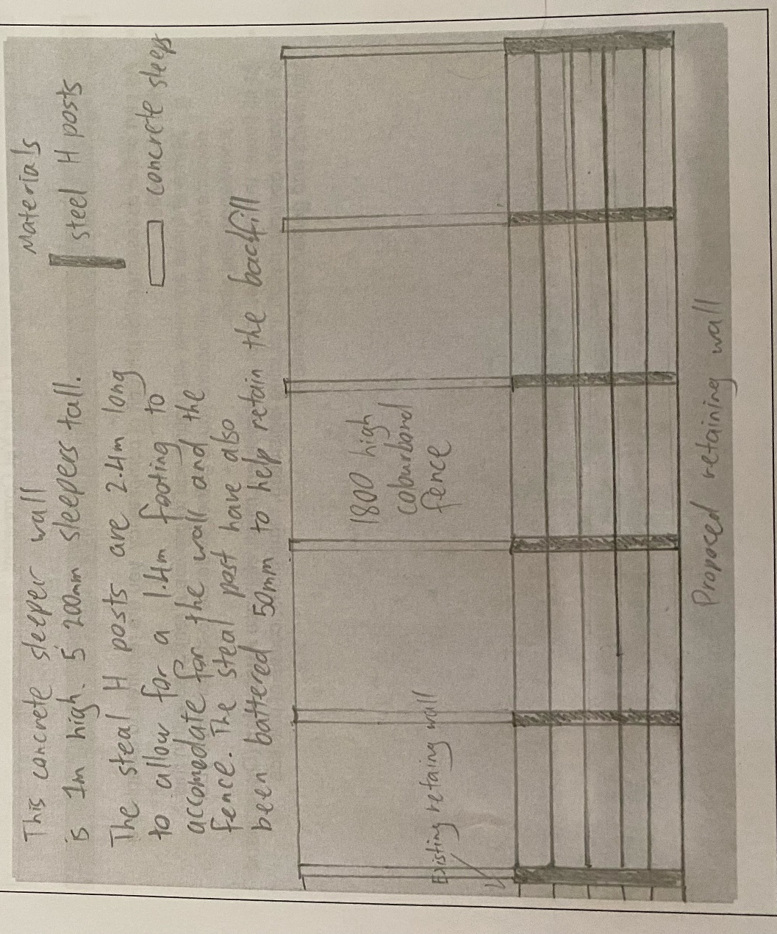

Outcome for Activity 1 | ☐ Satisfactory  ☐ Not satisfactory
Trainer/Assessor comments

Identify/list the detail on the landscape plan shown.

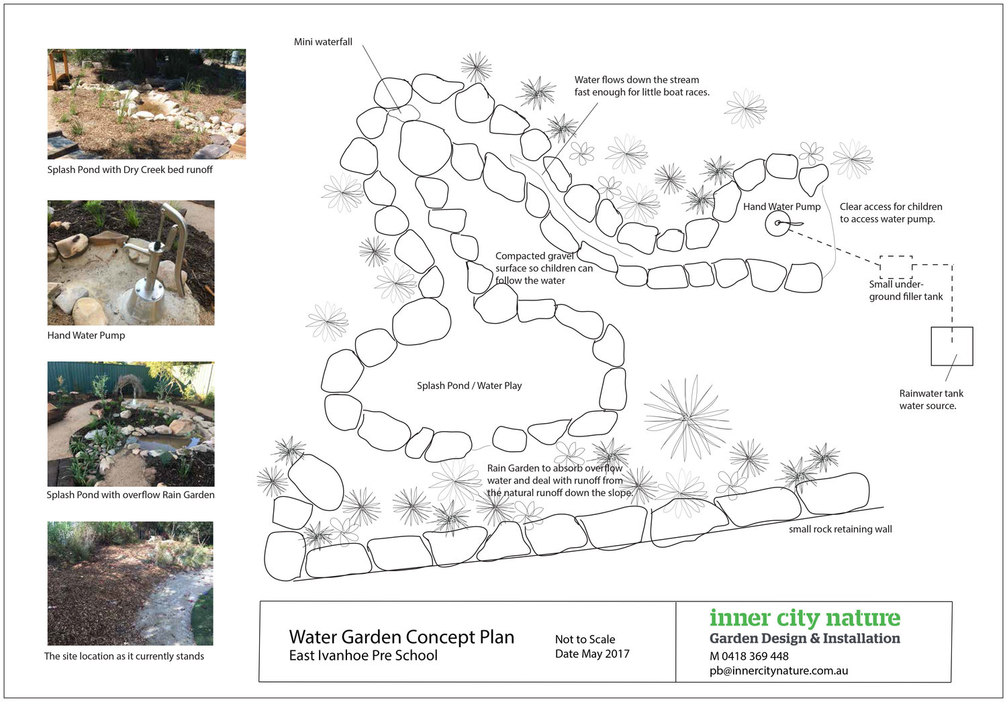

Response
Site location as it stands
Proposed stream design and location
Positioning of rocks for the stream
Positioning of features eg pump, water tank, mini waterfall
Proposed retaining wall and garden

Outcome for Activity 2 | ☐ Satisfactory  ☐ Not satisfactory
Trainer/Assessor comments

List the materials required to complete the retaining wall, by using the wall and water feature construction plan shown.

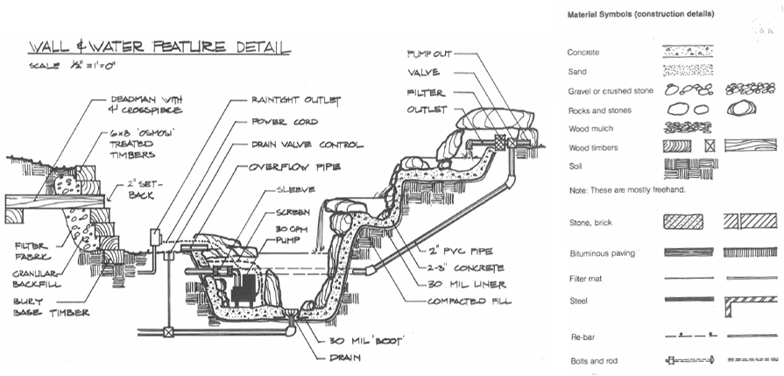

Response
Concrete
Sand
Gravel
Rocks and stones
Wood mulch
Wooden sleepers
Soil
Stone, brick
Bituminous paving
Filter mat
Steel
Re-bar
Bolts and rod

Outcome for Activity 3 | ☐ Satisfactory  ☐ Not satisfactory
Trainer/Assessor comments

Identify the requirements of your local council with regards to retaining walls.

Response
In accordance with the Queensland Building Act 1975, a building approval is required for the construction of a retaining wall where any of the following apply:
• has a surcharge loading over the zone of influence for the wall (refer to Figure 1 for example); or • the total height of the wall and of the fill or cut retained by the wall is more than 1m above the wall’s natural ground surface; or
• the wall is closer than 1.5m to a building or another retaining wall.

Outcome for Activity 4 | ☐ Satisfactory  ☐ Not satisfactory
Trainer/Assessor comments

What strategies could you implement to address environmental impacts, including:
- Spillages
- Dust
- Site cleanliness
- Noise

Impact | Strategy
- Spillages | Keep all chemicals and fuels in approved containers with the lids firm and away from operating areas.
- Dust | Use a water suppressant when cutting concrete, pavers, and tiles.  Wear a correctly fitting respirator or dust mask when required.  Use a vacuum system to removing dust when cutting wood.
- Site cleanliness | Sweep or vacuum messes straight away to stay on top of them  Hose down dirty pathways and driveways.  Blow off dirty areas at the end of each day.  Set up bins for litter and recyclable materials.
- Noise | Isolate noisy work when possible eg cutting timber away from where everyone is working.  Use correctly fitting PPE when around noisy operations such as ear plugs or earmuffs.

Outcome for Activity 5 | ☐ Satisfactory  ☐ Not satisfactory
Trainer/Assessor comments

List the components for four (4) common surface drainage systems used in landscape construction.

System | Components
- Spoon | A spoon drain like a channel and grate is a strip that can bend and mauver with the environment and have an open face. They can become prone to blockages due to soil, sticks and leaves are the most cost effective and efficient drainage system in gully’s or to assist natural water channels
- Channel and grate | Channel and grate drains are often used in pathways or driveways where water floods over a larger surface area in a low volume. The drain will fall one way or the other for the water to run into either garden or into the stormwater system.
- Pit | Pit drains have only a small square exposed for water to flow into when they are installed. They are very good for draining environments where water all falls to one point. They are easy to plug into the stormwater system for the water to escape and also easy to attach channel and grate drains to.
- Contour | A contour drain works by using and manipulation the earths contour to redirect waterflow away from an area or towards a desired drain or dam.

Outcome for Activity 6 | ☐ Satisfactory  ☐ Not satisfactory
Trainer/Assessor comments

List the advantages and disadvantages of drainage behind and through the built wall (as shown).

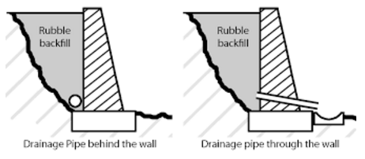

Drainage pipe behind the wall
Advantages
Looks nicer than having holes through the wall
Leaves the wall stronger not leaving little points where it could potentially crack
Disadvantages
Drainage isn’t as effective especially when the bottom of wall meets up with concrete.

Drainage pipe through the wall
Advantages
Provides better drainage for the wall’s stability and longevity.
Weep holes can be pointed onto specific plants next to the wall or into pit or strip drains so water isn’t flowing onto the surface in front of it.
Disadvantages
Doesn’t look as nice as a wall without weep holes
Areas around the weep hole are more likely to crack overtime.

Outcome for Activity 7 | ☐ Satisfactory  ☐ Not satisfactory
Trainer/Assessor comments

Explain the following terms:
- Batter
- Angle of repose

Term | Definition
- Batter | Batter when referring to a retaining wall is the angle and the amount of angle a retaining wall should lean against what its retaining. This allows the weight of the wall to push on the fill in order to give it strength.
- Angle of repose | The angle of repose is the steepest angle of descent or dip relative to the horizontal plane to which a material can be piled without slumping. In a retaining wall that can be used to determine how much fill will be reliant on the wall

Outcome for Activity 8 | ☐ Satisfactory  ☐ Not satisfactory
Trainer/Assessor comments

Describe what is happening the in sketched diagram and the photograph shown below.

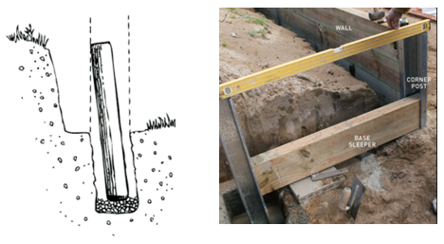

 | Description
- Sketched diagram | The post is leaned back towards the area it is retaining before being set in place.
- Photograph | A bay of the wall beginning to be built in a timber sleeper retaining wall. The level between the two posts vary a bit so calculations will need to be made on how to cut a sleeper at an angle so that they will all fit in.

Outcome for Activity 9 | ☐ Satisfactory  ☐ Not satisfactory
Trainer/Assessor comments

Have team members take photos and videos of your involvement with retaining wall projects.

Identify each photo / video with a letter label and describe each photo / video in the table below. Submit the photo / video files along with this workbook.

Advantages
A | 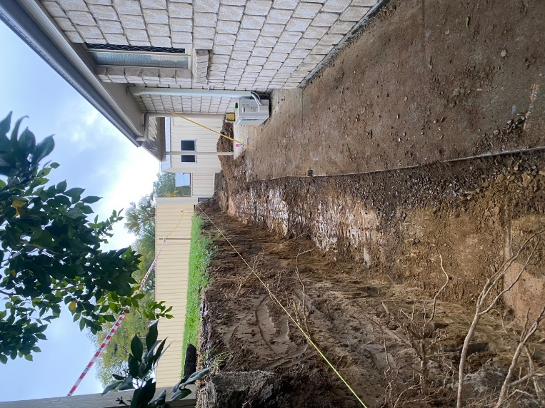Here is an example of one of our dig outs. The stringline represents the middle of the proposed retaining wall and the boundary between the two properties. It is important to dig at least 300mm past this line to allow room for sufficient drainage
B | 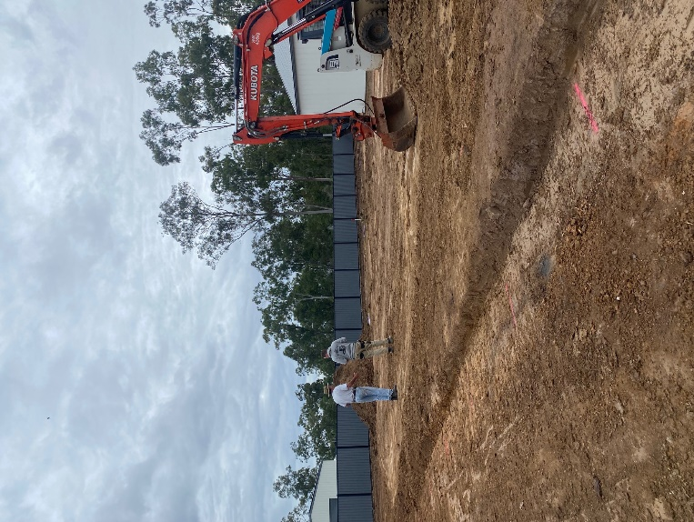Another example of dig out for a much smaller wall. Made square 5m off of the side of the house
C | 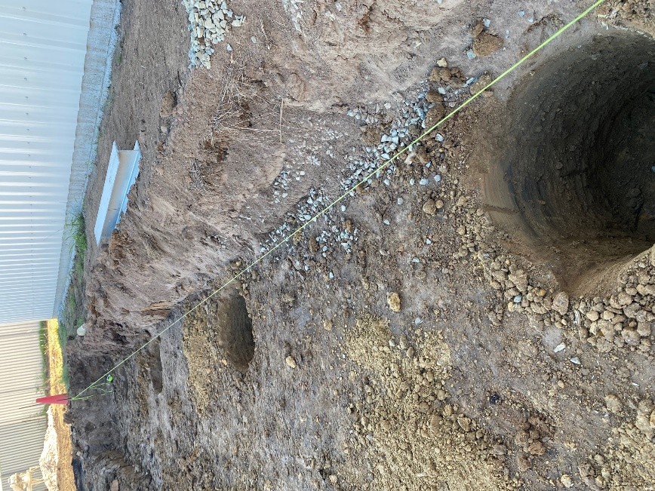Post holes are then drilled with the excavator and auger to the appropriate depth and the stringline is set up again to make sure they are in position
D | 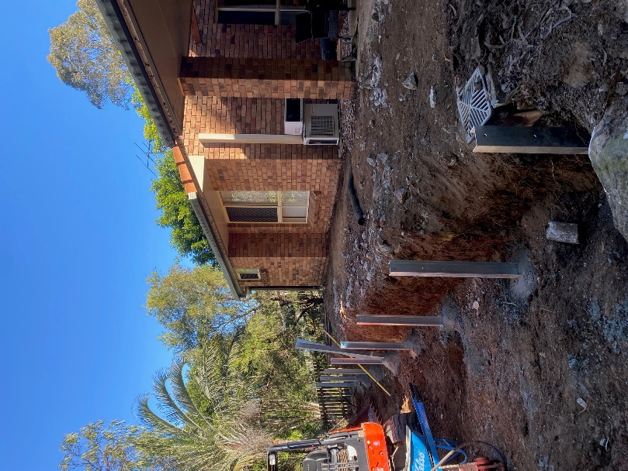The post are then concreted into the ground using a stringline, level and laser level to determine their height and that they are straight while maintaining appropriate offset
E | 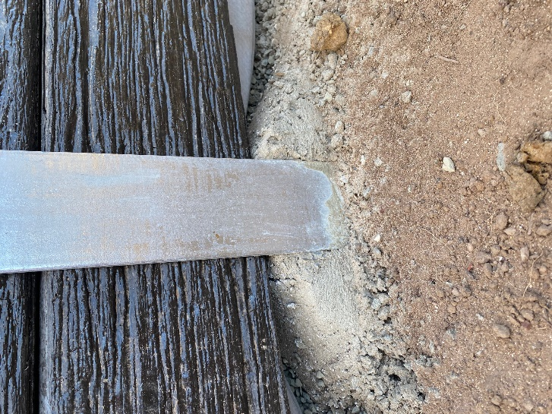The bottom of the posts are then floated level in their C channels to the appropriate height and leaving the front clear to be paved against.
F | 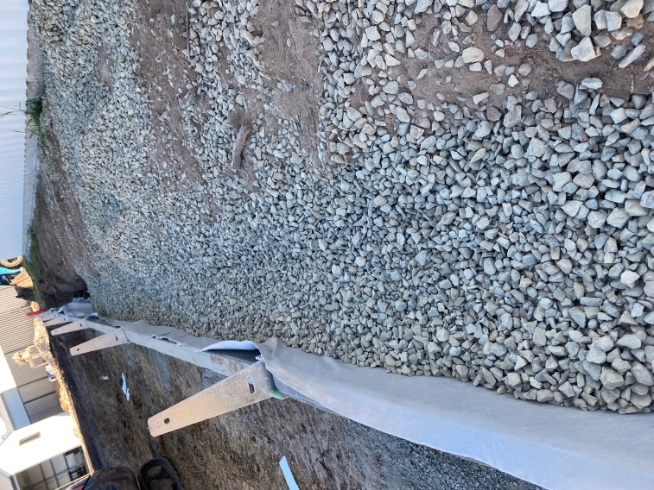Landscape fabric, ag pipe and drainage gravel is put behind to allow water to flow through and out the side of the wall while holding up the soil.
G | 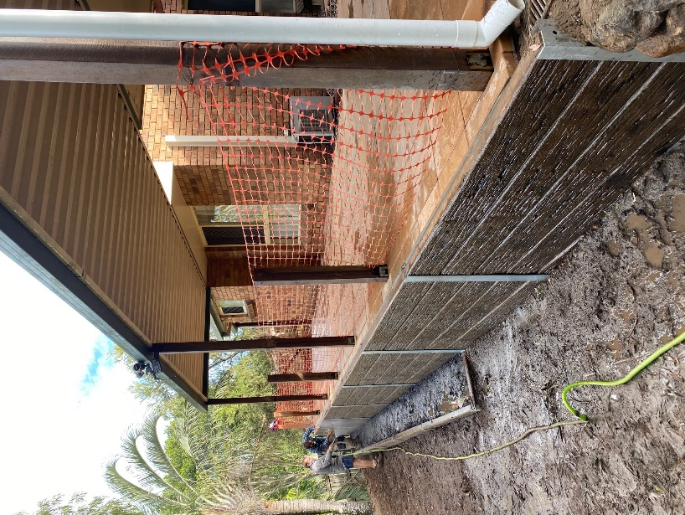Bunting should be used at the top of the wall when there is a risk of falling until a permanent solution is built.
H | 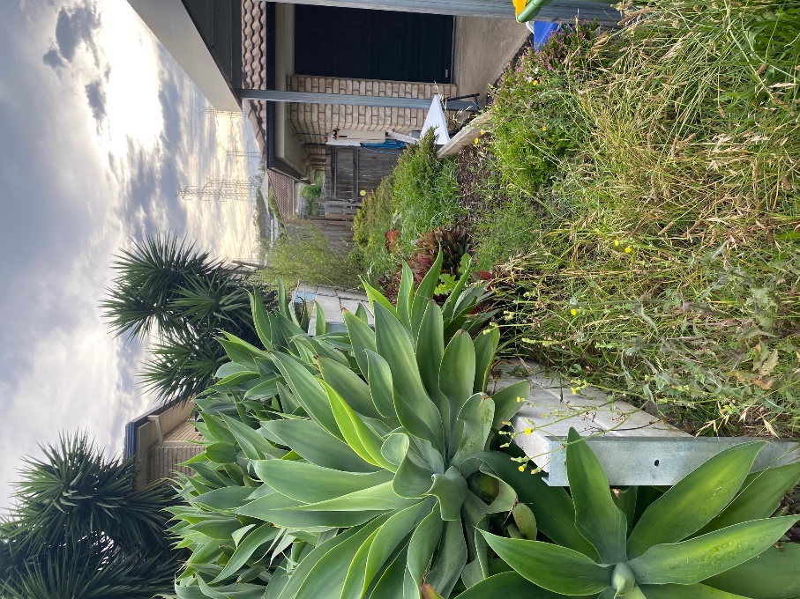  A before shot of a retaining wall we replaced that is seen falling over. The wall had incorrect footings and drainage.
I | 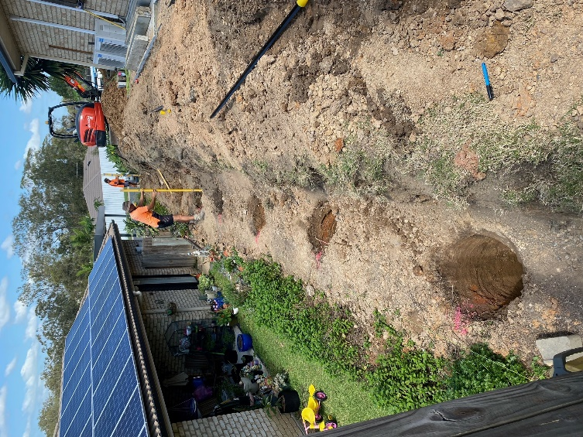  After removing the old posts and putting the sleepers aside we dug out for the wall and drilled the holes to 2.1M deep to allow for the fill that the wall is built on and the fence that was put ontop.
J | 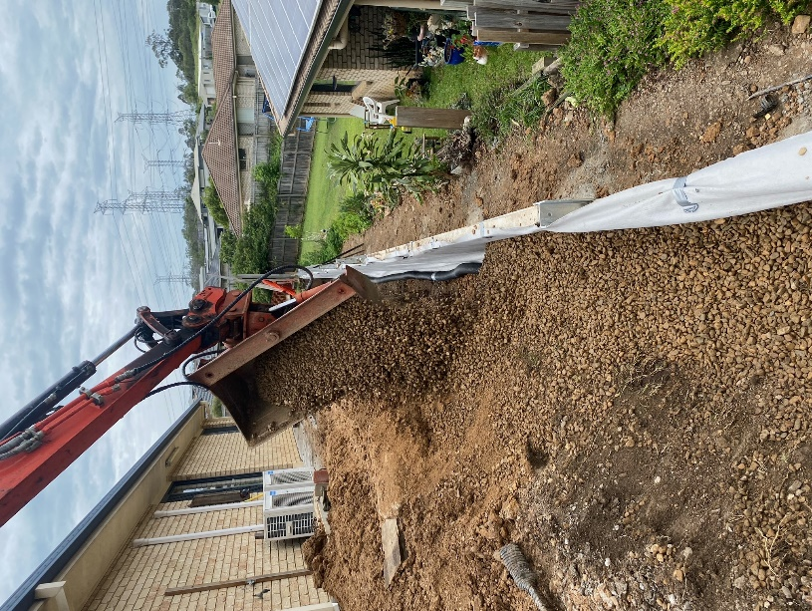  Backfilling the wall using the excavator where it could reach and wheelbarrowing it where we couldn’t. Ag pipe and landscape fabric was installed beforehand.
K | 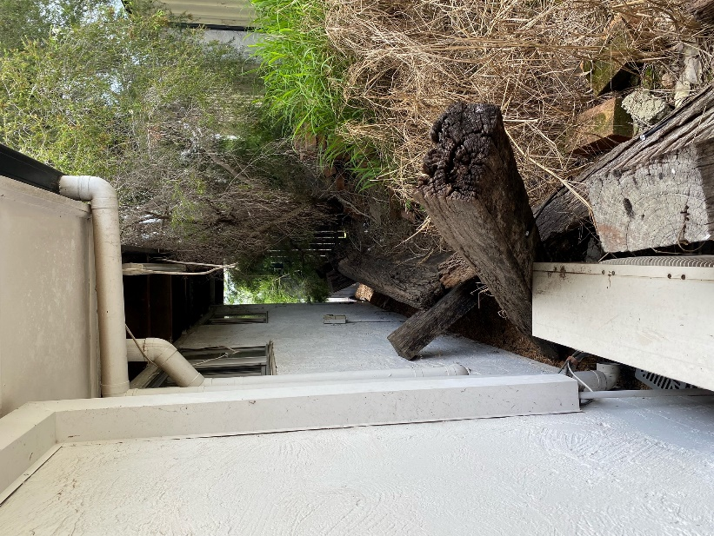  A shot of an old retaining wall made out of railway sleepers that had fallen on the house.
L | 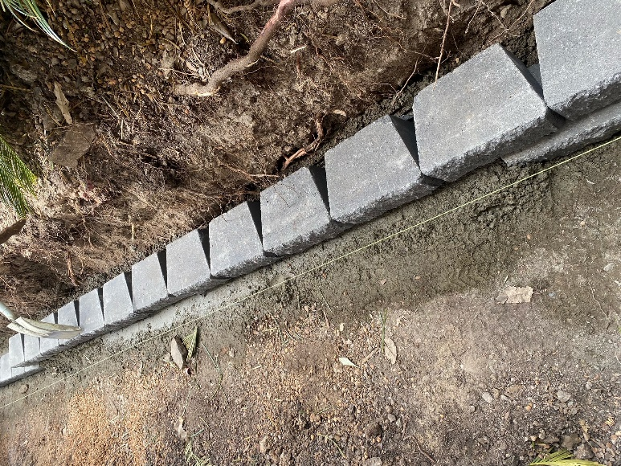  The footing for the new retaining wall to be guilt on. 100mm of concrete deep with a block tapped in level using a rubber mallet, level and stringline to get the straight parts straight.
M | 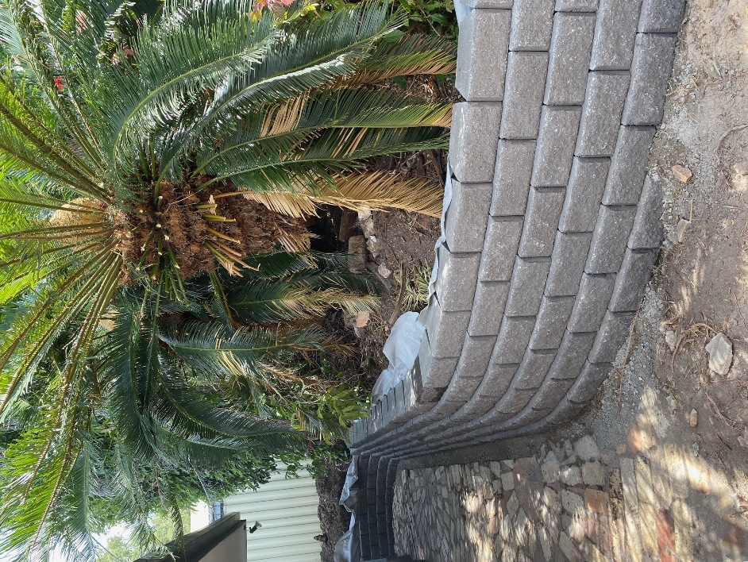  A photo of the same retaining wall built with blocks cut in and landscaping fabric installed during the process of backfilling with gravel.
N
O
P
Q
R
S
T
U
V
W
X
Y
Z

Outcome for Activity 10 | ☐ Satisfactory  ☐ Not satisfactory
Trainer/Assessor comments

