
AHCLSC306
Implement a paving project

Copyright © 2022 CSTC Pty Ltd

All rights reserved. No part of the contents of this publication may be reproduced or used in any form or by any means – graphic, electronic, or mechanical including photocopying, digitising, recording, or information storage-and-retrieval systems – without the written permission of CSTC Pty Ltd.
ASSESSMENT FOR AHCLSC306

Student name | Melinda Jensen
Date of assessment submission | Click here to enter a date.

Trainer/Assessor’s name
Date of assessment marking | Click here to enter a date.
Outcome for unit | ☐ Competent  ☐ Not Yet Competent

TASK INSTRUCTIONS

- As part of the assessment for this unit of competency, you are required to complete a series of activities.
  - Some of these activities will require you to provide a response within this document, others will require you to gather evidence to demonstrate your knowledge and skills.
- At all times, the responses in your assessment must reference Australian (Queensland or Federal) documentation, including legislation, regulations, codes of practice, standards and guidance publications.

ACTIVITIES

Identify/list the scope of the work to be carried out from the concept plan shown.

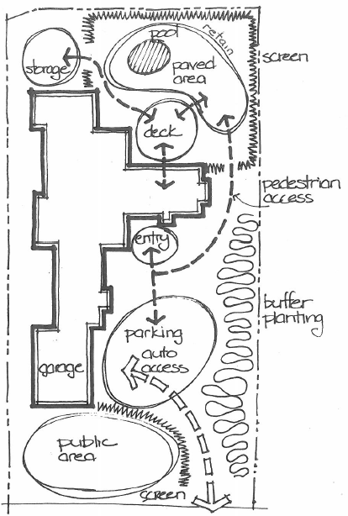

Response
Paved areas (concrete?) public area and par park
Need access to auto access (driveway)
Paved area to/from driveway to entry
Paved area from entry to area around pool
Paved area surrounding pool
Paved access between deck and house
Paved access between deck and pool paved area
Paved access to storage area
Retaining wall to the back area of the pool paved areal

Outcome for Activity 1 | ☐ Satisfactory  ☐ Not satisfactory
Trainer/Assessor comments

Identify/list the detail on the landscape plan shown.

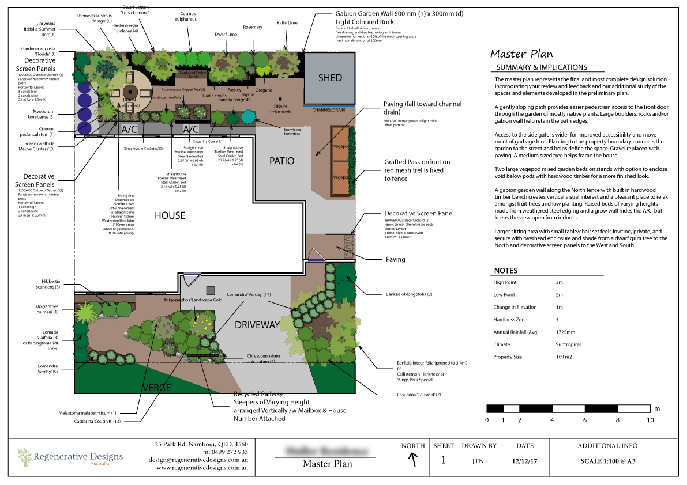

Response
Drainage requirements
Drainage
Elevation high point and low point
Climate
Plant type and location
Material requirements (pavers, rock wall, sleepers screen panels etc)
Paved pattern
Location of services

Outcome for Activity 2 | ☐ Satisfactory  ☐ Not satisfactory
Trainer/Assessor comments

Using the graphics shown, create a simple plan that details a paved path through a garden with grass, trees, shrubs, rocks and steps.

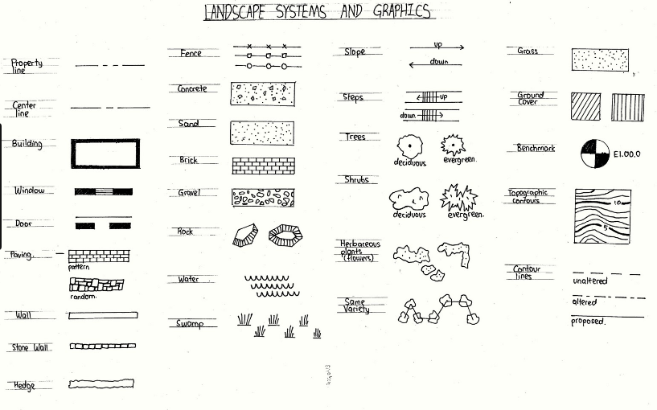

Response
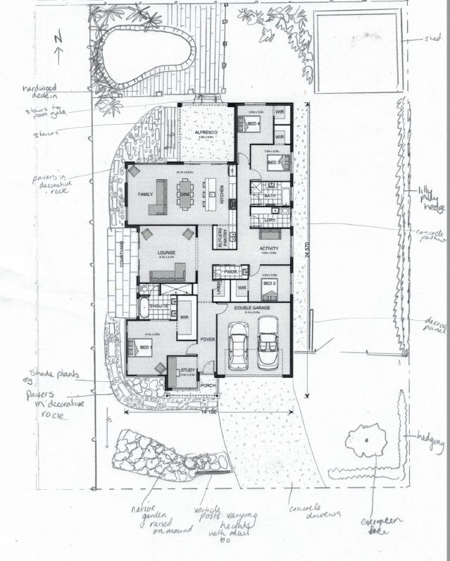

Outcome for Activity 3 | ☐ Satisfactory  ☐ Not satisfactory
Trainer/Assessor comments

Research the advantages and disadvantages of concrete, clay and stone pavers.

For each material, provide one (1) example of a project where it would be most appropriate to use the material and one (1) example of a project where it would not be appropriate to use the material. Explain your responses.

Concrete pavers
Appropriate
Where you are looking for a specific colour for design as concrete pavers offer a variety of colours
Not appropriate
Bright sunny areas as colour is prone to fading and will need sealing to prevent. Increased maintenance

Clay pavers
Appropriate
Naturally coloured so resist fading and staining so can be used in high traffic sunny areas
Not appropriate
15 -20% more expensive than concrete pavers and are not as economic in large areas especially in limited budget projects

Stone pavers
Appropriate
Can be set directly into soil with little preparation and are good for when a particularly natural look is required for the project
Not appropriate
Can retain moisture and crack in particularly cold weather and would not be appropriate for southern sides of property where there are high periods of shade and moisture

Outcome for Activity 4 | ☐ Satisfactory  ☐ Not satisfactory
Trainer/Assessor comments

Obtain photographs of common landscaping materials and finished landscapes (both soft and hard).

Explain the differences between your emotions/feelings when you see each photograph in black and white and in colour.

Photograph 1
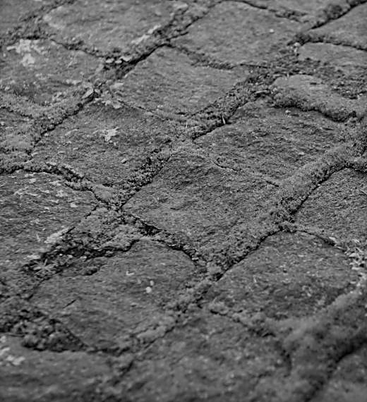

Black and white: Emotions and feelings
Old, antique
Colour: Emotions and feelings

Photograph 2
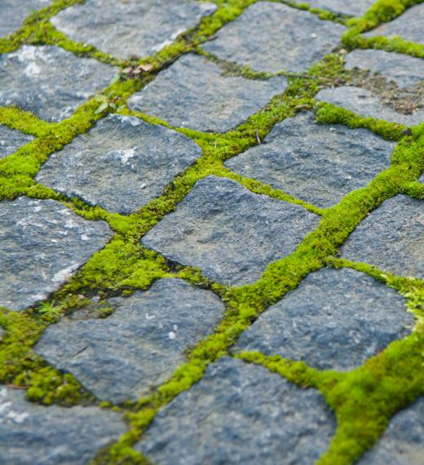

Black and white: Emotions and feelings
Colour: Emotions and feelings
Natural calming cool

Photograph 3
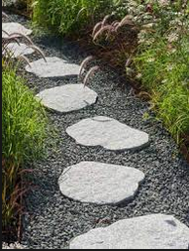

Black and white: Emotions and feelings
Colour: Emotions and feelings
Serene, adventurous

Photograph 4
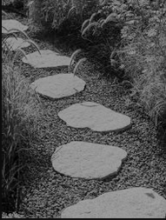

Black and white: Emotions and feelings
focussed
Colour: Emotions and feelings

Outcome for Activity 5 | ☐ Satisfactory  ☐ Not satisfactory
Trainer/Assessor comments

Research and identify eight (8) different paving patterns, including the common usage, advantages and disadvantages for each pattern.

Pattern 1 name | 90 degree herringbone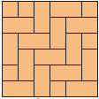
Common usage
Recommended for areas of high traffic
Advantages
Has maximum strength if the long side is traverse to the direction of the wheels
Disadvantages
Can only use rectangular pavers for this pattern.

Pattern 2 name | Stretcher bond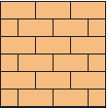
Common usage
A simple design in long areas. Good where a classic look is required
Advantages
Strong design and does not require high skills to achieve
Disadvantages
Lines need to be met carefully as imperfections will show

Pattern 3 name | Stretcher bond with contrasting header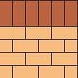
Common usage
Require added strength with an edge restraint
Advantages
Added strength and a contrasting border adds visual appeal
Disadvantages

Pattern 4 name | 45 degree herringbone
Common usage
Same areas as a 90 degree herringbone but with added characterPav
Advantages
Extra strength and added appeal
Disadvantages
More cuts required and not simple cuts. Generally requires a cutting saw

Pattern 5 name | 45 degree stretcher bond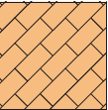
Common usage
Same areas as for stretcher bond but with added ambience
Advantages
Added character with the same advantages as a stretcher bond
Disadvantages
More complicated cuts

Pattern 6 name | Stack bond
Common usage
Simplest design and used for the modern look
Advantages
Easy to lay. No cutting required
Disadvantages
Not a strong design. Not to be used for heavy traffic areas such as driveways

Pattern 7 name | Basketweave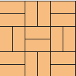
Common usage
Good for small areas
Advantages
Adds character and contrast
Disadvantages
Reserved for smaller rectangular pavers

Pattern 8 name | Circular (radial) 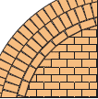
Common usage
Natural areas
Advantages
Excellent for natural flow areas such as paths or small entertainment areas with a focal point such as a brazier or firepit
Disadvantages
Limiting with size and have to be careful with the gaps between pavers

Outcome for Activity 6 | ☐ Satisfactory  ☐ Not satisfactory
Trainer/Assessor comments

Select a paver type (with known specifications) and calculate the material costs for a straight path that measures 6m long by 900mm wide.

Response
Paver type – 200 x100x40 = 0.02m2

Pavers required for 6 x .9 = 5.4m2

= 270 pavers required
@ $37.30/m2 = $201.42

Subbase =5.4 x 0.1 = 0.54m3
@ $60m3 x 0.41m3 = $24.60

Bedding sand = 5.4 x 0.05 = 0.27m3
@ $70m3 x 0.27 = $18.90

Haunching = approximately 12Lm
@ $7.91 concrete blend
+ 8 bags of cement= $63.28

Gap sand 1 20kg bag per 8m2 = $15.90

Total Cost =$324.10

Outcome for Activity 7 | ☐ Satisfactory  ☐ Not satisfactory
Trainer/Assessor comments

Research the advantages and disadvantages of installing edging before and after laying pavers.

Installing edging before laying pavers
Advantages
Can aid with screeding
Disadvantages
Need to ensure that it is embedded into a concrete haunch otherwise it will fail

Installing edging after laying pavers
Advantages
Neatest and simplest method is concrete haunching which can be hidden by turf or gardens
Disadvantages
Have to be careful not to disturb the surrounding pavers when deeper than bedding sand and get concrete on the pavers

Outcome for Activity 8 | ☐ Satisfactory  ☐ Not satisfactory
Trainer/Assessor comments

List environmentally safe products for cleaning.

Response
Bicarb soda and vinegar applied with stiff brush
Guardit® environmental paver and concrete cleaner
Simple Green oxy concrete and driveway cleaner®

Outcome for Activity 9 | ☐ Satisfactory  ☐ Not satisfactory
Trainer/Assessor comments

Have team members take photos and videos of your involvement with paving projects.

Identify each photo / video with a letter label and describe each photo / video in the table below. Submit the photo / video files along with this workbook.

Advantages
A | After discussions with client as to placement of the paving for firepit, the area was measured at 1200 (allowing for 400 around the paving area and the screed)
B | Used the mattock to break up the dirt so I could dig out the area
C | Digging out area
D | Cleaning out the area using a placer rake
E | Checking that the height level is correct. I allowed 80mm for the subbase area and approximately 25 mm for the bedding layer. I wanted the pavers to be above ground level as I intend to turf around the paved area
F | I filled the area with sub base (I used crusher dust) and made level areas in all four corners so that I had level pads in which to screed from.
G | Once the sub base was level, I used my compactor to compact the crusher dust
H | I sprayed the sub base material with water to moisten and then compacted the area with a hand compactor (not big enough to use the mechanical plate compactor)
I | I then covered the area with approximately 25mm of bedding sand, and spread roughly evenly over the area
J | Forgot the screed rails so used the method of leveling out the four corners and then used the screed to level out the bedding sand
K | Placed the first paver (400 x 400) in which in this particular pattern is the centre paver. Made sure it was level
L | Placed the smaller 200mmwide pavers around the outside of the central paver checking for level and that they lined up
M | Using the level, I made sure that the pavers were in line, making adjustments using the rubber mallet
N | Digging a trench along the paving edge ensuring it is going into the sub base
O | Mixing the premix concrete to use for the haunch. I made a fairly dry mix so that it would be able to stand up by itself and not slump
P | Shovelling concrete into place, being careful not to get it on the top of the pavers
Q | Using a magnesium float trowel to smooth the concrete ensuring that it goes halfway up the pavers to ensure they stay in place. Keeping it on a steep gradient so that it is hidden under surrounding grass (when I lay it!)
R | Brushing fine sand mixed with a handful of cement powder into the joints between the pavers
S | Hosing the paved area down ensuring that all joints are filled with sand mixture
T | Finished paved area with fire pit
U | Cleaning and maintaining tools before storage
V
W
X
Y
Z

Outcome for Activity 10 | ☐ Satisfactory  ☐ Not satisfactory
Trainer/Assessor comments

