BSBITU306
Design and produce business documents
Learner Workbook



Table of Contents

Table of Contents 1
Candidate Details 2
Assessment – BSBITU306: Design and produce business documents 2
Competency Record to be completed by Assessor 3
Activities 5
Activity 1A 5
Activity 1B 6
Activity 1C 7
Activity 1D 8
Activity 2A 9
Activity 2B 10
Activity 2C 11
Activity 2D 12
Activity 3A 13
Activity 3B 14
Activity 3C 15
Activity 3D 16
Activity 4A 17
Activity 4B 18
Activity 4C 19
Activity 4D 20
Skills and Knowledge Activity 21
Major Activity 22

Candidate Details

Assessment – BSBITU306: Design and produce business documents
Please complete the following activities and hand in to your trainer for marking. This forms part of your assessment for BSBITU306: Design and produce business documents.
Name: Zoe Lwin
Address: 79 Waterview Avenue, Wynnum, 4178
Email: zoejade_98@hotmail.com
Employer: Lwins Cleaning
Declaration
I declare that no part of this assessment has been copied from another person’s work with the exception of where I have listed or referenced documents or work and that no part of this assessment has been written for me by another person.
Signed: ____________________________________________________________
Date: ____________________________________________________________
If activities have been completed as part of a small group or in pairs, details of the learners involved should be provided below:
This activity workbook has been completed by the following persons and we acknowledge that it was a fair team effort where everyone contributed equally to the work completed. We declare that no part of this assessment has been copied from another person’s work with the exception of where we have listed or referenced documents or work and that no part of this assessment has been written for us by another person.
Learner 1: ____________________________________________________________
Signed: ____________________________________________________________
Learner 2: ____________________________________________________________
Signed: ____________________________________________________________
Learner 3: ____________________________________________________________
Signed: ____________________________________________________________

Competency Record to be completed by Assessor
Learner Name: _______________________________________________________
Date of Assessment: _______________________________________________________
The learner has been assessed as competent in the elements and performance criteria and the evidence has been presented as:
Assessor Initials
Authentic
Valid
Reliable
Current
Sufficient

Learner is deemed: COMPETENT NOT YET COMPETENT (Please circle)

If not yet competent, date for re-assessment: ____________________________________

Comments from Trainer / Assessor:
__________________________________________________________________________________________________________________________________________________________________________________________________________________________________________________________________________________________________________________________________________________________________________________________________________________________
Assessor Signature: ________________________________________________________
Observation/Demonstration

Throughout this unit, you will be expected to show your competency of the elements through observations or demonstrations. Your instructor will have a list of demonstrations you must complete or tasks to be observed. The observations and demonstrations will be completed as well as the activities found in this workbook. An explanation of demonstrations and observations:
Demonstration is off-the-job
A demonstration will require:
- Performing a skill or task that is asked of you
- Undertaking a simulation exercise
Observation is on-the-job
The observation will usually require:
- Performing a work based skill or task
- Interaction with colleagues and/or customers
Your instructor will inform you of which one of the above they would like you to do. The demonstration/observation will cover one of the unit’s elements.
The observation/demonstration will take place either in the workplace or the training environment, depending on the task to be undertaken and whether it is an observation or demonstration. Your instructor will ensure you are provided with the correct equipment and/or materials to complete the task. They will also inform you of how long you have to complete the task.
You should be able to demonstrate you can:
- Select and prepare resources
- Design document
- Produce document
- Finalise document
You will also need to show:
- Reading
- Writing
- Oral communication
- Navigate the world of work
- Interact with others
- Get the work done
Activities

Activity 1A
Estimated Time | 20 Minutes
Objective | To provide you with an opportunity to select and use appropriate technology and software applications to produce required business documents.
Activity | What is a business document?  As an organisation, the business documents you create, both written or electronic, represent you in relation to external parties.  Give examples of types of business documents.  All business documents have a specific purpose within a company. Some types of business documents include; account statements which represent a financial state and are essential for an organisations budgeting, client databases which store necessary client details and newsletters that allow an organisation to provide clients with advice. Some other business documents include project reviews, proposals, reports and web pages.  When producing business documents, it essential to use the correct technology and software. Give examples of these.  Since business documents are a record of company dealings and may need to be referred to for a long time, it’s important that these are well written and stored using the correct software and technology. That is; computers, photocopiers, printers and scanners. Software packages are available for accounting, database, presentation, spreadsheet and word processing.  In relation to your own organisation, decide on a business document. Describe what this document may include. What is the correct technology and software that you should use to produce your business document?  Client databases: While there are various software options available, within my organisation, accounting software packages such as MYOB provide a location to store client information and a system of accessing and collating this data into a business document. This information allows an organisation to contact clients, issue bills, send clients special offers, track complaints and refer to client notes. The information included shows the clients address and number, email, previous purchases as well as customer feedback and preferences.

Activity 1B
Estimated Time | 25 Minutes
Objective | To provide you with an opportunity to select layout and style of publication according to information and organisational requirements.
Activity | Give examples of different layouts and styles you may need to consider when developing business documents.  Selecting the correct layout and styles ensures that a business document is readable and suits its purpose. Depending on the type of document, some different layouts and styles to consider include:  - Page orientation  - Colours  - Fonts  - Text size  - Headings  - Margins  - Headers and footers  - Spacing  - Page numbering  When selecting layouts and styles, you must take organisational requirements into consideration. What can these include?  Organisational guidelines will govern the style and layout of a business document. It might be necessary to consider these requirements regarding:  - Budgets  - Correctly identifying and opening files  - Legal policies  - Locating data  - Log-on procedures  - Manufacturers guidelines  - OHS policies  - Quality assurance  - Saving a closing files  - Security  - Storing data  What may organisational policies and procedures outline?  These company guidelines are in place to outline how to develop documents and where to store them, how much time to spend and a style guide to use when creating documents. Organisational policies may also focus on quality assurance, security issues, and legal procedures.  Why is consistency important when developing business documents?  It is important to ensure that layouts and styles are consistent throughout a document so that; the content flows smoothly, it looks professional, the document makes sense and is easy to follow.  How can you ensure consistency?  The easiest way to ensure consistency across a range of business documents is to make use of any available templates and style guides.  Using a business document that applies to your organisation as an example, outline the correct layouts and styles.  Business Report: The structure or layout of business report would need to include the date, authors name, a title page, table of contents, summary of main points, introduction, conclusion and page numbers. The styles incorporated such as colours, fonts and text size would depend on organisational requirements and may come from a style template.

Activity 1C
Estimated Time | 25 Minutes
Objective | To provide you with an opportunity to ensure document design is consistent with company and/or client requirements, using basic design principles.
Activity | What things should you remember when designing business documents?  When developing business documents, it is helpful to understand basic design principles that ensure your document is consistent with organisational/client requirements. Some tips that are beneficial to remember include:  - text information accompanied by a visual aid is often easier to remember  - overuse of colours and fonts can distract or deter the eye  - humour is good memory aid  - poor grammar, punctuation and spelling can distract or confuse the audience  - images containing people are remembered more easily that pictures of objects  Name the four principles you should consider. What do they involve?  Four important principles to consider in the development of business documents include;  - Contrast: helps guide the readers eye by emphasising key elements within the document such as lines, fonts, shapes and colours  - Alignment: when elements visually connect with each other, it makes the document more coherent, creates an ordered design, and eliminates mess.  - Repetition: by repeating visual elements within a document, it helps to connect the elements, strengthen the design, create associations and ensure consistency.  - Proximity: related items that are visually grouped within a document emphasise relationships between elements and provide a focal point.  We often associate different colours with a variety of things. Choose three colours and outline what you associate these with.  Affective manipulation of colours can evoke various emotions and ideas in our audience. For example, people often associate the colour red with aggression, danger and strength, while green can represent money, health and nature. Another example is white which can depict simplicity and purity.  Using a business document that relates to your own organisation, show how you can apply the basic design principles to them.  Account Statement: To apply the basic principles of design, this document could be split into a top and bottom section. The top section would outline; the date, the business name and address and the customer’s name, address and account number. Because of the nature of the document, it would also include financial details such as balance, sales, payments, credit and interest amounts. The bottom section of the document would again state the organisation name, customer’s info (name, address, account number) plus invoice details. In terms of layout and design principles, the document may also make use of logos, gridlines and colours.

Activity 1D
Estimated Time | 15 Minutes
Objective | To provide you with an opportunity to discuss and clarify format and style with person requesting document/publication.
Activity | When should you discuss and clarify the format and style of a business document with the person that has requested it?  To avoid wasting time producing an incorrect document, it is important to consult with the person requesting the document and attain clarification and authorisation before developing and producing the document. It may also be necessary to gain further information from them throughout the design process.  Give examples of the things you may discuss and clarify.  Some points to discuss with a person requesting a document would include;  - Size of text  - Size of images  - Colour scheme  - Positioning of information  Explain a situation in which you have had to seek clarification from the person that has requested the document you are about to develop.  At times, is it requested that our organisation create job reports to inform external companies when working with them to assist a mutual client. On these occasions, I have consulted with personal from other organisations to clarify; what details/information need to be included in the report and how the document needs to be laid out.

Activity 2A
Estimated Time | 20 Minutes
Objective | To provide you with an opportunity to identify, open and generate files and records according to task and organisational requirements.
Activity | For TWO different types of business documents (that relate to your own organisation), give details on how you would identify, open and generate files and records.  Project Reviews:  A project review allows you to examine how a particular part of the business is performing, and requires an analysis. These types of documents can be generated using a spreadsheet.  Proposals:  Depending on organisational procedures and systems, business proposals might be created using a spreadsheet, presentation, or written document. At times, a proposal might include more than one of these methods. Business templates may also be in place for generating proposals.

Activity 2B
Estimated Time | 20 Minutes
Objective | To provide you with an opportunity to design document to ensure efficient entry of information and to maximise presentation and appearance of information.
Activity | Why is the efficient entry of information important?  It is good to ensure the design of your document allows for efficient entry of information in order to minimise errors. A document must include accurate information so that it is not misleading and allows for correct analysis.  Outline ways in which you can design documents to minimise the chance of information errors occurring.  Some ways to minimise the chance of errors occurring are by linking your document with others, using a system that can identify mistakes. Spreadsheets are one such system as they provide ways to recognise errors within a document and can identify when incorrect characters have been used. Another way to ensure accuracy of information entry is by using a layout that is simple and logical. The make the required fields more obvious, consider the use of dashed lines, check boxes, scales and comment boxes.  Give an example of a document you have created and how you maximised the presentation and appearance.  When designing a website, it’s appearance can be enhanced by manipulating the use of colours, shapes, fonts, sizes and positioning of elements, in accordance with organisational requirements.

Activity 2C
Estimated Time | 15 Minutes
Objective | To provide you with an opportunity to use a range of functions to ensure consistency of design and layout.
Activity | Give examples of the functions that may ensure consistency of the design and layout of your documents.  Some of the functions that can be used to achieve consistency of design and layout within a business document include alternating headers and footers, editing, merging documents, spell checking, table formatting, using columns and using styles.  Using one of the examples you have just given, describe the process of carrying it out.  When creating business documents, your organisation may already have existing styles that are used to save time and ensure the design is consistent. Using styles allows the document to incorporate;  - different sizes, colours and fonts for headings  - indented bullet lists  - table of contents  - contrasting colours which emphasise text  - consistent paragraph spacing

Activity 2D
Estimated Time | 20 Minutes
Objective | To provide you with an opportunity to operate input devices within designated requirements.
Activity | Define input devices.  Input devices are equipment used to feed data into a computer. Designing and creating business documents requires the use of a range of input devices including a keyboard, mouse, numerical keypad and scanner.  Give examples of input devices.  While a keyboard, mouse, numerical keypad and scanner are often the essentials, other examples of input devices include a touchscreen, webcam, joystick, microphone and barcode scanners.  Choose one device and explain its function.  A numerical keypad is found on the computer keyboard (usually on the right-hand side) and is used to insert numerical values into the computer. This is an extremely useful function, as numbers and amounts are an important feature of client databases, account statements and various other business documents.  Choose a type of document and list the input devices you require to develop it.  Report: This type of business document may include written text, numerical values and photographs. Therefore, to produce this document, the input devices required would include a mouse, keyboard, numerical keypad and possibly a scanner to insert images. A touchscreen could also be used if signatures were required.

Activity 3A
Estimated Time | 15 Minutes
Objective | To provide you with an opportunity to complete document production within designated timelines according to organisational requirements.
Activity | What is a timeline?  Timelines are a system of marking key events and tasks in a required sequence of occurrence. Having designated timelines in place within an organisation helps to ensure that documents are completed on time.  Give examples of good time management.  Good time management means that you are increasing the efficiency and effectiveness of your time by consciously planning and exercising control over it. Some tips to help achieve this include:  - Recording deadlines  - Prioritising tasks  - Tracking progress  - Choosing the appropriate technology and software for a given task  - Knowing how to deal with potential problems  Give an example of a time you needed to produce something within a designated timeline. How did you do this? How could improve this?  When producing documents within my organisation, there are usually deadlines in place. Therefore, it is important to first find out what dates the task/sections of the task are required to be complete. Then, plan how you will achieve the task according to this timeline, prioritising your needs. To improve time management, it is helpful to find out how to solve problems as soon as they arise to avoid wasting time/getting behind.

Activity 3B
Estimated Time | 10 Minutes
Objective | To provide you with an opportunity to check document produced to ensure it meets task requirements for style and layout.
Activity | Give examples of the things that you may need to check.  Depending on the requirements or format of a document, there may be various features which require checking. These could include some/all of the following:  - Line and paragraphing spacing  - Margin size  - Justification  - Text size and colour  - Font  - Structure  - Use of bold and italics  - Page numbering and page breaks  - Table and image properties  For two different types of business documents, list the specific things you will need to check.  Newsletters: this type of document includes written text, images, multiple pages and the layout is often creative and stylised. Therefore, it would be necessary to check all the features mentioned above. To ensure the document appears professional, particular attention would be given to the formatting in terms of line and paragraph spacing, margin size, page numbering and page breaks.  Reports: as this is primarily a written document, checking features such as the paragraphing, spacing, fonts and margins would be most important.

Activity 3C
Estimated Time | 15 Minutes
Objective | To provide you with an opportunity to store document appropriately and save document to avoid loss of data.
Activity | Outline the disadvantages of storing documents in their paper form.  An organisation will often have various methods of saving and storing documents, both in electronic and paper form. However, paper storage systems may present some challenges including;  - limited space  - difficult to find  - expensive  - threats to the environment  - risk of damage/loss of documentation  Outline the advantages and disadvantages of storing documents electronically.  Using electronic storage systems allows you to overcome the potential problems of paper storage, however there may still be some disadvantages. That is; devices may malfunction or get lost, devices may have compatibility issues and computer viruses can pose a threat to stored data. When it comes to online storage, a good internet connection is required and documents can be hacked. To overcome these potential problems, it is important to make backups and use a range of storage methods.  Outline the procedures in place within your organisation regarding saving and storing documents. Make suggestions on how to improve these procedures.  My organisation uses a variety of electronic and paper storage systems. These include a system of folders and subfolders on the computer hard-drive where business documents are saved. Current paper versions of most documents are also stored in an organised paper filing cabinet while older documents are archived. Client databases and accounting information is backed up on the computer hard-drive as well as online. A way in which we could improve is by have a more organised system of making and compiling back-ups to decrease the chance of important documentation being lost.

Activity 3D
Estimated Time | 25 Minutes
Objective | To provide you with an opportunity to use manuals, training booklets and/or help-desks to overcome basic difficulties with document design and production.
Activity | Briefly describe what manuals are and what they include.  A manual is a written document that is designed to provide assistance for a person using a particular system and may contain images or diagrams that guide the user through a problem. Sections of a manual often include; frequently asked questions, troubleshooting and a glossary/index. They might also provide contact details or places to find further help.  What are training booklets? What are they used for?  Training booklets are more specific and provide instruction on how a person can carry out or improve their performance of a given action or task. These are useful during and after the training stage and act as a good reference to help overcome future issues.  What makes a training booklet effective?  An effective training booklet must be easy to read and understand. It uses illustrations to improve understanding, has an attractive design and can be used for future reference.  How can you get help-desk support?  Help desk support is point of contact with someone who has extensive knowledge of a particular system and can assist when issues arise.  These can be accessed through various channels such as websites, instant messaging, emails and free telephone numbers. For some problems, there may be an in-house help desk within your organisation.  If a basic difficulty arose in the production of one of your business documents, how would you deal with this? Explain why you chose this method.  Depending on the nature of the problem, there are various places to access the knowledge/information required to overcome it. If the issue relates to software/technology, I will often refer to a physical/online manual. Often, an internet search is quick and can provide the necessary information.

Activity 4A
Estimated Time | 10 Minutes
Objective | To provide you with an opportunity to proofread document for readability, accuracy and consistency of language, style and layout prior to final output.
Activity | What is proofreading?  Proofreading involves rereading a document so that errors can be detected and resolved before printing and finalising a document.  What can proofreading help to detect errors in?  By carefully proofreading a document, errors can be detected in spelling, language, grammar, punctuation and style. It also allows you to find mistakes within layout elements such as colours, headings and images.  Outline the steps needed to test readability.  There are various readability tests available to ensure your document is easy to read and understand. To test the readability of a word document involves the following steps.  - Check the ‘file’ tab  - Click ‘options’  - Click ‘proofing’  - Tick the box ‘check grammar with spelling’  - Select ‘show readability statistics’  - Open the file you wish to test  - Run ‘spell check’  - The reading level of the document will then be displayed

Activity 4B
Estimated Time | 10 Minutes
Objective | To provide you with an opportunity to make any modifications to document to meet requirements.
Activity | Give examples of the modifications you may need to make to your documents.  To correct mistakes within your document, you may need to make modifications such as correcting spelling, grammar and punctuation mistakes, improving the readability, and making the style of the document more consistent.  How can you improve the readability of your documents?  When modifying a document, it may be necessary to rewrite sections to improve its readability. If the document is too simple, this might involve filling out the content; adding further detail and justification. However, if the document is too complex or convoluted, you may need simplify text and explanation of topics. Some ways to improve readability include the use of;  - Words with one or two syllables  - Illustrations, bullets points or graphs  - Short sentences where possible  - Connective words that guide the reader  Some other tips are to highlight important words or topics in bold, and explain the meaning of difficult words.

Activity 4C
Estimated Time | 20 Minutes
Objective | To provide you with an opportunity to name and store document in accordance with organisational requirements and exit application without data loss/damage.
Activity | Give an example of a bad document name.  Appropriate document names allow files to be systematically stored and easily located later on. The document name should clearly indicate the type/purpose of document and date of its creation. Storing a report with the name ‘Report’ is not a suitable document name.  Give an example of a good document name.  An appropriate document name should be detailed and consistent.  Eg. ‘(3)SalesReportMarch2017’  What tips should you consider when naming your documents?  Some tips to keep in mind when naming document include using;  - Key words  - Name/initials  - File date  - Alphabetical codes  - Version numbers  What issues may arise when naming and storing documents?  Some limitations do apply when naming and storing documents, and it is important to remember that you can’t use; too many characters or restricted characters such as < > ? / ; *. Compatibility issues may also present a problem.  Outline the procedures in place within your organisation outlining how you should store your documents.  Within my organisation, electronic documents are stored within a system of folders and subfolders separating various document types and are named using initials and date so they can be easily located. Hardcopies of business documents are also stored in a physical filing system.

Activity 4D
Estimated Time | 10 Minutes
Objective | To provide you with an opportunity to print and present document according to requirements.
Activity | Outline the steps for printing a document.  To print a document involves the following steps;  - Click ‘file’  - Click ‘print’  - Choose number copies required  - Adjust settings  - Select ‘print’  The ‘Print preview’ option allows you to see the printed document beforehand and provides a final opportunity to check for errors.  What are the requirements for how you should present your documents?  Depending on the type of document, presentation may be required in; a folder, plastic wallet, ring binder or stapled.

Skills and Knowledge Activity
Estimated Time | 1 Hour
Objective | To provide you with an opportunity to demonstrate your knowledge of the foundation skills, knowledge evidence and performance evidence.
Activity | Complete the following individually and attach your completed work to your workbook.  The answers to the following questions will enable you to demonstrate your knowledge of:  - Reading  - Writing  - Oral communication  - Navigate the world of work  - Interact with others  - Get the work done  - Appropriate technology for production requirements  - Functions and features of contemporary computer applications  - Organisational policies, plans and procedures  - Organisational requirements for document design  Answer each question in as much detail as possible, considering your organisational requirements for each one.  - Create three different documents using two different software applications in each. Ensure these follow any organisational policies or requirements that are in place, are correctly presented and can be printed for presenting at a meeting – write a brief dialogue for your presentation on each document, stating what they are and their purpose.  Quotation:  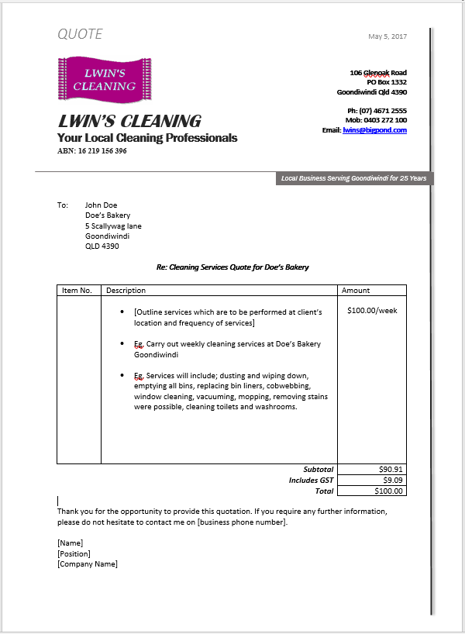  - Software used: accessed client databases using MYOB, produced document using Microsoft Word.  - Purpose of Document: to provide potential clients with an estimated cost to carry out services.  Customer statement:  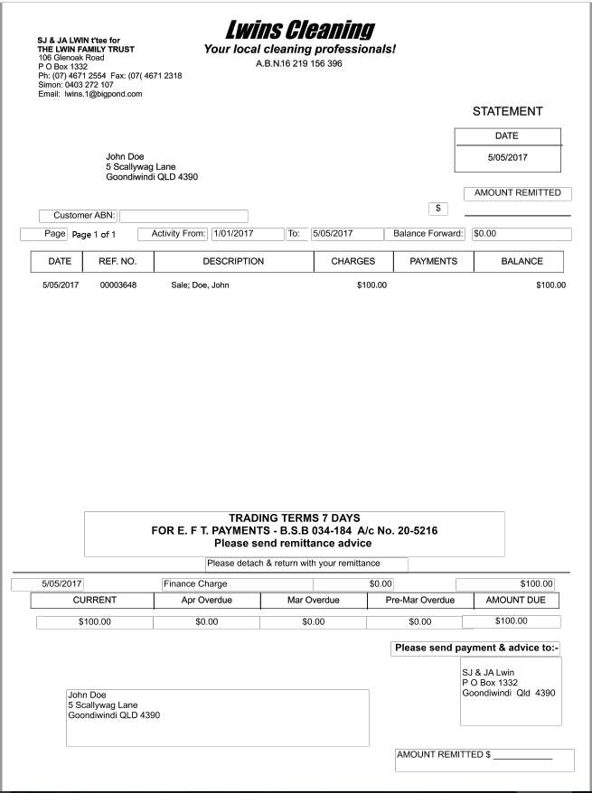  - Software used: produced using MYOB, presented using and printable from Adobe PDF reader.  - Purpose of Document: to show outstanding/running balance of customers account.  Credit Application Form: (Myob, Microsoft word)  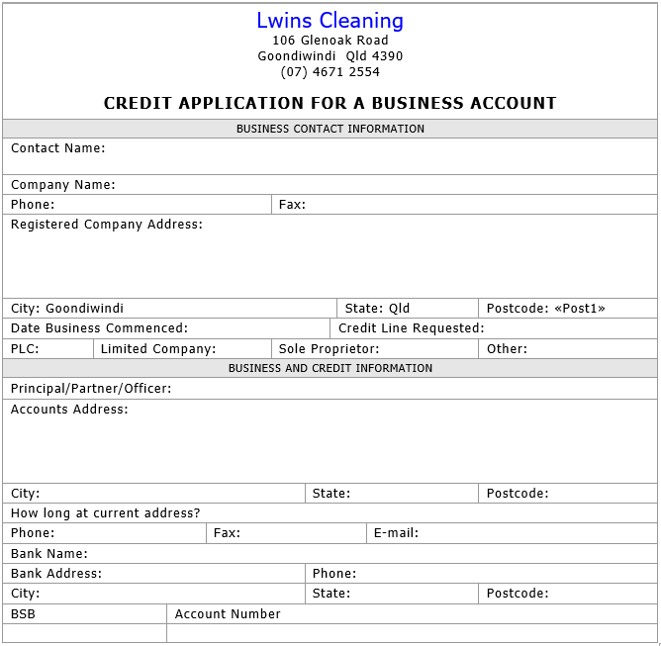  - Software used: produced using MYOB, presented using and printable from Microsoft Word.  - Purpose of Document: client request for an extension of credit (legal document outlining organisation trading agreements with customers).  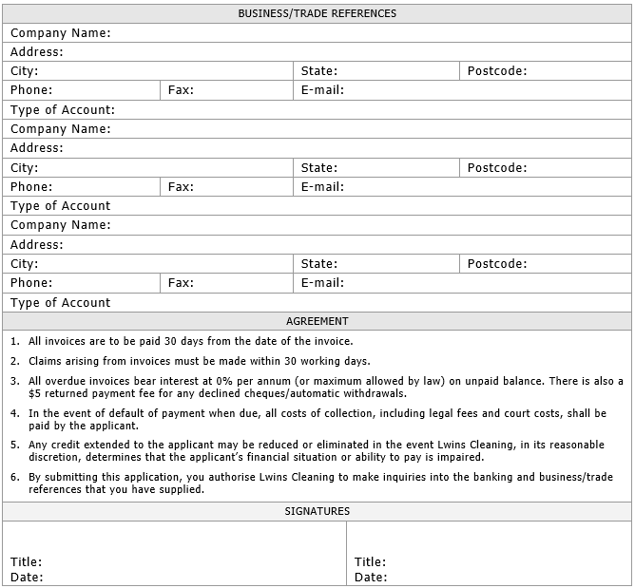

Major Activity
Estimated Time | 1 Hour
Objective | To provide you with an opportunity to demonstrate your knowledge of the entire unit.
Activity | This is a major activity – your instructor will let you know whether you will complete it during class or in your own time.  Attach your completed answers to the workbook.  You must individually, answer the following questions in full to show your competency of each element:  - Select and prepare resources  - Design document  - Produce document  - Finalise document  Using one type of business document as an example:  Financial Report  - Select the appropriate technology and software applications to use.  Choice of technology and software is important when designing and producing business documents.  Technology required: computer (to design document), printer (to produce copies of document for circulation and/or presentation).  Software required: accounting software such as MYOB (which will collate financial data within a given time period), Microsoft excel (to prepare tables and graphs), Microsoft word and Adobe pdf reader.  - Select the layout and style you would use and explain how this related to organisational requirements.  It is important to choose a layout and style which suits the purpose of a document and contributes to its readability. Within my organisation, requirements surrounding budgets, policies, saving files and security must be considered. A financial report must be easy to follow and understand, therefore the styles will include; portrait orientation, title page, table of contents, colour coding of and information within tables and graphs, consistent font size 11 - with headings slightly larger, key points in bold for emphasis, margins and page numbering.  - Explain how you could use basic design principles to ensure design is consistent with requirements.  To ensure the design of a document is consistent with organisational requirements, it is helpful to consider the principles of contrast, alignment, repetition and proximity. Contrasting lines, fonts, shapes and colours allows you to highlight key points within a document and helps guide the reader. Alignment ensures consistency as it creates an ordered design and aids the coherence of a document. The use of repetition can create associations to strengthen design and by considering the proximity of elements, you can provide a focal point. Business templates can also be used to ensure design remains consistent.  - Say you were to discuss and clarify this with the person that has requested this document; when would you do this? What would you discuss?  It is necessary to clarify content and design features with the person requesting the document before producing it. Consultation regarding the document may also occur during its development.  - Identify the files and records you would need to open and/or generate. Briefly describe this process.  In order to produce a financial report, you would need to access, analyse and present past financial records and build future projections. These records could be located within client records, accounting software, stored files and computer archives. Accounting software could be used to collate financial data within a given time period. Various features of this information could then be analysed, graphed and presented using templates.  - Outline ways in which you would design your document to ensure efficient entry of information.  To ensure the document is easy to follow, and information can be entered efficiently, design features such as dashed lines, check boxes, scales and comment boxes can be included.  - Outline the functions that you would use to ensure consistency of design and layout.  To ensure consistency of design and layout, functions such as alternating headers and footers, editing, spell checking and table formatting can be used. One of the most important of these will be table formatting as this assures consistency across table styles, background colours, borders, columns and spacing.  - List the input devices that you would need to use in order to develop your document.  The input devices required to produce the document will include a keyboard, mouse, number keypad and scanner.  - Describe the techniques you would use in order to meet the designated time line.  Techniques which contribute to effective time management include recording deadlines, prioritising tasks, tracking progress, choosing appropriate technology/software and fixing problems right away. These will be incorporated to ensure a designated timeline is met.  - List the aspects of the style and layout of your document that you would need to check meet the requirements.  Style and layout features to check will include; paragraph spacing, margin size, text size, colour and font, structure, use of bold and italics, page numbering and table and image properties.  - Outline how you would save and store your document in order to avoid loss of data.  To ensure data is not at risk or lost, the document will be stored in multiple locations; on the computer and backed up on an external USB or drive. Storing a hard copy of the document would ensure safety even further.  - If you were to face basic difficulties, where would you turn?  There are various places to find solutions to basic problems. These include manuals, training booklets or help-desks. Using the internet to access online information would likely be the quickest and easiest way to find a solution.  - How would you proofread your document?  Effective proofreading would involve reading out loud to check for spelling, grammar, language and punctuation issues. Checking readability and style elements like colours, heading and images is also important when proofreading.  - If you were to find mistakes when proofreading, how would you rectify these?  Once located, spelling, grammar and punctuation mistakes can be easily rectified by simply selecting the correct option, while readability mistakes may require you to rewrite or reword sections of a document.  - Describe how you would name and store your document.  So that the document could be located in future, it would be important to include details such as names/initials, date, codes and version numbers in the file name. It would also be helpful to store the document systematically, with others of the same type.  - Give details on how you would print your document.  To print the document, the computer would need to be connected to a printer, either directly, or remotely through the internet. Then, within the software application, the number of copies and appropriate print options would need to be set before printing the document.

