
AHCLSC306
Implement a paving project

Copyright © 2021 CSTC Pty Ltd

All rights reserved. No part of the contents of this publication may be reproduced or used in any form or by any means – graphic, electronic, or mechanical including photocopying, digitising, recording, or information storage-and-retrieval systems – without the written permission of CSTC Pty Ltd.
ASSESSMENT FOR AHCLSC306

Student name | Lachlan Pomerenke
Date of assessment submission | Click here to enter a date.

Trainer/Assessor’s name
Date of assessment marking | Click here to enter a date.
Outcome for unit | ☐ Competent  ☐ Not Yet Competent

TASK INSTRUCTIONS

- As part of the assessment for this unit of competency, you are required to complete a series of activities.
  - Some of these activities will require you to provide a response within this document, others will require you to gather evidence to demonstrate your knowledge and skills.
- At all times, the responses in your assessment must reference Australian (Queensland or Federal) documentation, including legislation, regulations, codes of practice, standards and guidance publications.

ACTIVITIES

Identify/list the scope of the work to be carried out from the concept plan shown.

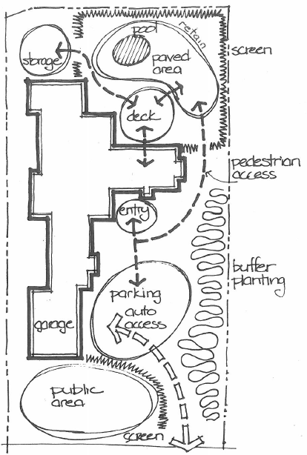

Response
Paving area around pool
Retaining around North end of pool
Installing screens
Garden area for planting

Outcome for Activity 1 | ☐ Satisfactory  ☐ Not satisfactory
Trainer/Assessor comments

Identify/list the detail on the landscape plan shown.

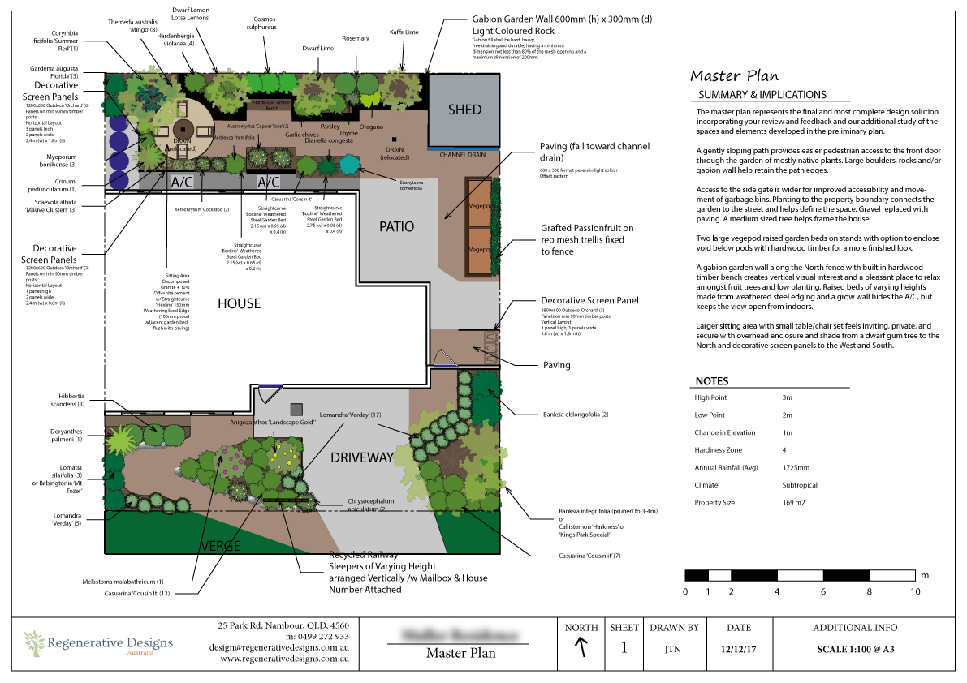

Response
Summary and implications of plans
Legend including scale, orientation, contour
Boundary
Areas to be paved
Garden Plans
Retaining wall plans
Decorative screen panel plans
Design company information
Existing buildings and structures

Outcome for Activity 2 | ☐ Satisfactory  ☐ Not satisfactory
Trainer/Assessor comments

Using the graphics shown, create a simple plan that details a paved path through a garden with grass, trees, shrubs, rocks and steps.

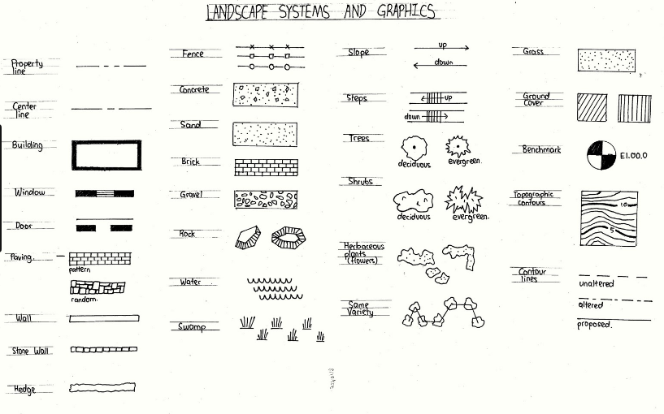

Response
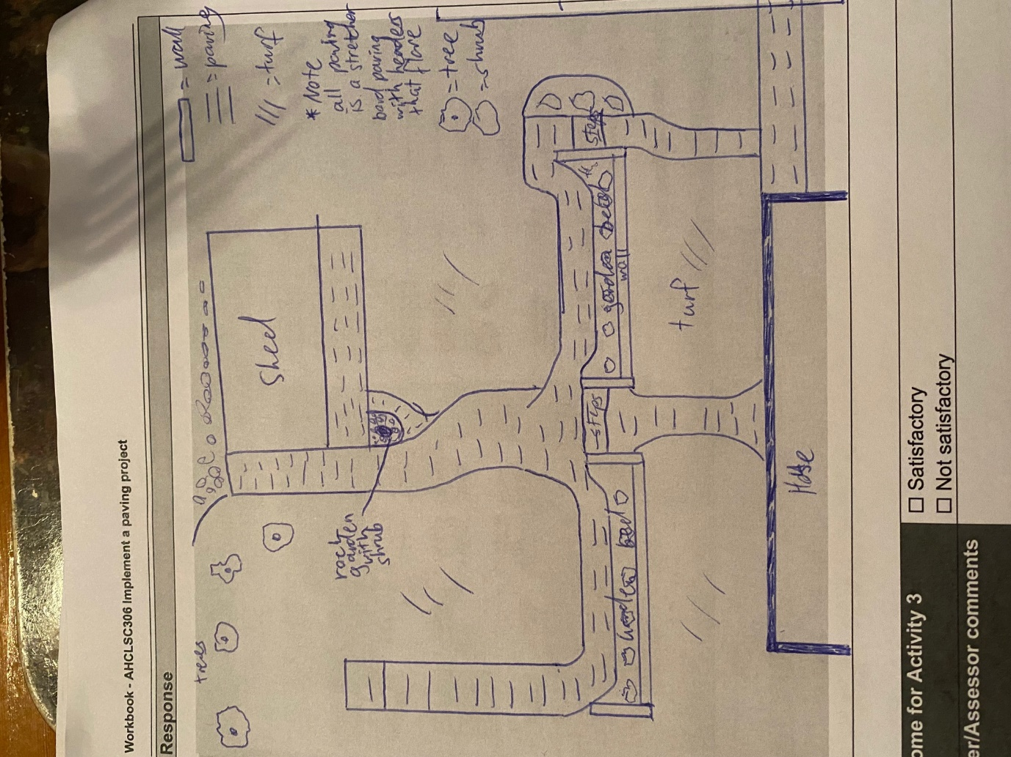

Outcome for Activity 3 | ☐ Satisfactory  ☐ Not satisfactory
Trainer/Assessor comments

Research the advantages and disadvantages of concrete, clay and stone pavers.

For each material, provide one (1) example of a project where it would be most appropriate to use the material and one (1) example of a project where it would not be appropriate to use the material. Explain your responses.

Concrete pavers
Appropriate
When paving in shaded areas or sealed outdoors. Great variety and cheapest price means they will work for most situations and are easy to cut to make nice features and flares
Not appropriate
Under constant sun will cause fading.
Under large weights such as vehicles will potentially crack over time

Clay pavers
Appropriate
In outdoor areas and under vegetation where staining is common to make cleaning easier
Not appropriate
When heavy loads will pass over such as vehicles and mowers

Stone pavers
Appropriate
Along the edges of a paved area to prevent the edge cracking with weight driving over it.
Over areas that will get constant weight
Not appropriate
When cutting in patterns are required and in large areas as they are very expensive

Outcome for Activity 4 | ☐ Satisfactory  ☐ Not satisfactory
Trainer/Assessor comments

Obtain photographs of common landscaping materials and finished landscapes (both soft and hard).

Explain the differences between your emotions/feelings when you see each photograph in black and white and in colour.

Photograph 1
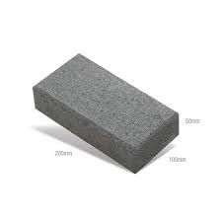

Black and white: Emotions and feelings
Bland and dull
Colour: Emotions and feelings
Looks nice with the wet look. The charcoal matches the colour bond charcoal which works well around homes

Photograph 2
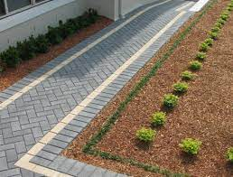

Black and white: Emotions and feelings
Path with a Herringbone at 45 degree pattern with a straight edge and header
Colour: Emotions and feelings
The cream colour helps break up the darkness of a straight charcoal path.

Photograph 3
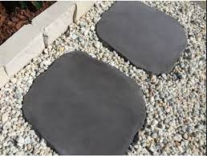

Black and white: Emotions and feelings
Natural stone pavers make nice steppingstones in gravel for a very natural look
Colour: Emotions and feelings
The charcoal pavers have a nice offset to the cream gravel and garden edge blocks

Photograph 4
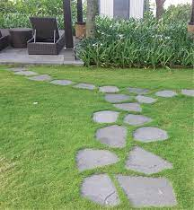

Black and white: Emotions and feelings
Again, the stone looks very natural and simple but nice
Colour: Emotions and feelings
The varying shades of charcoal still look very natural but also match the pavers in the background for the patio.

Outcome for Activity 5 | ☐ Satisfactory  ☐ Not satisfactory
Trainer/Assessor comments

Research and identify eight (8) different paving patterns, including the common usage, advantages and disadvantages for each pattern.

Pattern 1 name | Stretcher bond
Common usage
Pathways
Advantages
Quick and easy to lay. Very easy to add a header and flair. strong enough to withstand heavy foot traffic and light vehicle traffic.
Disadvantages
May not be as aesthetically pleasing as other more complicated designs

Pattern 2 name | Herringbone at 45 degrees
Common usage
Driveways and paths
Advantages
Strong pattern that reduces any movement when vehicles pass over
Disadvantages
Time consuming, requires a lot of cuts.

Pattern 3 name | Herringbone at 90 degrees
Common usage
Pathways and driveways
Advantages
Strong enough for traffic on flatter surfaces. Doesn’t require too many cuts
Disadvantages
Not as strong as Herringbone 45 degrees

Pattern 4 name | Circular pattern
Common usage
As a feature
Advantages
Breaks up the blandness of an area. A catchy feature that can complement other colours in the paving work or other landscaping features nearby.
Disadvantages
Weak patter, requires a lot of cuts and will leave gaps that need grout or mortar

Pattern 5 name | Basket weave pattern
Common usage
To create a heritage, look along paths or patios
Advantages
Easy to lay, requires very little cuts, other colours can be blended in very easily to break it up
Disadvantages
Not strong enough to suit driveway areas.

Pattern 6 name | European fan pattern
Common usage
Very eye-catching feature
Advantages
Breaks up simple pattern areas. Easy to mix in other colours. Looks very nice
Disadvantages
Very hard to lay, requires a lot of cuts, Not suitable for vehicles.

Pattern 7 name | Triple stretcher bond
Common usage
Paths that require a bit more strength
Advantages
Better suited for paths where on occasion vehicles may pass over. Strong. Simple to lay.
Disadvantages
Difficult to cut around curves. Harder to line up perfect thirds than halves with the simple stretcher bond.

Pattern 8 name | Stack bond
Common usage
Little pads for air con units or small storage sheds
Advantages
Super simple top lay. No cuts required. Very cheap
Disadvantages
No strength. Will slide if driven on. Best for just storage purposes or to create a small pad

Outcome for Activity 6 | ☐ Satisfactory  ☐ Not satisfactory
Trainer/Assessor comments

Select a paver type (with known specifications) and calculate the material costs for a straight path that measures 6m long by 900mm wide.

Response
Haven brick charcoal pavers $0.57 each 200x100mm stretcher bond pattern
Edge to edge 1m = 5 pavers 5x6 = 30
At 100mm wide 9 rows will be need
30x9 = 270 pavers.
After the first stretch is finished the next stretch will require a paver to be cut at each end. This will use the same amount of pavers though and will only be necessary to do 4 cuts

Outcome for Activity 7 | ☐ Satisfactory  ☐ Not satisfactory
Trainer/Assessor comments

Research the advantages and disadvantages of installing edging before and after laying pavers.

Installing edging before laying pavers
Advantages
A perfect edge can be laid up against to make the laying process move very quickly
Disadvantages
If the edge is not perfect the pavers will either have to be cut in or the edge redone. This will most likely result in taking up much more time

Installing edging after laying pavers
Advantages
If adjustments need to be made to the paved area it is easy to do so
Disadvantages
Pavers can be moved during the edging process, so it is important to make sure your lines are straight at the end of the project. If the cement is spilled on he pavers it will have to be cleaned with a sponge as hosing can destroy the edge before it Is set

Outcome for Activity 8 | ☐ Satisfactory  ☐ Not satisfactory
Trainer/Assessor comments

List environmentally safe products for cleaning.

Response
Water either hosing or with a gurney, sponge, or scrub
Hydrochloric acid and water solution. Will need to be washed off and diluted as you go and sealed afterwards.
General purpose paving and concrete cleaners from bunnings are also an option.

Outcome for Activity 9 | ☐ Satisfactory  ☐ Not satisfactory
Trainer/Assessor comments

Have team members take photos and videos of your involvement with paving projects.

Identify each photo / video with a letter label and describe each photo / video in the table below. Submit the photo / video files along with this workbook.

Advantages
A | 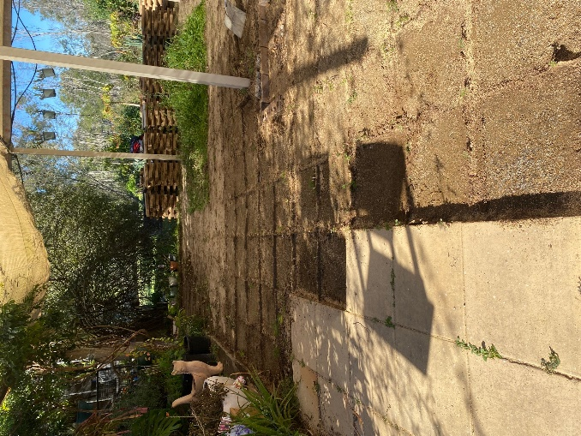Removing old paving work to excavate the subbase, add more materials. Compacting and screeding.
B | 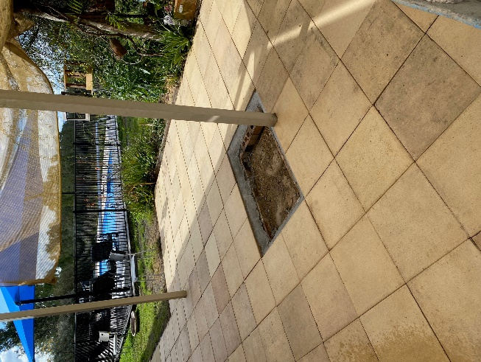Laying pavers on the new subbase and adding a concrete edge to lock them in.
C | 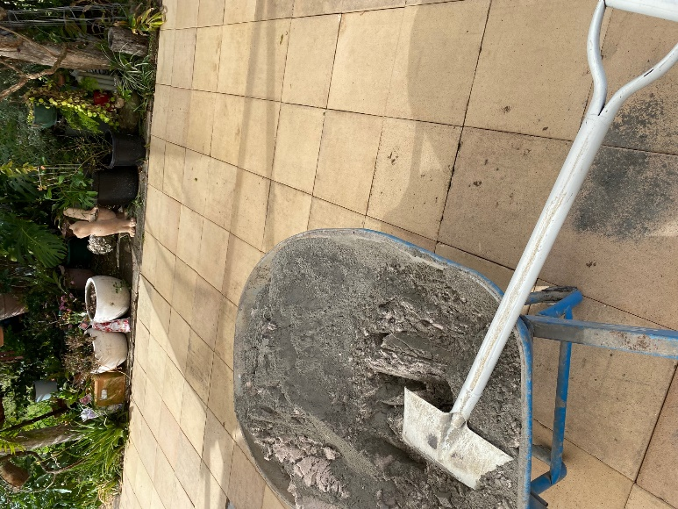Sand and cement mixture to be hosed and swept into all the gaps of the pavers
D | 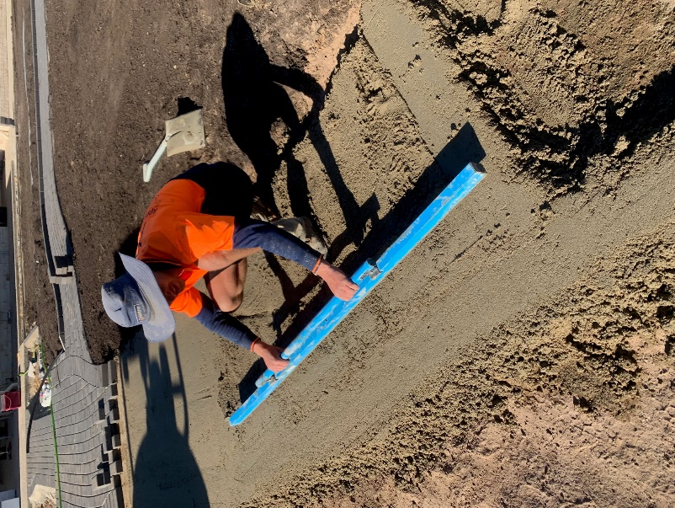Screeding a sand and cement subbase to be laid on.
E | 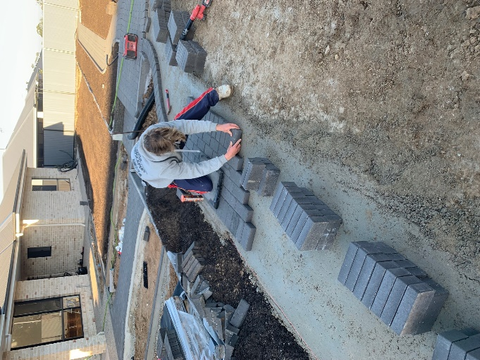Laying a stretcher bond pattern with a header on the sand and cement base
F | 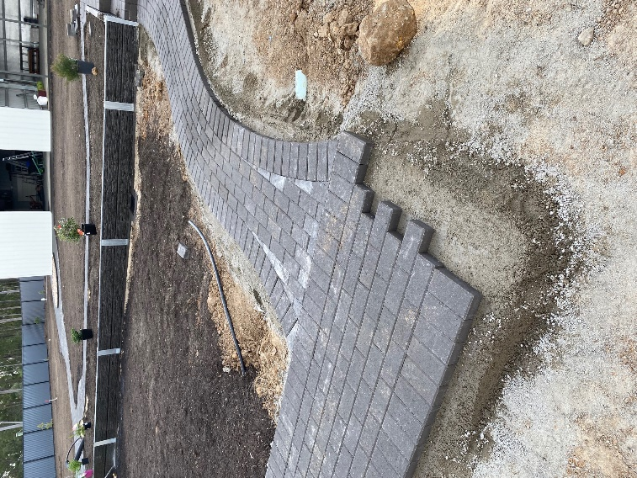Marking and cutting pavers to desired shape in the stretcher bond pattern.
G | 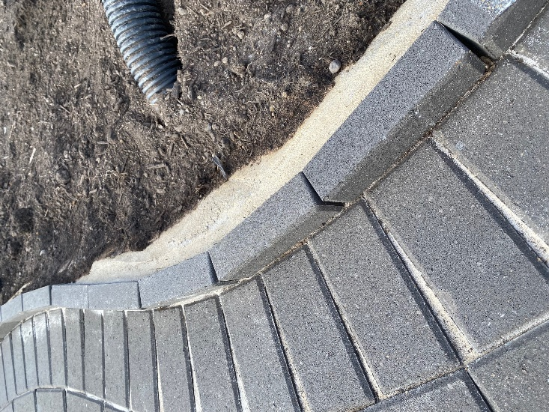Adding concrete to the edge of our paving and floating it to lock in the pavers.
H | 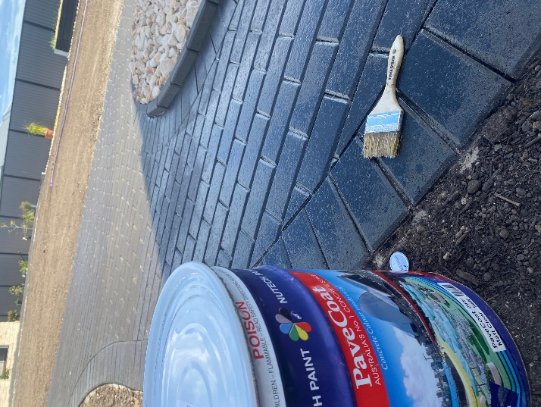Sealing the pavers with a wet look sealer to give them colour and protect them after thoroughly washing them.
I
J
K
L
M
N
O
P
Q
R
S
T
U
V
W
X
Y
Z

Outcome for Activity 10 | ☐ Satisfactory  ☐ Not satisfactory
Trainer/Assessor comments

