BSBLDR414
Lead team effectiveness

ASSESSMENT SUMMARY

The assessment activities for BSBLDR414 Lead team effectiveness cover all aspects of the unit of competency. For Apprentices/Trainees, this includes supervisor completion of the Apprentice/Trainee Record (ATR).

Participants must read all the information given before starting any assessment task. The assessment tasks are intended to be fair, flexible, valid and reliable. If a Participant has any questions or requires alternative arrangements to be made such requests should be directed to their Trainer/Assessor, who should note such arrangements in the ‘Assessor Comments’ on the affected assessment. If a Participant feels they are not yet ready to be assessed, they should discuss their options with their Trainer/Assessor.

To satisfactorily complete the assessment, the Participant is required to answer all questions correctly and demonstrate their skills to industry standards. If a Participant does not answer all questions or perform all tasks, they will be deemed ‘Not Satisfactory’ for the task and ‘Not Yet Competent’ for the unit of competency.

The Trainer/Assessor can provide the Participant with additional information on interpreting the assessment outcomes and guide the Participant’s options. If a Participant is still deemed ‘Not Satisfactory’ they will have the opportunity to undertake a supplementary assessment or appeal the result as per the process in the Student Handbook.

By signing below, the Participant acknowledges:
- They understand the assessment instructions and requirements, and consent to being assessed.
- The work submitted is to be their own work – with the work of/with others needing to be clearly acknowledged and documented.
- They consent to any photo/video recording of their work that occurs during assessment.

Participant name | Amber Graham
Participant signature | 

Pre-requisite unit(s) to be achieved and authenticated prior to undertaking assessment
Not applicable

Task | Date completed | Assessment Results
Theory Exam | Select Date. | Satisfactory | Not Satisfactory
Practical Assessment | Select Date. | Satisfactory | Not Satisfactory
Outcome for BSBLDR414 | Select Date. | Competent | Not Yet Competent

Evidence requirements checklist (ticked by assessor and evidence supplied to RTO)
Theory Exam | Practical Assessment  Team development plan

Assessor Name
Assessor Signature | 

BSBLDR414
Lead team effectiveness

THEORY EXAM

Participant name | Amber Graham

FOR THE PARTICIPANT
Instructions
- You will complete written questions as outlined on the following pages. You must attempt all questions and provide enough detail in your responses to demonstrate your knowledge.
- It is anticipated that you should complete this assessment within two (2) hours, but additional time may be allowed upon negotiation with the Assessor.
- You must complete all questions unassisted by the Assessor or other personnel but may refer to reference material as needed. All questions must be answered correctly for a ‘Satisfactory’ assessment outcome to be awarded.
  - An oral examination may be allowed under certain circumstances, whereby your answers will be documented by another party.
  - Any written questions that are incomplete, or not answered satisfactorily will need to be completed again after further training support.
    - If you answer a question incorrectly but modify your response, put your initials next to the written change (or the Assessor must initial a verbal change).
Resources required
Pen

FOR THE ASSESSOR
Instructions
- Where oral examination has occurred, ensure that this is acknowledged in writing (e.g. FT001 and Assessor Comments)
- All questions must be satisfactorily demonstrated by the Participant for a Satisfactory determination (indicated by an Assessor tick to the right of the question).
- Assessors are to complete marking in pen of a different colour to the Participant.
- If the Participant verbally modifies their response, write in the modified response verbatim and put your initials next to the written change.

ASSESSOR COMMENTS
As necessary, outline:
- Details on reattempts, alternative arrangements or reasonable adjustments made.
- Where a Participant is deemed ‘Not Satisfactory’, provide recommendations for future training.

- Identify a team that may exist in the workplace. Consider the purpose of the team, its goals and objectives. Name and describe the roles and responsibilities for at least three (3) team members. Finally, identify at least one (1) method that will assist with monitoring progress towards the team goals.

Answer | Point | Detail
 | Team purpose | Project teams
 | Goals and objectives | Short term | Get one new referral this month by sending out a weekly newsletter (four newsletters total) to all clients and offer a discount off their next booking as an incentive.
 | Goals and objectives | Long term | Increase efficiency in the workplace by 10 percent by the end of quarter three by implementing Scrum so our employees can keep track of their process and complete at least 75 percent of their weekly commitments.
 | Team members | Role | Description | Responsibilities
 | Team members | 1 | Resource investigator | Determine and secures the resources needed for a particular project
 | Team members | 2 | Coordinator | Focusses on the team’s objectives, delegates work to team members
 | Team members | 3 | Completer-Finisher | Used at the end of the task to undertake quality control checks
 | Progress monitoring | Is the team clear on its goals and objectives and how these are to be carried out?  Is the culture of the organisation supportive towards the team and its goals?  Are individual team members still comfortable with their roles and happy in the team?

- True or False (Tick your response): A team leader is more of a mentor than overseer who checks work.

Answer |  | True
 |  | False

- Match the leadership styles and definitions by writing the appropriate letter next to each number in the centre column.

Answer | Style |  |  | Definition
 | 1 | Authoritarian | 1 - B | A | Leaders who let the team function without much interference
 | 2 | Democratic | 2 - C | B | Leaders who fully control their team
 | 3 | Laissiz-Faire | 3 - A | C | Leaders who try to include everyone in the decision-making process

- Identify two (2) benefits and two (2) drawbacks of transactional leadership.

Answer | Benefits | Drawbacks
 | Clearly defined rewards and consequences for meeting or not meeting those goals | Employees feel like followers, rather than innovators or leaders
 | Employee security in knowing there are no surprises regarding expectations of outcomes | Employees can feel stifled by their work environment

- Which of the following are characteristics of transformational leaderships? Tick all that apply.

Answer | Choice | Possible Answers
 |  | The leader acts as a role model to employees
 |  | Close, consistent focus on the company vision
 |  | A high value on interpersonal relationships
 |  | Inspiration as a tool to motivate employees

- Why is it important for team leaders to include team members in the planning process?

Answer | This makes the work more meaningful and improves morale, self-esteem and outcomes. Team members better understand each others’ tasks and the team’s goals. Team members take more responsibility for their individual work in the team effort

- For each of the listed activities in the table below, identify two (2) methods that team leaders can use to involve team members.

Answer | Activity | Method/s to involve team members
 | Goal setting | Set clear, identifiable and achievable goals that the team agrees with. Provide encouragement, promoting creative and innovating approaches to problem-solving
 | Decision making | To improve productivity, a manager should not be consulted each time a decision is to be made
 | Work allocation | Organising its own activities, meetings etc

- True or False (Tick your response): Diverse teams produce more creative results than teams in which members are less diverse.

Answer |  | True
 |  | False

- Provide two (2) examples of how the knowledge, skills and background of team members can enhance team practices.

Answer | Consider the skills and experience each member can contribute to the team. Try to allocate work according to skills and abilities to get the most out of the team members.  Do not force relationships or working groups that will cause conflict. Delegate the work fairly to avoid resentment.

- Provide two (2) reasons that responsibilities must be carefully delegated within the work team.

Answer | The skills and experience that each member can contribute to the team  Ensure that work is fairly delegated to avoid resentment between group members  Try to allocate work according to skills and abilities to get the most out of team members

- Describe what innovation brings to the workplace. Provide one (1) example of innovative practice.

Answer | Involving the various skilled team members in the planning allows for improved practices such as innovation – Application of better solutions to meet requirements

- Describe (3) methods that may be used to measure a team’s innovation.

Answer | Is the team clear on its goals and objectives and how these are to be carried out?  Is the culture of the organisation supportive towards the team and its goals?  Are individual team members still comfortable with their roles and happy in the team?

- Explain how encouraging team members to assist each other in undertaking their roles and responsibilities can improve productivity.

Answer | This makes the work more meaningful and improves morale, self-esteem and outcomes  Team members better understand each others’ tasks and the team’s goals  Team members take more responsibility for their individual work in the team effort

- Describe (3) methods that may be used to measure a team’s productivity.

Answer | Achievement of objectives (i.e. meeting set objectives)  Measuring quantitative productivity (i.e. how many parts, applications, products, or calls processed per hour, day or month)  Measuring profit (i.e. tracking revenue)

- Which of the following are likely outcomes from involving team members in all aspects of a job? Tick all that apply.

Answer | Choice | Possible Answers
 |  | Causes members to resent the team
 |  | Makes the work more meaningful
 |  | Improves self-esteem of team members
 |  | Improves team morale
 |  | Team members take more responsibility for their individual work

- Explain how providing feedback to team members can encourage and motivate team members – building trust and positive working relationships.

Answer | Encouraging the team and rewarding both team and individual efforts shows that the team and its members are valued.  A valued team will be inspired to keep working towards its goals – as well as remain focussed, energetic and cohesive in its actions  .

- Identify one (1) issue, concern or problem that may be identified by team members. Describe the signs that you would recognise to identify the issue and how the matter could be resolved by internal team negotiation.

Answer |  | Response
 | Issue, problem, or concern | Underperformance
 | Signs | Deadlines not being met
 | Solution via negotiation | Review and amend work plan.  Closer management to ensure that deadlines are met.

- Identify one (1) issue, concern or problem that would need to be resolved by an external party. Describe the signs that you would recognise to identify the issue and who the matter should be referred to.

Answer |  | Response
 | Issue, problem, or concern | Additional training
 | Signs | Raised by the team
 | Solution via negotiation | Management may need to provide opportunities for professional development

- Identify three (3) ways that the team leader can serve as a role model to, and motivate, the team.

Answer | Effective Communication.  Recognising needs of team  Setting goals and motivating the team  Provide encouragement, promoting creative and innovating approaches to problem-solving.

- For each of the following areas, provide one (1) example of how the team leader’s contributions to the work team can enhance the organisation’s image:
- Internally, within the work team and the organisation
- Externally, with clients/customers

Answer | Question | Response
 | Within the work team and organisation | Be a good mentor, advisor and team member themselves.  Ensure that their own contribution to the work team serves a role model for other team members
 | With clients and customers

- Provide three (3) communication methods that a team leader may encourage the team to use, and situations that each communication method would be suitable for.

Answer | Method | Suitability
 | Use a consultative approach | demonstrations
 | Actively listen to team member concerns | Recognising needs of team members at team meetings when asked questions or problems raised
 | Provide regular feedback to team members | To encourage or enhance performance.

- Identify two (2) ways that the team leader can establish open communication with management.

Answer | Having meeting with management, delivering regular reports)  Both good and bad news must be reported – problems will not be avoided by only reporting good news

- Identify two (2) issues, concerns and problems that may be raised by the team to management.

Answer | If the team requires additional training to complete their job, management may need to provide opportunities for professional development. The team leader may provide guidance on the type of training needed.  If the deadline is not achievable, requesting this to be reviewed or extended..

- Identify two (2) issues, concerns and problems related to the team that may be raised by management back to the team.

Answer | Providing information and guidance on matters overarching the day-to-day operations of the team  Providing assistance where the team is having difficulties and cannot resolve matters internally - This will be outlined in the organisation’s escalation policies and procedures

- Describe one (1) situation where the team leader may have to negotiate with management on behalf of the team.

Answer | Underperformance may be flagged by management. The team leader may need to guide the team to enable it to work as more effective unit. Alternatively, the team leader may be required to negotiate the level of performance expected, if too high

Refer to the extract below from an Escalation Policy and Procedure to respond to Q26. to Q28.

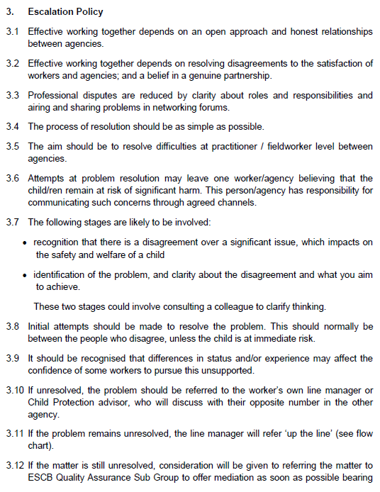
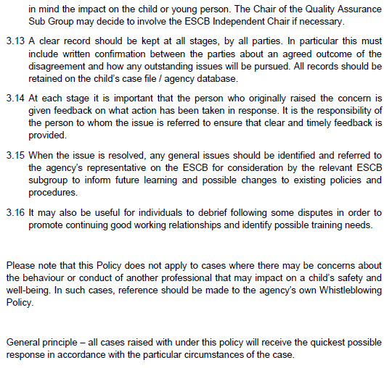
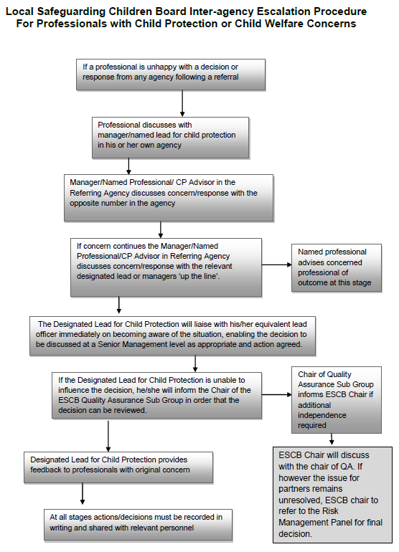

- Order the following steps from 1 to 5 to identify the correct order of issue escalation where a problem is unresolved.

Answer | Step Number | Steps
 | 1 | The people who disagree should make the initial attempts to resolve the problem
 | 5 | When the issue is resolved, any general issues should be identified and referred back to the agency’s representative to inform future learning and possible changes to existing policies and procedures
 | 3 | If the problem remains unresolved, line manager will refer ‘up the line’
 | 4 | If the matter is still unresolved, the matter may be referred to the Quality Assurance Sub Group to offer mediation
 | 2 | If unresolved, the problem should be referred to the worker’s own line manager

- True or False (Tick your response): It is the goal for all cases raised under this policy to receive the quickest possible response.

Answer |  | True
 |  | False

- If the ESCB Chair cannot resolve the issue, which body can make the final decision?

Answer | Risk Management Panel l

BSBLDR414
Lead team effectiveness

PRACTICAL ASSESSMENT

Participant name | Amber Graham

FOR THE PARTICIPANT
Instructions
- The tasks outlined on the following pages will require performance of normal workplace activities, as a result of a structured activity set by an Observer in the workplace or a simulated activity set by your Assessor/Observer.
- The timeframe for these tasks will be established by your Assessor/Observer, in consideration of location conditions and industry requirements.
- You must complete all tasks unassisted by the Assessor or other personnel, unless the steps note this assistance.
- You must attempt all tasks (and itemised steps) for a ‘Satisfactory’ assessment outcome to be awarded.
  - For any observation conducted that is incomplete, or without satisfactory performance, the observation will need to be completed again after further training support.

FOR THE ASSESSOR/OBSERVER
Instructions
- The following observation record should be used to judge and record your observations of the Participant as they complete the task(s) set. You must record your observations of the Participant’s performance.
  - For each occasion, indicate the task performed and whether it was a simulation or workplace-based task.
    - Any simulated assessment must ensure the Participant still performs under workplace conditions which reflect industry standards.
  - In the comments, provide clear detail regarding the task that the Participant was required to do (e.g. PPE used, materials handled, attachments connected, plant types).
- All steps must be satisfactorily demonstrated by the Participant for a ‘Satisfactory’ determination (indicated by an Assessor tick to the right of each itemised step, or an Observer tick to the right of each itemised step, and confirmation by an Assessor in the Assessor Comments).
  - Where you have determined that one or more task steps have not been satisfactorily demonstrated, provide the Participant with additional support and outline details of such assistance in the Assessor/Observer Comments. Allow the Participant two (2) further opportunities to demonstrate the task again to allow an opportunity for a ‘Satisfactory’ assessment outcome to be achieved.
  - If after three (3) attempts the Assessor determines that the Participant cannot demonstrate the required steps, a ‘Not Satisfactory’ outcome is to be determined.

TASK OUTCOME
Task | Date | Task Type (Tick) | Location | Task outcome (Tick)
 |  |  |  | Satisfactory | Not Satisfactory
Task 1 | 24/08/2022 | Workplace  Simulation | Timber Creek Camp

ASSESSOR COMMENTS
As necessary, outline:
- Details on reattempts, alternative arrangements or reasonable adjustments made.
- Where a Participant is deemed ‘Not Satisfactory’, provide recommendations for future training.

ASSESSOR COMMENTS: PRACTICAL TASK 1
Individual student (as named on cover page)
Multiple students [ All from Attendance Report, Specific students involved – identify students]
Task | Provide detail
1.B. | Feedback provided to team members:  Yes, positive reinforcement
1.C. | Support offered to identify and resolve problems, issues and concerns:  Yes – extra training with demonstrations
1.D. | Issues passed from management to the team and vice versa:  Yes, more PPE was to be ordered as we were running low. Team advised management.

BSBLDR414
Lead team effectiveness

Practical Task 1
Description of task:
A suitable observer is to verify the participant’s ability to lead team effectiveness, including:
- Leading and consulting with the team to develop a team development plan that addresses –
  - Team cohesion
  - Innovation and productivity measures
  - Issues management and actions
- Communicating with team members and management to –
  - Consult, encourage, support and provide feedback to the team
  - Model team leadership behaviours and approaches
  - Resolve problems

The Observer is to provide detailed comments on the tasks completed by the Participant (on the Observer Comments, overleaf). The Assessor is to verify the Observer’s comments, noting their findings in the Assessor Comments (on the back of the Practical Assessment cover page) and provide the assessment outcome.
Resources required:
Team Development Plan Template
Observer details
Name of observer: | John Ash
Role of observer  (Confirm suitability to sign) | Acting Manager
Email address of observer | Johnash59@gmail.com
Signature of observer: | 
Date: | 24/08/2022

When completing the task, did the Participant: | Tick if satisfactorily completed.  Provide comments if left unticked.
- Lead and consult with the team to establish and document a team development plan, incorporating:
- Team purpose, roles, responsibilities, goals, objectives and plans
- Consideration of organisational goals, objectives and plans
- Team cohesion
- Innovation and productivity measures
- Issues management and actions
- Lead team to develop cohesion, including:
- Providing opportunities for input of team members into planning, decision making and operational aspects
- Encouraging and supporting team members to take responsibility for own work and to assist each other
- Providing feedback to team members to encourage, value and reward individual and team efforts and contributions
- Participate in and facilitate work team, including:
- Leading and supporting team members in meeting expected outcomes
- Actively encouraging team members to participate in and take responsibility for team activities and communication processes
- Giving the team support to identify and resolve problems, issues and concerns
- Acting as a role model to enhance the organisation’s image for work team, clients and customers
- In line with organisational escalation policies and procedures, maintain open communication by passing information from management to the team and vice versa (including issues, concerns and problems).

OBSERVER COMMENTS

TEAM DEVELOPMENT PLAN

DATE OF EFFECT
Start | 24/08/2022 |  | End |  | 25/08/2022
GOALS, PLANS AND OBJECTIVES
Outline the team’s purpose, goals, and objectives. Identify how this fits within the organisation’s goals, objectives and plans.
To get AC units cleaned correctly. Spot checks for mold to be done while cleaning. All maintenance on AC units must be reported and documented.
OBJECTIVES FOR TEAM
Objective |  | Work process |  | Responsible employee |  | Start date | End date
Team cohesion |  | Work together |  | Shauna, Heather |  | 24/08/2022 | 25/08/2022
Innovation |  | Application of better solutions to meet requirements |  | Shauna |  | 24/08/2022 | 25/08/2022
Productivity |  | Measuring how many units are being done per hour |  | Amber |  | 24/08/2022 | 25/08/2022
Issues management |  | Record and document |  | Amber |  | 24/08/2022 | 25/08/2022
REVIEWING AND ASSESSMENT METHODS
How will you track the plan’s implementation, the team’s progress (e.g. through team meetings, reports)?
Through team meetings and reports
ADDITIONAL SUPPORT
Is there any additional support needed to reach the desired goals (e.g. courses, classes, resources).
I have done a demonstration on how to correctly clean AC units using correct chemicals, equipment and what PPE to wear. I have shown what to look out for regarding mold.
EXPECTED OUTCOME
Team leader’s expectations on the outcome based on the data.
This task will be completed within 24 hours
OUTCOME IF GOALS AND OBJECTIVES ARE NOT MET
Identify the consequences and further steps if the team fails to satisfy the standards set by the plan.
Living or working near an old and moldy air conditioner can increase your chances of respiratory infection. Cleaning your air conditioner allows it to perform more efficiently by reducing the stress and pressure, that dust and debris build-up usually put on your unit. When air filters get clogged and become dirty, the normal flow of air is impeded thus making your unit work harder than it should.

