CPCCBC4012B
Read and interpret plans and specifications

THEORY EXAM INSTRUCTIONS

- This exam will occur under standard assessment conditions.
  - An oral examination may be allowed under certain circumstances.
Answers will be documented and FT003 (Oral examination declaration form) must be completed.
- Participants must provide enough detail in their responses to demonstrate their knowledge and skills.
- Please fill in the details below, providing your name, signature and date of assessment.
  - Your signature acknowledges that this is your own work.
- If a participant initially answers a question incorrectly but modifies their response, they must follow the instructions below:
  - If a participant changes their response in writing, they must put their initials next to the written change.
  - If a participant changes their response verbally, this must be noted on the exam paper by the assessor.

Participant name | ANGELO NAVARRO TOLENTINO
Participant signature | 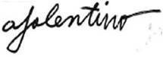

Assessor name
Assessor signature | 

Date | 20/03/2018

Number of questions | Number of questions answered correctly | Satisfactory?
77 |  | Yes | No
Assessor Comments
- What does the term ‘plan’ mean when referencing plans and drawings for construction purposes?

Answer | With reference to plans and drawings for construction, the term “plan” is a document prepared by designers and consultants that contain essential information about a project. Plans, also known as “blueprints” or “working drawings” show the concerned parties what is to be built.

- Name the people and organisations who will have an interest in plans and drawings for a construction project.

Answer | The following people and organizations who will have interest in plans and drawings for a construction project are the clients, lending body, local council, supply authorities, builders and subcontractors wanting to quote, engineers, subcontractors(various trades), real estate agents, neighbours, kitchen manufacturers, landscapers, various material or product suppliers, environmental agencies, and mechanical service installers.

- What will plans show to the interested parties?

Answer | Plans will show interested parties in the proposed structure what it will look like when it is completed, and how it will be constructed. In addition, plans will identify key features such as ceiling heights and variations, doors, light fittings and power supplies, services, wall penetrations, walls, and many more.

- What types of plans is it necessary to be familiar with for building and construction projects?

Answer | To undertake building and construction projects, one has to be familiar with the different plans such as, block plans, site plans, floor plans, elevations plans, and estate road layouts. The compass direction evident in all plans and drawings is the “North Point”. They are likely to be found on key plans, site plans, block plans, and floor plans.

- All plans and drawings give a compass direction.
Which compass direction is always shown and on which drawings is it likely to be found?

Answer | The compass direction evident in all plans and drawings is the “North Point”. They are likely to be found on key plans, site plans, block plans, and floor plans.

- What does a location plan contain?

Answer | A location plan contains the lot number/s, deposit plan numbers, the north point, and scale of the drawing.

- What does a site or block plan contain?

Answer | The site or block plans contains the following:  1.A datum  2. Building orientation to North Point  3. Outline of site boundaries showing location of proposed building and existing dwellings  4. Plan page number, client name, project address, scale, reference numbers and dates  5. Major geological and topographical features (trees and vegetation)  6. Contours and slopes  7. Depths  8. Distance from the boundaries to the building foot print  9. Driveways, stormwater drainage, easements and right of carriage  10. Soil and surface water drains  11. Service runs from the house to mains  12. New levels on the sire in connection with the new house  13. Paving  14. Retaining Walls

- What features would you expect to look for and find on plans and drawings for a construction project?

Answer | On typical plans and drawing, it is expected to find the features enumerated below:  1. Ceiling heights and variations  2. Doors  3. Light fittings and power supplies  4. Services  5. Wall penetrations  6. Walls  Generally, plans will also show the location of various features on site and illustrate details about the following:  1. Building  2. The height, position and bulk of the building  3. Allow builders and tradespeople to prepare written quotations based on plan.  4. Provide information to the surveyors with “to set out” details  5. Illustrate the tradespeople the structure to be built.

- What do floor plans identify?

Answer | Floor plans accurately provides and identifies the layout or arrangements of rooms or other parts of the interior of a construction project, It may also contain other information such as general dimensions, materials represented through symbols, development details, and many more.

- What are elevation views? What do they provide to the plan reader?

Answer | In drawing, elevation views refer to the sides of a specific type of project. They provide readers with a square view of the project from the East, West, North and South.

- What is a section?

Answer | A section is a vertical (cut) view through the building. The direction of section lines or arrows is usually shown on the plans to help interpret the sectional view.

- What are detailed drawings?

Answer | Detailed drawing are supplementary plans that provide further details of roads, pathways, parking areas, boundaries and landscaping.

- What are specifications?

Answer | Specifications are a set out by minimum standards or codes necessary to satisfy a task, in this case, confirming to the requirements of the plans.

- What information will you find in a title block to a drawing?

Answer | The title block to a drawing contains the following:  1. North Point  2. Project Name  3. Project Address  4. Drawing Title  5. Scale  6. Date  7. Drawing No.  8. Contact Details  9. Revisions

- What is the significance of the Australian Architectural Standards?

Answer | The significance of the Australian Architectural Standards is to provide information on codes, certifications and processes to avoid violations regarding building and construction in general.

- What will you find in the Waste Management Plans & Site Management plans?

Answer | For a waste management plan, you will see all general details about the project site. It will showcase the materials used for the project and how it will be disposed, how much will be the estimated waste on-site and off-site and where the waste or recyclable materials will be transferred.  On the otherhhand, the site management plan consists of ways on how the builder or contractor will ensure the safety of the development. The parts of this plan is enumerated below:  1. Safety  2. Noise and Vibration Controls  3. Air and Dust Management  4. Stormwater and sediment control  5. Waste and Materials reuse 6. Traffic Management

- What is a landscape plan?

Answer | A landscape plan is similar to a floor plan, but for an outdoor setting. Like the floor plan, it helps the reader visualize what is to be built or developed on a site.

- What is the purpose of a shadow diagram? Who primarily would seek one?

Answer | The purpose of the shadow diagram is to prove that neighbouring properties adjacent to the site of work won’t be significantly impacted by the new building or extensions. Planning councils would seek these drawings, and sometimes building surveyors. The diagram will also play a part in the submission of the building permit.

- What is a bracing schedule?

Answer | A bracing schedule is a detailed list of materials required for roof installation. On the schedule, you will also see the detailed specifications of the materials such as designation, dimension, quantity, and kind of material.

- What must we do with plans and drawings in our on-site environments? How often should plans and drawings be viewed on site?

Answer | First and foremost, copies of the plans and drawings should always be available on-site at all times. Builders, designers, and other involved parties should also work hand-in-hand to update each of the documents with regards to the developments of the project.  Plans and drawings should be viewed consistently from time to time to avoid any miscommunication and be informed of any variation in any of the documents.

- Explain the meaning of the abbreviations in the table below.

Answer | Abbreviation | Meaning
 | ACRYL | Acrylic
 | AS | Australian Standard
 | ASSD | Assumed Datum
 | B | Basin
 | BN | Bull Nose
 | BTH | Bath
 | BWK | Brickwork
 | CB | Concrete Block
 | CF | Concrete Floor
 | CG | Clear Glass
 | CJ | Ceiling Joist
 | CORR | Corrugated
 | CWT | Cold Water Tank
 | DG | Double Glazing
 | DH | Double Hung
 | DPC | Damp Proof Course
 | DSB | Distribution Switch Board
 | DW | Dish Washer
 | EJ | Expansion Joint
 | FPBD | Fibrous Plaster Board
 | FFL | Finished Floor Level
 | FHR | Fire Hose Reel
 | GPO | General Purpose Outlet
 | HBD | Hardboard
 | HTR | Heater
 | HWD | Hardwood

- Why and when would you use presentation drawings?

Answer | Presentation drawings are used because they convey basic design concepts of the project to the clients. It is used to show compliance with board standards and help advertise existing stock plans. In addition, presentation drawing are also necessary when attending public hearings and design reviews.

- Service drawings provide information about a variety of different components and equipment. In order to identify individual items, it is usual to give them a reference number on drawings such as services layout drawings and location plans.
What details might we expect to see from service drawings?

Answer | The details you can expect from service drawing are the following:  1. Hot and Cold water supplies, above and below ground drainage  2. Sanitary Appliances  3. Refuse Disposal  4. Heating  5. Ventilation  6. Air Conditioning  7. Electrical installation including lighting, telecommunications, gas installation, fire protection, mechanical conveyors and security systems.

- What are working drawings? What do they record?

Answer | A working drawing is a blue print which is complete with enough plan and section views to enable the depicted items construction without additional information. It records or explain the appearance and construction of an existing building or sketch,

- What is an isometric view?

Answer | An Isometric view is a projection of an object by showing three faces in a drawing. It is a view consisting of three lines defining three forces or planes which produce three equal angles using vertical lines, and horizontal lines at 30 degrees to the horizontal.

- Sketch a concrete block in isometric view.

Answer

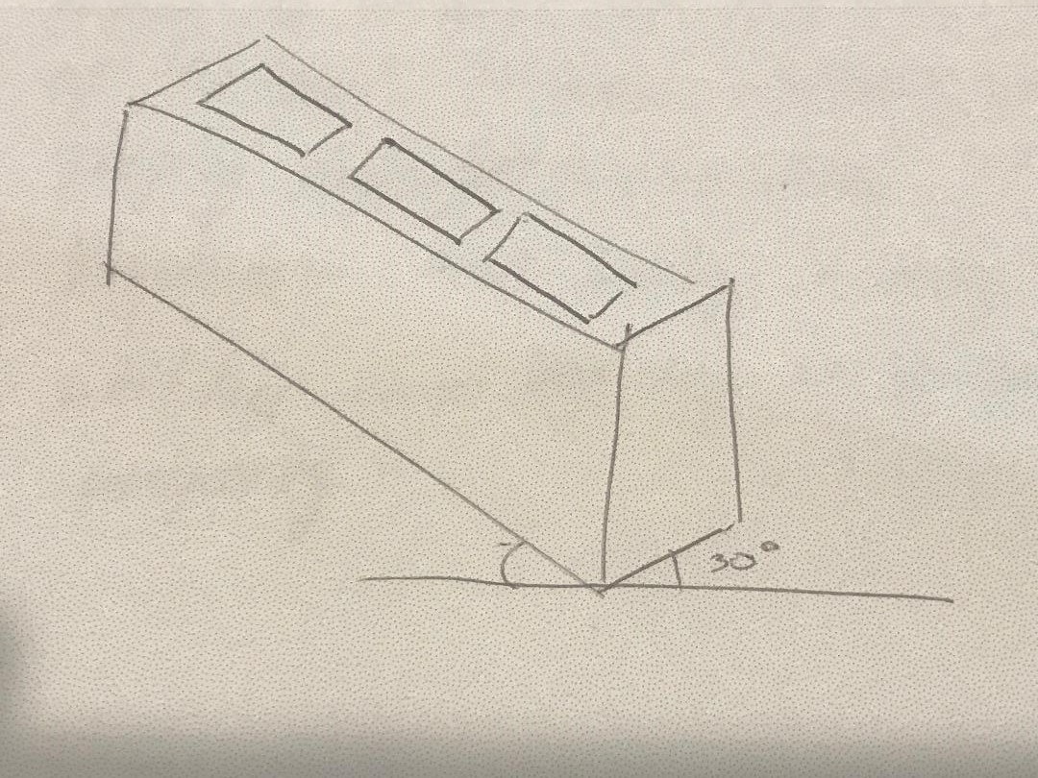

- What is the purpose of perspective projection and representation in drawing of architectural buildings and edifices?

Answer | The purpose of the perspective projection is to give the interested individual an idea of the structure’s realistic appearance as seen by the eye or camera when all parallel lines converge at infinite vanishing points as they recede from the observer.  There are three basic typed of representations for perspectives: One-point (One Vanishing Point), two-point(two vanishing points) and three point (three perspective points) as all sides of the object are at an angle with the picture frame.

- What is a topographical survey?

Answer | A topographical survey is concerned with noting the natural and manmade features of the land. It shows contours, which represent varying sloped or elevations. It will illustrate present vegetation. And lastly, it may also portray utilities that may exist on the property.

- What is an ecological survey?

Answer | An ecological survey contains information that identifies habitats and or species that exist within an area where development or construction will occur.

- What is significant to keep in mind when developing the Schedule of Quantities (also known as a Bill of Quantities)?

Answer | To prepare the Schedule of Quantities, the estimator should give big consideration on the following:  1. Detailed Drawings to scale  2. Detailed Specifications  3. Detailed Scope of works  4. Finishes Schedule  5. Details of contract conditions  6. A site report and other additional plans

- What should be applied in consideration of stress, load and bearing calculations in the design, the drawings and the building of a structure?

Answer | In consideration of stress, load and bearing calculations in the design, all building code requirements and calculation pertinent to design shall be complied with.

- What is a prime cost (PC) item? Give an example.

Answer | A prime cost (PC) is an amount of money included in a contract sum to purchase a specified item such as tiles, tops, doors or bathroom fittings. For example, the client would like to replace matte finished floor tiles with something more expensive for the floor finish such as polished tiles.

- What is a provisional sum (PS) item? Give an example.

Answer | A provisional sum (PS) is an amount of money included in contract sum to cover work and or materials not detailed when entering the contract. Let us take site excavation in an urban setting as an example. Contractors may need to provide additional support for other structures surrounding the actual site location as a safety precaution. This will mean added costs.

- Suggest when you would need to provide ‘additional’ plans.
Give some examples of such plans.

Answer | One will need additional plans if there are instances wherein you need to provide further information of roads, pathways, parking areas, boundaries and landscaping. As an examples, it may be necessary to provide a traffic and parking report for all kinds of developments for council approval. All detailed site plans that shows critical adjoining parts of surrounding properties and the locality. Another example is a Stormwater Drainage Concept Plan that will show how stormwater will be managed on site.

- How do you identify and record customer variations?

Answer | You can identify customer variations by initially looking at the specifications which set out the minimum standards or codes necessary to obtain relevant sizes for all structural components and provide details of building materials and fittings. One can record customer variations by simply updating the initial specifications and noting if there is an addition or deduction that needs to be done some items.

- When reading and interpreting (or amending) variations project specifications, what documentation should you also refer to?

Answer | When reading and interpreting variations project specifications, one should consider or refer to the following:  1. Plans  2. Contracts  3. Engineer’s Details  4. Building Permits  5. Other Permits  6. Legal Documentations

- So you don’t end up in a dispute what strategies can you employ with your customer/client/home owners?

Answer | To avoid disputes with customers, clients, and homeowners, one should remind them that they have the responsibility to put variations in writing to the builder as early as possible through an official document. Clients should put everything in writing, including the cost and signed consent of all concerned parties in the contract. It is also essential to submit a request for time extension and that all payments be made in accordance with the time indicated.

- Name each of the drawing symbol images shown in the table below.

Answer | Name | Image
 | Wall, Cavity Brick | 
 | Wall, Brick Veneer | 
 | Wall, Timber Stud | 
 | Window, Cavity Wall | 
 | Window, Single Wall | 
 | Single Swing Door | 
 | Double Swing Door | 
 | Pocket Door | 
 | Sliding Door, Exposed on Wall | 
 | Socket Outlet | 

- Draw symbols for the following items.

Answer | Item | Drawing
 | Basin | 
 | Bidet | 
 | Bath | 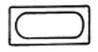
 | Drinking fountain | 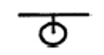
 | Sink: Single bowl | 
 | Sink: Double bowl | 
 | Tub: Double | 
 | Tub: Single | 
 | Drinking trough | 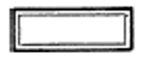
 | Hotplates | 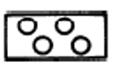
 | Shower | 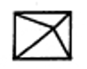
 | Shower bath | 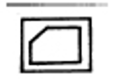
 | Urinal stall | 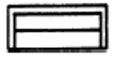
 | Vanity basin | 
 | Water Closet (Toilet) | 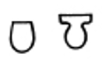

- Draw the following window symbols in elevation.

Answer | Item | Drawing
 | Hinged at side | 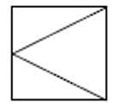
 | Hinged at top | 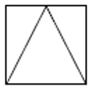
 | Sliding horizontally | 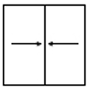
 | Fixed | 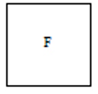

- Draw symbols for the following items.

Answer | Item | Drawing
 | Brickwork | 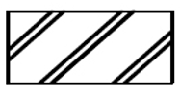
 | Blockwork | 
 | Concrete | 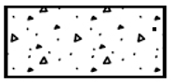
 | Plaster/Render | 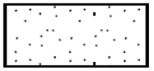

- Provide a description of the residence shown in the plan drawing below.

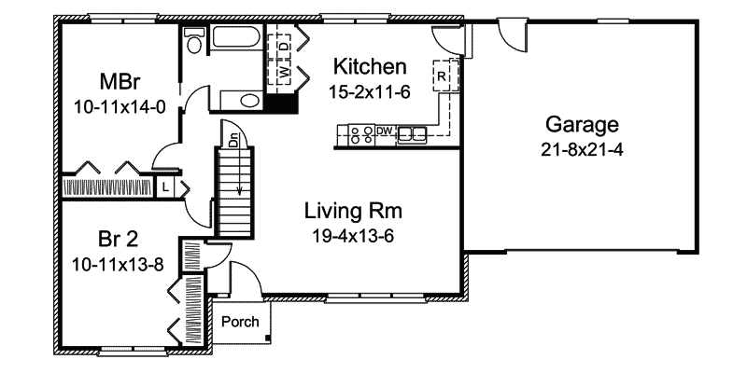

Answer | The drawing illustrate above is a residential floor plan. Evidently, the plan includes different spaces that typical dwellings have. It shows a garage, living area, kitchen, two bedrooms and one common toilet and bath. In addition, standard deliverables such as appliances and built-in furniture are included.

Refer to the sectional drawing below to respond to Q43. to Q63.


- Give a brief description about the building from the detail available in the sectional drawing.

Answer | The sectional drawing illustrates the different areas of the structure together with its material composition. It clearly depicts that the structure is a dwelling that had two verandas, a family room, a bathroom, and two bedrooms, all based on the cut section.

- Who is the client?

Answer | H&M Smith

- Where is this project to be built?

Answer | Lot 16 Glenvalley Road Richmond

- What are the contact details for the draftsman?

Answer | Joe Forman  Ph: 03 9514 2311  Mob: 0413 113 133  18 Fairview Road, Richmond 3216

- What sheet number is this drawing?

Answer | 5

- What timber is required for loading and non-load bearing walls?

Answer | DAR Oregon and F7 Oregon Timber

- What spacing is recommended for common studs?

Answer | 600 mm

- What type of roof truss is to be installed?

Answer | Scissor Trusses

- What centres are the trusses positioned at?

Answer | 30 deg. Top Chord and 20 deg. Bottom Chord

- What size are the veranda posts?

Answer | 90 x 90

- What timber species are the veranda posts to come from?

Answer | DAR Oregon

- What pitch is the roof?

Answer | 30 deg. Pitch

- What size are the noggings and at what spacing?

Answer | 35 x 70 at 1350 mm spacing

- What size are the ceiling joists?

Answer | Intermediate Size

- What timber is used for roof battens and what spacing?

Answer | FG Prime Battens at 900 mm spacing

- What thickness is the plasterboard sheeting?

Answer | 10 mm

- What type of flooring is to be installed?

Answer | Plywood Flooring

- What is the roof cladding material?

Answer | Colorbond corrugated metal roofing

- Where will you find information about the footings?

Answer | Engineers Drawing

- What do the letters DAR refer when timber ordering?

Answer | Dressed All Round

- Explain 240 x 63 LVL. What does it refer to on the section?

Answer | 240 x 63 Laminated Veneer Lumber (LVL) should be the type of timber used for joists at the veranda area. In addition, length of set out is indicated to be continuous.

Refer to the drawing overleaf to respond to Q64. to Q75.

- What is the number of the drawing?

Answer | 2

- What is the Job Number?

Answer | OOR - 112

- What is the scale of the drawing?

Answer | 1:100

- What does the drawing show?

Answer | The drawings show the East, West, North and South elevation views along with a few general building measures and material specifications.

- Which view shows the front of the house?

Answer | East Elevation

- How many motor vehicles can be parked in the garage?

Answer | Two

- What are the window and doors made from?

Answer | Aluminium Framed Windows and Timber Door

- What is the size of the eaves?

Answer | 450 mm

- What are the eaves lined with?

Answer | Hardiflex

- What type of roof structure is the roof built from?

Answer | Trusses

- What is the roof cladding materials made from?

Answer | Colorbond corrugated metal roofing

- What is the roof pitch?

Answer | 30 deg.



- You have spoken with a client on the phone and they are seeking to make amendments to some plans. They wish to add two more bedrooms to extend their home from the current four bedrooms to six bedrooms.
The two new bedrooms are to both have ensuites (including single shower in each, double bowl vanity unit and under cupboard and toilet) with walk in robes, including the extension of the existing hallway with built-ins for the existing Bed 1 and Bed 2. The Family Room is to be extended to the rear wall in line with kitchen rear wall.
The client has faxed through the image below. Re-sketch and redesign the drawing and add the two new bedrooms along with extended hallway, ensuites, walk-in robes and the Family Room extension for consideration by the client.
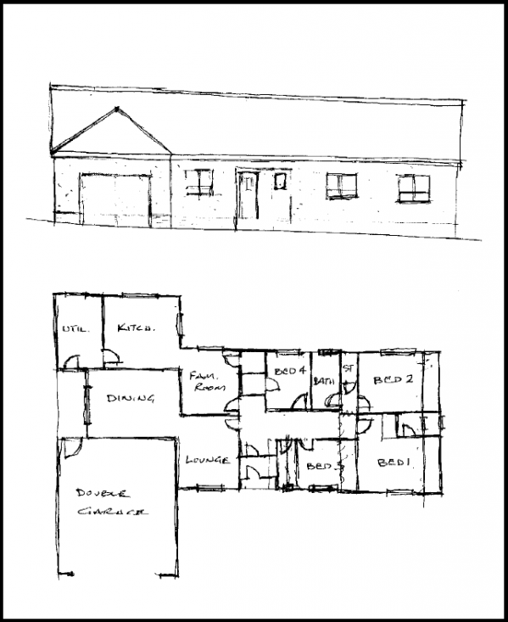
SKETCH
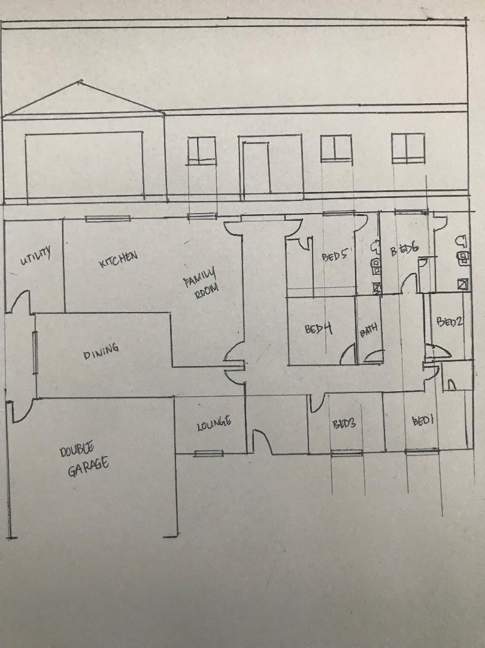

Answer

- Referring to Q76. compose an email to the client, providing an estimate of the additional labour hours/costs and material quantities/costs that have resulted from the their request.

Answer | To the client,  Good Day! I’m writing this message in response the phone call that we had just recently with regards to the amendments that you want done to the existing plans.  I would like to inform you that our team had already acted and have come up with a revised plan of the house together with the corresponding overhead costs due to variations (additions).  As reference, I have listed below the following amendments you requested:  1. Two new bedrooms with ensuite (including single shower in each, double bowl vanity unit and under cupboard and toilet)  2. Walk in robes for each additional bedroom  3. Extension of existing hallway  4. Family room is to be extended to the rear wall in line with kitchen rear wall.  Expected Costs:  - For manpower, we would need an additional time for the trades to work on the extension of walls at the family room area and hallways, installation of plumbing fixtures, finishing of the ceiling and flooring, installation doors for new areas, and the addition of walk in robes including a few interior walls. The cost of for manhours will depend on how many additional days it will take for us to finish the job.  - For material costs, we would need to purchase additional boards for the interior walls. We will need to buy toilet fixtures for the two new bedrooms and new doors for every new room. And finally, since there will be extensions in the interior of the house, we will need to buy more materials to uniformly match the floor and ceiling finish.

