Introduction to site communications and administration processes:
Site communication 1:
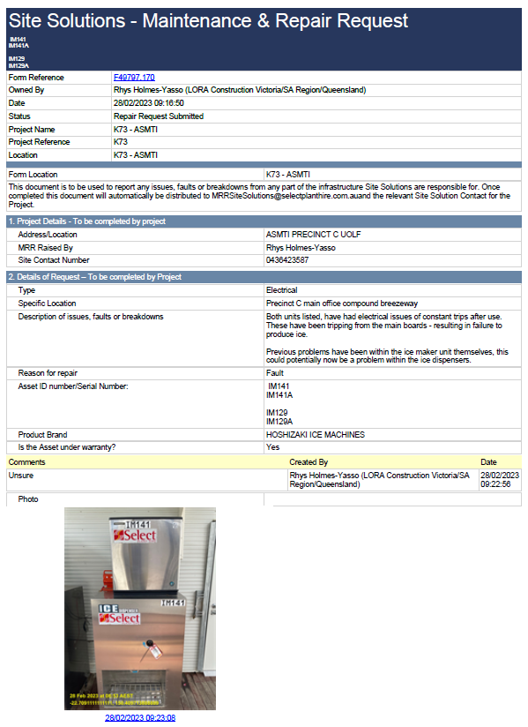
Throughout the ASMTI Project we had various site compound assists installed within our site compound offices. Prior to site establishment we had engaged a sub-contractor through Laing O’Rourke to take the scope of installing site offices, crib rooms, lunchrooms, and a breezeway to connect all these site buildings together. The same contractor installed assets such as ice machines and water bubblers. Throughout the project these assets had multiple

This form is then distributed to the sub-contractor to engage a local contractor to repair these items of action.
Due to the project being rural, I generally had to explain and forward details and information of access along via phone and email.
Below is a snippet of an Email trial forwarded through to the Manufacture sub-contractor of the ice machine for access into site to fix these items.
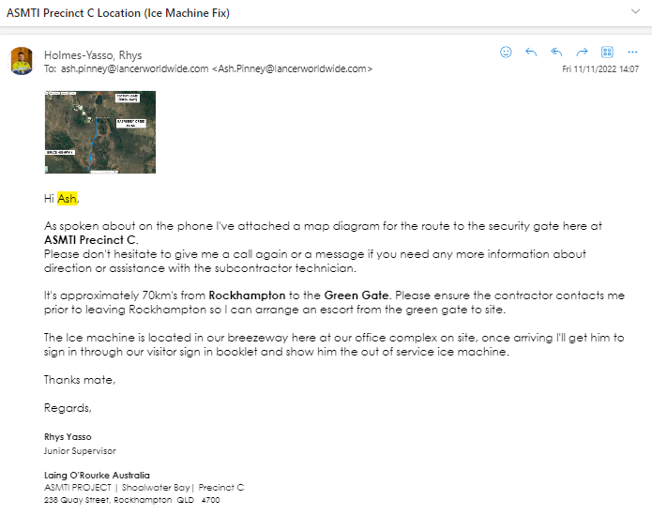

Photo attached show’s a larger image of the drawing submitted through to email.

Once the form and email has been forwarded through to the sub-contractor, this information is then distributed back to our commercial team to process internally.

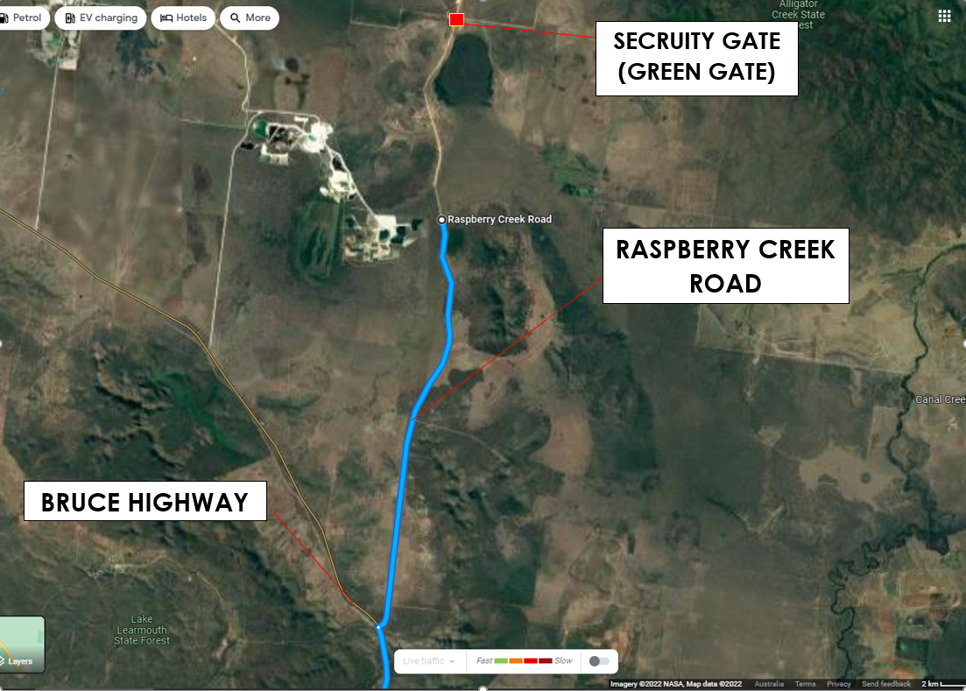

Site Communication 2:
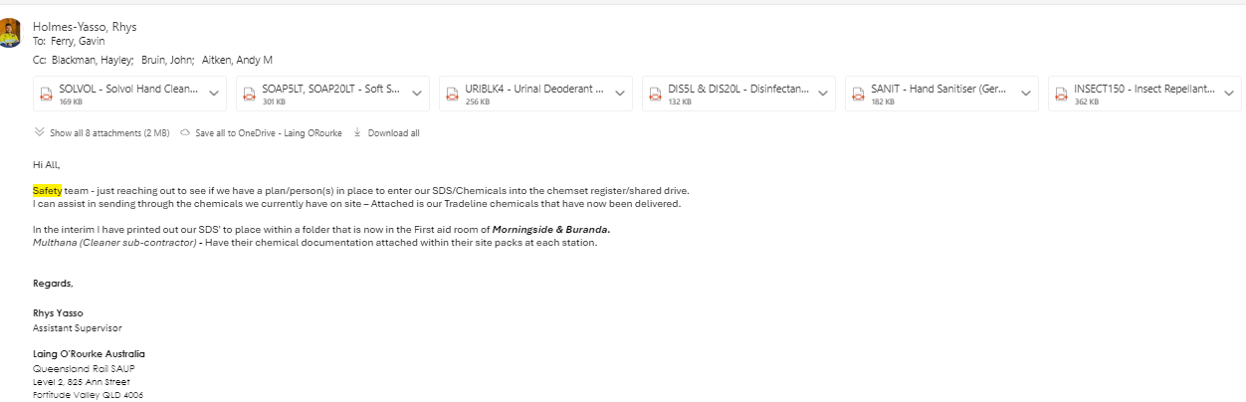
Snippet below show’s an email trial forwarded through from myself regarding chemical registers and chemical record procedures and processes. In the interim as stipulated within the email, I have ensured we have all chemicals recorded on-site on a hard copy and have all safety data sheets on hand within the first room for record keeping. This is an item that will soon appear within site checklists, specific inspections, and evidence to present in certifier, union, and legislative matters relevant to site.

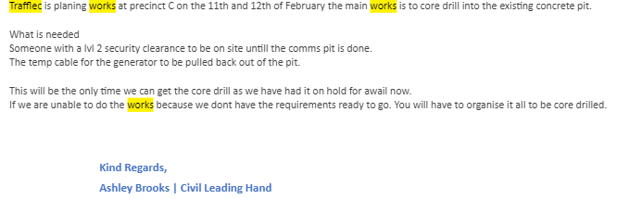
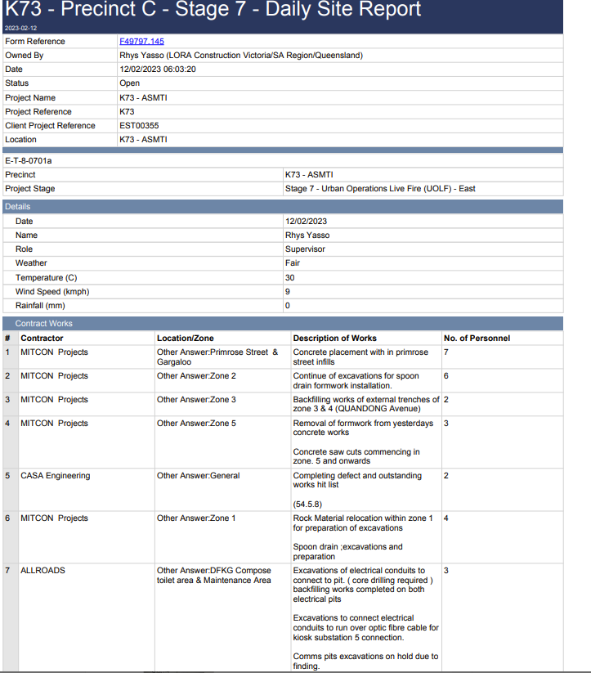
Admin Process 1:
Day before the commencement of a sub-contractor’s work, I conducted an inspection on all qualification documentation was facilitated through a LO’R used system called ‘EIFY’, This system is able to track each sub-contractor’s personnel details, qualifications, and additional relevant information required to attend site. Below is a snippet of the personnel inspected, at this person was the nominated operator for the day of works (Excavator Operator)
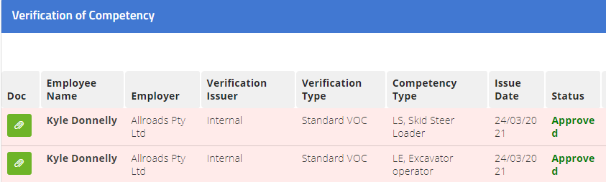
Under Laing O’Rourke requirements, for an operator to undertake plant operations, the operator must have all relevant qualifications uploaded and approved through EIFY – this includes a valid and in date verification of competency as well as the Statement of attainment (Or RII competency)
Kyle **** was solely the operator during this works, and approved to operate the machinery.
From the same works this sub-contractor’s investigation was conducted from is a daily site report that ties in within our administrative process, shown below.

The daily site report attached is documentation uploaded within a LOR used system called fieldview – Having this documentation ensures that work date and descriptions can be accessible by project wide personnel for visibility and to ensure that all works have been documented and recorded each day. This includes the number of on-site personnel conducting the works. .

