Part 1
1.4 Introduction
This project is for Unit 1 Generator Transformer half life cycle maintenance. This includes pre-testing works, changing of all the 3-phase high voltage bushing, radiator cooling fans refurbishment, oil filtration with vacuum fill and post testing after completion of works. This document will provide all the stakeholder an outline of the necessary work required to implement the projects deliverables. This will ensure that there is a common understanding of the projects scope and deliverable by all the stakeholders. No external resources or outsourcing are anticipated for this project.
Business Background
Energy Life Ltd commenced business twenty years ago specializing in high voltage electrical works from construction, installation and commissioning. Maintenance has always been a strong exertion for the company winning various bids for power stations equipment maintenance for the last five years across Australia.

1.0 PROJECT CHARTER
1.1 Project Authorisation
This charter formally authorises the Energy Life Ltd to implement a maintenance program on Unit 1 Generator Transformer as to provide Power Generation Limited a sustainable power plant for production and generation of energy
The project plan will be developed within the group and submitted to the client for their approval. The project plan will include the extend of work, schedules and financial proposal and final presentation of the plan
1.2 Project Workscope
The purpose of this project is to carry out the half life cycle maintenance of Unit 1 Generator Transformer, change out HV bushings of all three phases and vacuum/filter existing oil in the transformer to remove contaminants and reduce moisture levels.
The scope for this project is defined by the scope statement, work breakdown structure (WBS) and WBS dictionary. The Project Manager and the Client will establish and approve documentation such as work procedures and job safety evaluation analysis for measuring project scope which includes deliverable quality checklists and work performance measurements. Proposed scope changes or variations may be initiated by the Project Manager and the Client. All change requests will be submitted to the Project Engineer who will then evaluate the requested scope change. If additional resources are required for the project the Project Manager will make the decision with the Team Leader and forward personal names to the Client for site/locality inductions. Upon acceptance of the scope change request the Project Manager will submit the scope change request to the Client for acceptance. Based on feedback and input from the Project Manager, the Client is responsible for the acceptance of the final project deliverables and project scope.
1.3 Roles and Responsibility
The Project Manager, the Client and project team will all play key roles in managing the scope of this project. As such, all team members must be aware of their responsibilities in order to ensure that work performed on the project is within the established scope throughout the entire duration of the project. Any communication on site by the Client without the presence of the Project Manager can be done with the Team Leader. The table below defines the roles and responsibilities for the scope management of this project.
Names / Roles | Responsibilities
The Client | Planning/Documentation  Evaluate need for scope change requests  Accept project deliverables
Project Manager | Identify/verify project scope  Facilitate/organize/communicate impact Assessments of scope change requests  Update project documents upon approval of all scope changes
Project Team Lead | Identify/verify project scope  Validate/participate scope change requests  Communicate/facilitate team members outcomes of scope changes
Project Team Members | Execute tasks  Evaluate the need for scope changes and communicate them to the project manager as necessary and carryout tasks as per project scope

1.4 Document Control
All documents relating to the project plan will be distributed to Power Generation Ltd and Energy Life Ltd for signing off as an agreement to the proposition of work. The Project Manager becomes the sole responsibility to control the document if any need arises

2.0 SCOPE MANAGEMENT PLAN
2.1 Scope Definition
The scope for this project was defined through a comprehensive requirements collection process. A thorough analysis was performed on the company’s past 7 years maintenance records and power transformer manual and manufactures recommendation. From this information, the project team developed the project requirements documentation/rpocedures and the requirements management plan.

The project description and deliverables were developed based on the requirements collection process and input from relevant subject matter experts and third-party recommendation as in technical support.

2.2 Project Scope Statement

The project scope statement provides a detailed description of the project, deliverables, constraints, exclusions, assumptions, and acceptance criteria. Additionally, the scope statement includes what work should not be performed in order to eliminate any implied but unnecessary work which falls outside the of the project’s scope. This will ensure that there is a common understanding of the projects scope and deliverable by all the stakeholders
This project includes the planning and its execution. The deliverables for this project would be excepted when all post testing is being completed with satisfactory results. This project does not include ongoing operations and maintenance and only internal personnel and resources may be used for this project. Additionally, the project is not to exceed 20 days in duration or $320,000 in spending. Assumptions for this project are that support will be provided by the Client and that adequate internal resources are available for the successful completion of this project.
  - Project Boundaries
The project includes all requirements associated with:
- Inquiry – site visitation to gather information to help in the planning and design.
- Planning - mapping out the plan and how-to execution required works.
- Appropriate manuals and materials associated with the operation and maintenance of the equipment is to be supplied by Client

  - Deliverables
The deliverables for the project include:
- pre-testing report
- changing of all the 3-phase high voltage bushing
- radiator cooling fans refurbishment
- oil filtration with vacuum fill
- post-testing report

  - Inclusions
The project inclusions for each deliverable include:
- pre-testing works – insulation resistance, ratio check and winding resistance
- changing of all the 3-phase high voltage bushing – tan delta test on existing bushings before removal, tan delta test on new bushings before and after installation
- radiator cooling fans refurbishment – remove fans, clean and paint before re-installs
- oil filtration with vacuum fill – vacuum pump minimum 6 hours prior filling oil, filter oil back into transformer and fill to required level
- post testing - insulation resistance, ratio check and winding resistance

  - Exclusions
The project exclusions for each deliverable include:
- pre-testing works – testing only on current tap
- changing of all the 3-phase high voltage bushing – the visual inspection and maintenance of neutral bushing
- radiator cooling fans refurbishment – painting of fan housing
- oil filtration with vacuum fill – testing of oil dielectric strength prior and after works
- post testing – maintenance of any additional equipment associated with the Unit Transformer
2.7 Auditing
Each phase of work will be regularly audited by the Client and Project Manager in order to foresee any issues, the Team Leader of Energy Life Ltd will conduct regular quality checks as the work progress. The outcomes of all internal and external audits are to be included in the status reports and overall project plan.
  - Project Handover
The project handover to Power Generation Ltd from Energy Life Ltd will occur after the completion of Phase 3.
The project will be signed off as complete only when:
- The client is satisfied all deliverables have been completed and delivered to the required standard/quality
- The Client has conducted the final inspection of the equipment and is happy to sign off on it
- The client would be required to settle all outstanding payments
- A Certificate of Compliance Report has been written and provided showing all project activities have been completed
2.9 Project Closure/Archival
Upon completion of the project, the project closure needs:
- Finalize all invoices that have not yet been paid to suppliers and contractors are settled prior to the preparation of project closure
- Any lessons learnt documentation must be documented and reviewed with lessons applicable to future projects.
- The completion report, project plan and formal acceptance and closure must all be signed off by the Client and Project Manager.
- The hard copy files must be filed in archives of Energy Life Ltd and the electronic files must be stored in the archival hard drive under a separate folder clearly identifying the project name and date of archiving.
3.0 Scope Verification
As this project proceeds the Project Manager will verify works against the original scope as defined in the scope statement, WBS and WBS Dictionary. Continuous verification will be done to foresee any issues and quality of work is not compromised. Once the Project Manager verifies that the scope meets the requirements defined in the project plan and the Client agrees for acceptance, they would formalize a document for acceptance of the deliverable. The Client will accept the deliverable by signing a project deliverable acceptance document. This will ensure that project work remains within the scope of the project on a consistent basis throughout the duration of the project.

3.1 Scope Control
The Project Manager and the project team will work together to control the scope of the project. The project team will leverage the WBS Dictionary by using it as a statement of work for each WBS element. The project team will ensure that they perform only the work described in the WBS dictionary and generate the defined deliverables for each WBS element. The Project Manager will oversee the project team and the progression of the project to ensure that this scope control process is followed.

If a change to the project scope is needed a process for recommending changes to the scope of the project must be carried out. Any project team member or Client can request changes to the project scope. All change requests must be submitted to the Project Manager in the form of a project change request document. The Project Manager will then review the suggested change to the scope of the project. The Project Manager will then either deny the change request if it does not apply to the intent of the project or convene a change control meeting between the project team and Client to review the change request further and perform an impact assessment of the change. If the change request receives approval by the Project Manager and Client who will formally accept the change by signing the project change control document. Upon acceptance of the scope change the Project Manager will update all project documents and communicate the scope change to all project team members

3.2 Root Cause Analysis
The purpose of Root Cause Analysis (RCA) is to determine the causes that contributed to any event during the project. From this RCA we will determine exactly what happened during the event resulting in a failure, how it happened, and why it happened. In order to accomplish this, a formal investigation will take place to prevent another similar failure in future
It is important to note that for the purpose of the RCA, root causes should be:
- As specific as possible
- Reasonably identifiable
- Able to be managed/controlled

If any event is to occur during the project duration the Failure Mode and Effects Analysis method (FMEA) would be used to carry out the analysis.
It outlines:
- Potential failures, consequences and causes
- Current controls to prevent each type of failure
- Severity (S), occurrence (O) and detection (D) ratings that allow you to calculate a risk priority number (RPN) for determining further action

Root Cause Analysis is just the beginning of the problem-solving process. Once you know the cause, the next step is implementing a solution and conducting regular checks to ensure you’re holding the gain and achieving sustainable continuous improvement

Part 2
1.0 Work Breakdown Statement (WBS)
In order to effectively manage the work required to complete this project, it will be subdivided into individual work packages which will not exceed 60 hours of work per week. This will allow the Team Lead to more effectively manage the project’s scope as the project team works on the tasks necessary for project completion. The project is broken down into four phases: the paperwork; the pre-maintenance phase; the maintenance phase; and the post-maintenance phase. Each of these phases is then subdivided further down to work packages which will require no more than 10 hours of work per day and no less than 60 hours of work in total per week (see WBS structure below).

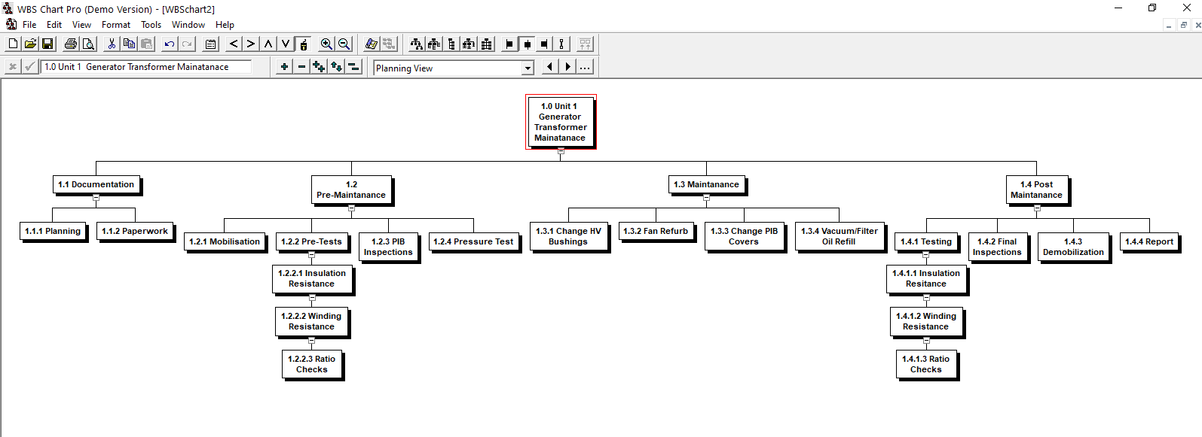
Figure 1.1 Work Breakdown Tree Structure

In order to more clearly define the work necessary for project completion the WBS Dictionary is used. The WBS Dictionary includes an entry for each WBS element. The WBS Dictionary includes a detailed description of work for each element and the deliverables, budget and resource needs for that element. The project team will use the WBS Dictionary as a statement of work for each WBS element.

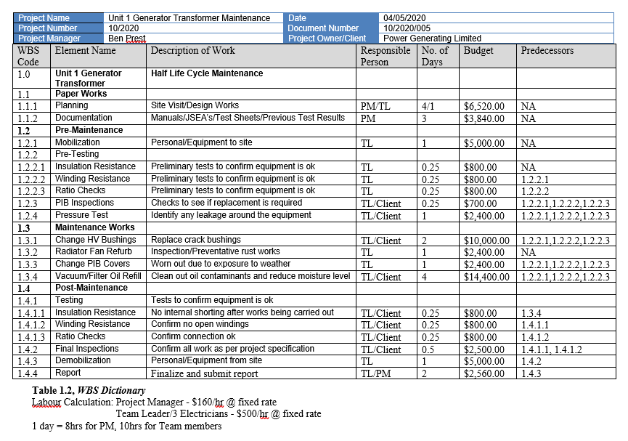
1.2 Gatt Chart Representation for Time Schedule

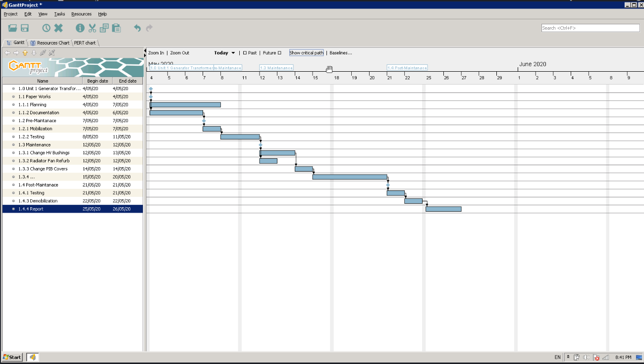
1.3 Pert Chart Representation for Time Schedule

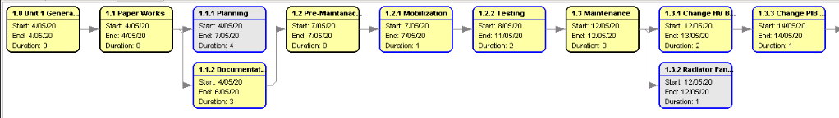

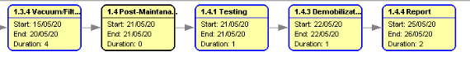
1.4 Project Milestones
The key milestones of this project include.
Phase1 – Paper Works
- Planning
- Documentation
Phase1 – Pre-testing works
- Insulation Resistance
- Winding Resistance
- Ratio Checks
Phase 2 – Maintenance
- changing of all the 3-phase high voltage bushing – tan delta test on existing bushings before removal, tan delta test on new bushings before and after installation
- radiator cooling fans refurbishment – remove fans, clean and paint before re-installs
- oil filtration with vacuum fill – vacuum pump minimum 6 hours prior filling oil, filter oil back into transformer and fill to required level
Phase 3 – Post Maintenance

Testing - insulation resistance, ratio check and winding resistance

Reports and achieving relevant documents
At the end of each task the Team Leader will access the time taken against the time schedule and discuss with team members of any procedures of how the task at hand could be done in a more effective way in terms of less procrastination which needs to be documented for future references

Part 3
- Quality Plan

1.1 Overview of Quality Requirements
There are several sources of quality requirements for this project. These include:
- General Equipment Manual Specifications
- Certificate of Compliance for Operation of Equipment
1.2 General Equipment Requirements
The primary benchmark for the quality management plan will be through the Electrical Safety Regulations imposed by the WorkSafe Queensland.
The maintenance of the Unit 1 Transformer must be as per the manufacturer manual specifications. The Client requires detailed plans of the project plan. The approval will be granted subject to the condition that any changes to the project must be carefully documented as per the change management procedure which includes authorization by the Project Manager and the Client Representative.
So far as the project is concerned, the following standards and regulations apply:
- Electricity Safety Act 2002
- Electricity Safety Regulations 2013
- AS2067-2016 Substations and High Voltage Installations

1.3 Operation of Equipment
All personal working or operating any equipment must be appropriately qualified/certified as follows:
- Construction induction card. All personnel working on, or otherwise accessing the site must be the holder of an appropriate construction induction card.
- Full Licensed Electrical Worker
- Certified High-Risk License holders as per work requirement
- HV certified switching and permit holder/insurer

2.0 Quality Assurance
The project integration processes will be audited on a task/phase basis with the Client providing test documentation of what is required to be done.
Most quality assurance will be conducted by the Client representative and Team Leader as the maintenance work progresses. Any issues will be reported to the project manager.

2.1 Quality Control
All inspection is covered by the related maintenance project. An audit will be conducted on the completed work at the end of each phase. This will be conducted by the project manager as part of their allocated project management duties.

- Quality Analysis Tool
PMBOK is an American National Standards Institute (ANSI) standard.
It provides a guideline to project management application which applies good practices to most project
and generally accepted

Task | People Standard | Process  Standard | Product/Service Standard | PM Standard | Strategy
Phase 1 | Qualification Skills | Site verification | Equipment manual specification. | PMBOK | PM ensures relevant documentation and procedures are available before start of project
Phase 2 | Qualification Skills | Equipment specification and standard | Equipment  maintenance  procedure  document.  Manual specification | PMBOK | TL to ensure works is as per plan and procedure.  PM/Client to conduct quality checks/audit.
Phase 3 | Qualification Skills | Equipment specification and standard | Equipment  maintenance  procedure  document  Manual specification | PMBOK | TL to ensure works is as per plan and procedure.  PM/Client to conduct quality checks/audit

3.0 Human Resource Plan

3.1 Resource Capability
This project is deemed high priority, so Energy Life Ltd personal and other staff provided by Power Generation will only perform duties associated with this project

The Project Manager will access the works progress and make a decision in consultation with the Team Leader if additional resources would be required to archive the deliverables within the time period

4.0 Communication Plan

4.1 Organizational Structure
Energy Life Ltd operates as a service provider and has three project managers and ten technicians who can be utilized at any-time during the project.

  - Escalation
The agreed procedures in place for handling conflict includes:
- All issues with Energy Life Ltd project team members are to be initially dealt with by the Project Manager.
- The Project Manager will report these issues to the company’s director during their weekly meetings. Any serious issues will be escalated to the director for resolution.
- Any site compliance issues regarding the maintenance work will be dealt directly by the site Work Health and Safety representative

5.0 Risk Plan
5.1 Constraints
The natural environment must be carefully preserved as per site requirements for environmentally sensitive areas with proper disposal of waste from the project especially for oil waste oil product
Other conditions imposed by site requirements.
Completion of all work within twenty days from initial start-up
5.2 Assumptions
- The maintenance plans have been approved by the Client.
- All raw materials will be available when needed at the costs quoted in the project plan.
- The maintenance program will go on as schedule.

  - Potential Issues
- Adverse weather condition likely rain will delay the project.
- Delays with delivery of materials to site for the project
- Testing equipment/apparatus breaking down
5.4 Risk Analysis
A risk analysis matrix has also been developed for the identified risks at every phase of the project.
All personal involved in the work should read and understand the risks involved and its mitigation to ensure their safety while carrying out required tasks.

All personal to sign on and off daily on the Job Safety Environmental Analysis (JSEA) for confirmation of understanding if there have been any changes to the work scope or any new hazard that has been documented in relation to the work.

An example given below and filled out whenever a new task is performed, or new hazard identified

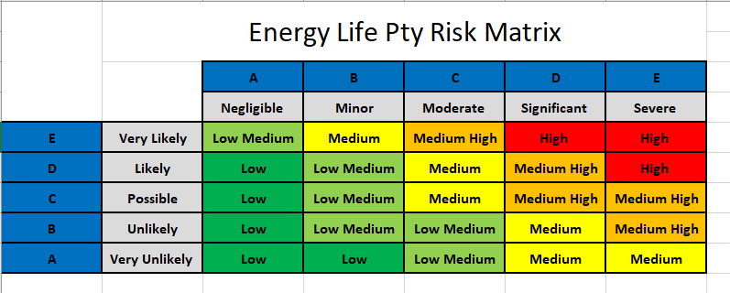

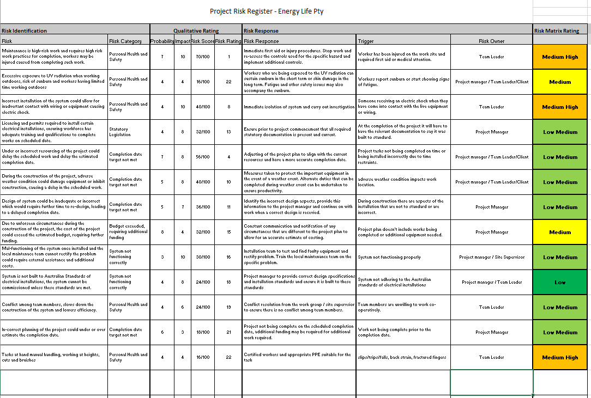
Part 4
1.0 Project Budget
The project budget of $320,000 is set aside by Power Generation to carry out the mentioned works.
All procurement and expenditure costs are to be supplied by the Client and provided there are no scope or time variations in the project, the budget in this project plan has a high level of confidence.

The procurement values have been signed off as a quote value with recommended/approved suppliers who have been given lead time for when the materials are required. Unless there are changes to project scope, there won’t therefore be any changes to the procurement costs. The purchase costs may increase as quotes were obtained at the time of the project plan. These costs may vary due to the long delay between the preparation of the project plan and the purchasing of the project raw materials and equipment.

The estimated costs for this project are included in the table below.

Expense | Budget ($) | Estimated Costs ($) | Allowable Variance ($)
Labour | 100,000 | 85,000 | + 15,000
Test equipment/delivery | 100,000 | 85,000 | + 15,000
Hardware | 75,000 | 60,000 | +15,000
Accommodation | 25,000 | 20,000 | + 5,000
Spares & associated items | 15,000 | 10,000 | + 5,000
Other | 5,000 | - | + 5,000
Total | 320,000 | 260,000 | + 60,000

1.1 Estimating Method
The estimating system used to calculate the figures is as per illustrated in Table 1.2 WBS Dictionary for labour costs with additional associated costs involved calculated as per individual phase.
- Phase 1 - $40,000.00
- Phase 2 - $120,000.00
- Phase 3 - $60,000.00

1.2 Contingency
Power Generation Ltd is paying a fixed sum of $320,000. The project estimate as per this project plan is $260,000 This leaves a variance of $60,000 to absorb any extra costs the project will incur. Energy Life Ltd has enough reserve cash to cope with the potential to expend up to $80,000 prior to the initial project payment.

1.3 Source of Funds
As per project agreement/contract between Power Generation Ltd and Energy Life Ltd, the fixed price contract of $320,000+GST will be paid for all the work covered in the project scope regardless of any project extensions, variations in scope, or increases in cost of labour, procurement or purchases.
The payments will be paid in 3 stages:
- Payment 1: 30% initial payment at the commencement of phase 1
- Payment 2: 50% progress payment upon completion of all phase 1 deliverables
- Payment 3: 20% progress payment upon completion of all phase 3 deliverables and delivery of project report

2.4 Cash Flow
As per agreement/contract payments will be made on the week ending of each phase of the project immediately upon completion. All purchases have been calculated to occur during the first week of each stage of the project.

Based on the data from the cost estimate per phase the Project Risk Analysis software was used to calculate the project S-Curve shown below with values taken as 5% on the estimate lower cost and 10% on the higher cost to plot your cumulative probability cost.

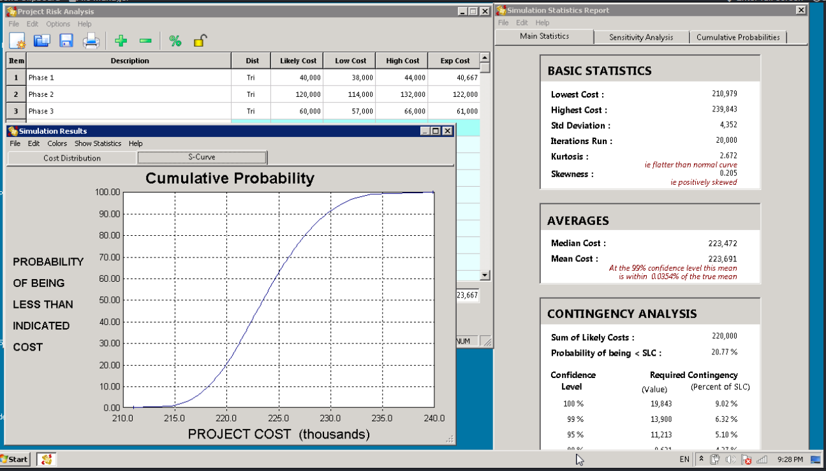

3.0 Project Completion
3.1 Procurement/Solicitation Planning
There will be no contractor required for this project as both Energy Life Ltd and Power Generation Ltd have a strong working relationship from past project engagements
3.2 Contract Administration
All contract administration will be conducted by the project administrator, reporting to the Project Manager. The project administrator is responsible for:
- Ensuring deliverables are being met (comparing audit reports with contract schedules).
- Advising the Project Manager and the payroll officer of invoices to pay.

3.3 Contract Close Out
At the end of the contract, the project administrator completes all project due diligence and advises the Project Manager when this is complete

