
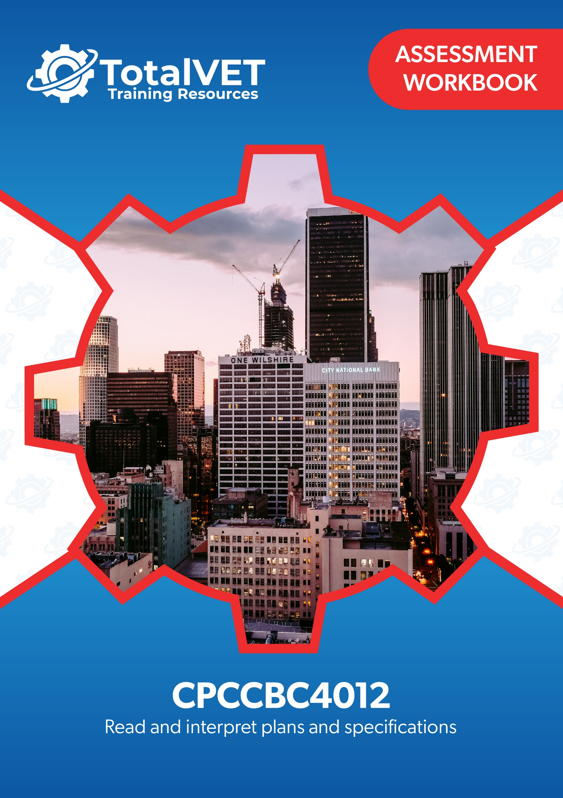
Copyright
This document was developed by TotalVET Training Resources.
© 2021 TotalVET Training Resources.
All rights reserved.
No part of this publication may be reproduced, stored in a retrieval system, or transmitted in any form or by any means, electronic, mechanical, photocopying, recording, or otherwise without the prior written permission of TotalVET Training Resources.

Version Control & Document History
Date | Summary of Modifications | Version
9 February 2021 | Version 1.0 released for publishing | 1.0
28 October 2022 | Revision of Practical Assignment, Workplace Assessment and Practical Plans Assignment | 1.1

Table of Contents
Table of Contents 3
Introduction 5
Competency-Based Assessments 6
Assessing Nationally-Recognised Training 7
Dimensions of Competency 8
Reasonable Adjustment 9
The Unit of Competency 10
The Context of Assessment 10
Assessment Methods 11
Resources Required for Assessment 12
Assessment Workbook Cover Sheet 13
Knowledge Assessment 14
Practical Assessment 40
Candidate Instructions 40
Preliminary Assessment Information 41
Practical Assignment 42
Overview 42
Workplace Assessment 46
Overview 46
Task 1 Confirm Currency of Plans, Specifications, and Amendments 47
Task 2 Confirm Details on Plans Comply with the Specifications 49
Task 3 Examine Detail Drawings to Determine Sizes and Thickness 53
Task 4 Discuss Details During the Planning Phase 55
Practical Plans Assignment 57
Overview 57
Task 1 Types of Plans and Aspects 59
Task 2 Construction Plans 62
Task 3 Materials from Specifications 66
Task 4 Concrete Footing and Slab 67
Task 5 Load Bearing Points 68
Task 6 Load Bearing Information 70
Task 7 Wind Bracing and Tie-Down Requirements 71
Task 8 Wind Bracing Materials and Tie-Down Methods 72
Task 9 Provisional Sum and Prime Cost Items 73
Task 10 Installation and Connection Points of Services 74
Task 11 Location of Fixtures 77
Task 12 Details of Finishes 79
Assessment Workbook Checklist 80
Record of Assessment (Assessor’s Use Only) 84

Introduction
The assessments in this workbook are divided into three categories: Knowledge Assessment and Practical Assessment.
The Knowledge Assessment is a set of general and workplace questions testing your knowledge and understanding of the general theory behind the unit.
You must answer all Knowledge Assessment Questions using your own words. However, you may refer to your Learner Guide and other relevant resources and learning materials to complete this assessment.
Some questions cover processes you would likely encounter in a workplace. Ideally, you should be able to answer these questions based on the processes that are currently in place in your workplace. However, if you do not currently have access to a workplace, then answer the questions based on processes that should be implemented in a typical workplace setting.
The Practical Assessment is made up of the Practical Assignment, Workplace Assessment, and Practical Plans Assignment. This assessment tests your practical skills with respect to the requirements of the unit of competency relevant in this workbook.
The Practical Assessment requires you to complete and submit workplace documents and other documentation relevant to the unit of competency.
The evidence you submit must be your own work except where due reference is made and where you are required to submit supplementary workplace documents such as policies and procedures.
When completing the assessments included in this workbook:
- Read the instructions provided in each task carefully before attempting to complete the task. The instructions will guide you on how to answer the question or complete the task satisfactorily.
- Follow the steps provided in each task.
  - If the question instructs you to describe, provide a description as your response. If the question instructs you to list, provide a list as your response.
  - Where there is a number of required responses, provide the required number of responses. For example, if you are asked to list three responses, provide three responses.
- Ensure that all your submissions for this assessment indicate your first and last name and that these submissions have been named according to the file naming convention prescribed in each task.

Competency-Based Assessments
Definition of Competency
Assessment in this context can be defined as the fair, valid, reliable, and flexible gathering and recording of evidence to support the judgement on whether competency has been achieved. Skills and knowledge (developed in a structured learning situation, at work, or in some other context) are assessed against national standards of competence required by industry, rather than compared with the skills and knowledge of other candidates.

The features of a competency-based assessment system are:
- It is focused on what candidates can do and whether it meets the criteria specified by the industry as competency standards.
- Assessment should mirror the environment the candidate will encounter in the workplace.
- Assessment criteria should be clearly stated to the candidate at the beginning of the learning process.
- Assessment should be holistic. That is, it aims to assess as many elements and/or units of competency as is feasible at one time.
- In competency assessment, a candidate receives one of only two outcomes – ‘competent’ or ‘not yet competent.’
- The basis of assessment is in applying knowledge for some purpose. In a competency system, knowledge for the sake of knowledge is seen to be ineffectual unless it assists a person in performing a task to the level required in the workplace.
- The emphasis in assessment is on assessable outcomes that are clearly stated for the trainer and candidate. Assessable outcomes are tied to the relevant industry competency standards where these exist. Where such competencies do not exist, the outcomes are based upon those identified in a training needs analysis.

Assessing Nationally-Recognised Training
Developing and conducting assessment, in an Australian Vocational Education and Training (VET) context, is founded on the Principles of Assessment and the Rules of Evidence:
Principles of Assessment
- Assessment must be valid
  - Assessment must include the full range of skills and knowledge needed to demonstrate competency.
  - Assessment must include the combination of knowledge and skills with their practical application.
  - Assessment, where possible, must include judgements based on evidence drawn from a number of occasions and across a number of contexts.
- Assessment must be reliable
  - Assessment must be reliable and must be regularly reviewed to ensure that assessors are making decisions in a consistent manner.
  - Assessors must be trained in national competency standards for assessors to ensure reliability.
- Assessment must be flexible
  - Assessment, where possible, must cover both the on- and off-the-job components of training within a course.
  - Assessment must provide for the recognition of knowledge, skills, and attitudes regardless of how they have been acquired.
  - Assessment must be made accessible to candidates through a variety of delivery modes, so they can proceed through modularised training packages to gain competencies.
  - Assessment must be mutually developed and agreed upon between assessor and the assessed.
  - Assessment must be able to be challenged. Appropriate mechanisms must be made for reassessment as a result of challenge.
- Assessment must be fair
  - Assessment process must consider the individual needs of the candidate.
  - Assessment must provide for reasonable adjustments, where appropriate, to consider the individual candidate’s needs.
(Source: Standards for RTOs 2015, Clauses 1.8 – 1.12)

Rules of Evidence
When collecting evidence, certain rules apply to that evidence. All evidence must be valid, sufficient, authentic, and current:
- Valid
Evidence gathered should meet the requirements of the unit of competency. This evidence should match, or at least reflect, the type of performance that is to be assessed, whether it covers knowledge, skills, or attitudes.
- Sufficient
This rule relates to the amount of evidence gathered. Enough evidence must be gathered to satisfy the requirements that the candidate be competent in all aspects of the unit of competency.
- Authentic
When evidence is gathered, the assessor must be satisfied that evidence is the candidate’s own work.
- Current
This relates to the recency of the evidence and whether the evidence relates to current abilities.
(Source: Training in Australia by M Tovey, D Lawlor)

Dimensions of Competency
The national concept of competency includes all aspects of work performance and not only narrow task skills. The four dimensions of competency are:
- Task skills
- Task management skills
- Contingency management skills
- Job or role environment skills

Reasonable Adjustment
‘Reasonable adjustment’ in VET is the term applied to modifying the learning environment or making changes to the training delivered to assist a candidate with a disability. A reasonable adjustment can be as simple as changing classrooms to be closer to amenities or installing a particular type of software on a computer for a person with vision impairment.
Why make a reasonable adjustment?
We make reasonable adjustments in VET to make sure that candidates with a disability have:
- The same learning opportunities as candidates without a disability, and
- The same opportunity to perform and complete assessments as those without a disability.
Reasonable adjustment applied to participation in teaching, learning, and assessment activities can include:
- Customising resources and assessment activities within the training package or accredited course
- Modifying the presentation medium
- Learner support
- Use of assistive/adaptive technologies
- Making information accessible both before enrolment and during the course
- Monitoring the adjustments to ensure candidate needs continue to be met
Assistive/Adaptive Technologies
Assistive/Adaptive technology means ‘software or hardware that has been specifically designed to assist people with disabilities in carrying out daily activities’ (World Wide Web Consortium - W3C). It includes screen readers, magnifiers, voice recognition software, alternative keyboards, devices for grasping, visual alert systems, digital note-takers.
(Adapted Reasonable Adjustment in teaching, learning and assessment for learners with a disability - November 2010 - Prepared by - Queensland VET Development Centre)
IMPORTANT:
Reasonable adjustment made for collecting candidate assessment evidence must not impact on the standard expected by the workplace, as expressed by the relevant unit(s) of competency. For example, if the assessment were gathering evidence of the candidate’s competency in writing, allowing the candidate to complete the assessment verbally would not be a valid assessment method. The method of assessment used by any reasonable adjustment must still meet the competency requirements.

The Unit of Competency
The units of competency specify the standards of performance required in the workplace.
This assessment addresses the following unit of competency:
CPCCBC4012 – Read and interpret plans and specifications (Release 1.0)
- Identify types of plans
- Read and interpret the plan
- Identify structural details
- Identify non-structural details
A complete copy of the above unit of competency can be downloaded from the TGA website:
https://training.gov.au/Training/Details/CPCCBC4012

The Context of Assessment
To complete the assessments in this workbook, students need to have access to their learning materials and the Internet. The Knowledge Assessment may be completed wholly at the candidate’s home or chosen place of study. The Practical Assessment must be completed in a workplace or a simulated environment.

Assessment Methods
This workbook uses the following assessment method/s:
- Knowledge Assessment
A set of general and workplace questions testing the candidate’s general knowledge and understanding of the general theory behind the unit.
- Practical Assignment
A series of written practical tests assessing the candidate’s practical knowledge and understanding of the unit of competency.
- Workplace Assessment
A set of tasks or activities completed according to set instructions and guidelines to meet the requirements of the relevant unit. These tasks and activities require you to have access to a workplace or a similar environment.
- Practical Plans Assignment
A series of assessment tasks testing the candidate’s practical knowledge and understanding of the unit of competency. The candidate needs to provide their responses to these assessment tasks, sometimes working with an appropriately experienced person in your workplace.

Resources Required for Assessment
The Training Organisation to provide/organise candidate with access to:
- Assessor to supervise and observe candidate as they complete assessments, where required.
- Workplace, or a similar environment, where the candidate can complete the assessments, and that will allow them access to:
  - Building and construction project
  - Relevant construction personnel whom the candidate will be verifying details on the construction plans and specifications with.
  - Construction plans
  - Construction specifications
  - Detail drawings
  - Documentation templates, including:
    - Construction Plan Details Verification Checklist
    - Material Quantity Takeoff Form
  - Relevant government building and construction and contract legislation
  - Current building and construction codes and standards
  - The National Construction Code (NCC)
  - Computers, applications and software to access CAD.

The candidate will need access to:
- Computer with Internet, email access, and a working web browser
- Installed software: MS Word, Adobe Acrobat Reader

Assessment Workbook Cover Sheet
To the candidate: Print this cover sheet and complete it by filling in all the required information and signing in the space provided. Your signature must be handwritten. Scan the completed cover sheet and submit it along with your evidence submissions. Use the filename: CPCCBC4012 Cover Sheet
Workbook | CPCCBC4012
Title | Read and interpret plans and specifications (Release 1.0)
First and Last Name | RHYS HOLMES-YASSO
Phone | PERSONAL: 0401829955  WORK MOBILE: 0436423587
Email | HEYYASSO@GMAIL.COM

Please read the Candidate Declaration below and if you agree to the terms of the declaration, sign and indicate the date in the spaces provided.
By submitting this work, I declare that:
- I have been advised of the assessment requirements, have been made aware of my rights and responsibilities as an assessment candidate, and choose to be assessed at this time.
- I am aware that there is a limit to the number of submissions that I can make for each assessment, and I am submitting all documents required to complete this Assessment Workbook.
- I have organised and named the files I am submitting according to the instructions provided. I am aware that my assessor will not assess work that cannot be identified and may request the work be resubmitted according to the correct process.
- This work is my own and contains no material written by another person except where due reference is made. I am aware that a false declaration may lead to the withdrawal of qualification or statement of attainment.
- I am aware that there is a policy of checking the validity of qualifications that I submit as evidence as well as the qualifications/evidence of parties who verify my performance or observable skills. I give my consent to contact these parties for verification purposes.
Name: RHYS HOLMES-YASSO | Signature: | Date signed: 12/02/2023

Knowledge Assessment
- Answer the following questions about concept drawing/sketches.
- What is the significance of concept drawing/sketches?
These drawings can serve many purposes and can be completed and created in a short amount of time. These are a great idea to use by drafting up introductory building plan/layout or offer opportunity for any new ideas or strategies of erecting the building project. If pitching a new building tactic – having a drawing on hand would be able to show an idea of simple building layouts, components, framework, and simple dimensions. Concept drawings are an effective way to discover initial ideas for designs.
- What are sketch plans?
These plans are sketched scaled drawings that show the correct dimensions and gauge of the buildings, surrounding areas, roads, boundaries and other relevant details of where the construction is situated. These are more detailed and informative then a simple drawing and enable the viewer to gather a more accurate and definitive idea of the building.
- How do you create presentation drawings?
These presentations are primarily designed using computer-aided design (CAD) such as programs like ‘AutoCAD’, ‘FreeCAD’, or ‘Solidworks’ in either 3 dimensional or 2-dimensional format. These designs provide significant details of the building with graphical information.

- Answer the following questions about architectural plans.
- What is an architectural plan?
These plans are to show detailed essentials within the aspects of the building and illustrate what the final building/design will look like. These plans are viewed by designers, engineers, supervisors, contractors and builders to help accomplish the construction. These drawings assist the proposal of ideas within project personnel to help communicate design perceptions.

- List down four details contained in an architectural plan.
- Site Plan
- Notes
- Scale Dimensions
- Architectural Floor Plan

- Answer the following questions about structural plans.
- What is a structural plan?
These plans contain information about the all the structural features and mathematical details of the building and how it needs to be built. Structural plans are usually proved to be accepted within the building and construction industry when it has been signed by a Professional Engineer.
- How is a structural plan different from an architectural plan?
The main factor of the difference between these two plans, is visual identification. Architects will not include structural details within a plan, as they are on the side of including the details of the desired site, depicting landscaping elements, electrical and mechanical properties and internal materials, even showing furniture. In comparison to Structural plans majority of the time they are needed for engineering requirements. However, the comprehension of detail of these plans can vary depending on the building project.

- List four details that can be found in a structural plan.
- Dimensions of structural materials
- Connection Types
- Designated Materials
- Detail Views

- Answer the following questions about civil plans.
- What is a civil plan?
These plans are usually supplied to civil engineers, and contain drawings affiliated with details such as open drains/drainage, crossfalls, earthworks, culverts, pavements and landscaping.
- List two details contained in a civil plan that can be found in an architectural plan.
- Scale dimensions
- Types of materials needed/used
- List two details contained in a civil plan that can be found in a structural plan.
- Culverts (Base Slab)
- Piling Pads (Retaining Walls/Building Structures)

- Answer the following questions about mechanical plans.
- What is a mechanical plan?
These plans generally include the dimensions and technical specifications for mechanical equipment that will be internal/external of the building of construction. These are crucial to have when you’re required to install mechanical equipment in specific locations internally/externally of a building.
- List down two types of equipment included in a mechanical plan.
- Air Handling Units
- Plumbing Equipment
- List down three details that are included in a mechanical plan.
- Thermostat Locations
- Design air-delivery rates
- Diffuser Locations

- Answer the following questions about electrical plans.
- What is an electrical plan?
These plans are used to present to a visual presentation of electrical and circuit systems. Electrical relates to any distribution boards, power lines high and low voltage, fuses, generators, air-conditioning and more essential equipment that may be installed within or outside the building being constructed.
- List down three details contained in an electrical plan.
- Electrical Legend
- Locations of power boards
- Voltages

- Answer the following questions about plumbing and drainage plans.
- What is a plumbing and drainage plan?
These plans are implemented to show illustration of plumbing and drainage systems. They are an excellent tool to use in giving the viewer a great idea in the layout and design of where the plumbing systems are to be installed.

- What is the purpose of a plumbing and drainage plan?
To show specific locations of vales, pipework, fixtures and heights (Dimensions) of fit off equipment. Helps minimise clashes with other trade materials/equipment. Use plans to relate to AS3500 (AS plumbing and drainage)

- What are the two primary concerns addressed by a plumbing and drainage plan?
- Water Supply System
- Drainage System
- List down two details contained in a plumbing and drainage plan that are related to water supply system.
- Pipe Dimensions
- Valve Locations
- List down two details contained in a plumbing and drainage plan that are related to drainage system.
- Set outs for Drainage
- Gradient Levels (falls for drainage)

- Answer the following questions about parts of a plan.
- What is a site plan?
Site plans are a general outline of the work area / construction zone which show’s setting, positioning and the form of a building on the construction site. These plans are designed into a smaller scale then usual to help capture all architectural features of the location. This can add great value to developers to potentially attain improvements to a property/building site.
- List five key features of a site plan.
- Road identification (Road names)
- Landscape elements
- Contours
- Compass points
- Property lines
- What is a floor plan?
Floor plans are technical drawings to scale, giving the viewer a visual representation of a view from above, similar to a ‘birds eye view’. They can share a better visualization of room spaces and dimensions by (m2), labialization of rooms, walls and doors.
- What information can be acquired from a floor plan? List five.
- Dimensions Of the Rooms (m2)
- Layout Of the Building
- Client Information
- Specification Notes
- What are two key differences between elevation view and section view?
- One view is a perspective of one side, where section views show all sides
- Elevation views include internal dimensions (heights) where section views focus on building components.
- List three types of information that can be found in an elevation view.
- North, South, East, West Views
- External component dimensions
- Internal material heights
- List three types of information that can be found in a section view.
- Furniture dimensions
- Fixture dimensions
- Equipment dimensions
- What is the purpose of detail views?
Details views are created to give a greater and exact detailed drawing to show exact measurements or configurations of components within for examination by giving you the ability to enlarge the view of a specific area on a plan. These are used to show exact dimensions of materials used in a plan, they can be used for supervision and engineers to access completed work for any defect or outstanding works that be present and give any viewer a fair indication of understanding how all materials are constructed together.

- Answer the following questions about datum and reduced levels (RL).
- What is the purpose of a datum in construction?
Datum is a surveyed benchmark for reference of measurements, these can be used on projects constructing finished surface levels, slab heights, pavements and offset markings.
- List two ways of how datum can be established in construction drawings.
- Can be used for the lowest point of the building (i.e., Basement)
- Can be used for the highest point of the building (i.e., Roof Level)
- What are reduced levels (RL)?
(Reduced Levels) RL’s refers to elevations, is a vertical distance which is used for heights and depths. These are used for an initial level to calculate comparative heights.
- List two ways of establishing reduced levels in construction drawings.
- A reference point to ensure levels are being constructed accordingly.
- To implement rise and fall methodologies.

- Answer the following questions about title blocks.
- What is a title block?
A section on a plan or a drawing, displaying relevant general specifications and information.
- Where is a title block usually located?
Generally, the right-hand side.
- List five types of information that can be obtained from the title block.
- Document Number
- Client Information
- Project name
- Scale Dimension
- Project Location

- Answer the following questions about scale and dimension drawing conventions.
- What are scale drawings used for?
These drawings are to give the viewer a visual representation of the precise measurements scaled down into a smaller/practical size than the original in a drawing format. Generally, most drawings will implement a scale dimension, used to calculate the actual size.
- Describe each ratio of standard scale ranges below.
Ratio | Description
- 1:100 | This ratio is displaying the building/construction exactly 100 times smaller than the element. i.e., If the slab was drawn to 30cm then real-life proportion would be 30m.
- 1:2 | This ratio is show’s the elements of the drawings twice the dimension as what’s stipulated in the drawing. You could also implement the equation of (Dimension) ÷ 2
- 1:1000 | This ratio is displaying the building/construction exactly 1000 times smaller than the element. i.e., If bridge elements were drawn to 30cm then real-life proportion would be 300m.
- 1:50 | This ratio gives you a visual representation of what the building would look like 50 times bigger or representing the real size of the elements the drawing displays it 50 times smaller.

- What is the importance of dimensions in construction drawings?
Without dimensions we wouldn’t have a source of any measurements within drawings, and have no way to define the sizing, lengths, widths, heights or depth of materials & elements within a construction drawing. These drawings are essential for co-ordinating building materials to confirm all components fit correctly and each part is in the right place. Builders/Trades understanding dimensions prior for instalment/construction assists their understanding of how everything should fit and look, and what tolerances they can account for.

- What system of measurement is used for dimensions in Australian construction drawings?
Australia uses the metric system within construction plans when calculating quantities, measuring or reading plans and defining units as metres (m) and millimetres (mm) which are most common.

- List three ways of how dimensions can be displayed in construction drawings.
- Angle Ratio (45ᵒ)
- Dimension Lines (L x W x H Format)
- Decimal Points

- Listed below are the different types of plans. Identify the corresponding terminologies used and the equivalent abbreviation for the type of plan indicated.
Type of Plan | Building and construction terminology | Abbreviation
- Architectural | CL | Centre Line
- Architectural | FFL | Finished Floor Level
- Structural | PCW | Pre-Cast Wall
- Structural | SC | Structural Column
- Mechanical | AHU | Air-Handling Unit
- Mechanical | EF | Exhaust Fan
- Electrical | MSB | Main Switch Board
- Electrical | FRPF | Fireproof
- Plumbing and drainage | FD | Floor Drain
- Plumbing and drainage | RDL | Roof Drain Leader

- Answer the following questions about utilities and services plans and specifications.
- What is the difference between a utilities plan and a services plan in the context of building construction?
Utility plans generally stipulate information about electricity, gas, water and sewage and other relevance’s. Service plans contain all components to assist in the building/construction development or management – These include Lighting, Exhaust Fans, Air conditioning and alarms.
- What is the importance of utilities specifications?
These specifications involve all required and essential information relevant to the components of the utility, having the correct information provided will remove the potential of any delays during the construction process.
- What is the importance of services specifications?
Services is similar in the fact that specifications specifically outline all the important information to the components of the services and provide information about these services that can’t be delivered within the drawing. Generally dealing with Electricity (Low Voltage & High Voltage) It’s crucial that specific products will be required to be used and applicable standards and how they are installed to a competent quality.

- Describe the aspects of drawings provided below.
Aspects of Drawings | Description
- Isometric drawings | Isometric drawings are generally used by Architects or engineers within the industry in a method of using 3D objects to explain depths and multiple perspectival views of the object. These aid the correspondence of scaled dimensions.
- Oblique drawings | Oblique drawings provide a 2-dimensional projection of a 3-dimensional drawing
- Perspective drawings | Definition of perspective drawings are a visual representation of how the building/image would be perceived by the eye. These are used on advertisements/billboards to give a viewer and idea of how it would look in person, or before their eyes in a certain location.
- Orthographic drawings | These drawings display 3-Dimensional objects/images are presented in a 2-dimensional format, showing all different sides of perspective.

- Answer the following questions about CAD drawings.
- What does CAD stands for?
Computer-Aided Design

- What are CAD drawings?
Computer-Aided design drawings have been designed through a CAD Application/Programme on computer software to design either 2D or 3D building and construction models/drawings/plans. This software is generally operated and designed with engineers and architects. Construction supervisors/managers having input in these drawings in design phase can have a big impact by including all different factors and elements that will provide specific locations for components.

- How is CAD used in building and construction?
CAD allows the viewer to examine all different parts and sections of a building and give a representation of the final construction or were past instalments are located (e.g Underground Services, Overhead Services and Structural footings) and generally what the finish product will look like. CAD can be used in the planning stage and after, whether it might be designing the structural components within the design prior or presenting a presentation of the finished product.

- Provide a brief description of the given classes of buildings according to the National Construction Code.
Building Class | Description
- Class 1a building | All Class 1 buildings are defined as dwellings. If one or more of these buildings form a single dwelling like detached house (Granny Flat) or two or more attached buildings with a separation wall internally
- Class 1b building | These buildings are considering one or more buildings that are formed together, such Unit complex’s, Boarding houses, or anything relevant that does not lodge more than 12 persons. These cannot be built or positioned above another dwelling or another class of building, excepting a private garage.
- Class 2 building | Residential Buildings (Apartment Buildings) which contain two or more sole-occupancy units, each being a separate dwelling.
- Class 3 building | Class 3 buildings are residential buildings other than Class 1 or 2. These are long-term or transient living accommodations for unrelated people. These include a dormitory-style accommodation or workers’ quarters, health care facilities like accommodations for children, elderly or people with a disability which must not be considered under class 9
- Class 4 building | A Class 4 building is the only dwelling or residence within any Class 5, 6, 7, 8 or 9 buildings.
- Class 5 building | An office building used for professional or commercial purposes, except for buildings of Class 6, 7, 8 or 9. Examples include a law office or an office for general medical practitioners.
- Class 6 building | Class 6 buildings are classified as buildings that directly sell goods by retail or supply services to the public, such as restaurants, cafes, public laundries, markets or hairdressers and barbershops.
Building Class | Description
- Class 7a building | A building which is a car park.
- Class 7b building | Warehouses, storage buildings and buildings used to display or procedure wholesale goods are considered class 7b.
- Class 8 building | These are process-type buildings such as buildings used for production, assembling, altering, repairing, finishing, packing or cleaning of goods or produce.
- Class 9a building | Healthcare buildings in which occupants are either undergoing or have undergone medical treatment or in need of physical assistance in the evacuation during emergencies.
- Class 9b building | Assembly buildings used for social, theatrical, political, religious or civil purposes. The following are examples of Class 9b buildings are schools, universities, childcare centres, pre-schools, sporting facilities, night clubs or public transport buildings.
- Class 9c building | An aged care building. An aged care building is defined as residential accommodation for elderly people who are provided with personal care services and need 24 hour staff assistance to evacuate the building in an emergency.
- Class 10a building | A private garage, carport, shed or the like.

Building Class | Description
- Class 10b building | Structures like fence, mast, retaining wall, swimming pool, antenna or other similar structures.
- Class 10c building | A private bushfire shelter

- The Building Code of Australia is divided into three volumes. Briefly describe the scope of each volume.
Volume | Description
- Volume One | Volume one consists of information about all construction requirements for buildings listed under Class 2 to Class 9 buildings, and all their relevant structures. The NCC Volume one also contains sections from A – J including specification requirements with Health and Amenity, Special use buildings, Fire resistance, Structure and additional governing requirements.
- Volume Two | Volume two contains information on construction requirements for buildings listed under Class 1 and 10(10a – 10c) which involve specific residential and non-liveable buildings and structures. There are 3 sections in total that are stipulated within the NCC Volume two, which include -Governing Requirements, Performance Requirements and Verification Methods, and Acceptable construction for deemed-to-Satisfy Solutions.
- Volume Three | Volume three contains information on technical requirements relevant to eh construction and design for plumbing and drainage system within buildings. This volume is contains sections A – E stipulating Water services, Excessive noise, facilities and sanitary plumbing and drainage systems and additional governing requirements which are mutual across the National Construction Code. Whenever plumbing works is conducted or where water services are built independent of buildings this volume is applied.

- Explain how the Building Code of Australia is relevant to construction drawings.
Without having buildings codes to follow, all construction drawings would be irrelevant – Within these codes are standards that must be met within the building and construction industry. These standards and codes include Fire Safety, Health and Habitability, and Structural safety. These drawings are to reflect NCC requirements, by showing materials, design, or construction meets that share Performance Requirement or DTS Provision.

- Answer the following questions about NCC requirements.
- Explain what the General Requirements of buildings are.
These requirements are also listed as ‘Governing Requirements’ which stipulate all rules and instruction of following and implementing the NCC in building and construction – These include accept of the design and construction, interpretation and reference documents. These can be used as a guide for engineers and builders to gain information about how technical requirements should be used in any scenario. These requirements aid the classifications of each building class.
- Explain what the Performance Requirements of buildings are.
These requirements outline the specific principles and standards of which must be met. These usually summarise the minimum level which building specifications must meet.
- Explain the relationship between a building’s Performance Requirements and compliance options (e.g., performance solutions, deemed-to-satisfy solutions).
Performance requirements can be met by compliant options, such as DTS – This can provide a builder for alternate solutions on situations. Generally building a standard home, you are most likely to implement a DTS Solution. Performance solutions and DTS are the most used paths to be compliant with the NCC.

- Answer the following questions about standards applicable to building and construction projects.
- Explain the importance of complying with standards during a building and construction project.
Standards aid the use of Methods and Technical Requirements to help build a safe and maintainable project. Without these documented standards we wouldn’t have a guide to build to the approved specifications, procedural requirements and abiding my government requirements.

- List two current standards relevant to the specification and interpretation of engineering drawings.
- Product Details
- Installation / Erection Procedures

- Specify your state/territory, and:
  - Identify three building and construction regulations that apply in your state/territory.
  - Summarise the regulatory requirements relevant to building drawings and sketches under each regulation you identified.
  - Provide a URL where you sourced your responses.
State/territory | Queensland

Regulations | Regulatory requirements | URL/Source
- 49 Signs to be exhibited—Act, s 52 | For section 52 of the Act, a sign must— (a) be made of weatherproof materials; and (b) have a surface area of at least 0.5m2; and (c) be printed in letters at least 5cm high and placed in a way that can be easily read from the nearest street alignment. | https://www.legislation.qld.gov.au/view/pdf/inforce/current/sl-2018-0138
- 50 Advertisements—Act, s 54 | For section 54(c) of the Act, the information to be included in an advertisement under section 54(a) and (b) of the Act must— (a) if written—be easily read; or (b) if spoken—be no less audible and clear than other spoken material contained in the advertisement. | https://www.legislation.qld.gov.au/view/pdf/inforce/current/sl-2018-0138
- 52 Partnerships—Act, s 56 | (1) For section 56(1)(c) of the Act, an advertisement must, in addition to stating the name under which the licensed contractor is licensed, state— (a) that the contractor is licensed under the Act; and (b) the contractor’s licence number. (2) The information mentioned in subsection (1) must— (a) if written—be able to be easily read; or (b) if spoken—be no less audible and clear than other spoken material contained in the advertisement. | https://www.legislation.qld.gov.au/view/pdf/inforce/current/sl-2018-0138

- Answer the following questions about building information modelling (BIM).
- What is building information and modelling (BIM)?
BIM is a process to build a 3-Dimensional model of the structure. These models can start from drawings or a blueprint, then be designed or converted through to CAD/BIM.
- What is BIM used for?
BIM is a productive and collaborative way to assist architects, contractors, managers, engineers and other building and construction professionals to design and construct a building in an examinable and detailed model. Having access to these designs can help builders/supervisors gain a better understanding how finished projects will look, locations of certain components and general visual representations of size, dimensions and specifications.

- Listed in the table below are common building and construction methods you usually encounter when reading and interpreting plans. Briefly describe each method.
Building and construction methods | Description
- Paintworks | Works applying paint or coating to materials (Painters, Epoxy Floorers, Waterproofing)
- Tilework | Works applying to materials of tiles, bricks and other masonry units – these works can be conducted for the construction of decorative tileworks, from walls, floor and to a ceiling.
- Steelworks | Works involving construction of steel building components – Rebar cutting, steel fixing, formwork, welding.
- Concrete works | Works involving pre-cast concrete, concrete pour, installation of concrete formwork, pre and post tensioning, and additional construction of concrete building elements.

Practical Assessment

Candidate Instructions
The Practical Assessment is a set of tasks that must be completed in a workplace, or in an environment with conditions similar to that of a real workplace.
This assessment will help you demonstrate skill requirements relevant to reading and interpreting plans and specifications.
The Practical Assessment includes the following:
- Practical Assignment
A series of written practical tests assessing the candidate’s practical knowledge and understanding of the unit of competency.
- Workplace Assessment
A set of tasks or activities completed according to set instructions and guidelines to meet the requirements of the relevant unit. These tasks and activities require you to have access to a workplace or a similar environment.
- Practical Plans Assignment
A series of assessment tasks testing the candidate’s practical knowledge and understanding of the unit of competency. The candidate needs to provide their responses to these assessment tasks, sometimes working with an appropriately experienced person in your workplace.

Preliminary Assessment Information
The tasks in this practical assessment must be completed in a workplace (or a similar environment) and in the context of a building and construction project which you are currently a part of.
E.g. You are a builder, a site manager in training, foreperson, or an apprentice in this project, etc.
Before starting the practical assessment, record the following information for your assessor’s reference.
When completing the tasks in this practical assessment ensure that your responses and performance must align with the information you have provided below.
For example (but not limited to):
- If the task asks you to refer to building and construction legislation and regulatory requirements, refer to the requirements that apply to the state/territory where your nominated building and construction project is undertaken.
- If the task requires you to follow organisational policies and procedures, refer to the policies and procedures in your nominated organisation/workplace.
Work role/title | Junior Supervisor
Organisation/workplace | Laing O’Rourke
Building and construction project | ASMTI STWBA (PRECINCT C)
Project overview | Australian-Singaporean Military Training Initiative Project
Building classification | Defence Structure
Project site address | Raspberry Creek Rd, Canal Creek QLD 4702
State/territory where this project is being undertaken | Queensland

Practical Assignment

Overview
The goal of this assessment is to assess your practical knowledge of:
- Workplace safety requirements
- Workplace processes
- Environmental requirements
This assessment has three tasks:
- Task 1 – Workplace Safety Requirements
- Task 2 – Workplace Processes
- Task 3 – Environmental Requirements
This task must be completed in the context of the workplace you have nominated in the “Preliminary Assessment Information” section.
You are required to:
- Review your workplace’s safety requirements relevant to safety when preparing for building and construction
- Review and briefly explain your workplace’s processes for accessing the latest copies of building construction plans
- Review the task instructions included in this Practical Assignment.
- Record your response as required in the instructions.
Resources required for assessment
- Workplace documents:
  - Workplace safety requirements in planning building and construction

- Review your workplace’s safety requirements relevant to building and construction and answer the following questions.
- List three (3) local and/or state/territory safety requirements that your workplace must meet to conduct building and construction work.
- Provide Safe System of Work
- Provide Safe Plant and Structures
- Provide instruction, training, information and supervision
- Explain your workplace’s processes when plans outline tasks that require high risk work (e.g. scaffolding, rigging etc.)
All subcontractors SWMS are to be reviewed for legal compliance, sequencing and logic and accepted by the subcontractor before starting work on-site. A copy of all SWMS reviewed and accepted by the subcontractor, must be supplied to Laing O'Rourke before works start (Regulation 312 of the WHS Regulations 2011). All required qualifications are to be reviewed prior to any machinery/plant operations on-site and uploaded required documentation to Laing O’Rourke systems as all Plant operations are considered High Risk Work. SMWS will be subjected to on-field reviews by the subcontractors to ensure the documented steps are relevant, correct and effective. Laing O'Rourke staff will complete task observations to verify the adequacy and effectiveness of the SWMS.
High risk construction work on site involves a SWMS procedure which entails three processes:
• Safe Work Method Statement (risk assessment process)
• SWMS Review Checklist
• SWMS Task Observation

- Review your workplace’s processes for implementing building construction plans and answer the following questions.
- What types of building construction documents does your workplace implement?
- Hazard Identification Risk Assessment and Control
- Incident Management and Emergency Preparedness, Response
- Safety Management System Compliance
- Project Details
- Scope of works
- Reference Documents
- Senior Management Commitment
- Whole-of-Project Consultation
- Summarise below your workplace’s processes for receiving and confirming building construction plans, including drawings and sketches.
Principal Managing Contractor to create and design the drawings for our workplace then issue to the relevant subcontractors. Sub-contractors also have a duty to design their own plans when required however these designs will have to be sent to the package managers and make comments/changes if needed. Between this communication procedure the documentation is passed through our ‘Document Controller’ employed by our company between reviews. During rectifications of issues/comments/re-designs for final approval, it's the responsibility of our Design managers / package managers to deem it IFC (Making the plan/design strictly for the way it is). During the communication between reviews and changes of the plans all documentation gets numbered and sent through to our PMs. Our PMCA is also copied into documentation communication to have the opportunity to provide input or comments if required. Once package managers have attained the completed documentation of all plans/design/sketch’s information is passed through to our Supervision team to ensure on-site construction / erection are being completed correctly according to the certified / approved plan.

- List three (3) local and or state/territory environmental requirements that your workplace must meet to conduct building and construction work.
- Duty to notify of environmental harm
- General environmental duty
- Meeting all state/territory environmental obligations and duties

Workplace Assessment

Overview
The goal of this assessment is to assess your practical knowledge and skills in:
- Identifying types of plans
- Reading and interpreting the plan
This workplace assessment is made up of five workplace tasks:
Task 1 – Confirm Currency of Plans, Specifications, and Amendments
Task 2 – Confirm Details on Plans Comply with the Specifications
Task 3 – Examine Detail Drawings to Determine Sizes and Thickness
Task 4 – Discuss Details During the Planning Phase
You are required to:
- Review the instructions in each task.
- Identify types of plans.
- Read and interpret the plan.
- Perform the workplace task according to the instructions provided
- Complete and submit any required documentation.
Resources required for assessment:
To complete this assessment, you will need access to the following:
- A workplace or a similar environment that will allow you access to:
  - Building and construction project
  - Relevant construction personnel whom the candidate will be verifying details on the construction plans and specifications with.
  - Construction plans
  - Construction specifications
  - Detail drawings
  - Relevant government building and construction and contract legislation
  - Current building and construction codes and standards
  - The National Construction Code (NCC)
  - Computers, applications and software to access CAD.

Task 1 Confirm Currency of Plans, Specifications, and Amendments
Through an email confirmation with relevant construction personnel, confirm the currency of plans, specifications and amendments. The construction personnel to be consulted with must have suitable experience (e.g. supervisor):
You will be assessed on:
- Practical knowledge of building and construction plans
- Practical skills in confirming the currency of plans, specifications and amendments with relevant construction personnel
Before starting this task, review the Workplace Assessment Task 1 – Assessor Checklist provided along with this workbook. This form lists all the practical skills you need to demonstrate while completing this task.
After completing this task, submit the following to your assessor:
- Email evidence of your discussion with relevant construction personnel
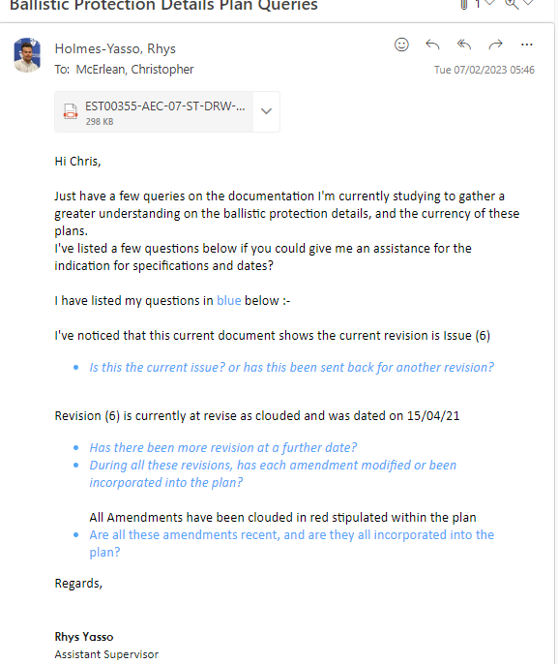

Insert email screenshot below
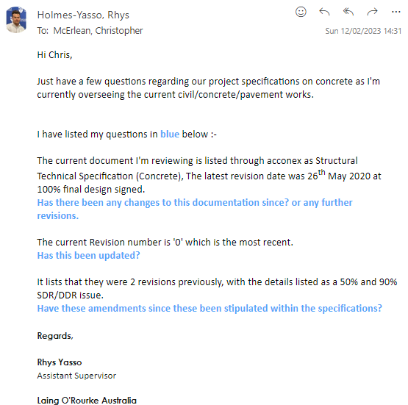

Task 2 Confirm Details on Plans Comply with the Specifications
Use Construction Plan Details Verification Checklist below to verify whether details on the construction plans comply with the specifications.
You will be assessed on:
- Practical knowledge of building and construction plans and specifications
- Practical skills in confirming the compliance of the details specified in construction plans with the construction specifications
Before starting this task, review the Workplace Assessment Task 2 – Assessor’s Checklist provided along with this workbook. This form lists the criteria your Construction Plan Details Verification Checklist submission must address to complete this task satisfactorily.
After completing this task, submit the following to your assessor:
- Three (3) examples of how the plans refer to and confirm the specifications.

Example 1
Provide excerpt (screenshot) of plans | 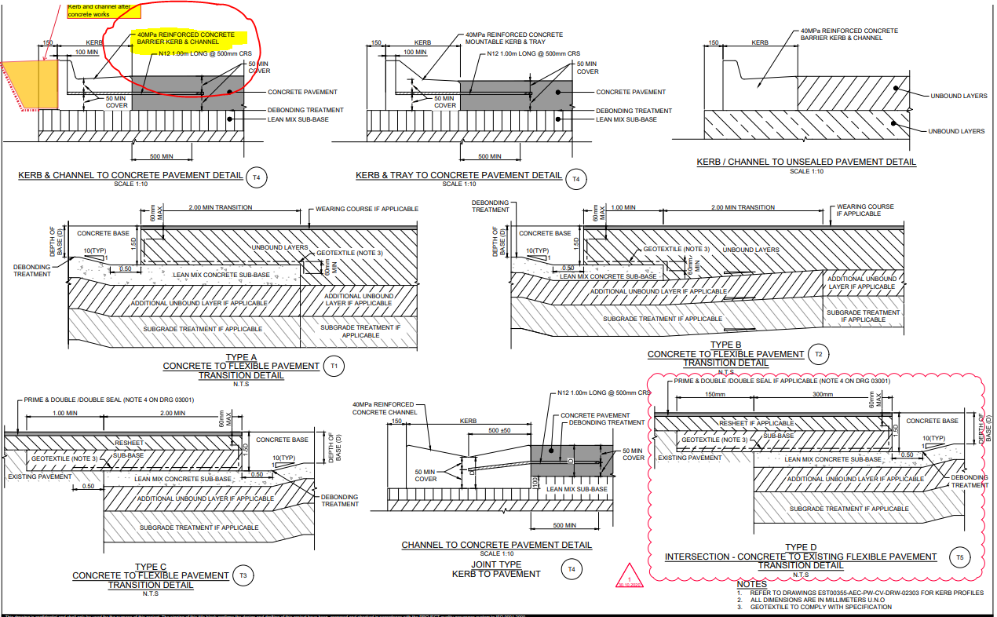
Provide excerpt (screenshot) of specifications | 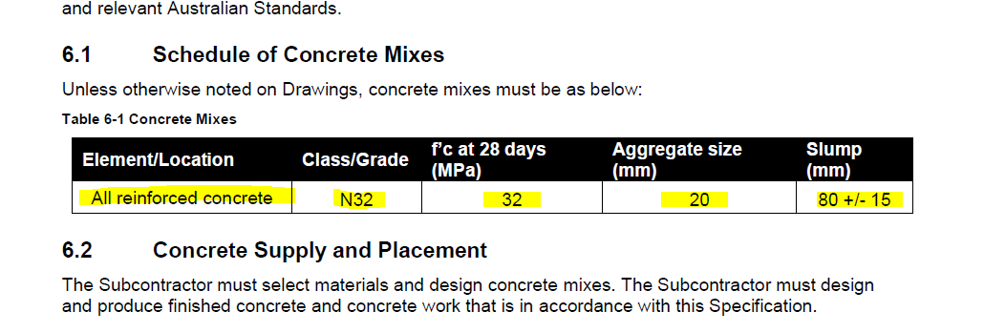
Confirm that plans comply with specifications | YES  NO (Explain why):

Example 2
Provide excerpt (screenshot) of plans | 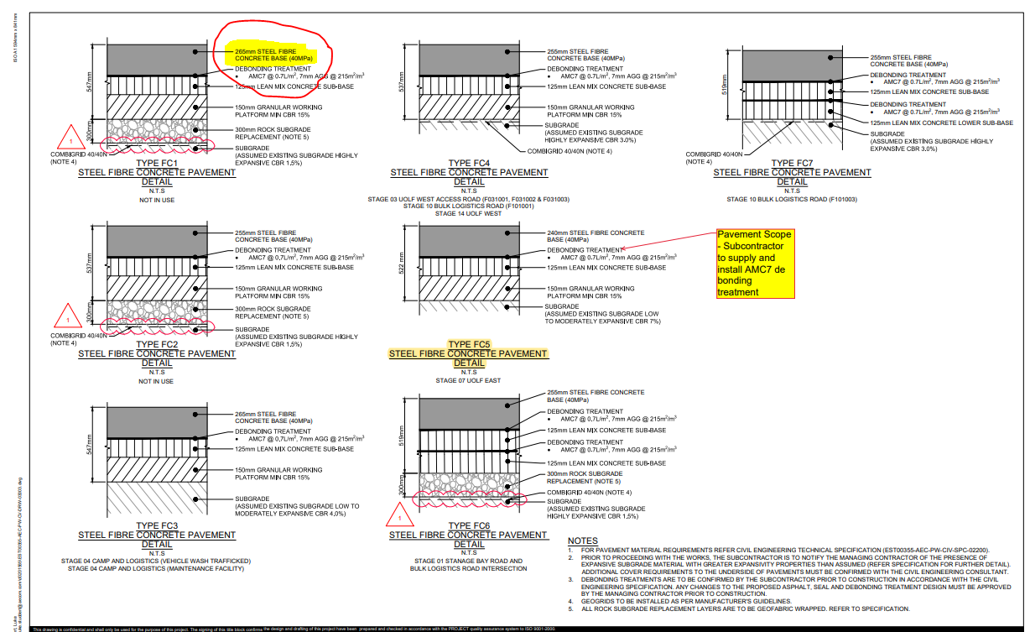
Provide excerpt (screenshot) of specifications | 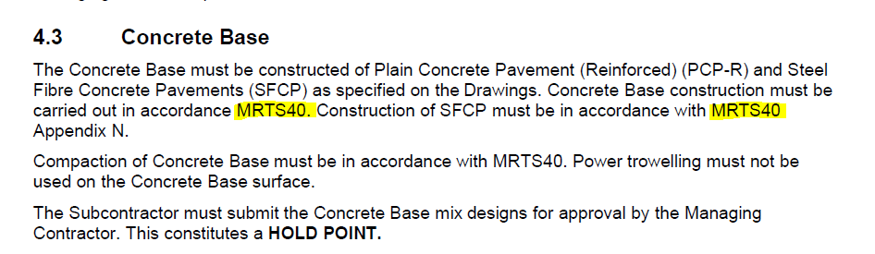
Confirm that plans comply with specifications | YES  NO (Explain why):

Example 3
Provide excerpt (screenshot) of plans | 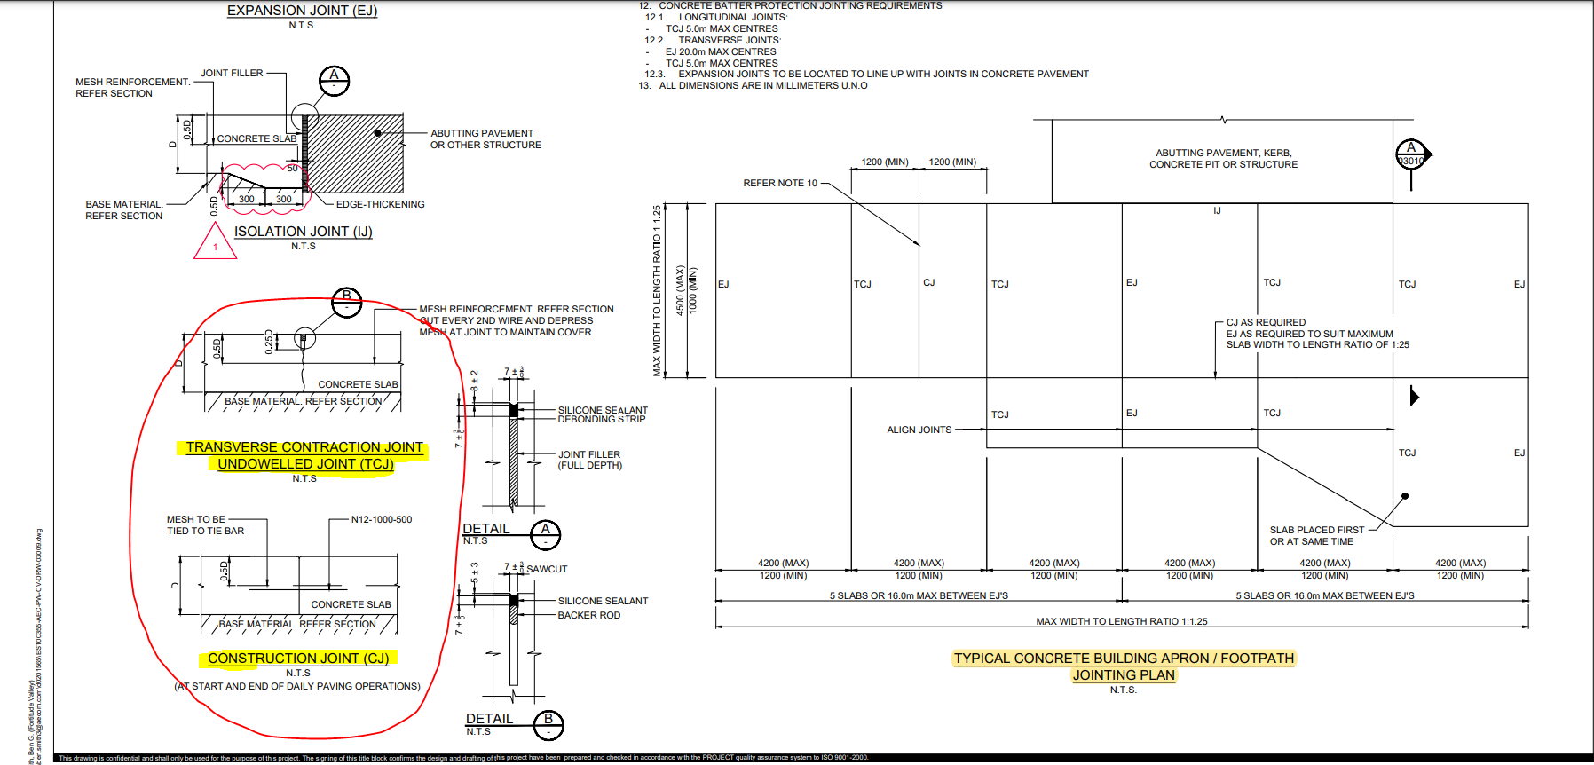
Provide excerpt (screenshot) of specifications | 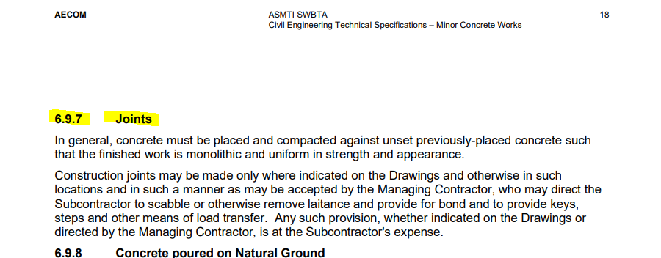
Confirm that plans comply with specifications | YES  NO (Explain why):

Task 3 Examine Detail Drawings to Determine Sizes and Thickness
Record the sizes, thickness, and quantity of the three (3) different materials listed on the detail drawings used on the building and construction project.
You will be assessed on:
- Practical knowledge of the sizes, thickness and quantity of construction items
- Practical skills in examining detail drawings to determine sizes and thickness
- Practical skills in interpreting two-dimensional and three-dimensional drawings and applying to estimation
Before starting this task, review the Workplace Assessment Task 3 – Assessor’s Checklist provided along with this workbook. This form lists the criteria your Material Quantity Takeoff Form submission must address to complete this task satisfactorily.
After completing this task, submit the following to your assessor:
- Completed Material Quantity Takeoff Form
- Detail drawings you used as basis in determining the sizes, thickness and quantity of materials

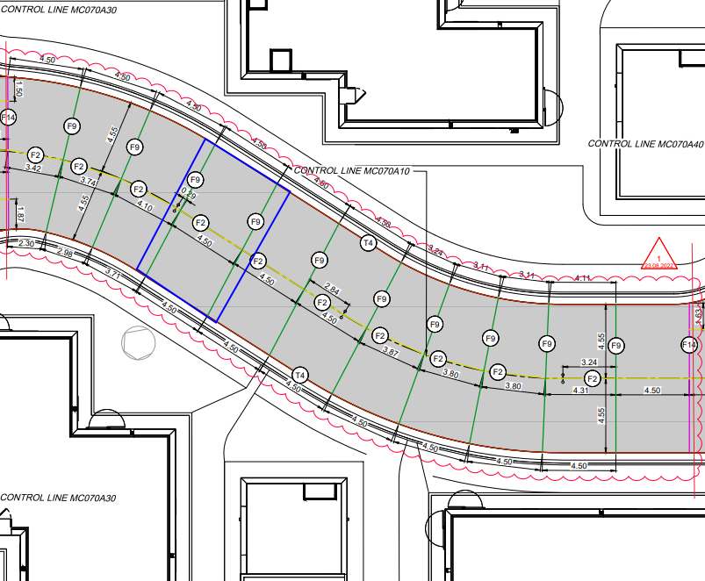
Material Quantity Takeoff Form

Completed by | Rhys Holmes – Yasso
Date completed | 07/02/2023

Items | Size |  | Thickness (mm) | Quantity (pcs)
Items | Height (mm) | Width (mm) | Thickness (mm) | Quantity (pcs)
1. Concrete | FC5 Pavements,  522mm (from Subgrade)  125mm Lean mix. | 9100mm | 240mm | 98.4329m3
2. N12 Dowel Bars | 450mm | 300mm | 300mm | 30.3 / 31
3. Backer Rod | 15mm | 15mm | 0.000225 m² | 100100mm

Task 4 Discuss Details During the Planning Phase
In the role of a supervisor, email the details of your estimates from Workplace Assessment Task 3 to subordinate construction personnel to order materials.
You will be assessed on:
- Practical knowledge of two-dimensional and three-dimensional drawings
- Practical skills in interpreting two-dimensional and three-dimensional drawings and applying to planning
Before starting this task, review the Workplace Assessment Task 4 – Assessor Checklist provided along with this workbook. This form lists all the practical skills you need to demonstrate while completing this task.
After completing this task, submit the following to your assessor:
- Email to those requiring your direction with regards to ordering materials

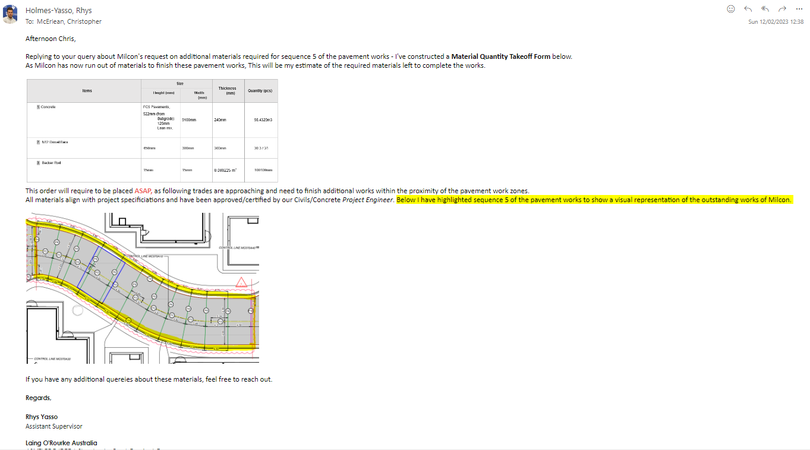

Practical Plans Assignment

Overview
The goal of this assessment is to assess your practical knowledge and skills in:
- Identifying types of plans
- Reading and interpreting plans
- Identifying structural details
- Identifying non-structural details
This assessment is divided into 12 assessment tasks.
Task 1 – Types of Plans and Aspects
Task 2 – Construction Plans
Task 3 – Materials from Specifications
Task 4 – Concrete Footing and Slab
Task 5 – Load Bearing Points
Task 6 – Load Bearing Information
Task 7 – Wind Bracing and Tie-Down Requirements
Task 8 – Wind Bracing Materials and Tie-Down Methods
Task 9 – Provisional Sum and Prime Cost Items
Task 10 – Installation and Connection Points of Services
Task 11 – Location of Fixtures
Task 12 – Details of Finishes
The assessment items included in this assessment will require you to demonstrate your knowledge and skills relevant to reading and interpreting plans.
You will record your responses in this workbook when completing the assessments.
Resources required for assessment:
To complete this assessment, you will need access to the following:
- Construction plans, including:
  - Site plan
  - Floor plan
  - Detail drawings
  - Structural drawings
- Construction specifications
- Wind bracing table
- Construction contract

Task 1 Types of Plans and Aspects
Provide examples of three (3) of the listed types of construction plans and briefly identify what they contain.
Record your responses in the spaces provided in each item.
You will be assessed on:
- Practical knowledge of the types of plans and aspects of drawings
- Practical skills in identifying the types of plans and aspects of drawings specific for the intended purpose

- Provide examples of three (3) of the listed types of construction plans and briefly explain their purpose:
  - Concept drawing/sketches
  - Architectural plans
  - Structural plans
  - Civil plans
  - Mechanical plans
  - Electrical plans
  - Plumbing and drainage plans

Type of Plan |  | Purpose
1 | Mechanical Plans | These plans are designed to give a visual representation on all mechanical components within the construction, including technical specifications, mechanical equipment design and location, and general dimensions of installations and connections.
2 | Structural Plans | The purpose of these plans are to guide the contractor in its construction, which contain all information on structural features and mathematical details of how the structure is to be built. These plans are also to be signed by a professional engineer before the construction is to commence.
3 | Concept Drawings/Sketches | The purpose of concept drawings and sketches is to create opportunity for any construction ideas, erection procedures, concept interrelationships and to communicate the technical details of a project in a building and construction format.

- Provide examples of three (3) of the listed aspects of drawings and briefly explain their purpose:
  - Site plan
  - Floor plan
  - Elevations
  - Sections
  - Details
  - Isometric drawings
  - Oblique drawings
  - Perspective drawings
  - Orthographic drawings

Aspects of Drawings |  | Purpose
1 | Site Plan | The purpose of site plans are to give the reader a general outline of the work and construction zone’s location and setting. These assist to capture all architectural features of the location where the construction will begin.
2 | Floor Plan | The purpose of floor plans are to provide a visual representation of the view from above (Birds-Eye-View) of the construction. These can give the builder/construction an assisted idea of the dimensions of room spaces, and labialization/location of rooms.
3 | Perspective Drawings | The purpose of perspective drawings it to give the viewer a visual representation of how the building/image would be perceived by the eye.

Task 2 Construction Plans
Review the construction plans for the project you are undertaking for this assessment.
You will be assessed on:
- Practical knowledge of the construction plans
- Practical skills in reading and interpreting the plans

- Identify one key feature for each of the plans you identified in Task 1:
Explain how each indicated key feature distinguishes the plan from other types of plans.

Type of Plan |  | Key Feature | How does this key feature distinguish the plan from the other types of plans?
1 | Mechanical Plan  Plan Shown Below  Plan #1 | Duct System Connections | This mechanical plan stipulates the location of the duct system connections within the buildings. The positioning/connections of these mechanical components will not be in any other plans.
2 | Electrical Plan  Plan Shown Below  Plan #2 | Distribution board building connections | This electrical plan stipulates the connections between the individual distribution boards within each building and the main switch board (MSB)
3 | Site Plan  Plan Shown Below  Plan#3 | Street Names | This site plan drawing shows the labialization of each street name around the work area of the buildings (Building and area labializations have also been included)

Plan #1

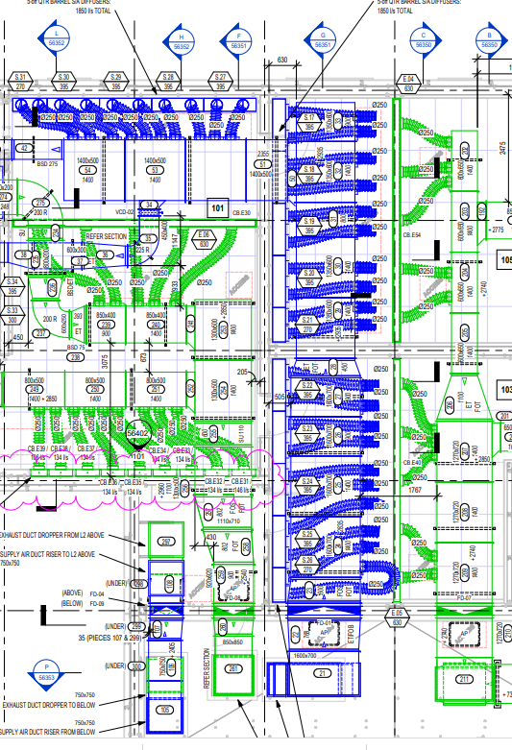
Plan #2
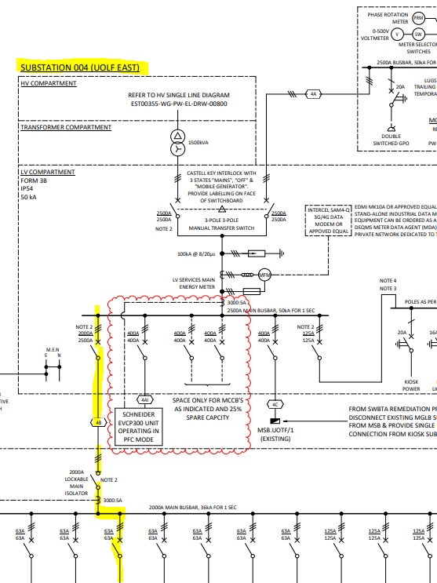

Plan #3
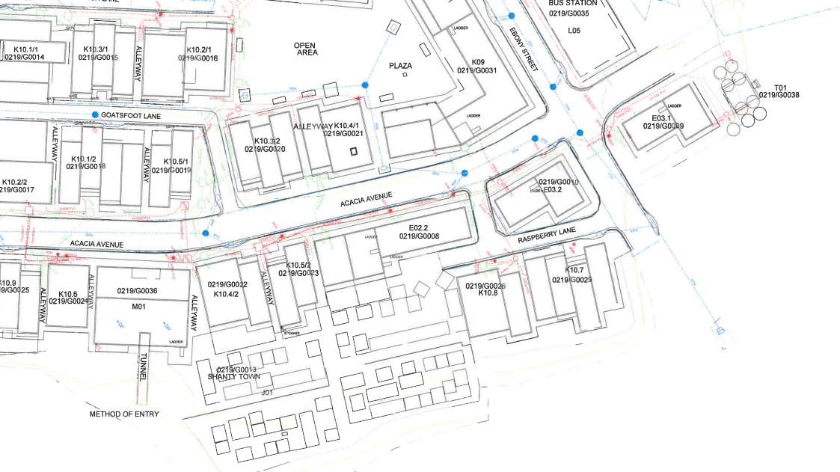

- Refer to an example of a site plan and outline the detail requested below. Ensure you supply the plan with your submission.

Questions | Candidate Responses
What is the address of the building project? | 72 COLEMANS RS, DANDENONG SOUTH, VIC
What is the block number of the land where the building is to be constructed? | LOT 63
What is the name of the road adjacent to the block of land? | WATTLE DRIVE
Based on the north point, describe the orientation of:
- The proposed building | The building is oriented towards the north-east direction
- The road used to access the entrance of the property | Water Drive is used as the entrance
What is the elevation of the datum? | DATUM RL 15.43
What are the elevations (reduced levels) of the site contours? | 15.00  16.00  17.00  18.00  19.00
Describe the contour of the land based on the site contour. | The way the contour lines are stipulated within the site plan is that the elevation (RL’s) Decrease from 19.00 to 15.00 – representing the uniform slope from the north side of the building to the south.

Questions | Candidate Responses
What are the site features to be removed? | BRK & TILES to be cleared and removed
What are the site features to be retained? | Existing trees within the construction lot (63) to be retained

- Refer to an example of a floor plan and outline the detail requested below. Ensure you supply the plan with your submission.

Questions | Candidate Responses
Describe the shape of the layout of the building. | 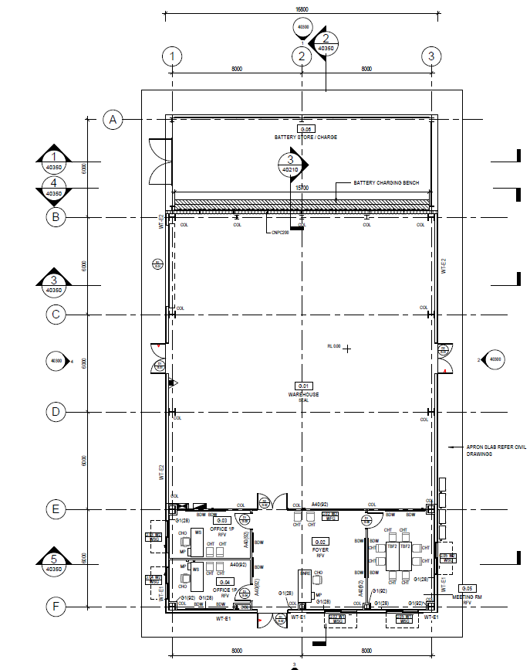
Identify all the building spaces in the floor plan and their corresponding dimensions. | Building Space: Battery Storage / Charge (G.06)  Dimensions: 6000 X 16800
Building Space: Warehouse (G.01)
Dimensions: 12000 x 16800
Building Space: Offices 1P (G.03)
Dimensions: 6000 x 8000
Building Space: Offices 1P (G.04)
Dimensions: 6000 x 8000
Building Space: Meeting Room (G.05)
Dimensions: 6000 x 4000
Building Space: Foyer (G.02)
Dimensions: 6000 x 4000
- Refer to an example of a plan outlining details about internal linings, external cladding and roof materials and outline the detail requested below. Ensure you supply the plan with your submission.

Questions | Candidate Responses
What materials are used for the internal linings of the building? | Water Seal
 | Rivet Fixings
What materials are used for the external cladding of the building? | Askin Wall Panels
What are the different roof materials used in the building project? | Weather Seal (Polyurethane Sealant)
 | Flashing (Pre-Painted Steel)
 | Foam Fill
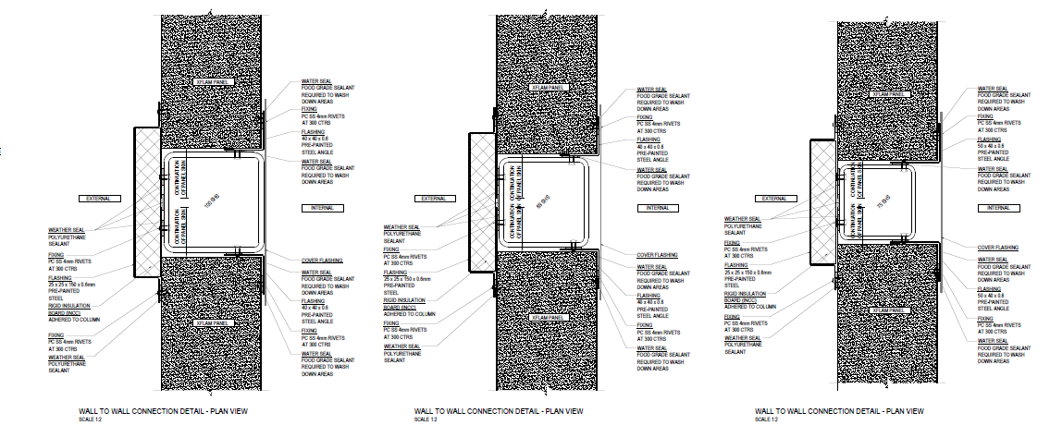
- Refer to an example of detail drawings and outline the detail requested below. Ensure you supply the drawings with your submission.

The wall-to-wall connection detail in drawing “IPQL000000 – 075” show’s all internal and external materials used within this connection. 4mm rivets are to be installed at 300 centres’, flashing dimensions of 25 x 25 x 150 x 0.6mm are to be installed on the external face. Between these connections of the walls polyurethane sealant is used to aid as a weather seal.

Task 3 Materials from Specifications
Refer to an example of specifications and outline the detail requested below. Ensure you supply the specifications with your submission.
You will be assessed on:
- Practical knowledge of the specifications document
- Practical skills in identifying materials from the specifications document

Questions | Candidate Responses
What materials are used for the internal linings of the building? | - 92mm Steel Studs  - 9MM Fcf Linings  - Insulation Partition Batt  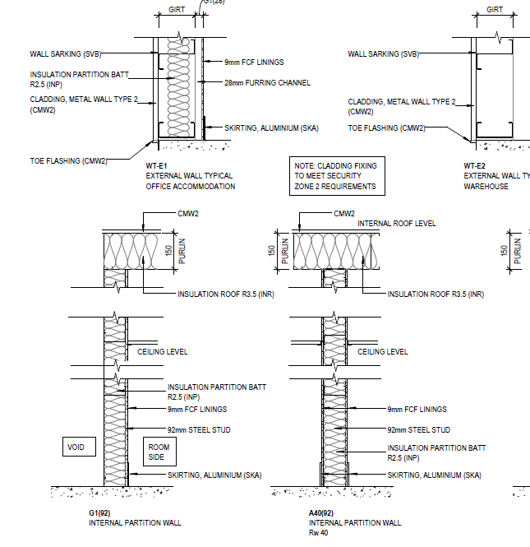  - Aluminium Skirting
What materials are used for the external cladding of the building? | - Toe Flashings  (CMW2) – Cladding, Metal Sheet (Roll Formed Trapezoidal)  - Wall Sarking  (SVB) – Snarking Vapour Barrier
 | 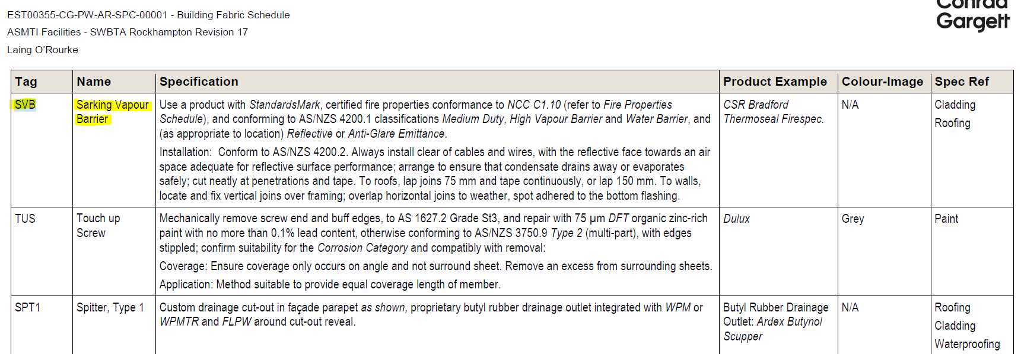
What are the different roof materials used in the building project? | - Roof Insulation  (INR) – Insulation roof (Provide reflective mineral wool blanket insulation on RSM mesh)  - Roof Purlings  - Universal Beam (UB)  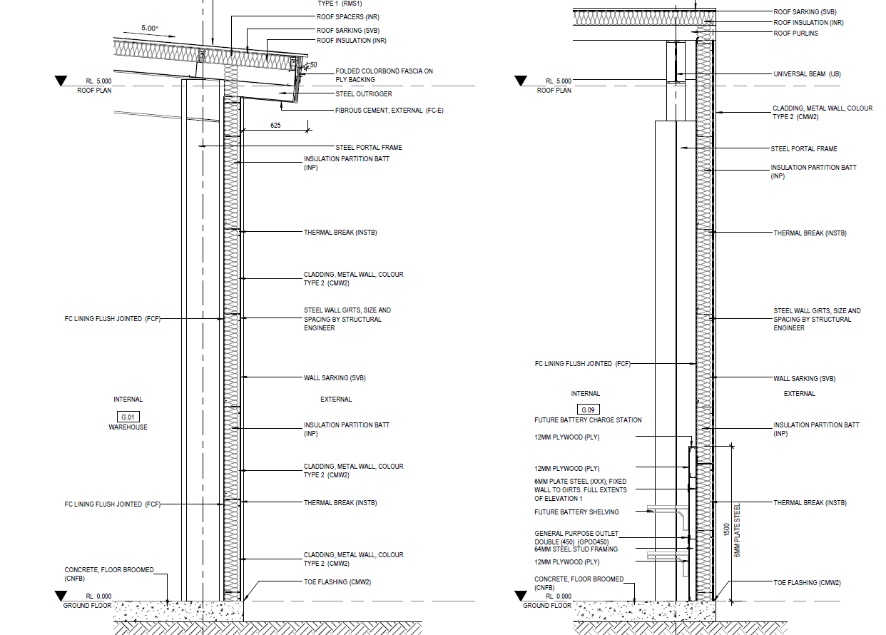

Task 4 Concrete Footing and Slab
Refer to an example of plan addressing footings, slabs and reinforcing and outline the detail requested below. Ensure you supply the plan with your submission. Alternatively, refer to:
    - Practical Plans Assignment Task 4 Footing and Ground Floor Slab Plan – 1
    - Practical Plans Assignment Task 4 Footing and Ground Floor Slab Plan – 2

- Describe the position of one (1) footing and slab-on-ground in the plans.
- Identify the following:
  - Size of footing +
  - Size of slab-on-ground
  - The type of reinforcing applied
You will be assessed on:
- Practical knowledge of concrete footing and slab sizes and position and type of reinforcing
- Practical skills in identifying the concrete footing and slab sizes and position and type of reinforcing

Footing
Position | Size | Type of reinforcing
Grid reference for the position (B2)  (IB3 Footing) | IB3 (400mm D x 300mm) W | N12-300-Z (STEEL BAR)

Slab-on-ground
Position | Size | Type of reinforcing
Slab on ground | SOG – 120mm | N12-300-Z (STEEL BAR)  Same reinforcement used
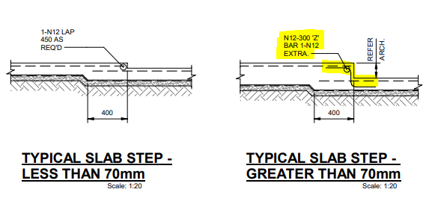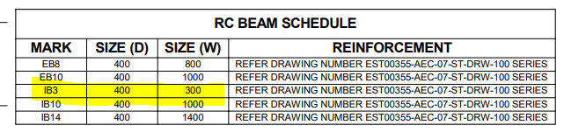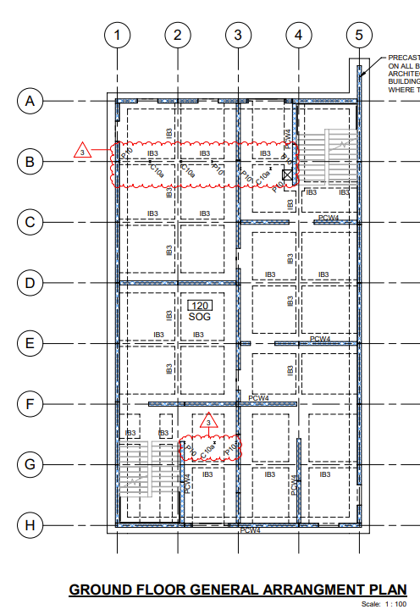

Task 5 Load Bearing Points
Refer to an example of a plan which identifies load bearing points (or columns). Alternatively, refer to Practical Plans Assignment Task 5.
Provide three (3) screenshots from the plans that identify load bearing points.
You will be assessed on:
- Practical knowledge of the load bearing points of the building
- Practical skills in identifying the load bearing points of the building

Load bearing points (or columns)
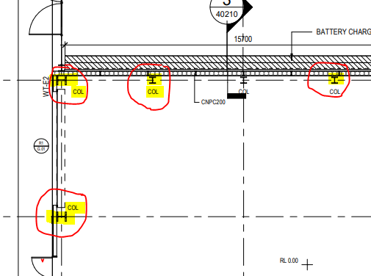
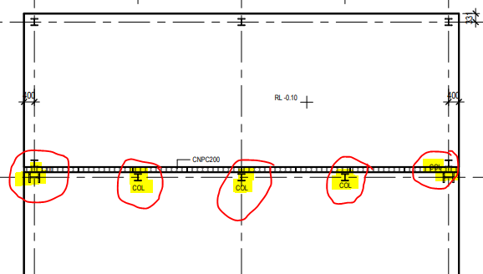
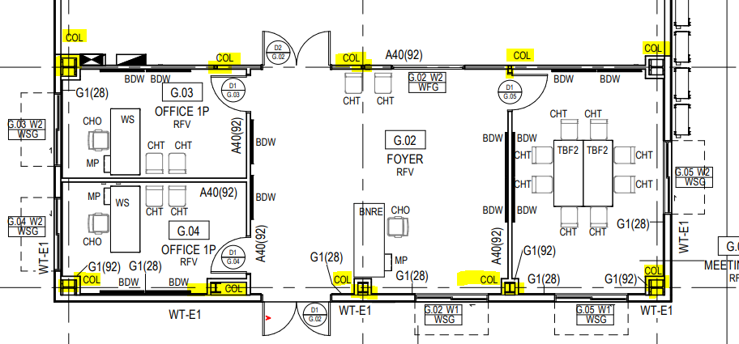

Task 6 Load Bearing Information
Refer to an example of structural drawings of structural members (e.g. columns, beams) and outline the detail requested below. Ensure you supply the plan with your submission.
Ensure to:
- Identify the strength of steel and concrete from the structural drawings.
- Indicate whether the strength of steel and concrete identified from the structural drawings are consistent with the information in the project specifications.
If your answer is NO, explain why the information in the structural drawings are not consistent with the specifications.
You will be assessed on:
- Practical knowledge of load bearing information from plans and specifications
- Practical skills in identifying structural load bearing information of the building and comparing information from specifications

Strength of Steel: | Steel Used:- (N12) Strength of steel specs:- (D500N)
Is the strength of steel specified in the structural drawings, consistent with the information in the project specifications?
YES NO
Explanation (Candidate to explain if their response is no)
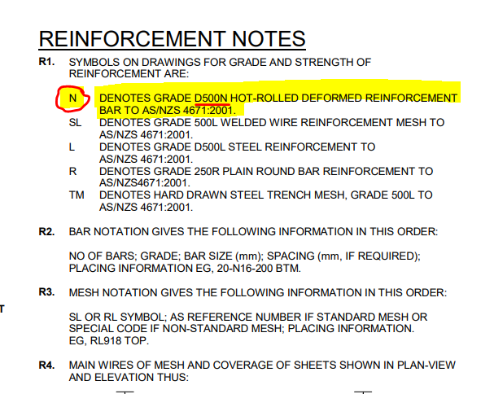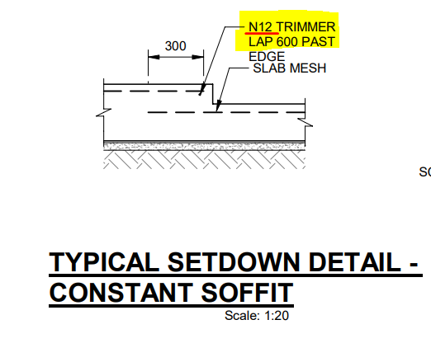
Strength of Concrete: | N32 Concrete Strength
Is the strength of concrete specified in the structural drawings, consistent with the information in the project specifications?
YES NO
Explanation (Candidate to explain if their response is no)
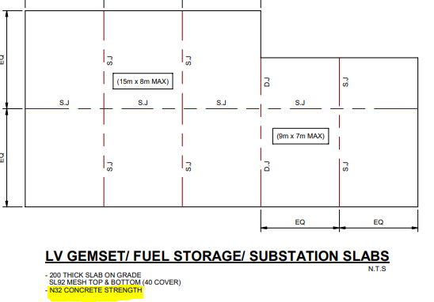

Task 7 Wind Bracing and Tie-Down Requirements
Refer to an example of plans and specifications which outline wind bracing and tie-down requirements and outline the detail requested below. Ensure you supply the plans and specifications with your submission.
You will be assessed on:
- Practical knowledge of wind bracing and tie-down requirements
- Practical skills in identifying wind bracing and tie-down requirements

What are the wind bracing requirements?
- XB.1 Bracings required are to be galvanized iron material to be used and dimensions are 30x1.0mm
- XB.3 Bracings required are to be galvanized iron material to be used dimensions are 30x1.0mm
- All straps are to be wrapped over the sides all rafters
What are the tie-down requirements?
- 2 Nails are to be installed at each crossover rafter, and wrap ends over side of the rafters
- 6 nails are to be installed in the wrapping connection
- All nails are to be the dimensions of 35 x 3.15 and galvanised nails to be used
- Strapping to be used to tie down the battens to the rafters
(Used Workbook Example)

Task 8 Wind Bracing Materials and Tie-Down Methods
Confirm whether the wind bracing materials and tie-down methods found in the plans and specifications from Practical Assessment Task 7 are accurate against the wind bracing table.
You will be assessed on:
- Practical knowledge of wind bracing and tie-down requirements
- Practical skills in identifying wind bracing and tie-down requirements

Wind bracing materials  (Student to list wind bracing materials below) | Candidate’s confirmation to whether the wind bracing material is accurate against the wind bracing table
Galvanised Iron 30 x 1.0mm strap | The wind bracing materials are listed within the table, however they’re listed within the plan in different dimensions. The plans list 30x0.8mm.
(18x16x1.2mm) fixed studs | The wind bracing materials are listed within the table, however they’re listed within the plan in different dimensions. The plans list 20x17x1.2mm.
2/30 x 2.8mm into top and bottom plate | The wind bracing materials are listed within the table, however they’re listed within the plan in different dimensions. The plans list 3/30 x 2.8mm.

Tie-down methods  (Student to list tie-down methods below.) | Candidate’s confirmation to whether the tie-down method is accurate against the wind bracing table
Fix bottom plate to floor frame or slab with nominal fixing only | This replicates the correct method listed within the wind bracing table
Hardwood timber braced fixed to each stud and plate with flat head nails | The wind bracing table stipulates to use nails for metal brace to each stud and plate, not timber.

Task 9 Provisional Sum and Prime Cost Items
Refer to an example of a construction contract and outline the detail requested below. Ensure you supply the extract of the construction contract with your submission.
Identify the following based on the documents you reviewed:
- Provisional sum (PS) items
- Prime cost (PC) items
You will be assessed on:
- Practical knowledge of provisional sum and prime cost items
- Practical skills in identifying provisional sum and prime cost items

What are the prime cost items?
Due to our construction contracts not specifically stipulating PC’s and PS’s and following defences confidentiality duties, I’ll explain my understanding over prime cost items and examples. Prime cost items in my descriptions are the costs of generally a type of material(s) used for the construction. This would also be defined at the direct costs, these include a building material, labour required or production. Alike provisional sums these costs to do not include indirect costs. Prime costs can include: - Baths, Taps, handles, carpet tiles or flashings
What are the provisional sums items?
Provisional Sum items are classed as the total sum that you will need to cover the cost of the planned construction. The higher the sum the more opportunity you must cover the cost, especially when there are potential extra costs that could make them selves present. These items cannot be precisely costed in advance. A provisional sum of construction could cover:- Trenching works, Excavations, Total sum of a construction/erection.

Task 10 Installation and Connection Points of Services
Provide screenshots from construction plans to:
- Locate the installation points of services
- Locate the connection points of services
You will be assessed on:
- Practical knowledge of the installation and connection points of building services
- Practical skills in locating the installation and connection points of building services

Installation Points of Services
(Student to provide a screenshot example of three (3) installation points of services, such as gas supply, air conditioning)
Attached Below Are Mechanical Air Ducting Installation Points
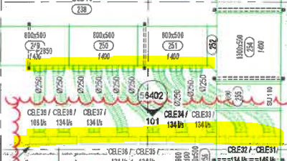
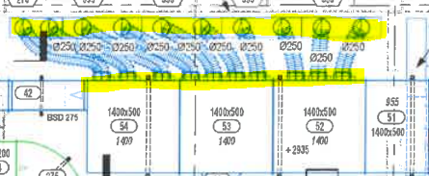
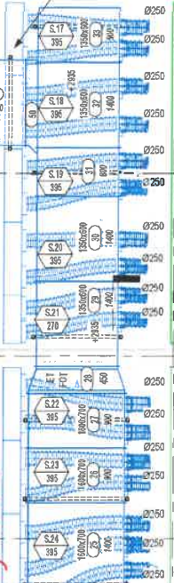

Connection Points of Services
(Student to provide a screenshot example of three (3) connection points of services, such as sewer connection, water supply connection point)
Attached Below Are Electrical Connections
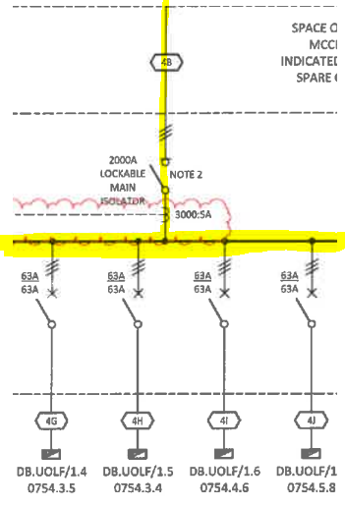
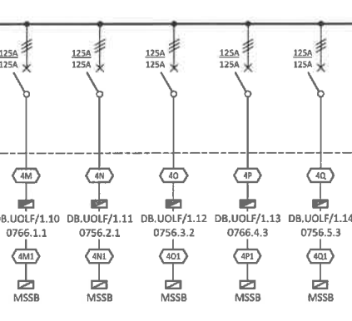
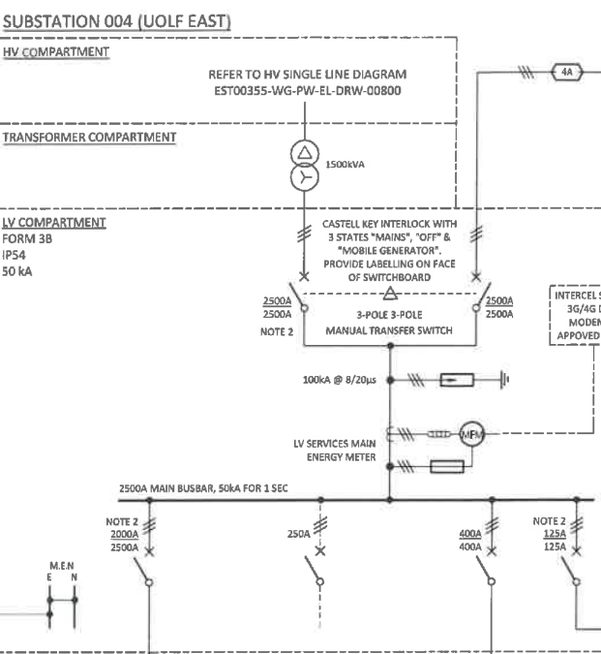

Task 11 Location of Fixtures
Provide screenshots of examples from plans which locate three (3) fixtures in plans.
You will be assessed on:
- Practical knowledge of fixtures
- Practical skills in identifying the location of fixtures from plans

Fixtures
(Student to provide a screenshot example of three (3) fixtures, such as toilet, ceiling fan, sprinkler system)
Attached Below Are Speakers, CCTV and Lighting
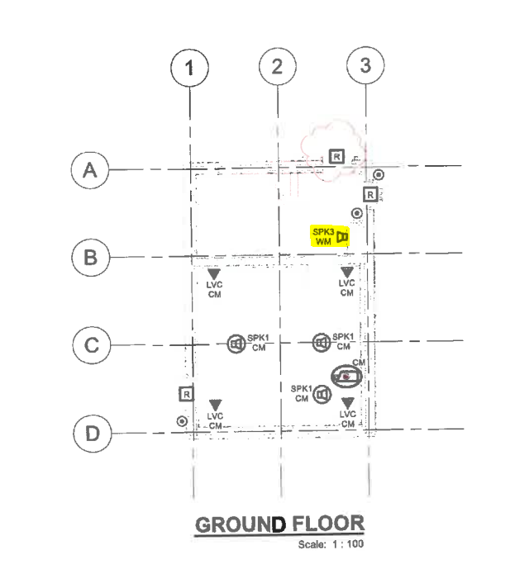
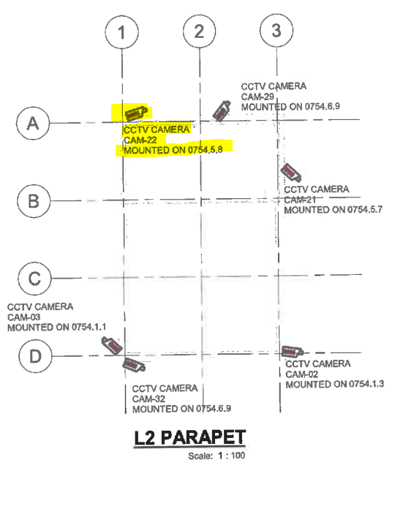
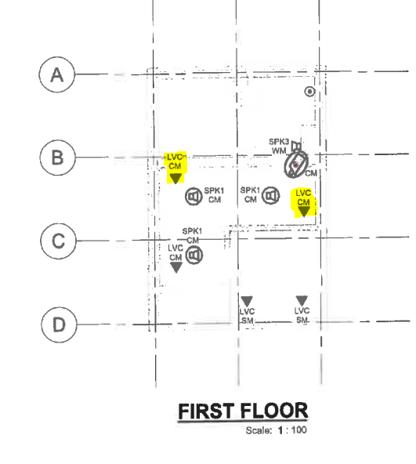

Task 12 Details of Finishes
Provide screenshots of examples from specifications which identify the details of three (3) finishes.
You will be assessed on:
- Practical knowledge of details of fixtures
- Practical skills in identifying details of fixtures

Finishes | Details of finishes from the specifications
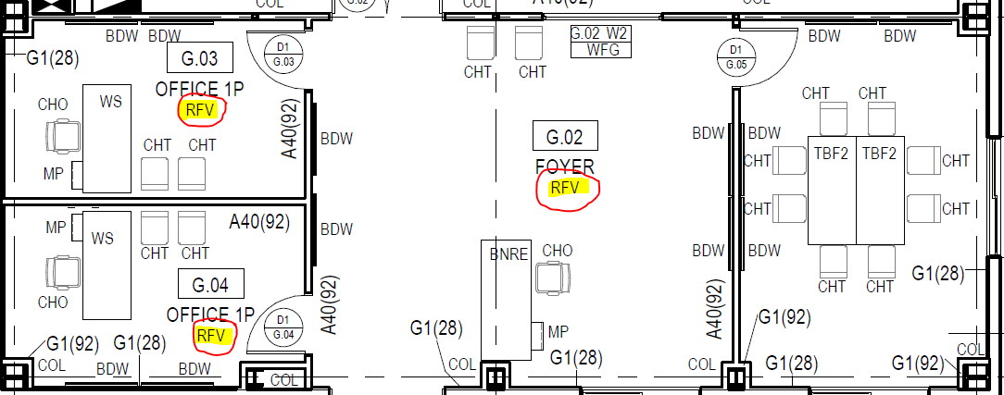 | Resilient Flooring Vinyl  (Vinyl sheet conforming to 2.0mm thick.  Colour:- Granit Dark Grey
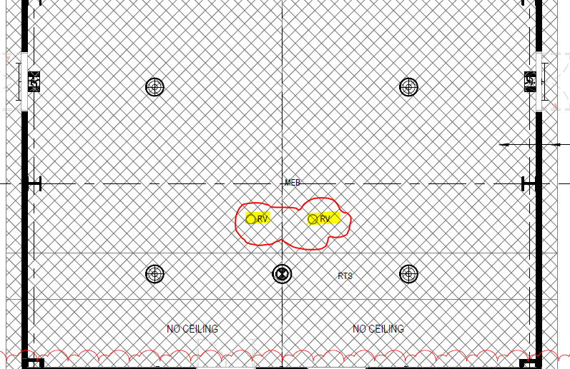 | Roof Vent Cowl or Pipe (RV)  Product as identified by Mechanical Services.  Pacific Air 150mm MCV150.
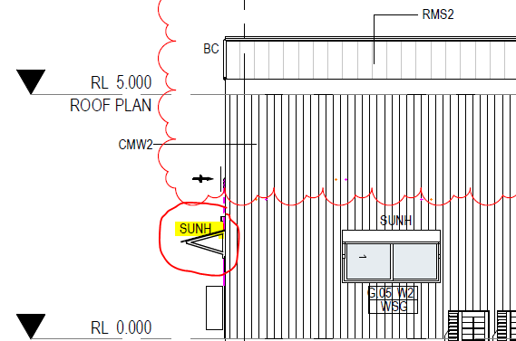 | Sun (Sunshade) Custom fabricated sunshade as shown (Colour image to match cladding)

Assessment Workbook Checklist
TO THE CANDIDATE
When you have completed this assessment workbook, review your work, and ensure that:
- You have completed all the Knowledge Assessments Questions.
- You have completed the Practical Assessments in this workbook
- Practical Assignment
- Workplace Safety Requirements
- Workplace Processes
- Environmental Requirements
- Workplace Assessment
- Confirm Currency of Plans, Specifications, and Amendments
- Confirm Details on Plans Comply with the Specifications
- Examine Detail Drawings to Determine Sizes and Thickness
- Discuss Details During the Planning Phase
- Practical Plans Assignment
- Types of Plans and Aspects
- Construction Plans
- Materials from Specifications
- Concrete Footing and Slab
- Load Bearing Points
- Load Bearing Information
- Wind Bracing and Tie-Down Requirements
- Wind Bracing Materials and Tie-Down Methods
- Provisional Sum and Prime Cost Items
- Installation and Connection Points of Services
- Location of Fixtures
- Details of Finishes
- You have saved and submitted the following evidence:
- This completed workbook
- Assessment Workbook Cover Sheet signed and scanned
- Plans used for Practical Plans Assignment Tasks 1, 2, 3, 4, 5, 6, 7 and 9

IMPORTANT:
You must achieve a satisfactory result in ALL assessment tasks to be deemed COMPETENT for the unit/s relevant to this workbook.
To be deemed competent in the unit/s of competency relevant to this workbook, you must successfully complete all the requirements listed above according to the prescribed benchmarks provided to the assessor.

TO THE ASSESSOR
When you have completed assessing the assessment workbook, review the candidate’s submission against the checklist below:
- The candidate has completed all the Knowledge Assessments Questions.
- The candidate has completed the Practical Assessments in this workbook
- Practical Assignment
- Workplace Safety Requirements
- Workplace Processes
- Environmental Requirements
- Workplace Assessment
- Confirm Currency of Plans, Specifications, and Amendments
- Confirm Details on Plans Comply with the Specifications
- Examine Detail Drawings to Determine Sizes and Thickness
- Discuss Details During the Planning Phase
- Practical Plans Assignment
- Types of Plans and Aspects
- Construction Plans
- Materials from Specifications
- Concrete Footing and Slab
- Load Bearing Points
- Load Bearing Information
- Wind Bracing and Tie-Down Requirements
- Wind Bracing Materials and Tie-Down Methods
- Provisional Sum and Prime Cost Items
- Installation and Connection Points of Services
- Location of Fixtures
- Details of Finishes
- The candidate has saved and submitted the following evidence:
- This completed workbook
- Assessment Workbook Cover Sheet signed and scanned
- Plans used for Practical Plans Assignment Tasks 1, 2, 3, 4, 5, 6, 7 and 9

IMPORTANT:
The candidate must achieve a satisfactory result in ALL assessment tasks to be deemed COMPETENT for the unit/s relevant to this workbook.
To be deemed competent in the unit/s of competency relevant to this workbook, the candidate must successfully complete all the requirements listed above according to the prescribed benchmarks.

Record of Assessment (Assessor’s Use Only)
RECORD OF ASSESSMENT
Candidate’s Name
RTO Name
RTO Contact Number
RTO Email Address
Assessor’s Name
Unit of Competency | CPCCBC4012 - Read and interpret plans and specifications (Release 1.0)

Knowledge Assessment | S | NYS
Question 1
Question 2
Question 3
Question 4
Question 5
Question 6
Question 7
Question 8
Question 9
Question 10
Question 11
Question 12
Question 13
Question 14
Question 15
Question 16
Question 17
Question 18
Question 19
Question 20
Question 21
Question 22
Question 23

Practical Assessment
Practical Assignment | S | NYS
Task 1
Task 2
Task 3
Workplace Assessment | S | NYS
Task 1
Task 2
Task 3
Task 4
Practical Plans Assignment | S | NYS
Task 1
Task 2
Task 3
Task 4
Task 5
Task 6
Task 7
Task 8
Task 9
Task 10
Task 11
Task 12

Rules of Evidence | S | NYS
All knowledge and skills evidence submissions are valid
All knowledge and skills evidence submissions are authentic
All knowledge and skills evidence submissions are sufficient
All knowledge and skills evidence submissions are current

Signature Authentication Checklist
This checklist will guide you in authenticating the signatures provided by the candidate in their assessment workbook and evidence submissions.
Read each checklist item and tick the box only if you confirm that the item is a true and accurate reflection of the signature authentication you have conducted.
Checklist | Completed
I have checked the signature provided by the candidate in the Assessment Workbook Cover Sheet against the signature they provided to the Training Provider.
I confirm the signature provided by the candidate in the Assessment Workbook Cover Sheet matches the signature they provided to the Training Provider.
I confirm ALL signatures provided by the candidate in their evidence submissions match with the signature they provided to the Training Provider.

Third-Party Verification Log
Instructions for the Assessor:
You are required to contact all third-party personnel involved in the candidate’s assessment to verify the candidate’s performance and evidence submissions and to confirm with them whether the candidate’s evidence submissions are true and accurate.
Complete this Third-Party Verification Log to document your completion of this process. When completing this log, provide all of the following required information for each third-party personnel:
- Name of third-party personnel contacted
- Role in the candidate’s assessment (e.g. workplace supervisor, observer, or candidate)
- Contact details (phone number or email address)
- Date contacted
You must also confirm that third-party personnel have verified the candidate’s evidence submissions are true and accurate.

Name of Third-party Contacted | Role in the Candidate’s Assessment | Contact Details (Phone number or email address) | Date contacted | Third-Party verifies evidence submissions of the candidate are true and accurate?
Yes No
Assessor’s Notes

Yes No
Assessor’s Notes

Yes No
Assessor’s Notes

Yes No
Assessor’s Notes

Overall Result for this Workbook | S | NYS
Overall Result

Assessor’s comments/feedback

Assessor Declaration
I declare that the results recorded in this Record of Assessment are true and accurate.
Assessor’s name | Assessor’s signature
Date signed | Assessor’s signature
End of Record of Assessment (For the Assessor’s Use Only)

End of Document

