CPCCBC4016A
Administer a construction contract

THEORY EXAM INSTRUCTIONS

- This exam will occur under standard assessment conditions.
  - An oral examination may be allowed under certain circumstances.
Answers will be documented and FT003 (Oral examination declaration form) must be completed.
- Participants must provide enough detail in their responses to demonstrate their knowledge and skills.
- Please fill in the details below, providing your name, signature and date of assessment.
  - Your signature acknowledges that this is your own work.
- If a participant initially answers a question incorrectly but modifies their response, they must follow the instructions below:
  - If a participant changes their response in writing, they must put their initials next to the written change.
  - If a participant changes their response verbally, this must be noted on the exam paper by the assessor.

Participant name | Justin Skehan
Participant signature | 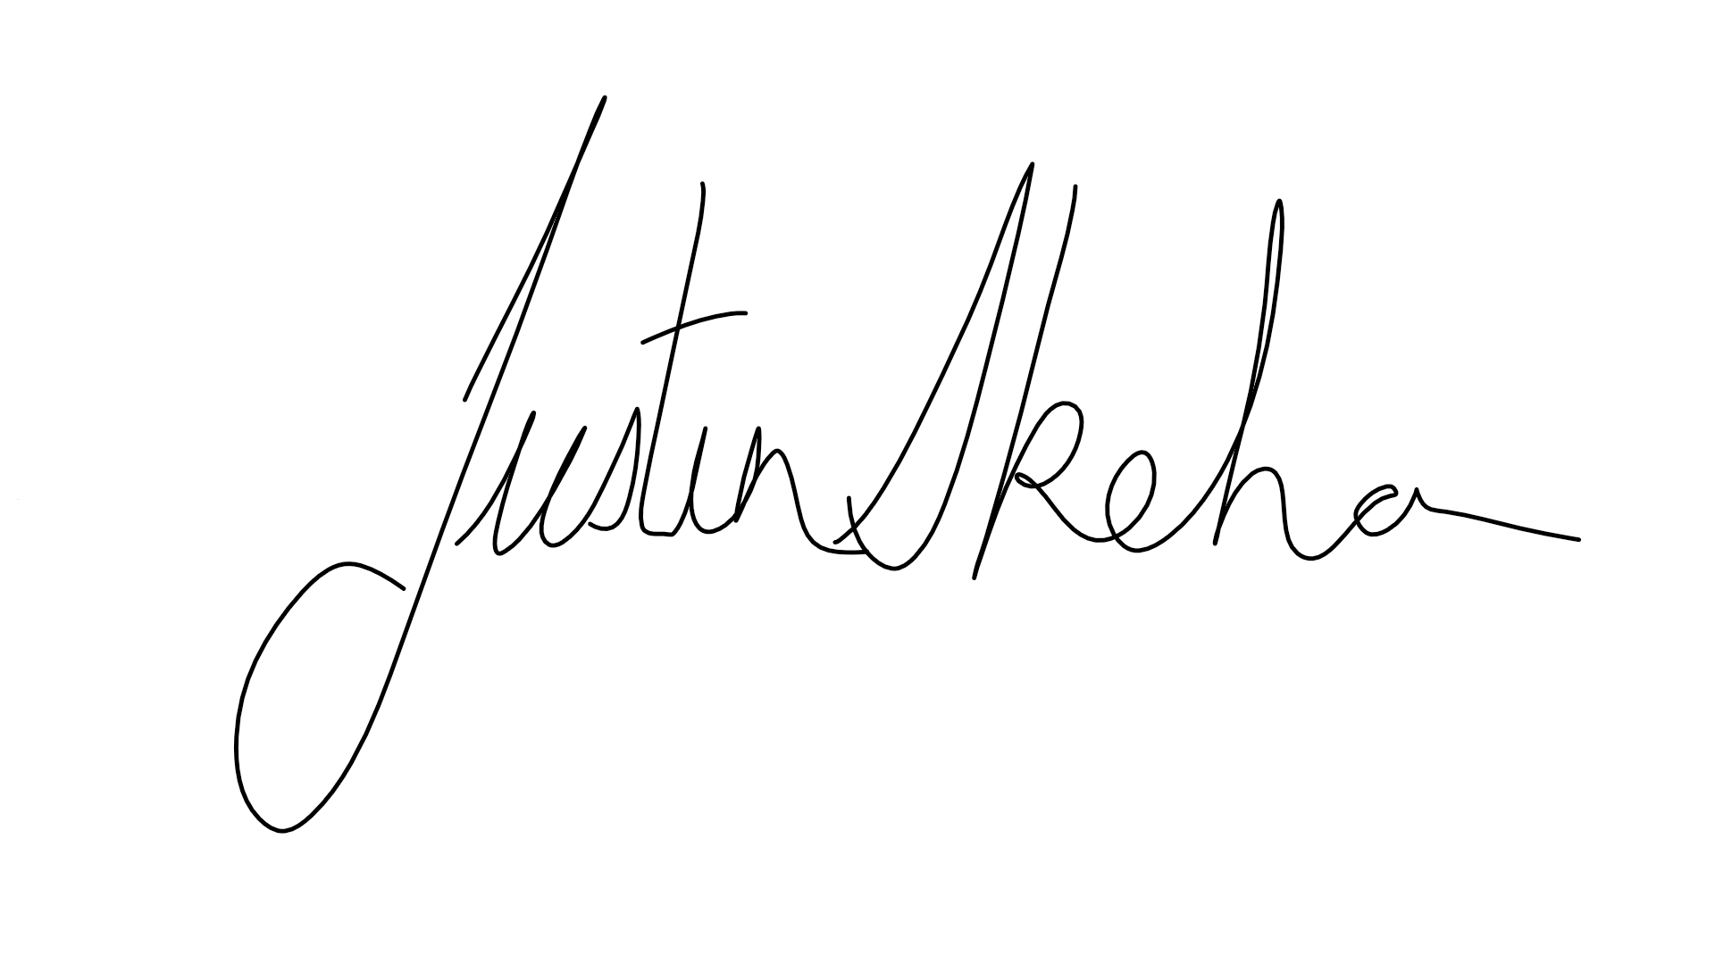

Assessor name
Assessor signature | 

Date | 15/09/2018

Number of questions | Number of questions answered correctly | Satisfactory?
49 |  | Yes | No
Assessor Comments

- Identify the various types of building and construction contracts and explain when it is appropriate to apply each type of contract.

Answer | Any residential building over the value of $3300 must have a signed contract in place. There are several contracts available in the market place from industry bodies like,  - QBCC  - Master Builders Association  - HIA  Some the standard contracts are for,  - New Home Construction Contract for the construction of an entire home  - Level 1 - Renovation, Extension and Repair Contract for renovations, extensions and routine repairs on existing homes for contracts $3,301 to $19,999  - Level 2 - Renovation, Extension and Repair Contract for renovations, extensions and routine repairs on existing homes for contracts $20,000 and over  - Natural Disaster Repairs Contract designed to help you organise repairs to a home, duplex or home unit after a natural disaster  - Demolition Contract  - Small Building Projects Contract  - Residential Cost-Plus contract can only be used where the extent of the work cannot be determined – for example termite repairs.  There are also Building Contract available from the Australian Building Industry Contracts (ABIC) these are jointly published by Master Builders Australia Limited (Master Builders) and the Australian Institute of Architects (Institute).  They are intended for use in building projects where an architect administers the contract. The 2018 revised editions of the ABIC Major Works (MW) and Simple Works (SW) commercial and domestic documents are now available under the relevant state and territory pages. For a revised edition of the ABIC Basic Works (commercial) contract refer to ABIC Basic Works BW 2018.

Answer

- Use the drawings you completed in the assessment for CPCCBC4014A (from the floor plan below) and the listed task requirements to prepare the new dwelling contract documentation for the client’s signature.

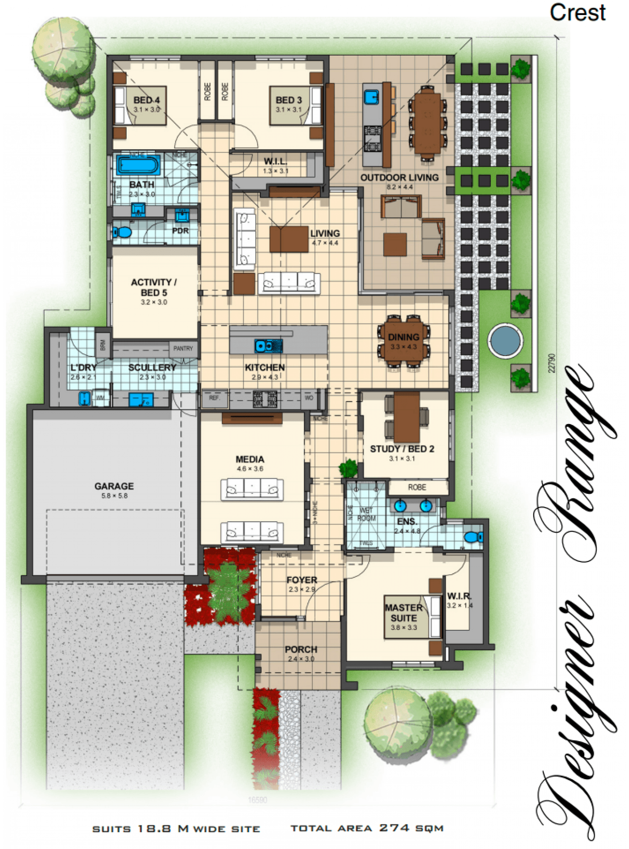
TASK REQUIREMENTS

You are to download the contract documents from the Queensland Building and Construction Commission (QBCC) website at: http://www.qbcc.qld.gov.au/sites/default/files/QBCC_New_Home_Construction_Contract.pdf

Your should:
- Analyse the various types of building and construction contracts you will need and then apply the appropriate application of each type of contract;
- Identify and apply legislative requirements relating to building and construction contracts.
- Identify and apply essential terms and elements of a valid contract;
- Analyse the importance of identifying an intention to create legal relations;
- Identify and analyse rights and liabilities of parties under a contract;
- Identify and apply common building contract terms and procedures;
- Identify and analyse circumstances that bring about a breach of contract;
- Accurately select the contract, appropriate for the type of construction;
- Accurately identify and prepare the range of documents collectively make up a contract;
- Accurately identify and apply requirements associated with an offer and acceptance of a contract;
- Confirm the capacity of the parties to form a binding agreement in the form of a contract; and
- Identify and apply factors associated with the parties' consenting to a contract.

Answer

- How should you handle any customer complaint?

Answer | When dealing with a customer complaint you should take the following steps to resolve the issue,  - Deal with the complaint immediately  - Keep calm and deal with the complainant with clear and concise communication  - Identify the actual problem  - Decide what can be done  - Arrange a second opinion to confirm your view  - Keep records  - Fix the problem

- What does the ‘cooling off’ period refer to when undertaking domestic building work with a total contract price of $20,000 or more?

Answer | A cooling off period means that either party can cancel the building contract as long as it is in writing and:  Before 5 business days after making of the contract;  or  If relevant provisions of the Act have not been met

- What are the consequences for a client not using a QBCC licensed contractor?

Answer | If you were to se a contractor that is unlicensed for any job it is like that you will have recursive action available to you if thing were to wrong on the job are after completion

- What is the Queensland Home Warranty Scheme?

Answer | The Queensland Home Warranty Scheme generally covers loss where a licensed building contractor fails to complete or rectify residential construction work.  The Scheme, administered by the QBCC, applies to work for detached houses, unit buildings of not more than three storeys and duplexes.

- What are the consequences of Cost Plus and Construction Management contracts on Home Warranty Insurance protection?

Answer | QBCC recommends home owners obtain formal legal advice before signing either of these types of contracts which reduce your Home Warranty insurance protection  Cost-plus and construction management contracts will also not entitle you to make a claim if the works are left incomplete.

- At the commencement of a contract valued over $20,000, what must the contractor give to the owner? What timeframes apply?

Answer | You must give the owner  - CONSUMER BUILDING GUIDE: Ensure Owner given Guide before they sign contract (s18 Schedule 1B of QBCC Act)  - COPY OF CONTRACT (incl. plans & specs): Give to Owner within 5 business days of signing (GC 2)  - HOME WARRANTY INSURANCE: Collect premium from Owner and pay to QBCC within 10 business days of entering the contract and before starting work (GC 12  )

- Where must the total contract price be stated?

Answer | The total contract price must be stated in the contract documents

- What are the maximum deposits recommended and how should progress payments be scheduled?

Answer | 1. Deposit 5% (Contract sum)  2. Base Stage 15%  3. Frame stage 20%  4. Enclosed stage 25%  5. Fixing stage 20%  6. Practical completion Balance

- Who has responsibility of building inspections and approvals?

Answer | It is the builder’s responsibility to arrange and give notice to the building certifier for each inspection stage of building work stated in the development approval.

- Identify and describe the term used to describe circumstances such as:
- Where there has been a change to the materials used or
- A change to the scope of the work to be performed under the contract?

Answer | This is called a variation, variations are generally requested by the client of the architect but may be generated by the builder

- How do you reduce the risk of dispute?

Answer | To help reduce disputes you should, clearly identify the parties to the contract clearly identify the scope of work and services, ensure the general conditions clearly define project responsibilities, ensure all aspects of the contract are properly executed and documented,

- What is the process for dispute resolution?

Answer | Dispute resolution refers to the processes by which  disputes are brought to an end. This can occur through:  - negotiated outcome, where the parties concerned sort out things themselves  - mediated outcome, where the parties use the ervices of an independent mediator to help them arrive at their own agreement,  arbitrated or adjudicated outcome, where an independent arbitrator or court determines how the dispute is to be resolved and makes a binding decision or order to this effect.

- When might an extension of time (EOT) apply? How is it approved?

Answer | When a customer asks for a time extension to the contract it requires:  - A variation in writing  - You to issue an ‘extension of time’ form – essentially asking the client to grant you an extension of the contract period to allow for delays caused by the variations  - The specific reasons for an extension of time are set out in the general conditions of the building contract and include reasons such as: inclement weather and delays caused by the owner, such as changes in the scope of works  - You should be familiar with the General contract conditions to you know what time extensions you are entitled to over the contract period

- When is the client/home owner required to pay the final contract payment?

Answer | it is at the point of practical completion that payment of the final progress claim becomes due. Final payment cannot be withheld as it is a contract breach. The builder has a contractual obligation to repair these minor defects, but this may not necessarily happen before handover although most builders would attempt to do so

- What are implied warranties?

Answer | In common law jurisdictions, an implied warranty is a contract law term for certain assurances that are presumed to be made in the sale of products or real property, due to the circumstances of the sale. These assurances are characterized as warranties irrespective of whether the seller has expressly promised them orally or in writing

- Explain the responsibilities of an Owner Builder.

Answer | As an Owner Builder you must,  Follow the conditions of your permit  - You must only carry out work covered in the permit  - Anyone you engage to carry out building work must be a licensed contractor  - You can’t perform any occupational work such as plumbing, draining, gas fitting or pest control unless you have an occupational licence  - You must have the appropriate licence to perform any fire protection work higher than $1,100.  Display an owner builder sign  Before work starts, you must display a sign on your site. Failure to do so could mean a fine.  It must:  - be clearly visible from the street  - show your owner builder permit number  - be made of weatherproof material  - be at least half a square metre in size  - be printed in letters at least 50mm high.  Supervise  You need to maintain quality control and oversee the standards of workmanship on your site.  You are also responsible for carrying out safe work practices. See Workplace Health and Safety (Qld) for more information.  Dealing with problems on site  Defective work  If you get into a dispute with your contractor over defective work we may be able to assist you reach a solution via our dispute resolution service.  You can apply to the Queensland Civil and Administrative Tribunal (QCAT) or seek independent legal advice for some assistance.  Payment and contract issues  If you and your contractor have a disagreement over payment or any of the conditions of the contract, you’ll need to get legal advice.  Be aware that if you don’t pay your subcontractors and suppliers, they can use the Building and Construction Industry Payments Act 2004 (BCIPA) to resolve their payment dispute

Answer

- What is ‘notifiable work’, who is responsible and to whom does it apply?

Answer | Plumbing and drainage work is often complex and requires a high level of skill and experience. In order to maintain high standards within the industry you are required to report any notifiable work.  Notifiable work is common, everyday plumbing and draining work performed by plumbers and drainers on existing buildings. If you are a QBCC plumbing and drainage licensee, you must always report notifiable work to us.  You will need to report on work such as,  - installing, replacing or removing any electric, gas, solar or heat pump hot water heaters  - installing fixtures such as toilets, showers and sinks  - extending, altering, replacing or removing water supply pipes  - extending, altering, replacing or removing waste pipes (depending on the placement of the pipework).

Answer

Answer

- What is the difference between the Prime Cost Item Schedule and the Provisional Sum Schedule in a contract? Give one example to help explain your answer.

Answer | A Prime cost is the combination of a manufactured product's costs of direct materials and direct labour. In other words, prime cost refers to the direct production costs. Indirect manufacturing costs are not part of prime cost.  Generally provisional sum is an amount allocated for a specialized work by a specialized firm, for which the details are not available at the time of tender. The provisional sum amount will be a best guess at the time of tender by the employer or contractor depending upon the type of provisional sum

- What does Section 109 of the Queensland Building and Construction Commission Act 1991 provide to the consumer/client?

Answer | 109 Access to building sites  (1) A building contractor must, at the request of a consumer,  allow the consumer reasonable access to a building site at  which building work is being carried out for the consumer.  (2) A contractual provision that is inconsistent with  subsection (1) is void.

- What are some of the preliminary contracts that a builder could ask a client to sign prior to signing the main contract?

Answer | you may ask a client to sign a document before entering into a contract for construction work.  Such a document is often used to obtain a soil report and foundation data, or to develop design, plans and specifications for the construction or renovation of a home.  Sometimes the document is called a pre-construction contract, preparatory work agreement, quote, order, preliminary contract, estimate, provisional quote, authorised tender acceptance, or contract request

- What are liquidated damages in terms of a signed building contract?

Answer | Contracts generally include a clause making provision for the contractor to pay liquidated damages to the client in the event that the contract is breached. In building contracts, liquidated damages usually relate to the contractor failing to achieve practical completion (i.e. completing the works so they can handover the site to the client) by the completion date set out in the contract. They are often calculated on a daily or weekly rate.  Liquidated damages are not penalties, they are pre-determined damages set at the time that a contract is entered into, based on a calculation of the actual loss the client is likely to incur if the contractor fails to meet the completion date

- What contract documentation would you review to identify any unusual aspects related to materials and installations for a low rise construction project?

Answer | The documentation you may review any unusual aspect related to materials installation would be,  - Manufacturers Installation guides  - National Code of Compliance  - Relevant Australian standards  - Specifications

- Where would you find any possible penalties associated with a build?

Answer | You will find penalties associated with the building in the contract documents you will find information on building penalties is provided by the QBCC

- What is the Australian Standard Contracts - AS2124 and AS4000 series?

Answer | Australian Construction Contracts series AS2124 and AS4000 govern how the parties to the construction contract behave and how the project manager and the contract manager administer the relationship between the parties. There are several popular standard forms of construction contracts that are currently used in Australia.  AS2124 and AS4000 are designed for use on major building and engineering projects where a ‘superintendent’ is engaged to administer the contract who is an independent professional (or a firm of consultants) or an employee of the principal. The contract  price may be calculated as a lump sum or re-measurement (schedule of rates/bill of quantities) or a combination of these.

- How does the Queensland Building and Construction Commission (QBCC) regulate the Queensland building industry?

Answer | The QBCC regulates the Building Industry by  - licensing contractors  - educating contractors about their legal rights and responsibilities  - educating consumers about their rights and obligations  - handling disputes fairly and equitably  - protecting homeowners against loss through the Queensland Home Warranty Scheme  - implementing and enforcing legislative reforms and, where necessary, prosecuting people not complying with the law

- What industry legislation should builders and trade contractors have a good understanding of?

Answer | you must also have a good understanding of the:  - Queensland Building & Construction Commission Act 1991 (QBCC Act)  - Queensland Civil Administrative Tribunal Act (QCAT) – previously the CCT  - Building Act 1975 & Regulations  - Building and Construction Industry Payments Act 2004 (BCIPA)  - Workplace Health & Safety Act 2011 (WHS Act)

- What supporting documents should you be aware of and include in your contracts with the consumer?

Answer | To ensure that your contract complies with the legislation, you must be aware of all Supporting Documents, including information about:  - Termite Management Documentation  - Engineering Specification Confirmation  - Foundation Maintenance Declarations  - Cooling off period

- What are the four (4) essential elements of an agreement for it to be regarded as a contract?
What is the consequence if any essential element is missing?

Answer | An agreement must contain the following four essential elements to be regarded as a contract:  - Offer  - Acceptance  - Intention of legal consequences  - Consideration  If any one of them is missing, the agreement will not be legally binding  .

- When would an offer be considered to have lapsed?

Answer | An offer will be considered as lapsed when,  - when the time for acceptance expires;  - if the offer is withdrawn before it is accepted; or  - after a reasonable time in the circumstances (generally the greater the value of the contract, the longer the life of the offer)

- What is able to be ‘accepted’? What happens to the offer if new terms are suggested?

Answer | If new terms are suggested these terms can either be accepted or rejected. Other wise you can negotiate on the terms but the contract is not deemed as accepted until both parties agree to the new terms

- What does it mean when a contract is supported by valuable consideration?

Answer | In order for a contract to be binding it must be supported by valuable consideration, meaning:  - One party promises to do something in return for a promise from another party  - Consideration is what each party gives to the other as the agreed price for the other’s promises  - Usually the consideration is the payment of money

- Identify the term for each of the definitions listed in the table below.

Answer | Term | Definition
 |  | Any construction or change to a building or facility that increases its external dimensions and cubic contents.
 |  | A procedure for resolving disputes that involves less formality than a court hearing. An arbitrator’s decision is final and cannot be appealed.
 |  | Assists builders, contractors and owners by ensuring that construction projects meet building regulations and codes of practice. Inspections assess design documentation and make on-site inspections during building work.
 |  | Demonstrates that a building, other than a dwelling has been inspected and passed.
 |  | The achievement of performance criteria described in a regulation or other statutory requirement. This is usually demonstrated by a compliance or approval certificate.
 |  | An agreement entered into between two or more parties that involves an exchange or specified goods and/or services for specified financial reimbursement or other considerations.
 |  | One or more buildings which in association constitute a single dwelling being a detached house or one or more attached dwellings.
 |  | A person who carries out domestic building work on his her own land, who is not in the business of building.
 |  | Independent professionals with the same power to issue building permits and occupancy permits as municipal building surveyors.
 |  | A person accepted by the appropriate authority as qualified to design, construct (or install) or supervise the erection of, buildings or services; usually recognised by a certificate of registration.
 |  | That part of an allotment which is covered by buildings, expressed as a percentage of the area of the allotment.
 |  | A minor clause in a contract the remedy for breach of which is damages for any loss. Also, a promise to repair or replace defective goods.

- Explain the terms listed in the table below.

Answer | Term | Definition
 | Minor breach
 | Material breach
 | Fundamental breach

- Who are the parties that need to be consulted with for binding agreements to be confirmed?

Answer | Parties that need to be consulted with for binding agreements to be confirmed include:  Buyer’s advocates: A licensed estate agent who acts for a buyer instead of a seller  Legal practitioners: they hold a current practising certificate and have professional indemnity insurance and can:  - Advise on terms and conditions that need to be included in a contract  - Perform legal work and provide legal advice to their client  Conveyancers: are persons other than legal practitioners who can:  - Undertake property conveying work  - Legal work or give legal advice

- What is consent?

Answer | consent is when one person after deliberation voluntarily agrees to the proposed contract

- When might ‘apparent consent’ be negated?

Answer | There will be no binding contract without the real consent of the parties. Apparent consent may be negated because of mistake, fraud, innocent misrepresentation, duress or undue influence, all of which are defences to the enforcement of the contract

- A construction contract can be terminated for ‘cause’ or for ‘convenience’. Explain these two terms.

Answer | A construction contract can be terminated for Cause or for Convenience.  1. A termination for cause occurs when one party stops work because of a deficiency in performance by the other party. Because the contract is terminated as a result of a party's own poor performance, the law typically provides the terminated party with little recourse in the event of a termination for cause.  2. A termination for convenience, occurs when the owner stops work for reasons other than a deficiency in performance by the contractor. Because a termination for convenience is not the result of poor performance, the law may provide the aggrieved contractor with significant rights against the breaching owner.

- What does repudiation mean?

Answer | Repudiation is a term used to describe the rejection of a proposal or idea.  When a party to a contract is unwilling, or exhibits behaviour which suggests that they are unwilling to perform their contractual obligations, the innocent party has the right to terminate the contract due to repudiation.

- Explain the concept ‘conditions for completion at the cost of the contractor’.

Answer | If the Client notices any omissions from the contract or if any defect are noticed after completion  - The Contractor must make good defects or omissions in the work under this Contract which become apparent within 6 months of the Date of Practical Completion.  - If there are any such defects or omissions, the Owner must give the Contractor written notice to make good such defects or omissions within the 6-month period  and must give the Contractor reasonable access to the Site for that purpose.  Subject to reasonable access being provided, the Contractor must within 28 calendar days of the notice being given rectify any defects notified to the Contractor under Condition 17.2 during usual business hours.

- What does ‘abandonment of contract’ mean?

Answer | Abandonment can have different meanings. One type of abandonment is contract abandonment, where the parties both have conducted themselves in such a way that the original contract is no longer valid. Both parties may mutually agree to do this, or it can become part of a claim.  Another type of abandonment is where a contractor fails to perform the work on a project by either not starting the project in a reasonable amount of time, or not completing the work, or failing to resume work in a reasonable amount of time. Abandonment of a construction project without legal excuse is a cause for disciplinary action under B&P sect.1707

- Throughout the building schedule, progress payments are made when each new stage is ready to commence.
Nominate the recommended stages and percentages for these progress payments on a typical new residential housing building project.

Answer | Progress payments are usually set out as follows  Deposit = 5%  Base Stage = 15%  Frame Stage = 20%  Enclosed Stage = 25%  Fixing Stage = 20%  Completion = 15%

- Which section of the Subcontractors’ Charges Act 1974 (Qld) address vexatious notices of claim?

Answer | Section 22 (1, 1A and 2) address vexatious notices of claim

- Describe the circumstances in which a person is deemed to give notice of a claim of charge without unreasonable grounds.

Answer | A person could be deemed to have claimed on unreasonable grounds if the person knows, or ought reasonably to know, that the amount of the  claim exceeds, to an unreasonable extent in the circumstances  of the claim,

- Who should you consult if you are considering ousting a contractor from a building site?

Answer | If you are considering this action you should consult your contract or lawyer

- What document should you refer to if you are considering ousting a contractor from a building site?

Answer | You should refer to the original contract documents to ensure you have a valid reason for ousting the contractor

- Contract Cost Adjustment Provisions address risk by providing mechanisms for adjusting contract payment to reflect changes in costs.
What can cost adjustment apply to?

Answer | Cost adjustment may be applied to the following:  - Labour and materials  - Currency exchange rates for goods purchased in foreign currency  - Other costs, including duties and taxes or shipping and transport  t

- What document will outline the time extensions you are entitled to over the contract period?

Answer | The specific reasons for an extension of time are set out in the general conditions of the building contract and include reasons such as: inclement weather and delays caused by the owner, such as changes in the scope of works

