TO: ALL STAFF  FROM: ERIN BAILEY  DATE: 25 FEBRUARY 2017  SUBJECT: CHANGE OF EVACUATION SITE | EXTREME TRAVEL PTY LTD.  ABN: 55 444 777 000  PO Box 555  IPSWICH Q 4304  Phone: 07 3432 0000  Fax: 07 3432 0001  enquiry@extremetravel.com.au  www.extremetravel.com.au
  MEMO

Team
As all you may be aware the evacuation site for Extreme Travel Australia has recently changed.
It is now located on the west side of the building, across the street, in the middle of the children’s playground.
The diagram below identifies the new site.
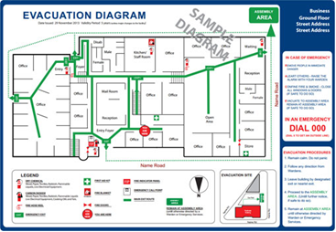

Please take the time to properly look over the new map and identify the exit routes that are closest to you. If you have any further questions please don’t hesitate to contact either myself or management.

eb

