CPCCBC4006B - Prctical Activity 1

Construction Specification and requirements
Project Address: Lot 8 Rees Court, Palm Beach, QLD

Slab and Footing requirements:
Strip footing system to be installed as per below.
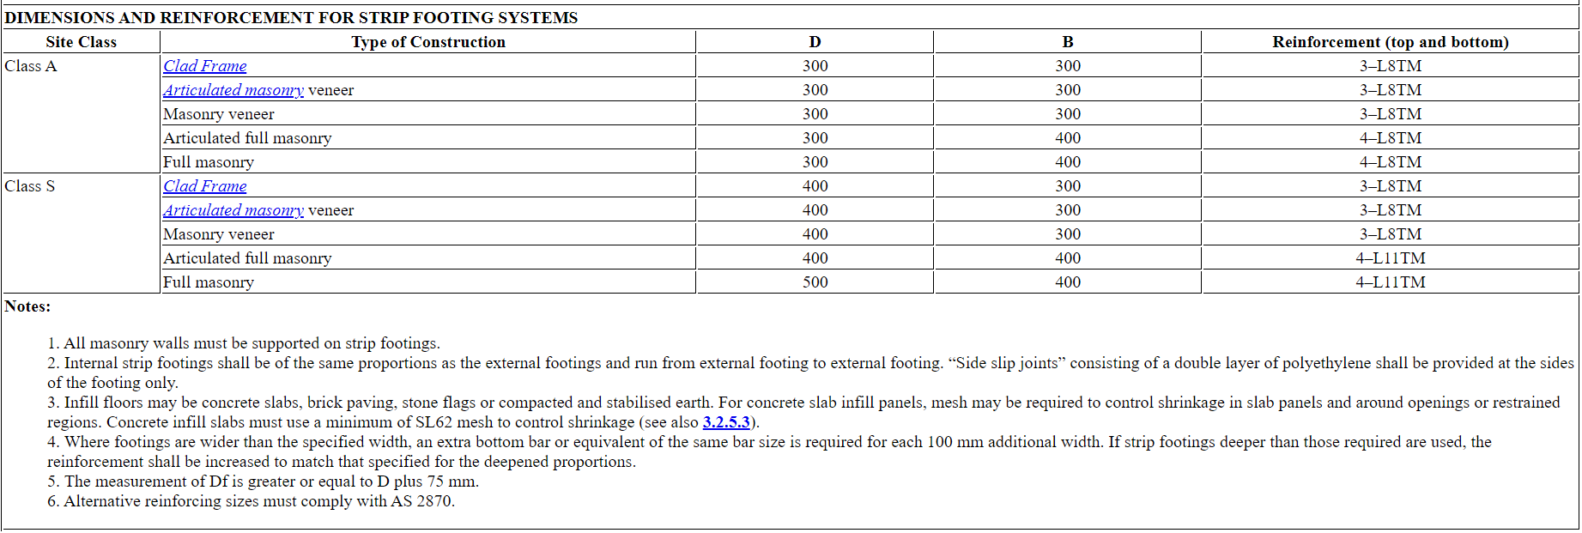

https://ncc.abcb.gov.au/ncc-online/NCC/2016-A1/NCC-2016-Volume-Two/Part-32-Footings-And-Slabs/Part-325-Footing-And-Slab-Construction/Part-325-Footing-And-Slab-Construction?inlineLink=%7BE60990D9-73E8-43C0-95A6-9D324C316B23%7D

Framing Material:
Timber framing as per BCA and Australian Standards – Traditional construction
BCA Code Vol 2 – Part 3.4.3
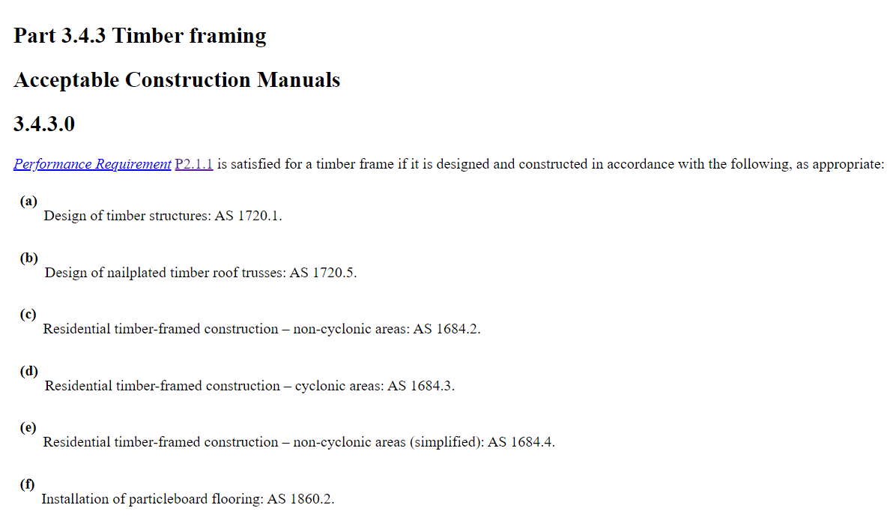

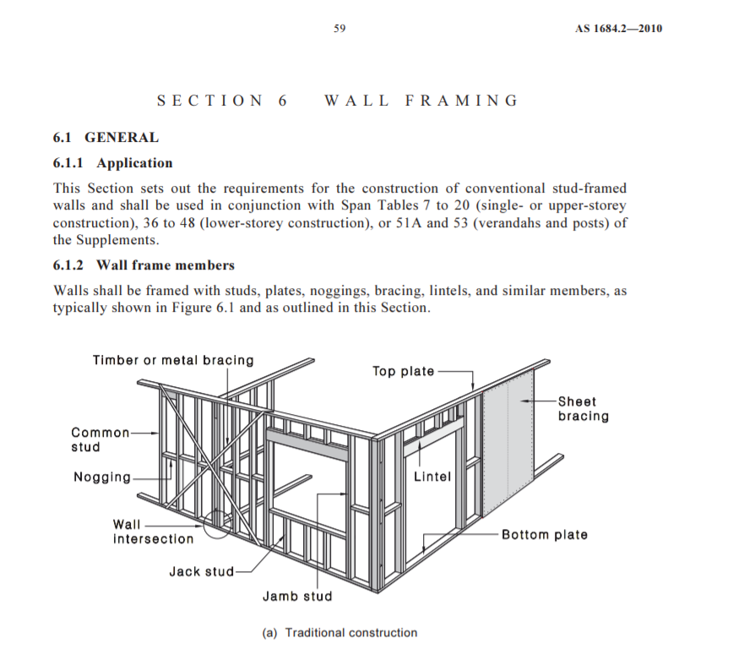
AS 1684.2-2010 Residential timber-framed construction - Non-cyclonic areas – Ref page 59
Stud dimensions: As per AS 1684.2—2010 – Studs – Ref page 60


