The test was performed using measurement gauge PosiTectore 6000 and readings are measured in microns.

Date of Tests Performed:

The Galvanizing thickness measurement tests were conducted on 23/04/2024 starting at 8:30 am.

Purpose of Test:

- To confirm the suitability of HDG components for corrosion category C3 post flooding events.
- Assess the adequacy of galvanized coatings on fire-rated and no fire-rated ladders, bends and tees ensuring compliance with industry standards.

Test Locations:

- All levels

Test Results Measurements:

FLV 450mm | 90 | 138 | 88 | 110 | 70 | Avg.= 99.2
FV 600mm | 70 | 84 | 130 | 86 | 96 | Avg.= 93.2
FLV 600mm | 94 | 113 | 78 | 64 | 88 | Avg.= 87.4
Comms 300mm | 126 | 92 | 58 | 104 | 72 | Avg.= 90.4
Cable ladder outside bend FR 450mm | 44 | 50 | 38 | 60 | 86 | Avg.= 55.6
Cable ladder outside bend 300mm | 58 | 68 | 70 | 48 | 78 | Avg.= 64.4

Conclusion:

Galvanising thickness test reading for fire rated and non-fire rated cable ladders are found to be well above 50 microns while in case of cable ladder bends, the average is found to be close to 50 microns.
50 microns is minimum acceptable HDG component suitability.

Report:
Cable Ladder Inspection:

Cable ladder inspection was conducted on March 23, 2024 at all levels. The purpose of inspection was to assess the condition of the cable ladder for any signs of corrosion or damage.
Environmental Considerations:

- C2 Environment for cable ladder for transfer pit and general areas (shaded yellow) to be installed. Zn corrosion is 0.4 mic/yr.
- Sump room at B7 (shaded red) is C3 micro-environment, Zn corrosion is 1.4 mic/yr.

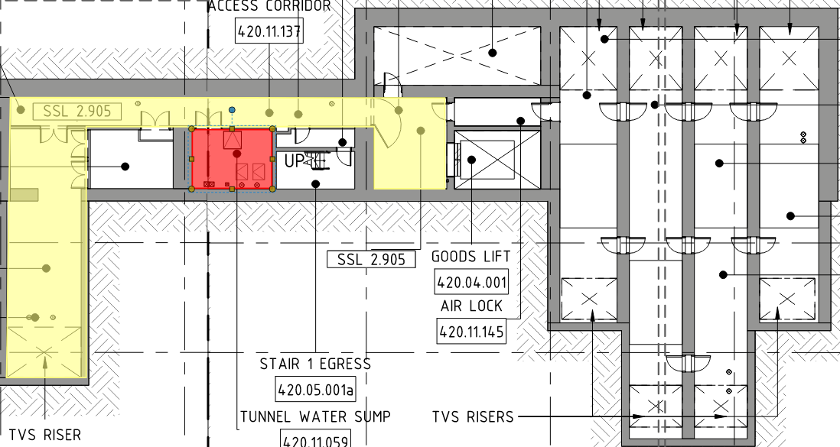

Conclusion:

To conclude, cable ladder and outside, inside bends did not show any signs of damage/corrosion and galavanising thickness readings support the claim.

Attached below are the results of cable ladder – Galvanising Thickness test that were done in November in at B5 BoH North, B5 BoH South, B4 cable basement. On comparing, it can be seen that B7 cable ladder has high galvanised reading despite being submerged for a period of time.

