CPCCBC4029B
APPLY CONSTRUCTION INFORMATION TO THE SALES PROCESS

Practical Task 1 (2X)
Description of task:
On two (2) occasions, a suitable observer is to verify the participant’s ability to apply construction information during the sales process in order to develop the customer’s knowledge of construction processes and the effects on the contract and building timelines.

The participant is to gather evidence of how they have completed each component of the Practical Task, which is to be submitted with this Practical Assessment sheet. Evidence to be submitted may include:
- RFI and relevant correspondence with client
- A variation, price and acceptance by the client

The observer is to provide detailed comments on the tasks completed by the participant. The assessor is to verify the observer’s comments in the Assessor Comments section, and provide the Practical Assessment outcome on the front cover of this document.
Resources required:
Two (2) sales contracts.

The sales process in Premier Fire operates on a maintenance contract basis. The sale of maintenance is governed by the Australian Standards which legally we have to adhere to. Maintenance contracts are won dependant on the type and amount of assets in a certain property at a fixed price. Rectification or defect works is then priced depending on the type and amount of defected assets which legally have to be rectified. Each testing period the technician will go out to the site and test the assets using an online Portal. Each asset that doesn’t pass the standard test is defected and quoted. The quotes are then sent to the client for approval and the works are scheduled in. Below are two examples of quotes I have raised in lieu of the recent flood activity in QLD.

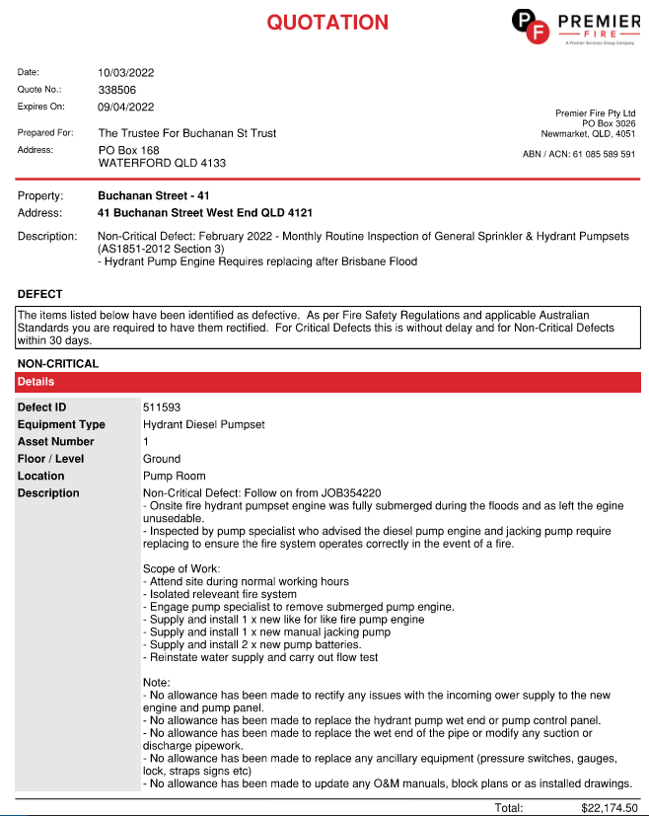

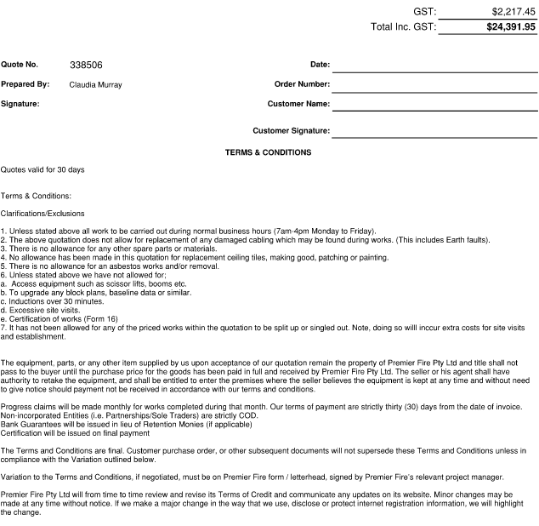

Below is a snippet of the approval of the quote from the client and direction to go ahead with the job.

From: Min Cao
Sent: Friday, 11 March 2022 12:38 PM
To: Claudia Murray <claudia.murray@premfire.com.au>; Subject: RE: RFI: JOB354220 - Buchanan Street - 41 - Premier Fire Pty Ltd Quotation (ID: 338506)

Hi Claudia

Approved quote is attached. please arrange the job urgently.

Regards
Min

The below is an example of a quote for a new pump damaged in the flooding and the recommendation of getting the second pump upgraded at the same time. This is demonstrating upselling in a bid to create more revenue for the company.

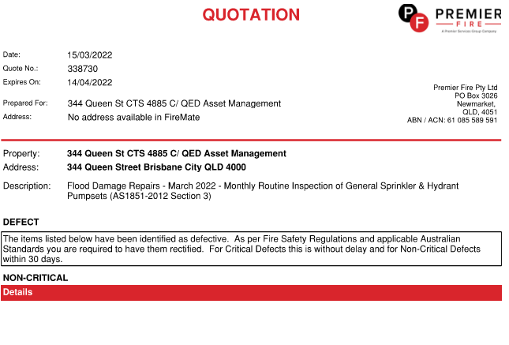

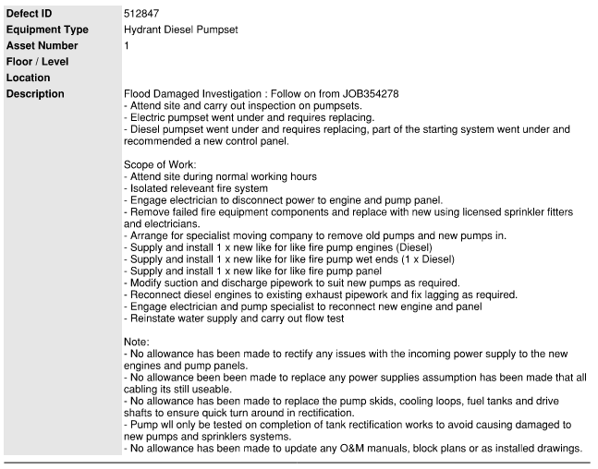
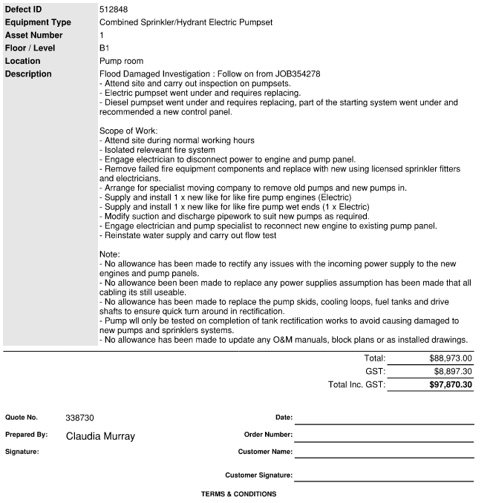

The below is a sippet from the response with the approval of Pump 1. Unfortunately this time the client was not willing to go ahead with the second pump replacement.

Hi Claudia,

Yes please proceed with the pump replacements at 344 Queen for $88,973.00 excluding GST. Please hold off on the second pump panel upgrade for the mean time.

The old pumps can be left in the basement store room for the insurers.

Kind Regards
Jordan Sullivan

