Case study C – activity 1D. Kira Wesley
Polka Dot 707707

Miss Smith
12 Parrot Parade, Tree Lane, The Forest
19th March 2018
Dear Miss Smith
It was great to speak to you earlier at Polka Dot. I would like to take this opportunity to welcome you on behalf of everyone at Polka Dot insurance. Here at Polka Dot, we know how important it is to have a friendly, helpful voice at the end of the phone.
To show you how much we value your custom, we are giving you $100 when you refer a friend.
See you soon,
Claire Bird

Case study F

BUSINESS MEETING MINUTES
Date:
Meeting Name:
Meeting Purpose:

1. ATTENDANCE AT MEETING
Name | Position | Note

[Name]

[Name]

[Name]

[Name]

2. MEETING NOTES, DECISIONS, ISSUES

3. ACTION POINTS
Action | Assigned to | Deadline

1.

2.

3.

Case Study G

Staff Name | Department | Start Date
Sharon Wise
Daniel Parker
Graham Pat
Tyler Rust

Case Study H;
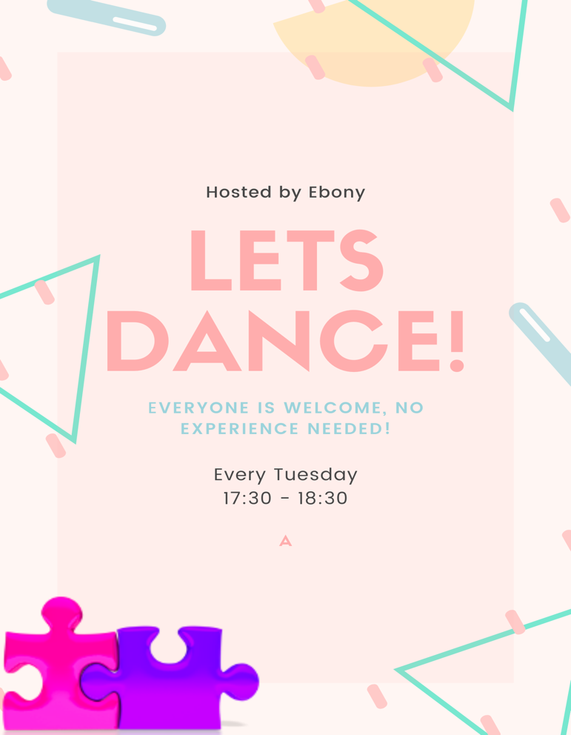

Activity 3A;

Good afternnon everyone, tomorrow we are having a meeting to talk about some things. See you all there.
Thanks, Kira

Email translated to simplified Chinese
大家下午好，明天我们要开会谈谈一些事情。再见
谢谢，基
Activity 3B – case study I;
Talking Heads
21/5/2020
351 Company Address, Sydney, Australia
talkingheads@gmail.com
0449 684 261

Dear all Staff,

There have been five accidents in the last year, resulting from use of faulty soldering equipment. These accidents have resulted in minor injuries to three staff members and one serious injury. As a result, all soldering tasks have been suspended. New soldering equipment has been ordered. Extensive training on how to safely use the equipment will be given before soldering tasks resume. The management would like to thank staff for their patience and apologise for the delay on projects.

Your sincerely, Talking Heading Organisation.

Activity 3E;
Talking Heads
21/5/2020
351 Company Address, Sydney, Australia
talkingheads@gmail.com
0449 684 261

Dear all Staff,

On the 18th of December 2018 at 15:00 there will be a group tutorial that will describe how to use the new soldering equipment safely. It is recommended that all staff attend. The tutorial will be followed by two weeks of close supervision, in order to ensure soldering equipment is being used safely.

Hope to see all of you there.

Your sincerely, Talking Heading Organisation.

Skills Activity

TOTEM POLE PRODUCTIONS

Totem Pole Productions has recently created a new set of policies and procedures which govern when and where employees have lunch. A problem has emerged due to extras wanting to talk and have lunch with the A-list film stars, who have now communicated their wish to be undisturbed during lunch hours.

Due to these circumstances, the following policies have been introduced:
- Extras must eat their lunch in the main restaurant between 12:00 and 14:00
- The Lobster Café is exclusively for actors, directors, and producers
- Extras must not disturb actors when they are having lunch
- Selfies with actors are not permitted on set
- Extras must not pursue autographs, unless the actor has given their permission at the beginning of filming.

If extras do not comply break these rules, they will not be used again.

Regards,
Totem Pole Productions


110 NORTH ST, NORVILLE, NSW
totempoleproductions@gmail.com
0459 776 353

Performance activity

State Cashmere Men's 100% Pure Cashmere Long Sleeve Pullover Crew Neck Sweater
A classic cut & wardrobe staple perfect teamed with denim & your favourite pair of boots. This 100% Pure Sustainable Mongolian Cashmere sweater is densely knitted with the finest and long staple cashmere which provides best anti-pilling performance. It is a super versatile, light weight and relaxed fit addition to your wardrobe!

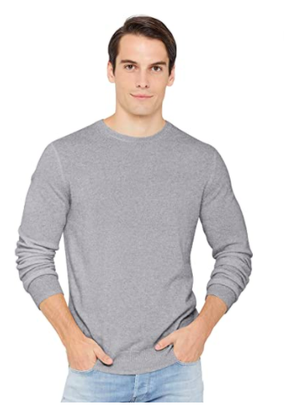
Model Measurements: height: 6'2, wearing size Large.

Label size | UK | Chest  (in inches) | Waist  (in inches) | Sleeve length  (in inches) | Shoulder width  (in inches)
S | S | 18.50 | - | 24.38 | 14.63
M | M | 19.63 | - | 25.25 | 15.50
L | L | 20.88 | - | 25.75 | 16.13
XL | XL | 22.50 | - | 26.38 | 16.88
XXL | XXL | 24.00 | - | 26.75 | 17.75

Brave Soul Men's Tame Casual Shirt
The brave soul flannel is a long sleeve traditional button up featuring a double chest pocket. Made form 100% brushed cotton it is warm, durable and comfy.
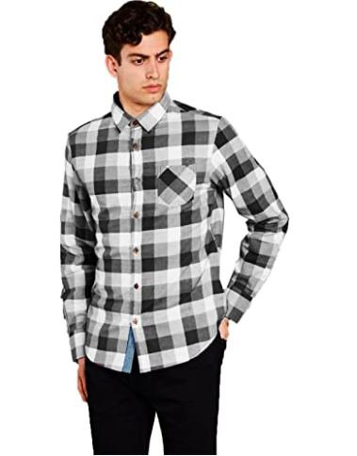
Label size | UK | Chest  (in inches) | Waist  (in inches)
S | S | 36 | -
M | M | 38 | -
L | L | 40 - 42 | -
XL | XL | 42 - 44

OCHENTA Men’s Casual Slim-Tapered Flat-Front Trousers Khaki
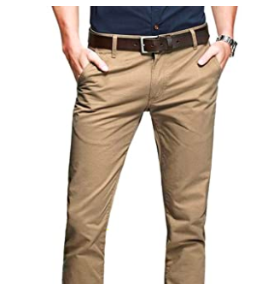
These 100% slim fit chino trousers and breathable and provide a neat comfy fit for all occasions.
Label size | UK | Germany | France | Spain | Italy | Waist  (in inches)
XS | 36 | 46 | 46 | 46 | 46 | 28 - 29
S | 38 | 48 | 48 | 48 | 48 | 30 - 31
M | 40 | 50 | 50 | 50 | 50 | 32 - 34
L | 42 | 52 | 52 | 52 | 52 | 35 - 37
XL | 44 - 46 | 54 - 56 | 54 - 56 | 54 - 56 | 54 - 56 | 38 - 41
XXL | 48 - 50 | 58 - 60 | 58 - 60 | 58 - 60 | 58 - 60 | 42 -45
XXXL | 52 - 54 | 62 - 64 | 62 - 64 | 62 - 64 | 62 - 64 | 46 - 49

