RIICOM301E
Communicate information

ASSESSMENT SUMMARY

The assessment activities for RIICOM301E Communicate information cover all aspects of the unit of competency. For Apprentices/Trainees, this includes supervisor completion of the Apprentice/Trainee Record (ATR).

Participants must read all the information given before starting any assessment task. The assessment tasks are intended to be fair, flexible, valid and reliable. If a Participant has any questions or requires alternative arrangements to be made such requests should be directed to their Trainer/Assessor, who should note such arrangements in the ‘Assessor Comments’ on the affected assessment. If a Participant feels they are not yet ready to be assessed, they should discuss their options with their Trainer/Assessor.

To satisfactorily complete the assessment, the Participant is required to answer all questions correctly and demonstrate their skills to industry standards. If a Participant does not answer all questions or perform all tasks, they will be deemed ‘Not Satisfactory’ for the task and ‘Not Yet Competent’ for the unit of competency.

The Trainer/Assessor can provide the Participant with additional information on interpreting the assessment outcomes and guide the Participant’s options. If a Participant is still deemed ‘Not Satisfactory’ they will have the opportunity to undertake a supplementary assessment or appeal the result as per the process in the Student Handbook.

By signing below, the Participant acknowledges:
- They understand the assessment instructions and requirements, and consent to being assessed.
- The work submitted is to be their own work – with the work of/with others needing to be clearly acknowledged and documented.
- They consent to any photo/video recording of their work that occurs during assessment.

Participant name | Sebastian Wade
Participant signature | 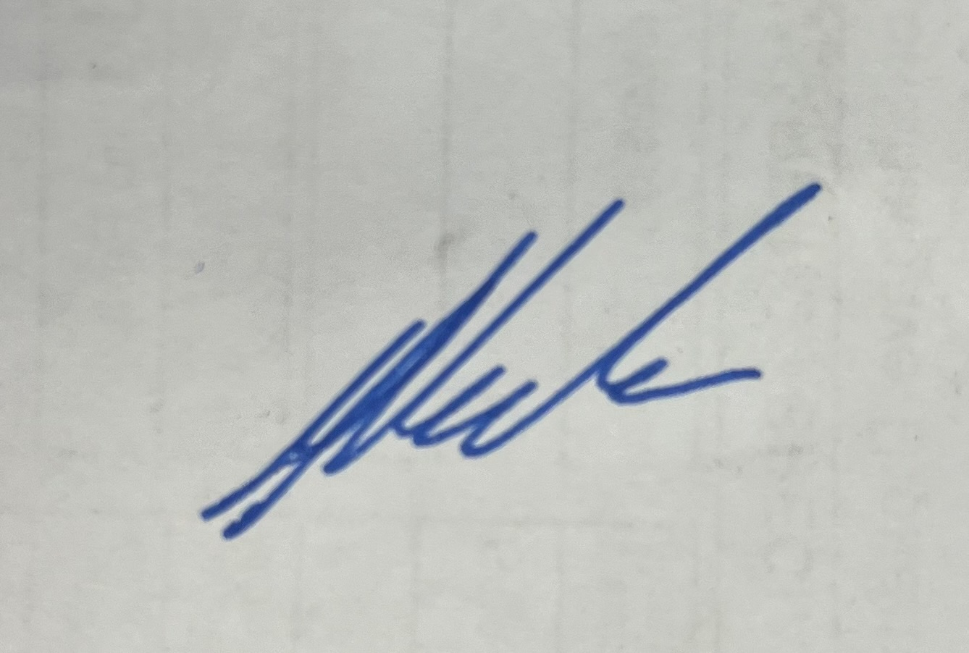

Pre-requisite unit(s) to be achieved and authenticated prior to undertaking assessment
Not applicable

Task | Date completed | Assessment Results
Theory Exam | Select Date. | Satisfactory | Not Satisfactory
Practical Assessment | Select Date. | Satisfactory | Not Satisfactory
Outcome for RIICOM301E | Select Date. | Competent | Not Yet Competent

Evidence requirements checklist (ticked by assessor and evidence supplied to RTO)
Theory Exam | Practical Assessment  Emails to supervisor (2X)

Assessor Name
Assessor Signature | 

RIICOM301E
Communicate information

THEORY EXAM

Participant name | Sebastian Wade

FOR THE PARTICIPANT
Instructions
- You will complete written questions as outlined on the following pages. You must attempt all questions and provide enough detail in your responses to demonstrate your knowledge.
- It is anticipated that you should complete this assessment within two (2) hours, but additional time may be allowed upon negotiation with the Assessor.
- You must complete all questions unassisted by the Assessor or other personnel but may refer to reference material as needed. All questions must be answered correctly for a ‘Satisfactory’ assessment outcome to be awarded.
  - An oral examination may be allowed under certain circumstances, whereby your answers will be documented by another party.
  - Any written questions that are incomplete, or not answered satisfactorily will need to be completed again after further training support.
    - If you answer a question incorrectly but modify your response, put your initials next to the written change (or the Assessor must initial a verbal change).
Resources required
Pen

FOR THE ASSESSOR
Instructions
- Where oral examination has occurred, ensure that this is acknowledged in writing (e.g. FT001 and Assessor Comments)
- All questions must be satisfactorily demonstrated by the Participant for a Satisfactory determination (indicated by an Assessor tick to the right of the question).
- Assessors are to complete marking in pen of a different colour to the Participant.
- If the Participant verbally modifies their response, write in the modified response verbatim and put your initials next to the written change.

ASSESSOR COMMENTS
As necessary, outline:
- Details on reattempts, alternative arrangements or reasonable adjustments made.
- Where a Participant is deemed ‘Not Satisfactory’, provide recommendations for future training.

- Which of the following should be considered when planning and preparing to communicate information? Tick all that apply.

Answer | Choice | Possible Answers
 |  | Your audience
 |  | Potential barriers to communicating
 |  | Means of communication available to share information
 |  | What needs to be communicated (i.e. context)
 |  | Achieving effective listening and audience participation

- What is the importance of knowing and understanding site policies and procedures with regards to communication? Tick your response.

Answer | Choice | Possible Answers
 |  | Because site policies and procedures are found in the legislation
 |  | Because there will be random tests of your knowledge
 |  | Because you will be required to induct others
 |  | Every site is different and has different rules and procedures

- Identify one (1) example of when verbal communication is an appropriate method to communicate a message.

Answer | For people working on site, toolbox talks everyday will discuss the project update, safety issues and all the important information. Verbal communication plays an important role in getting the feedback and direct communication in toolbox meetings

- Which of the following would be best expressed verbally with all workers present? Tick your response.

Answer | Choice | Possible Answers
 |  | Details of an employment contract
 |  | Personal information
 |  | Site rules

- Match the following message types with the most appropriate communication type by writing the appropriate letter next to each number in the centre column.

Answer | Message type |  |  | Communication method
 | 1 | Short message within visual range | 1 - b | A | Two way radio or telephone
 | 2 | Planning with multiple team members | 2 - c | B | Hand signals
 | 3 | Information required, no visual range | 3 - a | C | Team meeting
 | 4 | Time needed to consider detailed message | 4 - d | D | Email with attachments

- Which of the following should occur when preparing to communicate information? Tick all that apply.

Answer | Choice | Possible Answers
 |  | Confirm the purpose of the communication in relation to the work
 |  | Identify who you are
 |  | Organise information in a logical and structured manner

- True or False (Tick your response): To avoid overloading the audience with information your presentation should come back to your main points to help prioritise, focus and sequence the information.

Answer |  | True
 |  | False

- Identify two (2) communication aids or media resource you might use to assist with delivering a presentation. For each resource, identify the benefit it offers to your presentation.

Answer | Aid / Resource | Benefit
 | Graphic Presentation like Powerpoint Slides | Helps people to understand more and also avoid long speakings
 | Handouts | Take away of information can also referred later

- True or False (Tick your response): Before presenting, you should check the venue to determine whether equipment is available and functioning, or whether you need to bring your own equipment.

Answer |  | True
 |  | False

- Identify two (2) tips for good verbal communication. Tick all that apply.

Answer | Choice | Possible Answers
 |  | Provide instruction once only
 |  | Use technical language at all times
 |  | Use short, simple sentences and words
 |  | Speak clearly and not too fast
 |  | Consider the target audience

- When speaking to someone, how do you find out that they have understood you correctly? Tick the two (2) best ways.

Answer | Choice | Possible Answers
 |  | Observe that they will remain silent as you speak
 |  | Get that person to acknowledge and repeat the statement back to you
 |  | Ask them questions

- Which of the following questions will produce the most detailed response? Tick your response.

Answer | Choice | Possible Answers
 |  | Did you understand a lot of what was said?
 |  | Explain to me what you understood.
 |  | Nod if you understood.
 |  | Did you understand?

- A new worker on site is having difficulty understanding verbal and non-verbal instructions. Why might this be the case? Tick all that apply.

Answer | Choice | Possible Answers
 |  | They have a different skill level
 |  | They have a different cultural background
 |  | They have problems understanding English
 |  | Varying physical and/or mental ability

- Identify two (2) tips for good listening. Tick all that apply.

Answer | Choice | Possible Answers
 |  | Provide feedback to show you have interpreted the information correctly when the talker has finished.
 |  | Interrupt as you have questions. Do not wait until the end.
 |  | Take notes if the information is complex or exact details are required.
 |  | Just listen. Don’t take note of non-verbal cues.

- Match the document type and purpose by writing the appropriate letter next to each number in the centre column.

Answer | Terms |  |  | Definitions
 |  | Logbook | 1 - b |  | A summary of what has occurred during the work period
 |  | Report form | 2 - a |  | Documenting machinery use and issues, including maintenance undertaken or required
 |  | Shift report | 3 - c |  | Can be used to identify hazards and incidents
 |  | SWMS | 4 - d |  | Provides methods for undertaking high risk work safely

- What is the purpose of a shift report?

Answer | The summary report of every shift to understand the completed tasks in the work shift

- What is the purpose of using dot points in written communications, such as shift reports or emails?

Answer | Dot points are used for good understanding of the information and also communicate your taught in a clear way.

- Fill in the blanks: Sub-headings are often seen in informational text and used to _________________ the reader’s _________________ to keep them reading down the page _________________ each sub-heading.
after
Capture
attention

Choose from | | attention | highlight | capture | following | opinion | fact |

- True or False (Tick your response): Site procedures may require you to use specified communication templates when preparing documentation (e.g. letterhead).

Answer |  | True
 |  | False

- True or False (Tick your response): It is good practice to set aside time during a presentation to accept and respond to audience questions.

Answer |  | True
 |  | False

- Describe how you might follow up on questions, if unable to address them during a meeting.

Answer | Mostly through email by sending an appropriate answer, or should organise a follow up meeting

- Identify two (2) methods that you might use to establish if your presentation goals have been met, to aid with future presentations.

Answer | 1.By conducting surveys for opinions  2. Implementation of recommendations.

- Which of the following are potential sources of workplace conflict?
Tick all that apply.

Answer | Choice | Possible Answers
 |  | Differences in personality
 |  | Poor communication
 |  | Resistance to change
 |  | Unclear job expectations

- Order the following steps from 1 to 5 to explain how to best address conflict.

Answer | Step Number | Steps
 | 1 | Establish each conflicting party’s view / priority
 | 3 | Negotiate any applicable timelines according to agreed priorities
 | 4 | Ensure that both parties understand and agree with the negotiated outcome
 | 5 | Monitor the situation to avoid further issues
 | 2 | Discuss and agree on an approach which will meet most of both parties’ needs

- True or False (Tick your response): During conflict resolution, the most promising way to gain commitment to a final agreement and ensure compliance is mutual satisfaction of interests.

Answer |  | True
 |  | False

- Which of the following should occur after conflict resolution negotiations? Tick all that apply.

Answer | Choice | Possible Answers
 |  | Seeking legal approval of outcomes
 |  | Monitoring performance of agreed actions
 |  | Re-negotiation if unforeseen events occur

- Which of the following points may need to be documented following conflict resolution negotiations? Tick all that apply.

Answer | Choice | Possible Answers
 |  | Circumstances under which the agreement can be modified/changed
 |  | Deadlines
 |  | Length of the agreement
 |  | What needs to occur

RIICOM301E
Communicate information

PRACTICAL ASSESSMENT

Participant name | Sebastian Wade

FOR THE PARTICIPANT
Instructions
- The tasks outlined on the following pages will require performance of normal workplace activities, as a result of a structured activity set by an Observer in the workplace or a simulated activity set by your Assessor/Observer.
- The timeframe for these tasks will be established by your Assessor/Observer, in consideration of location conditions and industry requirements.
- You must complete all tasks unassisted by the Assessor or other personnel, unless the steps note this assistance.
- You must attempt all tasks (and itemised steps) for a ‘Satisfactory’ assessment outcome to be awarded.
  - For any observation conducted that is incomplete, or without satisfactory performance, the observation will need to be completed again after further training support.

FOR THE ASSESSOR/OBSERVER
Instructions
- The following observation record should be used to judge and record your observations of the Participant as they complete the task(s) set. You must record your observations of the Participant’s performance.
  - For each occasion, indicate the task performed and whether it was a simulation or workplace-based task.
    - Any simulated assessment must ensure the Participant still performs under workplace conditions which reflect industry standards.
  - In the comments, provide clear detail regarding the task that the Participant was required to do (e.g. PPE used, materials handled, attachments connected, plant types).
- All steps must be satisfactorily demonstrated by the Participant for a ‘Satisfactory’ determination (indicated by an Assessor tick to the right of each itemised step, or an Observer tick to the right of each itemised step, and confirmation by an Assessor in the Assessor Comments).
  - Where you have determined that one or more task steps have not been satisfactorily demonstrated, provide the Participant with additional support and outline details of such assistance in the Assessor/Observer Comments. Allow the Participant two (2) further opportunities to demonstrate the task again to allow an opportunity for a ‘Satisfactory’ assessment outcome to be achieved.
  - If after three (3) attempts the Assessor determines that the Participant cannot demonstrate the required steps, a ‘Not Satisfactory’ outcome is to be determined.

TASK OUTCOME
Task | Date | Task Type (Tick) | Location | Task outcome (Tick)
 |  |  |  | Satisfactory | Not Satisfactory
Task 1 | Select Date. | Workplace  Simulation
Task 2 | Select Date. | Workplace  Simulation

ASSESSOR COMMENTS
As necessary, outline:
- Details on reattempts, alternative arrangements or reasonable adjustments made.
- Where a Participant is deemed ‘Not Satisfactory’, provide recommendations for future training.

ASSESSOR COMMENTS: PRACTICAL TASK 1
Individual student (as named on cover page)
Multiple students [ All from Attendance Report, Specific students involved – identify students]
Task | Provide detail
1.B. | Identify communication methods used, and supportive aids:
1.E. | Comments on verbal communication of participant during meeting:
1.F. | Comments on visual communication of participant during meeting:
1.G. | Identify audience feedback provided and how it was responded to:
1.I. | Outcomes of evaluation between participant and supervisor:

ASSESSOR COMMENTS: PRACTICAL TASK 2
Individual student (as named on cover page)
Multiple students [ All from Attendance Report, Specific students involved – identify students]
Task | Provide detail
2.B. | Identify communication methods used, and supportive aids:
2.E. | Comments on verbal communication of participant during meeting:
2.I. | Identify audience feedback provided and how it was responded to:
2.J. | Outcomes of evaluation between participant and supervisor:

RIICOM301E
Communicate information

Practical Task 1
Description of task:
The participant must prepare and deliver a toolbox talk presentation, providing instruction on how to use a two-way radio during work tasks. The presentation requires the participant to:
- Communicate information verbally, including asking audience members questions to check their understanding
- Communicate information visually (e.g. notes on a whiteboard)
- Demonstrate two-way radio use, including dealing with issues

To ensure all workers are provided with the presentation notes, including those not in attendance at the meeting, the participant must email the Assessor a copy of their visual notes (e.g. photograph of whiteboard or PowerPoint presentation), using an appropriate subject line and providing a short description of the email attachment. The email must include the participant’s name, unit code and unit name.

Detail of tasks undertaken must be recorded in the Assessor’s Comments (on the back of the Practical Assessment cover page).
Resources required:
- Two-way radio
- Access to email (e.g. mobile phone)

When completing the task, did the Participant: | Tick if satisfactorily completed.  Provide comments if left unticked.
- Refer to relevant documentation, including:
- Workplace policies and procedures
- Two-way radio manufacturer information
- Prepare appropriate communication methods and media resources for presentation (e.g. whiteboard).
- Commence presentation with an explanation of presentation purpose.
- Logically sequence and demonstrate process on how to use a two-way radio, including addressing common issues.
- Appropriately communicate verbally during presentation – clearly speaking and using simple English.
- Appropriately communicate visually during presentation – using supportive aids (e.g. whiteboard).
- Use targeted questioning techniques to check the understanding of audience members.
- Provide appropriate responses to the reactions and feedback from the audience.
- Evaluate the outcomes of the presentation with supervisor.
- Email presentation notes to supervisor to ensure all workers receive notes.

RIICOM301E
Communicate information

Practical Task 2
Description of task:
The participant is required to conduct on a toolbox talk presentation on how to effectively handle and resolve workplace conflicts, according to workplace policies and procedures. Two (2) scenarios must be addressed:
- Face-to-face conflict
- Conflict arising during a telephone call

The scenarios responded to can be up to the participant, but the situations must be realistic (e.g. contractor conflict; conflict over supplies). Conflict resolution strategies must address:
- Addressing communication barriers
- Identifying common objectives between the parties that can be mutually supported
- Agreeing on an approach to meet the majority of objectives for conflicting parties
- Providing advice on implementation of appropriate resolution methods
- Identifying how resolution methods can be monitored for effectiveness

The presentation requires the participant to:
- Communicate information verbally, including asking audience members questions to check their understanding
- Communicate information visually, demonstrating how to take notes in a shift report on how the conflict was handled and resolved, plus recommendations to avoid future incidents
- Demonstrate emailing of shift report notes to supervisor (i.e. Assessor), with appropriate subject line and short message (including unit code and name)

Tasks are at the Assessor’s Discretion, but detail of tasks undertaken must be recorded in the Assessor’s Comments (on the back of the Practical Assessment cover page).
Resources required:
- Pen and paper
- Access to email (e.g. mobile phone)

When completing the task, did the Participant: | Tick if satisfactorily completed.  Provide comments if left unticked.
- Refer to relevant documentation, including workplace policies and procedures.
- Prepare communication methods and media resources for presentation (e.g. shift report, pen).
- Commence presentation with an explanation of presentation purpose.
- Logically address face-to-face conflict and telephone-based conflict:
- Addressing communication barriers
- Identifying common objectives between the parties that can be mutually supported
- Agreeing on an approach to meet the majority of objectives for conflicting parties
- Providing advice on implementation of appropriate resolution methods
- Identifying how resolution methods can be monitored for effectiveness.
- Appropriately communicate verbally during presentation – clearly speaking and using simple English.
- Effectively demonstrate how to take notes in a shift report on how conflict was handled and resolved, plus recommendations to avoid future events – using simple language and dot points.
- Demonstrate effectively emailing of shift notes to supervisor.
- Use targeted questioning techniques to check the understanding of audience members.
- Provide appropriate responses to the reactions and feedback from the audience.
- Evaluate the outcomes of the presentation with supervisor.

