Workplace Assessment 10 – Assessor’s Checklist
(This form is for the assessor’s use only)

Purpose
This Assessor’s Checklist lists the specific criteria that the candidate’s submission for Workplace Assessment Task 10 must satisfactorily meet.
This form is to be completed by the candidate’s assessor to document their assessment of the candidate’s submission in Workplace Assessment Task 10.

Task Overview
For this task, the candidate is required to review the policies and procedures in their organisation to ensure there are measures in place to prevent breach of contract.
In this task, the candidate will be assessed in their:
- Practical knowledge of minimising liquidated damages and penalties.
- Practical skills in reviewing policies and procedures to ensure there are measures in place to minimise liquidated damages and penalties.

Instructions to the Assessor

During the assessment
- Review the candidate’s submission.
- For each criterion listed in this checklist:
  - Tick YES if you confirm the candidate’s submission satisfactorily meets the criterion.
  - Tick NO if you confirm the candidate’s submission does not satisfactorily meets the criterion.
- Write specific comments on the candidate’s performance in each criterion. Your feedback/insights will be helpful in addressing any area/s for improvement.

After the assessment
- Complete all parts of the Assessor’s Checklist, including the Assessor Declaration on the last page of this form. Your signature must be handwritten.

Candidate Details
Candidate name | Dawei Yang

Assessor Details
Candidate is assessed by | Steve Zhu

Context of the Assessment
Workplace/organisation | Dawn construction
State/territory where project is based/located in | QLD
State/territory legislative requirements that apply to this project | LQD
The organisation's policies and procedures for minimising liquidated damages and penalties

Assessor’s Checklist
The candidate’s Policies and Procedures Checklist: | YES/NO | Assessor’s comments
- Shows each item has been ticked YES or NO to confirm whether policies and procedures have measures in place to prevent breach of contract.  Note: Ensure that a completed Policies and Procedures Checklist is also submitted as evidence to meet the requirements of this task. | YES o NO
- Includes comments for items where the candidate ticked NO. | YES o NO
- Comments include recommendations from candidate to address gap in policies and procedures. | YES o NO
- Shows candidate correctly check each item against the policies and procedures reviewed. | YES o NO

Assessor Declaration
By signing here, I confirm that I have thoroughly reviewed the candidate’s submissions for this workplace assessment task.
I confirm that the information recorded on this Assessor’s Checklist is true and accurately reflects the candidate’s submission for this workplace task.
Assessor’s signature | 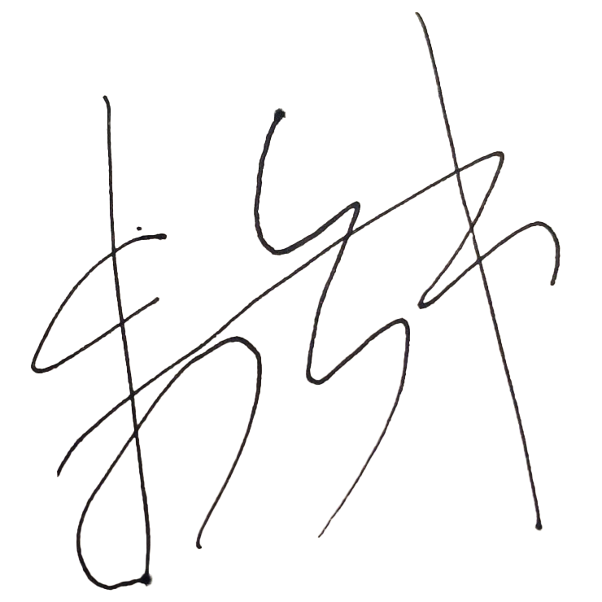
Assessor’s name | Yanzhong Zhu
Date signed | 16/02/23

End of Workplace Assessment - Assessor’s Checklist

