BSBPMG518
Manage project procurement

PRACTICAL ASSESSMENT INSTRUCTIONS

- The following practical assessment will require the participant to complete work related activities.
- Observations will be conducted of the participant’s work to determine whether they display sufficient practical skills and knowledge.
- Please fill in the details below, providing your name, signature and date of assessment.
  - Your signature acknowledges that the assessor provided clear instructions and the participant understood what was required to complete this assessment.
- The assessor may substitute a Practical Task with another task of equal value.
  - Alternate tasks must be fully documented by the assessor.

Participant name | Scott Johnston
Participant signature | 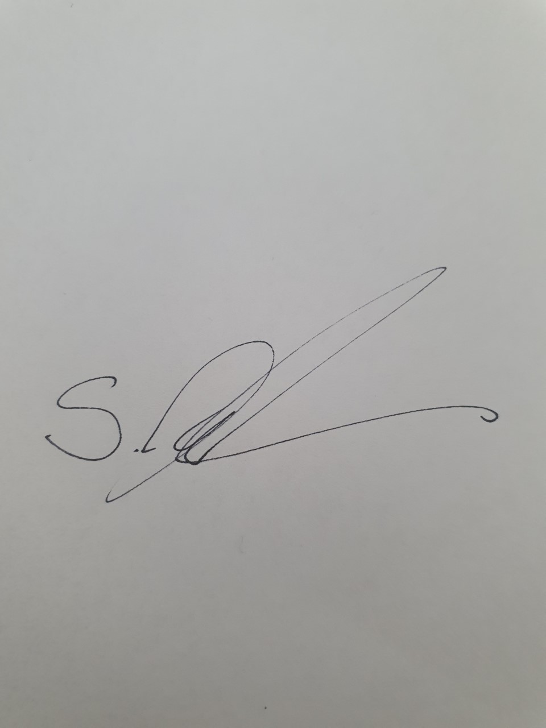

Assessor name
Assessor signature | 

Date | Click here to enter a date.

Number of tasks | Number of tasks completed | Satisfactory?
1 |  | Yes | No

Assessor Comments
BSBPMG518
Manage project procurement

Practical Task 1
Description of task:
A suitable observer is to verify the participant’s ability to undertake procurement in projects.

These tasks may be simulated or real. The participant is to gather evidence of how they have completed each component of the Practical Task, which is to be submitted with this Practical Assessment sheet. The observer is to provide detailed comments on the tasks completed by the participant. The assessor is to verify the observer’s comments in the Assessor Comments section, and provide the Practical Assessment outcome on the front cover of this document.
Resources required:
Project documentation, Organisational documentation relevant to procurement and contracts.
Assessment of task
Name of participant: | Scott Johnston
Name of observer: | Brad Smith
Role of observer  (Confirm suitability to sign) | Project Manager – Cv Services
Email address of observer | Brad.smith@cvservices.com.au
Signature of observer: | 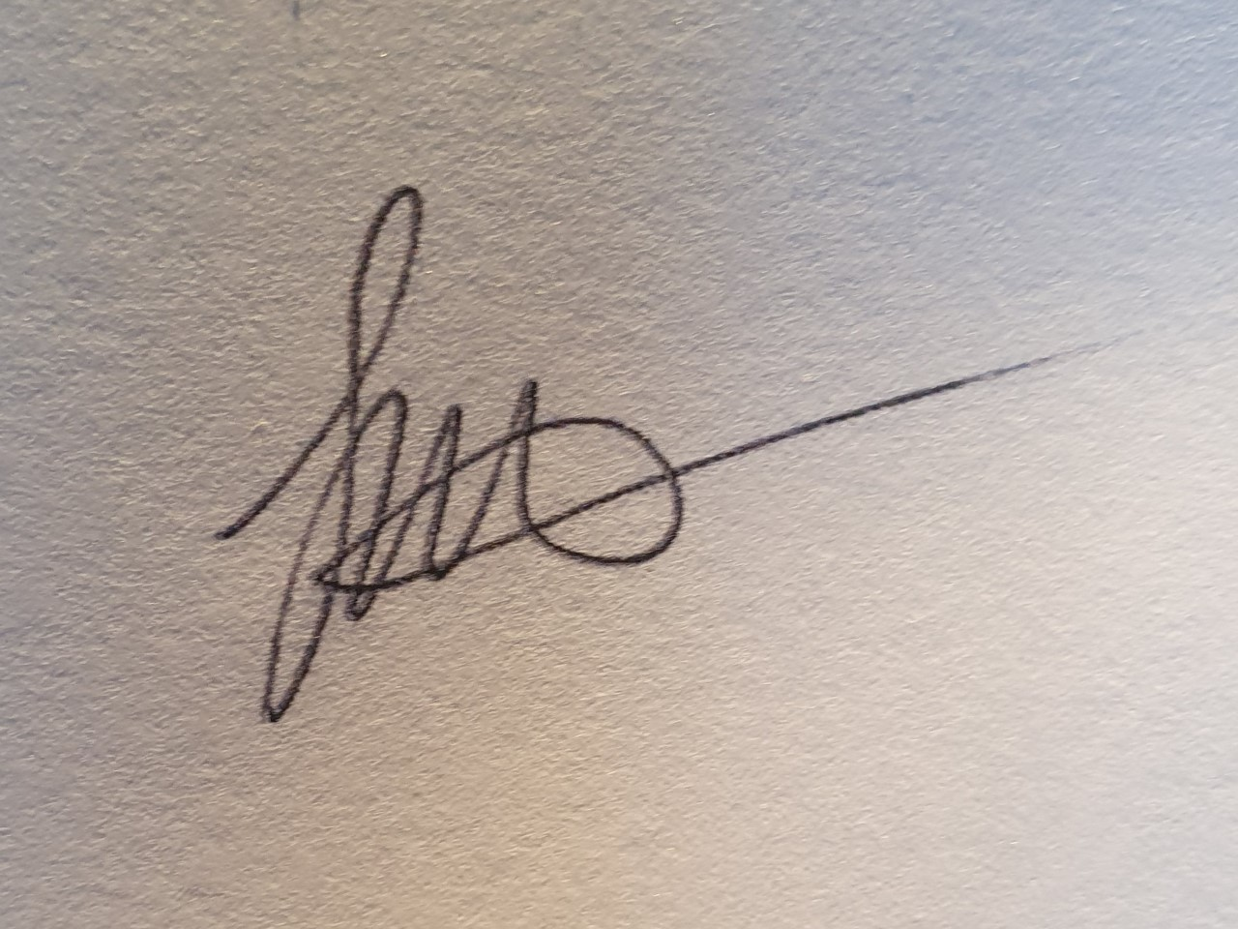
Date: | 18/05/2020
When completing the task, did the participant: |  | Tick if satisfactorily completed.  Provide comments if left unticked.
1 Determine procurement requirements
- Seek input from stakeholders to identify procurement requirements. |  | þ
- Establish and maintain, within delegated authority, agreed procurement management plan. |  | þ
2 Establish agreed procurement processes
- Obtain information from suppliers capable of fulfilling procurement requirements. |  | þ
- Determine or adopt established selection processes and selection criteria, and communicate to vendors to ensure transparency. |  | þ
- Obtain relevant approvals for procurement processes to be used. |  | þ
3 Conduct procurement activities
- Identify and act according to probity and project governance constraints. |  | þ
- Communicate agreed proposals and/or specifications to prospective vendors to ensure clarity of understanding of project objectives. |  | þ
- Solicit vendor responses according to proposal requirements. |  | þ
- Evaluate responses and select preferred vendors according to current legal requirements and agreed selection criteria. |  | þ
- Negotiate with preferred contractor or supplier, to agree on terms and conditions of supply. |  | þ
4 Implement and monitor procurement
- Implement established procurement management plan and make modifications in line with agreed delegations. |  | þ
- Review progress and manage agreed variations to ensure timely completion of tasks and resolution of conflict within the legal framework of the supply agreement. |  | þ
- Identify and report procurement management issues and implement agreed remedial actions to ensure project objectives are met. |  | þ
5 Manage procurement finalisation procedures
- Conduct finalisation activities to ensure vendor deliverables meet contracted requirements. |  | þ
- Review project outcomes using available procurement records and information to determine effectiveness of procurement processes and procedures. |  | þ
- Document lessons learned and recommended improvements for application to future projects. |  | þ
The participant’s performance was: þ Satisfactory Not Satisfactory

observer Comments

