BSBWHS411
Implement and monitor WHS policies, procedures and programs

ASSESSMENT SUMMARY

The assessment activities for BSBWHS411 Implement and monitor WHS policies, procedures and programs cover all aspects of the unit of competency. For Apprentices/Trainees, this includes supervisor completion of the Apprentice/Trainee Record (ATR).

Participants must read all the information given before starting any assessment task. The assessment tasks are intended to be fair, flexible, valid and reliable. If a Participant has any questions or requires alternative arrangements to be made such requests should be directed to their Trainer/Assessor, who should note such arrangements in the ‘Assessor Comments’ on the affected assessment. If a Participant feels they are not yet ready to be assessed, they should discuss their options with their Trainer/Assessor.

To satisfactorily complete the assessment, the Participant is required to answer all questions correctly and demonstrate their skills to industry standards. If a Participant does not answer all questions or perform all tasks, they will be deemed ‘Not Satisfactory’ for the task and ‘Not Yet Competent’ for the unit of competency.

The Trainer/Assessor can provide the Participant with additional information on interpreting the assessment outcomes and guide the Participant’s options. If a Participant is still deemed ‘Not Satisfactory’ they will have the opportunity to undertake a supplementary assessment or appeal the result as per the process in the Student Handbook.

By signing below, the Participant acknowledges:
- They understand the assessment instructions and requirements, and consent to being assessed.
- The work submitted is to be their own work – with the work of/with others needing to be clearly acknowledged and documented.
- They consent to any photo/video recording of their work that occurs during assessment.

Participant name | Joshua ferguson
Participant signature | Joshua Ferguson

Pre-requisite unit(s) to be achieved and authenticated prior to undertaking assessment
Not applicable

Task | Date completed | Assessment Results
Theory Exam | Select Date. | Satisfactory | Not Satisfactory
Practical Assessment | Select Date. | Satisfactory | Not Satisfactory
Outcome for BSBWHS411 | Select Date. | Competent | Not Yet Competent

Evidence requirements checklist (ticked by assessor and evidence supplied to RTO)
Theory Exam  Practical Assessment | Completed team WHS training need  Additional workplace WHS hazard/risk assessment and incident reporting documents completed and submitted as evidence

Assessor Name
Assessor Signature

BSBWHS411
Implement and monitor WHS policies, procedures and programs

THEORY EXAM

Participant name | Joshua Ferguson

FOR THE PARTICIPANT
Instructions
- You will complete written questions as outlined on the following pages. You must attempt all questions and provide enough detail in your responses to demonstrate your knowledge.
- It is anticipated that you should complete this assessment within two (2) hours, but additional time may be allowed upon negotiation with the Assessor.
- You must complete all questions unassisted by the Assessor or other personnel but may refer to reference material as needed. All questions must be answered correctly for a ‘Satisfactory’ assessment outcome to be awarded.
  - An oral examination may be allowed under certain circumstances, whereby your answers will be documented by another party.
  - Any written questions that are incomplete, or not answered satisfactorily will need to be completed again after further training support.
    - If you answer a question incorrectly but modify your response, put your initials next to the written change (or the Assessor must initial a verbal change).
Resources required
Pen

FOR THE ASSESSOR
Instructions
- Where oral examination has occurred, ensure that this is acknowledged in writing (e.g. FT001 and Assessor Comments)
- All questions must be satisfactorily demonstrated by the Participant for a Satisfactory determination (indicated by an Assessor tick to the right of the question).
- Assessors are to complete marking in pen of a different colour to the Participant.
- If the Participant verbally modifies their response, write in the modified response verbatim and put your initials next to the written change.

ASSESSOR COMMENTS
As necessary, outline:
- Details on reattempts, alternative arrangements or reasonable adjustments made.
- Where a Participant is deemed ‘Not Satisfactory’, provide recommendations for future training.

- What is the purpose for consultation mechanisms to effectively manage health and safety risks in the workplace? Include in your answer three (3) different consultation mechanisms available in your industry.

Answer  1.  2.  3. | Workplace Health and safety committees - workplace health and safety committees are made to assist the workplace in monitoring WHS on site. It’s a committee made of members that are aware  Toolbox talks and prestart meetings - These are short informal meetings prior to shift or tasks where supervisors and workers discuss specific safety topics, risk associated with the works and any concerns workers have.  WH&S reps - WHS Reps are elected on some sites by the workers, these representatives act as a liaison between workers and management regarding safety. They can raise safety concerns, be involved in safety inspections and ensure workers safety concerns are addressed with in a timely matter.

- Respond to the key elements of each of the following legislation as they apply to your industry.

Answer | Legislation | Provisions applicable to industry
 | WHS Act | - Duty of Care  - Risk management  - Incident reporting and investigation
 | WHS Regulations | - Managing high risk works  - Safe work method statements  - Managing construction works  - Regulations for specific hazards
 | Codes of Practice | - Construction works code of practice  - Electrical safety  - Safe use of cranes and hoists

- Consider a scenario where your supervisor has asked you to prepare and communicate information about hazard identification and risk assessment to the team. Describe two (2) methods and tools you would use to achieve this and ensure the information is easily accessible.

Answer  1.  2. | JHA’s for risk assessment  Risk rating matrix to assess level of risks

- How would you determine whether the methods and tools used in Q3. were effective in communicating the information.

Answer | To determine if the information communicated to the team was effective and understood. Questions would be asked after to engage the team and ensure they had picked up on the information provided. Once this was completed onsite inspections and conversations would be had to see the tools being utilised in the field.

- What are the benefits of using mentoring for WHS focused learning to support the training for a worker wanting to progress to a team leader role?

Answer | Mentoring for WHS focused learning provides personalized guidance, strengthens leadership and communication skills, enhances WHS knowledge, and promotes a culture of safety across teams. By helping workers transition into leadership roles with the right combination of technical knowledge, practical experience, and safety leadership skills, mentoring ensures that they are prepared for WHS challenges they will face as team leaders

Read the following extract from the Safe Work and Return to Work Awards 2017 to respond to Q6.

Decmil Australia
Category four – Most significant improvement to work health and safety performance

After identifying a culture of poor reporting around minor incidents, hazard observations and near miss events, Decmil Australia made improvements to its operations and safety system including:
- communicating the importance of incident/near miss reporting
- reviewing targeted inspections, specific to each project
- implementing a behavioural based safety program
- providing hazard identification cards and setting measures for the entire team.
These changes are sustained, monitored and evaluated through Decmil's SHIELD program (Safety and Health in Every Level at Decmil). The company's health, safety and environment achievements since 2014 include:
- 500 days lost time incident free in April 2017
- seven months recordable incident free on 10 June 2017 for the QGC Project team (current QGC Project TRIFR is 0.00)
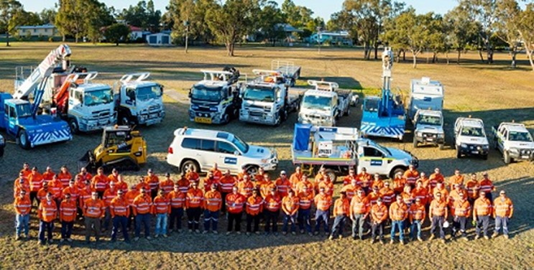
- improved communications and successful adoption of the new processes by employees including incident and near miss reporting.
Decmil Queensland Gas Company team

- Why is ‘near-miss reporting’ important and why did changes mentioned in the extract lead to the company winning the award for “Most significant improvement to work health and safety performance”?

Answer | Near miss reporting is important as this helps identify reoccurring/trending near misses that are leading to that major incident that has the potential to cause harm or damage to personnel or plant. By identifying these we can work on preventing this from happening.  They identified were they were lacking and what was leading to the need to make these changes. By identifying and making the change they were able to improve the safety and WHS awareness with in the business. By doing this they were able to encourage a high safety culture with in the business and it was lead from the top.

- You have been asked to present WHS information to new site inductees at your workplace. Write notes to support your presentation ensuring you cover relevant policies and procedures, the need for these, who can assist if there are issues and where documents are located.

Answer | Introduction  - Welcome new employees to the site  - Introduce the importance of site safety  - Encourage that safety is everyone’s responsibility and to speak up  - outline WHS commitment on site (Our commitment to ensure everyone goes home safely at the end of the day)  Site Policies and procedures  - Discuss site policies and procedures surrounding WHS on site  - Mandatory PPE (Certain tasks require certain PPE to complete the tasks)  - Risk management Processes  - Permits to work (Certain tasks require certain permits to complete work working at heights, confined space entry, hot works)  - Risk assessments (Risk assessments completed for every task to identify hazards and implement controls. This should be completed before starting any task)  - SWMS  Discuss the importance and reasons behind these policies and procedures  - Policies and procedures put in place to minimise the risk to workers on site and to prevent incidents and injuries  - Legal obligation under the WHS Act that require us to follow these policies and procedures  Who can assist you with WHS Issues or questions  - Site Safety reps  - Site supervision and management personnel  - Site safety officers  Location of WHS documentation  - Job specific documentation (SWMS, JHA’s) can be located on site or site office  - Safety documentation (PTW forms, Safety policies and procedures, risk assessments) Can be located through safety officer, site office or online systems. Contact site supervisor or safety officer if these are needed.  - Site Emergency procedures (Evacuation plans, first aid procedure, first aid officers) Posted in common areas crib rooms, site offices, near exits/entry points.

- Your team must dispose of old diesel drums. Complete the following Risk management Plan using information from the SDS in Handout 1.

Answer | Risk Management Plan
 | Completed by: Joshua Ferguson |  |  | Date: 11/11/2024
 | Hazard identification
 | Hazard: Disposal of old diesel drums
 | Risk Assessment
 | What harm could the hazard cause? | Exposure to Hazardous chemicals, potential environmental contamination, manual handling injuries,
 | What is the likelihood of this happening? | Moderate to high likelihood of this happening if the correct handling and disposal procedures are not followed
 | Persons at risk | Workers involved in the process and Environment
 | Existing control measures | PPE, Signage, Drum Inspections prior to moving, correct training, drums stored in designated area away from ignition sources
 | Consequence | Moderate to severe personnel injury (Crushing, chemical burns, strains and sprains. Moderate to Severe Environmental harm
 | Likelihood | Moderate Risk personnel injury & Medium to high risk environmental harm
 | Outcome | Medium Risk personnel injury & High risk Environmental
 | Control measures
 | Elimination | Eliminate the need to store old diesel drums by utilising other ways of storing diesel (portable Fuel pods etc) or if possible utilise a more sustainable energy source or fuel type that does not pose the same risk
 | Substitution | Safer chemicals or methods to clean drums or dispose of them. Substitution is limited
 | Isolation | Keep empty or partially used drums away from full drums to minimise confusion or accidents
 | Engineering | Have spill contamination kits available to manage accidental leaks or spills during drum handling and disposal
 | Administrative or PPE | SOP in place for handling and disposal of hazardous materials
 | Administrative or PPE | Mandatory PPE while handling Hazardous Materials
 | Preferred control option | Engineering - Spill kit available at all times while handling and disposal of drums
 | Preferred control option | Administrative and PPE - SOP in place and strictly followed aswell As PPE to be worn at all times and Enforced
 | Implementation
 | Associated activities | Resources required | Person/s responsible |  | Sign off and date
 | Transporting Drums to Disposal Area | PPE, Disposal Service | Site manager, Site workers, Safety Officer |  | Joshua Ferguson - 11/11/24  James Dolan - 11/11/24
 | Handling of the Drums | Drum handling Equipment | Site workers, site manager, Safety officer |  | Joshua Ferguson - 11/11/24  James Dolan - 11/11/24
 | Review Scheduled review date:
 | Are control measures in place? Yes
 | Are controls eliminating/minimising risk? Yes
 | Are there any new problems with the risk? To be assessed after Disposal to assess if any issues arose and adjust control measures accordingly

- How would you communicate the information collected in the previous question with your work team to ensure worker safety?

Answer | Information around correct Disposal of empty diesel drums would be communicated to work team/site personnel through a toolbox talk on correct handling and disposal of Hazardous materials

- When discussing site safety with the team this morning, concerns were shared around the ‘slips’ hazard when entering the site office.
The team suggested the consequence is a back injury which is quite serious, but the risk rating is only low. They are of the opinion that it should be medium or high risk.
As per company procedure and legal requirement, you, as team leader must advise the WHS committee of this consultation, request a review and advise of consultation outcomes. How would you go about this?

Answer | - Noted down issues raised by time  - Do my own risk assessment of it  - send email to safety team outlining the issue raised and my personnel risk assessment of it  - I would then follow up on the email by having the conversation with the safety team

- Workplace procedures require that you send an email to the WHS committee to ensure your request for a review of the team findings relating to slip hazard at the site office is received in writing. Complete the email below with your request.

Answer | 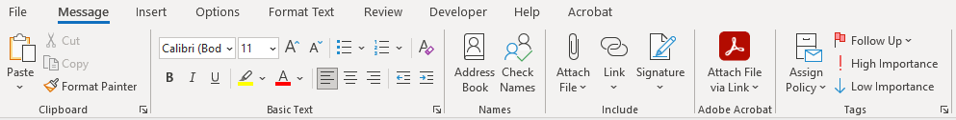  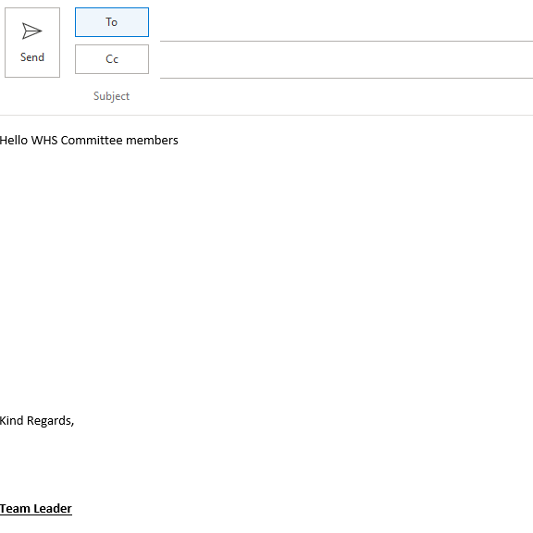  Team, emailing you today in regard to a safety issue raised by our team during this morning prestart.  Issue raised this morning was surrounding the slip hazard while entering the office and the current risk rating of it. The team believes that the current risk rating of low is in correct.  Since this was raised to myself this morning I have since completed my own risk assessment of this hazard and believe that a reassessment of the risk rating and review of the existing controls on this needs to be completed due to the potential severity of this hazard.  Please confirm that you have received this email and I look forward to your feedback on the matter. Feel free to contact me to discuss this further if need be.  [Grab your reader’s attention with a great quote from the document or use this space to emphasize a key point. To place this text box anywhere on the page, just drag it.]

You have received the following email in response to your email to the WHS committee. Read this to respond to Q12.

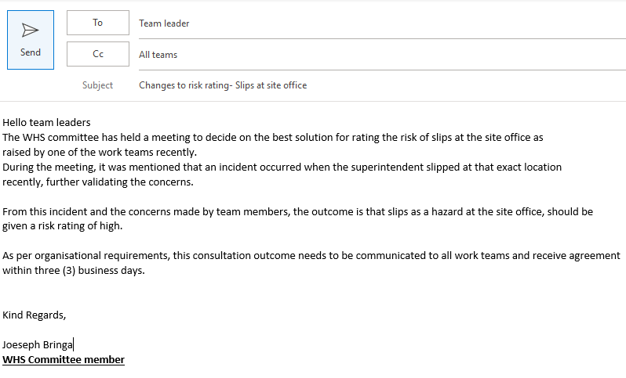

- Write a memo for the notice board to all team members about contacting you regarding their agreement to the changes mentioned.

Answer | Memo
Team,

Regarding Safety issue raised around the slip hazard while entering the office and the risk rating for this hazard being incorrect. Find below feedback regarding this.

- Issue was raised with safety team and meeting regarding this was held
- Reassessment of risk rating for this hazard was completed aswell as a review of the current controls in place for it.

After this reassessment and review was completed, I can confirm that the current risk rating for the slip hazard while entering the office has been amended and is now a high risk rating.

Once again well done team for raising this concern and speaking up on safety issues.

You have collected all responses and calculated 85% of the workers agree with the changes to be made to the risk rating for slips at the site office. It has also been suggested that non-slip flooring be implemented to address the concerns.

- How will you communicate the results and the recommendations in a way to meet workplace reporting and recording requirements?

Answer | - write a formal review outlining initial issue raised, feedback from safety team after review and the feedback from the team after the review  - send formal review to all project personnel  - Review and change to be toolboxed at the following prestart  - Non-slip flooring to be installed

- Considering safety training held at your workplace, what methods would you apply to train relevant workers in the following?

Answer  First aid  Drug use and work  Manual handling  Using SDS  Emergency  Procedure  Fatigue  Managing | Hands on training, First Aid training through a registered RTO & Refresher courses when required  Tool box talk on drug use in the work place, Awareness sessions show casing real life scenarios surrounding drug use in work place, tool box talk on company policy and procedures  Manual handling training through practical sessions, regular tool box talks on correct manual handling procedures  Interactive tool box talks around correct procedure for handling hazards materials, Examples of SDS displayed and discussed in inductions  Fire drills, Emergency response drills, emergency response exercises, Evacuation drills, tool boxes on Emergency procedures on site  Fatigue management training, tool box talks

Read the following team training record showing training that new workers have received, to respond to Q15. and Q16.
Team member | General Construction Induction training (White Card) | Site induction | Manual Handling | Emergency response | First Aid
Jeremy Still
Henry Oppenheim
Jules Freeman
Jake Monet
Antony Johns
Silvia Haack
Fred Hollows
Imogen Flank
Xavier French
Martin Short

- HR have provided you with the team training record for a new team you will be leading for a construction project. View the team training record above and explain what training must be prioritised and why.

Answer | - General construction training for the 4 members that done have it needs to be priorities as this is a requirement to work on a construction site  - Site inductions need to be completed for the remaining workers that haven’t completed it. This is a site requirement to have as it outlines our policies and procedures for the site  - Emergency response training, this should be completed with the site induction as all personnel should be aware of site emergency response procedure prior to starting  - Manual Handling training to be completed, to ensure all workers are aware of the correct manual handling procedures on site to minimise the risks of strains and sprains while completing manual handling tasks  - First aide training to be completed to ensure all personnel can conduct first aide if required to.  Training has been listed in order or priority.

- Complete the table using information from the training records to clarify the number of new employees requiring specific training.

Answer | Number of employees requiring training | White card | Site induction | Manual Handling | Emergency response | First aid
 | Number of employees requiring training | 4 | 5 | 3 | 6 | 4

- How will you ascertain which of the new employees will require first aid and fire warden training?

Answer | - assess new employees previous training to see what they do and don’t have and create and complete a training plan  - have the conversation with all parties, supervisors, site managers and site safety team to outline requirements for employees and what training is required

- Site inductions are held face to face every five (5) days by a WHS officer to meet the demands of this large site. What discussion will you need to have and with whom to confirm and book the team members into their site inductions? How will you consult/confirm details with these persons?

Answer | - Discussion with onboarding team on start dates for new employees  - Start dates for employees be sent through to safety team outlining on what employees require site inductions on what days  - once confirmation from safety team surrounding inductions has been received an email to team members on start times, dates and location of site inductions to be sent.  - Follow up with team members to ensure they have received confirmation of inductions times and dates

- Why would coaching be a good method of training regarding the use and purpose of Safety Data Sheets?

Answer | Coaching is a good method of training regarding the purpose of SDS’s as it offers hands on guidance, immediate feedback and real time application of safety protocols. It also encourages engagement, a safety conscious culture and helps build workers confidence in handling of hazardous materials.

- What is the importance of maintenance and storage of WHS incident records? Include in your response two (2) specific incident records you have maintained and how this was achieved.

Answer | Maintaining and storage of WHS incident records is essential for an organisation to comply with legal requirements, tracking of safety performances, implementing continuous improvements of safety practices within the organisation. Also keep keeping accurate and detailed records of incidents helps identify trends, prevent future accidents/incidents.  2 incidents records I have maintained.  - Manual handling incident involving a work that has sprained the park while loading and unloading steel bollards out of the back of an LV. This was achieved through following site and organisations reporting policies and procedures. Initial incident report completed and filed to online systems, aswell as investigation and corrective action completed reported, filed and toolboxed to teams.  - Fuel spill on site while refuelling of plant. Fuel hose has dislodged from fuel tank while still on causing in fuel to be spilled on to the ground. Initial incident report completed and filed once corrective action was taken to control the spill. Investigation completed and corrective action implemented. Incident recorded and kept on our online systems

- How do you keep up to date on changes to WHS laws, and related organisational policies and procedures relevant to your role?

Answer | - Regular review of WHS legislation and regulatory websites  - Regular meetings with WHS team in regard to upcoming changes of policies and procedures  - Regular audits and reviews of organisational policies and procedures

BSBWHS411
Implement and monitor WHS policies, procedures and programs

PRACTICAL ASSESSMENT

Participant name | Joshua Ferguson

FOR THE PARTICIPANT
Instructions
- The tasks outlined on the following pages will require performance of normal workplace activities, as a result of a structured activity set by an Observer in the workplace or a simulated activity set by your Assessor/Observer.
- The timeframe for these tasks will be established by your Assessor/Observer, in consideration of location conditions and industry requirements.
- You must complete all tasks unassisted by the Assessor or other personnel, unless the steps note this assistance.
- You must attempt all tasks (and itemised steps) for a ‘Satisfactory’ assessment outcome to be awarded.
  - For any observation conducted that is incomplete, or without satisfactory performance, the observation will need to be completed again after further training support.

FOR THE ASSESSOR/OBSERVER
Instructions
- The following observation record should be used to judge and record your observations of the Participant as they complete the task(s) set. You must record your observations of the Participant’s performance.
  - For each occasion, indicate the task performed and whether it was a simulation or workplace-based task.
    - Any simulated assessment must ensure the Participant still performs under workplace conditions which reflect industry standards.
  - In the comments, provide clear detail regarding the task that the Participant was required to do (e.g. PPE used, materials handled, attachments connected, plant types).
- All steps must be satisfactorily demonstrated by the Participant for a ‘Satisfactory’ determination (indicated by an Assessor tick to the right of each itemised step, or an Observer tick to the right of each itemised step, and confirmation by an Assessor in the Assessor Comments).
  - Where you have determined that one or more task steps have not been satisfactorily demonstrated, provide the Participant with additional support and outline details of such assistance in the Assessor/Observer Comments. Allow the Participant two (2) further opportunities to demonstrate the task again to allow an opportunity for a ‘Satisfactory’ assessment outcome to be achieved.
  - If after three (3) attempts the Assessor determines that the Participant cannot demonstrate the required steps, a ‘Not Satisfactory’ outcome is to be determined.

TASK OUTCOME
Task | Date | Task Type (Tick) | Location | Task outcome (Tick)
 |  |  |  | Satisfactory | Not Satisfactory
Task 1 | Select Date. | Workplace  Simulation

ASSESSOR COMMENTS: GENERAL
As necessary, outline:
- Details on reattempts, alternative arrangements or reasonable adjustments made.
- Where a Participant is deemed ‘Not Satisfactory’, provide recommendations for future training.

ASSESSOR COMMENTS: PRACTICAL TASK 1
Individual student (as named on cover page)
Multiple students [ All from Attendance Report, Specific students involved – identify students]
Task | Provide detail
1.1A. | Specify method used to share information and workplace polices/procedures shared:
1.1B. | Specify which identified hazards and controls were shared with team:
1.2A. | Specify method used to share the importance of consultation for managing WHS risks:
1.2C. | Specify issue raised through consultation:
1.2D. 1.2C. | Specify method of reporting issues upward:
1.2E. | Assessor describe how participant shared information with work team:
1.3C. | Specify type of training and method of training agreed on for one (1) participant:
1.3D. | Specify training arrangements made for one (1) team member:
1.3E. | Specify workplace learning opportunities provided for three (3) team members:
1.4B. | Specify procedure followed to report a hazard or incident:
1.5D. | Specify methods used to keep up-to-date:

BSBWHS411
Implement and monitor WHS policies, procedures and programs

Practical Task 1
Description of task:
The participant must demonstrate the ability to effectively implement and monitor the work health and safety (WHS) policies, procedures and programs for a team in one (1) work area in an organisation including demonstrating and providing evidence of the following:
- confirming and documenting team training needs to meet workplace and legislated requirements
- consult with stakeholders and make arrangements to meet WHS training needs of team members
- provide workplace training opportunities to team and individuals to support achievement of identified WHS training needs
- communicate information to work team about WHS laws, workplace policies, procedures and programs, the importance of consultation mechanisms, hazards and risk assessment including in the communication where information can be accessed
- adhere to workplace policies and procedures to apply consultation mechanisms for managing work area hazards, reporting issues raised and communicating both upward and downward throughout consultation to outcome
- manage monitor and report on hazards, controlling risks according to workplace procedures and legislated requirements
- identify and report inadequacies in existing risk controls monitoring outcomes of reports on inadequacies
- complete and maintain WHS incident records in work area
- use aggregate information and data from work area records to meet workplace recordkeeping requirements

These tasks may be simulated or real. The Participant is to gather evidence of how they have completed each component of the Practical Task, which is to be submitted with this Practical Assessment sheet. The Observer is to provide detailed comments on the tasks completed by the Participant (on the Observer Comments, overleaf). The Assessor is to verify the Observer’s comments, noting their findings in the Assessor Comments (on the back of the Practical Assessment cover page) and provide the assessment outcome.
Resources required:
Work team, workplace policies and procedures, WHS documents, records and recording documents, HR training records, access to current state regulator and legislation.
Observer details
Name of observer: | Joshua Ferguson
Role of observer  (Confirm suitability to sign) | Foreman
Email address of observer | Joshferguson62@gmail.com
Signature of observer: | 
Date: | 13/11/2023

When completing the task, did the Participant: | Tick if satisfactorily completed.  Provide comments if left unticked.
1 Provide information to work team about WHS policies and procedures
- Locate and share with work team workplace and state appropriate and current WHS legislation and related workplace policies and procedures.
- Share information to work team about identified site hazards and outcomes of risk assessment and control.
- Communicate information in a way that was logically presented, clear and accurate.
- Communicate information using structure and language suitable for audience.
- Use questioning and active listening to clarify understanding and make the audience feel at ease during face to face communications.
- Use written format during WHS presentation that apply appropriate structure, layout and language to ensure the information is understandable by the audience.
2 Implement and monitor work team consultative arrangements for managing WHS
- Share information with team and demonstrate the importance of consultation mechanisms for the management of WHS risks using methods that are easy to understand.
- Adhere to workplace procedures for consultation by asking work team for opinions and information relating to the management of work area hazards.
- Manage issues raised through consultation using questioning, responding, explaining, clarifying and expanding on ideas and information as required, evaluating choices and determining severity based on workplace and legislated WHS requirements for determining risk levels and the hierarchy of controls.
- Communicate and report on potential new hazard upward according to site requirements.
- Communicate the outcomes of reporting upward with work team within acceptable workplace timeframes using appropriate verbal and written communication.
3 Implement and monitor organisational procedures for providing WHS training to work team
- Access relevant HR records to determine white card, site induction, qualifications and licences held by team members.
- Complete a table or relevant workplace document to demonstrate team members training needs to meet work and legislated requirements. (Evidence of document is required.)
- Discuss training needs and methods of training available with individual team members, discussing and agreeing on training required and method to be applied.
- Discuss and arrange training for team member with relevant stakeholder.(internal/external).
- Organise workplace learning opportunities for workers requiring or requesting specified WHS training.
4 Implement and monitor organisational procedures and legal requirements for identifying hazards, and assessing and controlling risks
- Consistently use workplace documents and follow procedures to identify and report on hazards in work area.
- Use workplace documents and undertake hazard and incident reporting according to workplace requirements to meet WHS legislation.
- Adhere to workplace requirements to control risks using the hierarchy of control measures.
- Identify, report and monitor outcomes of reports on inadequacies in existing risk controls using the hierarchy of control measures according to WHS laws.
- Use approved processes to monitor outcomes of reports on inadequacies, as required, to ensure prompt organisational response.
5. Implement and monitor organisational procedures for maintaining WHS records
- Complete and maintain WHS incident and near-miss records related to work area according to work place policies and procedures, and WHS laws.
- Use near-miss and historical data to determine risk levels when applying risk assessment.
- Apply appropriate procedures for incident response, investigation, notification and reporting
- Keep up to date on changes to WHS laws, and related organisational policies and procedures relevant to own role.

OBSERVER COMMENTS

