
AHCLSC302
Construct landscape features using concrete

Copyright © 2020 CSTC Pty Ltd

All rights reserved. No part of the contents of this publication may be reproduced or used in any form or by any means – graphic, electronic, or mechanical including photocopying, digitising, recording, or information storage-and-retrieval systems – without the written permission of CSTC Pty Ltd.
ASSESSMENT FOR AHCLSC302

Student name
Date of assessment submission | Click here to enter a date.

Trainer/Assessor’s name
Date of assessment marking | Click here to enter a date.
Outcome for unit | ☐ Competent  ☐ Not Yet Competent

TASK INSTRUCTIONS

- As part of the assessment for this unit of competency, you are required to complete a series of activities.
  - Some of these activities will require you to provide a response within this document, others will require you to gather evidence to demonstrate your knowledge and skills.
- At all times, the responses in your assessment must reference Australian (Queensland or Federal) documentation, including legislation, regulations, codes of practice, standards and guidance publications.

ACTIVITIES

Identify/list the scope of the work to be carried out from the concept plan shown.

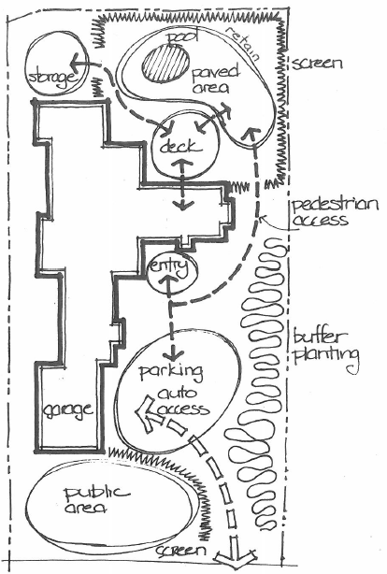

Response

Outcome for Activity 1 | ☐ Satisfactory  ☐ Not satisfactory
Trainer/Assessor comments

Identify/list the detail on the landscape plan shown.

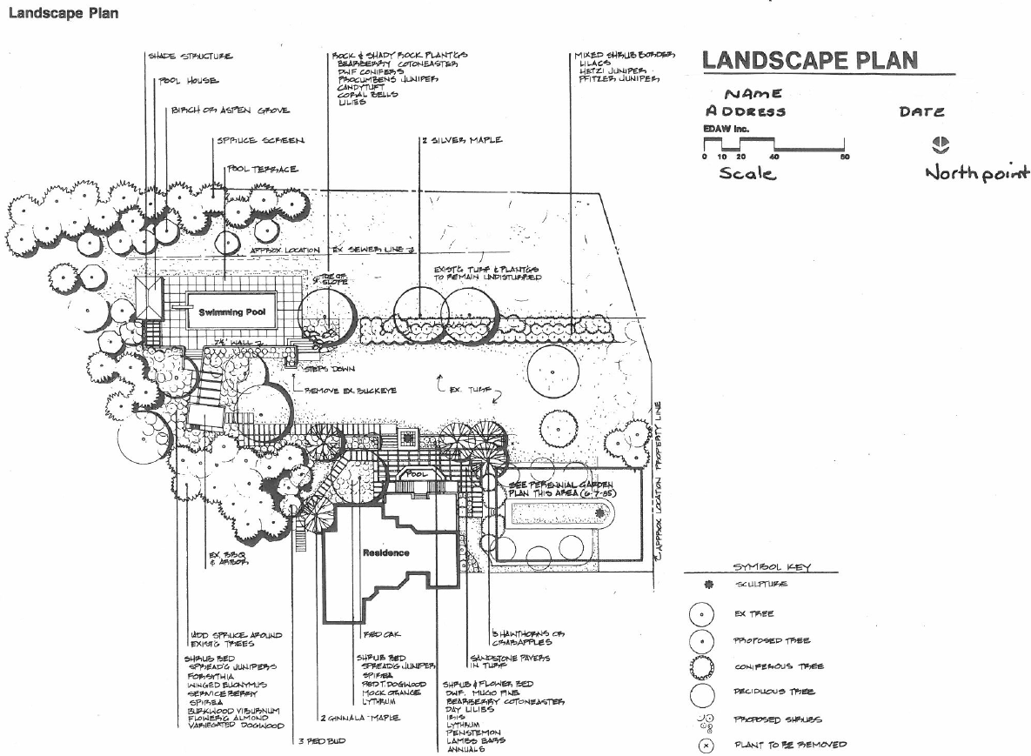

Response

Outcome for Activity 2 | ☐ Satisfactory  ☐ Not satisfactory
Trainer/Assessor comments

List the materials required to complete the water feature, by using the wall and water feature construction plan shown.

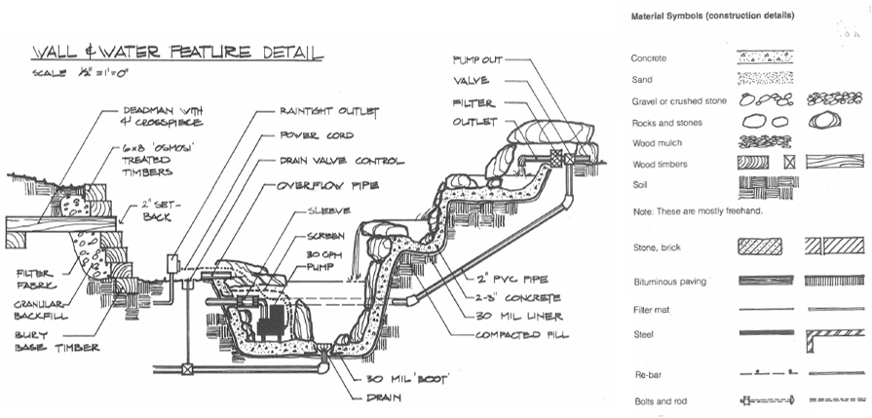

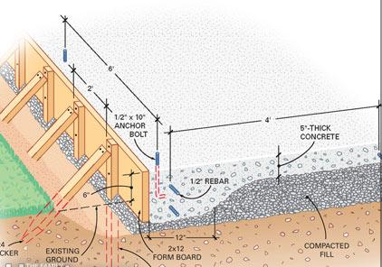

Response

Outcome for Activity 3 | ☐ Satisfactory  ☐ Not satisfactory
Trainer/Assessor comments

Research and list relevant laws and standards relating to concreting works
(e.g. Building Codes, Australian Standards, Codes of Practice)

Name of document
- Laws
- Standards
- Codes

Outcome for Activity 4 | ☐ Satisfactory  ☐ Not satisfactory
Trainer/Assessor comments

List the components for four (4) common surface drainage systems used in landscape construction.

System | Components
- Spoon
- Channel and grate
- Pit
- Contour

Outcome for Activity 5 | ☐ Satisfactory  ☐ Not satisfactory
Trainer/Assessor comments

List the advantages and disadvantages of drainage behind and through the build wall (as shown).

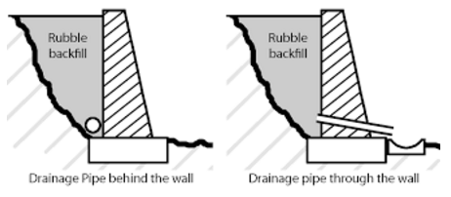

Drainage pipe behind the wall
Advantages
Disadvantages

Drainage pipe through the wall
Advantages
Disadvantages

Outcome for Activity 6 | ☐ Satisfactory  ☐ Not satisfactory
Trainer/Assessor comments

Explain the purpose of a slump test. Describe the process of how such a test is conducted.

Response

Outcome for Activity 7 | ☐ Satisfactory  ☐ Not satisfactory
Trainer/Assessor comments

Research and list a range of curing compounds and the advantages of using each type

Curing compound | Advantages

Outcome for Activity 8 | ☐ Satisfactory  ☐ Not satisfactory
Trainer/Assessor comments

List environmentally safe products for cleaning.

Response

Outcome for Activity 9 | ☐ Satisfactory  ☐ Not satisfactory
Trainer/Assessor comments

Have team members take photos and videos of your involvement with concrete features.

Identify each photo / video with a letter label and describe each photo / video in the table below. Submit the photo / video files along with this workbook.

Advantages
A
B
C
D
E
F
G
H
I
J
K
L
M
N
O
P
Q
R
S
T
U
V
W
X
Y
Z

Outcome for Activity 10 | ☐ Satisfactory  ☐ Not satisfactory
Trainer/Assessor comments

