Section A

Totem Pole Production
Policies and Procedures

A problem has occurred due to extras wanting to talk and have lunch with A-list film stars, who have now communicated their wish to be undisturbed during lunch hours.
Lunch policies and rules for employees:
- Extras must eat their lunch in the main restaurant between 12:00 and 14:00
- The Lobster Café is exclusively for actors, directors, and producers
- Extras must not disturb actors when they are having lunch
- Selfies with actors are not permitted on set
- Extras must not pursue autographs, unless the actor has given their permission at the beginning of filming.

Managers have clearly stated that the extras who breaks these rules will not be used again in the future.

Section C
- 100% Genuine 2-ply Inner Mongolian Cashmere
- Ribbed Crew Neck, cuffs and hem. Superior softness with easy fit comfort
- 100% Pure Sustainable Mongolian Cashmere
- The care label may read "dry clean only," but hand washing a cashmere sweater will actually make it softer over time. Be sure to: wash it Inside out in cold water; use baby or Wool and Cashmere shampoo; press out the excess water, but do not wring the sweater; lay it flat on a towel and reshape it as it dries. Fold to store. Never hang.
- Himmlisch weich, warm und leicht
- Super versatile; Light weight; Relax fit. Classical design. Wearing with shirt shows formal for working, and wearing with jeans shows leisure at home and party.
- Densely knitted with the finest and long staple cashmere which provides best anti-pilling performance
- Model Measurements: height: 6'2"/ waist: 32". Model is wearing size:Large

State Cashmere Men's 100% Pure Cashmere Jumper Long Sleeve Pullover Crew Neck Sweater

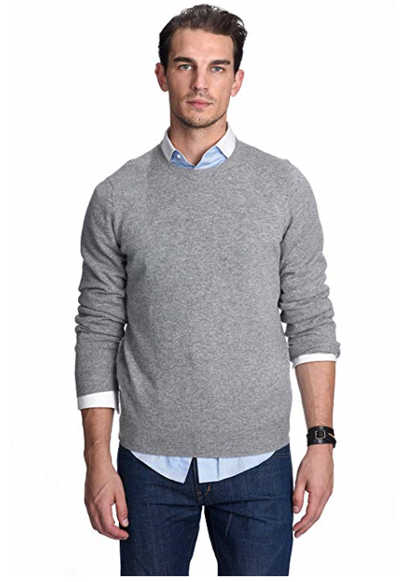

Brave Soul Men's Tame Casual Shirt
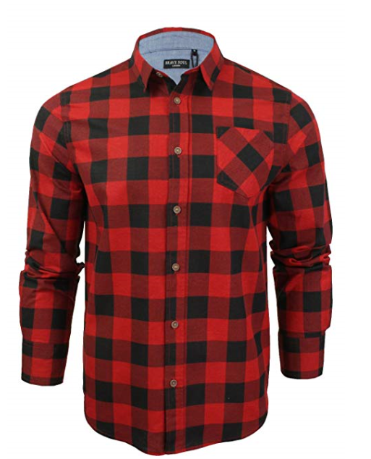

- Heavy brushed checked shirt
- 100% Cotton
- Machine wash - Cold (30° max)
- Fastening: Buttoned
- Collar Style: Classic
- Regular Fit
- Regular Fit
- Long Sleeve
- MSH-69TAME

- Breathable chino pants, as they are slim fit trousers, may slight tight when first time wear, please choose one size larger than you usualy wear if prefer more room
- Fleece lined are now available for cold weather, Ideal for casual & formal wear
- 100% Cotton
- Fastening: Zip
- Casual
- Slim
- R8-01-Khaki-33
- 2 front slash pockets, 2 back pockets
- Slim fit style/ Hand/Machine cold wash separately
- Kind Notice: belt not included,shipping time: 1-3days fulfilled by Amazon,5-12 fulfilled by Seller

OCHENTA Mens Casual Slim-Tapered Flat-Front Trousers Khaki Lable 33


