BSBPMG407A
Apply risk management techniques

THEORY EXAM INSTRUCTIONS

- This exam will occur under standard assessment conditions.
  - An oral examination may be allowed under certain circumstances.
Answers will be documented and FT003 (Oral examination declaration form) must be completed.
- Participants must provide enough detail in their responses to demonstrate their knowledge and skills.
- Please fill in the details below, providing your name, signature and date of assessment.
  - Your signature acknowledges that this is your own work.
- If a participant initially answers a question incorrectly but modifies their response, they must follow the instructions below:
  - If a participant changes their response in writing, they must put their initials next to the written change.
  - If a participant changes their response verbally, this must be noted on the exam paper by the assessor.

Participant name | Toni Thomsen
Participant signature | 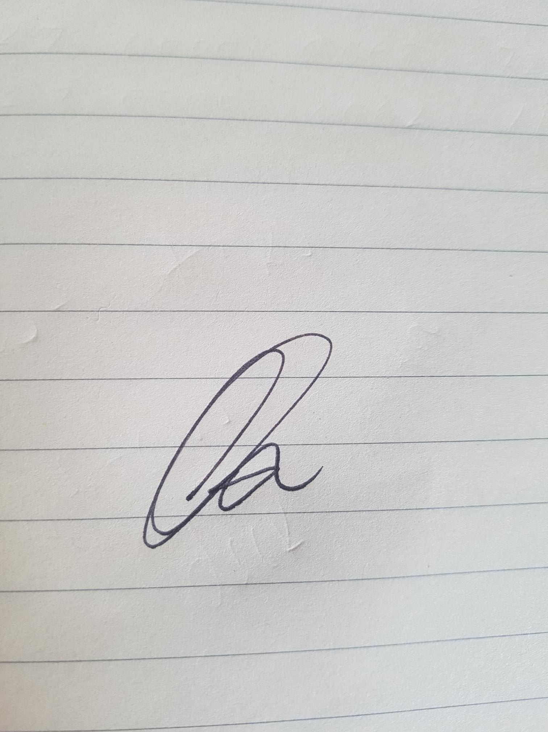

Assessor name
Assessor signature | 

Date | 22/10/2018

Number of questions | Number of questions answered correctly | Satisfactory?
16 |  | Yes | No
Assessor Comments
- Describe a project below. Conduct a SWOT analysis for the project. Identify at least two (2) points per area.

Project description | External Repaint to commercial property

Answer | Area | Detail
 | S | All 10 boys have been allocated to job to get the project achieved in time frame  Given 2 weeks for project but should only take 8-9 days
 | W | Bad weather when painting externally can delay schedule time  Having all 10 workers on one job which doesn’t allow for an extra project to be completed
 | O | Work better together as a team  List goals that each painter wants to achieve by end of day
 | T | Injury on the worksite as high work is involved  Weather/Equipment hire

- Consider the project you identified in Q1. For each of the areas identified in the table below, identify one (1) risk that may arise.

Answer | Area | Project risk
 | Environmental | Bad weather
 | Finance | Budget runs over
 | Human resources | Workers fall sick
 | Legal | Equipment hire damage
 | Technology | Equipment Hire breaks down/Faulty

- Using ticks, identify whether each of the risk analysis methods listed below is either ‘qualitative’ or ‘quantitative’.
Answer | Qualitative | Quantitative | Method
 |  |  | Analyses expected monetary value
 |  |  | Considers likelihood of occurrence and impact on projective objectives
 |  |  | Ranks risks

Refer to the Risk Matrix below when responding to Q4.

Matrix | A:  Catastrophic | B:  Major | C:  Moderate | D:  Minor | E:  Insignificant
1: Almost certain | E | E | H | H | M
2: Likely | E | H | H | M | M
3: Occasionally | H | H | M | M | L
4: Unlikely | H | M | M | L | L
5: Rare | M | M | L | L | L

E: Extreme | H: High | M: Medium | L: Low

- Referring to your responses in Q2. rate each of the risks you identified using the Risk Matrix shown above. Identify the Likelihood and Impact you have determined, plus the overall risk rating.
Prioritise each risk from 1 to 5 (1 = highest priority, 5 = lowest priority).

Answer | Area | Risk rating | Priority
 | Environmental | Likelihood: 2  Impact: A  Risk rating: 1 | 1
 | Finance | Likelihood: 3  Impact: A  Risk rating: 2 | 2
 | Human resources | Likelihood: 3  Impact: B  Risk rating: 3 | 3
 | Legal | Likelihood: 2  Impact: B  Risk rating: 5 | 5
 | Technology | Likelihood: 2  Impact: A  Risk rating: 4 | 4

- Order the elements of the hierarchy of control, from 1 to 6 (i.e. most effective to least effective).

Answer | Label (1 – 6) | Element
 | 3 | Isolate the hazard
 | 6 | Provide and use Personal Protective Equipment (PPE)
 | 1 | Eliminate the hazard
 | 4 | Control the hazard by engineering means
 | 5 | Control the hazard by administrative means
 | 2 | Substitute the hazard

- Referring to your responses in Q2. propose one (1) risk control for the risk identified in each of the areas listed below.

Answer | Area | Risk control
 | Environmental | Isolate the hazard – remove boys for worksite due to weather
 | Finance | Administrative Means
 | Human resources | Provide and use PPE
 | Legal | Administrative Means – Have  insurance and contracts in place
 | Technology | Control hazard by engineering means

- Which of the following parties should be consulted and agree to proposed risk managed strategies, plans and reporting mechanisms? Tick all that apply.

Answer | Choice | Possible Answers
 |  | Project manager
 |  | Project specialist
 |  | Team members

- True or False (Tick your response): Organisations all use the same risk analysis methods, techniques and tools.

Answer |  | True
 |  | False

- Identify the four (4) options that may be followed once you have established the revised risk level.

Answer | Do nothing  Implement rise controls  Reassess the risk  Accept the risk

- What is the name of the risk level measured after risk controls have been implemented? Tick all that apply.

Answer | Choice | Possible Answers
 |  | Initial risk
 |  | Revised risk
 |  | Residual risk
 |  | Updated risk

- On what document should incidents be recorded?

Answer | Issues Register

- What is to be completed when a variation is to be made to the project?

Answer | Change request

- True or False (Tick your response): You should report opportunities for action in the same way as risks.

Answer |  | True
 |  | False

- Identify two (2) types of documents that may be referred to when conducting a review of a risk management plan.

Answer | Project files and records  Risk diaries, incident logs, occurrence reports

- Explain the relevance of evaluating project outcomes (e.g. agreed major milestones) as part of reviewing risk management activities.

Answer | The report will ensure any mistakes in similar projects are not made again.  It also allows future incidents to be better managed,

- True or False (Tick your response): You may refer to past projects for lessons learned regarding risk management, even when the past projects are not identical to the current one.

Answer |  | True
 |  | False

