
READ
CPCCBC4012B
AND
INTERPRET
PLANS
AND
SPECIFICATIONS
ASSESSMENT SUMMARY

The assessment activities for CPCCBC4012B Read and interpret plans and specifications cover all aspects of the unit of competency required. To demonstrate competence in this unit, a participant must undertake all tasks and complete them satisfactorily and consistently. For Apprentices and Trainees, this includes employer completion of the Employer Record Book (ERB).

Participants must read all the information given before starting any assessment task. The assessment tasks are intended to be equitable, fair and flexible. If a participant has any questions or requires alternative arrangements to be made such requests should be directed to their Trainer/Assessor, who should note such arrangements in the ‘Assessor Comments’ on the affected assessment. If a participant feels they are not yet ready to be assessed, they should discuss their options with their Trainer/Assessor.

To satisfactorily complete the assessment, the participant is required to answer all questions correctly and demonstrate their skills to industry standards. If a participant does not answer some questions or perform some tasks, they will be deemed ‘Not Satisfactory’ for the task and ‘Not Yet Competent’ for the unit of competency. The Trainer/Assessor is able to provide the participant with additional information on interpreting the assessment outcomes and provide guidance on the participant’s options. Should a participant still be deemed ‘Not Satisfactory’ they will have the opportunity to undertake a supplementary assessment or appeal the result.

By signing the cover page for each assessment item, the participant acknowledges they understand the assessment instructions and requirements and consent to being assessed. The participant also verifies and assures the RTO that the work submitted is their own work.

UAA Darshika
Participant Name

Theory Exam | ◻ Satisfactory | ◻ Not Yet Satisfactory
Practical Assessment | ◻ Satisfactory | ◻ Not Yet Satisfactory
 | ◻ Competent | ◻ Not Yet Competent

Assessor Name | Myles Walder
Assessor Signature |   Click here to enter a date.
Unit Competence Determination Date


READ
CPCCBC4012B
AND
INTERPRET
PLANS
AND
SPECIFICATIONS

THEORY EXAM INSTRUCTIONS

- This exam will occur under standard assessment conditions.
  - An oral examination may be allowed under certain circumstances, whereby the Participant’s answers will be documented by a party other than the Participant. This must be acknowledged in writing (e.g. FT001 and Assessor Comments)
- Participants must provide enough detail in their responses to demonstrate their knowledge and skills.
- Please fill in the details below, providing your name, signature and date of assessment.
  - Your signature acknowledges that this is your own work.
- Assessors are to complete marking in pen of a different colour to the Participant.
- If a Participant initially answers a question incorrectly but modifies their response, they must follow the instructions below:
  - If a Participant changes their response in writing, they must put their initials next to the written change.
  - If a Participant changes their response verbally, this must be noted on the exam paper by the assessor.

Participant name UAA Darshika Participant signature Dars³ika
Date 02/02/2021

Assessor name Myles Walder Assessor signature

Date Click here to enter a date.

Number of questions | Number of questions answered correctly | Task outcome (Tick)
87 |  | Satisfactor y | Not Yet Satisfactor y
87 |  | ◻ | ◻

ASSESSOR COMMENTS

Q1. Plans and specifications are used to inform which of the following processes? Tick all that apply.
Answer ◻
Choice | Possible Answers
x | Building contracts
x | Development applications
x | Estimation
x | Planning
x | Supervisory tasks
x | Tenders

Q2. Which compass direction is always shown on plans and drawings?

Answe r
True north
◻

Q3. What information is provided on a location plan?

Answe r
Shows a site on a particular street A location plan details the:
- Lot number/s
- Deposit plan numbers
- North point
- Scale (usually 1:5000)
◻

Q4. What detail does a site or block plan contain?

Answe r
Provides specific detail of the block on which a development is proposed

A Site or Block Plan is usually gives the following information:
- A datum - reference height to other site levels
- Building location and orientation to north point
- Outline of site boundaries showing location of proposed building and existing dwellings
- Street frontage names
- Major geological and topographical features (trees and vegetation)
- Datum points, contours and slopes
- Driveways, stormwater drainage, easements and right of carriage
- Soil and surface water drains, pipe sizes
- Service runs from the house to mains - utility services location (sewer, water, gas, electricity)
- Details of paving and retaining walls
◻

Q5. What do floor plans identify?

Answe r
Floor plans: Shows detail of the proposed structure, such as rooms, positions of fixtures, floor coverings
floor plan it shows the size and thickness of structural members and relationships between spaces.
◻

Q6. What is a landscape plan and what information might it provide?

Answe r
Landscape plan: Shows details of plants, paths, garden layouts and retaining walls.

A Landscape Plan is a plan of a site showing the footprint of a proposed development, existing vegetation to be retained, any existing vegetation to be removed, proposed vegetation to be planted and proposed built elements (such as pathways, driveways and courtyards).
◻

Q7. What are elevation views? What do they provide to the plan reader?

Answe r
An elevation is a view you see when standing in front of that wall. It may be multi-storey or single-storey.
Elevation views
View of the proposed structure from its sides (i.e. from north, south, east and west).
Each side is what is called an elevation view. Elevations indicate:
- Finish to external walls and
- Size of windows, doors and balconies
◻

Q8. What is a section?

Answe r
Key features
A section is a vertical view (slice) through the building. The direction of section lines or arrows is usually shown on the plan to help interpret the sectional view.

The section is a view of the house after it has been cut vertically at some point. Like the floor plan it shows the size and thickness of structural members and relationships between spaces.
For example, it shows the height from the ground to the floor, the height between the floor and the ceiling, and how the roof is to be constructed.
◻

Q9. What are detailed drawings?

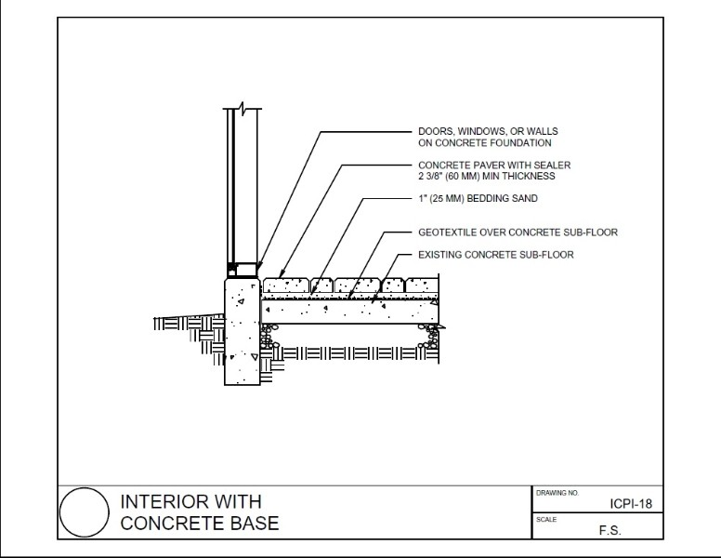Answe r
Detail drawings provide a detailed description of the geometric form of a part of an object such as a building, bridge, tunnel, machine, plant, and so on. They tend to be large-scale drawings that show in detail parts that may be included in less detail on general arrangement drawings.

Detailed plans: Illustrate a particular method of construction of finish.
◻

Q10. What are specifications?

Answe r
Specifications are details that support drawings and plans, providing details of the materials and techniques to be used, details of fixtures and fittings, and standards to be observed.

Specifications set out the minimum standards or codes required for all structural components and provide details of building materials and fittings, such as:
- Windows, frame material and type of glass
- Doors, size, material and the swing on the door
- Finishes/colours to walls, floors and ceilings
- Door types and models of locks, latches, hinges, push plates and pull handles

General items contained within Building Specifications include a:
- Full description of work
- Precise list of materials
- Details of all fittings, fixtures and finishes (appliances – make and model)
- Precise list of products (e.g. types, brands, grades, thickness, colour, model)
◻

Q11. Explain the meaning of the abbreviations in the table below.
Answe ◻
Abbreviatio  n | Meaning
ACRYL | Acrylic
AS | Australian Standard
ASSD | Assumed Datum
B | Basin
BN | Bull Nose
BTH | Bath
BWK | Brickwork
CB | Concrete block
CF | Concrete floor
CG | Clear glass
CJ | Ceiling joist
CORR | Corrugated
CWT | Cold water tank
DG | Double glazing
DH | Double hung
DPC | Damp proof course
DSB | Distribn. switchboard
DW | Dishwasher
EJ | Expansion joint
FPBD | Fibrous plaster board
FFL | Finished floor level
FHR | Fire hose reel
GPO | General purpose outlet
HBD | Hardboard
HTR | Heater
HWD | Hardwood

Q12. Name each of the drawing symbol images shown in the table below.
Answer ◻
Name | Image
 | 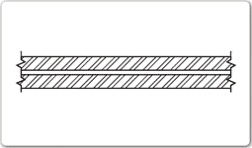
 | 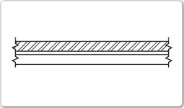
 | 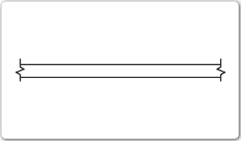
Pivoted window | 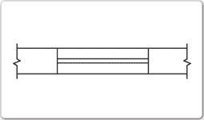
Vented window | 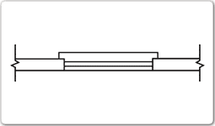
Door | 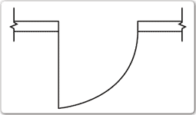
French door | 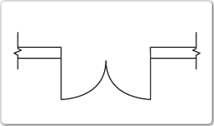
Pocket door | 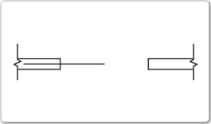
Sliding door | 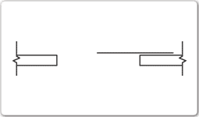
Substation/Power socket | 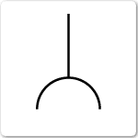

Q13. Identify what the following window symbols represent on elevations.

Answer ◻
Item | Drawing
Hinged at side | 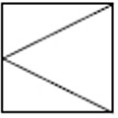
Hinged at top | 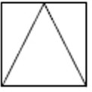
Sliding horizontally | 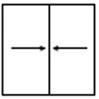
Fixed | 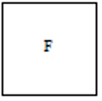


Q14. What does a clouded area on a plan indicate?

Answe r
On plans, revisions or amendments are represented by a clouded area
◻

Q15. An amendment to specifications could relate to which of the following?
Tick all that apply.

Answer ◻
Choice | Possible Answers
◻ | Contact details of all construction crew members
x | Materials or products used
x | Methods of carrying out specified work

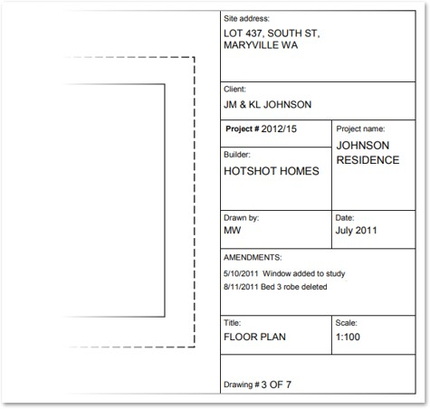
Refer to the title block below to respond to Q16. to Q18.
Source: http://www.dtwd.wa.gov.au/sites/default/files/teachingproducts/BC1934_CCBY.PDF

Q16. On what date was an amendment made to the window details?

Answe r
05/10/2011
◻

Q17. True or False (Tick your response): Details of the window in Q16. should also be reflected in the specifications and confirmed with the client.

Answer ◻
x | True
◻ | False

Q18. What amendment occurred on 08/11/2011?

Answe r
Bed 3 robe deleted.
◻

Refer to the site plan below to respond to Q19. to Q26.
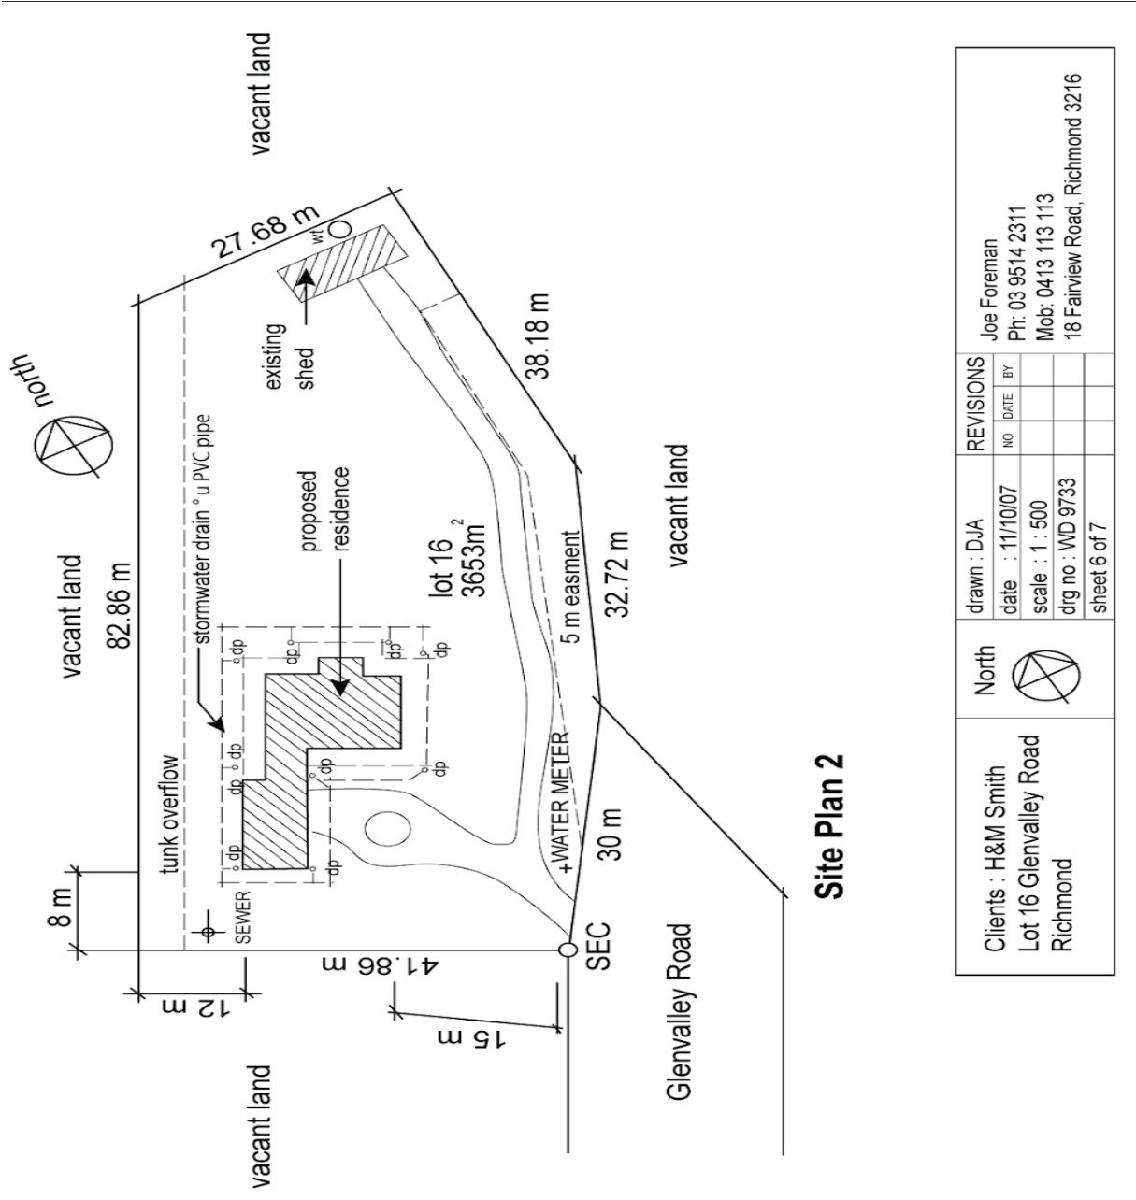

Q19. What structure is being built on this site? Tick your response.
Answer ◻
Choice | Possible Answers
x | Residence
◻ | Road
◻ | Shed
◻ | Water meter

Q20. What is the Lot number of this site?

Answe r
Lot 16
◻

Q21. What is the size of this lot?

Answe r
3653m2
◻

Q22. Is the shed at the north-east of the proposed structure to be removed or retained? Tick your response.

Answer ◻
Choice | Possible Answers
◻ | Removed
x | Retained

Q23. True or False (Tick your response): The sewer is at the eastern boundary of the property.

Answer ◻
◻ | True
x | False

Q24. True or False (Tick your response): The driveway is located to the south of the proposed property.

Answer ◻
x | True
◻ | False

Q25. What size is the easement on the eastern boundary of the site?

Answe r
5m
◻

Q26. True or False (Tick your response): The stormwater drain is constructed from PVC pipe.

Answer ◻
x | True
◻ | False

Refer to the contour plan below to respond to Q27. to Q28.

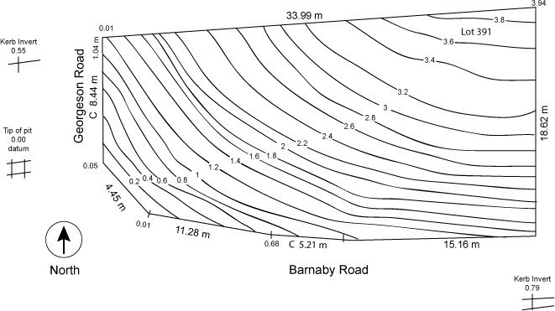

Q27. What is the level at the northernmost point of the site?

Answe r
3.94
◻

Q28. Which end of the site has the lowest level? Tick your response.
Answer ◻
Choice | Possible Answers
◻ | East
x | West

Refer to the sectional drawing below to respond to Q29. to Q49.
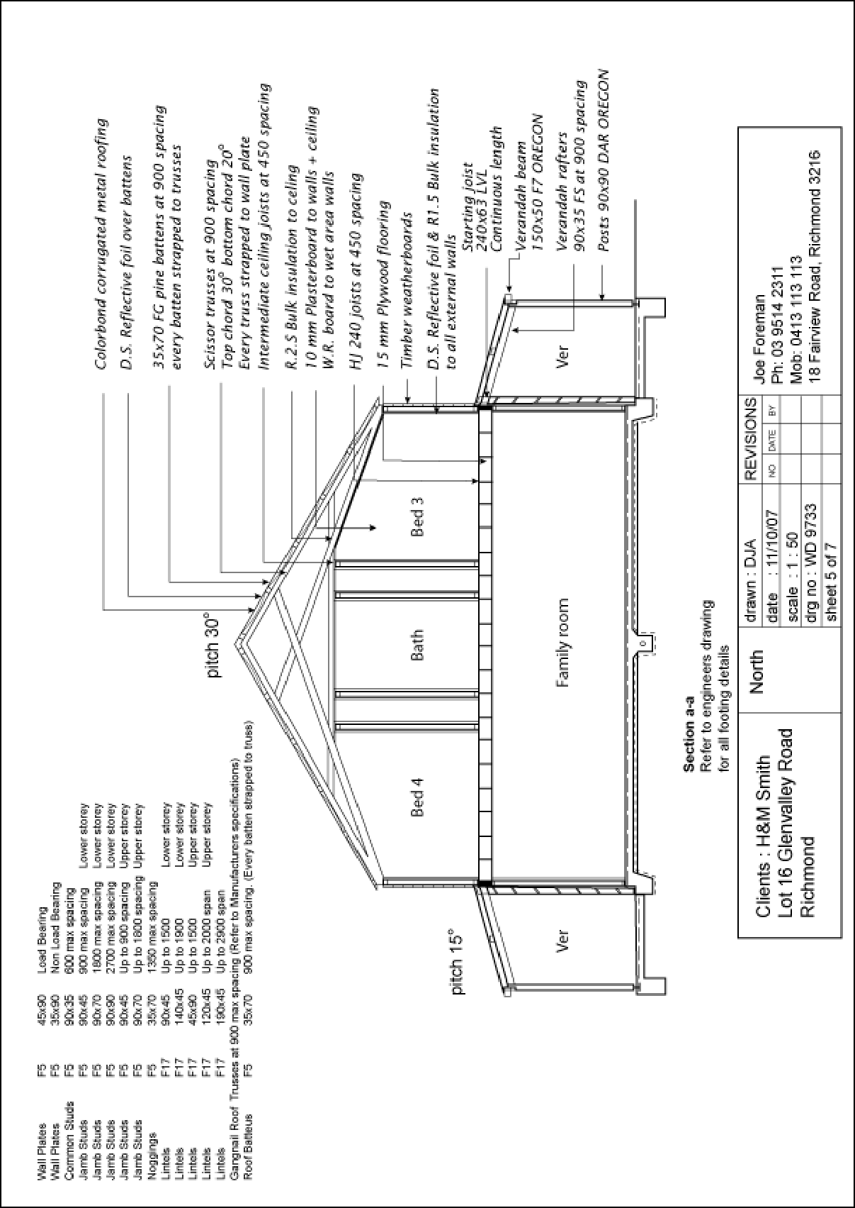

Q29. Give a brief description about the building from the detail available in the sectional drawing. Is it the same structure proposed in Q19. to Q26.?

Answe r
This is a section detail of structure proposed in Q19. to Q26. This indicates a section through the entire building.
It shows the size and thickness of structural members. Following details indicate in this section:
- Position of bed, bath, verandah and family room
- Roof detail including roof materials, size of battens, spacing of trusses and joists,roof pitch
- About ceiling and wall material details
- Floor material and spacing details
- Size of wall plates, size and spacing of common studs, jamb studs, size and span of lintels, size and spacing of roof battens
◻

Q30. Who is the client?

Answe r
H & M Smith
◻

Q31. Where is this project to be built?

Answe r
Lot 16, Glenvalley Road, Richmond
◻

Q32. What are the contact details for the draftsman?

Answe r
Joe Foreman
Ph: 03 9514 2311
Mob: 0413 113 113
◻

Q33. What sheet number is this drawing?

Answe r
Sheet 5
◻

Q34. What timber is required for loading and non-load bearing walls?

Answe r
Timber weatherboards
◻

Q35. What spacing is recommended for common studs?

Answe r
600mm max spacing
◻

Q36. What type of roof truss is to be installed?

Answe r
Scissor truss Gangnail roof trusses
◻

Q37. What centres are the trusses positioned at?

Answe r
Wall plate
◻

Q38. What size are the veranda posts?

Answe r
90mm x 90mm
◻

Q39. What timber species are the veranda posts to come from?

Answe r
DAR OREGON
◻

Q40. What pitch is the roof?

Answe r
Pitch 30 degrees, pitch 15 degrees for verandah
◻

Q41. What size are the noggings and at what spacing?

Answe r
35mm x 70mm - 1350mm max spacing
◻

Q42. What size are the ceiling joists?

Answe r
at 450mm spacing
◻

Q43. What timber is used for roof battens and what spacing?

Answe r
FG pine battens at 900mm spacing
◻

Q44. What thickness is the plasterboard sheeting?

Answe r
10mm
◻

Q45. What type of flooring is to be installed?

Answe r
Plywood flooring
◻

Q46. What is the roof cladding material?

Answe r
metal
◻

Q47. Where will you find information about the footings?

Answe r
Engineering drawings
◻

Q48. What do the letters ‘DAR’ refer when timber ordering?

Answe r

Timber that has been dressed all round ie on all surfaces.
◻

Q49. Explain what ‘240 x 63 LVL’ refers to on the sectional drawing. What do the letters ‘LVL’ refer to?

Answe r
laminated veneer lumber (LVL) Thickness 63mm
Depth 240mm
◻

Refer to the drawing below to respond to Q50. to Q65.
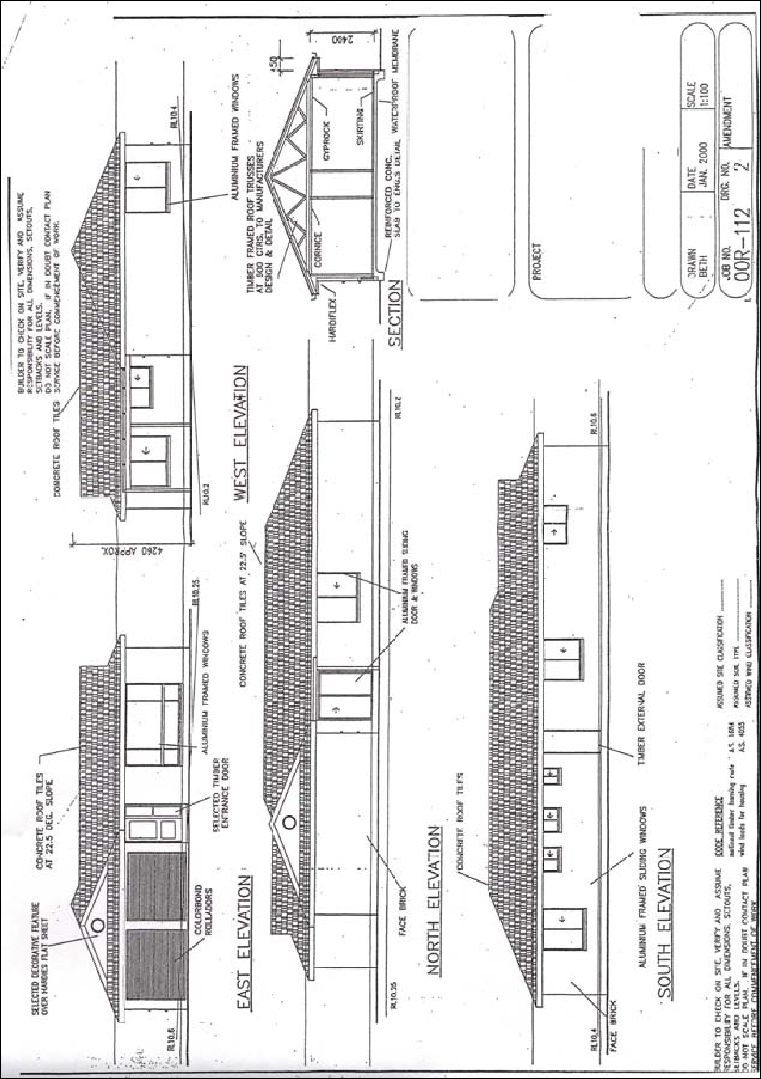

Q50. What is the number of the drawing?

Answe r
2
◻

Q51. What is the Job Number?

Answe r
00R-112
◻

Q52. What is the scale of the drawing?

Answe r
1:100
◻

Q53. What does the drawing show?

Answe r
East elevation, west elevation, south elevation, north elevation and section detail of the building
◻

Q54. Which view shows the front of the house?

Answe r
East elevation
◻

Q55. How many motor vehicles can be parked in the garage?

Answe r
2
◻

Q56. What are the window and doors made from?

Answe r
Timber, Aluminium,
◻

Q57. What is the size of the eaves?

Answe r
450mm
◻

Q58. What are the eaves lined with?

Answe r
Hardflex
◻

Q59. What type of roof structure is the roof built from?

Answe r
Timber framed roof trusses
◻

Q60. Which Part of the NCC should be read for more detail about the requirements for the roof structure in Q59.?

Answe r
Part 3.11.6
◻

Q61. Which Australian Standard should be read for more detail about the roof structure in Q59. ?

Answe r
AS 1720
◻

Q62. What is the roof cladding materials made from?

Answe r
concrete roof tiles
◻

Q63. Which Part of the NCC should be read for more detail about the roof cladding materials in Q62. ?

Answe r
Part 3.5.1
◻

Q64. Which Australian Standard should be read for more detail about the roof cladding materials in Q62. ?

Answe r
AS 2049
◻

Q65. What is the roof pitch?

Answe r
22.5 deg.
◻

Q66. Identify one (1) regulatory body you may need to submit plans to for approval?

Answe r
City council
◻

Q67. Briefly describe the approval process and timeframes for an approval through the regulatory body in Q66.

Answe r
All Class 1a buildings need building approval.

You can arrange for building approval of your new house through a building certifier. You must give the certifier scaled and detailed plans prepared by a draftsperson or architect.

Your certifier can seek a relaxation of some building requirements (e.g. minimum distances from side boundaries). This is a request to Council for a Building Work Referral Agency Response for consideration of the design and siting provisions of the Queensland Development Code (QDC).

DA process can take anywhere between 2 weeks and 4 months in accordance with the statutory timeframes.
◻

Q68. What is a prime cost (PC) item? Give an example.

Answe r
A PC item is:
- An amount of money included in a contract sum to purchase a specified item such as tiles, taps, doors or bathroom fittings
- An agreed estimated amount is included at contract signing but the specific products are not selected until a later stage
- A builder must estimate the cost of such items at or above the lowest amount these items could reasonably cost

For example if a client selects a more expensive door than allowed by the PC item, say a $500 door compared with a $440 PC amount, a variation will be required to cover the additional $60. If the PC item varies, so will the final contract sum.
◻

Q69. What is a provisional sum (PS) item? Give an example.

Answe r
A provisional sum is:
- An amount of money included in contract sum to cover work and/or materials, not detailed when entering the contract
- Typically builders will include a PS for site work costs
- The builder is legally required to take reasonable steps to ensure an accurate site works cost estimate but unforeseen events mean that the provisional sum is exceeded which is added to the contract sum

For example a building site may seem sandy and clean with minimal siteworks required, however, there may be large limestone rocks/tree trunks concealed below the surface which only emerge once siteworks commence, causing cost overrun.
◻

Refer to the Bill of Quantities below to respond to Q70. to Q76.

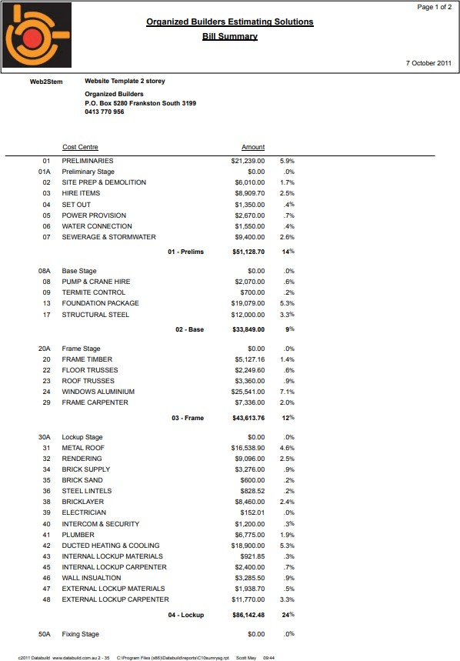

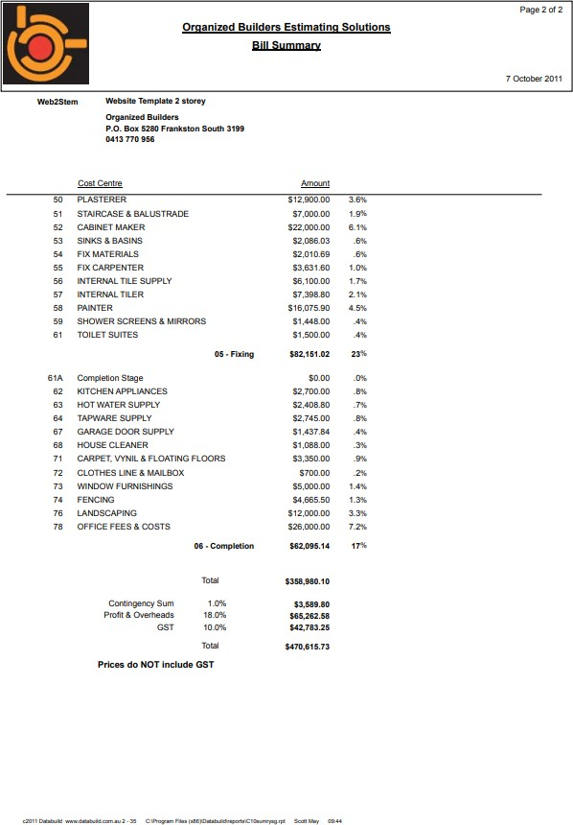

Source: http://organizedbuilders.com.au/sites/default/files/BOQ-Summary.pdf

Q70. True or False (Tick your response): This Bill of Quantities represents a job for a two-storey house.

Answer ◻
x | True
◻ | False

Q71. Identify two (2) materials being used for the floors?

Answe r
carpet and vynil
◻

Q72. True or False (Tick your response): A landscaper has been contracted for this job.

Answer ◻
x | True
◻ | False

Q73. How much does the contracted plasterer cost?

Answe r
$12,900.00
◻

Q74. How much do the kitchen appliances cost?

Answe r
$2,700.00
◻

Q75. What percentage of the total cost does the fixing stage represent of the building contract?

Answe r
23%
◻

Q76. What percentage of the total cost does the completion stage represent of the building contract?

Answe r
17%
◻

Refer to the Purchase Order below to respond to Q77. to Q82.

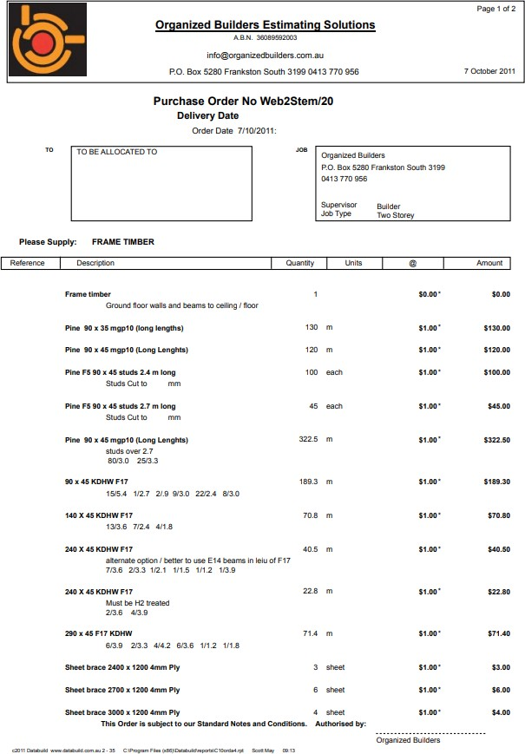
Source: http://organizedbuilders.com.au/sites/default/files/Databuild-Bill-of-Quantities.pdf

Q77. How many Pine F5 90 x 45 studs (2.4m long) are required?

Answe r
100
◻

Q78. If the material in Q77. increased in cost to $2.75 each, what would be the total cost for this material?

Answe r
$10,275.00
◻

Q79. How many sheet of ply are required in total (i.e. all sizes)?

Answe r
13
◻

Q80. What material has the highest total cost?

Answe r
Pine 90 x 45 mgp10(long lengths)
◻

Q81. How many metres are required of the material in Q80. ?

Answe r
322.5m
◻

Q82. What beam is identified as being a better option than F17?

Answe r
E14 beams
◻

Refer to the labour chart below to respond to Q83. to Q86.
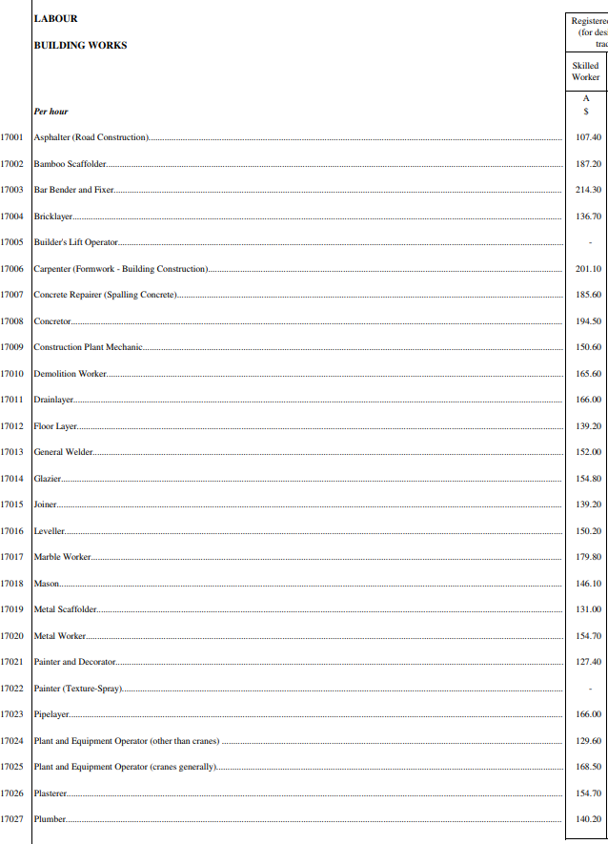
Source: https://www.archsd.gov.hk/media/89170/sor2013_vol1_builders_works_2013_11_04.pdf

Q83. Based on the hourly rates given, which is the least expensive trade to contract?

Answe r
Asphalter (Road construction)
◻

Q84. If the trade in Q83. were to be contracted for two (2) hours’ work, how much would this cost?

Answe r
$214.80
◻

Q85. Based on the hourly rates given, which is the most expensive trade to contract?

Answe r
Bar bender and fixer
◻

Q86. If the trade in Q85. were to be contracted for six (6) hours’ work, how much would this cost?

Answe r
$1,285.80
◻

Q87. Name the building legislation (Act and Regulations) that apply within your jurisdiction and should be referenced when reading plans and building contracts.

Answe r
Queensland Building and Construction Commission Act 1991 Queensland Building and Construction Commission Regulation 2018
◻


READ
CPCCBC4012B
AND
INTERPRET
PLANS
AND
SPECIFICATIONS

PRACTICAL ASSESSMENT INSTRUCTIONS

- The following practical assessment will require the Participant to complete work related activities.
- The Assessor will conduct observations of the Participant’s work to determine whether they display sufficient practical skills and knowledge.
- Please fill in the details below – providing your name, signature and date of assessment.
  - The Participant’s signature acknowledges that the Assessor provided clear instructions and the Participant understood what was required to complete this assessment.
- The Assessor may substitute a Practical Task with an alternate task of equal value.
  - Alternate tasks must be fully documented by the assessor in the Assessor Comments area.

Participant name UAA Darshika Participant signature Dars³ika
Date 02/02/2021

Assessor name Myles Walder Assessor signature

Date Click here to enter a date.

Task | Task outcome (Tick)
Task | Satisfactory | Not Yet Satisfactory
Task 1 (Occasion 1) | ◻ | ◻
Task 1 (Occasion 2) | ◻ | ◻

ASSESSOR COMMENTS

INTERPRET
CPCCBC4012B
READ AND
PLANS AND
SPECIFICATIONS

Practical Task 1 (2X)
Description of task:
On two (2) occasions, a suitable observer is to verify the participant’s ability to read and interpret plans and specifications in order to inform estimation, planning and supervisory activities.
The participant is to gather evidence of how they have completed each component of the Practical Task, which is to be submitted with this Practical Assessment sheet. Evidence to be submitted may include:
- Any drawing with a cloud or mark-up you have inserted.
- Copy of the correspondence regarding mark up and any site management/authorising engineer response.
The observer is to provide detailed comments on the tasks completed by the participant. The assessor is to verify the observer’s comments in the Assessor Comments section, and provide the Practical Assessment outcome on the front
cover of this document.
Resources required:
Drawings (including site plan), Specifications, Tender documentation, Telephone, Facsimile machine, Computer.
Assessment of task
Name of participant: | UAA Darshika
Name of observer:
Role of observer
(Confirm suitability to sign)
Email address of observer
Signature of observer:
Date: | Click here to enter a date.
When completing the task, did the participant: |  | Tick if satisfactorily completed.  Provide comments if left unticked.
 |  | 1st  Occasion | 2nd  Occasion
1 Interpret drawings
1.1A. Identify purpose and advantage of different types of drawings. |  | ◻ | ◻
1.1B. Identify different aspects of drawings. |  | ◻ | ◻
- C. Identify, understand and apply:  - Commonly used symbols and abbreviations  - Common building and construction terms on drawings |  | ◻ | ◻
1.1D. Identify building site from location drawings. |  | ◻ | ◻
- E. Identify on the site plan:  - True north  - Building orientation  - Key features in relation to building and other structures  - Levels  - Contours  - Service entry points  - Site features to be removed or retained |  | ◻ | ◻

1.1F. Identify key features of plans, elevations and sections. | ◻ | ◻
1.1G. Identify client requested variations to standard plans on drawings. | ◻ | ◻
2 Interpret specifications
1.2A. Identify and correctly apply Provisional Sum (PS) and Prime Cost (PC)  values. | ◻ | ◻
1.2B. Identify and confirm customer variations to standard specifications and  communicate changes to organisational personnel. | ◻ | ◻
1.2C. Apply and communicate correct interpretations of essential elements to  estimation, planning and supervisory tasks (including labour hours/costs and material quantities/costs). | ◻ | ◻
1.2D. Identify Building Codes or standards affecting the work to be undertaken (including references to Australian Standards and the National Construction Code). | ◻ | ◻
1.2E. Identify key features of products included in the specification, including the design, purpose, aesthetics and cost relationships. | ◻ | ◻
3 Communicate with others
1.3A. Consult with industry professionals, clients, organisational personnel  and appropriate local authorities. | ◻ | ◻
- B. Effectively communicate using the following methods:  - Verbally using language/concepts appropriate to cultural differences  - Non-verbal communication  - Using technology (including telephone, facsimile, email) | ◻ | ◻
The Participant’s performance was: ◻ Satisfactory ◻ Not Satisfactory
OBSERVER COMMENTS

