TENDER SUBMISSION

Hamilton Hayes Henderson Architects
22 March 2024
5 COTTONWOOD PLACE OFFICE DEVELOPMENT (D&C)

Date 22/03/2024.

Mr Robert Divens
Director and Partner
Hamilton Hayes Henderson Architects
8 Pacific Avenue
Miami QLD 4220

Dear Robert

RE: Tender Submission for 5 Cottonwood Place Office Development (D&C)

Alder Constructions are pleased to submit our Design & Construct tender proposal for the above-mentioned project, aligning with the provided documentation and clarifications outlined within our offer. Alder Constructions is a reputable construction company with 20 years of experience in delivering high-quality projects on time and within budget. We are confident in our ability to execute the 5 Cottonwood Place Office Development project requirements to the highest standards, aiming to meet your expectations.

Tender Sum (excluding GST) $6,947,497.00
GST 10% $694,749.70
Tender Sum (including GST) $7,642,246.70

1 ASSUMPTIONS & INCLUSIONS

In the development of our offer, we have made the following Inclusions:

  - This offer is based on the documentation provided during the tender period received up to the 01st March 2024.

  - Our design fees are based on the provided fee matrix, assuming all necessary scopes required by Alder are included. We’ve considered all services and deliverables expected by Alder and adjusted our pricing accordingly to ensure alignment and transparency throughout the project.

  - Clear and unimpeded access to the site will be provided at all times. Any modifications to this arrangement may impact our delivery schedule and/or incur additional costs.

  - We have incorporated an estimate for the connection fees to GCCC assets into our Lump Sum amount, which may be adjusted based on the final charges determined by GCCC. We highly recommend initiating these works promptly, considering the potential delays often experienced in council processes due to their substantial workload.

  - We have based out D&C fee on a proposed D&C duration of 30 weeks. Refer attached Program

  - Our pricing is inclusive of all the work outlined in this tender document. Should specific elements be chosen and excluded from our scope of work, we retain the right to reassess our pricing, methodology and sequencing accordingly.

  - We have assumed that all services are adequately capacitated and readily available directly outside the site boundary. Our offer does not include provisions for service upgrades, and only those services indicated on the preliminary design drawings have been considered.

  - Our tender is valid for a period of 60 days from the date of this offer.

- EXCLUSIONS

We have excluded the following items from our D&C price:

  - Infrastructure Charges

  - Supply authority fees and charges.

- ADDENDA

Addendum No and Description | Date Received
N/A

Should our offer be under consideration, we would welcome the opportunity to review the agreement’s contents with you in detail.

Our preferred procurement model for this project is an 80% Guaranteed Maximum Price (GMP) Design and Construct (D&C) Offer. Our project timeline indicates subcontractor engagement beginning at a 60% level, with design activities continuing as the GMP is finalised. This approach to the GMP ensures that the Principal benefits from competitive pricing within the subcontractor market while expediting project completion.

Upon submission of our D&C offer, we will provide complete transparency by disclosing all proposed subcontractors.

Should you have any questions or require further discussion on any aspect, please do not hesitate to reach out. We are available to address any queries you may have.

Yours sincerely,
Alder Constructions

Tyanna Childs
Contract Administrator
M: 0434575242 Email: Tyanna.childa@aldercon.com.au

Table of Contents
ATTACHMENTS………………………………………………………………………………………………………………………… 5
APPENDIX 1 – CONTRACTOR DETAILS………………………………………………………………………….. 6
APPENDIX 2 – OFFER BREAKUP……………………………………………………………………………………. 7
APPENDIX 3 – SCHEDULE OF ALTERNATIVESOLUTIONS / COST SAVINGS…………………….. 10
APPENDIX 4 – PRELIMINARY PROGRAM………………………………………………………………………. 11
APPENDIX 5 – CONSTRUCTION METHODOLOGY………………………………………………………….. 13
ANNEXURE 1 – SITE LAYOUT PLAN……………………………………………………………………… 26
APPENDIX 6 – PROJECT EXPERIENCE…………………………………………………………………………… 28
APPENDIX 7 – INSURANCE CERTIFICATES……………………………………………………………………. 37
APPENDIX 8 – CAPABILITY STATEMENT………………………………………………………………………. 41

Appendix 1
Contractor Details

Alder Constructions has solidified its reputation as a leader in civil and infrastructure development, leveraging over 20 years of industry experience. Our growth trajectory has been marked by the evolution of a distinctive business mode, encompassing both civil engineering and construction divisions. This integrated approach equips us with the versatility and expertise needed to successfully deliver a wide range of complex and high-quality projects.

Our capabilities span the spectrum of civil and infrastructure endeavours, encompassing everything from earthworks, road construction, and bridge development to marine infrastructure, treatment plants, and specialised remediation projects. Additionally, we have garnered recognition for our excellence in constructing architecturally sophisticated commercial buildings across various sectors, a testament to our commitment to delivering exceptional quality and attention to detail.

Company Name: | Alder Constructions Pty Ltd
ABN: | 31 106 657 470
Address: | 116 Siganto Drive, Helensvale QLD 4212
Authorised representative: | Tyanna Childs  0434 575 242 | Tyanna.childs@aldercon.com.au
Phone Number: | 07-5514 4900
Email: | mail@aldercon.com.au
QBCC Licence No: | 1066 730
QBCC Licence Details:

Appendix 2
Offer Breakup

PROJECT: 5 COTTONWOOD PLACE OFFICE DEVELOPMENT
TENDER: ALDER CONSTRUCTIONS PTY LTD
DATE: 22/03/2024

 |  | TOTAL
 | TRADE BREAKUP | Excl GST
DIRECT COSTS
1 | Civil Earthworks and Roadworks | $ 190,705.00
2 | Civil Stormwater | $ 181.400.00
3 | Concrete Place Package | $ 114,900.00
4 | Formwork | $ 317,421.00
5 | Reo Steel Supply | $ 143,386.00
6 | Concrete Supply and Testing | $ 108,868.00
7 | Concrete Grinding & Honing | $ 17,221.00
8 | Reo Steel Fix | $ 69,955.00
9 | Brick & Block Work | $ 163,370.00
10 | Structural Steel | $ 351,840.00
11 | Metal Roofing & Cladding | $ 231,320.00
12 | Sheet Metal and FC Cladding | $ 430,176.00
13 | Aluminium Windows & Doors | $ 545,744.00
14 | Roller Doors & Shutters | $ 8,800.00
15 | Architectural Metalwork | $ 241,005.00
16 | Doors, Frames, and Hardware Supply | $ 47,750.00
17 | Ceilings, Partitions, and Fitout Carpentry | $ 411,549.00
18 | Waterproofing | $ 16,520.00
19 | Painting | $ 33,640.00
20 | Toilet Partitions | $ 14,025.00
21 | Glazed Partitions | $ 72,715.00
22 | Tiling Supply and Lay | $ 51,730.00
23 | Floor Mats, Tactiles and Stair Nosing | $ 10,502.00
24 | Joinery and Fitments | $ 15,040.00
25 | Statutory Signage | $ 2,024.00
26 | Electrical and Data | $ 427,520.00
27 | Dry Fire Protection | $ 69,500.00
28 | Hydraulic Works | $ 231,601.00
29 | Sanitary Fixtures & Fittings | $ 40,038.00
30 | Mechanical Services | $ 370,707.00
31 | Lift Services | $ 145,000.00
32 | Landscaping Package | $ 22,216.00
PRELIMINARIES
33 | Bonds, Guarantees and Insurances | $ 69,247.00
34 | Other mobilisation costs | $ 55,105.00
35 | Staff | $ 609,846.00
36 | Survey | $ 23,000.00
37 | General Running Costs | $ 53,848.00
38 | Cleaning and Rubbish Removal | $ 62,386.00
39 | Plant and Equipment | $ 52,130.00
40 | Scaffold and Access | $ 213,789.00
DESIGN AND APPROVALS
41 | Consultant Fees | $ 202,096.00
42 | Fees & Approvals | $ 59,802.00
OVERHEADS AND MARGIN
43 | Overheads and Margin | $ 629,460.00
Sub-Total |  | $ 6,947,497.00
Total (Excluding GST) |  | $ 6,947,497.00
Goods and Service Tax (GST) |  | $ 694,749.70
TOTAL (Including GST) |  | $ 7,642,246.70

D&C Offer Breakup Clarifications

The following clarifications apply to our D&C budget estimate:

- INCLUSIONS
Please note that our D&C Estimate encompasses the following:

  - Consultant fees for IFC & Construction as details in the Fee Matrix provided.
  - Q-Leave
  - Plumbing application and inspection fees.
  - Operational Works assessment fees.
  - BA Application fees.
  - Service connection application and permit fees (GCCC).
  - Rerouting existing services as depicted on plans.
  - High level pad footings
  - Mechanical and electrical services.
  - Wall tiles in amenities to 2m AFL.
  - The following PC Rates:
    - Wet area wall tile supply at $49.50/m²
    - Wet area floor tile supply at $49.50/m²
    - Balcony tile supply at $71.50/m²
    - Lobby tile supply at $55.00/m²

- EXCLUSIONS
Please note that our D&C Estimate does not include the following:

  - GST.
  - Infrastructure Charges.
  - Supply authority fees and charges.
  - Infrastructure charges.
  - Authority connection fees.
  - Any payments to Veolia Waste Services.
  - Upgrade existing infrastructure.
  - Rerouting existing inground services not shown on plans.
  - Water meter.
  - Gas services.
  - Contaminated material treatment and removal.
  - Acid Sulfate Soils.
  - Transformers, HV works, Energex fees and charges.
  - Carpark lighting.
  - Foundation piling (if required).
  - Internal partition walls between indicative tenancies (shown dashed on plans).

Appendix 3
Schedule of Alternative Solutions / Cost Savings

ALTERNATIVE | SAVINGS
Realign Level 2 columns over Level 1 columns | $31,800.00
Delete blade walls to North and South facades | $165,000.00
Replace Cemintel Barestone and Territory with painted FC | $109,000.00
Replace Louvreclad blades with local alternate supplier | $63,000.00
Delete louvre windows on North and South facades | $31,000.00
Replace honed blockwork to core with tiled blockwork | $13,000.00
Replace internal glass walls with plasterboard | $27,000.00
Delete exposed beams/coffering from ceilings and soffits | $72,000.00
TOTAL SAVINGS | $511,800.00

ATTACHMENTS

Appendix 4
Preliminary Program

(To be attached when compiling documents in Adobe)

ATTACHMENTS

Appendix 5
Construction Methodology

(To be attached when compiling documents in Adobe)

ATTACHMENTS

Appendix 6
Project Experience

(To be attached when compiling documents in Adobe)

Relevant Project Experience
Alder Constructions showcases a wealth of experience in successfully executing projects within live operational settings, often characterised by tight site constraints, the need for pedestrian diversion and management, and substantial stakeholder and community engagement.
We possess a deep understanding of risks inherent in commercial construction and live environments, and we have full confidence in our skilled workforce to execute projects safely and efficiently.
Below, we present the following projects as evidence of our capability to navigate live operational environments while ensuring safe access to surrounding businesses and services.

PROJECT EXPERIENCE – SUMMARY
 | Scope
 | Design & Construct | New Build | Amenities & Communal Facilities | Carparking & Civil Works | Live Operational Environment | Tight Site Constraints | Traffic / Pedestrian Management
The York Commercial Precinct | 
M1 Connect Business Hub
Alder Place
Colas Office – Gold Coast
Energex Greenslopes Redevelopment
Energex Stafford Depot
Cleveland District State High School – New tuckshop & Engagement Centre

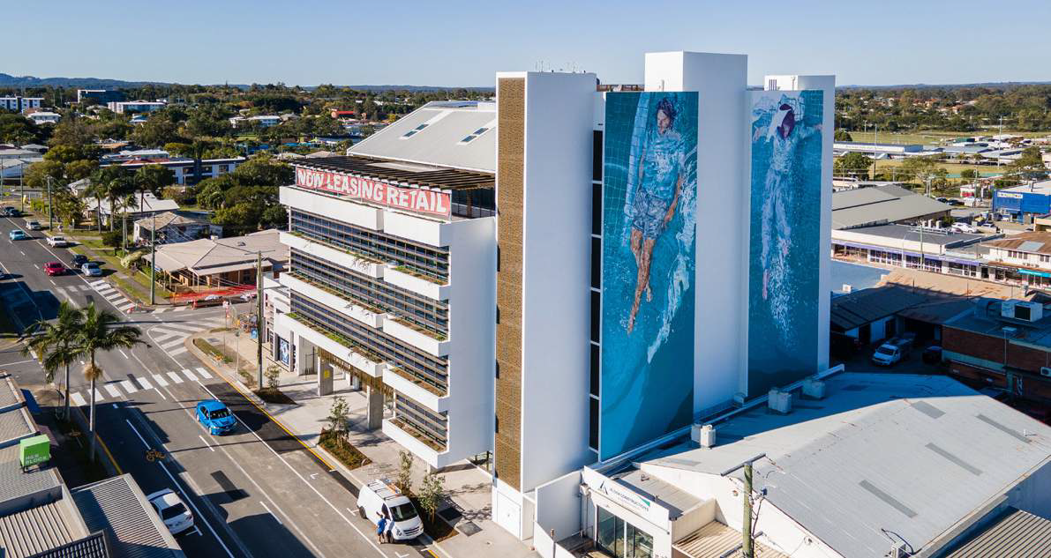
The York Commercial Precinct

The development is inspired by the vision to revitalise Beenleigh as a compact and vibrant hub for the surrounding community.

The York redevelopment is a new mixed-use development comprising a 4,000m², seven storey commercial building project, with ground floor retail space and revitalisation of John Lane. The York will combine premium workspace with small office, home office (SOHO) opportunities and pedestrian access to John Lane. The regeneration of this underutilised space is an important symbol of the
economic and social development in the local Beenleigh area and greater Logan.
WATCH OUR FLY THROUGH VIDEO // https://youtu.be/_PdOl-6AcGA

PROJECT VALUE:
$16.4m
SECTOR:
BUILDING // OFFICE
DELIVERY MODEL:
ECI / DESIGN & CONSTRUCT

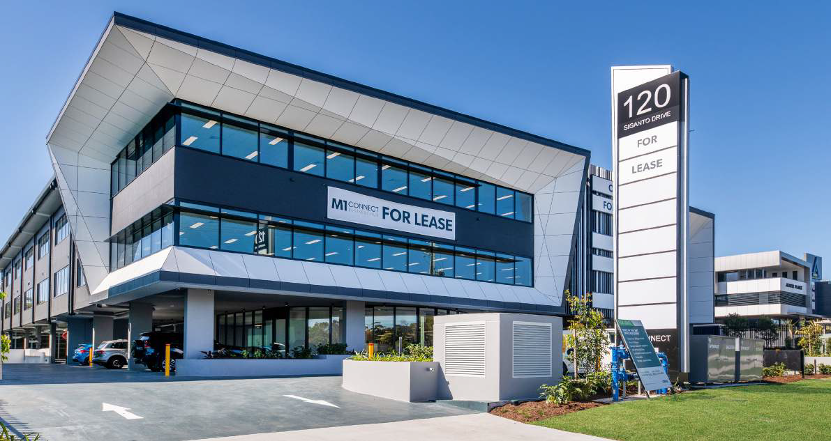

M1 Connect Business Hub

Alder Constructions have teamed up with Alder Developments to deliver the design and construction of a new multi-million dollar A-grade office complex with café facilities and basement parking, boasting 5,682 m² of commercial office space over 3 levels. This project is architecturally designed with high quality finishes, featuring an entry foyer with high level timber batten ceilings and halo lighting, feature entry stairs, full feature tiled floors and lift core areas as well as glazed curtain walls to foyer and internal tenancy frontages, external sunshades and awnings and a prominent facade offering prime exposure to the M1 Motorway.

With combined building and civil capabilities, Alder Constructions completed civil works and associated infrastructure including driveway, footpaths, external hardscaping and soft landscaping of garden areas which have been designed for streetscape beautification.

PROJECT VALUE:
$13.3m
SECTOR:
BUILDING // OFFICE
DELIVERY MODEL:
ECI / DESIGN & CONSTRUCT

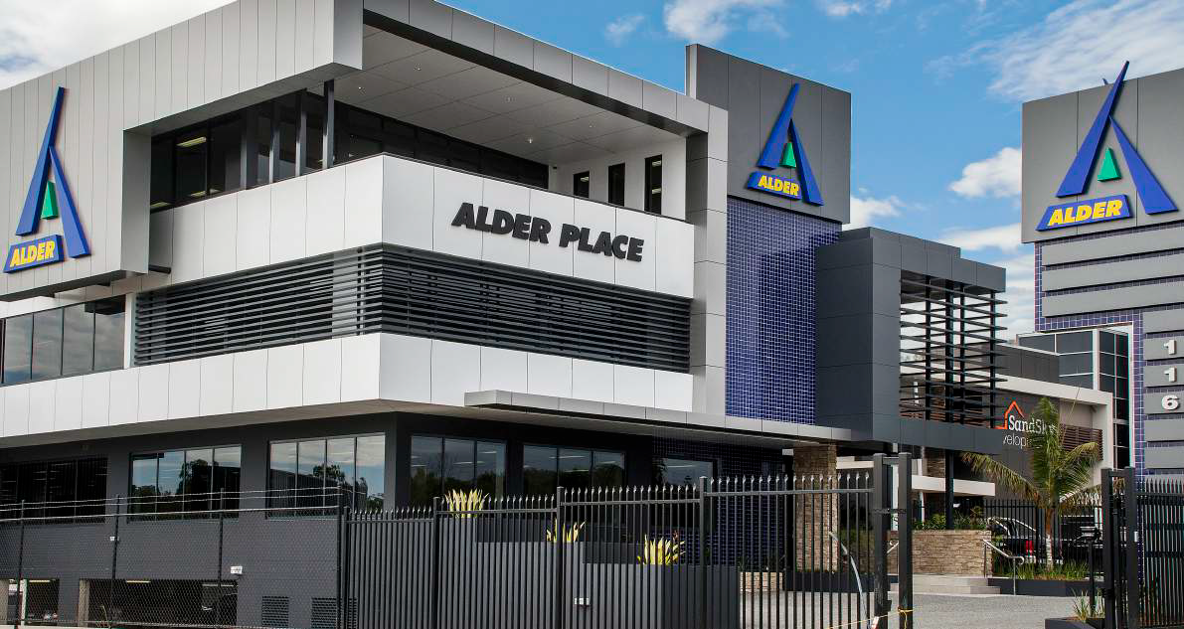
Alder Place

Alder Place is the result of the ongoing success of our company within South-East QLD and Northern NSW construction industry.

Alder Constructions’ employees now enjoy the benefits of a high-quality corporate headquarters. The Alder Place corporate office is located on Siganto Drive, Helensvale and has direct exposure to both the north and southbound view of the M1 motorway.

PROJECT VALUE:
$4.1m
SECTOR:
BUILDING // OFFICE
DELIVERY MODEL:
ECI / DESIGN & CONSTRUCT

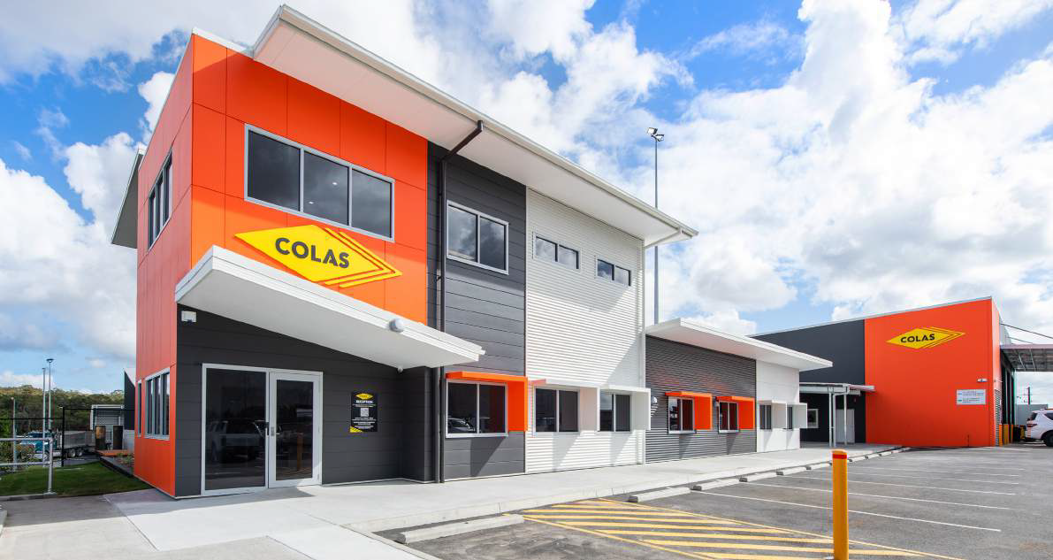
Colas Office – Gold Coast

Alder Constructions was engaged to design and construct Colas’ new office building to cater to their operational requirements and growth in the Gold Coast area. The scope of work included all necessary designs and approvals, concrete and pavement works, building foundations, and the construction of a two-story building with nine offices, meeting and board rooms, a reception area, kitchen facilities, storage room, and amenities. New services, such as drainage, water, electricity, and gas, were also installed. Additional works included extending the existing workshop awning adjacent to the new building and building a covered walkway between the existing workshop and the new office building.

Alder Constructions previously completed the design and construction of Colas’ new Asphalt Batching Plant in 2021.
PROJECT VALUE:
$1.95m
SECTOR:
BUILDING // OFFICE
DELIVERY MODEL:
DESIGN & CONSTRUCT

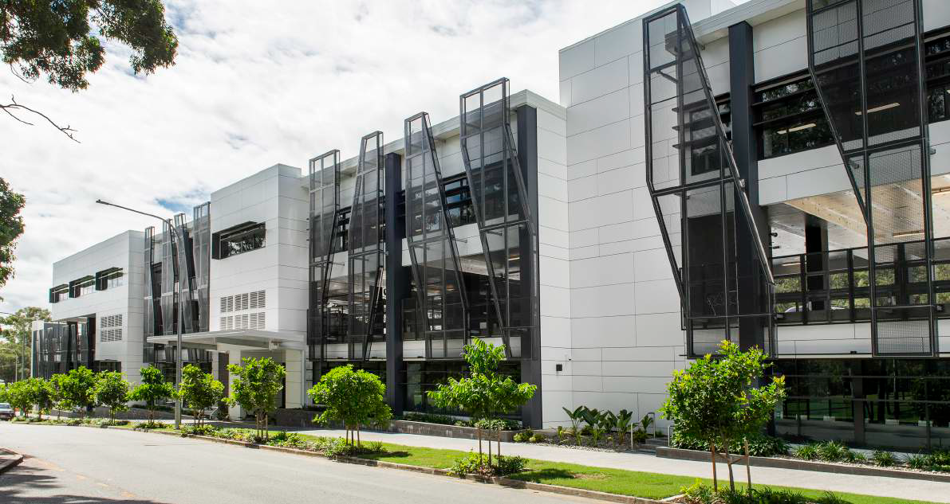
Energex Greenslopes Redevelopment

Alder Construction has delivered the construction of a flagship project for Energex - Greenslopes Redevelopment Project. The multi-million dollar redevelopment of the site features a new 5000m², multi-level office complex plus extensive site improvements, new truck wash bays and streetscape beautification.

The new workspace is home to more than 200 Energex field, design and project staff from the existing depot and other Brisbane locations. The new site increases light vehicle parking to 130, cater for nearly 80 response vehicles and works seamlessly with the existing refurbished 3000m² warehouse.

PROJECT VALUE:
$24.7m
SECTOR:
BUILDING // OFFICE
DELIVERY MODEL:
Construct Only

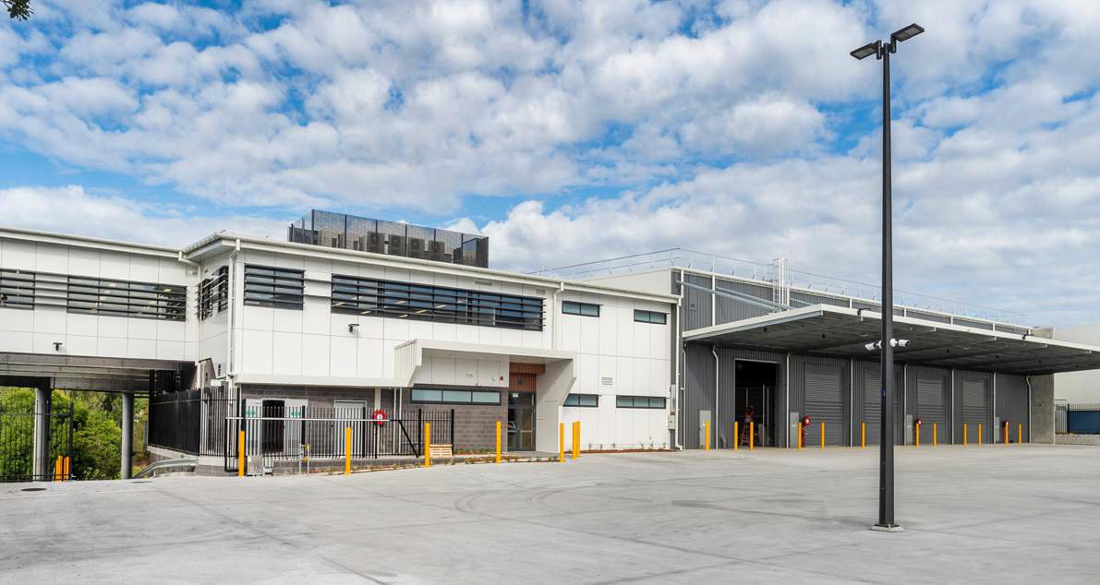

Energex Stafford Depot

Energex’s crews now have improved access to Brisbane’s inner northern suburbs and CBD with the new depot at Stafford completed. The Babarra Street depot is home to over 150 Energex field and support staff allowing them to respond more effectively to emergency outages and network maintenance in Brisbane’s inner north. With the Stafford depot up and running, it houses 40 response vehicles, with a 2,040m² warehouse and 1,290m² contemporary office space.

Alder Constructions worked collaboratively with Ranbury, PDT Architects, Bellas & Reitano and WSP to deliver the new depot and is excited to continue the journey with Energy Queensland on the new Energex Greenslopes redevelopment project.

WATCH OUR FLY THROUGH VIDEO // https://youtu.be/l0zTzaZ9-QY

PROJECT VALUE:
$12.9m
SECTOR:
BUILDING // OFFICE
DELIVERY MODEL:
Construct Only

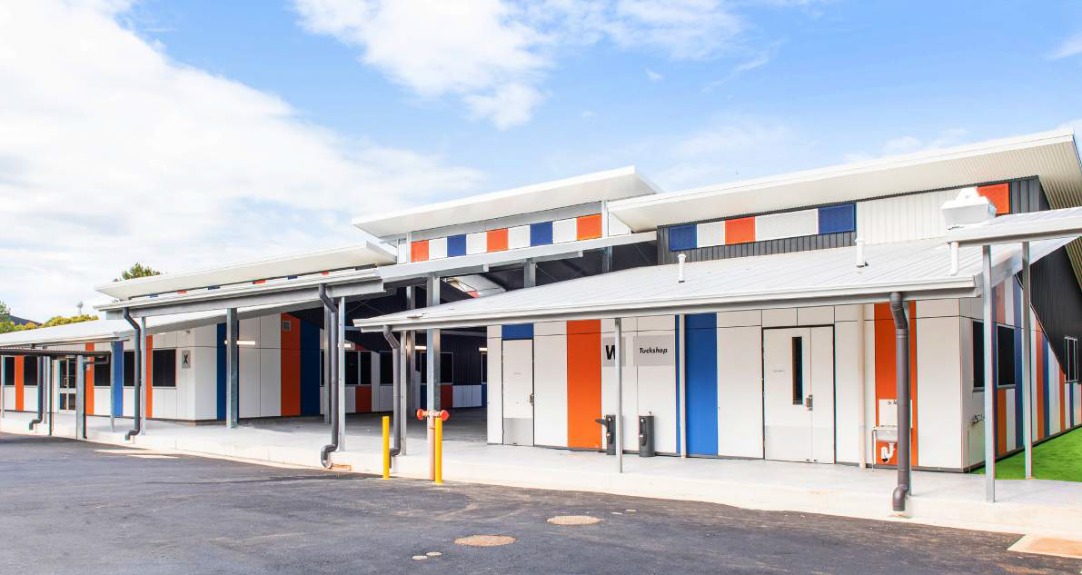
Cleveland District State High School

The project featured the complete design and construction of a new single-storey Tuckshop and Student Engagement Centre. The newly constructed facility comprised eight offices, a conference room, a student kitchenette, a first aid room, and ambulant compliant amenities.

In addition to the main buildings, the project included several minor works such as an outdoor covered area that linked the two new buildings, a new walkway link to a nearby existing block, a new epoxy
footpath, and the demolition and re-asphalting of the current carpark on the site. The works were completed on a site with a tight footprint, requiring detailed coordination and management of all activities.

Despite the tight site footprint, all works were coordinated with strict traffic and pedestrian management prioritising the safety of students and staff while minimising disruptions to school operations.

PROJECT VALUE:
$3.9m
SECTOR:
BUILDING // EDUCATION
DELIVERY MODEL:
Design & Construct

ATTACHMENTS

Appendix 7
Insurance Certificates

(To be attached when compiling documents in Adobe

ATTACHMENTS

Appendix 8
Capability Statement

(To be attached when compiling documents in Adobe)

Capability Statement

