Construction Environmental Management Plan

DOCUMENT DETAILS
CLIENT | CleanCo Queensland Limited
PROJECT | Swanbank BESS
WORK REQUEST | WR1853038
DOCUMENT TITLE | Swanbank BESS Construction Environmental Management Plan
CCQ DOCUMENT NUMBER | SBK-F-175-2000-013
YUR DOCUMENT NUMBER | SBK-F-YUR-ENV-PLN-0002
CURRENT REVISION | A

ENDORSEMENT AND APPROVAL
At Rev A | Authored By | Endorsed By | Approved By
Name | Sooty Phomsouvanh | Eddie Connellan | Brendon Watts
Title | HSE Specialist | Senior Environmental Advisor | Project Manager
Date | 30/05/2024

Construction Environmental Management Plan - Document Control Record

DOCUMENT CONTROL
Rev | Date | Status | Author(s) & Reviewer
A | 30/05/2024 | Issued for Use | Eddie Connellan

TABLE OF CONTENTS
1 Introduction 6
1.1 Purpose 6
1.2 Distribution, Update and Review 6
1.3 Project Description 7
1.4 HSE Management System Overview 8
2 LEADERSHIP AND COMMITMENT 10
2.1 Policy 10
2.2 Roles and Responsibilities 10
3 PLANNING 13
3.1 Environmental Obligations 13
3.2 Environmental Assessment 13
3.3 Environmental Aspects & Impacts 14
3.4 Legal Requirements 15
3.5 Objectives and Targets 15
4 SUPPORT 16
4.1 Resources 16
4.2 Competency 16
4.3 Training and Awareness 16
4.3.1 Procedure 16
4.4 Communication 17
4.4.1 Procedure (Internal) 17
4.4.2 Procedure (External) 17
4.5 Environmental Documentations 18
4.5.1 Construction Environmental Management Plan 18
4.5.2 Environmental Management Sub-Plans 18
4.5.3 Control of Documents 18
4.5.4 Control of Records 18
5 Operation 19
5.1 Operational Planning and Controls 19
5.2 Incident & Emergency Preparedness and Response 20
5.2.1 Incidents 20
5.2.2 Emergency Preparedness and Response 20
6 PERFORMANCE EVALUATION 20
6.1 Monitoring, measurement, and analysis 20
6.2 Evaluation of Compliance 21
6.3 Internal Audit 22
6.4 Management review 22
7 IMPROVEMENT 22
7.1 Non-conformance and Corrective Actions 22
7.2 Continual Improvement 23
8 Appendices 24
8.1 Appendix 1 – EQL Environmental Sustainability and Cultural Heritage Policy 24
8.2 Appendix 2 – ISO14001:2015 Certificate of Registration 25
8.3 Appendix 3 – Legal Requirement Register 26
8.4 Appendix 4 – Environmental Aspect and Impact Register 29
8.5 Appendix 5 – ISO 14001:2015 Compliance Matrix 32
8.6 Development Approval Conditions: Decision Notice Approval 3590/2023/MCU 33
8.7 Referral agency conditions: Development Permit SARA 2305-34576 34
8.8 Ecological Values: 34
8.9 Appendix 6 – Erosion and Sediment Control Management Plan 37
8.10 Appendix 7 – Weed Management 49
8.11 Appendix 8 – Air Quality and Dust Management Plan 49
8.12 Appendix 9 – Noise and Vibration Management Plan 50
8.13 Appendix 10 – Waste Storage and Disposal 52
8.14 Appendix 12 – Aboriginal Cultural Heritage Management Plan 54

TABLE OF TABLES
Table 1: Roles and Responsibilities 10
Table 2: Level of Risk Calculation 14
Table 3: Objectives and Target 15
Table 4: List of Sub-plans 19
Table 5: Notification Timeframe 20
Table 6: Monitoring Types 21

Introduction

Purpose
This Construction Environmental Management Plan (CEMP) and supporting documents has been developed to:
- Describe the Environmental processes and measures which will be implemented by Yurika during the Swanbank BESS project.
- Comply with Environmental legislative requirements for a construction project.
- Conform with Yurika HSE Management System Manual requirements as outlined in Section 1.4.

Distribution, Update and Review
The latest approved version of this Plan will be available in hardcopy format at the project site office, available to all persons in the workplace undertaking construction work or associated with the construction works.
All persons at the project will be made aware of this Plan and its hardcopy location via the Project Induction, prior to commencing construction work.
Yurika’s Project Manager will electronically distribute updated versions of this Plan to key stakeholders:
The endorsement and version control section of this Plan will be used to track the approval of this Plan, clearly state the most up to date version of the Plan and to summarise key change information relevant to any update of the Plan.
When a new version of this Plan is developed and approved, Yurika will formally communicate the update to workers on the project.
The Project Manager is to maintain, review and update this Plan on a 6-monthly basis as a minimum, or where deemed relevant as a result of:
- Incident actions or learnings.
- Deficiencies or actions derived from audits or assurance (internal, external or client).
- Environmental legislative change.
- Changes to project scope, design or on-site activities.
- Consultation with workers on the project.

Project Description
Entity | Address | Key Contact
Client: | CleanCo Queensland Limited  Level 18, 140 Creek Street, Brisbane QLD 4000. | Rhys Parsons, Project Delivery Manager  0419 773 430
Principal Contractor: | Yurika Pty Ltd (ABN 19 100 214 131)  4/26 Reddacliff St, Newstead QLD 4006 | Brendon Watts, Project Manager  0436 124 934
Project Details
Project Name: | Swanbank BESS
Project Address: | Swanbank Power Station (Access via Memorial Drive)  305-311 Swanbank Road, Swanbank QLD 4306
Anticipated Start Date: | 8 January 2024
Project Duration: | 1 years and 8 months
Brief Project Description: | The scope includes the design, supply, installation, and commissioning of 275kV Battery Energy Storage Systems (BESS).
Project Type: | ☒Design and Construct
Constructions Hours: | 6:30am – 6:30pm, Monday to Saturday and at no time on Sundays or public holidays. Approval for out of hours work is required by CleanCo.
Construction Activities and Sequence
Typically, the following sequences of activities are anticipated:
Site Establishment - installing boundary fencing, construction facilities (e.g., site office, amenities), geotechnical investigations, survey works and access tracks.
Asbestos Removal: Remediation of asbestos contaminated materials. Using Heavy Vehicle for transporting regulated waste material.
Demolition: Demolish of existing concrete foundation, and recycling of steel in foundation and stockpiling. Using Heavy Vehicle for transporting of construction waste.
Earthworks: Installing environmental controls including temporary drainage and temporary sediment controls, undertaking cut and fill works to achieve desired levels, removal of unsuitable material, batter and embankment shaping, importing construction materials.
Structures: Building permanent drainage and capping, below ground services, earth grid construction and foundation construction.
Fire System: Construction of Fire Safety Systems and relevant infrastructure.
Pavement: Forming sub and base layers and construction final pavement finishes.
Electrical Install –BESS Works, and construction of Switchyard, Secondary Systems, Switch Room, Control Room, Switch Room and Overhead Lines.
Commissioning – Testing and commissioning of BESS and Switchyard in readiness and final commissioning in readiness for commercial operation for handover.
Fencing: Construct fencing for BESS boundary.

HSE Management System Overview
The following diagram summarises Yurika’s overarching HSE management system framework
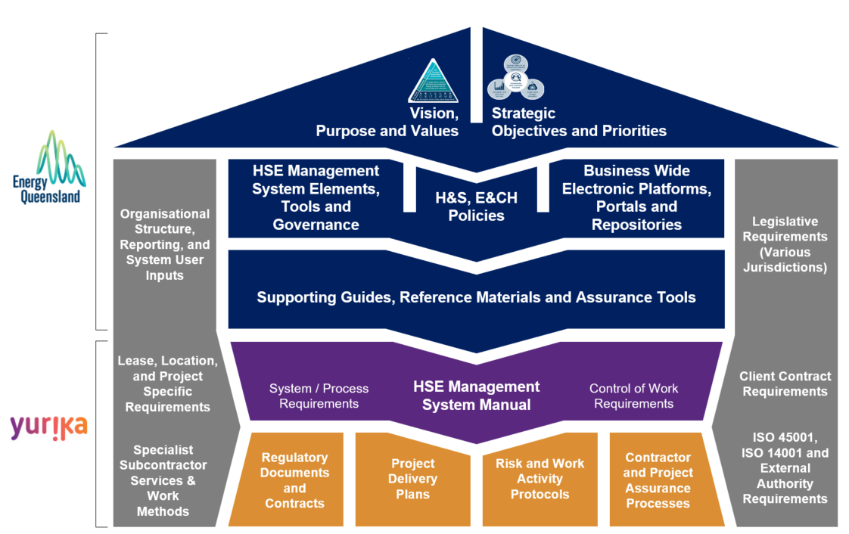
Figure 1 – HSE Management System Framework
This diagram illustrates how:
Colour | Definition
Dark-Blue | Group-wide and whole of Energy Queensland (EQL) requirements provide the overarching principles, direction, system requirements and expectations of Yurika, inclusive of the HSE Policy.
Purple | The HSE Management System Manual sets the HSE standard across Yurika’s operations and projects and these are influenced by internal and external requirements (inclusive of clients, OFSC, ISO45001, ISO 14001, legislation across various jurisdictions; and Yurika personnel).
Orange | Project and work activity specific outputs are developed as a cascade of the Yurika HSEMS Manual requirements and as influenced by client, specialist subcontractors, legislative requirements (unique to that location / activity scope) and management system (OFSC, ISO45001, ISO 14001) output requirements.
Yurika, as a business / subsidiary company within the EQL Group leverage from and align to group / corporate wide processes and requirements where relevant to Yurika activities. As such, Yurika documents and/or outputs may at times be EQL branded, Ergon Energy branded, Energex branded, or Yurika branded if specific to the business.
EQL and its subsidiary companies are currently accredited to operate the HSE IMS which complies with ISO45001:2018 Occupational health and safety management systems and ISO14001:2015 Environment management systems (refer to Appendix 2).
The scope of accreditation involves the provision of planning, design, construction, installation, operation, maintenance and asset management of an electricity transmission and distribution network (Distribution Network Service Provider) and ancillary services including training, metering, generation, laboratory testing and calibration.
The following diagram summarises in greater detail the key elements and protocols (not exhaustive) that constitute the Yurika Health, Safety and Environmental Management System.

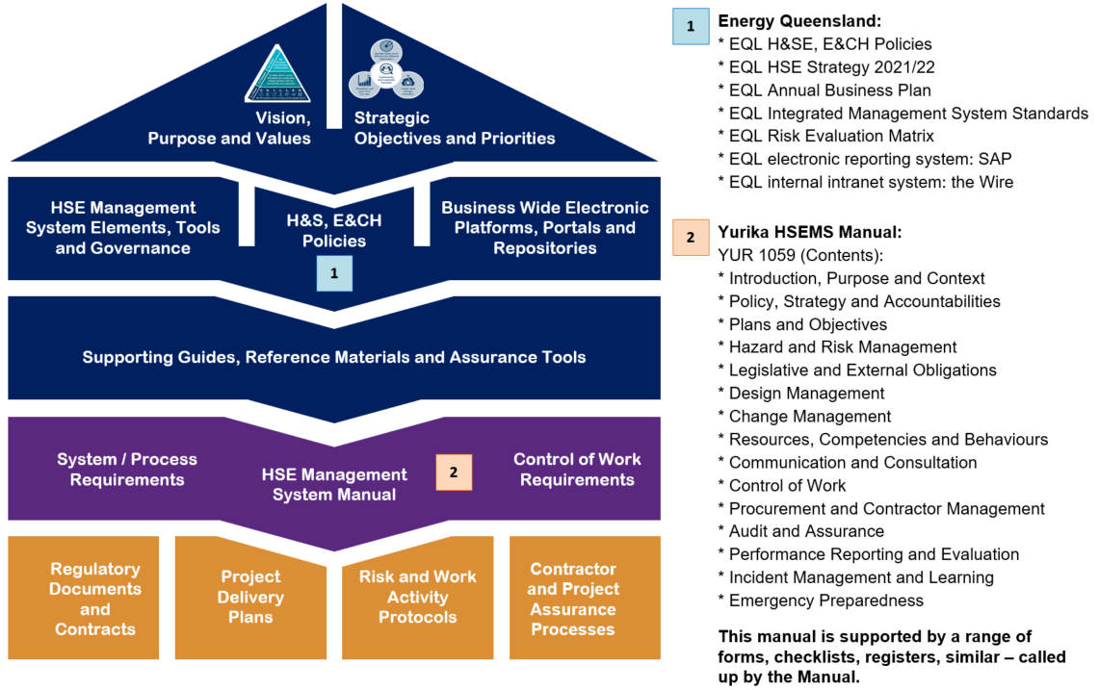
Figure 2 – Yurika HSE Management System Elements

This Construction Environmental Management Plan does not include a duplication of content from the HSEMS Manual elements as listed above. Instead, this plan summarises key requirements and outputs that are relevant to the scope of activities for this project.
Where further information is sought or required, the Project Manager should be contacted so that additional HSE Management System Manual information can be provided.

LEADERSHIP AND COMMITMENT

Policy
The EQL Policy reflects the environmental commitment of Yurika, continued compliance with relevant environmental legislation and regulatory requirements, and ongoing improvement in environmental performance. The policy is reviewed, to ensure that it reflects the ongoing environmental operations commitment of Yurika to continual environmental improvement.
The EQL Environmental Sustainability & Cultural Heritage Policy statements (refer to Appendix 1) apply across all Yurika works and will be communicated as part of the Project Induction.

Roles and Responsibilities
All employees and contractors have a duty not harm human health or the environment under the Environmental Protection Act 1994. Notwithstanding any specifications in the CEMP, the Principal, Contractor and all Sub-contractors must:
• report environmental incidents to their immediate superior and participate in the investigation and corrective action required to reduce environmental harm or the re-occurrence of the incident; and
• comply with the requirements of environmental legislation.
The roles and responsibilities assigned to individual roles outlined Table 1.
Table 1: Roles and Responsibilities
Role | Responsibilities
Project Director / Project Manager | - Ensure all works comply with relevant regulatory and Project requirements.  - Ensure the requirements of this CEMP are fully implemented, and in particular, that environmental requirements are not secondary to other construction requirements.  - Support the environmental policy.  - Liaise with the CleanCo and the Regulatory Agencies as required.  - Participate and provide guidance in the regular review of this CEMP and supporting documentation.  - Provide adequate resources (personnel, financial and technological) to ensure effective development, implementation and maintenance of this CEMP.  - Ensure that all personnel receive appropriate induction training, including details of the environmental and community requirements.  - Ensure that all complaints are investigated to ensure effective resolution.  - Stop work immediately if an unacceptable impact on the environment is likely to occur.
Construction Manager | - Plan construction works in a manner that avoids or minimises impacts on the environment.  - Ensure the requirements of this CEMP are fully implemented.  - Ensure construction personnel manage construction works in accordance with approval requirements.  - Ensure environmental management procedures are implemented.  - Ensure all Project personnel attend the Project Induction prior to commencing works.  - Stop work immediately if an unacceptable impact on the environment is likely to occur.
Environmental Representative i.e. Environmental Lead / Manager and/or project HSE Specialist | - Overall responsibility for the development (including revisions) and implementation of an EMS in accordance with ISO14001.  - Overall responsibility for the development (including revisions) and implementation of this CEMP.  - Provide advice to the Project Team on environmental matters.  - Report to the Project Director and other senior managers on the performance and implementation of the CEMP.  - Ensure management reviews of the CEMP are undertaken.  - Ensure environmental risks of the Project are identified and appropriate mitigation measures implemented.  - Identify where environmental measures are not meeting the targets set in this CEMP and where improvement can be achieved.  - Ensure environmental procedures as outlined in this CEMP are implemented.  - Ensure environmental compliance as outlined in this CEMP.  - Obtain and update all environmental licences, approvals and permits as required.  - Lead liaison with Environmental Representatives from the State and/or Regulatory Agencies as requested by the Project Director.  - Maintain environmental document control, reporting, inductions and training as outlined in this CEMP.  - Undertake environmental auditing including external audits as outlined in this CEMP.  - Undertake environmental auditing as requested from the Regulatory Agencies.  - Oversee monitoring and inspections in accordance with this CEMP.  - Manage all subcontractors and consultants with regards to environmental matters, including assessing their environmental capabilities and overseeing the submission of their environmental documents.  - Prepare and/or distribute environmental toolbox talks, presentation and/or awareness notes if required.  - Review and approve EWMS.  - Develop environmental awareness and Project specific environmental items into the Project Induction.  - Implement training programs regarding environmental requirements for site personnel and subcontractors if required.  - Stop works where there is an actual or immediate risk of harm to the environment, or to prevent environmental non-conformities, and advise the Project Director and Construction Manager.  - Notify the Regulatory Agencies if there is an environmental incident and ensure all corrective items are actioned and completed.  - Assist the Construction Manager to resolve environment related complaints.
Project HSE Specialist | - Assist in preparing the CEMP including any further revision.  - Provide advice to the Project Team and subcontractors on environmental matters.  - Undertake site inspections, monitoring activities and completing checklists and forms.  - Ensure all inspections, corrective actions, and monitoring records are appropriately maintained, reviewed and any non-conformance issues addressed.  - Manage daily environmental aspects of the Project.  - Provide written reports to the Environment Lead of non-conformances and/or corrective actions.  - Assist in developing training programs regarding environmental requirements and deliver where required, including delivery of the environmental component of the toolbox talks.  - Stop works and advise the and Environment Lead and Construction Manager of the need to stop work immediately if an unacceptable impact on the environment is likely to occur.
Project Personnel / Subcontractor | - Comply with relevant requirements of this CEMP as directed.  - Participate in the mandatory Project Induction.  - Report any environmental incidents to the Construction Manager immediately or as soon as practicable and undertake reasonable steps if they can be adopted to control the incident.  - Undertake remedial action as required to ensure environmental controls are maintained in good working order.  - Stop works and advise the Environment Lead and Construction Manager of the need to stop work immediately if an unacceptable impact on the environment is likely to occur.

PLANNING

Environmental Obligations
All construction personnel working on the Project have the following general obligations:
  - A person must not carry out any activity that causes or is likely to cause environmental harm, unless measures to prevent or minimise the harm have been taken.
  - To inform the administering authority and landowner or occupier when an incident has occurred that may have caused or threatens serious or material environmental harm.
  - Minimise pollution of land, air, and water.
  - Use pollution control equipment and keep it in proper working order.
  - Minimum impact on the natural and cultural heritage environment.
  - Give notice to the CleanCo and any relevant Regulatory Agencies of Aboriginal Cultural Heritage, and Historical Cultural Heritage discovery.
  - Minimise the occurrence of offensive noise.
  - Keep CleanCo and community informed of Project milestones, upcoming activities, and duration of relevant aspects of the works.
  - Take all reasonable steps to ensure compliance with the requirements of this EMP.
  - Comply with the requirements of applicable environmental legislation and CleanCo QLD’s Engineering, Procurement and Construction Contract – Balance of Plant Works for the Swank BESS Project.

Environmental Assessment
The planning of the Project has been undertaken and there are several environmental documents that have been produced.
Subsequently through the detailed design phase changes to the alignment location may also be necessary and will not reflect the exact locations that were presented in the following environmental documentation:
- 500MW Concept Design Site Layout Rev A (Aurecon): 3 April 2023
- 500MW Concept Design Elevations Rev A (Aurecon): 31 March 2023
- 500MW Concept Design Site Location Rev A (Aurecon): 1 March 2023
- Swanbank BESS Traffic Impact Assessment Rev B01 (Aurecon): 3 March 2023
- Swanbank BESS Stormwater Management Plan Rev 3 (Aurecon): 3 June 2023
- Swanbank Future Energy and Hydrogen Precinct – Desktop Geotechnical Assessment Doc No. P522045 (Aurecon): 21 July 2022
- Swanbank BESS Hazard and Risk Assessment Rev A (Aurecon): 3 April 2023
- Ipswich City Council Decision Notice Approval (3590/2023/MCU): 14 April 2023
- Ipswich City Council Guideline 24 – Stormwater Management Implementation
- Ipswich City Council Guideline 28 – Dispersive Soil Management Implementation
- Environmental authority (EPPR00750913): 25 May 2020
- Powerlink Referral Agency Response (Advice): 6 June 2023
- SARA Referral Agency Response (305 and 327 Swanbank Road, Swanbank): 21 June 2023
- Energy Queensland Limited’s Environmental Management System: Environmental Standard: Australian Standard AS/NZS ISO 14001

Environmental Aspects & Impacts
A key part of the Environmental Management Plan is the identification of those activities undertaken by Yurika that may significantly impact upon the environment.
In accordance with YUR 1303 Risk and Opportunity Management Procedure, Yurika will apply the risk methodology to determine the Level of Risk (Risk Rating/Score) for activities impacting on the environment and to prioritise its significance.
The risk matrix utilised is a 6 x 6, Likelihood versus Impact configuration. The Risk Matrix (Level of Risk Calculation) is shown in Table 2.
Table 2: Level of Risk Calculation
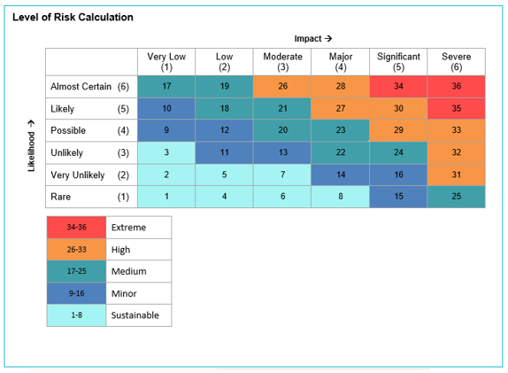
Yurika has established an Environmental Aspects and Impacts Register and is documented in Appendix 4.
The environmental aspects and impacts are reviewed on a 6 monthly basis to ensure that they remain current. The review also considers legislative and other requirements, changes in activities, past performance and other factors such as financial and business requirements.
Refer to the following documents for further details:
- YUR 1303 Risk and Opportunity Management Procedure
- Environmental Aspects and Impacts Register (Appendix 4)

Legal Requirements
A register of legal requirements for the Project is contained in Appendix 3. This register will be managed electronically by the Project and be reviewed on a six (6) monthly basis or when changes occur.
Any changes made to the legal requirements register will be communicated to the Project Team where necessary through Prestart Meeting or Toolbox Talks.
Any environmental compliance update received from Department of Environment, Science, and Innovation (DESI) will be evaluated by the Environmental Manager, whether the legislation is applicable to our construction activities. If determined to be applicable, then corrective action must be undertaken to update the appropriate environmental documents.
Current Legislation and Standards documents can be obtained electronically by navigating through Department of Environment, Science and Innovation website on Environment | Department of Environment, Science and Innovation, Queensland (desi.qld.gov.au) and Australia Standards which is supplied by the parent companies free of charge.
Refer to the following document for further details:
- Legal Requirement Register (Appendix 3)

Objectives and Targets
As a means of assessing environmental performance during construction of the Project, environmental objectives and targets have been established. These objectives and targets have been developed with consideration of key issues identified through the environmental risk assessment process. The objectives and targets are consistent with the Yurika’s policy and will assist in monitoring whether the commitments of the policy are being met.
The targets are incorporated into the relevant environmental management aspects.
Measurement and reporting against these performance targets will be formally undertaken monthly as part of the Project Monthly Report.
Monitoring and analysing trends, positive performance and areas of improvement will form part of monthly project management meetings.
Environmental objectives and targets for the Project are provided in the Table 3.
Table 3: Objectives and Target
Objective | Target | Measurement Tool
Construct the Project in accordance with the environmental management plan | Full compliance with statutory approvals and permits | Audits
Compliance with all legal requirements | No regulatory infringements.  No formal regulatory warning. | Inspections  Audits
Continuously improve environmental performance. | Develop and maintain a program of ongoing environmental training.  Capture lessons learnt from environmental incidents to minimise repeat issues.  Encourage and reward innovation and effort throughout the workforce. | Environmental Training Register  Environmental Incident Investigation  Environmental Innovation Award

SUPPORT

Resources
Yurika has identify specific environmental resources to help achieve it objectives and targets of the CEMP. Resources include qualified and experience environmental specialist and equipment required to control the environmental activities to minimise harm to the natural environment.

Competency
Yurika Environmental Representative must possess an environmental qualification to be competent to manage Yurika environmental activities. A copy of the qualification must be kept for records. Hence an Environmental Manager and/or Project HSE Specialist has been appointed to manage the environmental activities.

Training and Awareness
Yurika has identified specific environmental awareness training needs to staff to facilitate the implementation of the CEMP.

Procedure
The following environmental training needs has been identified for GMS staff to complete:
- Project Induction (combination of Health, Safety and Environmental) provided to all staff and subcontractors.
- Fire Ants Awareness to front line staff.
- Erosion and Sediment Control to front line staff.
- Unexpected Finding/Discovery to front line staff; and
- Spill Response to front line staff.
- Toolbox Talks on the relevant environmental topics, examples.
- Environmental No Go Areas and Minimal Disturbance Areas.
- Environmental Incidents.
- Aboriginal Cultural Heritage.
- Historical Cultural Heritage.
- Protected flora and fauna in relation to the Nature Conservation Act.
- Weed management in relation to plant and equipment.
- Weed management in relation to importing fill.
- Noise and vibration techniques and locations of sensitive receptors.
- Dust control techniques and locations of sensitive receptors.
- Contaminated land identified.
- Vegetation clearing in relation to fauna protection, habitat protection and mulch management.
- The importance of topsoil protection.
- Site specific Erosion Sediment Control techniques.
- Working near watercourses - clearing, storage of material and construction of temporary and permanent crossings.
Once training has been completed, a receipt such as an attendance sheet, etc if training is conducted internally or certificate if conducted by Registered Training Organisation (RTO) will be kept as records. This information is forwarded to our Training Representative so they can update the Training Matrix/ Register.

Communication
Yurika recognises the need for effective communication internally and externally. Communication is important to:
    - ensure that all personnel are aware of the environmental aspects and impacts of environmental activities; and
    - demonstrate commitment to environmental issues and to respond to subcontractors and client concerns.
The procedure communications internally and externally are described in Sections 4.4.1 & 4.4.2.

Procedure (Internal)
Internal communication is an integral component of the CEMP. Regular communication between Yurika employees and reporting of the effectiveness of environmental management measures assists Yurika to achieve ongoing improvement in environmental performance.
Internal communication is between GMS staff and management in relation to environmental performance is through:
- Management meetings with accompanying Minutes.
- Environmental Alerts; and
- Email notification detailing relevant changes to policy, plan, programs, procedures, work instructions, other system’s documentation, and environmental aspects.

Procedure (External)
Yurika has chosen not to communicate it environmental aspects to the following external stakeholders unless requested by the Project Manager:
- CleanCo QLD.
- Department of Transport and Main Roads; and
- Department of Environment Science and Innovation.
If external communication is required, the Project Manager will document the external communication through the following methods:
- Meeting Minutes.
- Project Document Collaboration System.
- Emails; and
- Formal Letter.

Environmental Documentations

Construction Environmental Management Plan
This CEMP provides the system to manage and control the environmental aspects of the Project during pre-construction, construction, and post construction until the Construction Area is relinquished by Yurika. It identifies all requirements applicable to activities described in Section 1.3. It also provides the overall framework for the system and procedures to ensure environmental impacts are minimised and legislative and other requirements are fulfilled. The strategies defined in this CEMP have been developed with consideration of the Project approval requirements and mitigation measures presented in the environmental assessment and approval documents. This CEMP establishes the system for implementation, monitoring and continuous improvement to minimise impacts from the Project to the environment.
This EMP (C) is consistent with:
- AS/NZS ISO14001: 2004, 'Environmental Management Systems - Requirements with Guidance for Use'.
- CleanCo EPC Contract Balance of Plant Works for the Swanbank BESS Project.
- DTMR guidelines and specifications as per the DTMR website.
The CEMP and sub-plans are required under CleanCo EPC Contract Balance of Plant Works for the Swanbank BESS Project.

Environmental Management Sub-Plans
Several environmental management sub-plans support the CEMP. These documents are prepared to identify requirements and processes applicable to specific impacts of the activities.
A list of sub-plans to this CEMP are provided in the Section 5.1 Operational Planning and Controls.

Control of Documents
The Environmental Representative will coordinate the preparation, review, approval and distribution of the CEMP as appropriate of the environmental documents as detailed throughout the CEMP.
A Project Document Collaboration System will be selected as the Project electronic document management system and platform for processing project-controlled documentation.

Control of Records
The Yurika is responsible for maintaining all environmental management documents and records associated with this CEMP and the approvals and permits. Types of records include:
- Monitoring, inspection, and compliance reports/records.
- Correspondence with Regulatory Agencies.
- Correspondence with the public and stakeholders.
- Induction and training records.
- Reports on environmental incidents, other environmental non-conformances, complaints, and follow-up action.
- Community engagement information.
- Minutes of group review and executive reviews.
All environmental management documents are subject to ongoing review and continual improvement. All changes to the environmental documentation must be approved by the Environmental Representative or delegate and/or the Project Manager or Project Director.
Depending on the type of records, the records will be kept in Lucidity, Project Document Collaboration System and/or Sharepoint.

Operation

Operational Planning and Controls
In accordance with the CleanCo EPC Contract Balance of Plant Works for the Swanbank BESS Project requirements operational controls for the construction activities has been determined as significant environmental aspects and impacts.
In response, Yurika has established sub-plans to ensure that the construction works are carried out accordingly and those potential adverse environmental impacts are minimised. The Sub-plans are listed in Table 4.
Table 4: List of Sub-plans
Document Name | Reference
Vegetation and weed management
Fauna and pest management
Water quality management
Air quality and dust management
Noise and vibration management
Traffic and access management
Waste Management
Soil erosion and drainage management
Hazardous Materials
Contaminated land management
Aboriginal Cultural Heritage
Emergency Response
Facilities and Laydown Area
Operational Readiness and Handover
Regular review of the suitability and effectiveness of the Sub-plan will be conducted by the Environmental Representative.

Incident & Emergency Preparedness and Response

Incidents
All HSE related incidents are to be reported immediately to Construction Manager and escalated to the Yurika Project Manager. This includes incidents involving impact or potential impact to workers, the environment or cultural heritage, service delivery, network asset, fleet, property and equipment or other personnel including members of the public.
Yurika will subsequently notify and report incidents to CleanCo according to the Notification Timeframe in Table 5.
Table 5: Notification Timeframe
Notification Timeframe | Method | To Whom
Within 1 hour after the incident occurs | Phone call or email | CleanCo Representative
Within 24 hours | Written interim Report | CleanCo Representative
Refer to the following document for further details:
- HSE Management System Manual YUR 1059
The HSE Management System Manual YUR 1059 will further detail requirements relating to reporting; recording and external notification; investigation; improvement actions and learning.

Emergency Preparedness and Response
Emergency response to matters on the construction site has been identified that potentially constitute an emergency is outlined in the YUR 1055 WR1853038 Emergency Response Management Plan.
Resources have been allocated to effectively manage all potential emergency situations.
Emergency response to matters associated with Yurika activities has been identified (most common is responding to fuel or oil spillage) and appropriate response is documented. The procedure addresses reasonably foreseeable environmental emergency situations that could arise through Yurika activities. However, potential emergencies and response are specifically related to site conditions and therefore generic response procedure, or instruction need to be adapted to the project.
Refer to the following document for further details:
- YUR 1055 WR1853038 Emergency Response Management Plan

PERFORMANCE EVALUATION

Monitoring, measurement, and analysis
The Environmental Representative will undertake environmental monitoring to develop and evaluate the effectiveness of environmental controls. The inspections will be recorded using Lucidity Application System or Yurika controlled Environmental Inspection Checklists of Forms.
If any maintenance and/or deficiencies in environmental controls or in the standard of environmental performance is observed, they will be recorded on the Environmental Inspection Checklist using Lucidity. A register of all corrective actions including due date, closed out date, item description and responsible person will be recorded in Lucidity and can generate a register when required.
Table 6 outlines monitoring types undertaken for the construction activity duration.
Table 6: Monitoring Types
Type of Monitoring | Undertaken by | Frequency | Forms
Informal of active work by subcontractor or Yurika / on the job environmental hazard identification | Construction Manager | Daily | Daily Diary
Formal Inspection | Construction Manager or Environmental Representative | Weekly | Lucidity
Post / After Rain Event (>10mm of rain) | Construction Manager or Environmental Representative | Event | Lucidity
Internal Audit | Environmental Representative | Quarterly | Lucidity or Yurika Internal Audit Report
Client Audit of CEMP | CleanCo Environmental Representative | At request | CleanCo Audit Report
Community Complaint  (Contact Name & Number is displayed on PC Construction Signage for community to contact Yurika) | Construction Manager | Event | Daily Diary or Email or Phone Call
An HSE Assurance Inspection Schedule outlines the environmental monitoring activities associated with the environmental aspects.
Any non-conformance received from audits, inspections and reviews are addressed and recorded in Lucidity.
Calibration or testing of environmental monitoring equipment will be in accordance with Manufacturer Operating Instruction.
Any complaints received from the community will be notified to CleanCo within 24 hours. Yurika will not act or respond to the complaint any further until approval from CleanCo QLD.

Evaluation of Compliance
A schedule has been developed to evaluate the compliance for the following requirements:
• Legal Requirements
- ISO 14001:2015 Environmental Management System
A matrix for each of the above can be found in Appendix 5.
Periodic reviews of compliance with the CEMP are completed on a regular basis to ensure that the system is functioning correctly and to identify any deficiencies.

Internal Audit
The frequency and detail of the audits is dependent on the environmental importance of the activity concerned and the results of previous audits. For this reason, the audit schedule is subject to periodic review. The audit schedule is managed by the Environmental Representative. The YUR 1308 Auditing and Management Review Procedure provides the steps required to be taken to conduct environmental management system audits and environmental compliance audits.
The Environmental Representative will ensure that audits are conducted independently in accordance with the audit schedule. The Environmental Representative will review the outcomes of internal and external (as required) audits and provide annual reports to the Project Manager, providing a means of communicating the results.
Refer to the following documents for further details:
- YUR 1059 HSE Management System Manual
- YUR 1308 Auditing and Management Review Procedure

Management review
The purpose of the management review is to ensure that the CEMP is regularly reviewed. Annual reviews will ensure continuing suitability, adequacy and effectiveness of the CEMP and provide a mechanism for reporting on environmental performance.
Environmental Management Review is conducted in accordance with the documents listed below.
Refer to the following documents for further details:
- YUR 1059 HSE Management System Manual
- YUR 1308 Auditing and Management Review Procedure

IMPROVEMENT

Non-conformance and Corrective Actions
Yurika is committed to continually checking conformance with the CEMP. The purpose of reporting on non-conformance, corrective and preventative action is to ensure any consequent impacts are mitigated and corrective and preventative action is taken where required. This information will contribute to the process of continual improvement of the CEMP.
The need for corrective and/or preventative action because of a non-conformance may be identified through the following mechanisms:
- CEMP / EMS audit non-conformances.
- Environmental Incidents.
- Environmental compliance audits or inspections.
- Complaints; and
- Monitoring.
Any amendments that are required to the CEMP in response to non-conformance are incorporated into the relevant documents.

Continual Improvement
Management reviews are undertaken as part of the continual improvement process. The management review can consist of group reviews.
A group review will be initiated on a quarterly or as required basis by the Environmental Representative and may include relevant Project Team members, stakeholders, and the Environment Team.
The review may include:
- Any change in Scope of Works may include new locations of site office, stockpiles, access roads, environmentally relevant activities, fuel storage locations, wash down bays etc.
- Review of the aspects and impacts register.
- Review of the legal register.
- Review of the environmental component of the Project Induction.
- Consideration of monitoring, inspection, and audit results.
- Consideration of incidents and lessons learnt.
- Review of the effectiveness of Erosion and Sediment Control.
- Consideration of changes in operational needs such as resourcing.
- Feedback from management reviews.
The outcome of the review could include amendments to the CEMP and associated sub-plans, revisions to the CEMP, or re-evaluation of objectives and targets.
Updates to this CEMP may also be required in response to:
- Changes to the generally accepted environmental best practice guidelines, new risks identified for the Project, pollution or contamination changes, or changes to legislation.
- Requests by the Regulatory Agencies or Department of Transport Main Road (DTMR),
Any changes associated with legislation and approval conditions will require approval from the relevant Regulatory Agencies and/or DTMR.

Appendices

Appendix 1 – EQL Environmental Sustainability and Cultural Heritage Policy
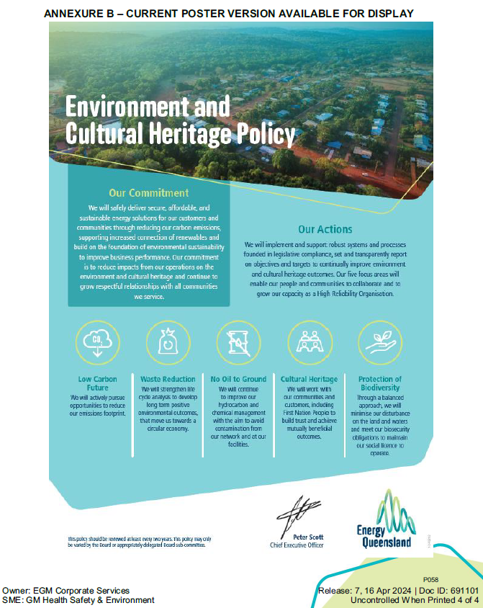

Appendix 2 – ISO14001:2015 Certificate of Registration
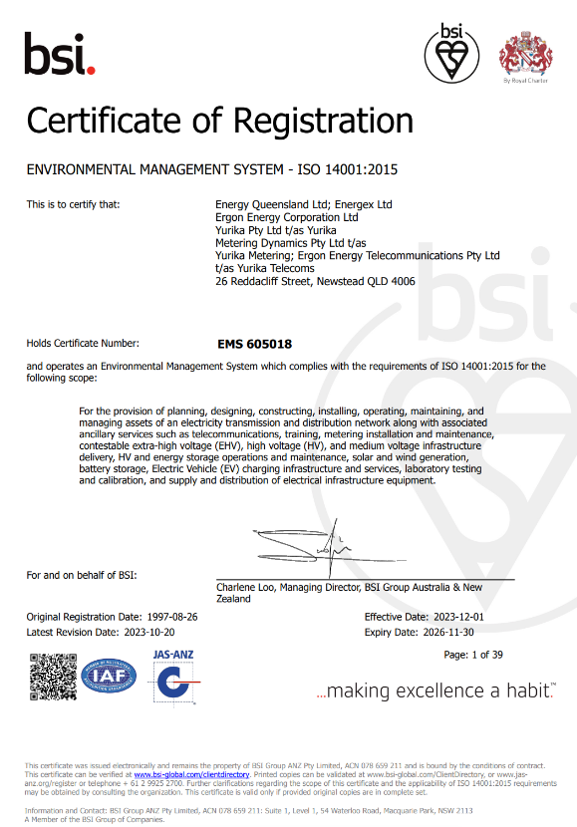

Appendix 3 – Legal Requirement Register
Table below lists applicable legislation that has an impact on the environmental aspects of Yurika construction activities.
Legislation | Activity | Requirement | Compliance Status
Environmental Protection Act 1994 and Environmental Protection Regulation 2008 | All construction activities. since all identified activities have some risk of harm to the environment | All construction activities have some risk of harm to the environment. Environmental harm be prevented or minimised by ensuring that persons carrying out an activity must take all reasonable and practicable steps to ensure that best practices in environmental management are used.
Biosecurity Act 2014 and Biosecurity Regulation 2016 | Importation of material to site | All Queenslanders have a ‘general biosecurity obligation’. Everyone is responsible for managing biosecurity risks that are under their control and that they know about, or should reasonably be expected to know about.
Environment Protection and Biodiversity Conservation Act 1999 and Environmental Protection and Biodiversity Conservation Regulations 2000 | Any activity having potential to impact on vegetation / flora | A person must not undertake any action that will have, or is likely to have, a significant impact on any Matter of National Environmental Significance (MNES). Site includes listed threatened flora species and Threatened Ecological Communities (TECs). A significant impact is an impact which is important, notable or of consequence, having regard to its context or intensity
Environmental Protection (Air) Policy 2008 | All activities with potential to generate dust and vehicle exhaust emissions | Responsibility to protect environmental values such as health and wellbeing, aesthetic environment, biodiversity and agriculture
Environmental Protection (Noise) Policy 2008; | All activities with potential to emit noise | Responsibility to protect environmental values such as human health and wellbeing in relation to parameters such as the ability to sleep, or the biodiversity ecosystems
Environmental Protection (Water) Policy 2009 | All construction activities since all identified activities require sediment, erosion and runoff control to minimise risk of harm to the environment | The environmental values of water include the attributes of the water’s aquatic ecosystem (its biota, physical form, riparian vegetation flow and physiochemical water quality) and apply to all Queensland waters. Stormwater, erosion and sediment control measures for the Site will be critical in minimising the potential for risks to sensitive waterways on and surrounding the Site
Environmental Protection (Waste Reduction and Recycling) Act 2011 and Waste Reduction and Recycling Regulation 2023 | All activities that generate waste | Responsibility to protect human health and the environment through appropriate waste management. Emphasis on waste and resource management hierarchy, with avoidance or reuse as the most preferred option through to disposal as the least preferred
Vegetation Management Act 1999 and Vegetation Management Regulation 2023 | All activities working in or adjacent to vegetated areas | Responsibility for the conservation and management of vegetation communities and provides protection for regional ecosystems classified as ‘endangered‘, ‘of concern‘ or ‘least concern‘ under the VM Act.
Nature Conservation Act 1992, Nature Conservation (Animals) Regulation 2020 and Nature Conservation (Plants) Regulation 2020 | All activities in or adjacent the identified buffer zones | The Act provides the framework for the conservation of nature (plants and animals) within Queensland. It prohibits the destruction or removal, unless authorised, of native flora and fauna species in the wild.
National Environment Protection (Assessment of Site Contamination) Measure 1999 | Contaminated land / soils assessment | Responsibility for appropriately and reliably assessing contamination levels in excavated materials
WHS Act 2011 and WHS Regulation 2011 | Asbestos Removal | Under the Work Health and Safety Act asbestos is classified as a dangerous good and must be appropriately handled, stored and transported. To that end, health monitoring is necessary during any asbestos removal work where there is a risk of exposure to asbestos
Queensland Heritage Act 1992 and Queensland Heritage Regulation 2015 | Activities that could disturb or destroy items of cultural heritage | Responsibility not to interfere with elements of cultural heritage identified on site
Aboriginal Cultural Heritage Act 2003 | Discovery of aboriginal cultural heritage items | Responsibility to protects 'Aboriginal cultural heritage' which is defined in section 8 as: anything that is a significant Aboriginal area or object [in Queensland]; or if there is evidence, of archaeological or historic significance, of Aboriginal occupation of an area
Land Protection (Pest & Stock Route Management) Act 2002 and Land Protection (Pest & Stock Route Management) Regulation 200 | Plant species declared by the state that cannot grow on land | Responsibility to not plant species declared by the state
Stormwater and environmentally relevant activities Guidelines | Stormwater management for ERA’s | Responsibility to manage stormwater at the place of the ERA so that environmental harm is avoided.
Environmental Protection Act 1994 and Manual for Assessing Consequence Categories and Hydraulic Performance of Structures. | Stormwater management guideline | Responsibility to manage stormwater at the place of the ERA so that environmental harm is avoided
Plant Protection Act 1989 and Plant Protection Regulation 2002 | Restriction on moving live fire ant | Responsibility to manage live fire ants
Aboriginal Cultural Heritage Act 2003 | Discovery of aboriginal cultural heritage items | Responsibility to protects 'Aboriginal cultural heritage' which is defined in section 8 as: anything that is a significant Aboriginal area or object [in Queensland]; or if there is evidence, of archaeological or historic significance, of Aboriginal occupation of an area
Transport Operations (Road Use Management) Act 1995 | Heavy vehicle transporting plant, equipment or materials to site | Responsibility of using the road whilst transporting

Appendix 4 – Environmental Aspect and Impact Register
Aspect | Potential Impact | Initial Risk |  |  | Control Measures | Residual Risk
Aspect | Potential Impact | Likelihood | Impact | Risk Score | Control Measures | Likelihood | Impact | Risk
Disposal of waste | Improper disposal (littering or illegal dumping) of waste generated from construction activities | Possible | Moderate | Medium | Waste management plan | Very Unlikely | Moderate | Sustainable
Flooding of excavation / trench after rain event | Water discharged with high levels of sediments can potentially kill marine life in natural watercourses and entering drainage | Possible | Moderate | Medium | Soil erosion and drainage management plan | Very Unlikely | Moderate | Sustainable
Movement of mobile plant and vehicle on land | Generation of unwanted dust and spreading to neighbouring properties  Complaints regarding dust nuisance | Possible | Moderate | Medium | Air quality and dust management plan | Very Unlikely | Moderate | Sustainable
Noise emission from operating of mobile plant and vehicle | Generation of noise nuisance to neighbouring properties  Complaints regarding noise nuisance | Possible | Moderate | Medium | Noise and vibration management plan | Very Unlikely | Moderate | Sustainable
Disturbance of heritage properties | Damage to heritage properties | Unlikely | Moderate | Minor | Cultural heritage plan | Very Unlikely | Moderate | Sustainable
Reduction of native wildlife species | Lost native flora and protected fauna species | Unlikely | Moderate | Minor | Fauna and pest management plan | Very Unlikely | Moderate | Sustainable
Spread of declared pest fire ants from movement of high risk items | Can cause damaged to native vegetation and spread diseases associated from plants to communities properties | Possible | Moderate | Medium | Fauna and pest management plan | Very Unlikely | Moderate | Sustainable
Spread and growth of weeds and declared plants in areas | Can cause damaged to native vegetation and spread diseases associated from plants to communities’ properties | Possible | Moderate | Medium | Vegetation and weed management plan | Very Unlikely | Moderate | Sustainable
Consumption of fossil fuel | Increase greenhouse gas emission & depletion of natural resources | Possible | Moderate | Medium | Monitoring of fuel consumption from mobile plant and vehicles from company and subcontractor | Very Unlikely | Moderate | Sustainable
Asbestos contamination | Illegal disposal of contaminated waste | Possible | Moderate | Medium | Asbestos Management Plan  Remediation Action Plan | Very Unlikely | Moderate | Sustainable
Contaminated water after the rain event on contaminated land | Negative impact on environment due contaminated water released to nearby | Possible | Moderate | Medium | Water Quality Management Plan  Contaminated Land Management | Very Unlikely | Moderate | Sustainable
Hazardous Substance Storage | Spill and Leaks into drainage system and out to waterway | Possible | Moderate | Medium | Hazardous Chemicals and Health Management Procedure  Minimise storage of Hazardous Substances onsite  Dedicated area to store Hazardous Chemicals  Spill Kit | Very Unlikely | Moderate | Sustainable
Heavy Vehicle transporting oversize plant or equipment to site | Disruption to road transport network | Possible | Moderate | Medium | Traffic Management Plan | Very Unlikely | Moderate | Sustainable
Emergency response | Can cause environmental harm or damaged to the natural environmental such as chemical of fuel spills  Fire | Unlikely | Moderate | Minor | Emergency Response Management Plan | Very Unlikely | Moderate | Sustainable
Construction Activities | Receive community compliant | Unlikely | Moderate | Minor | Construction Environmental Management Plan  Principal Contractor Signage displayed of Manager and Supervisor Name and Contact. | Very Unlikely | Moderate | Sustainable

Appendix 5 – ISO 14001:2015 Compliance Matrix
PRINCIPAL REQUIREMENT |  | CEMP REFERENCE
Clause | System Requirement | Section Reference
 | Environmental management system requirements (title only) | -
5 | Leadership
5.1 | Leadership and Commitment | 2.1
5.2 | Environmental Policy | 2.1
5.3 | Organisational roles, responsibilities, and authorities | 2.2
6 | Planning
6.1 | Actions to address risks and opportunities | 3.3
6.2 | Environmental objectives and planning to achieve them | 3.5
7 | Support
7.1 | Resources | 4.1
7.2 | Competence | 4.2
7.3 | Awareness | 4.3
7.4 | Communication | 4.4
7.5 | Documented information | 4.5
8 | Operation
8.1 | Operational planning and control | 5.1
8.2 | Emergency preparedness and response | 5.2
9 | Performance evaluation
9.1 | Monitoring, measurement, analysis and evaluation | 6.1-6.2
9.2 | Internal audit | 6.3
9.3 | Management review | 6.4
10 | Improvement
10.1 | General | 7
10.2 | Nonconformity and corrective action | 7.1
10.3 | Continual improvement | 7.2

Development Approval Conditions: Decision Notice Approval 3590/2023/MCU
Applicant’s Responsibilities (Cleanco Queensland Limited):
- The applicant must discharge stormwater runoff from the development generally in accordance with the Stormwater Management Plan referenced under Part 3 ‘Approved Plans, Specifications and Drawings’ of this Decision Notice (Condition 12a).
- The applicant must submit an amended Stormwater Management Plan for Stage 1 in addition to detailed drawings for stormwater quality infrastructure demonstrating compliance with (12a).
- The applicant must submit to the assessment manager for approval treatment flow rate details of the proposed gross pollutant traps to be installed that comply with c(i) and how these devices can cater conveyance of pipe design event; and
- The applicant must submit to the assessment manager for approval details of the location and type of gross pollutant traps to be installed.
- The applicant must achieve the water quality objectives outlined in Table 2.3.1 of Planning Scheme Policy 3 ‘General Works’ and Implementation Guideline 24 ‘Stormwater Management’ of the Ipswich Planning Scheme to treat the entire proposed road prior to stormwater runoff discharging from the site.
- The applicant must construct the bioretention basin in accordance with the Stormwater Management Plan listed at part 3 of this approval subject to incorporation of a saturated(s) filter zone within the bio-retention basin to support plant survival, per section 2.3.4 of Planning Scheme Policy 3 ‘General Works’ of the Ipswich Planning Scheme.
- The applicant must submit detailed drawings for the basin that achieves a low maintenance fully vegetated outcome designed in accordance with section 2.3.5 of Planning Scheme Policy 3 ‘General Works’ of the Ipswich Planning Scheme and designed in consultation with a Landscape Architect registered with the AILA.
- The applicant must submit to the assessment manager for approval treatment flow rate details of the proposed gross pollutant traps to be installed that comply with d(i) and how these devices can cater conveyance of pipe design event; and
- The applicant must submit to the assessment manager for approval details of the location and type of gross pollutant traps to be installed.
- The applicant must submit to the assessment manager, a stormwater maintenance plan for the entire stormwater system, prepared in accordance with Implementation Guideline 24 ‘Stormwater Management’ of the Ipswich Planning Scheme.
- The applicant must implement the stormwater maintenance plan in perpetuity to the satisfaction of the assessment manager.
- The applicant must design all internal works (carparking/earthworks) in accordance with Planning Scheme Policy 3 ‘General Works’ and Implementation Guidelines 24 ‘Stormwater Management’ and 28 ‘Dispersive Soil Management’ of the Ipswich Planning Scheme.
- The applicant must submit to the assessment manager a Dispersive Soil Management Plan (DSMP), prepared by a suitably qualified person in accordance with Council’s Implementation Guideline 28 ‘Dispersive Soil Management’ of the Ipswich Planning Scheme.

Referral agency conditions: Development Permit SARA 2305-34576
(Under section 56(1)(b)(i) of the Planning Act 2016 the following conditions must be attached to any development approval relating to this application) (Copies of the documents referenced below are found at Attachment 5).
- Carry out stormwater management of the development generally in accordance with section 4 of the Swanbank BESS Stormwater Management Plan, prepared by Aurecon, dated 19 December 2022, Project 521394 File Swanbank Battery Energy Storage System – SWMP.docx, revision 0.

Ecological Values:
- The previously developed site has ‘zero’ ecological value.
- The area is mapped as containing ‘category X’ vegetation.
- There is no remnant vegetation within the project footprint.
- No clearing will be taking place within 100m of a protected plants trigger area.
- There are no watercourses (defined by the Water Act 2000) within the project footprint.
- There are no waterways that will be subjected to waterway barrier works (Fisheries Act 1994).
- There are no Aboriginal Cultural Heritage sites within the project footprint.
- There is no essential habitat within the project site that would house protected animal species (Federal or State Status).
- There is no Core koala habitat, locally refined koala habitat or identified koala broad-hectare area within the project area.
- The area is however mapped ‘Koala district A’.
- The project area may contain least concern wildlife and or colonial breeders.
- No further approvals or permits are required under Federal, State or local law for the construction of the BESS.
The project site, during construction will be managed in accordance with the following:
- AS4373 – Pruning of Amenity Trees.
- AS4970 – Protection of Trees on Development Sites.
- Vegetation Management Act 1999: Accepted development vegetation clearing code – Clearing for infrastructure.
- Nature Conservation (Animals) Regulation 2020.
- Nature Conservation (Koala) Conservation Plan 2017 – June 2023
- DESI Operation Policy: Wildlife (Plants): When a protected plant in Queensland is taken to be ‘in the wild’.
- DESI approved Species Management Plan (high/low risk)
- Aboriginal Cultural Heritage Act 2003: Duty of Care Guidelines.
- Environmental Protection Act 1994: Procedural guide – Releases to waters from land development sites and construction sites 2500m² and greater.

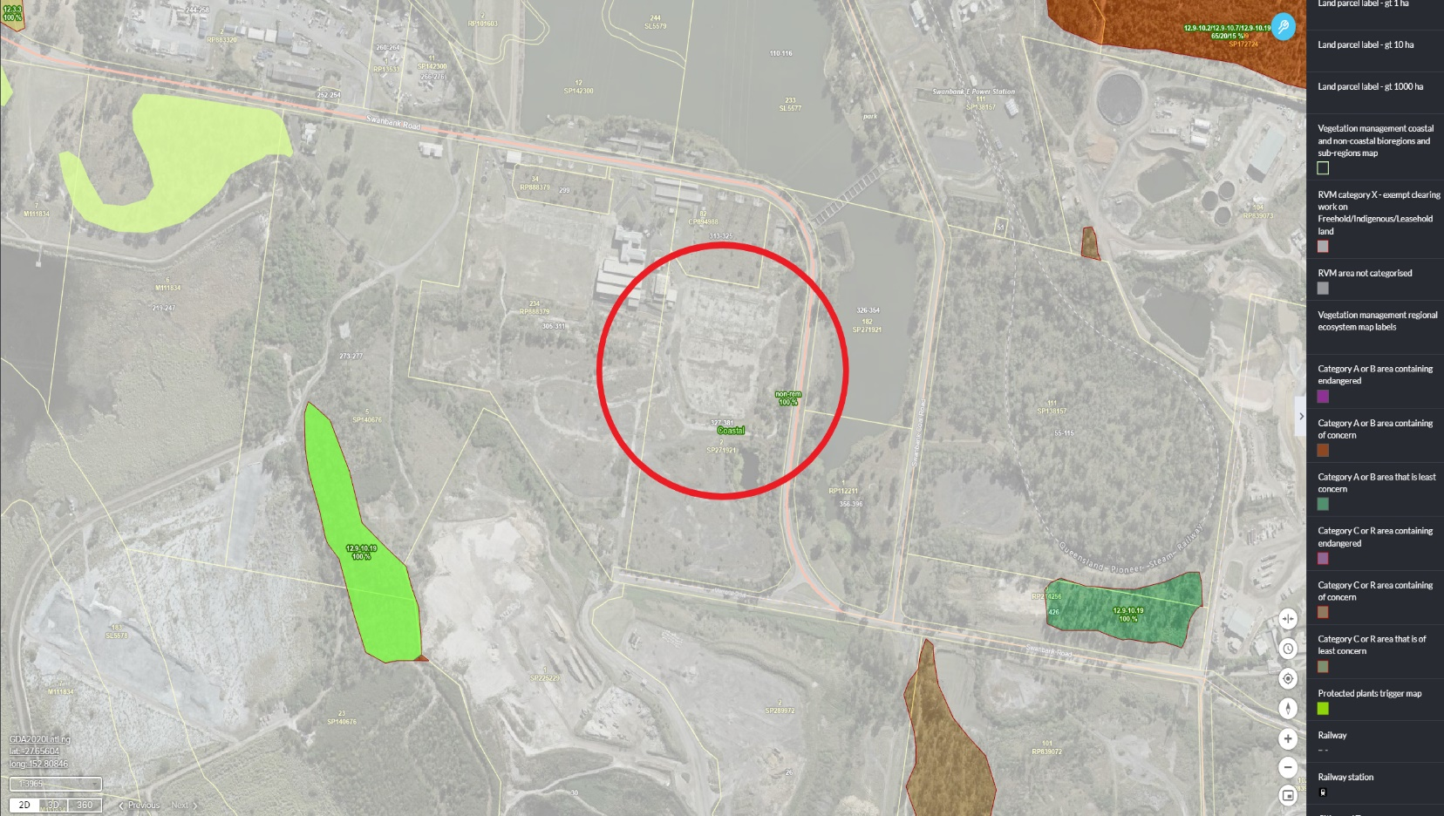
Figure 3: Regulated Vegetation Management mapping.
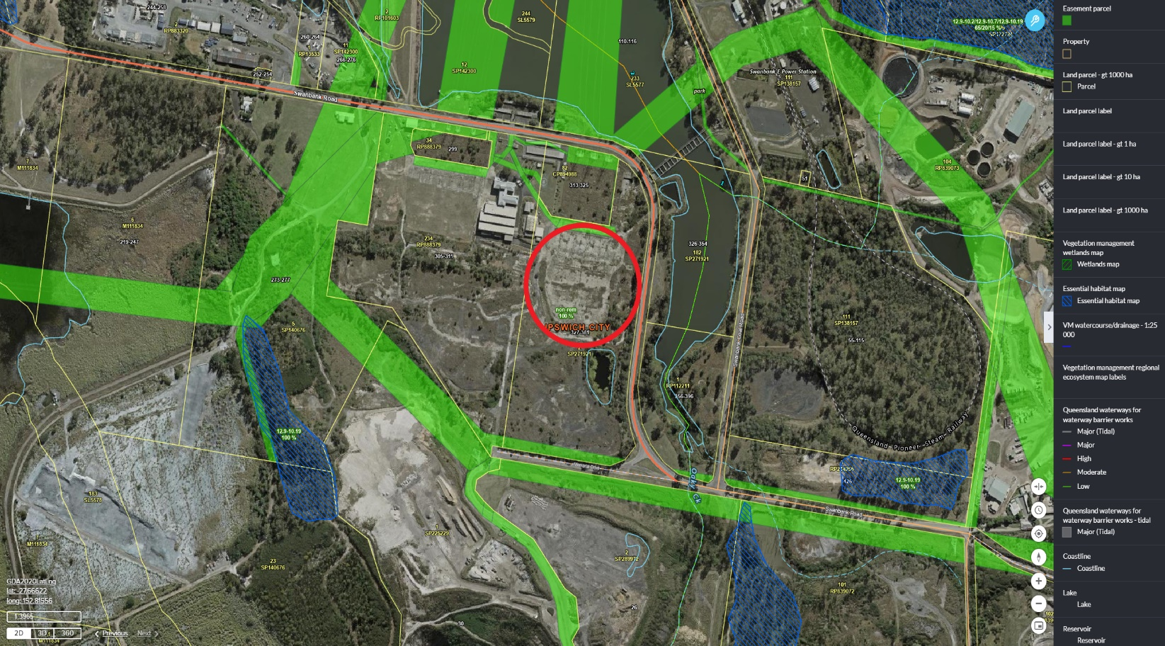
Figure 4: Watercourse, body, and waterway mapping.

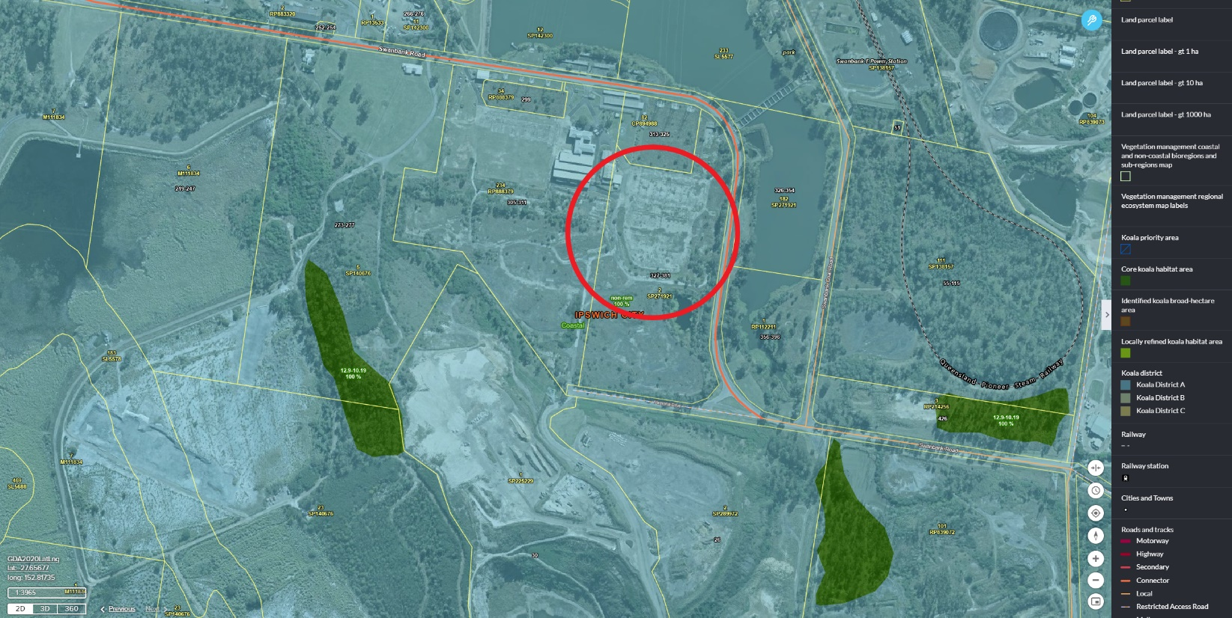
Figure 5: Koala mapping.
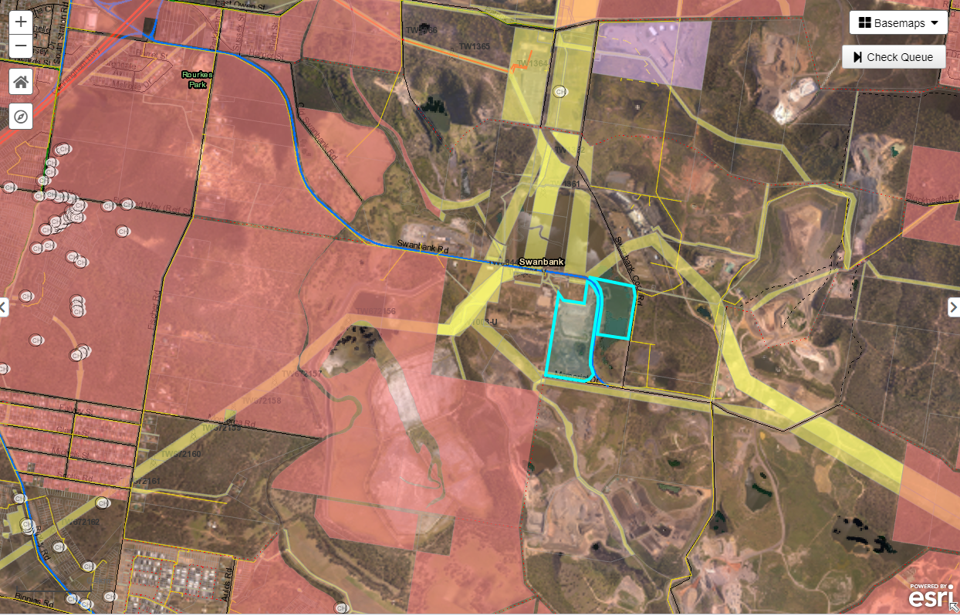
Figure 6: Aboriginal Cultural Heritage Sites

Appendix 6 – Erosion and Sediment Control Management Plan
Erosion and sediment control measures will run in parallel with the International Erosion Control Association’s best practice erosion & sediment control – for building and construction sites: November 2008. A site-specific erosion and sediment control plan (ESCP) has been developed in-line with the approved Swanbank BESS detailed designs and will be updated prior to operational works.
Stormwater management for the site will be in accordance with the Environmental Protection Act 1994: Procedural guide – Releases to waters from land development sites and construction sites 2500m² and greater.
(1) stop sediment leaving the Project site.
(2) catch sediment leaving the site due to exposed soils (sediment basins etc.).
(3) stop releases, flows or discharges containing prescribed water contaminants entering roadside gutters, roadside stormwater drains and the receiving waters environment.
(4) prevent the production of contaminants, and where not feasible, the contaminated stormwater will be appropriately treated to ensure that releases will not affect the environmental values of waters.
(5) implement drainage control so all Project areas subject to concentrated flows have adequate flow paths (drainage lines, channels, and batter chutes) constructed and maintained to convey flows for all rain events up to and including accepted thresholds.
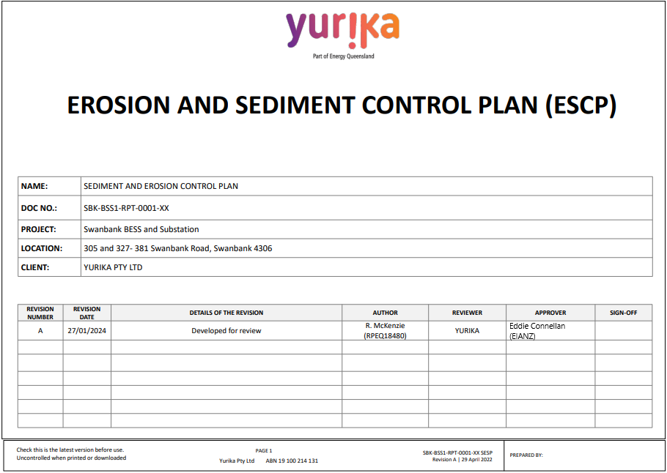

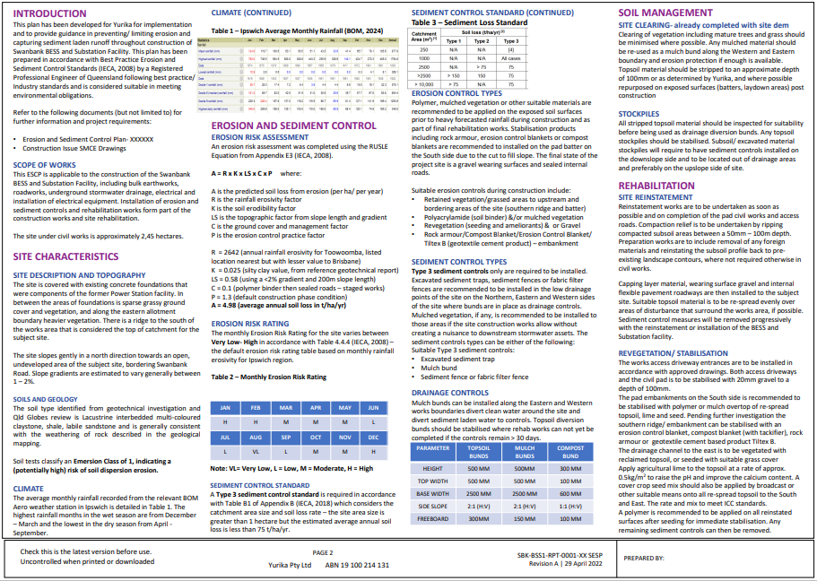
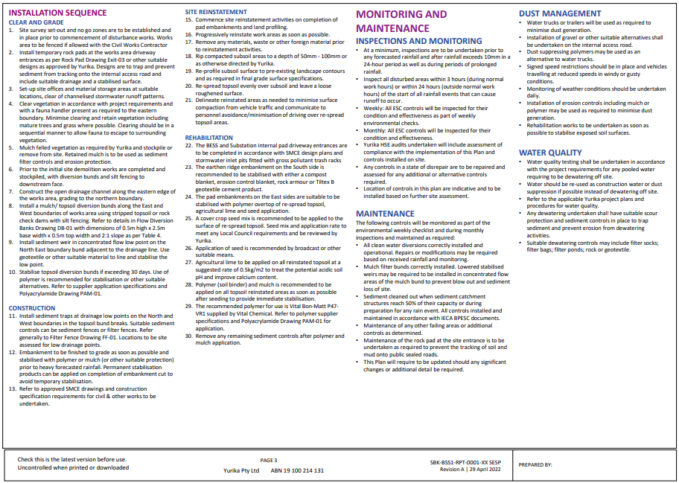
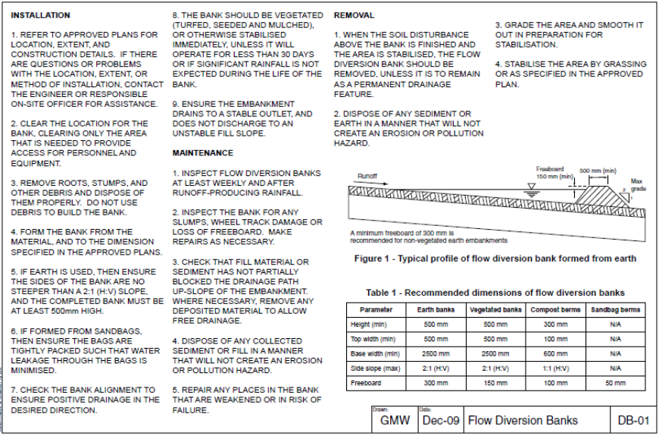
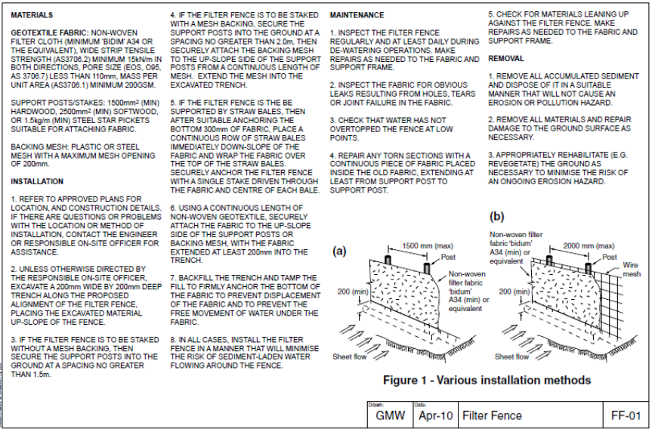
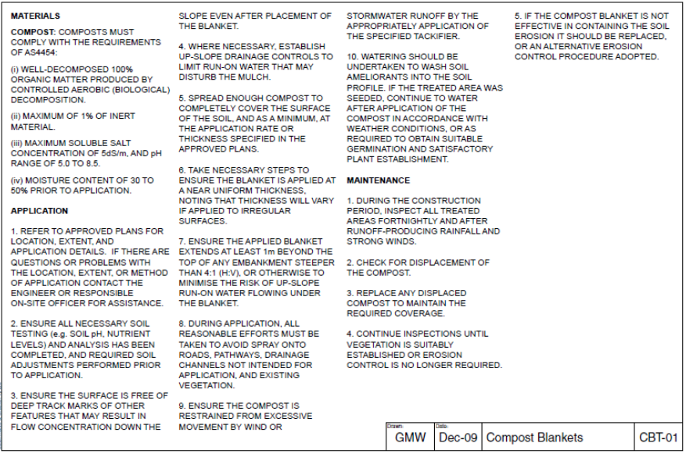
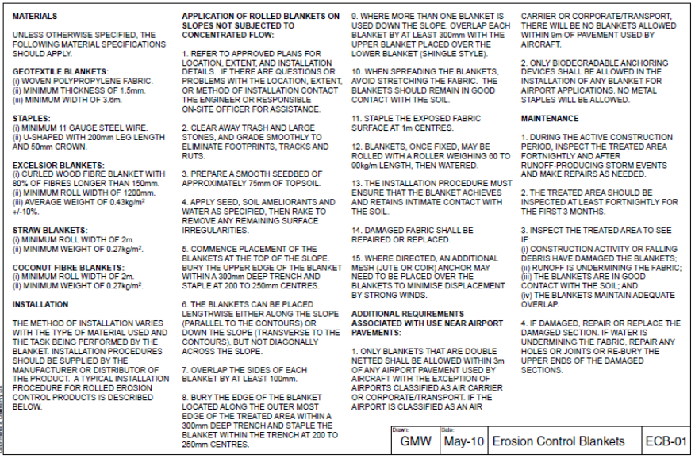
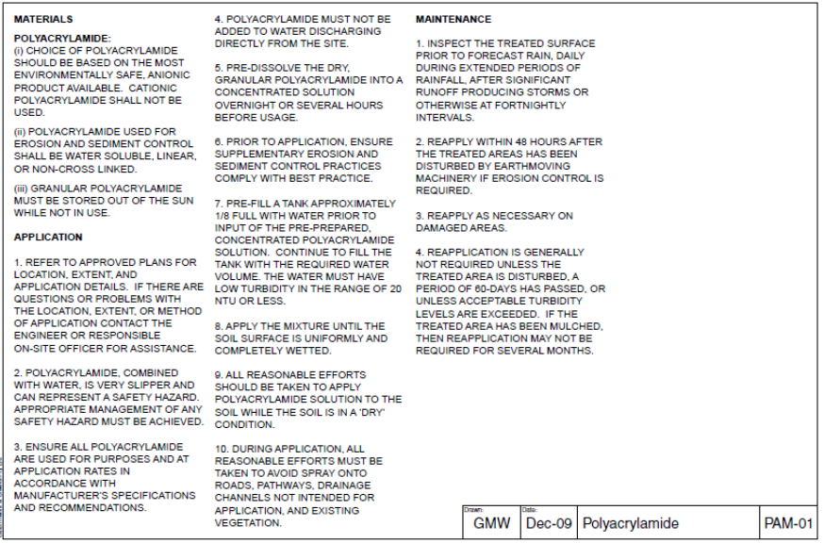
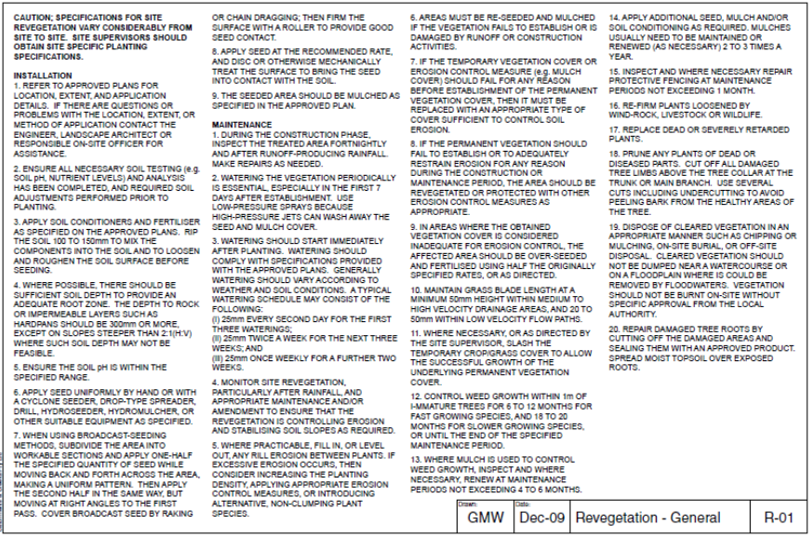
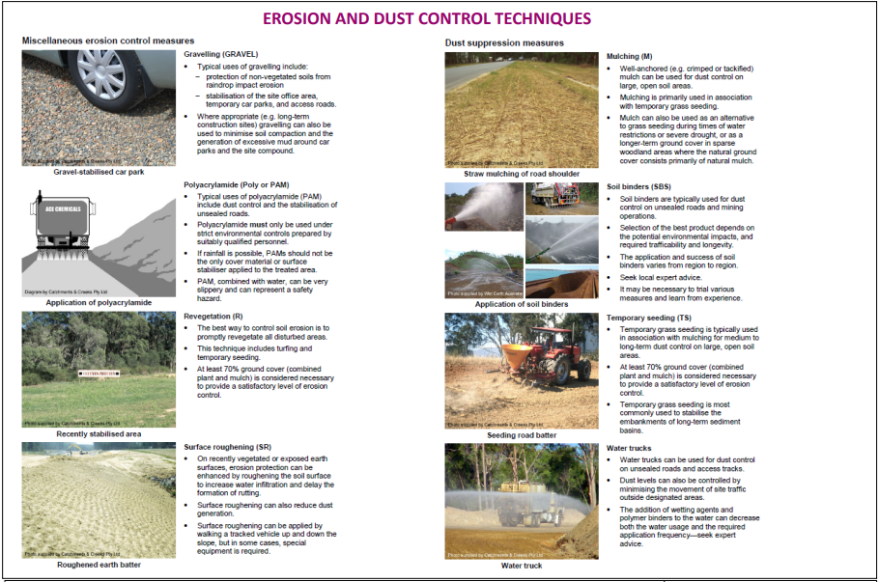
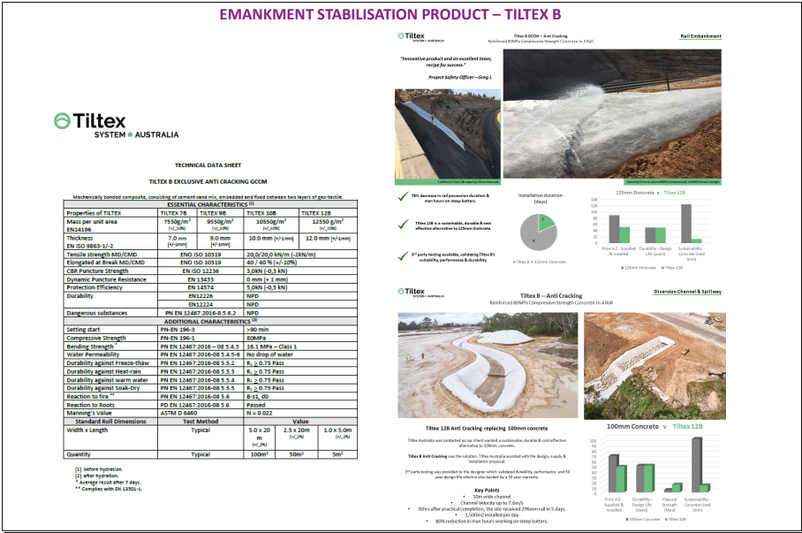
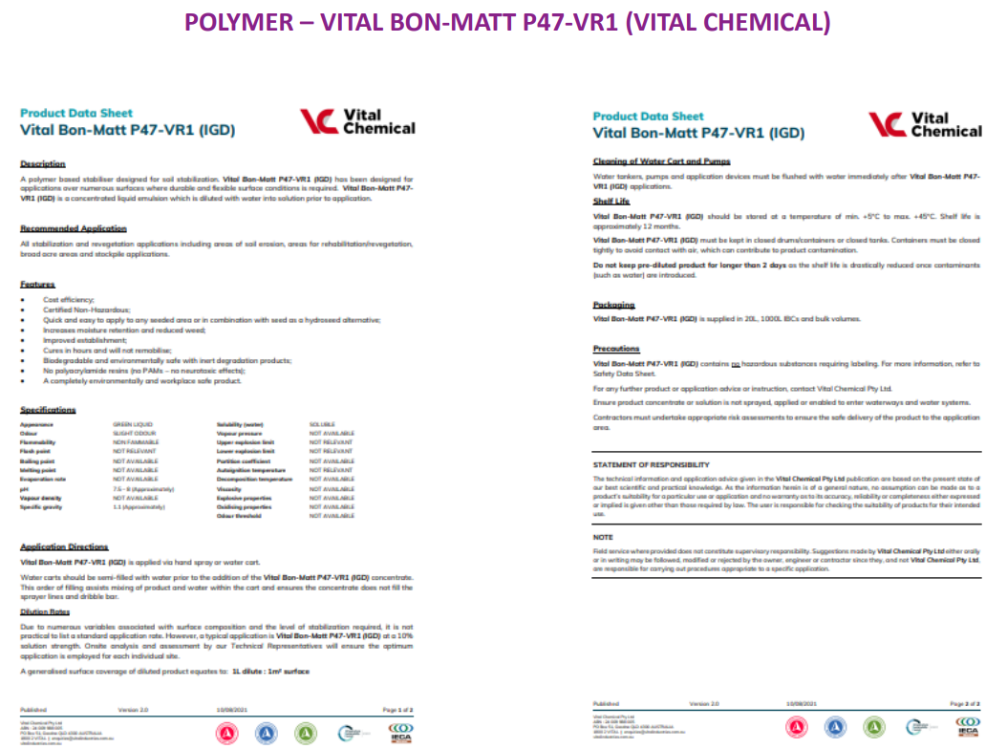

Appendix 7 – Weed Management
The Biosecurity Act 2014 identifies and classifies certain species as noxious weeds or pest animals and provides a system of controls on noxious species.
The project area is likely to contain weeds listed as Category 3. Yurika has a duty to prevent the spread of weed or pathogen to, from and within the Project site. Mitigations measures are to include:
- Controlled access - Designated entry points are to be used as site access during construction activities. These are to be defined at the pre-start meeting with all contractors.
- Controlled movement – vehicle movements will be controlled across the Project area. Construction activity will be planned to aid this process.
- Imported soil – any imported soil is to be inspected and recorded as weed free and/or sourced from a weed free location and accompanied with a weed free declaration certificate.
- Vehicle hygiene – vehicles entering the project site must be clean, be able to produce washdown records and the appropriate clean machinery declaration certificate. Vehicles, plant and machinery will be cleaned down in the designated wash. down area prior to exiting the site.
- Training – staff and contractors will be trained in weed identification and vehicle hygiene procedures.
- Regular monitoring - An ongoing monitoring and management regime will involve monitoring of weed infested areas to determine effectiveness of weed control measures until weed densities are less or equal to the pre-disturbance density, or new species infestations are eradicated. If previous weed treatments are found to have been ineffective, a review of the weed management activities will be undertaken, and treatments modified as necessary.
- Disposal – weed infested topsoil will be managed in accordance with relevant State and local government guidelines.
- Treatment – weeds with the project area will be treated and or destroyed by recognized and accepted practices.
- Remove / Dig out – Taking any action that would lead to the death of the tree or plant including the complete removal of root system.
- Herbicide application – Foliar spray, basal bark, stem injection, wick wipe.
- Cut stump - Cutting off plant / tree at its base and apply selective herbicide to stump.
- Stem injection - Cutting through bark into sapwood tissue and apply herbicide immediately.
- Foliar spray - Applying (spraying) liquid herbicide directly to leaves.
- Basal bark - Paint stems with herbicide on the lower portion of the plant.
- Wick wipe - Direct application of herbicides via curtain material bushed against target grass.

Appendix 8 – Air Quality and Dust Management Plan
Measures will be implemented to minimize dust during construction. Potential impacts include, degradation of air quality, complaints from neighbours and adverse health impacts. Mitigation measure are below:
- Plant and machinery would be maintained in accordance with manufacturers specification.
- Any loose materials transported to site in trucks will be appropriately covered to reduce dust generation.
- Measures including watering or covering exposed areas would be used to minimize or prevent dust generation. Focus water targeting for areas with high potential for dust.
- Visual surveillance for dust generation during work activities. Work would cease when high levels of airborne dust cannot be adequately controlled (dry and windy days).
- Vegetation and other materials not to be burned on-site.
- Restricting vehicle access and speed limits on roads, pads, and other unsurfaced areas of the Project site.
- Yurika has a total of five (5) dust monitoring stations within the construction area (and in proximity to the construction area). CleanCo Queensland will notify Yurika if dust emission levels are approaching EPP limits.
- Yurika will manage watering and minimise dust generation immediately when requested by CleanCo Queensland.

Appendix 9 – Noise and Vibration Management Plan
Airborne noise generated by construction activities would be managed in accordance with the applicable EPA Guidelines, which are based on protecting residential premises from unreasonable noise. Construction hours for the project will be in accordance with Ipswich City Council requirements.
Prior to undertaking any out of hours work, Yurika will consider the nature of the activity, noise levels at the receiver and duration of the work and determine if nearby residents should be notified (and whether other noise reduction measures should be implemented).
Consideration will also extend to the place of residence of each site personnel, and the local community who may be affected by increased vehicle movements. If complaints are received due to out of hours work, Yurika will review the complaint and investigate ways of mitigating impacts relating to the complaint issues.
The occurrence of offensive noise will be minimized by using equipment with noise control features where available and ensuring it is properly maintained.
The following targets have been established for the management of noise and vibration impacts during construction:
- Minimise noise and vibration complaints from the community and stakeholders.
- 100% compliance with complaints response timeframes.
- 100% compliance with Rockhampton Regional Council out of hours work requirements, when required.
- 100% compliance with complaints investigation and close-out.
- Zero noise-related actions taken by Regulators.

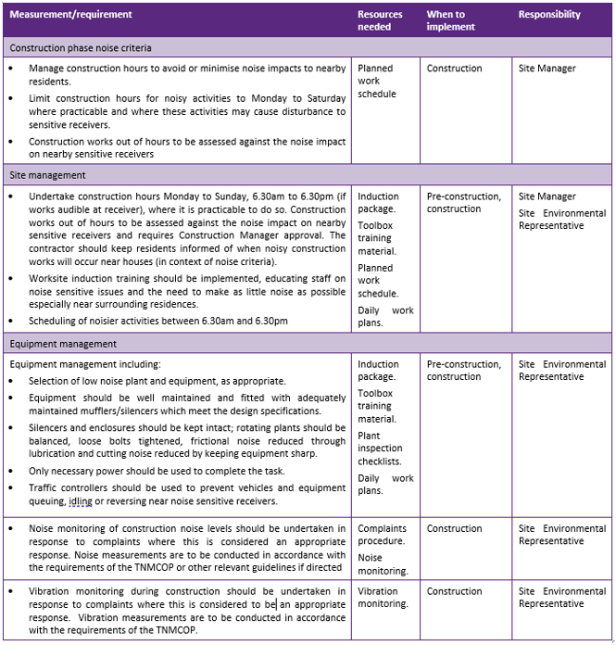

Appendix 10 – Waste Storage and Disposal
- Maintenance of Wastewater Treatment Systems – Prior to final discharge, wastewater generated by washing and cleaning vehicles or other equipment and plant must be treated via separators, traps or sumps.
- Managing Unknown Land Contamination Encountered During Field Activities – during construction for the Project, if unknow contamination is encountered or suspects: Halt works as soon as it is safe to do so, restrict access, contact relevant site manager for direction in managing the situation.
- Managing Land with Known Contamination during Field Activities – compliance with State law is required here.
- All earthworks are to be undertaken in accordance with general environmental protection measures to avoid unwanted movement and deposition of soil. These measures include the control of dust, stormwater run-off, sediment/erosion, spillage from haulage trucks and odor releases during handling or movement of contaminated material.
- Any soil excavated on the site shall be assessed for contaminants of concern to determine if the material is contaminated and to identify appropriate management and disposal/re-use options.
- Representative sampling and analysis of soil from excavations in contaminated areas must be managed by a suitably qualified and experienced person.
- If during any site earthworks or excavation, offensive or noxious odors and/or evidence of gross contamination, not previously detected are observed, site works are to cease in that area and action taken to immediately abate the environmental harm. Contact the relevant site manager for direction.
- Managing stripped topsoil and soil stockpiles – the management of topsoil and soil on-site will be in accordance with IECA 2008 Best Practice.
- Topsoil will be stripped and set aside for use in progressive site rehabilitation, close to the point of origin. Areas which are no longer influenced by traffic/machinery will have topsoil reinstated, thereby creating a soil bedding layer for the natural and assisted germination of vegetation.
- Soil stockpiles will be placed close to point of origin, compacted and have tackifier applied to reduce any impacts associated with erosion.
- stockpiles should be located upslope of a sediment fence or other type of sediment barrier.
- Stockpiles should not be located within an overland flow path.
- … where this is not possible then a perimeter bank should be constructed upslope of the stockpile to direct run-off in a controlled manner around the stockpile.
- Managing Construction debris / rubbish – waste product associated with construction will be stored on-site within appropriately marked skips ready for removal by a licensed contractor for disposal / remediation at a licensed waste disposal facility.
- Managing Regulated Waste – regulated waste will be managed in accordance with all relevant Queensland Laws and will include:
- Written approval of acceptance from the approved waste disposal facility.
- ERA licensing conditions of transporter and receiver will be handed over to Stanwell.
- Management of Hazardous Chemicals – storage, emergency spill containment and cleanup will be managed as per below:
- Storage:
- Liquid form hazardous substances will be stored in a covered, bunded area with capacity to retain 120% of the largest container and at least 25% of the total volume of all substances stored in the event of a spill.
- Bunds will be maintained free of stormwater and hazardous substances prior to rain events where practicable.
- Hazardous substances will be stored away from sensitive receptors wherever practicable.
- Diesel generators are to be either self-bunded or situated within a bunded area.
- Copies of an up-to-date SDS Register and risk assessment will be kept at all storage locations and first aid facilities.
- Hazardous substances are to be stored and handled in accordance with SDSs.
- All hazardous substances will be labelled.
- Fuel storage is to be in accordance with AS 1940:2017 The storage and handling of flammable and combustible liquids.
- Incompatible materials will not be stored together.
- The servicing and the maintenance of machinery and equipment will be undertaken over an impervious surface.
- Decanting will be undertaken within bunded areas at storage facilities.
- Hazardous substance transfers (including refuelling) will be undertaken with secondary containment in place (e.g., drip trays) and decanting undertaken within the bunded area of storage facilities.
- The onsite storage of hazardous substances will be minimised as much as practicable.
- The washing of plant, vehicles and equipment will take place in such a way that wash water is contained within an impervious basin for treatment and / or disposal as appropriate.

- Spill preparation and response:
- Project personnel will be trained with respect to spill preparedness and response.
- Spill kits are to be maintained onsite and located in proximity to chemical storage and handling areas.
- Spill kit contents are to be commensurate to the type and quantity of chemicals stored onsite.
- Spill response procedures will be developed and implemented in line with the following response hierarchy:
- Cut off the source of the spill.
- Contain the spread of the spill.
- Recover and contain spilled liquids, affected soils and materials used for cleanup.
- Dispose of associated waste.

Appendix 12 – Aboriginal Cultural Heritage Management Plan
The Swanbank BESS Project site as defined as a Category 4 (area previously subject to significant ground disturbance) in accordance with the Aboriginal Cultural Heritage Act 2003 and subordinate Aboriginal Cultural Heritage Act 2003: Duty of Care Guidelines.
Construction activity associated with the Yurika BESS is generally unlikely to harm Aboriginal cultural Heritage. Under the Duty of Care Guideline, it is reasonable for the construction activity(s) to proceed without further cultural heritage assessment.
Yurika has a duty of care not to harm Aboriginal cultural heritage whilst carrying out the approved activities and will take all reasonable and practicable measures to ensure compliance.
If at any time during the said construction activity, it is necessary to excavate, relocate, remove, or harm a cultural heritage find:
- The activity should cease immediately.
- Yurika will notify CleanCo Qld who will notify and engage the Aboriginal Party (AP) – Yuggera Ugarapul People.
- Advice and agreement will be sort from the AP as to how best the situation is to be managed to avoid or minimise harm to the Aboriginal cultural heritage.

Figure 6: Aboriginal Cultural Heritage Sites

