CPCCBC4014A
Prepare simple building sketches and drawings

THEORY EXAM INSTRUCTIONS

- This exam will occur under standard assessment conditions.
  - An oral examination may be allowed under certain circumstances.
Answers will be documented and FT003 (Oral examination declaration form) must be completed.
- Participants must provide enough detail in their responses to demonstrate their knowledge and skills.
- Please fill in the details below, providing your name, signature and date of assessment.
  - Your signature acknowledges that this is your own work.
- If a participant initially answers a question incorrectly but modifies their response, they must follow the instructions below:
  - If a participant changes their response in writing, they must put their initials next to the written change.
  - If a participant changes their response verbally, this must be noted on the exam paper by the assessor.

Participant name | Emma Carew
Participant signature | 

Assessor name
Assessor signature | 

Date | 10/05/2018

Number of questions | Number of questions answered correctly | Satisfactory?
12 |  | Yes | No

Assessor Comments
Refer to the drawing below to respond to Q1. to Q2.

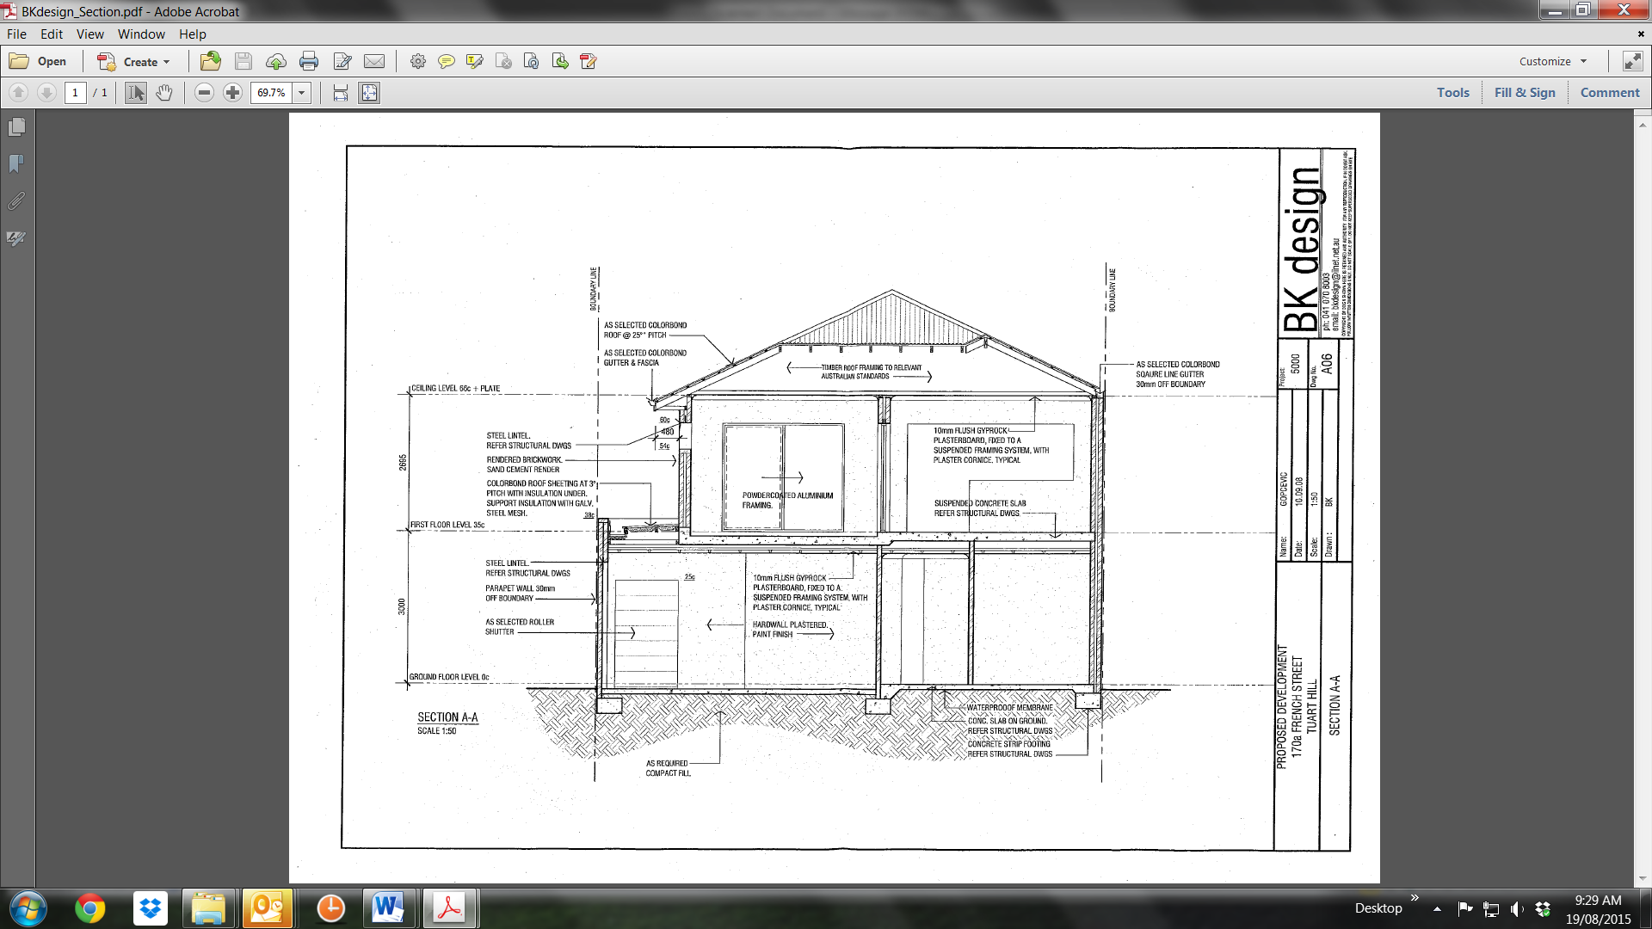

- Reproduce the Section Drawing. Apply dimensions using an appropriate scale and insert your own Title Block.

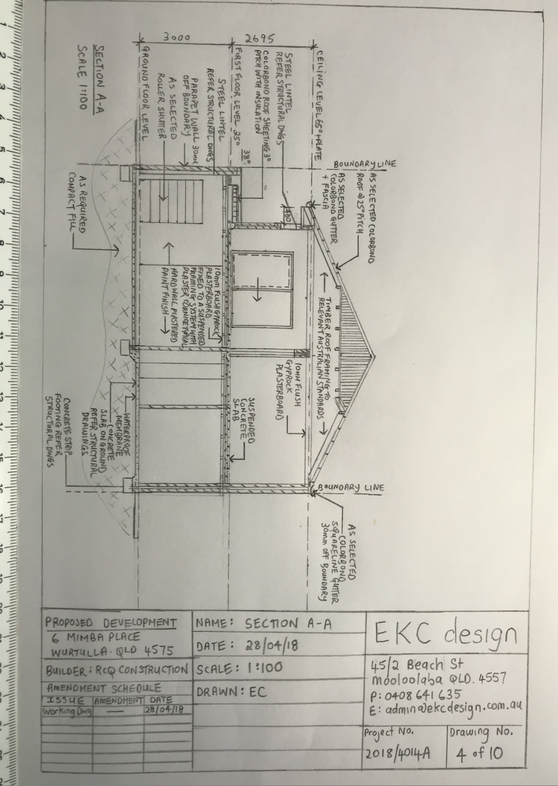

Answer

- Write a paragraph or two sufficient to explain this dwelling’s sectional view to a client or trade contractor.

Answer | A two storey house with sand cement render finished on brick walls.  Concrete slab on ground with strip footings and waterproof membrane.  A suspended concrete floor for second storey with 2600 ceiling heights, all wooden timber trusses, finished off with a 29 degree Colorbond roof and square line gutter.  All internal walls are finished with 10mm plasterboard on timber framing with typical plaster cornice, all painted to client specification.  Parapet wall 30mm off boundary.  1350 wide by 2100 high roller shutter as per client specification.

Refer to the floor plan below to respond to Q3. to Q12.
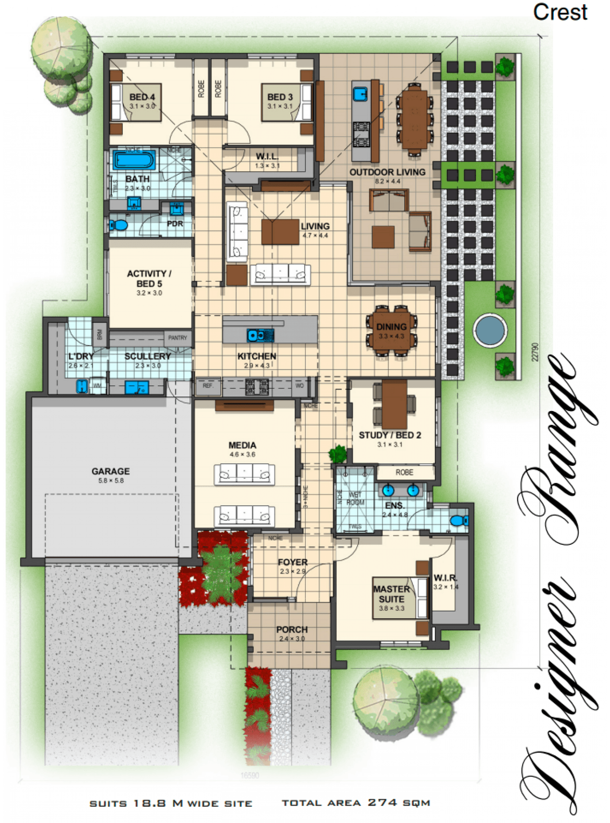

- Use the floor plan to create your own title block and produce the North, South, East and West Elevations.

- Determine your own finished ceiling height and aluminium window and door sizes appropriate to the scale of the rooms and building (and applicable standards/codes).
- Assume it is slab on ground, rendered brick veneer construction, timber trussed roof and concrete roof tiles; metal fascia and gutters, driveway and paths are exposed aggregate.

Please refer to attachments with submission:
- Q3. Elevations – North & West
- Q3. Elevations – South & East

Answer

- Identify an address with fictitious house and lot number and the block of land and land shape for the home and then create a Site Plan.
- Your boundary set offs are to accord with Brisbane City Council requirements. You are to determine these by contacting Brisbane City Council.
- Clearly mark the direction and contours on this site plan.
- Identify on your site plan the location of any existing buildings, trees, fences and other structures.
- Determine the ingress and egress points for traffic management to, from and over the site.
- Using appropriate drawing conventions, you are to mark the location of utilities and services including water, telecommunications, sewerage, storm water and electrical.

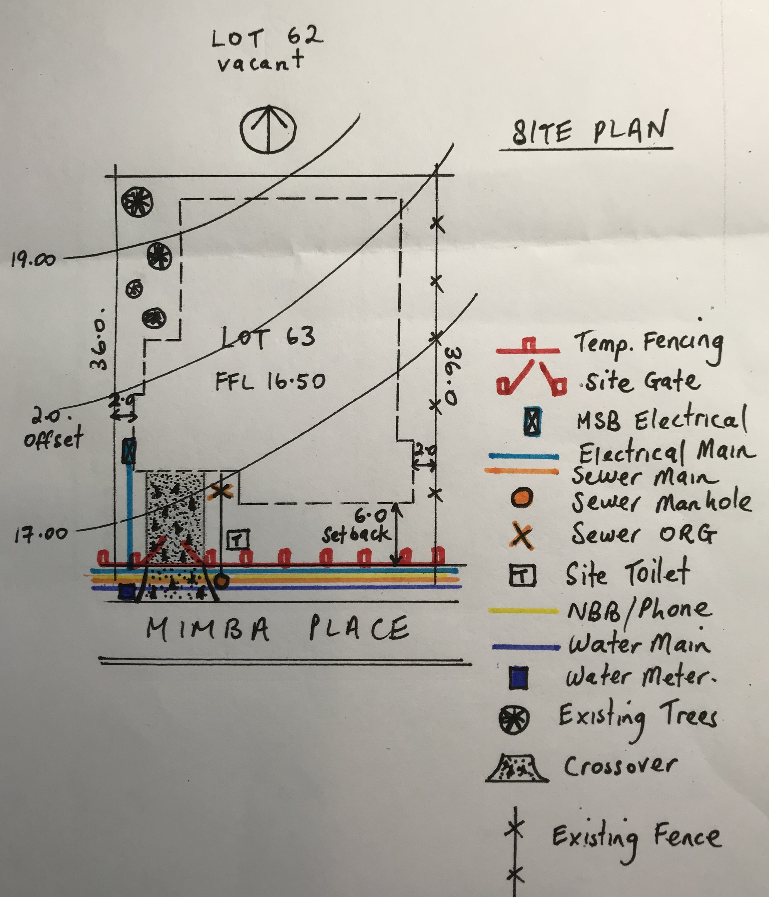

Answer

- Referring to the floor plan, create a windows and doors schedule.

Please refer to attachment with submission:
- Q5. Door & Window Schedule

Answer

- Referring to the floor plan, create a lighting plan and determine single and double GPO locations to be used as a guide by your electrical sub-contractor for a preliminary wiring quote.

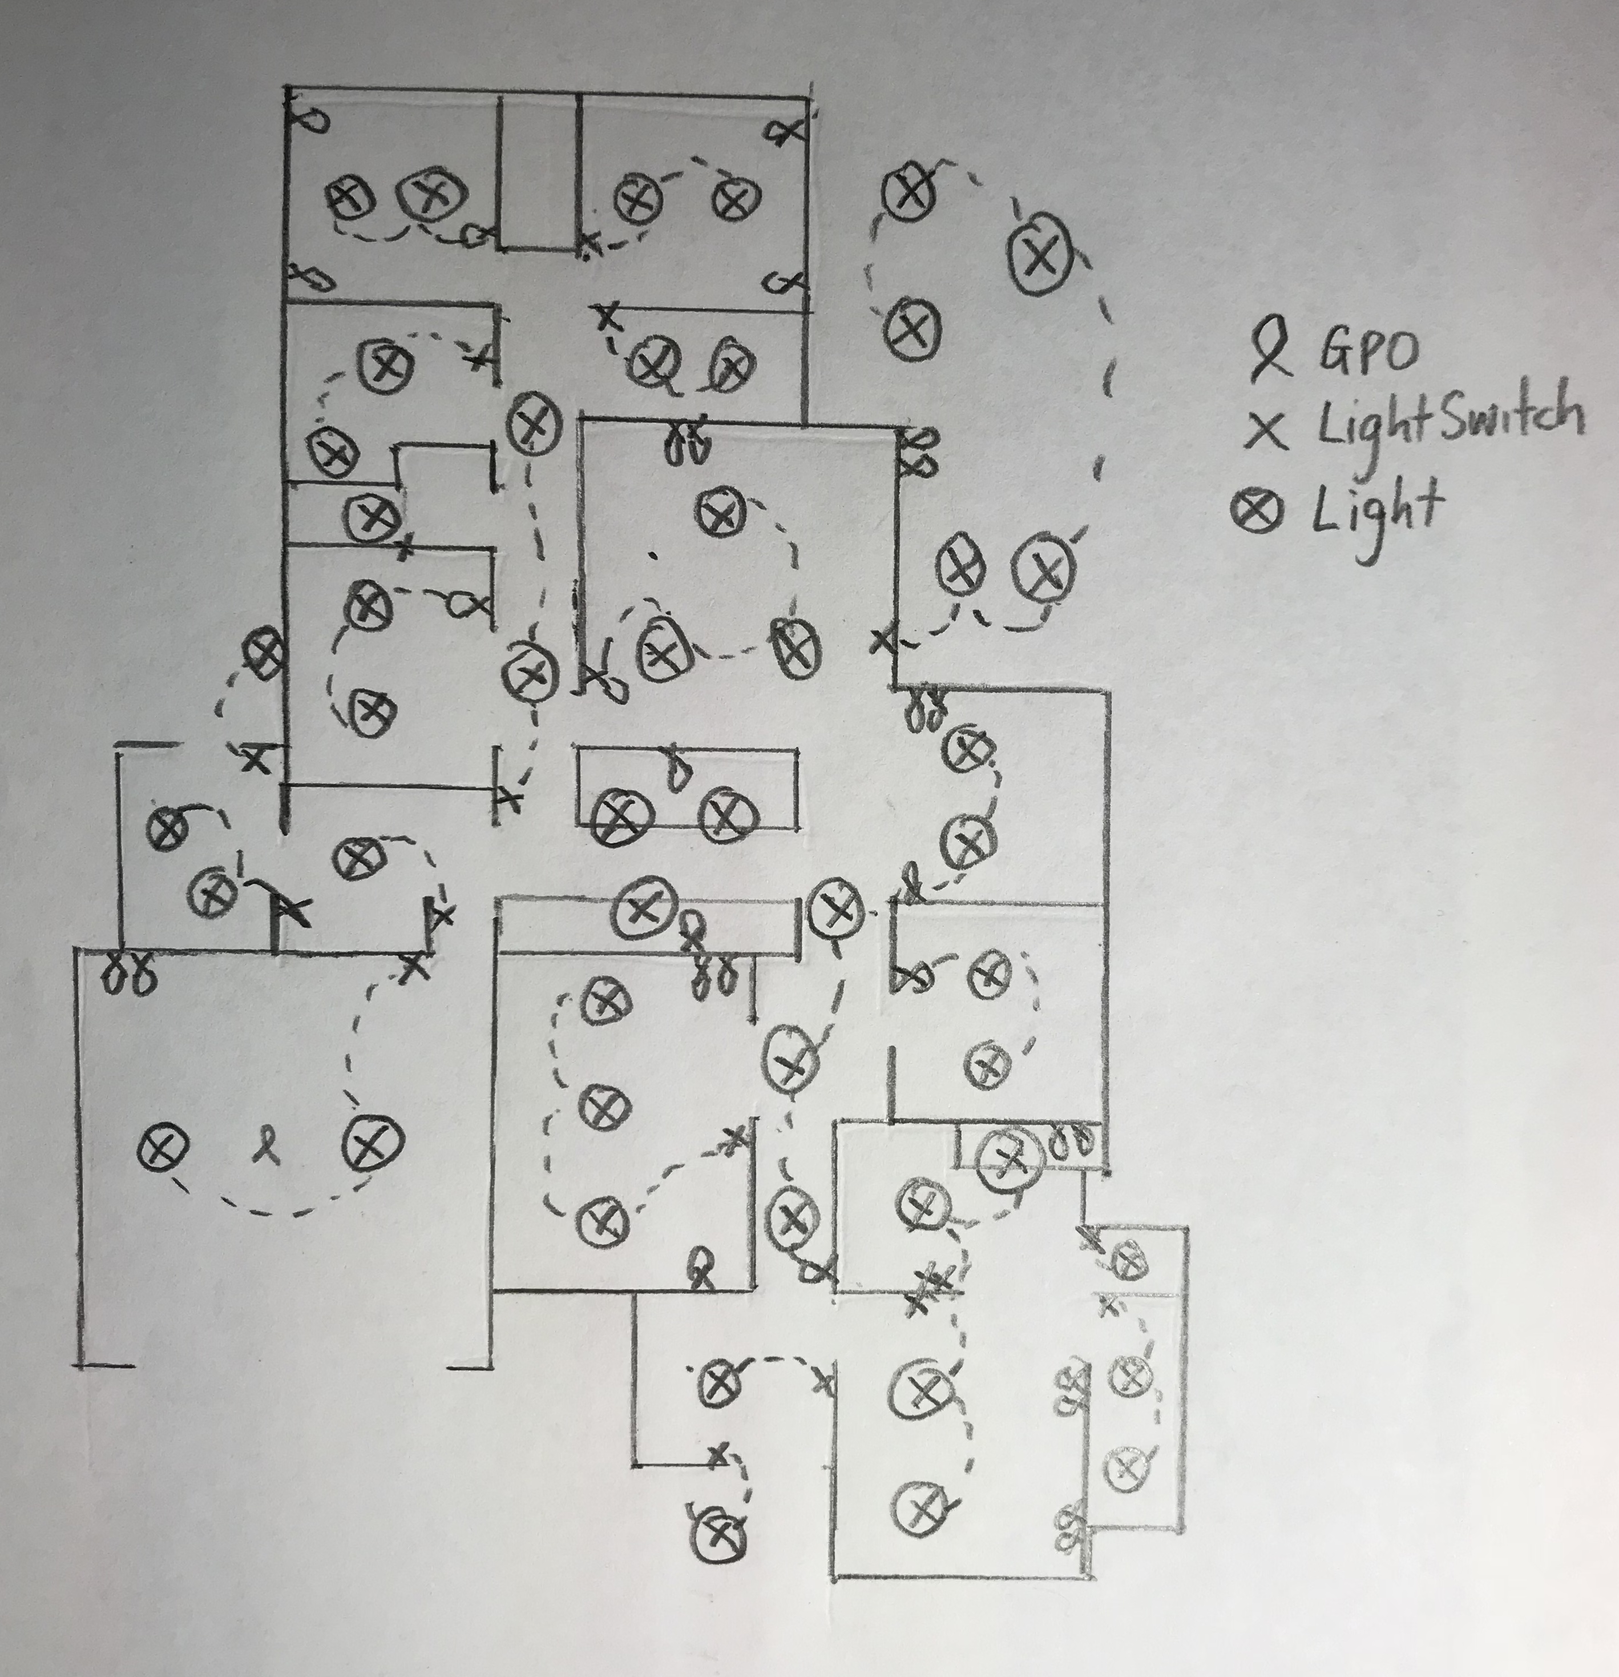

Answer

- Draw a schematic preparatory drawing of all pipework (including sewerage, plumbing, electrical and other services).
To assist with determining the location and installation details for all the in-ground and under-slab services (i.e. prior to pouring of the foundations and concrete slab), refer to the floor plan and the site plan you developed in 0

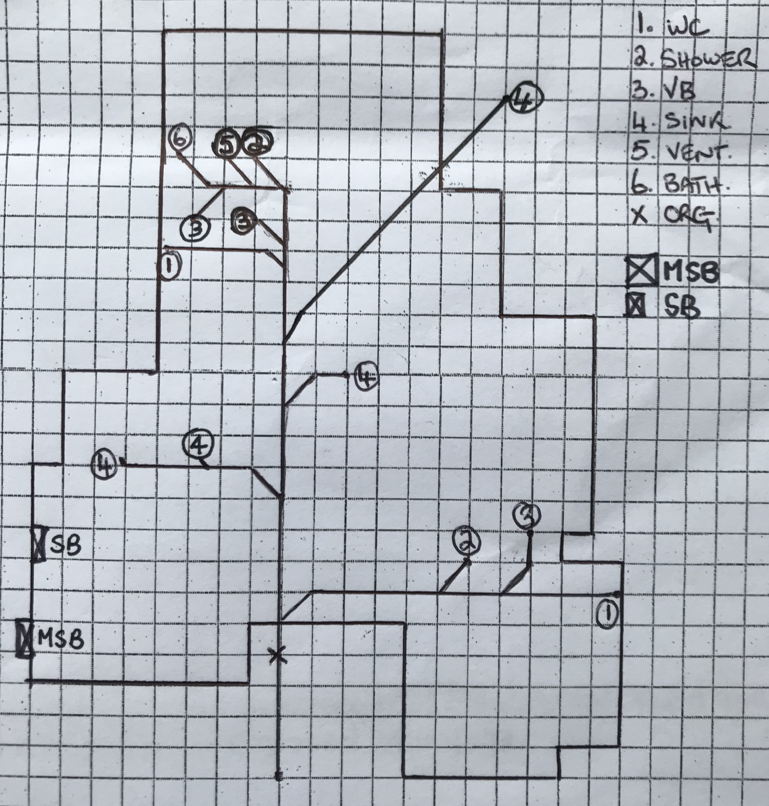

Answer

- Identify all internal and external wall penetrations and create a schedule and sketch to be provided to each of the affected trade sub-contractors.
Refer to the drawings in Q3. and 0to assist with this task.

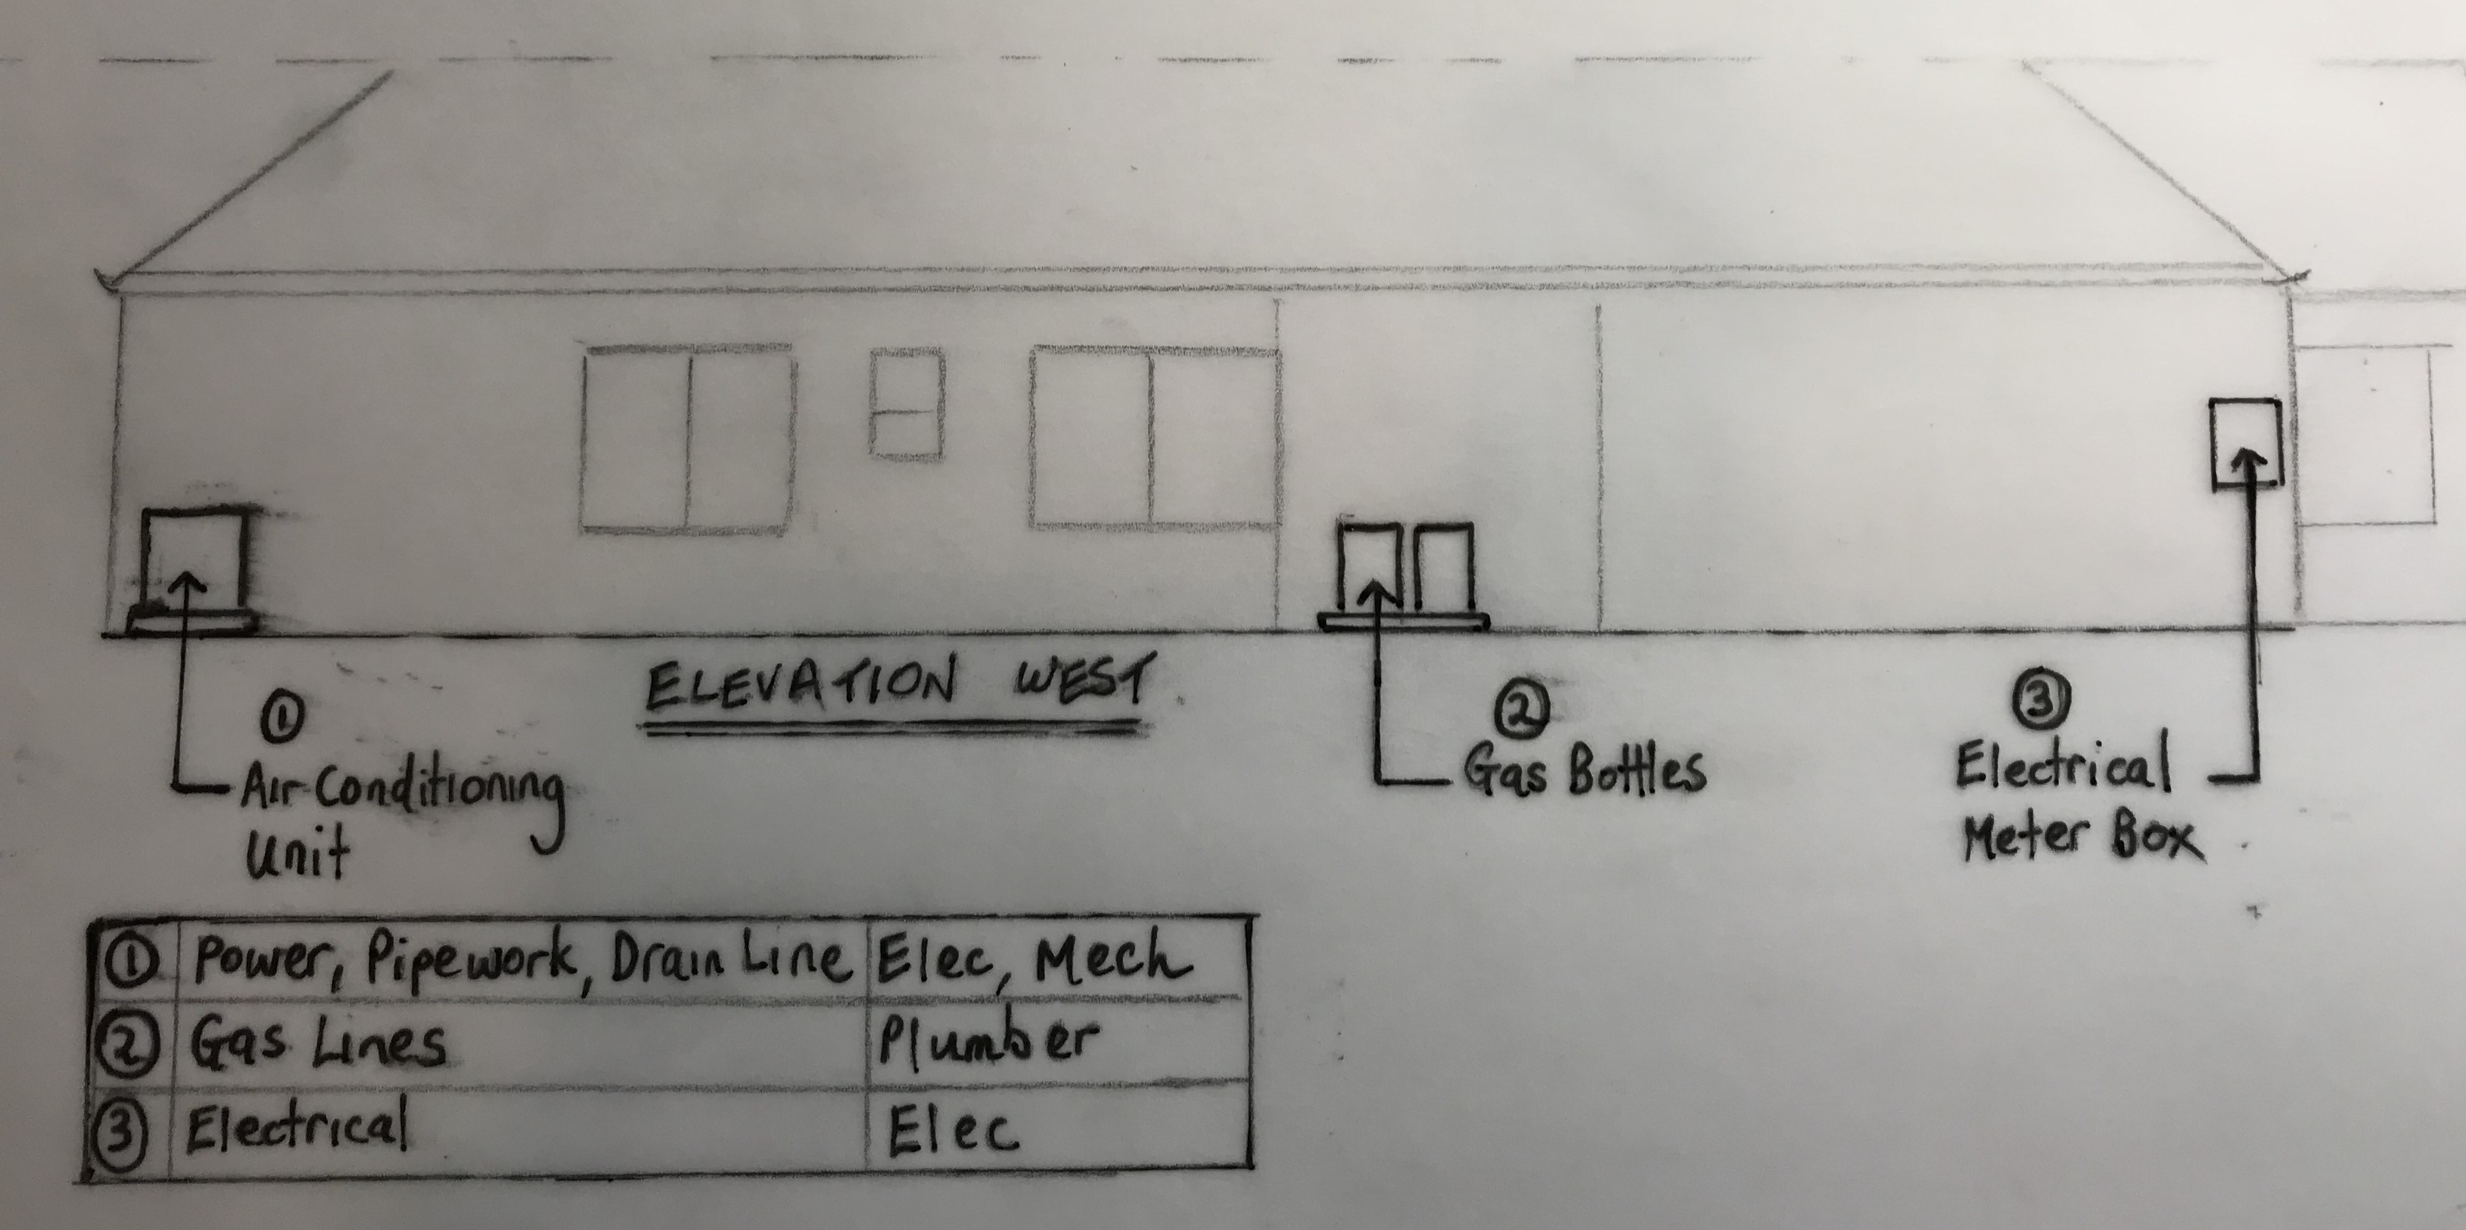

Answer

- Your client has approached you seeking consideration to redesign the area of the laundry, scullery and Bedroom 5. They are considering foregoing Bedroom 5 altogether and increasing the scullery to make it a large butler’s walk-in pantry and essentially leaving the laundry as is.
They have asked you to redesign this area of the home and have agreed to pay you for it separately. You have agreed to terms in this regard. You have agreed you will prepare formal floor plan sketch/es of this area redesigned for discussion with the client in two weeks’ time.
You are to also present a pros and cons written argument for the client to help them determine if they should proceed with this variation.

TIPS

Your initial research should consider what goes into a Butler’s Pantry, what are others doing with designs and layouts including refrigeration, storage, preparatory areas, electrical equipment and white goods.

You should intend to visit and/or research new and existing housing estates and establish what other Developers and Builders are incorporating in Butler’s Pantry in their housing designs then to capture camera and computer images so you can discuss these various options and the drawn variation with the client as you present your ideas and sketch floor plan amendments for reconfiguring this area of their home.

Answer | Quote Proposal: Butler’s Walk-in Pantry and Study in lieu of Bed 5  Please note that the space available from Bedroom 5 and Scullery for a Butler’s walk-in Pantry is quite significant therefore the following design and quote also includes allowance for a Study.  Study Design  The design for the study has allowed for a window, carpet, full length desk with LED lighting, overhead storage cupboards and single cavity slider.  Butler’s Pantry Design  The design for the butler’s pantry has allowed for tiles to floor and splashbacks, fridge space, bench space areas and power points for coffee machine and other electrical equipment such as bread maker, slow cooker, Thermomix.  Two prepping areas have been allowed for on both sides of the butler’s pantry, along with overhead cupboards for storage of serving plates, coffee/tea cups, wine glasses and cutlery. A wine rack space has also been included along with a full height pull out pantry cupboard which includes soft close storage drawers.  The positives for this design change  You will gain a study and also a butler’s pantry which will add re sale value to the property and also user value.  The negatives for this design change  You will lose bed 5 which does add value to the property but by replacing with a study and butler’s pantry this will add value back plus utilising two living spaces instead of one.  This Quote includes the following:  Study  Butler’s Walk-in Pantry  Less Credit for Bed 5 and Scullery Allowances  Total Study & Butler’s Walk In Pantry Quote $11,711.92  Less Credit Allowance for Bed 5 / Scullery – $ 2917.70  Total $ 8794.22  Plus GST $ 879.42  Total Quote $ 9673.64
  Aluminium Double Hung Window - 600 x 900 | $ 270.00
  Carpet - 3000 x 1800 – Supply & Install Rate $45/m2 | $ 267.30
  Laminated Benchtop (Desk) – 3000 x 800 | $1755.00
  Overhead storage cupboards - 3000 x 800 x 388 | $ 360.00
  2 x Double GPO’s | $ 220.00
  1 x LED Lighting strip | $ 105.00
  2 x Downlights | $ 140.00
  Plaster and Paint | $ 375.00
  Sub Total | $3492.30
  Plus 10% Margin | $ 349.23
  Total | $3841.53
  Tiles – Floor – 3000 x 1800 - Supply PC Allowance - $35.00/m2 | $ 207.90
  Tiles – Floor – Installation | $ 297.00
  Joinery  Prep Areas – Incl. 2 x laminated bench tops, including full height splashback, 4 x floor cabinets with shelves, 1 x floor cabinet with drawers, 7 x wall cabinets with shelves, and 1 x tall pantry – refer to joinery design drawings. | $4840.00
  4 x Double GPO’s | $ 440.00
  2 x Single GPO’s | $ 200.00
  4 x Downlights | $ 280.00
  Waterproofing, Plaster & Paint | $ 890.00
  Sub Total | $7154.90
  Plus 10% Margin | $ 715.49
  Total | $7870.39
  Study – 1 x Cavity slider - 2340 x 820 | -$ 390.00
  Study – 1 x Aluminium framed sliding window – 1500 x 2100 | -$1102.50
  Study - Carpet – 3200 x 3000 – Supply & Install Rate $45/m2 | -$ 475.20
  Scullery – Storage cabinets + Pantry | -$ 950.00
  Total Credit | -$2917.70

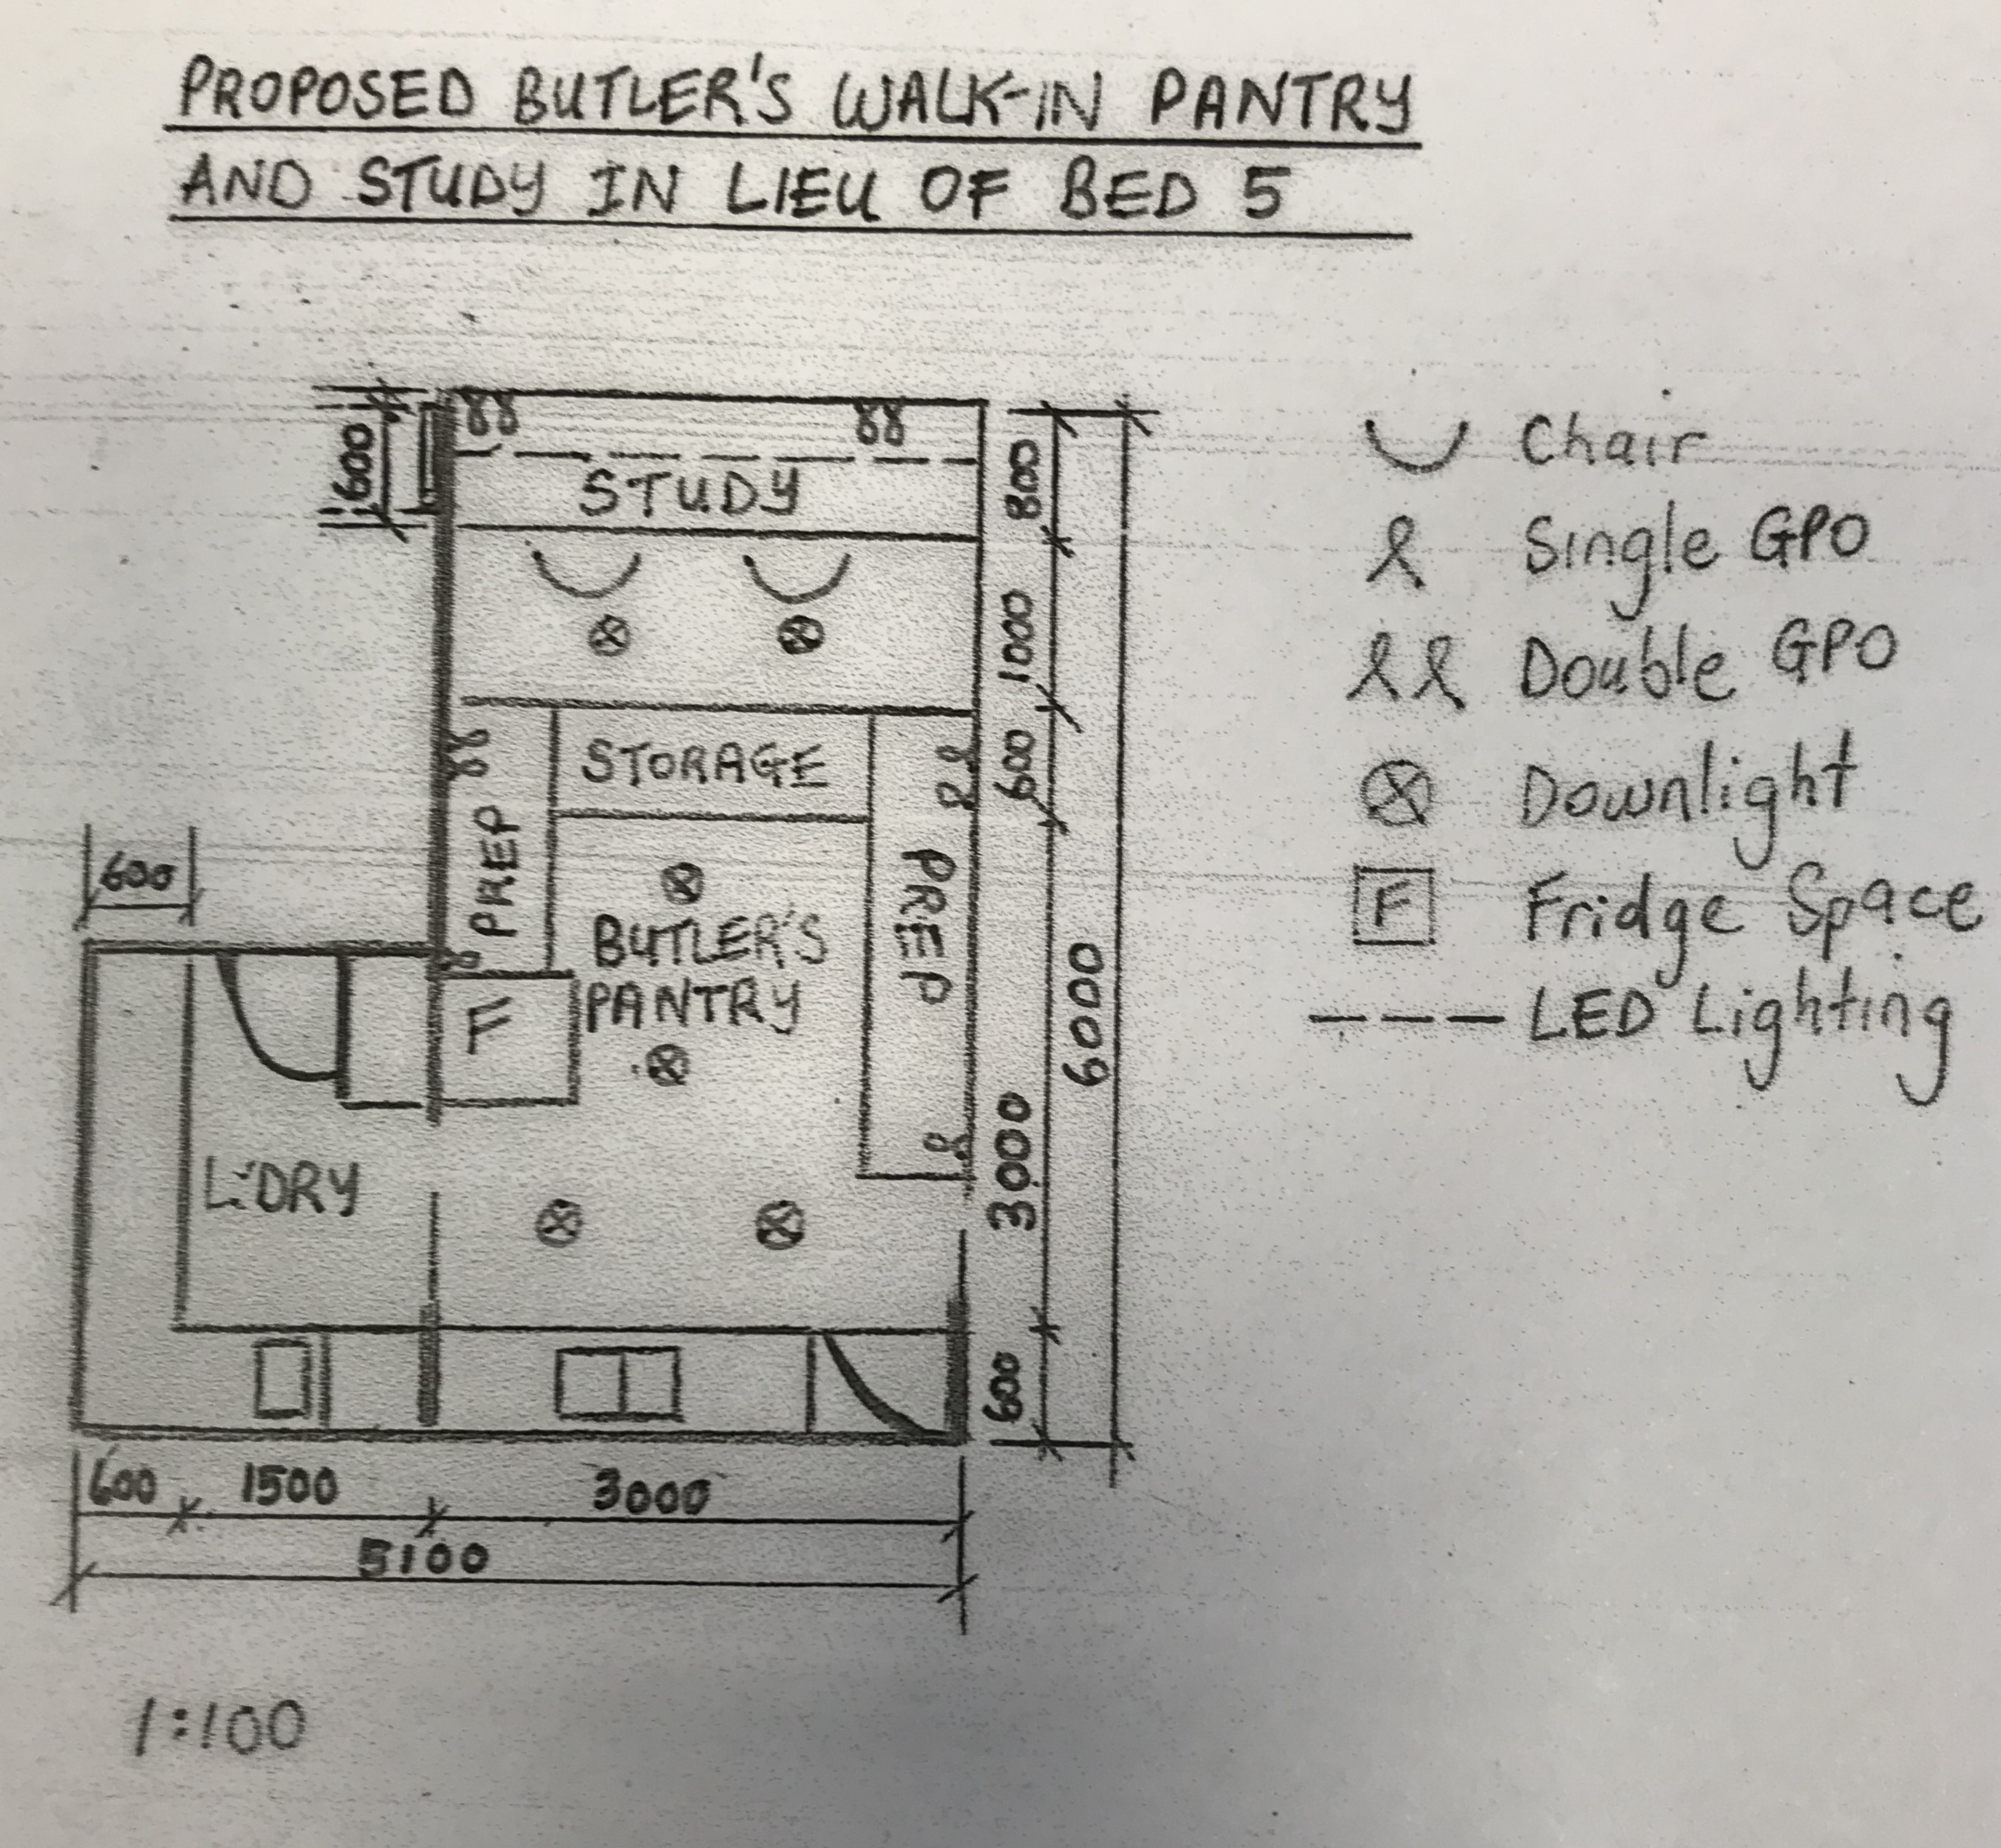

- Consider the erection of scaffolding for the brick layer, metal fascia and gutter installation and soffit installation.
Draw a scaffold plan for the entire building and draw an elevation showing a minimum of two bays and one corner return. Ensure the plans follow all relevant standards, codes and authority requirements.

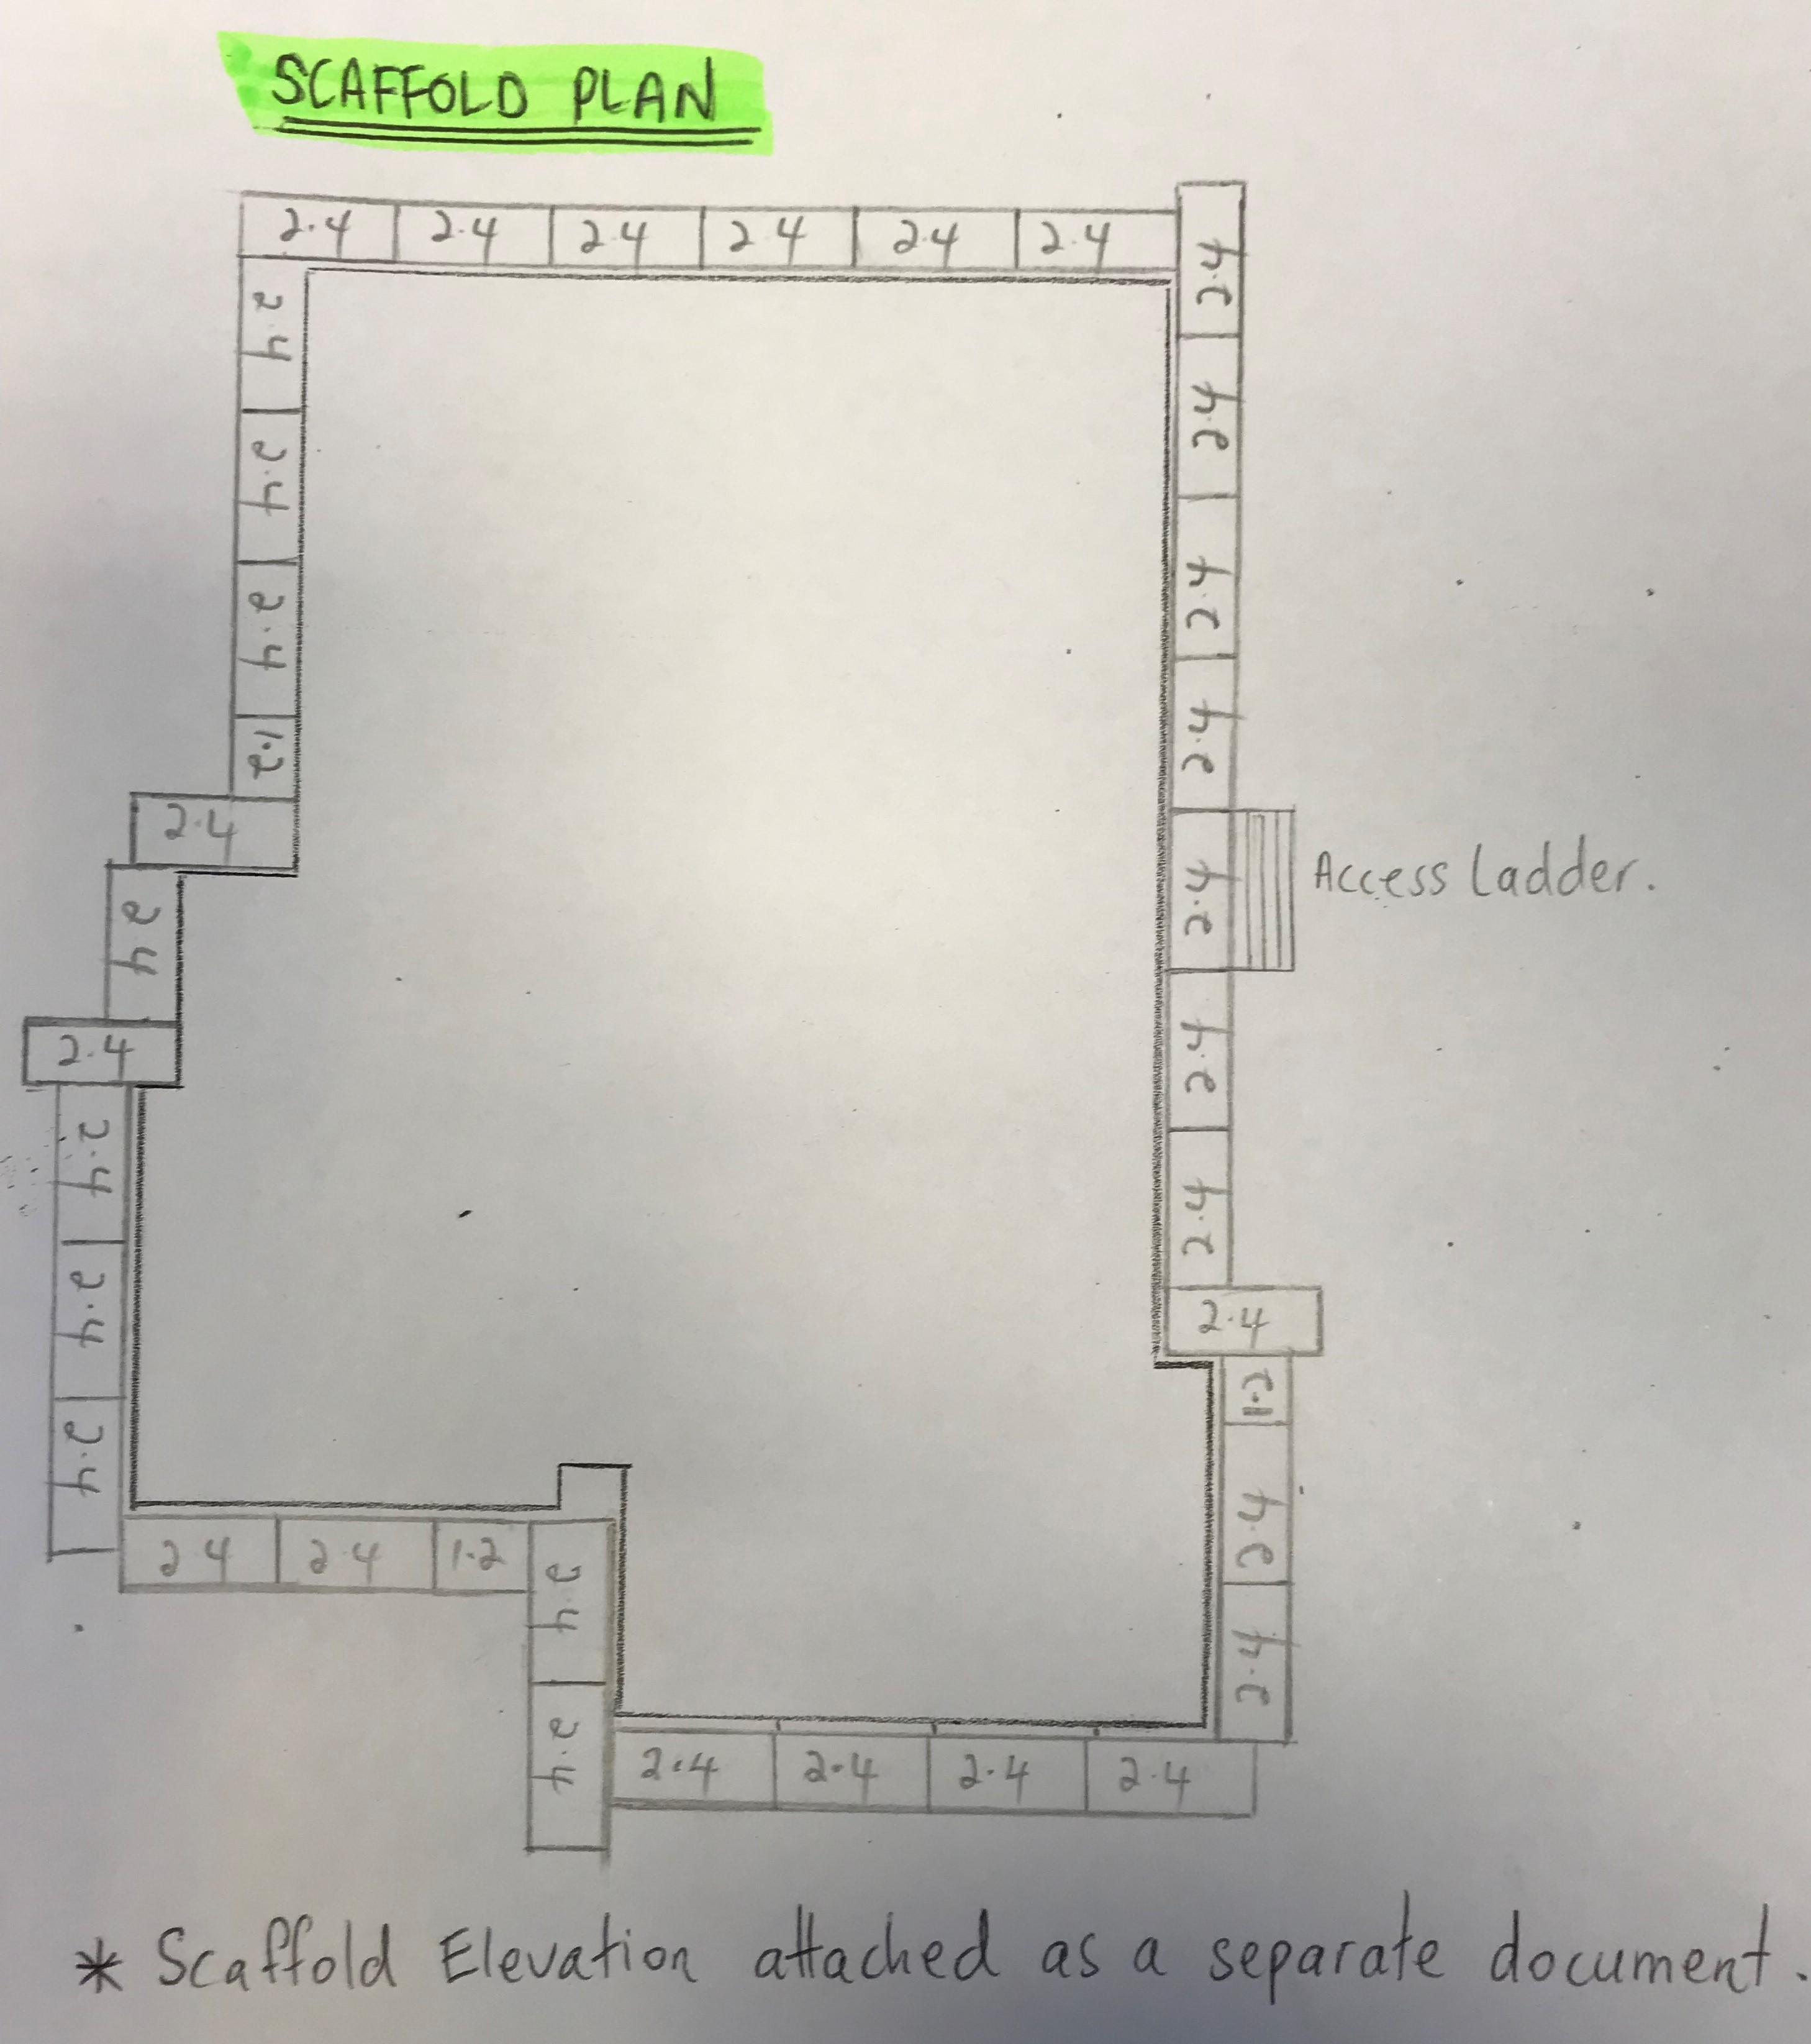

Answer

- Write a personal protective equipment (PPE) plan and from this prepare a PPE induction toolbox talk for the site.

Answer | 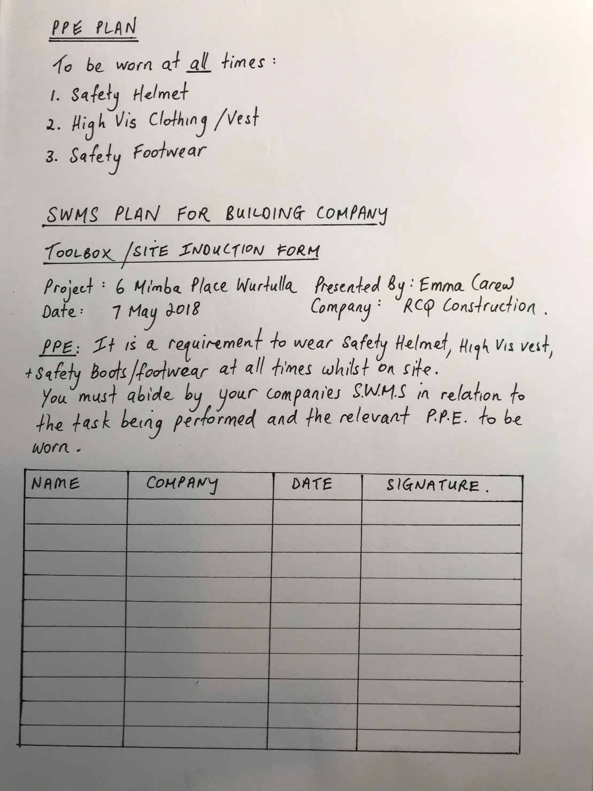

- Write a Hazards Identification Plan for the site which details local pedestrian and traffic flow as well as ingress and egress for cars and trucks, deliveries and personnel overhead cabling and power supply, power access for trades services and locations, dealing with waste materials and general public and on-site worker safety.

Answer | Please refer to attachment with submission:  Q12. Hazard Identification Plan

