CPCCBC4005A
Produce labour and material schedules for ordering

PRACTICAL ASSESSMENT INSTRUCTIONS

- The following practical assessment will require the participant to complete work related activities.
- Observations will be conducted of the participant’s work to determine whether they display sufficient practical skills and knowledge.
- Please fill in the details below, providing your name, signature and date of assessment.
  - Your signature acknowledges that the assessor provided clear instructions and the participant understood what was required to complete this assessment.
- The assessor may substitute a Practical Task with another task of equal value.
  - Alternate tasks must be fully documented by the assessor.

Participant name | Alexander Butler
Participant signature | 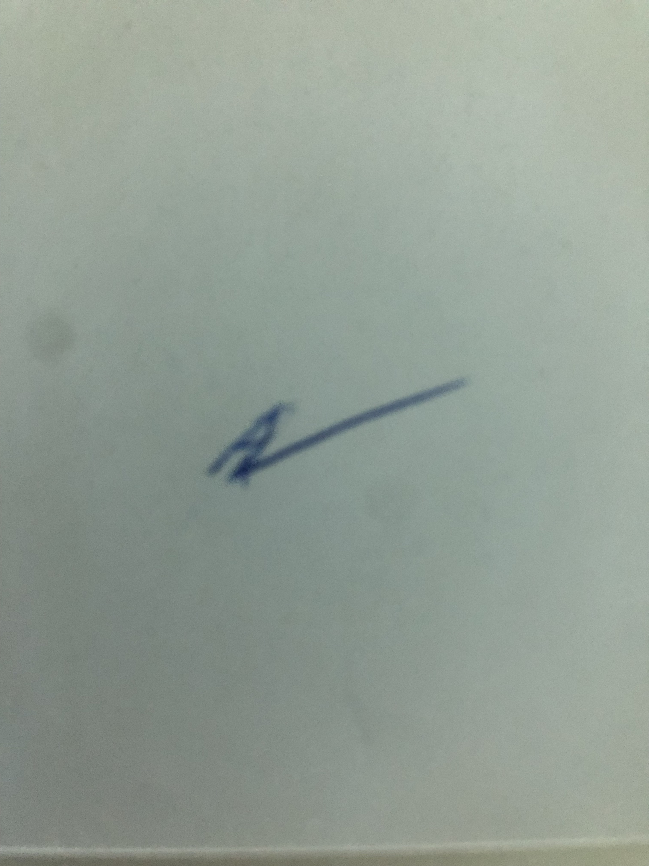

Assessor name
Assessor signature | 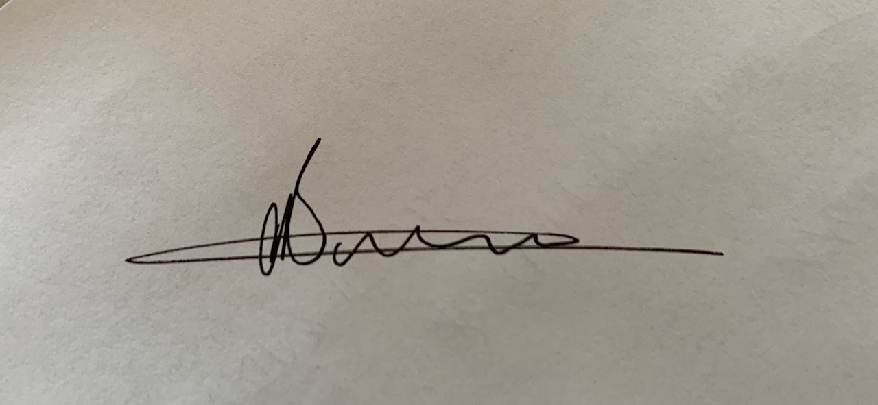

Date | 29/10/2019

Number of tasks | Number of tasks completed | Satisfactory?
1 (2X) |  | Yes | No

Assessor Comments
CPCCBC4005A
Produce labour and material schedules for ordering

Practical Task 1 (2X)
Description of task:
On two (2) occasions, a suitable observer is to verify the participant’s ability to produce schedules of resource requirements so that orders can be placed for materials and labour for projects, and costs can be recorded and tracked as they are incurred. These tasks may be simulated or real.
- Occasion 1: Residential project
- Occasion 2: Commercial project

The participant is to gather evidence of how they have completed each component of the Practical Task, which is to be submitted with this Practical Assessment sheet. The observer is to provide detailed comments on the tasks completed by the participant. The assessor is to verify the observer’s comments in the Assessor Comments section, and provide the Practical Assessment outcome on the front cover of this document.
Resources required:
Contract documentation (including plans and specifications), computer.
Assessment of task
Name of participant: | Alex Butler
Name of observer: | Conan Butler
Role of observer  (Confirm suitability to sign) | Operations manager
Email address of observer | conan@eastcoastconcrete.com.au
Signature of observer:
Date: | 27/10/2019
When completing the task, did the participant: |  | Tick if satisfactorily completed.  Provide comments if left unticked.
 |  | 1st  Occasion | 2nd  Occasion
- Consider all contract conditions in the schedules, including:
- All contractual requirements
- Local government and regulatory bodies’ conditions of approval
- Colour selections
- Variations to contracts, raised by the client or builder
- Produce material and labour schedules, including:
- Details of nominated suppliers and contractors in work schedules
- Application of contract rates
- Produce relevant overlay drawings.
- Include contract details and instructions on orders.
- Prepare site files, including:
- All necessary site documents, including plans and specifications
- Preparation of call forward sheets, detailing all orders
- Analyse project costs against estimates during construction.
- Analyse approved variation costs.
- Provide a final project cost analysis.
- Maintain data files of standard costs, including:
- Approved variation cost increases
- Changes to standard plans, specifications, and cost files
- Effectively communicate using the following methods:
- Verbally using language/concepts appropriate to cultural differences
- Non-verbal communication
The participant’s performance was: Satisfactory Not Satisfactory

observer Comments

