CPCCBC4005A
Produce labour and material schedules for ordering

THEORY EXAM INSTRUCTIONS

- This exam will occur under standard assessment conditions.
  - An oral examination may be allowed under certain circumstances.
Answers will be documented and FT003 (Oral examination declaration form) must be completed.
- Participants must provide enough detail in their responses to demonstrate their knowledge and skills.
- Please fill in the details below, providing your name, signature and date of assessment.
  - Your signature acknowledges that this is your own work.
- If a participant initially answers a question incorrectly but modifies their response, they must follow the instructions below:
  - If a participant changes their response in writing, they must put their initials next to the written change.
  - If a participant changes their response verbally, this must be noted on the exam paper by the assessor.

Participant name | Justin Skehan
Participant signature | 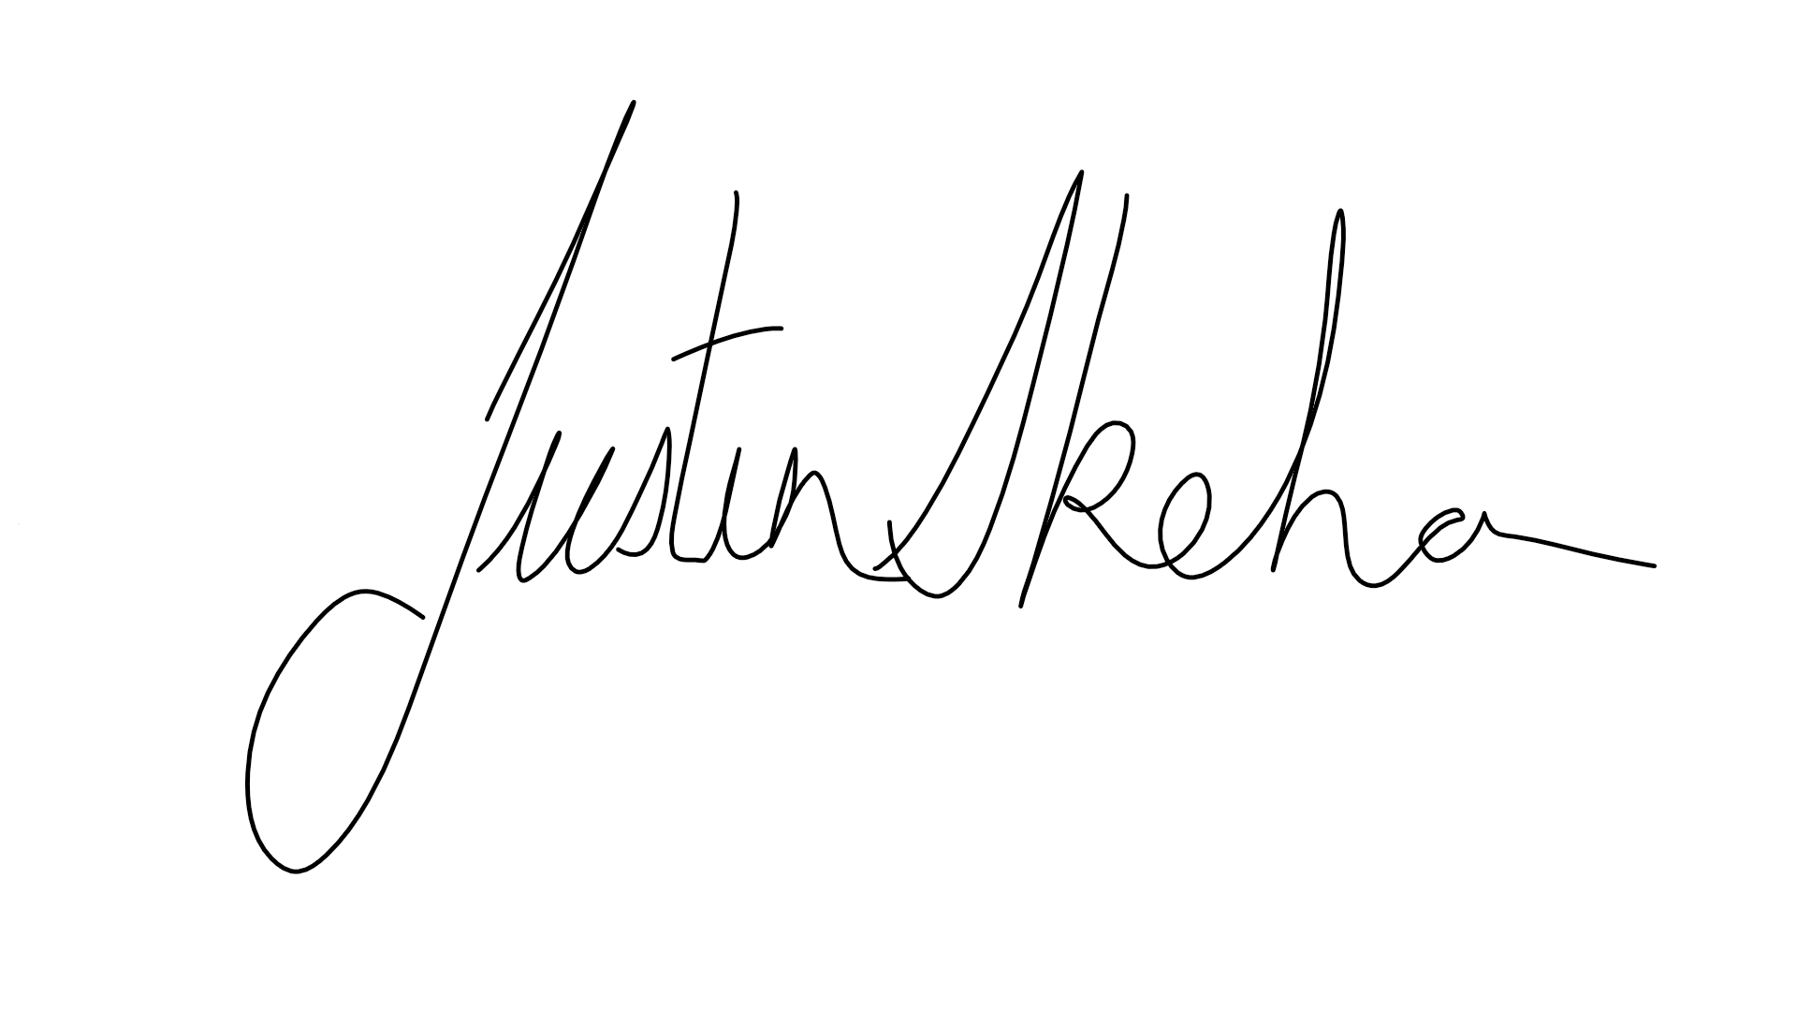

Assessor name
Assessor signature | 

Date | 7/09/2018

Number of questions | Number of questions answered correctly | Satisfactory?
27 |  | Yes | No

Assessor Comments
- What is the critical reason of identifying and interpreting plans, drawings and specifications for a building project?

Answer | the critical reason of identifying and interpreting plans, drawings and specifications for a building project is to ensure you can have a full understanding of the building project the steps required and the materials that are required on the job

- Explain the purpose for date stamping of plans, drawings and specifications.

Answer | The purpose of date stamping plans is to ensure all parties involved in the project can identify they are working on the correct version of the drawings and specifications

- Nominate at least five (5) people and/or entities that would use plans, drawings and specifications on a building project.

Answer | Five other parties that will use the project drawings and specifications are,  - Structural Engineer  - Local Council  - Building Certifiers  - Surveyors  - Subcontractors

- Name some of the types of drawings and details you would expect to find on plans and drawings for a building project.

Answer | Some drawings include  - Site Plan Showing, datum, contours and orientation  - Floor Plan Showing, frame sizes, windows, doors, room layout  - Bracing Plan Showing, LBW, tiedown, bracing requirements

- Is it necessary to acquire all building plans and specifications at the beginning of the negotiation period to know all building project details prior to commencing work? What does the builder need to know?

Answer | The Plans will show the builder what the proposed structure will look like when completed and how it is to be constructed. It will show the shape and size if the proposed building as well as its location on the site. It will also show selected material and how and where they are to be used. They will also include section and elevation drawings which will highlight heights and how various structural parts are to be built

- Drawings for a building project are arranged in an approximate order of construction. What should a set of drawings consist of?

Answer | A set drawing should consist of drawings such as,  - Block plans  - Site plans  - Floor plans  - Foundations plans  - Elevations  - Roof plans  - Section through the entire building  - Service Plans  You will also require any available engineering drawings for applicable structural application details

Read through the scenario below to respond to Q7. to Q15. Error! Reference source not found.

You are the Building Contractor and your client has sought preliminary estimates for a renovation job on a commercial business premises on the ground floor of a 12 story high rise which you believe may exceed $15,000 in value. You client has sought firm figures before committing and signing a contract. New electrical wiring for lights and power points are already installed in the pre-existing timber wall and ceiling framing.

You are to create a construction schedule, ordering forms for materials, scheduling the work and scheduling sub-contractors and by using your current industry networks you are to obtain quotes from sub-contractors as if this were a real job. Advise your colleagues this is for an assignment in your course in the Certificate IV in Building (Building).

Choose a fictitious future date for the project to commence and then fully schedule your build, your materials and materials ordering from suppliers and schedule your sub-contractors start and finish dates.

Write draft emails (do not send them) to each sub-contractor detailing the information you need from them and seeking them to submit a quotation and advise you of their approximate work start and finish dates. All sub-contractors are to be labour only. As the builder you will supply all materials and consumables excluding tools, plant and equipment. Attach all these draft emails to your assignment. Armed with the appropriate knowledge ask your sub-contractors to present you a quote for labour only for the job (plastering and then doors + furniture and skirting installations) and their work timelines (start/finish dates).

The Project:
The commercial office project has eight (8) rooms all adjacent (side-by-side) to each other.
  - Room 1 is 6000 x 3300
  - Room 2 is 3900 x 3300
  - Room 3 is 4000 x 3300
  - Room 4 is 4800 x 3300
  - Room 5 is 5200 x 3300
  - Room 6 is 7400 x 3300
  - Room 7 is 8000 x 3300
  - Room 8 is 9000 x 3300

75mm moulded skirting boards and architraves are to be used to fit out each room. Each room has the same street frontage and each room on its street frontage outer wall has a sliding glass aluminium window 1540 x 2650 facing the street. You have to fit the windows to the already installed load bearing timber framing. In the centre of the opposite wall to the windows of each room is a single doorway each opening into the same hallway. All doors open inward into their respective room. The doors for each room are 2040 x 820 x 35 flush panel, hollow core.

Door and window jambs are for covering 75 x 45 treated pine wall framing with 10mm regular plasterboard sheeting lining the internal walls and 13mm acoustic plasterboard lining the ceilings.

You have to hang doors, fit jambs, door stops, fit and attach privacy set door furniture and a door open retainer and door stop. (Builder’s Choice)

- Calculate and cost the lineal timber order for skirting and architrave and allow 5% wastage. The cost per lineal metre for moulded 75 x 12 architrave and skirting is $6.40/m.

Answer | Skirting required  - 157lm x $6.40 = $1004.80  Architrave required  - 154lm x $6.40 = $985.60  Total Cost $1990.40

- Calculate the square metres of 13mm ceiling and 10mm wall plasterboard required to sheet out internal walls and ceilings in each of the nominated rooms. Please note:
- The finished ceiling height is 3300mm.
- The floor is already fitted with floating timber floor over concrete.
- All wall and ceiling framing is in place as is electrical wiring and ready for sheeting.

Answer | 13mm Plasterboard required for internal ceilings  - 160 SQM  10mm Plasterboard required for internal walls  - 493 SQM

- Research, price and schedule the sheeting for each room and write an order to a supplier for the plasterboard linings.

Answer | Plasterboard room schedule as follows purchase order is attached  Room 1  Walls  - 3600 x 1200 x 10mm x 6  - 6000 x 1200 x 10mm x 6  Ceiling  - 6000 x 1200 x 13mm x 3  Room 2 and 3  Walls  - 3600 x 1200 x 10mm x 6  - 4200 x 1200 x 10mm x 6  Ceiling  - 4200 x 1200 x 13mm x 3  Room 4  Walls  - 3600 x 1200 x 10mm x 6  - 4800 x 1200 x 10mm x 6  Ceiling  - 4800 x 1200 x 13mm x 3  Room 5  Walls  - 3600 x 1200 x 10mm x 6  - 5400 x 1200 x 10mm x 6  Ceiling  - 5400 x 1200 x 13mm x 3  Room 6  Walls  - 3600 x 1200 x 10mm x 6  - 4800 x 1200 x 10mm x 2  - 6000 x 1200 x 10mm x 6  Ceiling  - 6000 x 1200 x 13mm x 3  - 4800 x 1200 x 10mm x 1  Room 7  Walls  - 3600 x 1200 x 10mm x 6  - 6000 x 1200 x 10mm x 8  Ceiling  - 6000 x 1200 x 13mm x 4  Room 8  Walls  - 3600 x 1200 x 10mm x 6  - 6000 x 1200 x 10mm x 9  Ceiling  - 6000 x 1200 x 13mm x 5

- If a sub-contract plasterer advises that his price (labour only) is $51.50 per square metre (inclusive of GST), estimate the cost to install and finish the plasterboard by this sub-contractor.

Answer | Total Plasterboard required 653SQM  - 653SMQ x $51.50 = $33629.50

- Contact a real plasterer and ask how long it would take to do this plastering (i.e. fix sheets, stop, set and finish).
Calculate the cost of installation and finishing of the plasterboard linings based on this sub-contractor’s quote and your own research for pricing the materials.

Answer | I contacted a local plasterer (Townsville Plasters) to get rates for fixing and setting of the plasterboard and the time frame that would be required to complete the job  - Fixing $4.00 Sqm Gst  - Set $4.50 Sqm + Gst  - Sheeting timeframe 2 days  - Setting time frame 3 days  The total cost to fix and set the sheets for this project would be  - $6105.55 inclusive of Gst  With a required timeframe of 5 days

- Your carpenter sub-contractor has advised that per door including full fit out for installing door jambs, hang door, fit door furniture, fit door stops, installed architrave and fit open door retainer and skirting door stop is $36.40 per hour and each door and fit out is 2 hours of labour only.
Calculate the labour only costs to hang all eight (8) doors.
Schedule all the materials, source suppliers and write your materials order to your supplier/s.

Answer | Labour Costs 8 x ($36.40 x 2) = $582.40  Materials  - 2040 x 820 x 35mm Redicote 8of  - 92 x 18mm Jamb 8/5.400  - 31 x 11mm Stop 8/5.400  - 75mm Mouldings 16/5.400  - Hirline Hinges 16of  - Door handles 8of  - Door Stops 8of  - Door Retainers 8of  Purchase order attached

- The carpenter sub-contractor also estimates that the skirting can be installed in 1½ days (a work day is 7.5 hours).
Based on his labour only rate of $36.40 per hour, estimate the cost for installing the skirting to all rooms.

Answer | The cost of installing the skirting  (7.5 x 1.5) x $36.40 = $409.50

- Schedule the activities for the sub-contract carpenter, write a full materials list and write out the relevant order form/s to order the materials from suppliers. Use real suppliers for pricing and ordering.

Answer | Carpentry activities required  - Install door jambs, hang door, fit door furniture, fit door stops, installed architrave and fit open-door retainer and skirting door stop  - Install skirting Boards  - Install window Reveals and Architraves  Materials required  - 2040 x 820 x 35mm Redicote 8of  - 92 x 18mm Jamb 8/5.400  - 31 x 11mm Stop 8/5.400  - 68 x 18mm Reveals 13/5.400  - 75mm Mouldings 58/5.400  - Hirline Hinges 16of  - Door handles 8ofT  - Door Stops 8of  - Door Retainers 8of  Purchase order attached

- During the fit out, the client suggests to you they would like Rooms 6, 7 and 8 to have double hung doors, rather than a single door. You will need to widen the current openings and price the variation.
Work up a quote for the variation to seek the client’s approval. Suggest where this would be filed in your documentation.
Prepare the paperwork for the variation to be approved and signed off by you as the principal contractors and the client.
What else will you need to do?

Answer | Quote for variation attached  Variation agreement attached  The documentation for the variation should be added immediately to the project files making them readily available for all parties that may need to access them

Read the following information to respond to Q16. to Q18.

A low set building floor plan measures 30 metres long x 16 metres wide. The drawings and specification states the bearers for the sub floor run the length with the floor joist across the width. The bearers are supported by engaged piers and intermediate 100mm x 100mm steel posts which are at 5 metre intervals over the length of the building and 4 metre intervals over the width. The timber flooring for this build is 80 x 19 Blackbutt (NSW) Std T&G and costs $86.50/m².

- Calculate the number of steel posts required in support of the sub floor timbers plus sketch your answer in support of this calculation. The sketch must be to scale 1:200

Answer | 25 steel posts will be required

Sketch:
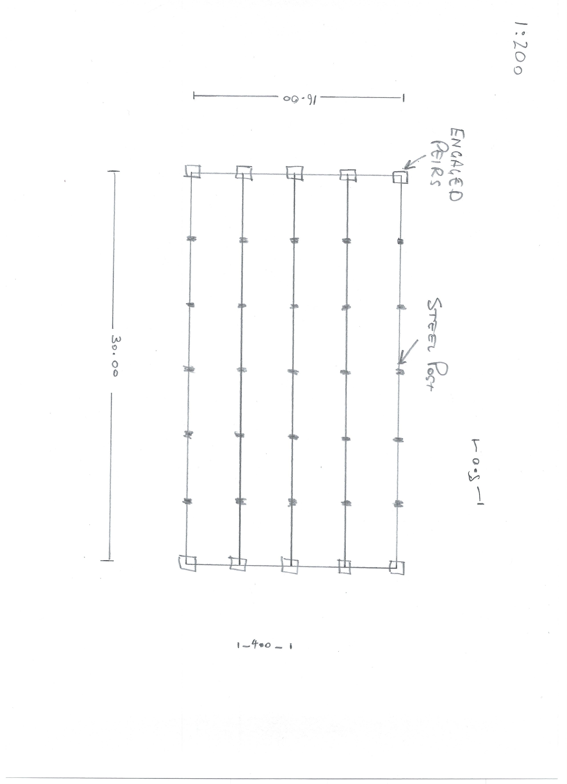

- Calculate the total square metres of timber flooring required plus 5% for waste.

Answer | Timber flooring required  30m x 16m + 5% wastage = 504 Sqm.

- A sub-contract carpenter nominates laying the floor at $100/m².
Estimate the labour cost for laying the floor.

Answer | Cost for laying the floor  30m x 16m = 480 Sqm.  480 Sqm x $100 = $48,000

Read the following information to respond to Q19. to Q21.
A single skin (veneer) brick wall is to be laid 21000mm long and 3300mm high in which there are four windows 1800x2410, 1800x1800, 600x900 and 1200x1810 and two external solid timber doors each 2040x820x45

- How many face bricks would be required if the number of bricks per square metre is 49?

Answer | Total wall area 21.0 x 3.3 = 69.8sqm  Total openings 13.64sqm  69.8 – 13.64 = 56.16 sqm  56.16sqm x 49 = 2752 Bricks required

- A standard brick is used for the wall and sills.
If a brick is 100 wide then estimate the number of bricks need to sill under each window?

Answer | Sill 1 25 bricks  Sill 2 18 bricks  Sill 3 9 bricks  Sill 4 19 bricks

- Your bricklaying subbie indicates he will have three tradesman bricklayers on site and one labourer. Estimate the number of days the bricklayers will be on site and the labour cost if:
- Each bricklayer lays 300 face bricks a day and their labour rate is $34.20/hour for the bricklayers
- 49 bricks make up 1m²
- The labour rate is $26.40/hour for the labourer

Answer | 2752 Bricks required  3 Bricklayers = 900 bricks per day  3 days labour will be required  Labour Costing  3 x Tradesmen @ $34.20 x 7.5hr per day = $769.50 day  1 x Labourer @ $26.40 x 7.5hr per day = $198.00 day  Total per day $967.50  3 days required on site  Total labour Charges $ 2902.50

- There are many different ways of estimating project costs. You can use your past experience, or ‘square metre’ rates but if you are unfamiliar with estimating and pricing then you should resort to the materials and labour method of costing using an item-by-item approach which is considered as the best industry approach to estimating.
What are at least three of the nominated methods for estimating?

Answer | 3 nominated methods are,  - Costing by area  - Costing by material and labour  - Costing by a guide or manual

- If a bricklayer can lay 300 bricks in a 7½ hour work hour day, and 49 bricks make up 1m², what is the total square metres (to two decimal places) of bricks laid by four bricklayers in an average work day?
Tick your response.

Answer | Choice | Possible Answers
 | ☒ | 24.48m²
 | ☐ | 82.44m²
 | ☐ | 48.42m²
 | ☐ | 42.84m²

- What is the logically quickest way to find potential sources and suppliers for goods and services these days for a contractor?

Answer | The internet is the quickest way to find potential sources and suppliers for goods and services

- What are three (3) ways for you to communicate with your suppliers for gaining quotes?

Answer | - Email  - Fax  - Phone  - In person

- Explain the concept of a ‘Labour Only’ quote.

Answer | A labour only quote is used when the only component of the project you are quoting is the labour content

You will be provided an allocated period by your instructor to complete this task.

- Referring to the supplied set of house plans, you must do the following scheduling and costing:

- Identify and nominate a supplier/s and schedule the materials and cost the internal and external timber wall framing.
- Identify and nominate a supplier/s and schedule the materials and cost the foundations and lower floor concrete slab including the schedule and costing for reinforcement.
- Identify and nominate a supplier/s and schedule the materials and cost for the sub floor framing and the flooring for the upper floor plan.
- Calculate the architrave and skirting required for the fit out of the upper floor only in lineal metres.
- Calculate the wet area tiles for the upper floor only which are client chosen for both floors and walls with the wall tiles 250 x 100 and floor tiles 300 x 300.
- Estimate the labour only cost to tile all the wet areas only in the home. The tiler charges labour only $44.00 per square metre.
- Determine the roofing material and number of square metres of it that are required.
- Complete the aluminium windows and doors schedule and other external doors schedule for the lower floor only.
- Complete a full internal doors schedule for the lower floor only.
N.B. Assume all doors are flush panel 2040mm in height and 35mm thick.
- Estimate the labour only cost for hanging all doors on the lower floor – if a tradesman takes 2 hours to jamb an opening, hang the door, fit the door furniture, door stops, architrave and fit a magnetic door-open-restraint. The hourly rate is $27.80 plus 20% on costs.
- Produce the Labour & Time Schedule for all the labour needed for the lower floor project. You may need to contact other sub-contractors to get a feel for labour and time costs (or if you feel you have the experience then call upon this experience to determine your labour schedules for each trade for this project).

Answer | a. Attached  b. Attached  c. Attached  d. – upper floor Skirting 103 Lm  - upper floor Architrave 207Lm  e. - Floor Tiles 300 x 300mm 17m2  - Wall Tiles 250 x 100m 52 Sqm  f. - 69m2 x $44.00 = $3036.00  g. - Garage Roof .42Bmt Kliplok Zinc 55m2  - Lower Roof .42Bmt Colorbond Trimdek 49m2  - Upper Roof .42Bmt Zinc Trimdek 175Sqm  h. Attached  I. – Redicote Doors 204 x 820 x 35mm 1/870 3/820 1/770 3/720 1/620  j. 9 Doors x (2x $27.80) + 20% = $600.48  k. Attached

Answer

