
AHCLSC303
Construct brick and block structures and features

Copyright © 2021 CSTC Pty Ltd

All rights reserved. No part of the contents of this publication may be reproduced or used in any form or by any means – graphic, electronic, or mechanical including photocopying, digitising, recording, or information storage-and-retrieval systems – without the written permission of CSTC Pty Ltd.
ASSESSMENT FOR AHCLSC303

Student name | Kelly Thorpe
Date of assessment submission | Click here to enter a date.

Trainer/Assessor’s name
Date of assessment marking | Click here to enter a date.
Outcome for unit | ☐ Competent  ☐ Not Yet Competent

TASK INSTRUCTIONS

- As part of the assessment for this unit of competency, you are required to complete a series of activities.
  - Some of these activities will require you to provide a response within this document, others will require you to gather evidence to demonstrate your knowledge and skills.
- At all times, the responses in your assessment must reference Australian (Queensland or Federal) documentation, including legislation, regulations, codes of practice, standards and guidance publications.

ACTIVITIES

Draw a simple concept plan for a proposed landscape design which includes brick/block work.

Response


Outcome for Activity 1 | ☐ Satisfactory  ☐ Not satisfactory
Trainer/Assessor comments

Identify/list the detail on the landscape plan shown.

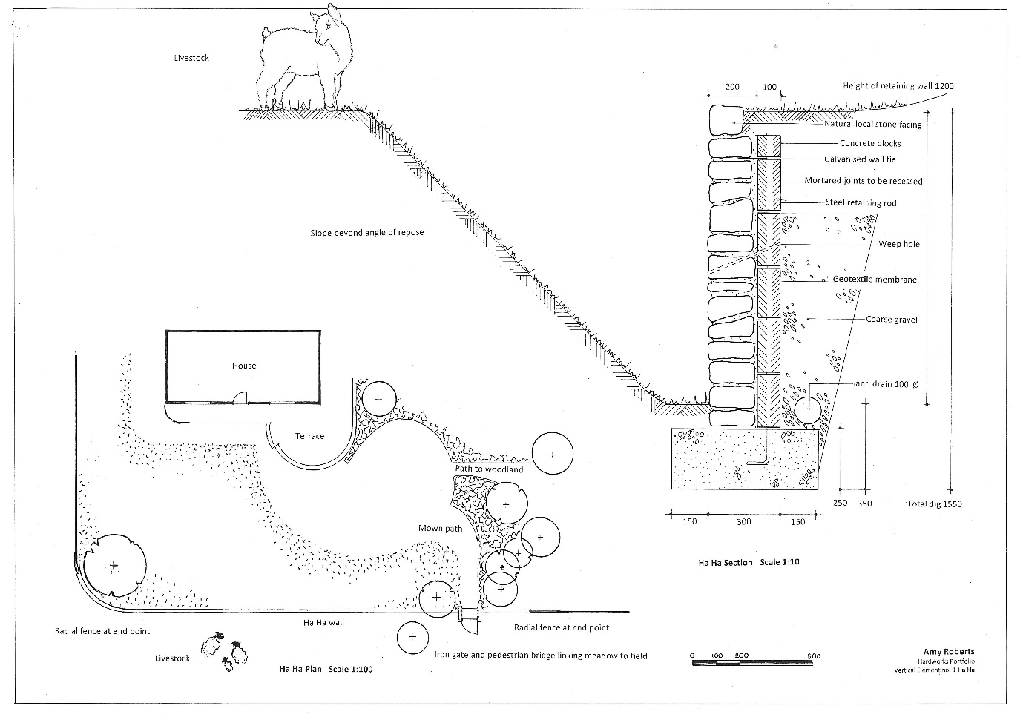

Response
Scale, name of author, what the retaining wall is to be made of (the materials) the retaining wall heights and widths in the various processes, Existing vegetation and planting detail. Streetscape works – anything that may go over the boundary line.

Outcome for Activity 2 | ☐ Satisfactory  ☐ Not satisfactory
Trainer/Assessor comments

List the materials required for the concrete block retaining wall construction plan shown.

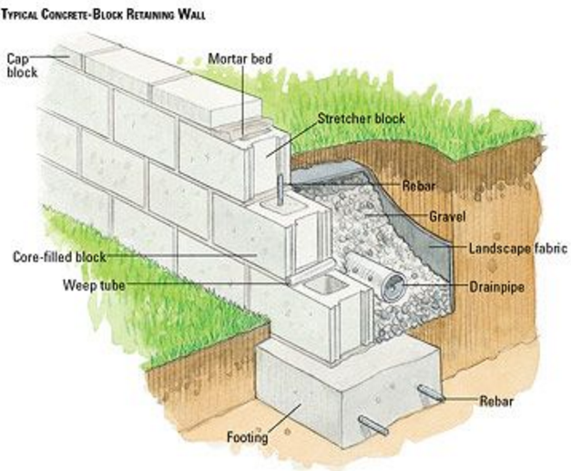

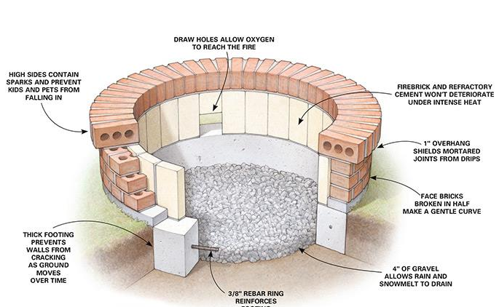

Response
Concrete blocks, cap blocks, weep tubes, gravel, landscape fabric, drainpipe, rebar, concrete/mortar

Outcome for Activity 3 | ☐ Satisfactory  ☐ Not satisfactory
Trainer/Assessor comments

Research and identify the standard dimensions of brick and concrete blocks.

Response
Bricks (all measurements are in millimetres)
Standard brick 230 x 110x 76
Long 468 x 108 x 38
Split 230 x 110 x 50
Linear 230 x 90 x 50
One and a half 230 x 110 x 119
Double height 230 x 110 x 162

Blocks

600 x 600 x 1000
500 x 500 x 1000
600 x 450 x 2400
400 x 400 x 1000
450 x 300 x 900
600 x 600 x 2400
1000 x 1000 x 1000

Outcome for Activity 4 | ☐ Satisfactory  ☐ Not satisfactory
Trainer/Assessor comments

List the components for four (4) common surface drainage systems used in landscape construction.

System | Components
- Spoon | Is a concrete drain formed in line with the ground surface and used to collect rainwater. Generally 1 metre wide and 80-120mm deep.
- Channel and grate | Plastic bases with grate on the top to stop blockages occurring, comes in a variety of sizes and shapes.
- Pit | Is a rectangular box with a grate on top, used to collect excess rainwater or excess water.
- Contour | Contour banks are used to slow/break down overland water flow on slopes, by reducing the slope of the land on can reduce problems such as erosion and water speed.

Outcome for Activity 5 | ☐ Satisfactory  ☐ Not satisfactory
Trainer/Assessor comments

List the advantages and disadvantages of drainage behind and through the build wall (as shown).

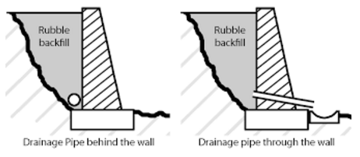

Drainage pipe behind the wall
Advantages
Relieves hydrostatic pressure preventing the wall from falling over and/or collapsing
Disadvantages
Water seeping through can take dirt with staining the blocks/timber, a garden fabric or geomesh should be used. Frogs and other pests can get in the drain pipe.

Drainage pipe through the wall
Advantages
Relieves hydrostatic pressure preventing the wall from falling over and/or collapsing.
Disadvantages
Dirt/ gravel or any other fill can seep out the holes in the wall. The holes can become blocked and pests such as frogs or mice can get in them,

Outcome for Activity 6 | ☐ Satisfactory  ☐ Not satisfactory
Trainer/Assessor comments

Research and list a variety of admixes.

Admix | Description
- Set Retarding | Delays the chemical reaction that takes place when the concrete start the setting process.
- Air entrapment | Increases the freeze thaw durability creating a more workable concrete
- Corrosion Inhibiting | Slows the corrosion of the reinforcing steel in the concrete
- Mineral | Includes natural products such as volcanic ash, fly ash and silica fume to create a more economical, durable product

Outcome for Activity 7 | ☐ Satisfactory  ☐ Not satisfactory
Trainer/Assessor comments

Research other methods of damp proofing (excluding DPC and base course) and identify the materials used.

Damp proofing method | Materials
- Integral | Water proofing compounds such as permo, silica, chalk, soap and petroleum are added to the concrete mix
- Cavity Wall | The main wall of the building is shielded by an out skin wall leaving a space between the two ensuring moisture stays on the outside.
- Surface Treatment | Water resistant compounds or substances such as sodium or potassium sulphates or barium hydroxide are applied to the mix
- Guniting | And impervious layer of cement mortar is deposited under high pressure generally around pipes and cisterns to seal the gaps.

Outcome for Activity 8 | ☐ Satisfactory  ☐ Not satisfactory
Trainer/Assessor comments

Research the suitability of the different types of bonds across various brick/block work projects.

Bond | Brick/block work project suitability
- Stretcher bond | Composed of stretchers set in a row and off set by a half brick, this is simple easy and has minimal waste.
- Flemish bond | Created by alternatively laying headers and stretchers, simple easy and has minimal waste as well. Not as strong as the English Bond.
- English bond | Made up of alternating headers and stretchers, this method is common for viaducts, bridges and embankments.
- Honeycomb bond | Is characterised by the absence of certain blocks, creating gaps in the wall, generally used for decorative purposes, to allow ventilation or as a screening.

Outcome for Activity 9 | ☐ Satisfactory  ☐ Not satisfactory
Trainer/Assessor comments

Research and list the specifications for mortar beds and perpend (perps).

 | Specifications
- Mortar beds | The horizontal joints between the blocks/bricks.. Building code for mortar calls for it to be 3/8 inch on load bearing walls and should not encroach into the cavity more than 5mm. There are numerous types of mortar joint finishes (raked, grapevine, extruded, concave, V, struck, flush) and there are four main types of mortar; N, O, S and M, all mixed with varying ratios of cement, lime and sand to create a mix.
- Perpend | Vertical joints between blocks and bricks, can be left open to form weep holes or cavity ventilators.  In stone masonry it is a long stone that extends through the entire wall locking the inner and outer wall together.

Outcome for Activity 10 | ☐ Satisfactory  ☐ Not satisfactory
Trainer/Assessor comments

List environmentally safe products for cleaning.

Response
Water, mild dish soap, vinegar, baking soda, high pressure water, broom.

Outcome for Activity 11 | ☐ Satisfactory  ☐ Not satisfactory
Trainer/Assessor comments

Have team members take photos and videos of your involvement with brick/block features.

Identify each photo / video with a letter label and describe each photo / video in the table below. Submit the photo / video files along with this workbook.

Advantages
A | 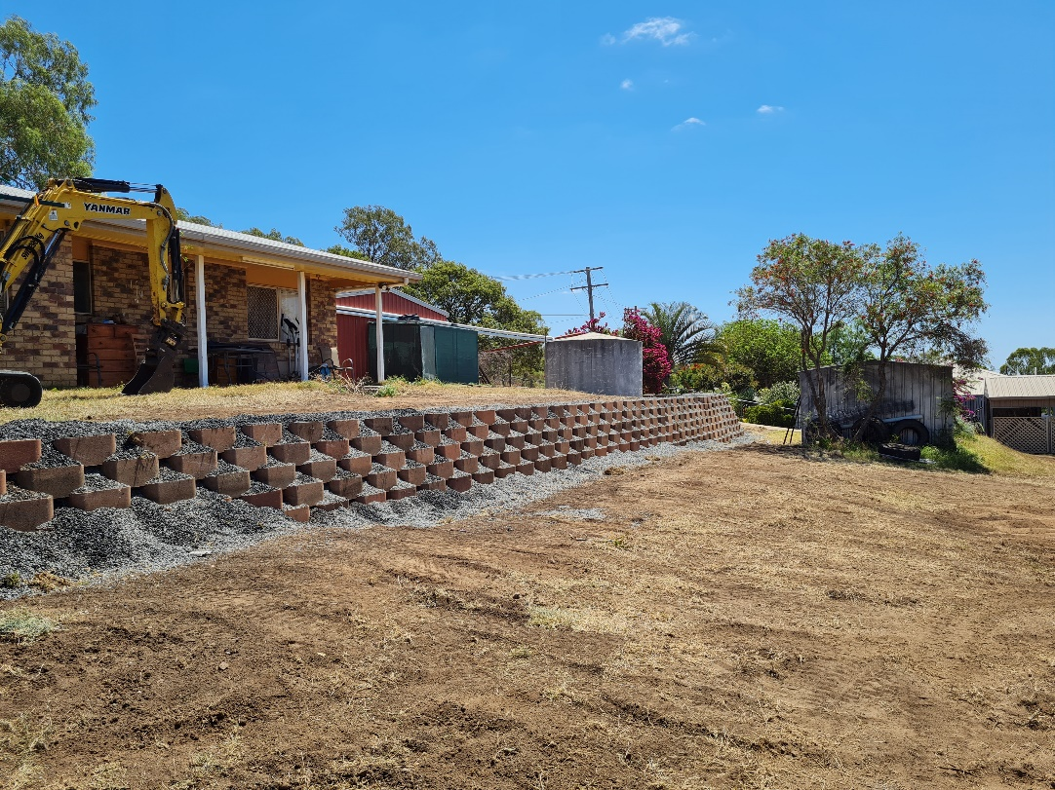  Brick retaining wall created using recycled bricks.
B | 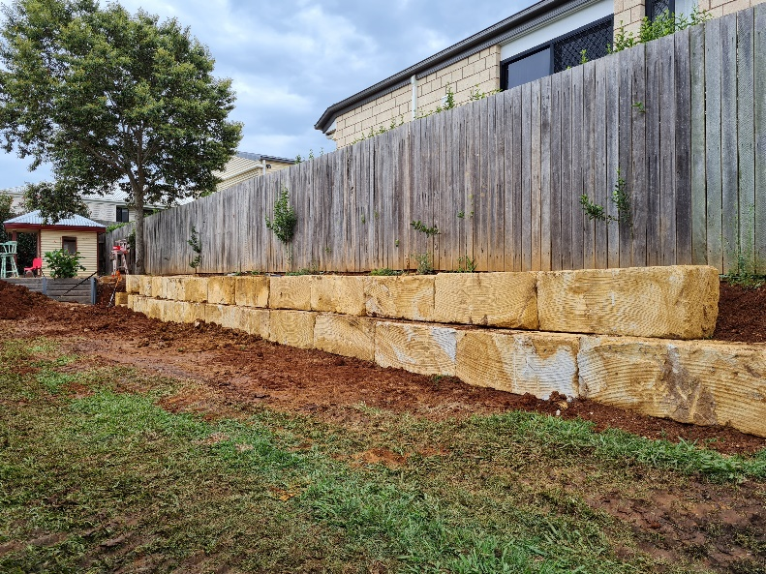  Sandstone block retaining wall.
C | 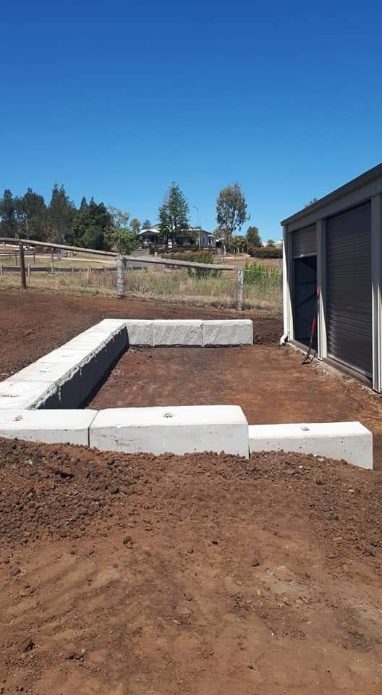  Cement block retaining wall/seating area
D | 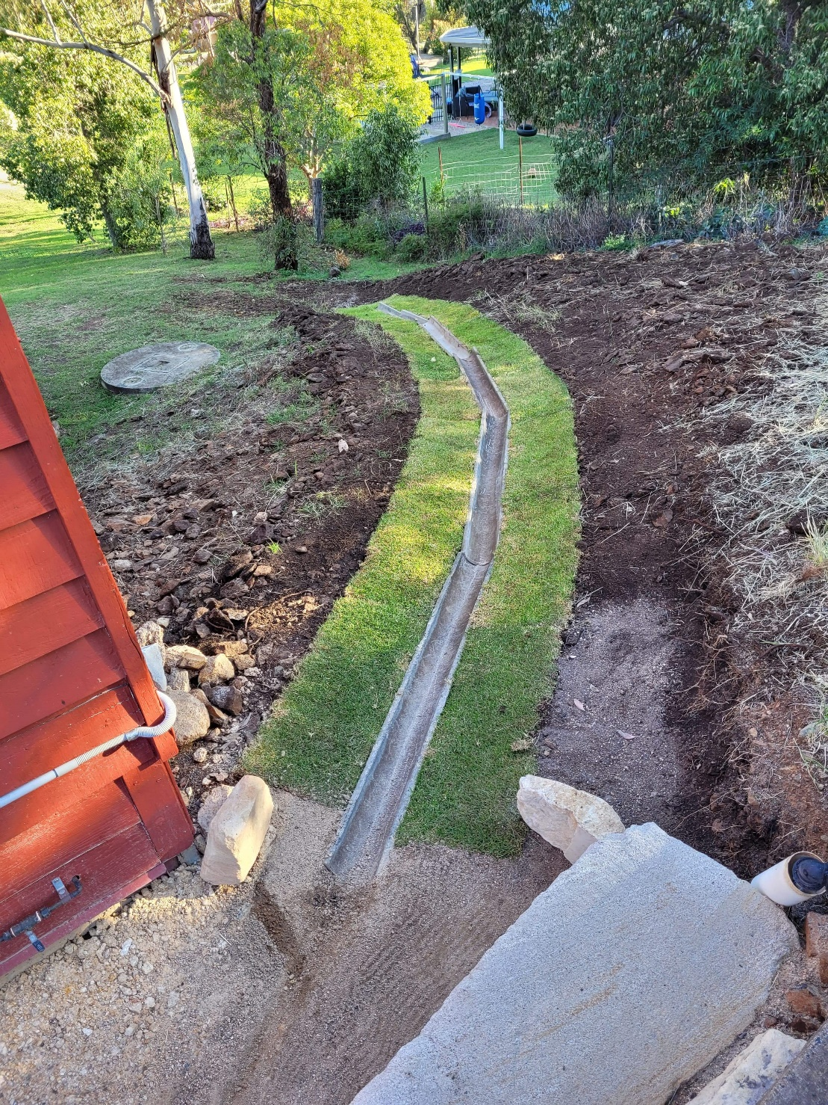  Small spoon drain to allow run off from between house and retaining wall
E
F
G
H
I
J
K
L
M
N
O
P
Q
R
S
T
U
V
W
X
Y
Z

Outcome for Activity 12 | ☐ Satisfactory  ☐ Not satisfactory
Trainer/Assessor comments

