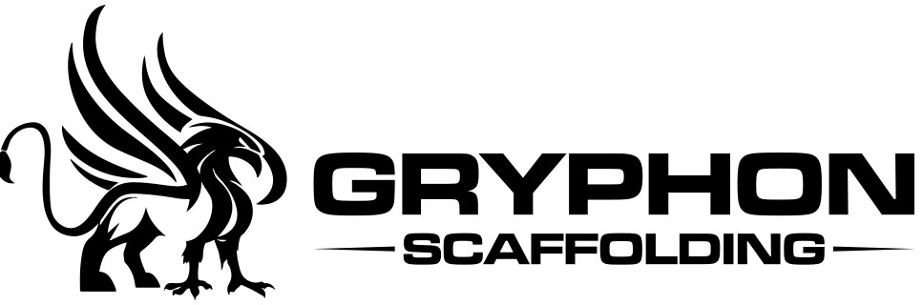

Meeting Minutes
21 August 2021
Present: | Bernadette Mau, Sekona Mau, Joshua Mau
Next meeting: | TBA
- Safe Work Method Statement
Safe Work Method Statement was presented by Bernadette.
Agreement that no further amendments are required to be made to the statement.
Bernadette to make 4 copies and to purchase folders for statement presentation.
- Equipment Register
Bernadette presented the Equipment Register document. Discussion was had and agreement that some minor adjustments are to be made and the document to be presented for approval at next meeting.
- General
Sekona gave an update of projects that he is currently working on submission for quotes. Also updated on feedback of quotes already submitted.
Joshua gave an update of relevant projects that are currently calling for interest.
- Meeting closed
Meeting closed 9.40 am

