
AHCLSC303
Construct brick and block structures and features

Copyright © 2020 CSTC Pty Ltd

All rights reserved. No part of the contents of this publication may be reproduced or used in any form or by any means – graphic, electronic, or mechanical including photocopying, digitising, recording, or information storage-and-retrieval systems – without the written permission of CSTC Pty Ltd.
ASSESSMENT FOR AHCLSC303

Student name | Morgan Anstee
Date of assessment submission | 19/10/2020

Trainer/Assessor’s name
Date of assessment marking | Click here to enter a date.
Outcome for unit | ☐ Competent  ☐ Not Yet Competent

TASK INSTRUCTIONS

- As part of the assessment for this unit of competency, you are required to complete a series of activities.
  - Some of these activities will require you to provide a response within this document, others will require you to gather evidence to demonstrate your knowledge and skills.
- At all times, the responses in your assessment must reference Australian (Queensland or Federal) documentation, including legislation, regulations, codes of practice, standards and guidance publications.

ACTIVITIES

Draw a simple concept plan for a proposed landscape design which includes brick/block work.

Response
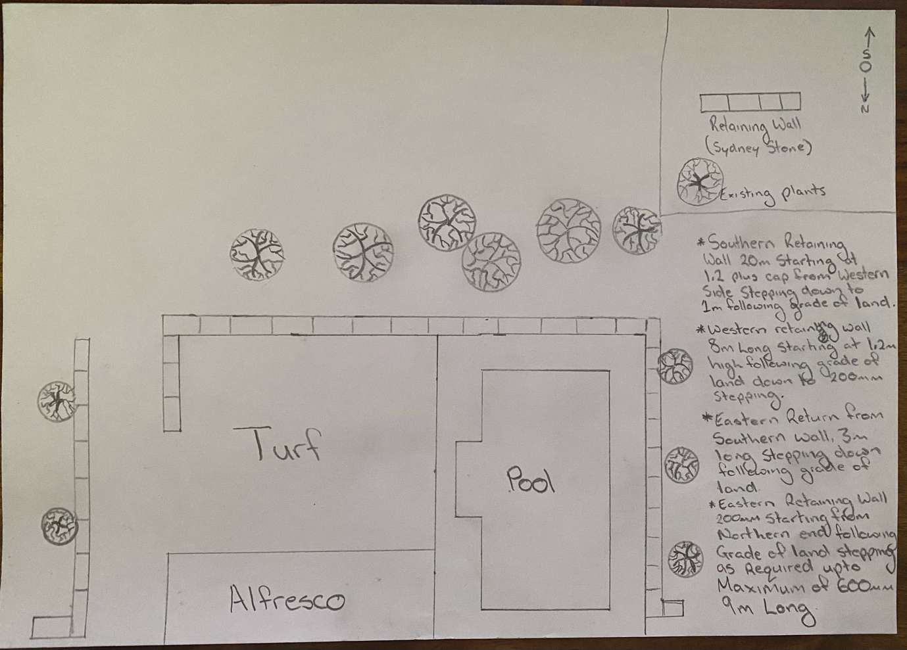

Outcome for Activity 1 | ☐ Satisfactory  ☐ Not satisfactory
Trainer/Assessor comments

Identify/list the detail on the landscape plan shown.

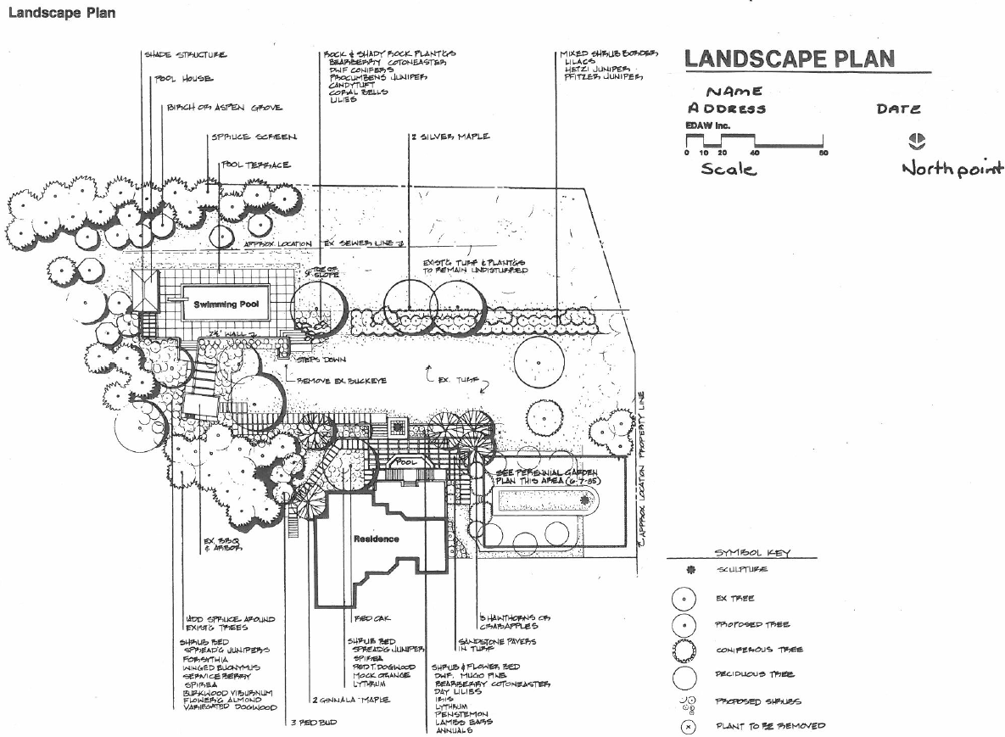

Response
- Symbol Key
- Scale
- Date
- Structures
- North Point
- Plant Species
- Name
- Address
- Landscape Layout
- Plant Species

Outcome for Activity 2 | ☐ Satisfactory  ☐ Not satisfactory
Trainer/Assessor comments

List the materials required for the concrete block retaining wall construction plan shown.

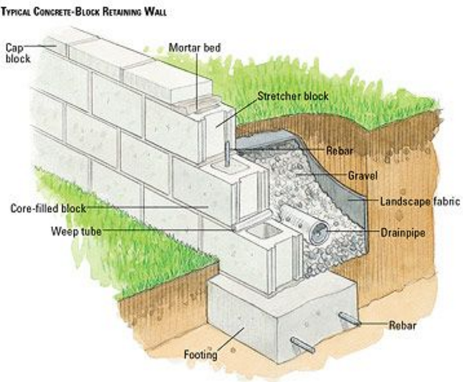

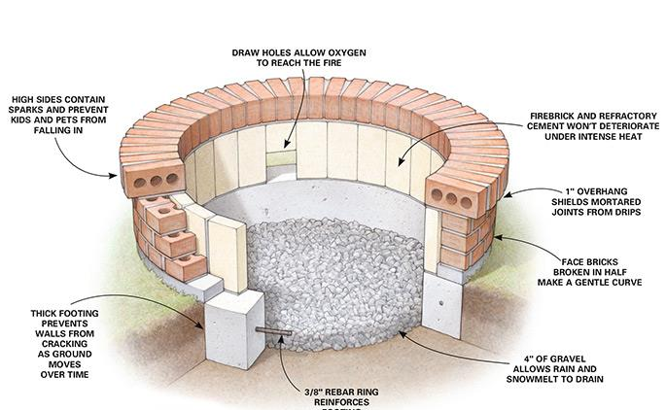

Response
- Footings
- Reber
- Drain Pipe
- Gravel
- Stretcher Block
- Core Filled Block
- Weep Tube
- Capping
- Mortar Bed
- Landscape Fabric
- Aggregate

Outcome for Activity 3 | ☐ Satisfactory  ☐ Not satisfactory
Trainer/Assessor comments

Research and identify the standard dimensions of brick and concrete blocks.

Response
Besser blocks are made to suit a nominal 200mm metros system ( known as 200 aeries block work ) when you take into account 10mm grout between blocks. Off the shelf, a standard besser block measures 390mm longs x 190mm high x 190 wide. But she it is laid in a 10mm mortar then those dimensions become 400mm long x 200mm high x 190mm wide.

Dimensions of a standard Brick are 76mm high x 230mm long x 110mm thick

Outcome for Activity 4 | ☐ Satisfactory  ☐ Not satisfactory
Trainer/Assessor comments

List the components for four (4) common surface drainage systems used in landscape construction.

System | Components
- Spoon | Machinery is used to shape the land to channel excess water ( e.g into sub-surface drain or storm water drain )  These are used in smaller landscape areas
- Channel and grate | An individually designed drain which intercepts a surface run-off and direct it into a known water course  An example includes diverting storm water
- Pit | A water storage pit or storage container  It is not designed to hold all the runoff, but needs to be large enough to contain the water pouring into it long enough to allow it to drain through the drainage pipes at a rate that keeps up with the flow of water
- Contour | A water carrying or water holding channel or ridge constructed of earth, located on or near a contour line  They are used to slow down the flow of water across a slope

Outcome for Activity 5 | ☐ Satisfactory  ☐ Not satisfactory
Trainer/Assessor comments

List the advantages and disadvantages of drainage behind and through the build wall (as shown).

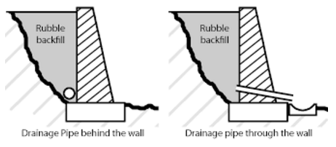

Drainage pipe behind the wall
Advantages
Simple to install, cost effective, simplicity

Aesthetically pleasing as hidden behind the wall
Disadvantages
Water build up behind the wall if fill and filters are not used adequately water has to travel along behind the wall to escape

Drainage pipe through the wall
Advantages
Simple to install, cost effective, water can scale through the wall instead of building up behind
Disadvantages
Could get blocked, therefore allowing water to build up.
Regular cleaning of pipe required.
Not as aesthetically pleasing.
Have to ensure water coming through the wall can not get waterlogged on the land below

Outcome for Activity 6 | ☐ Satisfactory  ☐ Not satisfactory
Trainer/Assessor comments

Research and list a variety of admixes.

Admix | Description
- Air – Entraining Admixture | Air-entraining admixtures are added to concrete to improve its workability and cohesiveness and to reduce the water demand, thereby reducing bleeding and material segregation. Excessive amounts will reduce potential strengths. AS 1379 allows up to 5% air entrainment
- Set-Retarding Admixtures | Set-retarding admixtures slow the setting of concrete. They are useful during warm to hot weather conditions, and when a concrete mix must be transported long distances
- Set-Accelerating Admixture | Reduce the setting times of concrete. They are often used during cool to cold weather conditions
- Water-reducing admixtures | Disperse the cement particles and improve the work-ability of the concrete without the addition of water

Outcome for Activity 7 | ☐ Satisfactory  ☐ Not satisfactory
Trainer/Assessor comments

Research other methods of damp proofing (excluding DPC and base course) and identify the materials used.

Damp proofing method | Materials
- Membrane Damp Proofing | Polyethylene sheeting laid under a concrete slab to prevent the concrete from gaining moisture through capillary action.  Membrane damp proofing is made from flexible materials such as bitumen, mastic asphalt, bituminous felts, plastic or polythene sheets or metal sheets
- Integral Damp Proofing | Putting additives in the concrete mix to make the concrete itself impermeable.  Chalk, Talc, Fullers earth, Which may fill voids of concrete under the mechanical action principle.  i.Compounds like alkaline silicates, aluminium sulphate, calcium chlorides, etc. which react chemically with concrete to produce water proof concrete  ii. Compounds like soap, petroleum, oils, fatty acid compounds such as stearates of calcium, sodium, ammonia etc. work on water repulsion principle. When these are mixed with concrete, the concrete becomes water repellent
- Pressure Grouting | Injecting Grout material into the structure  Adding cement grout under pressure , into cracks, voids, fissures and so on present in the structural components of the building, or in the ground. Thus the structural components and the foundations which are liable to moisture penetration are consolidated and are thus made water-penetration
- Surface Coating | Using a thin waterproof material for resistance to moisture.  Layer of water repellant substances or compounds ware applied on these surface through which moisture enters. The use of water repellant metallic soaps such as calcium and aluminium pelted and stearates are much effective against rain water penetration. Pointing and plastering of the exposed surfaces must be done carefully, using water proofing agents like sodium or potassium silicates, aluminium or zinc sulphates, barium hydroxide and magnesium sulphates etc.

Outcome for Activity 8 | ☐ Satisfactory  ☐ Not satisfactory
Trainer/Assessor comments

Research the suitability of the different types of bonds across various brick/block work projects.

Bond | Brick/block work project suitability
- Stretcher bond | The stretchers, laid eight he length of the wall, develop longitudinal bonding strength: while headers, laid across the width of the wall, bond the wall transversely. Structural bonding of mask art walls with metals flush ties is used in both solid wall and cavity wall construction. Metal ties also allow slight different movements of the facing and backing which may relieve stresses and prevent cracking
- Flemish bond | Each course of the brick consists of alternate stretchers and headers, with the headers in alternate course centered over. The stretchers in the intervening course. Where the headers are not used for the structural bonding, they may be obtained by using half brick called “clipped” or “snap” headers. Flemish bond may be varied by increasing the number of stretchers between headers, it is designated as “ double stretcher garden wall” bond. Garden wall bond may also be laid with four or even five stretchers between the headers
- English bond | English bond is composed of alternate courses of headers and stretchers. The headers are centred on the stretchers and joints between stretchers in all courses are aligned vertically. Snap headers are used in courses which are not structural bonding courses
- Honeycomb bond | In a brick wall, the omission of some headers or stretchers either to provide ventilation or to serve as a decorative element

Outcome for Activity 9 | ☐ Satisfactory  ☐ Not satisfactory
Trainer/Assessor comments

Research and list the specifications for mortar beds and perpend (perps).

 | Specifications
- Mortar beds | Normal thickness should be around 10mm, although there is a Australian Standard the specifies the thickness of mortar beds to different applications, AS 3700:2011 Masonary Construction
- Perpend | AS3700: tolerances for structural reasons states that the specs are 10mm but with a tolerance of +/- 5mm, there are expectations if all parties agree

Outcome for Activity 10 | ☐ Satisfactory  ☐ Not satisfactory
Trainer/Assessor comments

Provide a bricklaying definition for a ‘pig in the wall’.

Response
A pig wall is when. The course of bricks is uneven. This could be caused by to much mortar on one end of the wall compared to the other end of the wall being constructed

Outcome for Activity 11 | ☐ Satisfactory  ☐ Not satisfactory
Trainer/Assessor comments

List environmentally safe products for cleaning.

Response
High pressure cleaning, Organo builders Kleen

Outcome for Activity 12 | ☐ Satisfactory  ☐ Not satisfactory
Trainer/Assessor comments

Have team members take photos and videos of your involvement with brick/block features.

Identify each photo / video with a letter label and describe each photo / video in the table below. Submit the photo / video files along with this workbook.

Advantages
A
B
C
D
E
F
G
H
I
J
K
L
M
N
O
P
Q
R
S
T
U
V
W
X
Y
Z

Outcome for Activity 13 | ☐ Satisfactory  ☐ Not satisfactory
Trainer/Assessor comments

