CPCCBC4014A
Prepare simple building sketches and drawings
ASSESSMENT SUMMARY

The assessment activities for CPCCBC4014A Prepare simple building sketches and drawings cover all aspects of the unit of competency required. To demonstrate competence in this unit, a participant must undertake all tasks and complete them satisfactorily and consistently. For Apprentices and Trainees, this includes employer completion of the Employer Record Book (ERB).

Participants must read all the information given before starting any assessment task. The assessment tasks are intended to be equitable, fair and flexible. If a participant has any questions or requires alternative arrangements to be made such requests should be directed to their Trainer/Assessor, who should note such arrangements in the ‘Assessor Comments’ on the affected assessment. If a participant feels they are not yet ready to be assessed, they should discuss their options with their Trainer/Assessor.

To satisfactorily complete the assessment, the participant is required to answer all questions correctly and demonstrate their skills to industry standards. If a participant does not answer some questions or perform some tasks, they will be deemed ‘Not Satisfactory’ for the task and ‘Not Yet Competent’ for the unit of competency. The Trainer/Assessor is able to provide the participant with additional information on interpreting the assessment outcomes and provide guidance on the participant’s options. Should a participant still be deemed ‘Not Satisfactory’ they will have the opportunity to undertake a supplementary assessment or appeal the result.

By signing the cover page for each assessment item, the participant acknowledges they understand the assessment instructions and requirements and consent to being assessed. The participant also verifies and assures the RTO that the work submitted is their own work.

Participant Name | CARLOS GARCIA

Task | Assessment Results
Theory Exam | Satisfactory | Not Yet Satisfactory
Practical Assessment | Satisfactory | Not Yet Satisfactory
Outcome for Unit of Competency | Competent | Not Yet Competent

Assessor Name
Assessor Signature | 
Unit Competence Determination Date | Click here to enter a date.

CPCCBC4014A
Prepare simple building sketches and drawings

THEORY EXAM INSTRUCTIONS

- This exam will occur under standard assessment conditions.
  - An oral examination may be allowed under certain circumstances, whereby the Participant’s answers will be documented by a party other than the Participant. This must be acknowledged in writing (e.g. FT001 and Assessor Comments)
- Participants must provide enough detail in their responses to demonstrate their knowledge and skills.
- Please fill in the details below, providing your name, signature and date of assessment.
  - Your signature acknowledges that this is your own work.
- Assessors are to complete marking in pen of a different colour to the Participant.
- If a Participant initially answers a question incorrectly but modifies their response, they must follow the instructions below:
  - If a Participant changes their response in writing, they must put their initials next to the written change.
  - If a Participant changes their response verbally, this must be noted on the exam paper by the assessor.

Participant name | CARLOS GARCIA
Participant signature | 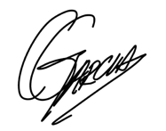
Date | 18/01/2020

Assessor name
Assessor signature
Date | Click here to enter a date.

Number of questions | Number of questions answered correctly | Task outcome (Tick)
23 |  | Satisfactory | Not Yet Satisfactory
ASSESSOR Comments
- Identify three (3) two-dimensional drawings/sketches that may be used to clarify or communicate ideas to clients or other parties. For each drawing/sketch, identify four (4) key features that may be shown.

Answer | Drawing/sketch type | Key features
 | Land boundaries, contours and footprint of building | Shows the:  1. Boundaries  2. Critical adjoining parts of surrounding properties, 3. Levels on the site  4.The locality  5.The positioning of the building or structure on the land
 | Floor Plan | Shows the:  1. Layout/arrangement of rooms  2. Light fittings and power supplies  3. Doors  4. Room size  5. Walls
 | Sectional View | Shows the:  - Detail of structural parts and how they are to be built or assembled  2. Ceiling heights and variations  3. Services  4. Wall penetrations

- Name two (2) advantages of a three-dimensional sketch/drawing.

Answer | - They provide a more realistic picture of a space  - They improve drawing efficiency and accuracy  3D modelling for design allows the designer to see what they would not see when designing in 2D but require more time to develop.  However, there are several software programs available to assist with their development.

- Name one (1) individual you might contact to establish the scope and standard of the job being undertaken.

Answer | Could contact the client/arquitect/building designer

- You need to inspect the relevant area to take measurements for your drawings/sketches. Identify two (2) safety requirements you would need to observe on site.

Answer | Safety requirements may be set out in a range of documents:  - Work Health and Safety Act 2011 (Qld)  - Work Health and Safety Regulation 2011 (Qld)  - Codes of practice  - Workplace policies, procedures, processes and systems  Job Safety Analyses, Safe Work Method Statements  Before commencing any tasks on a building site, you should carry out a full site assessment and identify any risks and all possible hazards. From there, you can put the appropriate safety procedures in place so that risks are minimised.

- Identify two (2) types of tools/equipment you would use when inspecting the area to take measurements.

Answer | Measuring wheel  Wind–up tapes

- Identify two (2) types of tools/equipment you might need when completing sketches/drawings.

Answer | Writing and sketching equipment - including HB pencils, rubber and biro  Clipboard and paper  Digital camera

- What action should be taken if any of the tools/equipment identified in Q5. and Q6. are found to be defective? Tick your response.

Answer | Choice | Possible Answers
 |  | Report, Record
 |  | Stop, Report, Record
 | þ | Stop, Tag, Report, Record
 |  | Stop, Fix, Report, Record

- True or False (Tick your response): It is best practice to double check measurements before recording them.

Answer | þ | True
 |  | False

- Explain the purpose of the scale on sketches/drawings.

Answer | Buildings are drawn in proportion to the actual measurement of the object which is known as the scale of the drawing

- You have measured a wall that is 2.4m high. Using a scale of 1:100, what size will this be drawn? Provide your answer in mm. Show your workings.

Answer | 24mm  2.4m/100=0.024m to mm=24mm

- Explain the purpose of a key or legend on sketches/drawings.

Answer | common symbols and abbreviations used, should they have more than one meaning, a key or legend should be included with any sketches/drawings developed

- Which of the following are true about drawing contours?
Tick all that apply.

Answer | Choice | Possible Answers
 | þ | Equally spaced contour lines indicate uniform slope
 |  | Closely spaced contour lines indicate flat surface
 | þ | Closely spaced contour lines indicate steep ground
 | þ | Concentric closed contours with decreasing values toward the centre indicate a pond
 |  | Concentric closed contours with decreasing values toward the centre indicate a hill

- Identify the Volume and Parts of the NCC that relate to metal sheet roof cladding for Classes 1 and 10, and Classes 2 to 9.

Answer | Classes 1 and 10 | Classes 2 to 9
 | NCC 2019  Vol2 – Part 3.5.1 | NCC 2019  Vol 1 – Part F1.5  Vol1 – Part J0.4

- Which Australian Standard is referenced in the NCC with regards to the requirements for the design and installation of metal sheet roof cladding?

Answer | AS 1562.1

- Sketch the following standard design symbols.

Answer | Item | Sketch
 | Compass (North) | 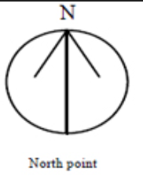
 | Sink with one bowl | 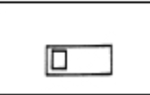
 | Stairs | 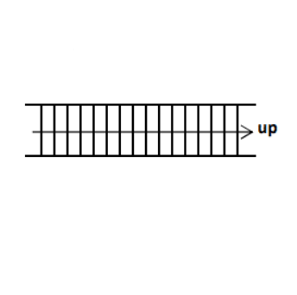
 | Toilet | 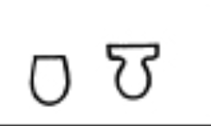

- Explain the meaning of the abbreviations in the table below.

Answer | Abbreviation | Meaning
 | BK | Brick
 | CBD / CPD | CupBoard
 | DP | Downpipe
 | INSUL | Insulation
 | KIT | Kitchen
 | MSB | Master switch board
 | PBD | Plasterboard
 | RWT | Rainwater tank
 | SHR | Shower
 | TEL | Telephone
 | WC | Water Closet

- True or False (Tick your response): The dashed/chain lines on the section view shown below represent the portions that have been in contact with the cutting plane.



Source: https://www.mcvts.net/cms/lib/NJ01911694/Centricity/Domain/131/Section_Views.pdf

Answer | þ | True
 |  | False

- Explain the use of hatching lines for sectional drawings.

Answer | The hatching lines represent the material type in contact with the cutting plane, as illustrated by the key/legend.

- True or False (Tick your response): In an offset sectional drawing, the cutting plane does not travel in a straight line.

Answer | þ | True
 |  | False

- Which of the following information should be included in the title block for a sketch/drawing? Tick all that apply.

Answer | Choice | Possible Answers
 | þ | Client details
 | þ | Contact details for person who prepared drawings
 | þ | Date drawing was completed
 | þ | Drawing number
 | þ | Drawing title
 | þ | Job number
 | þ | Project name and address
 | þ | Revisions / Amendments (if applicable)
 | þ | Scale

- True or False (Tick your response): Amendments usually have to be signed or initialled by both the builder and the client to show they both agree.

Answer | þ | True
 |  | False

- Explain why it is good practice to have a single repository for sketches/drawings.

Answer | It is important to have a central location where documents are stored to ensure there is a reference point to check that the sketches/drawings being used are the most current.  The title block of a document, provides the history of that document, but not if any future changes have been made.

- Name the Regulation and identify the section that outlines the requirement for structure designers to produce a safety report.
Briefly describe the requirements.

Answer | Section of Act | Requirements
 | s295 of WHS Regulation 2011 | 295 Designer must give safety report to person who commissions design (1) The designer of a structure or any part of a structure that is to be constructed must give the person conducting a business or undertaking who commissioned the design a written report that specifies the hazards relating to the design of the structure that, so far as the designer is reasonably aware— [s 296] Work Health and Safety Regulation 2011 Chapter 6 Construction work Current as at 1 July 2019—revised version Page 247 Authorised by the Parliamentary Counsel (a) create a risk to the health or safety of persons who are to carry out any construction work on the structure or part; and (b) are associated only with the particular design and not with other designs of the same type of structure. Maximum penalty— (a) for an individual—121/2 penalty units; or (b) for a body corporate—60 penalty units. Note— In relation to the separate penalty for an individual and a body corporate, see the note to section 50(2). (2) If the person conducting a business or undertaking who commissions a construction project did not commission the design of the construction project, the person must take all reasonable steps to obtain a copy of the written report mentioned in subsection (1) in relation to that design. Maximum penalty— (a) for an individual—121/2 penalty units; or (b) for a body corporate—60 penalty units. Note— In relation to the separate penalty for an individual and a body corporate, see the note to section 50(2)

CPCCBC4014A
Prepare simple building sketches and drawings

PRACTICAL ASSESSMENT INSTRUCTIONS

- The following practical assessment will require the Participant to complete work related activities.
- The Assessor will conduct observations of the Participant’s work to determine whether they display sufficient practical skills and knowledge.
- Please fill in the details below – providing your name, signature and date of assessment.
  - The Participant’s signature acknowledges that the Assessor provided clear instructions and the Participant understood what was required to complete this assessment.
- The Assessor may substitute a Practical Task with an alternate task of equal value.
  - Alternate tasks must be fully documented by the assessor in the Assessor Comments area.

Participant name | CARLOS GARCIA
Participant signature | 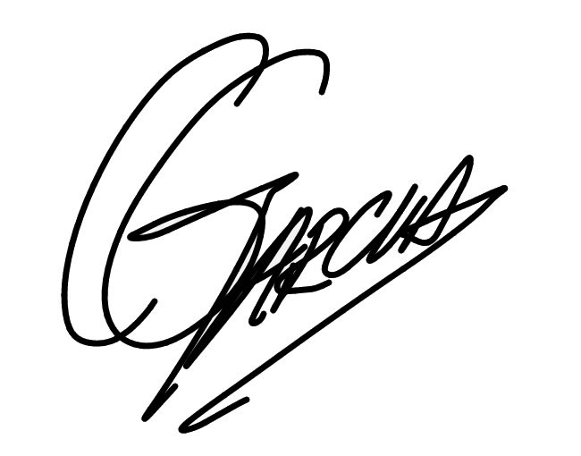
Date | 9/03/2020

Assessor name
Assessor signature
Date | Click here to enter a date.

Task | Task outcome (Tick)
Task | Satisfactory | Not Yet Satisfactory
Task 1 (Occasion 1)
Task 1 (Occasion 2)

Assessor Comments
CPCCBC4014A
Prepare simple building sketches and drawings

Practical Task 1 (2X)
Description of task:
On two (2) occasions, a suitable observer is to verify the participant’s ability to produce sketches and drawings for a small work project (Note: The participant is not required to demonstrate complex drafting skills). Sketches and drawings may be simplified versions taken from architectural drawings, designed to capture design concepts or options. They may be used for estimating purposes and to show measurements and other requirements for building and construction works. Standard drawing conventions and features must be implemented (including direction, scale, key, contours, symbols and abbreviations).

The participant is to gather evidence of how they have completed each component of the Practical Task, which is to be submitted with this Practical Assessment sheet. Evidence to be submitted may include:
- Building sketches from projects the candidate has worked on

The observer is to provide detailed comments on the tasks completed by the participant. The assessor is to verify the observer’s comments in the Assessor Comments section, and provide the Practical Assessment outcome on the front cover of this document.
Resources required:
Computer, digital camera, pen and paper.
Assessment of task
Name of participant: | CARLOS GARCIA
Name of observer:
Role of observer
(Confirm suitability to sign)
Email address of observer
Signature of observer:
Date: | Click here to enter a date.
When completing the task, did the participant: |  | Tick if satisfactorily completed.  Provide comments if left unticked.
 |  | 1st  Occasion | 2nd  Occasion
- Identify and record types of drawings required and key features, in compliance with the cope and standard of the job.
- Identify and follow WHS requirements on site and statutory/authority requirements.
- Gather and check tools and equipment required for inspection, measurement and producing drawings.
- Inspect relevant area, taking and recording required measurements.
- Create simple 2D and 3D sketches and drawings, using standard drawing conventions and incorporating relevant codes and standards.
- Create sectional drawings of simple structural elements, using standard drawing conventions.
- Record essential information on the drawings with symbols and abbreviations, according to standard drawing conventions.
- Label, date and process drawings according to organisational administration and quality procedures.
- Effectively communicate using the following methods:
- Using language/concepts appropriate to cultural differences
- Non-verbal communication
The participant’s performance was: Satisfactory Not Satisfactory

observer Comments

