Skills & Knowledge
- Using data from your company, create a database with at least three connected tables and a formula. Run a query and a report on it to produce relevant information. Prepare the report up to company standards then print and attach it to the workbook.

Data Base: Employee Monthly Printer Costings
Formatted with: Microsoft Excel
Formula used: AUTO SUM

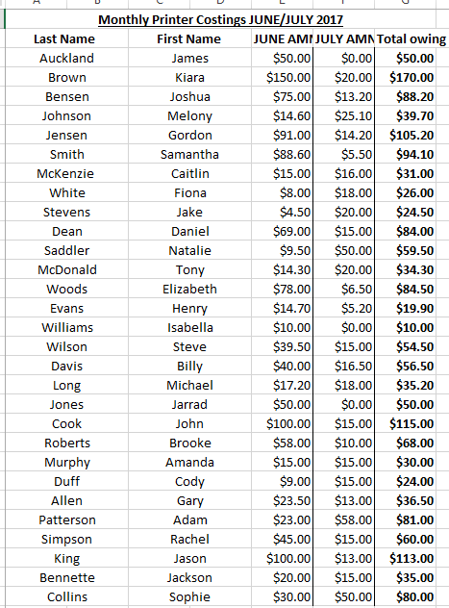

Table 1: June Owings Table 2: July Owings
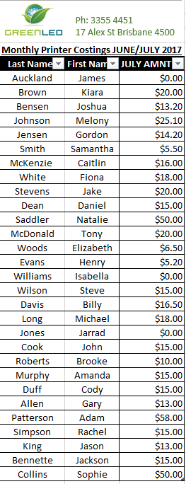
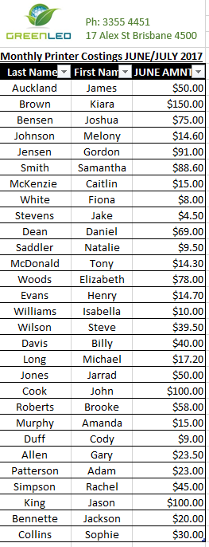

Table 3: Total Owings

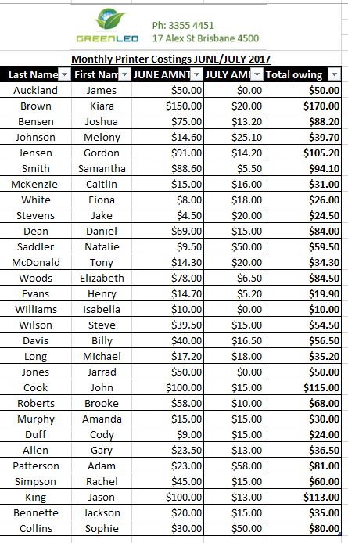

Report: Sum of Findings
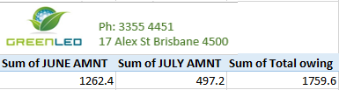
Major Activity
- What things should you consider when planning a database?
Things to consider when planning a database can include:
- What information will the database hold
- Who will have access to the database
- Organisation requirements
- Database backup and recovery plan
- File name
- File type
- What application/software will be used to create the database
- Style, design and Layout of database
- What things should you consider when creating a report?
Things to consider when creating a report can include:
- The layout and contents of the database
- What questions will be asked
- What information will be needed to answer questions
- What database is needed to extract information
- What data is relevant for this report

- What things should you consider when finishing the report?
Things to consider when finishing the report:
- Has it provided the correct information?
- It if effective?
- Layout and design
- Does it comply with organisational requirements?
- backup or recovery file

