Meeting Overview
Reference | MEET-110820
Title | Safety Committee Meeting #21
Meeting Type | HSE Committee Meeting
Date Created | 11/08/2020
Created By | Mitch Ryan
Date Completed | 19/08/2020
Completed By | Mitch Ryan
Status | Complete

Agenda
- Business arising from previous meeting.
- Issues/Hazards/observations identified.
- Issues from client.
- Injuries/incidents.
- Document review.
- Upcoming works.
- General business.

Safety Committee Minutes | 1. Business arising from previous meeting.  Fire hose reel that have no water to be tagged out or removed. Through out E wing Tag out with out of service tag or removed redundant reels that are accessible. - check the line feeding the hose reels. Bris Fire to identify pipes running to old hose reels, tag out old hose reels. Plumbers can check the feed is separate to current riser.  Tank area review of batter, sediment controls. Install CBR. - closed.  Light for site office entrance mounted of scaffold. - Light been ordered - closed L6 toilet waiting for Asbestos clearance then toilet can be installed. Rise has been installed by plumbers.  Poly line and tap in walkway scaffold south tower move back out of walkway. - closed Asbestos Awareness Course - Numbers/names/Subbies for course?  Scaffold general clean up - Water bottles available for workers to use for personal use. If workers want water bottles see Shannon  Danger sun over - info session for site to be organised. 9th September course is organised. 1 hour course. 8 am course.  - Issues/Hazards/observations identified Short week since last meeting.  Site walk - Good walk. Review of items plugged into switchboards. Access into work areas. set up of exclusion zones.  Toilets being blocked up with toilet rolls.  Co-ordination of lifting in Herston Square with crane. Co-ordination of pedestrian access across front of Herston Square. Stop pedestrian when loads are being lifted or lower. Seat belts to be worn in mobile plant.  - Client - AU  Independent Audit for AU by Safe Assure. Gareth Davies. Positive feedback from site walk.  4.Injuries/Incidents  - Corrective actions issued.  Seatbelts to be worn in mobile plant  - Document Reviews.  Master Floor Prep -  Trident traffic for Bramston Ave. Scooter  - Upcoming work  CC bore into SW.  Lift shaft demo North tower  Scaffold eastern and court yards of E wing.  Lead paint remediation Internal windows and doors North E wing External lead paint remediation external North E wing.  North Tower east elevation scaffold  North tower SW scaffold  9. General business  Talk to work group about amenities

Attendees
Useless Builders [Signed: 4/4]
Peter Daicos  Signed: 11:04 AM 18/08/2020 |  | 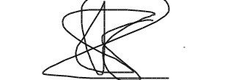
Gavin Brown  Signed: 5:15 AM 19/08/2020 |  | 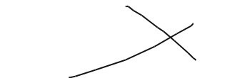
Tony Shaw  Signed: 11:01 AM 18/08/2020 |  | 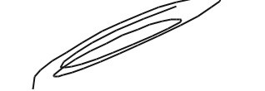
Scott Russell  Signed: 11:05 AM 18/08/2020 |  | 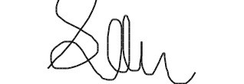
 | Aztech Services Australia Pty Ltd [Si | gned: 1/1]
Chris Tarrant  Signed: 11:02 AM 18/08/2020 |  | 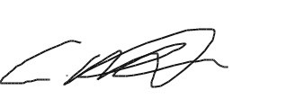
 | CC P&D Pty Ltd [Signed: 1/1]
Damien Monkhurst  Signed: 11:02 AM 18/08/2020 |  | 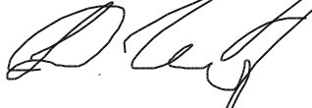
 | Delta Group [Signed: 2/2]
Nathan Buckley  Signed: 11:01 AM 18/08/2020 |  | 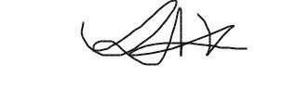
Scott Cummins  Signed: 11:01 AM 18/08/2020 |  | 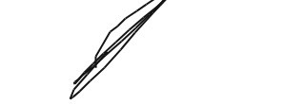
 | Perigon Pty Ltd [Signed: 1/1]
Mick Mcguine  Signed: 11:03 AM 18/08/2020 |  | 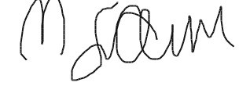
 | TJM Holdings (QLD) Pty Ltd [Signe | d: 1/1]
Scott Pendlebury  Signed: 11:03 AM 18/08/2020 |  | 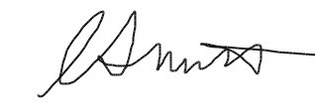
Issues Identified
Comments
N/A

