CPCCBC4011B

Practical Assessment Tasks:

Practical Assessment task 1:
Attached is a floor plan of a Class 2 Low rise commercial building you are planning to commence.
Upon review of the soil report you are concerned the ground slab has not been designed correctly.
The soil report states the soil is a class ‘S’, use the NCC Volume 2 attached to determine the stiffened raft slab design required and answer the following questions:

Question/ Item: | Answer/ requirement | Volume & Section of the NCC where you find the answer/ requirement
What does an ‘S’ Class Soil type mean according to NCC Vol 2? | Slightly reactive clay sites with only slight ground movement from moisture changes | NCC Volume 2 Part 3.2.4 Table 3.2.4.1
What Australian Standard is referenced in NCC Vol 2 regarding concrete slabs and footings? | AS 2870 | NCC Volume 2 Part 3.2.5
If the building is be constructed with a masonry veneer, what is the minimum depth required for the stiffened raft slab measured from top of slab to bottom of edge beam? | 300mm | NCC Volume 2 Part 3.2.5 Figure 3.2.5.3a & Table 3.2.5.4a/b

Practical Assessment Task 2:

As previously mentioned, the vertical structure of the Class 2 low rise building shown is to be constructed using masonry.
Refer to the NCC Vol 2 provided and complete the following table:

Question/ Item: | Answer/ Requirement: | Volume & Section of the NCC where you find the answer/ requirement:
What is the Australian Standard referenced as the ‘Acceptable Construction Manual’ to be complied with when constructing masonry veneer structures? | Performance Requirements P2.1.1, P2.2.2 and P2.2.3 are satisfied for masonry veneer if it is designed and constructed in accordance with one of the following:  (a)AS 3700.  (b)AS 4773.1 and AS 4773.2. | NCC Vol 2 Section 3 Part 3.3.5
If the masonry veneer nominated for the building is a hollow unit (meaning brick with (hollow cored sections), what is the minimum compressive strength that must be achieved? | 10 MPa | NCC Vol 2 Section 3 Part 3.3.5.3
What is the required mortar mix required for the masonry veneer if the masonry classification is ‘P’ (Protected)? | General Use 1:2:9 (Cement/Lime/Sand  Concrete Masonry 1:0:5  (Cement/Lime/Sand) | NCC Vol 2 Section 3 Part 3.3.5.4 & Table 3.3.5.1 & Table 3.3.5.2

Practical Assessment Activity 3:

Upon reviewing the construction drawings and referencing the NCC Vol 2, you find that the wall tie specification nominated in the drawings is not suitable due to the construction project being built in an ‘N3’ wind zone area. The current drawings nominate a ‘light duty veneer tie’.

Use the email template below to draft an email to the structural engineer for the project asking to have the drawing notes revised detailing the correct wall tie specification for a 450mm wall stud spacing in an N3 wind category area.
Your email to the engineer must detail the required wall tie spec, reference the relevant Australian Standard and section of the NCC Vol 2 that must be complied with along with information stating where the wall ties must be located according to the NCC.

To: Rarely Falls Engineering Specialists;
Body of email:

Hi Myles

I would like to draw your attention to the specification nominated for the wall ties where a light duty veneer tie has been stipulated.

Unfortunately this type of tie is only suitable for N2 Wind rated areas. This project currently sits within a N3 rated wind zone.

As per AS/NZS 2699.1 & NCC Vol 2 Section 3 Part 3.3.5.10, Table 3.3.5.3a & Table 3.3.5.3b we require medium duty ties, for a wall with 450mm stud spacing, with 250mm Horizontal centres & 400mm Vertical centres.

The location and placement of the ties are as per Table 3.3..5.3b. I have attached a snip from the relevant section of the NCC

Could you please revise the drawings notes to detail the correct wall tie specification. Thank you

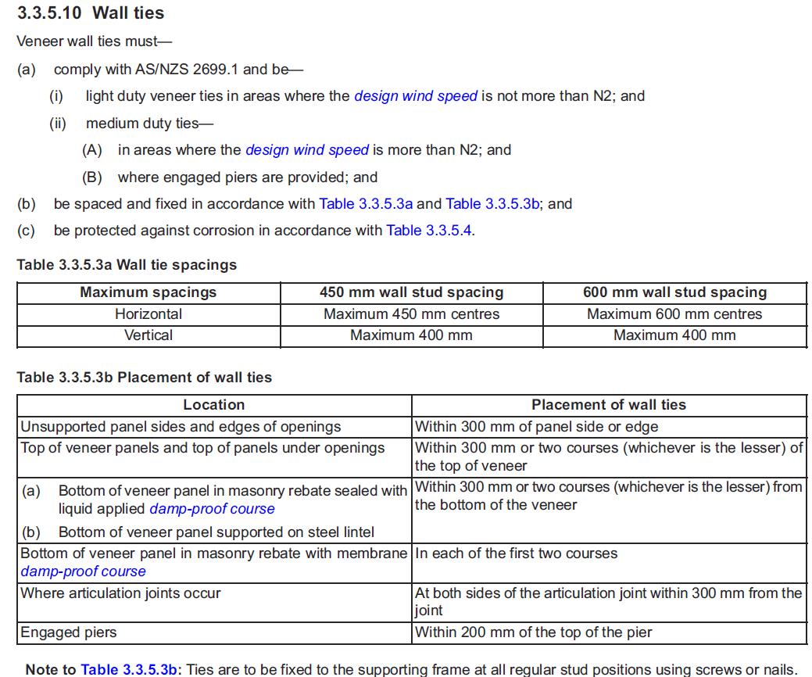

Yours Truly, Nick Sharpe

