Workplace Assessment 1 – Assessor’s Checklist
(This form is for the assessor’s use only)

Purpose
This Assessor’s Checklist lists the practical skills that the candidate must demonstrate/perform while completing Workplace Assessment 1.
This form is to be completed by the candidate’s assessor to document the candidate’s performance in Workplace Assessment 1.

Task Overview
For this task, the candidate is required to seek email confirmation with relevant construction personnel, confirm the currency of plans, specifications and amendments. The construction personnel to be consulted with must have suitable experience (e.g. supervisor).

In this task, the candidate will be assessed in their:
- Practical knowledge of building and construction plans
- Practical skills relevant to confirming the currency of plans, specifications and amendments with relevant construction personnel

Instructions to the Assessor

After the assessment
- Complete all parts of the Assessor’s Checklist, including the Assessor Declaration on the last page of this form.

Candidate Details
Candidate name | Dawei Yang

Assessor Details
Candidate is assessed by | Steve ZHu

Context of the Assessment
Workplace/organisation | Dawn construction

Resources required for the assessment | - Building and construction project  - People resources (i.e. relevant construction personnel)  - Opportunities to discuss with relevant construction personnel to confirm the currency of plans, specifications and amendments  - Construction plans  - Construction specifications

Assessor’s Checklist
During the confirming of the currency of plans: | YES/NO | Assessor's comments
- The candidate verifies the currency of the plans and amendments.
- The candidate identifies the publication date of the plans. | YES NO
- The candidate asks if the plans in use are the current ones, based on the publication date specified on the plans. | YES NO
- The candidate identifies the date of the amendments specified on the plans. | YES NO
- The candidate asks if the specified amendments are the most recent ones. | YES NO
- The candidate asks if all amendments specified are incorporated into the plan. | YES NO

During the confirming of the currency of specifications: | YES/NO | Assessor's comments
- The candidate verifies the currency of the specifications and amendments.
- The candidate identifies the publication date of the specifications. | YES NO
- The candidate asks if the specifications in use are the current ones, based on the publication date specified on the specifications. | YES NO
- The candidate identifies the date of the amendments specified on the plans. | YES NO
- The candidate asks if the specified amendments are the most recent ones. | YES NO
- The candidate asks if all amendments specified are incorporated into the specifications. | YES NO

Assessor Declaration
By signing here, I confirm that I have thoroughly reviewed the candidate’s email for this workplace assessment task.
I confirm that the information recorded on this Assessor’s Checklist is true and accurately reflects the candidate’s performance during their completion of the workplace task.
Assessor’s signature | 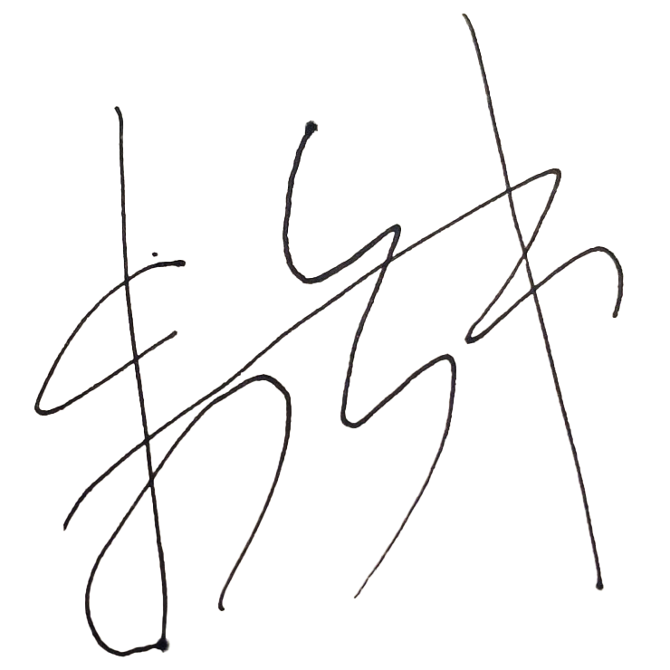
Assessor’s name | Steve Zhu
Date signed | 06/11/2022

End of Workplace Assessment – Assessor’s Checklist

