BSBLDR414
Lead team effectiveness

ASSESSMENT SUMMARY

The assessment activities for BSBLDR414 Lead team effectiveness cover all aspects of the unit of competency. For Apprentices/Trainees, this includes supervisor completion of the Apprentice/Trainee Record (ATR).

Participants must read all the information given before starting any assessment task. The assessment tasks are intended to be fair, flexible, valid and reliable. If a Participant has any questions or requires alternative arrangements to be made such requests should be directed to their Trainer/Assessor, who should note such arrangements in the ‘Assessor Comments’ on the affected assessment. If a Participant feels they are not yet ready to be assessed, they should discuss their options with their Trainer/Assessor.

To satisfactorily complete the assessment, the Participant is required to answer all questions correctly and demonstrate their skills to industry standards. If a Participant does not answer all questions or perform all tasks, they will be deemed ‘Not Satisfactory’ for the task and ‘Not Yet Competent’ for the unit of competency.

The Trainer/Assessor can provide the Participant with additional information on interpreting the assessment outcomes and guide the Participant’s options. If a Participant is still deemed ‘Not Satisfactory’ they will have the opportunity to undertake a supplementary assessment or appeal the result as per the process in the Student Handbook.

By signing below, the Participant acknowledges:
- They understand the assessment instructions and requirements, and consent to being assessed.
- The work submitted is to be their own work – with the work of/with others needing to be clearly acknowledged and documented.
- They consent to any photo/video recording of their work that occurs during assessment.

Participant name | Ho Ling Sandy Ma
Participant signature | 

Pre-requisite unit(s) to be achieved and authenticated prior to undertaking assessment
Not applicable

Task | Date completed | Assessment Results
Theory Exam | Select Date. | Satisfactory | Not Satisfactory
Practical Assessment | Select Date. | Satisfactory | Not Satisfactory
Outcome for BSBLDR414 | Select Date. | Competent | Not Yet Competent

Evidence requirements checklist (ticked by assessor and evidence supplied to RTO)
Theory Exam | Practical Assessment  Team development plan

Assessor Name
Assessor Signature | 

BSBLDR414
Lead team effectiveness

THEORY EXAM

Participant name | Ho Ling Sandy Ma

FOR THE PARTICIPANT
Instructions
- You will complete written questions as outlined on the following pages. You must attempt all questions and provide enough detail in your responses to demonstrate your knowledge.
- It is anticipated that you should complete this assessment within two (2) hours, but additional time may be allowed upon negotiation with the Assessor.
- You must complete all questions unassisted by the Assessor or other personnel but may refer to reference material as needed. All questions must be answered correctly for a ‘Satisfactory’ assessment outcome to be awarded.
  - An oral examination may be allowed under certain circumstances, whereby your answers will be documented by another party.
  - Any written questions that are incomplete, or not answered satisfactorily will need to be completed again after further training support.
    - If you answer a question incorrectly but modify your response, put your initials next to the written change (or the Assessor must initial a verbal change).
Resources required
Pen

FOR THE ASSESSOR
Instructions
- Where oral examination has occurred, ensure that this is acknowledged in writing (e.g. FT001 and Assessor Comments)
- All questions must be satisfactorily demonstrated by the Participant for a Satisfactory determination (indicated by an Assessor tick to the right of the question).
- Assessors are to complete marking in pen of a different colour to the Participant.
- If the Participant verbally modifies their response, write in the modified response verbatim and put your initials next to the written change.

ASSESSOR COMMENTS
As necessary, outline:
- Details on reattempts, alternative arrangements or reasonable adjustments made.
- Where a Participant is deemed ‘Not Satisfactory’, provide recommendations for future training.

- Identify a team that may exist in the workplace. Consider the purpose of the team, its goals and objectives. Name and describe the roles and responsibilities for at least three (3) team members. Finally, identify at least one (1) method that will assist with monitoring progress towards the team goals.

Answer | Point | Detail
 | Team purpose | Health and Safety Team
 | Goals and objectives | Short term | Monitor the site to make sure its compliance with WHS legislation
 | Goals and objectives | Long term | To minimize the injury and fatality rate in the industry
 | Team members | Role | Description | Responsibilities
 | Team members | 1 | Safety Manager | Oversee the safety aspects of the whole project site and ensure the site complies with all WHS legislation
 | Team members | 2 | Safety Officer | Daily inspection on site to check on WHS control measures and the working environment; incident investigation and reporting
 | Team members | 3 | Graduate Safety Officer | Assist in data entry and WHS related paperwork or research; assist the Safety Officer in inspection and incident reporting
 | Progress monitoring | The frequency and pattern of incidents to happen on site

- True or False (Tick your response): A team leader is more of a mentor than overseer who checks work.

Answer |  | True
 |  | False

- Match the leadership styles and definitions by writing the appropriate letter next to each number in the centre column.

Answer | Style |  |  | Definition
 | 1 | Authoritarian | 1 - B | A | Leaders who let the team function without much interference
 | 2 | Democratic | 2 - C | B | Leaders who fully control their team
 | 3 | Laissiz-Faire | 3 - A | C | Leaders who try to include everyone in the decision-making process

- Identify two (2) benefits and two (2) drawbacks of transactional leadership.

Answer | Benefits | Drawbacks
 | Clearly defined short and long term goals | Little room for flexibility or adaptability
 | Clearly defined rewards and consequences for meeting or not meeting those goals | Employees feel like followers, rather than innovators or leaders

- Which of the following are characteristics of transformational leaderships? Tick all that apply.

Answer | Choice | Possible Answers
 |  | The leader acts as a role model to employees
 |  | Close, consistent focus on the company vision
 |  | A high value on interpersonal relationships
 |  | Inspiration as a tool to motivate employees

- Why is it important for team leaders to include team members in the planning process?

Answer | Leaders can have a diverse set of perspectives to consider. Employees feel motivated to participate in decision-making which make them feel like their input is valued.

- For each of the listed activities in the table below, identify two (2) methods that team leaders can use to involve team members.

Answer | Activity | Method/s to involve team members
 | Goal setting | 1.Discuss that during team meetings, so that team members are involved and can contribute their thoughts  2.Having a brainstorming session to encourage team members to voice up
 | Decision making | 1.Interview the team members and collect feedback from them members before the decision are made  2. Encourage team members to comment on it during team meeting
 | Work allocation | 1.Allocate the work during team meeting, so team member can negotiate with the team leader  2.Discuss with team member through performance review

- True or False (Tick your response): Diverse teams produce more creative results than teams in which members are less diverse.

Answer |  | True
 |  | False

- Provide two (2) examples of how the knowledge, skills and background of team members can enhance team practices.

Answer | 1.Communication skills (e.g. dealing with different language/ acent/ client perspective  2. Problem-solving and critical thinking abilities demonstrated by those who have learned from previous experiences or cultural values

- Provide two (2) reasons that responsibilities must be carefully delegated within the work team.

Answer | 1.All team members can understand their role and responsibilities better which can lead to better performance  2. To avoid resentment between team members

- Describe what innovation brings to the workplace. Provide one (1) example of innovative practice.

Answer | Innovation can bring new practices or technologies to the workplace which may be able to boost the morale of staffs. For example, introduce the 4-day working week. This is an innovative idea for a new working style, by cutting the working day to only four days to increase the efficiency and performance of staffs

- Describe (3) methods that may be used to measure a team’s innovation.

Answer | 1.no. of new ideas proposed  2. proportion of ideas selected for implementation  3. no. of unsuccessful projects

- Explain how encouraging team members to assist each other in undertaking their roles and responsibilities can improve productivity.

Answer | Different team members come with different skill sets, by assisting each other in undertaking their roles and responsibilities, they can increase the efficiency of work. Also, brainstorming among team members can generate more innovative ideas and consider the job in different points of view.

- Describe (3) methods that may be used to measure a team’s productivity.

Answer | 1.Achievement of objectives (e.g. meeting the set objectives)  2. Measuring quantitative productivity (e.g. how many calls processed per hour)  3. Measuring the profit

- Which of the following are likely outcomes from involving team members in all aspects of a job? Tick all that apply.

Answer | Choice | Possible Answers
 |  | Causes members to resent the team
 |  | Makes the work more meaningful
 |  | Improves self-esteem of team members
 |  | Improves team morale
 |  | Team members take more responsibility for their individual work

- Explain how providing feedback to team members can encourage and motivate team members – building trust and positive working relationships.

Answer | Providing feedback to team members can encourage and motivate team members as it can recognise the contribution and effort of the team members, thus boosting the team morale.

- Identify one (1) issue, concern or problem that may be identified by team members. Describe the signs that you would recognise to identify the issue and how the matter could be resolved by internal team negotiation.

Answer |  | Response
 | Issue, problem, or concern | Some team members can’t work along well
 | Signs | Always have arguments at work and the low productivity when they work together
 | Solution via negotiation | Team leader can step in to have a chat with the team members separately, to try to find the root cause. Assign the team members to partner with other people

- Identify one (1) issue, concern or problem that would need to be resolved by an external party. Describe the signs that you would recognise to identify the issue and who the matter should be referred to.

Answer |  | Response
 | Issue, problem, or concern | No communication between the team
 | Signs | Instruction from the top is not passed to the fellow team members,
 | Solution via negotiation | And get an external party to step in and organise some team building activities and boost the team spirit.

- Identify three (3) ways that the team leader can serve as a role model to, and motivate, the team.

Answer | 1.Follow all the correct handling procedures listed by the company at work  2. Always wear the appropriate PPE at work  3. Actually working together with the team instead of just giving out commands

- For each of the following areas, provide one (1) example of how the team leader’s contributions to the work team can enhance the organisation’s image:
- Internally, within the work team and the organisation
- Externally, with clients/customers

Answer | Question | Response
 | Within the work team and organisation | If a team leader work hard and willing to help, team members are more willing to contribute more and help out which create the “Golden Team”
 | With clients and customers | If a team leader is organising at work, work can become more productive and efficient. If the work can meet the deadline provided by the client, they will have a good impression on the organisation.

- Provide three (3) communication methods that a team leader may encourage the team to use, and situations that each communication method would be suitable for.

Answer | Method | Suitability
 | Team meeting | Address issues that all team members need to know or can discuss together for ideas and thoughts, e.g., setting team goals
 | Email | Address issues that only certain team members that get involved or some topics that are suitable for discussion privately
 | Group chat on social media | For entertainment or minor stuff. Members can chat freely in the group and increase the bonding between team members

- Identify two (2) ways that the team leader can establish open communication with management.

Answer | 1.Regular meeting with management, can exchange ideas with the management, know more about their expectations and can seek for assistance if needed  2. Put in report, can put in recommendations from the team

- Identify two (2) issues, concerns and problems that may be raised by the team to management.

Answer | 1.Not enough resources to finish the work task assigned  2. Not enough time to finish the work task assigned

- Identify two (2) issues, concerns and problems related to the team that may be raised by management back to the team.

Answer | 1.Underperformance, can’t meet the deadline of the job  2.Requested too many resources or budget

- Describe one (1) situation where the team leader may have to negotiate with management on behalf of the team.

Answer | The level of performance expected from the management

Refer to the extract below from an Escalation Policy and Procedure to respond to Q26. to Q28.

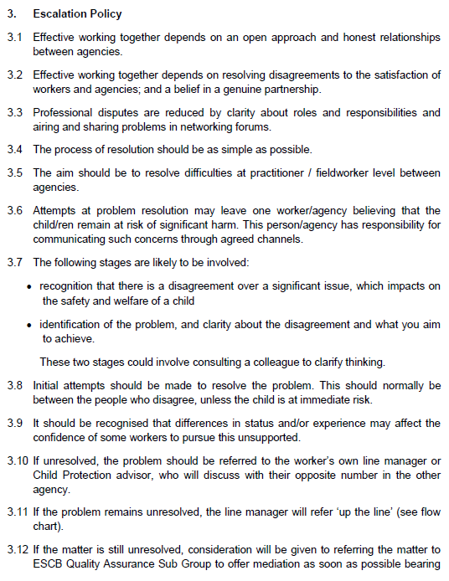
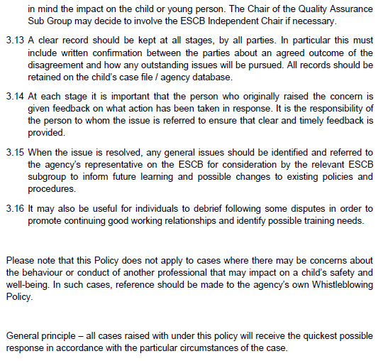
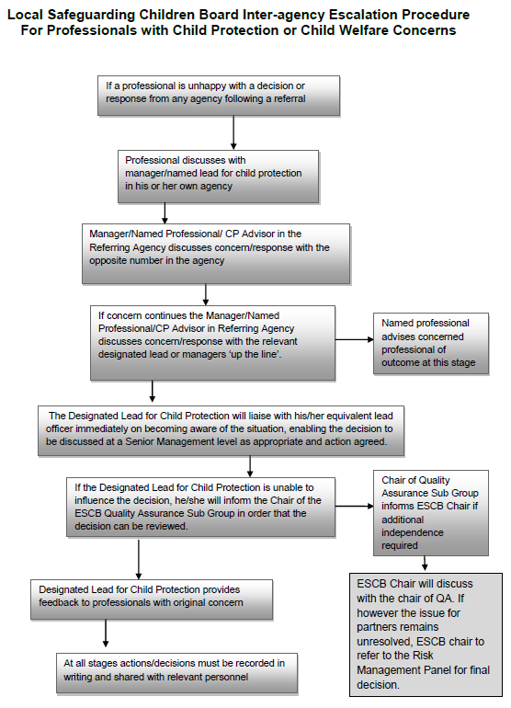

- Order the following steps from 1 to 5 to identify the correct order of issue escalation where a problem is unresolved.

Answer | Step Number | Steps
 | 1 | The people who disagree should make the initial attempts to resolve the problem
 | 5 | When the issue is resolved, any general issues should be identified and referred back to the agency’s representative to inform future learning and possible changes to existing policies and procedures
 | 3 | If the problem remains unresolved, line manager will refer ‘up the line’
 | 4 | If the matter is still unresolved, the matter may be referred to the Quality Assurance Sub Group to offer mediation
 | 2 | If unresolved, the problem should be referred to the worker’s own line manager

- True or False (Tick your response): It is the goal for all cases raised under this policy to receive the quickest possible response.

Answer |  | True
 |  | False

- If the ESCB Chair cannot resolve the issue, which body can make the final decision?

Answer | Risk Management Panel

BSBLDR414
Lead team effectiveness

PRACTICAL ASSESSMENT

Participant name | Ho Ling Sandy Ma

FOR THE PARTICIPANT
Instructions
- The tasks outlined on the following pages will require performance of normal workplace activities, as a result of a structured activity set by an Observer in the workplace or a simulated activity set by your Assessor/Observer.
- The timeframe for these tasks will be established by your Assessor/Observer, in consideration of location conditions and industry requirements.
- You must complete all tasks unassisted by the Assessor or other personnel, unless the steps note this assistance.
- You must attempt all tasks (and itemised steps) for a ‘Satisfactory’ assessment outcome to be awarded.
  - For any observation conducted that is incomplete, or without satisfactory performance, the observation will need to be completed again after further training support.

FOR THE ASSESSOR/OBSERVER
Instructions
- The following observation record should be used to judge and record your observations of the Participant as they complete the task(s) set. You must record your observations of the Participant’s performance.
  - For each occasion, indicate the task performed and whether it was a simulation or workplace-based task.
    - Any simulated assessment must ensure the Participant still performs under workplace conditions which reflect industry standards.
  - In the comments, provide clear detail regarding the task that the Participant was required to do (e.g. PPE used, materials handled, attachments connected, plant types).
- All steps must be satisfactorily demonstrated by the Participant for a ‘Satisfactory’ determination (indicated by an Assessor tick to the right of each itemised step, or an Observer tick to the right of each itemised step, and confirmation by an Assessor in the Assessor Comments).
  - Where you have determined that one or more task steps have not been satisfactorily demonstrated, provide the Participant with additional support and outline details of such assistance in the Assessor/Observer Comments. Allow the Participant two (2) further opportunities to demonstrate the task again to allow an opportunity for a ‘Satisfactory’ assessment outcome to be achieved.
  - If after three (3) attempts the Assessor determines that the Participant cannot demonstrate the required steps, a ‘Not Satisfactory’ outcome is to be determined.

TASK OUTCOME
Task | Date | Task Type (Tick) | Location | Task outcome (Tick)
 |  |  |  | Satisfactory | Not Satisfactory
Task 1 | Select Date. | Workplace  Simulation

ASSESSOR COMMENTS
As necessary, outline:
- Details on reattempts, alternative arrangements or reasonable adjustments made.
- Where a Participant is deemed ‘Not Satisfactory’, provide recommendations for future training.

ASSESSOR COMMENTS: PRACTICAL TASK 1
Individual student (as named on cover page)
Multiple students [ All from Attendance Report, Specific students involved – identify students]
Task | Provide detail
1.B. | Feedback provided to team members:
1.C. | Support offered to identify and resolve problems, issues and concerns:
1.D. | Issues passed from management to the team and vice versa:

BSBLDR414
Lead team effectiveness

Practical Task 1
Description of task:
A suitable observer is to verify the participant’s ability to lead team effectiveness, including:
- Leading and consulting with the team to develop a team development plan that addresses –
  - Team cohesion
  - Innovation and productivity measures
  - Issues management and actions
- Communicating with team members and management to –
  - Consult, encourage, support and provide feedback to the team
  - Model team leadership behaviours and approaches
  - Resolve problems

The Observer is to provide detailed comments on the tasks completed by the Participant (on the Observer Comments, overleaf). The Assessor is to verify the Observer’s comments, noting their findings in the Assessor Comments (on the back of the Practical Assessment cover page) and provide the assessment outcome.
Resources required:
Team Development Plan Template
Observer details
Name of observer:
Role of observer
(Confirm suitability to sign)
Email address of observer
Signature of observer:
Date: | Select Date.

When completing the task, did the Participant: | Tick if satisfactorily completed.  Provide comments if left unticked.
- Lead and consult with the team to establish and document a team development plan, incorporating:
- Team purpose, roles, responsibilities, goals, objectives and plans
- Consideration of organisational goals, objectives and plans
- Team cohesion
- Innovation and productivity measures
- Issues management and actions
- Lead team to develop cohesion, including:
- Providing opportunities for input of team members into planning, decision making and operational aspects
- Encouraging and supporting team members to take responsibility for own work and to assist each other
- Providing feedback to team members to encourage, value and reward individual and team efforts and contributions
- Participate in and facilitate work team, including:
- Leading and supporting team members in meeting expected outcomes
- Actively encouraging team members to participate in and take responsibility for team activities and communication processes
- Giving the team support to identify and resolve problems, issues and concerns
- Acting as a role model to enhance the organisation’s image for work team, clients and customers
- In line with organisational escalation policies and procedures, maintain open communication by passing information from management to the team and vice versa (including issues, concerns and problems).

OBSERVER COMMENTS

TEAM DEVELOPMENT PLAN

DATE OF EFFECT
Start | 1/09/2024 |  | End |  | 1/10/2024
GOALS, PLANS AND OBJECTIVES
Outline the team’s purpose, goals, and objectives. Identify how this fits within the organisation’s goals, objectives and plans.
Team purpose: To reach the monthly KPI
Goal: To raise the awareness of team members towards safety hazards and checking the effectiveness of safety measures on site, thus in long term lower the incident rate
Objectives: To encourage team members to pay more attention to the potential hazards at work by submitting 5 site inspection reports every month

The company aim at eliminating or minimise the chance of injury at work by implementing safety control measures. The team purpose is to get all team members to reach the monthly KPI by submitting the required safety site inspection report, which fits within the organisation’s goal, objectives and plans.
OBJECTIVES FOR TEAM
Objective |  | Work process |  | Responsible employee |  | Start date | End date
Team cohesion |  | Team building activity |  | Sally |  | 1/09/2024 | 1/09/2024
Innovation |  | Brainstorming session |  | Billy |  | 1/09/2024 | 8/09/2024
Productivity |  | Reporting KPI progress |  | Ben |  | 9/09/2024 | 23/09/2024
Issues management |  | Assist team member to finish KPI |  | Johnny |  | 23/09/2024 | 30/09/2024
REVIEWING AND ASSESSMENT METHODS
How will you track the plan’s implementation, the team’s progress (e.g. through team meetings, reports)?
Through team meetings, I can discuss with team members on everyone progress on their KPI, to see if the requirement of KPI (5 per month) is too hard for them, any new team member need further assistance or training to finish their KPI etc.
Also, study the trend of incident and incident rate, see if the KPI helps in minimize the safety hazards and promote the work health safety of staff.
ADDITIONAL SUPPORT
Is there any additional support needed to reach the desired goals (e.g. courses, classes, resources).
Induction of new staff member on how to use the system to put in site inspection report. Also, can organising WHS training, so team members got more awareness or knowledge on spotting safety hazard or risks.
EXPECTED OUTCOME
Team leader’s expectations on the outcome based on the data.
Expect everyone can meet their KPI. And in long term, the no.of incident onsite will decrease
OUTCOME IF GOALS AND OBJECTIVES ARE NOT MET
Identify the consequences and further steps if the team fails to satisfy the standards set by the plan.
Consequences: Team member’s work load increased because of the KPI requirement but the incident rate still high on site.

Further steps: Interviews the participated team member on any improvement of the plan.
Discuss with the management to see if further training or resources are needed.

