Pre Start Meeting

Completed on
11 Jun 2020 07:51 PM

Job Name
Erub freezer

Job Number
PDRDAR1

Employee Name
Stacey Lui

Conducted on
11 Jun 2020 06:56 AM

Location
QLD 4875
Australia
(-9.59714396050768, 143.76065063235006)

Is this a new client?
No

Question |  | Response |  | Details
 |  | Do a Pre-Start
Were there any safety/environmental incidents yesterday? |  | No
Were there any near misses yesterday? |  | No
What was done to improve Safety yesterday? |  | Use of harness on roof  Ensure site was tidy and free of trip hazards  Correct ppe  Correct manual handling
How do you rate the performance of everyone yesterday? |  | Green Day
Todays Activities and objectives: |  | Install ceiling battens and noggins in storeroom  Cut door for sight glass  Install door  Prep for demo
Are there any new risks or hazards to be aware of : |  | Weather  Loose structures
What additional safety measures will be implemented today : |  | House keeping  Communication  Looking out for your mate
Any relevant TSIRC/Community Communications to be aware of: (eg: cultural event/sorry business) |  | Nil
Please get all staff to sign on.
Signature
Signature 1
Please enter your name and sign. | Ryan Tibbits |  | 11 Jun 2020 07:06 AM |  | 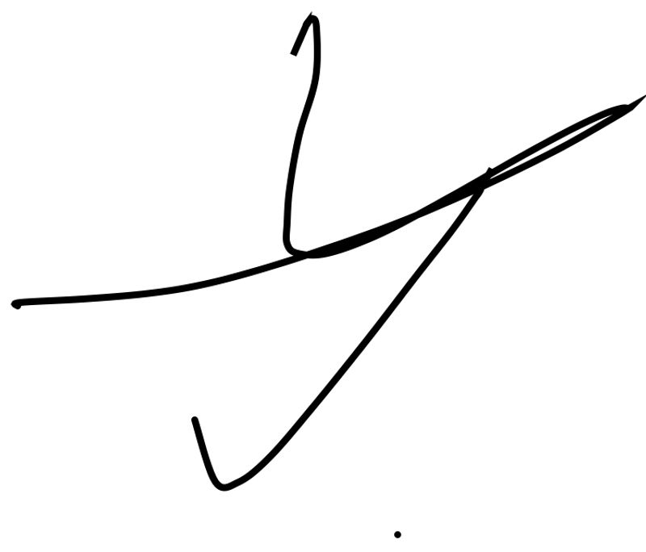
Signature 2
Please enter your name and sign. | Cedar Thaiday |  | 11 Jun 2020 07:06 AM |  | 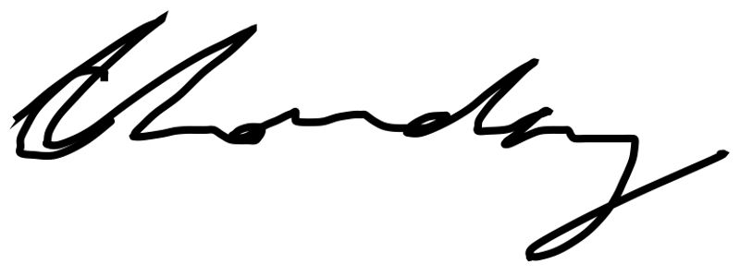
Signature 3
Please enter your name and sign. | Marlon Saylor |  | 11 Jun 2020 07:07 AM |  | 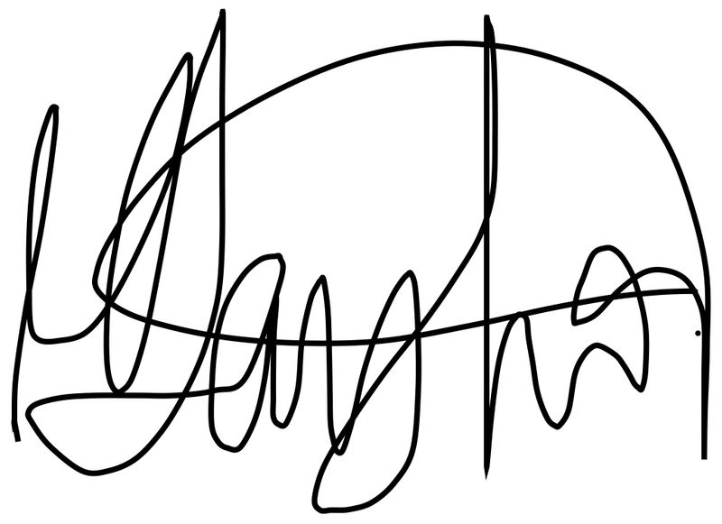
Any Safety / Environment / Community or other concerns |  | Nil
Is there anyone new to site that hasn’t signed on to the initial site specific JSA? |  | No

