PRACTICAL ASSESSMENT 2

Communication of unsatisfactory work to concrete sub-contractor:
Good morning Scott,
Yesterday your guys poured the ground slab for ‘Townhouse 3’, unfortunately the step down in the concrete for the bathroom was not installed as you can see in the picture below:

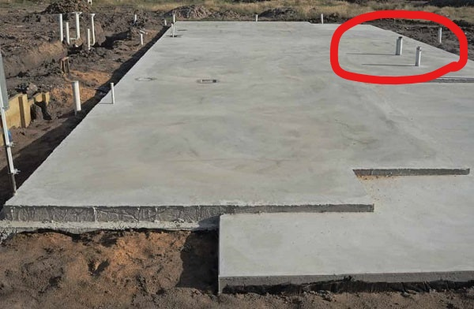

The slab will need to be cut and jackhammered down to below the intended RL and then filled up with self levelling contcrete to the RL that it is meant to be. As the installation of the set downs is part of your contract this will need to be done at your expense. Please don’t hesitate to get in contact with me if you have any questions or concerns.
Thanks
Matt Cumiskey

Material delivery for commercial build of townhouses:

Deliveries to 10-18 Robertson Street Carina Monday 12th October 2020
Delivery for: | Supplier: | Description: | Qty/Units: | Delivery received by: | Notes:
East electrical | MM Electrical | 21mm conduit | 5 x 50 3.6m lengths | Matt | 1 pack of 50 was taken to each townhouse
Pete’s Plasters | USG Boral | 2400x1200 gyprock | 70 sheets | Matt | Sheets for townhouse 3
Tony’s Tiling | Beaumont | Bathroom floor tiles | 6 boxes of tiles | Matt | Bathroom floor tiles for main bathroom and ensuite for Townhouse 1

